Easy SMTA Wizard User Guide

Revision Date
Jul 24, 2018

Contents
Background 1
Installing the Wizard 1
Configuring the SMTA Connection 2
How to Transmit Data 3
Document Attachments 5
Implementation Approach 5
Serializing / Deserializing SMTA Data 6
Securely Storing Credentials 7
Outstanding Items 7
SMTA-Report mapping to GRIN-Global 8
Appendix A. Document Revision Notes. 9

Background
Easy-SMTA is the Information Technology System developed in support of the users of the Multilateral System of Access and Benefit-sharing of the International Treaty on Plant Genetic Resources for Food and Agriculture (ITPGRFA).
Blue Bicycle Technologies was contracted by CIMMYT to create a GRIN-Global Curator wizard to support the publishing of order request data to Easy-SMTA. This document provides instructions on how to use the new functionality, as well as a brief overview of the design approach.

Installing the Wizard
The Easy-SMTA wizard follows the standard GRIN-Global Curator Tool framework for wizards. To install the wizard for a standard Curator Tool installation, the following steps are required:
- Copy the “EasySMTAWizard.dll” to the Wizards sub directory of the GRIN-Global Curator Tool installation.
- Through the GRIN-Global Admin tool, import the following two dataviews:
  - get_SMTA_Report
  - get_SMTA_Report_Material
- Add your Provider ID to the app_settings with the name of “SMTA-PID-Provider”. The provider ID is provisioned by The Food and Agriculture Organization (FAO) and tied to your Easy-SMTA account.
- [Optional] Run the “EasySMTAWizard_Resources.sql” script on the GRIN-Global database server to add resource text for alternative languages.
When installed correctly, the user will be able to launch the Curator Tool and see an Easy SMTA Wizard icon on the toolbar:
During launch, the wizard will verify the existence of the dataviews and the provider PID. If one or more of these items do not exist, the following error dialog will be displayed:
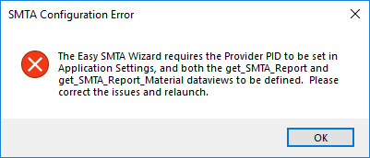

Configuring the SMTA Connection
The Easy SMTA Wizard must be configured with the SMTA server address, username and password before any data can be transmitted. The username and password can be requested through the web by visiting https://mls.planttreaty.org.
Once credentials have been obtained, open the Easy SMTA Wizard and select the “Configure…” button in the lower left corner of the wizard form. Clicking the button will display the Configuration dialog.
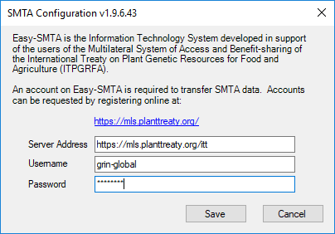
The server address will default to the production Easy-SMTA server at https://mls.planttreaty.org/itt. There is also a testing server located at https://easy-smta-test.planttreaty.org/itt. Credentials for the two systems must be requested separately.
The configuration settings are encrypted and stored locally on the client machine per user.

How to Transmit Data
The Easy SMTA Wizard functions by pulling Order Requests and Order Request Items from GRIN-Global, formatting them as SMTA documents, and transmitting those documents to the Easy SMTA server. Per the SMTA protocol, each Order Request is sent as a separate document.
Start by selecting one or more Orders in the Curator Tool and launching the wizard.
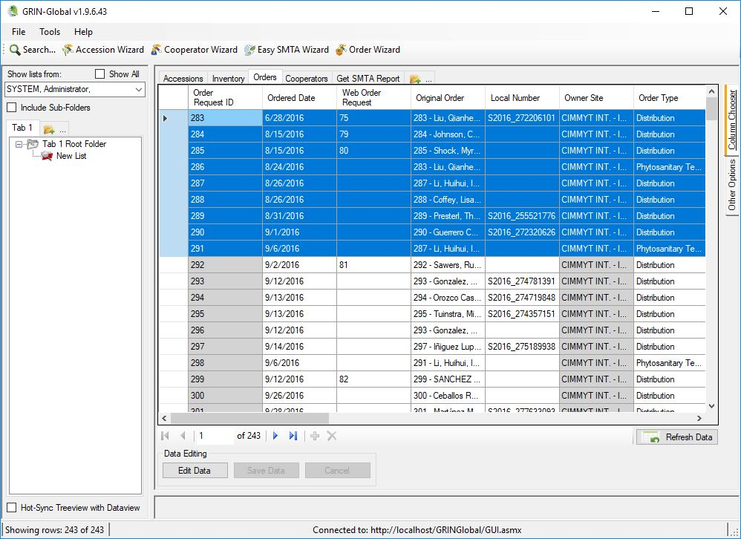

When the Easy SMTA Wizard is launched, the selected orders will be displayed in the pending transfer table:
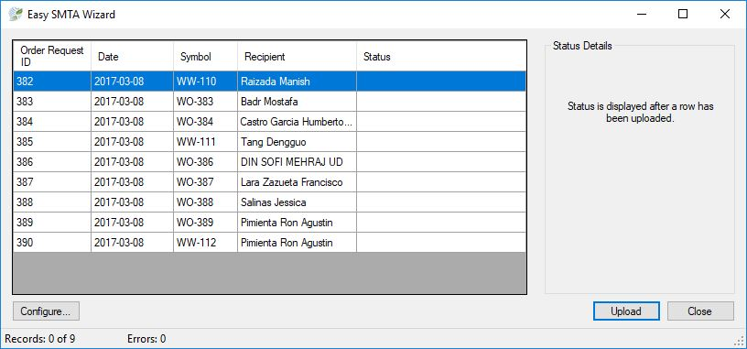

Simply select the “Upload” button to start transmitting SMTA records.
Note: If the “Upload” button is disabled, the Easy SMTA Wizard has not been configured with a server, username and password. Click the “Configure…” button to resolve.
During the transfer, the wizard dialog updates with the status of the operation. The status column within the table indicates whether each order request is successful, and the footer displays the progress and number of errors.
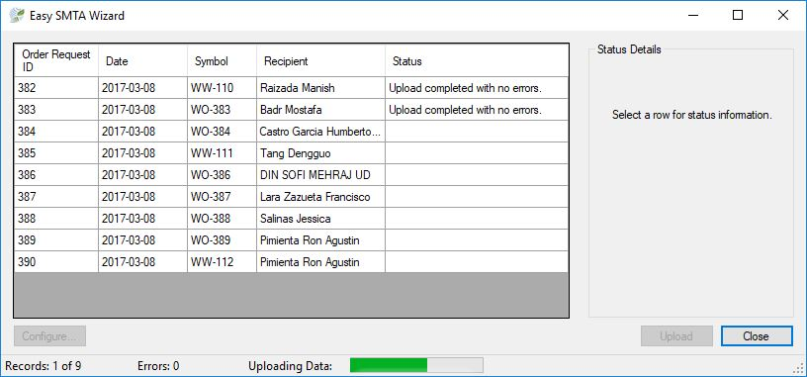

Once the transfer is complete, a message box will appear to display the results.
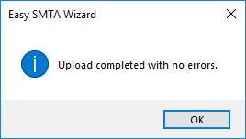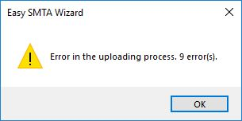

Selecting a row within the table will display any errors returned by the Easy-SMTA server in the “Status Details” portion of the dialog.
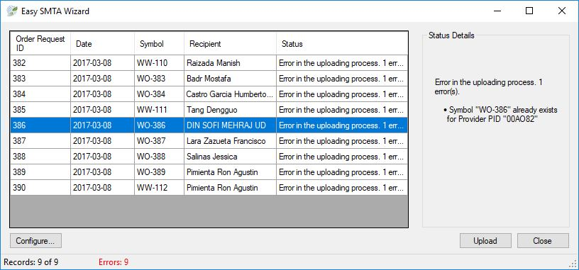

Document Attachments
The SMTA protocol supports attaching a PDF to the SMTA request. If an attachment exists on the order request of the category “SMTA” and the attachment is a PDF, the document will be sent to the Easy-SMTA server.

Implementation Approach
As noted above, the implementation follows the standard Curator Tool wizard framework.
The core classes in the implementation are as follows:
Class | Purpose
EasySMTAWizard.cs | Main dialog of the Easy-SMTA Wizard, which is responsible for orchestrating the transfer. The class populates an SMTARequest object from the order request data from the dataview.  The SMTARequest object is transferred to the server through the SMTAController class.
SMTAController.cs | The SMTAController class is a shared object through the wizard which maintains state and performs the serialization and transfer of SMTARequests to the SMTA server.  Responses are deserialized to SMTAResponses and returned to the caller.  For large orders with 100 or more order items, the SMTAController compresses the data using gzip prior to sending.
SMTARequest.cs  SMTAProvider.cs  SMTAMaterial.cs  SMTADocument.cs | Classes which mirror the structure of the SMTA request object. Once populated, the request is serialized to XMLS and sent.
SMTAResponse.cs  SMTAError.cs | Classes which mirror the structure of the SMTA response object. When a response is received, it is deserialized to an SMTAResponse.
SMTAException.cs | There are error cases when an SMTAResponse is never received from the server. For example, if the user credentials are incorrect.  In these cases, an SMTAException is thrown with details on the issue.
EasySMTAConfigForm.cs | Configuration dialog for the SMTA Wizard
Configuration.cs | Responsible for managing the SMTA configuration by reading and decrypting from storage, as well as encrypting and storing.

Serializing / Deserializing SMTA Data
The SMTA protocol is based on XML documents transported of HTTPS. The wizard implementation accommodated the XML format by relying on the .Net System.Xml.Serialization library.
A set of .Net classes have been created (stored in the Model folder of the solution) which mimic the hierarchy of the SMTA request and response data. To send an SMTA request, a SMTARequest object is created, populated with GRIN-Global data, serialized to XML and transported over HTTPS. The response is deserialized into an SMTAResponse object.
Should the SMTA XML object be extended in the future, a developer could modify the Easy SMTA Wizard to add the new elements by taking a few simple steps. For example, if the SMTA request were to include a “specialNote” element one would:
- Add a new “SpecialNote” string property to the SMTARequest class.

- Add an XMLElement attribute to the new property which matches the XML element name (and casing)
[XmlElement("specialNote")]
public string SpecialNote { get; set; }

- Modify the CreateSMTADocument method of the EasySMTAWizard class to map the correct order request data element to the new property.
request.SpecialNote = orderRow["note"].ToString();
With three lines of code, the new element is included in the SMTA data transfer.

Securely Storing Credentials
SMTA credentials are per individual user, so the implementation was designed to ensure that the credentials are stored securely. It handles the case where each user logs into GRIN-Global from a unique Windows account, or when they login with their individual logins from a shared Windows account.
Credentials are stored in a text file located in the Window user’s application data folder. Specifically, it is stored at C:\Users\<username>\AppData\Roaming\GRIN-Global\Curator Tool. A file is created for each curator username. For example, if a user with username joeblow configures a SMTA connection, a file names smta_joeblow.txt will be created containing client id, client secret, and tokens.
Only users who login into the machine with the same Windows user account will be able to access the file. In the case multiple users access the Curator Tool from a single Windows account, the contents of the file are further encrypted using the Windows Data Protection API.
If at any time the credentials file is deleted or corrupted, the next time the user attempts to upload data, the configuration wizard will run automatically.

Outstanding Items
With the implementation in place, the Curator Tool installation must be modified to
- Ensure the .Net 4.5.2 library is installed on the target machine.

SMTA-Report mapping to GRIN-Global
SMTA-Report |  | GRIN-Global fields |  | Comments
Pos | Column | Table | Field
 |  | Order_request_action | order_request_id
 |  | Order_request_action | Completed_date
1 | Symbol | Order_request_action | order_request_id
2 | Date | Order_request_action | Completed_date
3 | Type |  | “cw”, “sw” or “si” | Order_request.web_order_request_id
4 | Language | Sys_lang | Iso_639_3_tag
5 | Provider type |  | '"or" / "in" | App_setting.name like 'SMTA-PID-Provider'. If cooperator.last_name is null then 'or' else 'in' end.*
6 | Provider PID | App_settings | Value | App_setting.name like 'SMTA-PID-Provider'.*
7 | Provider name | Cooperator | Last_name + First_name | App_setting.name like 'SMTA-PID-Provider'.*
8 | Provider address | Cooperator | address_line1 + address_line2 + address_line3 | App_setting.name like 'SMTA-Provider-Cooperador-id'.*
9 | Provider country | Cooperator | geography_id | App_setting.name like 'SMTA-Provider-Cooperador-id'.*
10 | Provider email | Cooperator |  | App_setting.name like 'SMTA-Provider-Cooperador-id'.*
11 | Recipient type |  | "or" / "in" | Order_request.final_recipient_cooperator_id. If cooperator.last_name is null then 'or' else 'in' end.*
12 | Recipient PID |  |  | For CIMMYT always is blank
13 | Recipient name | Cooperator |  | Order_request.final_recipient_cooperator_id
14 | Recipient address | Cooperator |  | Order_request.final_recipient_cooperator_id
15 | Recipient country | Cooperator |  | Order_request.final_recipient_cooperator_id
16 | Shipment name | Cooperator |  | Order_request.final_recipient_cooperator_id
17 | Document location |  |  | For CIMMYT always is blank
18 | Retrieval information | App_settings |  | App_setting.name like 'SMTA-retInfo.*
19 | Filename | Order_request_attach
*See EasySMTAWizard_Resources.sql file.

Appendix A. Document Revision Notes.

- Jul 24, 2018
  - Added SMTA-Report mapping to GRIN-Global section.

