Standard Material Transfer Agreement (SMTA)

Standard Operating Procedure and Guide for NPGS

Revision Date
December 20, 2023

This document explains how GRIN-Global distributes plant germplasm accessions covered by the Standard Material Transfer Agreement (SMTA).

Comments/Suggestions
Please contact Marty Reisinger at either marty.reisinger@usda.gov or mar@rrginc.com with any suggestions or questions related to this document.

Complete documentation of GRIN-Global is available online at the GRIN-Global (GG) project’s documentation page: https://www.grin-global.org/userdocs.htm. Recommended: bookmark this page and avoid printing, as the GG documents are frequently revised.

Table of Contents

Background on Standard Material Transfer Agreement (SMTA) 3
USDA Notes: National Plant Germplasm System (NPGS) 3
Non-ARS Sites Not Covered by the MLS 3
GRIN-Global and Standard Material Transfer Agreement 3
Summary of the NPGS Request Workflow 4
NRR Review Process 4
Domestic Distributions – All Sites 6
Germplasm Received into NPGS with SMTA 6
Germplasm Received into NPGS without SMTA 6
International Requests 7
Four GG sites (TGRC, DLEG, NTSL, TOB) not covered by the MLS 7
International Requests for ARS Germplasm (excludes the four non-ARS Collections) 7
Requesting Accessions Covered by the SMTA 9
Shopping Cart SMTA Indicator 9
Confirmation email to the User 10
Processing Orders with SMTA Items in the Order Wizard 10
Recording the Accession’s SMTA Status in the Curator Tool 11
Frequently Asked Questions 13
SMTA Wizard 14

Background on Standard Material Transfer Agreement (SMTA)
See https://www.fao.org/plant-treaty for a complete explanation of the Multilateral System (MLS) and the Standard Material Transfer Agreement (SMTA). The complete text of the SMTA is online at https://www.fao.org/3/a-bc083e.pdf
The International Treaty on Plant Genetic Resources for Food and Agriculture (ITPGRFA) was adopted by the Thirty-first session of the Food and Agriculture Organization (FAO) Conference on November 3, 2001. The Treaty facilitates access to the propagative materials of 64 crops in the MLS for research, breeding, and training.

USDA Notes: National Plant Germplasm System (NPGS)
The U.S. became a Contracting Party to the ITPGRFA after the treaty was ratified by the U.S. Senate on September 28, 2016. On November 2, 2017, approximately 500,000 active accessions of more than 15,000 species of the NPGS were added to the MLS. Accessions acquired since then will follow the same procedures described in this document.
NPGS uses GRIN-Global to accept germplasm requests from users worldwide. Beginning January 1, 2024, all international requests will be handled according to the protocol described in the following sections. The NGRL Database Management Unit will be responsible for aggregating and reporting the NPGS SMTA data to the Secretariat of the ITPGRFA.

Non-ARS Sites Not Covered by the MLS
20 genebank sites have accession-level data in the NPGSWEB GRIN-Global database. However, four sites were not included in the ARS designation to be part of the MLS. The four sites that use the NPGS database but will not be following the ARS SMTA distribution protocol are:

- Desert Legume Program (DLEG) at the University of Arizona.
- USDA U.S. Forest Service National Seed Lab (NTSL)
- C.M. Rick Tomato Genetics Resource Center (TGRC) at the University of California at Davis
- U.S. Nicotiana Germplasm Collection (TOB) at North Carolina State University

GRIN-Global and Standard Material Transfer Agreement
The GRIN-Global (GG) genebank software for managing accessions and inventory has features to accommodate the SMTA documentation requirements. For example, on the GG website, germplasm requestors must select an Accept SMTA checkbox when the requested accessions are covered by the SMTA; if the user does not accept, the GG software automatically removes the SMTA accessions from the germplasm request list.
An SMTA reporting wizard is also available for GG. This wizard can be optionally installed and then runs within the Curator Tool. Typically, only one person for each genebank organization, the GG administrator or a similar designated individual, would install and operate the wizard. (See the SMTA Wizard section for details.)
All material distributed with the SMTA will be reported to the Secretariat of the ITPGRFA.

Summary of the NPGS Request Workflow
Requesters using the NPGS GRIN-Global site (https://npgsweb.ars-grin.gov/gringlobal/search) must create a profile before they can request germplasm using the shopping cart and checkout process. In their contact information, the requester provides two addresses: a primary address and a shipping address (the addresses can be identical). The country of the shipping address impacts the processing. Domestic (within the U.S. states and territories) and international (outside the U.S. states and territories) requests follow different logical workflows.
- all international shipping addresses will trigger an SMTA acceptance from the requester except for four non-ARS sites ((TGRC, DLEG, NTSL, TOB) not covered by the MLS
- domestic requests to all NPGS sites will not universally trigger SMTA acceptance, but those accessions that had been accepted into NPGS under SMTA will require the requester to accept the SMTA
Details follow.
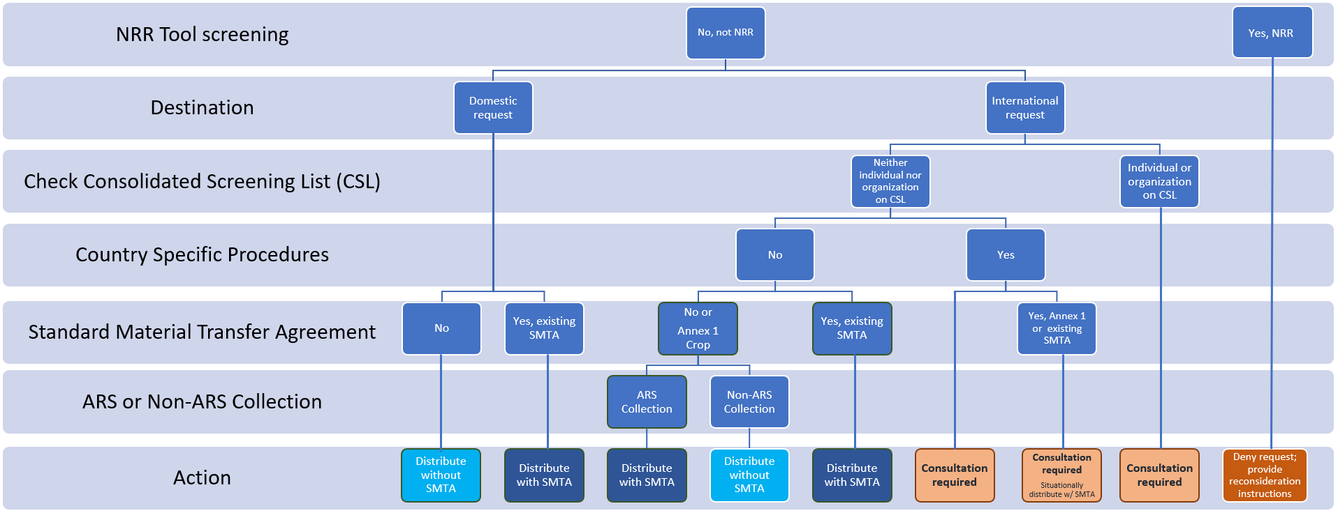

NRR Review Process
In the NPGS, most incoming germplasm requests submitted via the GG website are initially evaluated within the NRR review process (above chart: “NRR Tool Screening”). A small percentage of incoming domestic requests that meet specific criteria bypass the screening process and immediately enter the NPGS web request queue. Beginning January 1, 2024, all international incoming requests will be reviewed by the NRR process.
Staff from NPGS use the NRR Tool to evaluate requests. They examine the pending request and consider multiple factors to determine if the request should be approved or denied. (NPGS staff with questions regarding the NRR process or the criteria may email GrinGlobal.Orders for more information. This information is intentionally not published here.) The NRR reviewer can also contact the curator(s) for input regarding the validity of the request if the decision is not apparent.
When a request is denied by an NRR reviewer, a templated email is sent to the requester describing the procedure for providing more information if they want to ask for a reconsideration of the denial.
Note: Requests denied by the reviewer are visible to the sites via the Order Wizard and can be accepted at the site level, even when an NRR reviewer initially denied the request.
Approved requests enter the NPGS web request queue. The NPGS sites then use the Curator Tool’s Order Wizard to review and fulfill the order.
In GRIN-Global, when an incoming web request is processed by a site, the request is converted into an “order” and is assigned an order number. When an incoming web request involves multiple NPGS sites, multiple orders (each with its own order number) will be generated. It is also possible that sites may handle the requests differently – one site may accept the request and another site could deny the material requested from their site.

Domestic Distributions – All Sites

Germplasm Received into NPGS with SMTA
Germplasm acquired by the NPGS with an SMTA will always be distributed with the SMTA. This applies to both domestic and international orders.
During the ordering / shopping cart process on the GG website, the requester must use the GG “click to accept” option for the germplasm to be included in the request. If the user does not use the click option, all SMTA germplasm are removed from the cart and ultimately the request.

Germplasm Received into NPGS without SMTA
For germplasm acquired by the NPGS without an already-existing SMTA, domestic distributions will not be accompanied by the SMTA.
Accessions PI 500000 and PI 600000 were acquired without an SMTA;
PI670518 was acquired into NPGS with an SMTA
Domestic Request
(Requester’s shipping address country is USA)
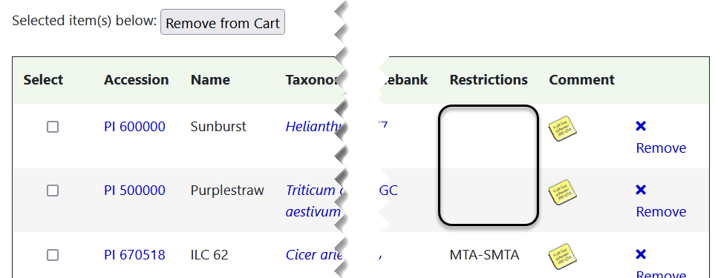
International Request
(Requester’s shipping address non -USA country)
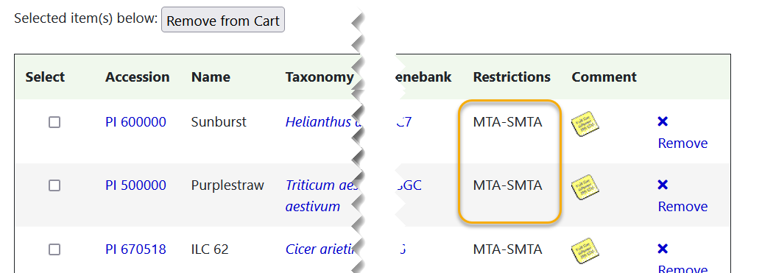

International Requests

Four GG sites (TGRC, DLEG, NTSL, TOB) not covered by the MLS
Four sites (TGRC, DLEG, NTSL, TOB) that use NPGS GRIN-Global are not part of the MLS. These four sites will process incoming requests as they always have. That is, these sites will require SMTA acceptance only when distributing material they acquired was accompanied by the SMTA. It does not matter if the shipping address is domestic or international.

International Requests for ARS Germplasm
(excludes the four non-ARS Collections)

Steps:

1. NRR Review
All incoming requests with an international shipping address will be reviewed by the NRR reviewers. (“NRR Tool Screening” in figure below.)

2. Check Consolidated Screening List (CSL)
The NRR reviewers will search the CSL https://www.trade.gov/data-visualization/csl-search to determine if the requester is on the list by either name or organization.
The CSL is a searchable database, maintained by the International Trade Administration of the U.S. Department of Commerce, which identifies individuals and organizations subject to U.S. restrictions on exports, reexports, or transfer of material items. If an incoming request includes the name of an individual or organization on the CSL, which should be rare, information accompanying the request will be forwarded to the ARS Office of the National Programs, National Program Leader (NPL) for Plant Genetic Resources. The NPL will promptly consult with other U.S. governmental agency contacts, as needed, and inform the NRR reviewer whether to accept or deny the request. It is unlikely the NPGS will fulfill any requests from individuals or organizations on the CSL.
Note: Eventually the NRR Tool software will be revised to automatically connect to the CSL via an API and search for the requester’s name and organization. When on the list, the NRR Tool will flag such requests so they can be referred to the NPL.

3. Country Specific Procedures
A list of countries, and in some cases regions within a country, from which germplasm requests require special consideration will be maintained by the NPL in consultation with other governmental agencies. Identifying incoming web orders from this list will initially be done manually by the NRR reviewers, but the NRR Tool software will eventually be modified to compare the shipping address country with the specific country list.
Requests with shipping addresses that match countries or regions on this list will be forwarded to the NPL for a final determination whether to deny or approve the request. If the request is approved, all material included in the ITPGRFA Annex 1 list of crops or that has a previously existing SMTA will be distributed with the SMTA.
4. Material that is an Annex 1 Crop or acquired by ARS without an existing SMTA
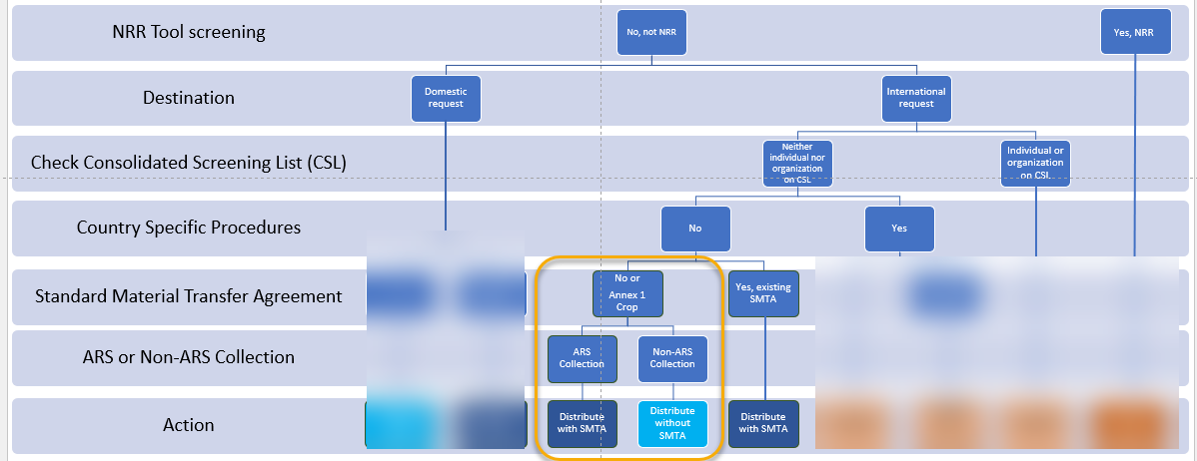
The Action taken varies if the site is a non-ARS or ARS site.

- ARS sites will distribute international requests with an SMTA.
- The four non-ARS sites (TGRC, DLEG, NTSL, TOB - not covered by the MLS) will distribute the international requests without an SMTA.

4. Material acquired by ARS with an existing SMTA
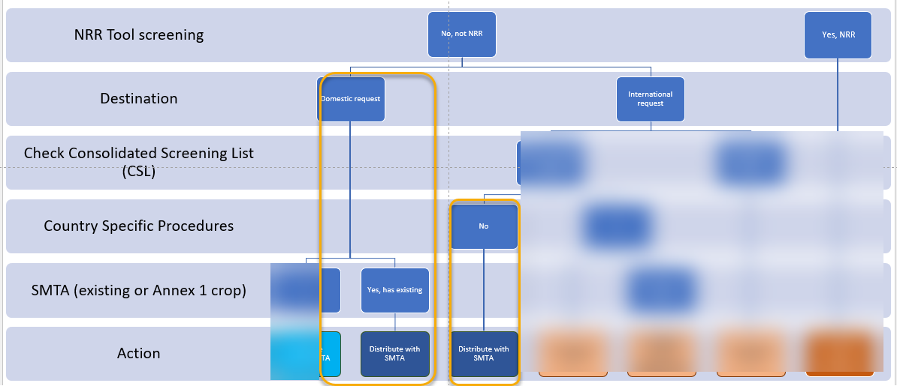
Material acquired with an existing SMTA will be distributed with the SMTA, to both domestic and international requestors. This is true for all sites using NPGS GG.

Requesting Accessions Covered by the SMTA

Shopping Cart SMTA Indicator
During the germplasm request process when the user reviews their shopping cart, SMTA accessions are highlighted:
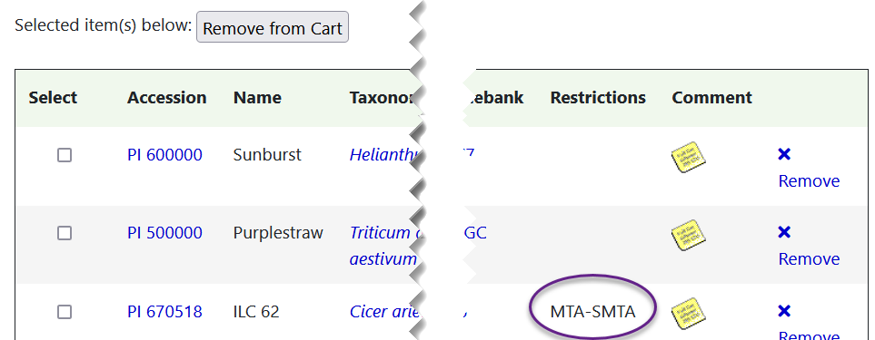
In the example above, the requester has a U.S. shipping address. The first two accessions listed in the shopping cart were not acquired by the NPGS with an SMTA; thus, there are no restrictions. The third accession, PI 670518, was acquired by NPGS with an SMTA, so the restriction is listed.
A requestor can remove any individual item from the cart by selecting its respective “X Remove” option. All SMTA accessions in the cart can be removed when the user selects the “No, I do not accept the terms of the SMTA and do not want to request the germplasm” option. (image below) When accessions with an SMTA restriction are in the cart, to proceed with the request, the requester must select the “Yes, I accept the terms of the SMTA and want to request the germplasm” option.
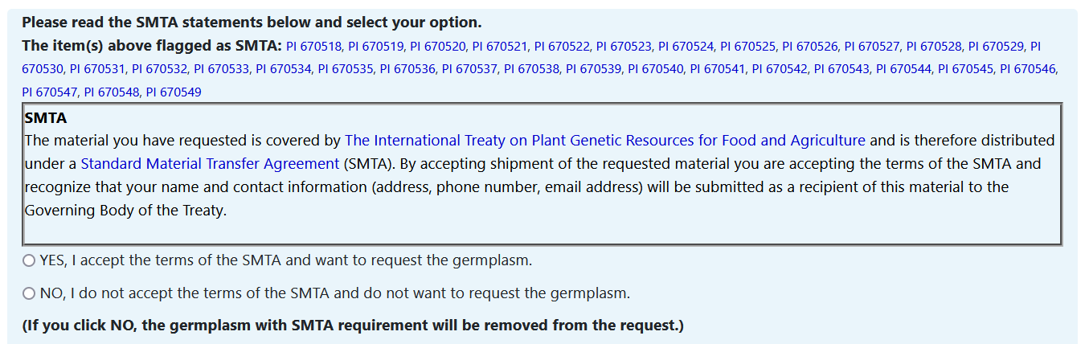
A warning will popup when SMTA items are in the cart and the requester has not selected the “Yes…” option.
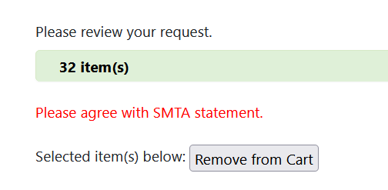

Confirmation email to the User
The web request confirmation email displays “SMTA Material” next to each requested item covered by SMTA.
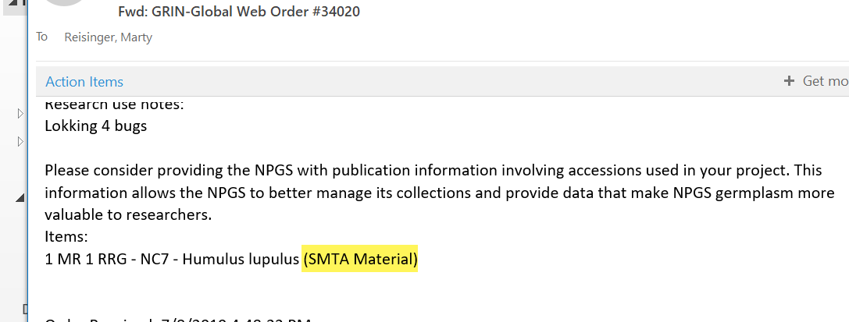

Processing Orders with SMTA Items in the Order Wizard
Accessions acquired with an SMTA and have an SMTA record in the Accession IPR table are highlighted in bright red in the Order Wizard items grid.
If the SMTA Check? box is selected, the Order Wizard will display a popup alert when any order items in the grid require SMTA acceptance but do not have an associated SMTA acceptance action.
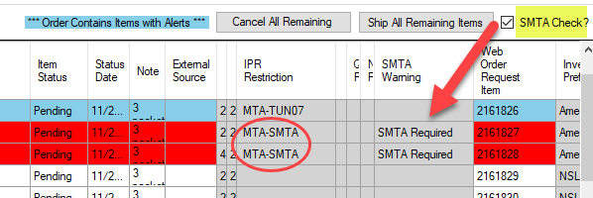
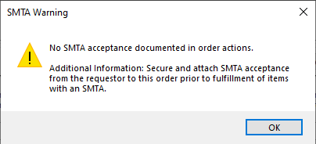

When the order is processed in the Order Wizard, an Order Request Action record is automatically generated, indicating the SMTA acceptance. The Action Information field lists the accessions.
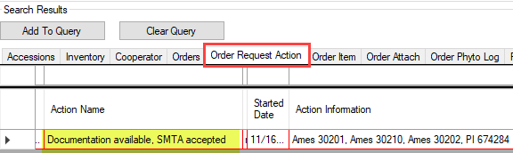
This action is also noted on the requester’s history page.
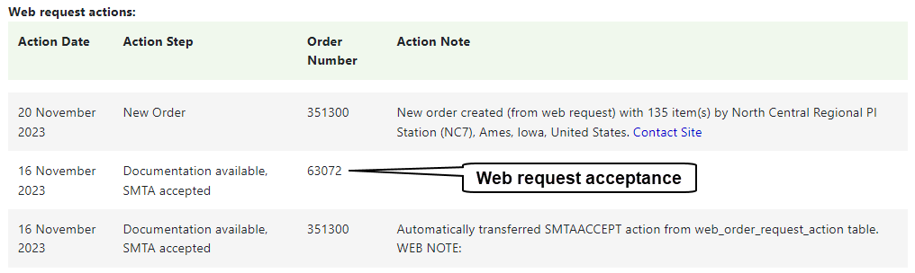

Recording the Accession’s SMTA Status in the Curator Tool
In GG, use the Accession_IPR (Intellectual Property Rights) dataview to indicate that an accession was accepted into NPGS with an SMTA.
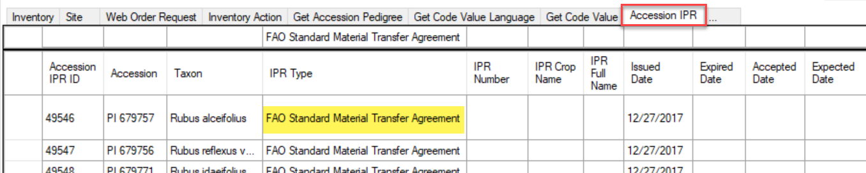
The two required fields are the Accession identifier and the IPR Type:
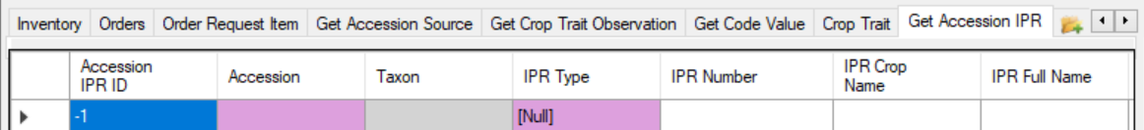
Alternatively, the Accession Wizard may also be used.
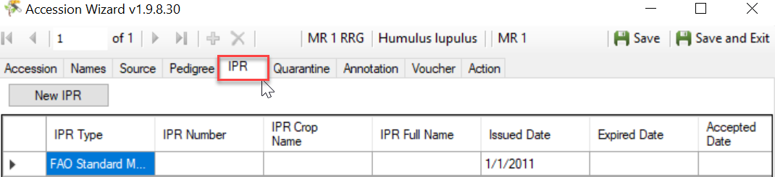

Frequently Asked Questions
Questions pertain to NPGS)
- What is changing?
Distributing all NPGS accessions of all taxa with the SMTA to international requestors is a new procedure.
- How will I accept the terms of the SMTA for material I am requesting?
There is a click-acceptance of the terms of the SMTA as part of the website shopping-cart checkout process. This has already been the procedure for several years when SMTA acceptance was required. The only change is that SMTA acceptance will now be required for all distributions to locations outside the U.S.
- Does this new procedure required accepting the SMTA for distributions in the U.S.?
NPGS material shipped to U.S. state and territorial locations will require SMTA acceptance only for accessions that the NPGS acquired with the SMTA. This is not new and has been the procedure for several years.
- Does this new procedure apply to all taxa or only Annex 1 crops?
It applies to all taxa being distributed by the NPGS. There are four non-ARS collaborators that use GRIN-Global to assist in managing their collections: Desert Legume Program at University of Arizona, Tobacco Collection at North Carolina State University, C. M. Rick Tomato Genetic Stocks Collection at the University of California at Davis, and the USDA U.S. Forest Service National Seed Laboratory. There four collections will require SMTA acceptance for distributions outside the U.S. only for material they acquired with the SMTA.
- What happens if I do not accept the SMTA when required?
For international requestors who do not accept the SMTA, your entire request will be cancelled at the shopping cart stage and will not be submitted to the NPGS. For domestic requestors who do not accept the SMTA, any accessions that require SMTA acceptance will be removed from your shopping cart before your request can be submitted.
- I am a U.S.-based researcher but want my request shipped to a research site outside the U.S. Will SMTA acceptance be required?
Yes. The shipping destination alone will determine whether SMTA acceptance is required. Any shipping destination other than U.S. states and territories will require SMTA acceptance.

- What are the implications of my accepting the SMTA?
It is beyond the capacity and scope of the NPGS to answer this question. See the ITPGRFA site, and especially the section on the SMTA for more information to help answer this question.
- Am I authorized to accept the SMTA?
It is beyond the capacity and scope of the NPGS to answer this question. However, it is important for the requestor to know the answer. You may need to consult with your organizational technology transfer/intellectual property contacts. The NPGS assumes that anyone who accepts the SMTA has determined that they are authorized to do so, especially for requestors from universities and research companies.

SMTA Wizard
NPGS is not currently using the SMTA Wizard.

The complete documentation for the Easy SMTA Wizard is online at
http://grin-global.org/docs/gg_Easy_SMTA_Wizard.docx It is expected that eventually one NPGS individual will be responsible for running the wizard – most likely the GG database administrator.

