Alternative GG Languages
Languages for displaying Coded Values (rather than their Titles)

Revision Date
July 21, 2020

Comments/Suggestions:
Please contact feedback@ars-grin.gov with any suggestions or questions related to this document. This and other GRIN-Global –related documentation can be downloaded from the GRIN-Global Training page.

The Appendix contains directions for creating a GG language GG and this document’s revision notes.

Table of Contents
Traits, Coded Values, and Titles 3
How does the Curator Tool user switch languages? 3
Creating Observation Records Using Codes 4
Codes and Code Groups 6
ENG Example 7
English Example 7
Where does the text for these codes come from? 8
Spanish Example 9
Title Trumps the Value 9
Updating the Lookup Tables When Switching Languages 10
Codes That Have Identical Values and Titles 11
Reviewing the Codes and Code Groups 13
Query to Display Codes & Code Groups 15
SQL for Cloning a Language 17
Document Revision Notes 19

Background

Observations, Traits, Coded Values, and Titles
When entering crop observations that use codes, two alternatives methods can be used. In one case, you can enter the Code. In the other, you can enter the code’s Title. Depending on the situation, users may prefer one method over the other. Users may prefer to use Titles when manually entering one or two observations manually, whereas when bulk adding many observations from an Excel spreadsheet, they prefer using the Codes.
Certainly, it is easier to recognize “1. Black” for Berry Color than to remember that “1” indicates the color “black” for this particular berry color trait. This is especially true when a trait has many possible values – it becomes very difficult to remember that 1 is “black,” 2 is “blue,” 3 is “purple,” 4 is ”red,” and so on. To compound the complexity, for some other trait a “1” might mean “oblong” whereas a “2” means “ovate.” When manually recording Crop Observations, one record at a time, most users would typically prefer to see these titles.
A “work-around” was designed to handle bulk importing. An alternative language to English was set up to facilitate mass loading of data by using the coded values. The language “ENG” was set up to accommodate this. (The ENG language is bundled with GG and is ready to use.)
Administrators: Directions for creating an alternative “language” are in the appendix.

Besides Titles, descriptors (traits) have a Description field. Descriptions do not have any impact here. The issue discussed here is with the Titles for the coded values.

From English to ENG

How does the Curator Tool user switch languages?
On the CT’s menu, the user needs to select File | Language.
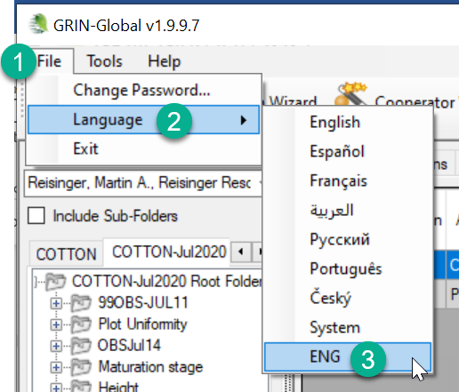
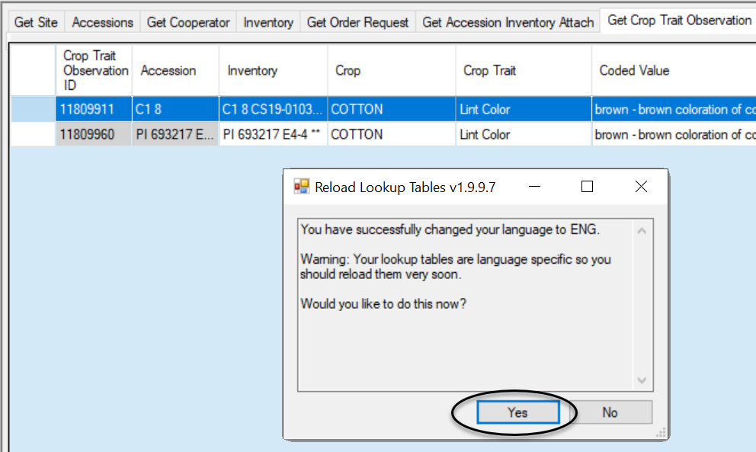
Update the three Crop-related lookups for the language being switched to, in the following order:
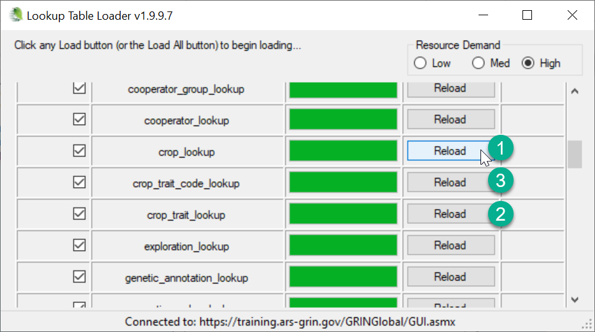

Bulk Adding Observations

Open the Get Crop Trait Observation Dataview
Refresh Data
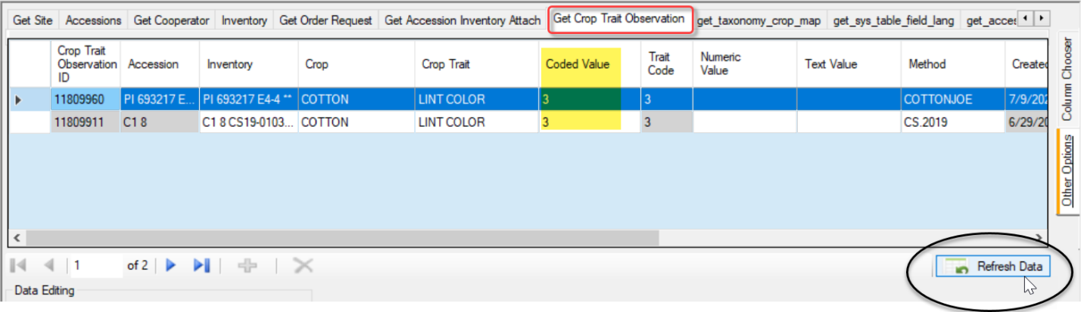

Prepare the Observations in Excel
Drag a row from the dataview into Excel. Four fields are required (shown in pink below). Complete the rows and drag and drop into the CT (in Edit mode). Use the codes in the Code Value column.
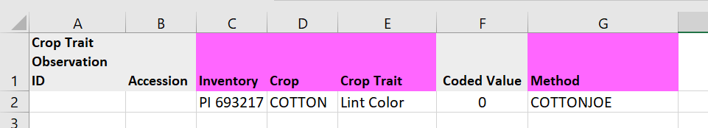

Save the Data
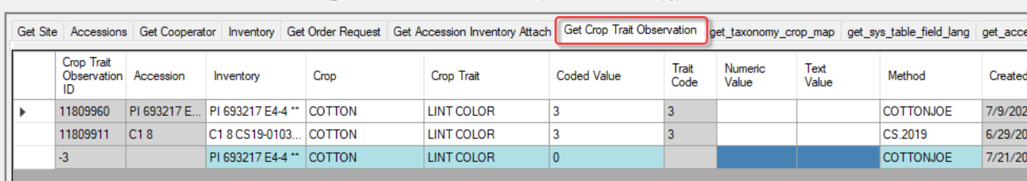

Switch Back to English
When you switch back, you will be prompted to update the lookup tables. As before, do so in order:
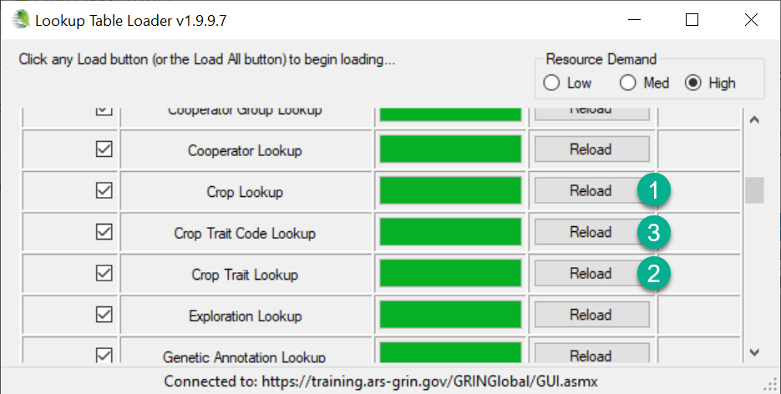

Codes and Code Groups
Many Curator Tool dataview fields use dropdowns to assist the user in selecting a valid entry. The dropdowns restrict the inputting of random text data. Instead, they require the user to select a value from a pre-populated set of choices which have been stored in a specific Code Group. The GRIN-Global administrator for the organization sets up and edits the values and titles for these codes typically using the GRIN-Global Admin Tool.
The standard GRIN-Global installation supplies a set of codes based on the codes used in the USDA National Plant Germplasm System (NPGS). The codes have been translated into five languages (English, Spanish, French, Russian, and Arabic), but the set is no longer current for all of the English codes.
The code values are typically short (less than under 20 characters). Various tables in GG (mainly code_value_lang) convert the internal codes to their lengthier titles, which are language specific. For example, the Order Item Status Code which is stored internally as “SHIPPED” can be displayed as ”Shipped order item” in English and “Envíe item del pedido” in Spanish.
Users seem to be in “two camps”–some users prefer seeing the shorter internal code values displayed, whereas other users prefer displaying the longer titles. One advantage of the shorter codes comes when bulk updating via the dragging and dropping of data from spreadsheets to GG.
To accommodate both preferences, the additional “language” (ENG) was included with the GG installation. Users who set their language to ENG will see the code values displayed in a number of places (after reloading the appropriate lookup tables). For example, when using ENG as their language, they will see the code “SHIPPED,” whereas users with English as their language will have the Code’s English title displayed “Shipped order item.” NPGS users are initially setup with English as their default language, but they can switch back and forth as desired. (Switching languages)

ENG Example
In the following example, when adding a new order request item record in the Curator Tool, with ENG selected for his language, the user will see the shorter codes for Item Status:
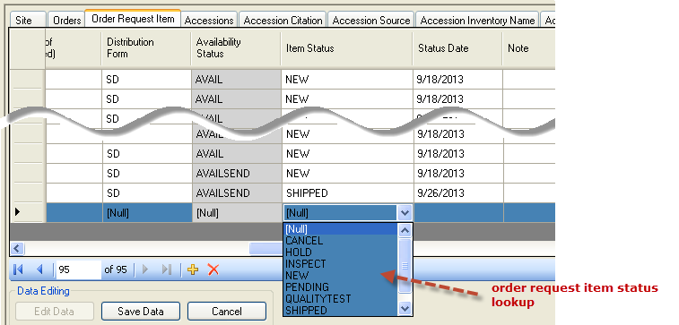

English Example
When the user’s language is English, the user will see the lengthier titles:
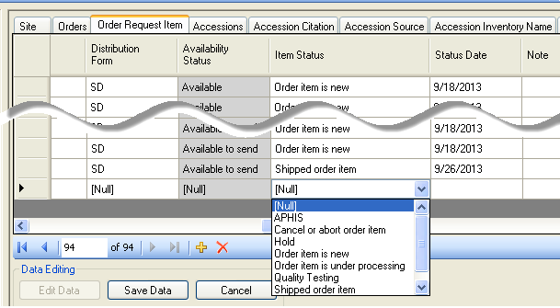
The GRIN system used a convention where the Codes were always spelled in upper case. This has been carried over to GRIN-Global, but other organizations may establish their own convention.
When loading data (such as dragging data from a spreadsheet into the CT, you should match the case and spelling. For example, in ENG, a valid Item Status code for the Order Request Items is NEW; in English, it is New.

Where does the text for these codes come from?
The administrator controls what text is stored with each code. The screen below was copied from the Admin Tool, which only the organization’s GRIN-Global administrator (or users with administrative privileges) will have access to. If you review the ENG and English described earlier, you can see the Value is displayed when ENG is the user’s selected language; Title is displayed when English is set for the user’s language.
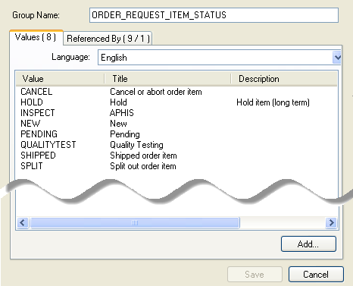
Administrators can reference two documents for updating codes. The Admin Guide has directions for using the Admin Tool’s Code editor; the Import Wizard Cookbook has details for bulk loading codes (initially done when the administrator is initially setting up the organization’s database).

Spanish Example
In the following example, Spanish was selected for the language. It appears that in this situation, there is a mixture – for some codes, some values are displayed, and for others, titles.
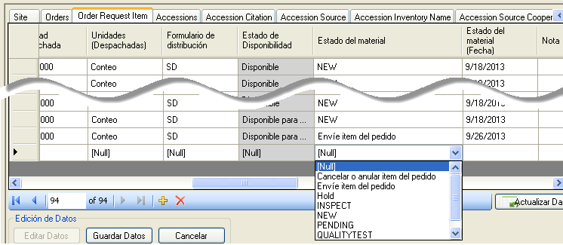
The following Admin Tool screen shows how the Spanish data was installed:
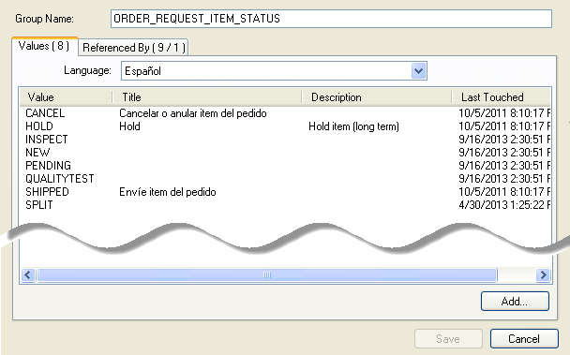

Title Trumps the Value
You can conclude that the Title trumps the Value, that is, when the user is selecting from a lookup, if the code has an associated Title, the Title will display in the Curator Tool , otherwise, the Value will display.
The following two screens illustrate how English and ENG are working. The English codes have associated Titles; the ENG codes do not. When the user is using English as his language, he will see the Titles displayed, when in ENG, only the Values. (A corollary to this: when viewing in English (or in any language), if the Code does not have a corresponding Title, only its Value will display.)
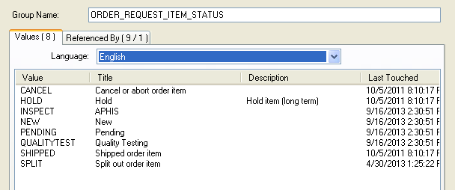
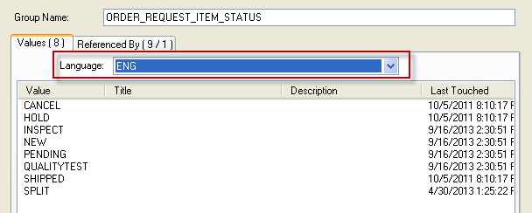

Updating the Lookup Tables When Switching Languages
Curator Tool users do not need to reload all of their lookup tables after switching languages, but they will be prompted that their tables are not up to date. Normally a user will rarely switch languages, but he can. The user may only need to reload few lookup tables if he is mainly concerned with seeing codes in a particular context.

Lookup tables that may need updating when a user switches languages
- Code Value Lookup
- Cooperator (Big) Lookup
- Crop Trait Code Lookup
- Crop Trait Lookup
- Geography Lookup
- Inventory Lookup
- Mailing Geography Lookup
- Source Descriptor Code Lookup
- Taxonomy Geography Map Lookup
English:
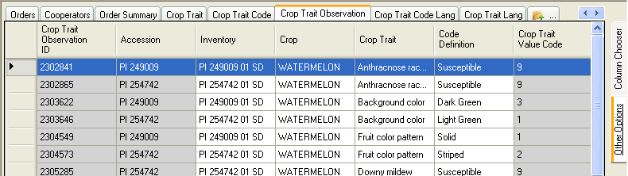
ENG:
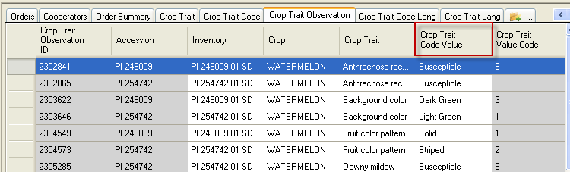
ENG: after Updating the Crop, Trait, and Trait Code Lookup Tables and Refreshing:
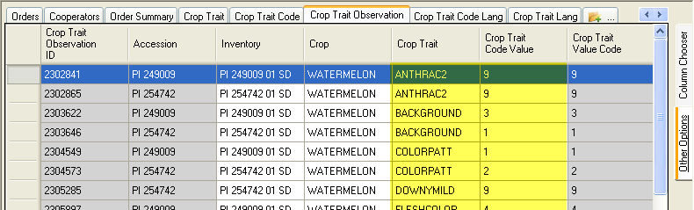
“Refreshing” –clicking the Refresh Data button:
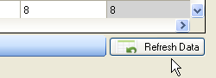

Codes That Have Identical Values and Titles
There are a few Code Groups which have identical titles and values. The primary reason the codes were set up in this fashion relates to the original GRIN nomenclature used by the NPGS. Other organizations adapting GG will most likely review the titles and delete / change them to meet the organization’s specific needs.
group_name | value | title
ACCESSION_STATUS | INACTIVE | Inactive
CART_TYPE_CODE | FAVORITE | Favorite
CART_TYPE_CODE | ORDER ITEMS | Order Items
COOPERATOR_STATUS | ACTIVE | ACTIVE
COOPERATOR_STATUS | DEAD | DEAD
COOPERATOR_STATUS | HISTORICAL | HISTORICAL
COOPERATOR_STATUS | INACTIVE | INACTIVE
GERMPLASM_FORM | ** | **
GERMPLASM_FORM | BD | BD
GERMPLASM_FORM | BL | BL
GERMPLASM_FORM | CA | CA
GERMPLASM_FORM | CL | CL
GERMPLASM_FORM | CM | CM
GERMPLASM_FORM | CT | CT
GERMPLASM_FORM | DN | DN
GERMPLASM_FORM | ER | ER
GERMPLASM_FORM | FI | FI
GERMPLASM_FORM | FR | FR
GERMPLASM_FORM | GS | GS
GERMPLASM_FORM | HE | HE
GERMPLASM_FORM | HS | HS
GERMPLASM_FORM | IO | IO
GERMPLASM_FORM | IV | IV
GERMPLASM_FORM | LA | LA
GERMPLASM_FORM | LV | LV
GERMPLASM_FORM | MF | MF
GERMPLASM_FORM | MI | MI
GERMPLASM_FORM | MS | MS
GERMPLASM_FORM | PD | PD
GERMPLASM_FORM | PF | PF
GERMPLASM_FORM | PL | PL
GERMPLASM_FORM | PO | PO
GERMPLASM_FORM | PR | PR
GERMPLASM_FORM | RH | RH
GERMPLASM_FORM | RN | RN
GERMPLASM_FORM | RT | RT
GERMPLASM_FORM | SC | SC
GERMPLASM_FORM | SD | SD
GERMPLASM_FORM | SG | SG
GERMPLASM_FORM | SP | SP
GERMPLASM_FORM | ST | ST
GERMPLASM_FORM | TC | TC
GERMPLASM_FORM | TU | TU
LITERATURE_TYPE | ARTICLE | Article
LITERATURE_TYPE | BOOK | Book
LITERATURE_TYPE | JOURNAL | Journal
LITERATURE_TYPE | PERIODICAL | Periodical
LITERATURE_TYPE | URL | URL
TAXONOMY_NOXIOUS_TYPE | AQUATIC | Aquatic
TAXONOMY_NOXIOUS_TYPE | SEED | Seed
TAXONOMY_NOXIOUS_TYPE | TERRAIN | Terrain
TAXONOMY_NOXIOUS_TYPE | TURF | Turf
TAXONOMY_SUPRAFAMILY | CLASS | Class
TAXONOMY_SUPRAFAMILY | DIVISION | Division
TAXONOMY_SUPRAFAMILY | KINGDOM | Kingdom
TAXONOMY_SUPRAFAMILY | ORDER | Order

As a reminder, in a new GG installation where the organization is starting with fresh data, the organization can establish which codes they intend to use and delete those that they will not use. For example, in the NPGS, at one time there were 312 codes for the code group PATHOLOGY_TEST. Review the Codes and Code Groups before going into production.

Reviewing the Codes and Code Groups
Obviously not all of these codes within the U.S. NPGS will be needed by other organizations adapting GRIN-Global. The initial thinking in providing these codes was (a) they serve as examples and (b) it is perhaps quicker for an organization to delete or edit than to not have any to start with.
Ideally an organization’s GG administrator will review these codes and edit them before the organization starts using GG in production. After a code is used by a record, the code cannot be deleted.
In the Admin tool, (accessible only to the GG administrator), under the Maintenance node, the Import Wizard can be used to list all of the codes (and the list can be exported to a spreadsheet), or also under Maintenance, the Code Groups option provides a means for reviewing, editing, and deleting codes. (The former method is explained in detail in the Cookbook for Importing Data, and the latter method is described in the Admin Tool Guide.
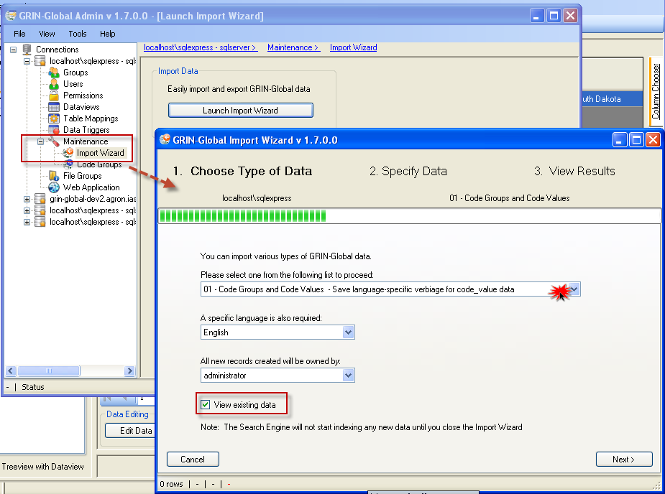
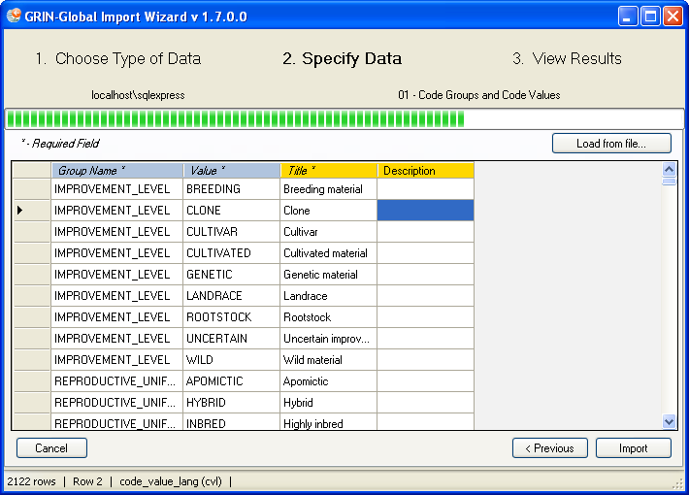

Query to Display Codes & Code Groups
You must be logged into the Public Website:
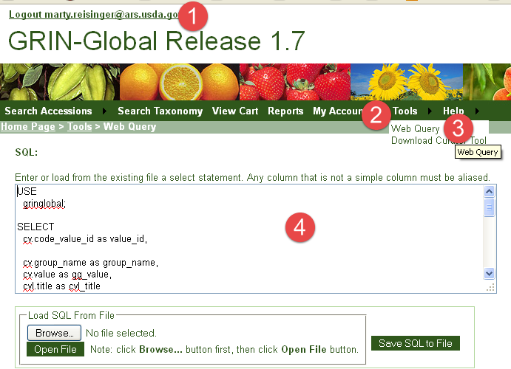
The following SQL can be use in the Public Website, under Tools | Web Query, to display the codes:
USE
gringlobal;

SELECT
cv.code_value_id as value_id,

cv.group_name as group_name,
cv.value as gg_value,
cvl.title as cvl_title

FROM
code_value cv

inner join code_value_lang cvl
on cv.code_value_id = cvl.code_value_id
left join sys_lang sl2
on cvl.sys_lang_id = sl2.sys_lang_id
WHERE
sl2.sys_lang_id = 1
/* and group_name = 'inventory_action' */
/* use and clause to search for a specific code */

ORDER BY
group_name,
gg_value

Appendix

SQL for Cloning a Language
The following SQL statements can be executed in SQL Server Management Studio (SSMS) to add a new language and to clone the friendly names for fields and dataviews. It is not necessary to copy the English entries for any of the other 11 lang tables since they are either unnecessary to the user or the desired behavior is for the lookups to default to the coded values rather than the titles.
In the SQL example below, the new language being created is “ENG” – a value of “9” was used for its sys_lang_id because there were already eight languages in the database. The SQL below will need to be modified to replace 9 with whatever id number you need for your new language. You will also need to replace the 1 (English in this example) with the number of the language that is being cloned.
One method to determine the existing available sys_lang_id values for your GG installation is to use the AT and run the preview tab for the get_sys_language dataview.
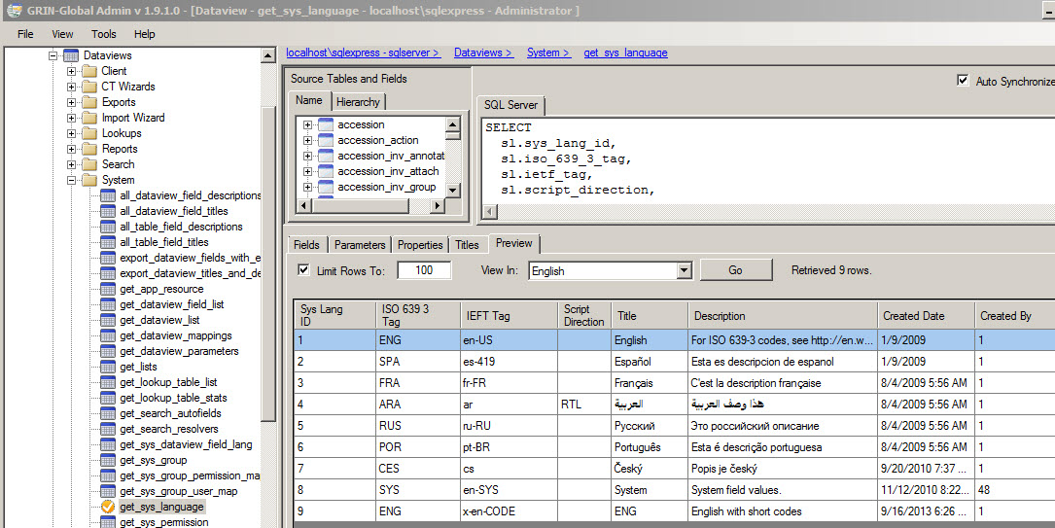

/*
In the first INSERT statement, create your new language name with appropriate codes, title and description. Details can be found at http://en.wikipedia.org/wiki/IETF_language_tag
or http://www.w3.org/International/articles/language-tags/

Change 1 only in the “WHERE sys_lang_id = 1” clauses. In this first Insert statement, leave the 1’s as shown.
*/

INSERT INTO sys_lang
(iso_639_3_tag, ietf_tag, title, description, created_date, created_by, owned_date, owned_by)
VALUES('ENG', 'x-en-CODE', 'ENG', 'English with short codes', GetDate(), 1, GetDate(), 1)

SELECT * FROM sys_lang
INSERT INTO sys_table_field_lang
(sys_table_field_id, sys_lang_id, title, description, created_date, created_by, modified_date, modified_by, owned_date, owned_by)

/*
In the following statements, replace 9 and 1 with the appropriate number for the new language and the language that is being cloned. See discussion above.
*/

SELECT
sys_table_field_id, 9, title, description, created_date, created_by, modified_date, modified_by, owned_date, owned_by
FROM sys_table_field_lang WHERE sys_lang_id = 1
INSERT INTO sys_dataview_field_lang
(sys_dataview_field_id, sys_lang_id, title, description, created_date, created_by, modified_date, modified_by, owned_date, owned_by)

SELECT
sys_dataview_field_id, 9, title, description, created_date, created_by, modified_date, modified_by, owned_date, owned_by
FROM sys_dataview_field_lang WHERE sys_lang_id = 1
INSERT INTO sys_dataview_lang
(sys_dataview_id, sys_lang_id, title, description, created_date, created_by, modified_date, modified_by, owned_date, owned_by)
SELECT
sys_dataview_id, 9, title, description, created_date, created_by, modified_date, modified_by, owned_date, owned_by
FROM sys_dataview_lang WHERE sys_lang_id = 1

You can test this by starting the CT. Click on the File menu at the top left, click on Language, then click on ENG at the bottom of the list instead of English. You will get a message about needing to reload your lookup tables, but you only need to reload a couple: Code Value Lookup, Crop Trait Code Lookup, and Crop Trait Lookup. Those should be quick to reload.

Appendix

Document Revision Notes

– July 21, 2020
- revamped the Codes for Observations section for clarity

– March 5, 2019
- added the “Creating Observation Records Using Codes” section

– September 16, 2015
- minor wording edits

– July 24, 2015
- major edit; included a background
- this document was renamed from “English to ENG” to

