Quick Overview on Connecting
Crystal Reports with GRIN-Global Data

Revision Date
July 27, 2016

This guide gives a brief overview of setting up Crystal Reports reports.
Change notes pertaining to this document are also summarized in the appendix.
The Table of Contents contains links to the document’s sections.

Comments/Suggestions:
Please contact feedback@ars-grin.gov with any suggestions or questions related to this document.

Table of Contents

Introduction 3
Using an Existing Report 4
Connecting Crystal Reports with GRIN-Global Data 6
Step 1: Select a Sample Data Source in GRIN-Global 6
Step 2: Using Crystal Reports, Use the Data from Step 1 to Design the Report 7
Step 3: Copy the Report (.rpt) File into the GRIN-Global “Reports” Folder 7
Step 4: Using the CT, Select Data and the Corresponding Report 7
Step 5: Mapping the Report to the Curator Tool User’s Settings 8
Appendix: Change Notes 9

Introduction
Crystal Reports is a popular, commercially-available report generator. Since it works with databases and data stored in spreadsheets, it can be used to design reports using GRIN-Global data.
This document does not provide a step-by-step tutorial on creating the actual report within the Crystal Reports application. Rather, this document discusses how to extract sample data from GRIN-Global as a basis for a report design and then how to eventually connect the report with GRIN-Global for ongoing use.
When you design a report with the Crystal Reports Report designer, you are not just designing a report for one-time use, but rather one that will work with new data as it becomes available within GRIN-Global. As the GG data changes, the report can be applied to the relevant data and the results can be viewed or printed.
Besides data reports, packing labels and other labels can be made this way and then accessed on an ongoing basis by the Curator Tool users. Users do not need to know how to design the reports, but how to access them via the Curator Tool.
If you are not familiar with Crystal Reports, there are many online resources on how to create reports using Crystal Reports – one helpful resource is the YouTube Crystal Reports channel. In google, search for crystal reports + youtube.

There are four basic steps to coordinating Crystal Reports and GRIN-Global:
- In the Curator Tool, select sample data as the basis for the report
- Using Crystal Reports, use the data from step 1 to design the report
- Name and save the report (.rpt) file; copy the .rpt file into the GRIN-Global “Reports” folder
- Using the CT, select data to be included in the report; select the corresponding report

Using an Existing Report
In the Curator Tool, a menu displays when a user right-clicks in the dataview grid. One of the menu items listed is Reports… If the user selects the Reports… option, a list of all existing reports displays. However, not all of the reports displayed necessarily work with the currently displayed dataview.
The reports have been designed to work with specific database fields so it is important that users learn which dataview to display in order to access the respective reports. All of the initial reports bundled with GRIN-Global require the Get Packing Slip dataview.
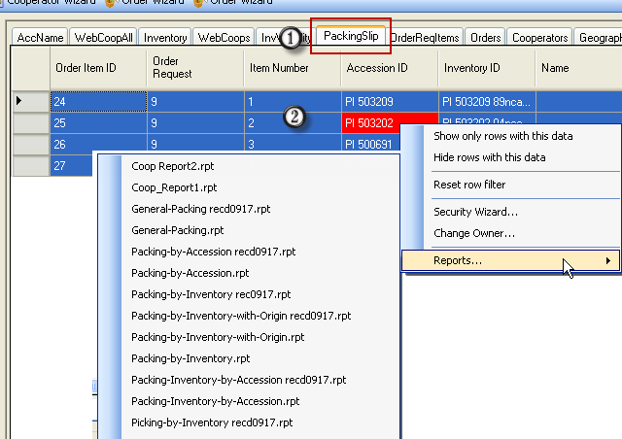

In the following example, the user was viewing the Get Packing Slip dataview and then selected the General Packing report.
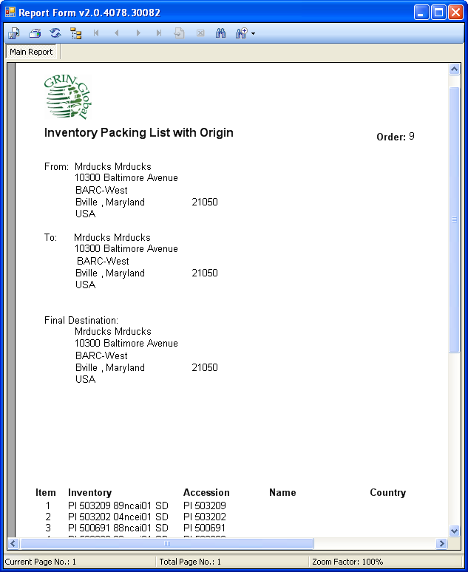

Connecting Crystal Reports with GRIN-Global Data

Step 1: Select a Sample Data Source in GRIN-Global
- Open Microsoft Excel (or another spreadsheet application); start a blank spreadsheet.
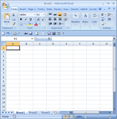
- In the Curator Tool, display data for which the report will be designed. (Open the respective dataview.)
- Select some (or all) of the rows in the dataview.
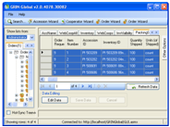
- Press the Ctrl key, and while holding it, drag the selected data into Excel.
- Save the spreadsheet to your hard drive. (Save the spreadsheet in the .xls format.)
Note that it is important that the column headings include the true field names.
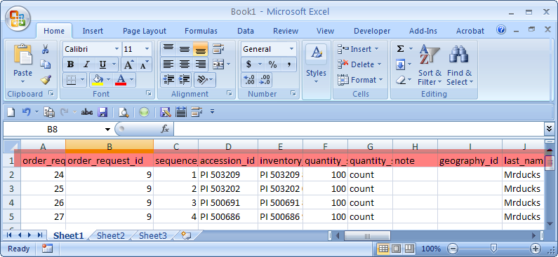

Step 2: Using Crystal Reports, Use the Data from Step 1 to Design the Report
- Start the Crystal Reports designer.
- Create a new, empty report.
- Using the Crystal Report Database Expert, create a new Database Connection (choose the one that provides Excel support – in VS2008 it is called “Access/Excel (DAO)”) and connect it to the file created in Step 1.
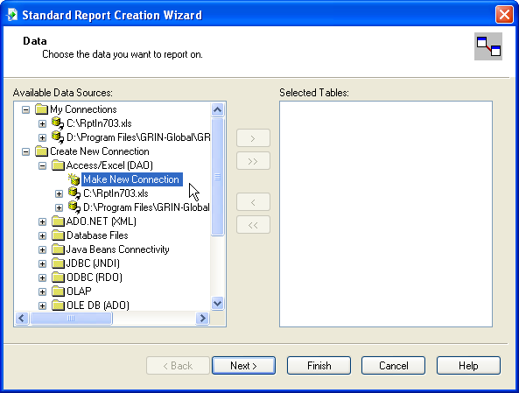
- Design the report.
- When the design is complete, save the report.

Step 3: Copy the Report (.rpt) File into the GRIN-Global “Reports” Folder
Copy the Crystal Report .rpt file created in Step 2 to your Reports directory for the Curator Tool
(a typical path is C:\Program Files\GRIN-Global\GRIN-Global Curator Tool\Reports)

Step 4: Using the CT, Select Data and the Corresponding Report
- In the CT, use the same dataview that was used to create the report.
- Select all or some of the rows in the dataview. (Only data from selected rows will be displayed in the report.)
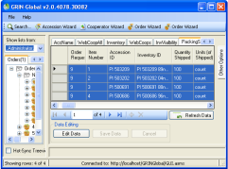
- Right-click on any of the highlighted rows and select Reports… at the bottom of the menu.
- Select your new report to see the results.
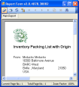

Step 5: Mapping the Report to the Curator Tool User’s Settings
As of November, 2014, the Curator Tool users three user files that are stored individually for each CT user on a PC.
When the GRIN-Global Curator Tool is installed on a User’s PC, several files are installed on the PC’s hard drive which affect user settings. The advantage of these files is that they can be configured by a GG administrator (or a user). The disadvantage is they are .txt files – a GUI is being considered to manage these files.
The three files are:
File | Purpose
AppSettings.txt | Controls certain CT user settings such as application-level settings for the GUI controls
ReportsMapping.txt | Associates a .report file (“.rpt”) with a dataview file (“.dataview”)
WebServiceURL.txt | This file indicates the servers available to the CT.

Please refer to the GG Admin Guide for information on establishing the connections for the Crystal Reports using the ReportsMapping.txt.

Appendix: Change Notes

– July 27, 2016
- made minor TOC and formatting modifications

– November 14, 2014
- added brief info regarding mapping the Reports to the CT User’s settings

