GRIN-Global Curator Tool

User Guide

Revision Date
December 2, 2025
 | This guide provides an overview to the GRIN-Global Curator Tool (CT) and provides details on the program’s interface. Individual topics are documented online under the User Documents section of the GRIN-Global Project website at:  https://www.grin-global.org/userdocs.htm  Please look at the index of that webpage for detailed documents on specific topics.  The Curator Tool software release notes are online at  https://www.grin-global.org/docs/CT_Release_Notes.pdf  Appendix A contains this document’s revision notes.  Review the Table of Contents which contains links to the document’s sections.  This video [ https://www.ars-grin.gov/npgs/gringlobal/videos/interface_basics.mp4 ] provides a brief overview of the main Curator Tool window.

Author
Marty Reisinger

Comments/Suggestions:
Please contact feedback@ars-grin.gov with any suggestions or questions related to this document.

Related Resources

GRIN-Global Documentation Website
Links to various GRIN-Global documents, videos, project history, etc.
https://www.grin-global.org/
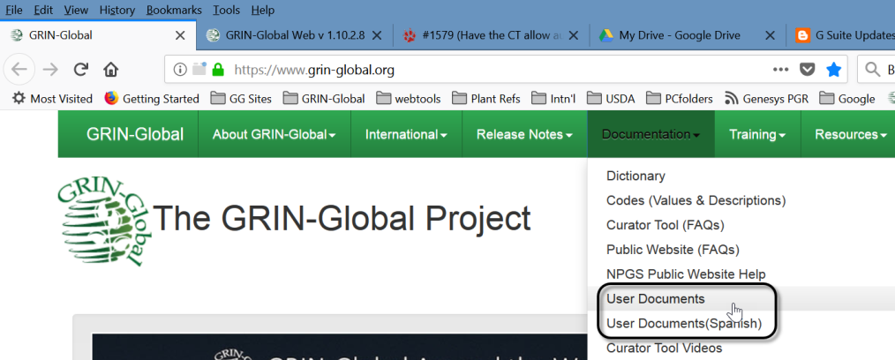

This and other GRIN-Global –related documentation can be downloaded from the GRIN-Global documentation website. See especially https://www.grin-global.org/userdocs.htm. Many topics discussed in this general user guide are explained in detail in their respective documents.

Videos Illustrating Curator Tool Concepts
These videos illustrate basic Curator Tools concepts and features:
https://www.grin-global.org/videos.htm

Curator Tool Introduction
The GG project website has several links to webinar series. Check out:
https://www.grin-global.org/intro_to_GG_usda.htm

Accessions and Passport Data
Accession overview and instructions for adding, editing, and deleting accession data:
https://www.grin-global.org/docs/gg_accessions_and_passport_data.docx

Multicrop Passport Descriptors
The FAO/BIOVERSITY Multi-Crop Passport Descriptors (MCPD V.2 ) is the result of a thorough revision of the original publication released by FAO/IPGRI in 2001. This document describes how GRIN-Global handles these descriptors.
https://www.grin-global.org/docs/gg_multi_crop_passport_descriptors_MCPD.docx

Source Habitat Observations
Five tables provide an extremely flexible method for adding more detailed information about the collection site which was not possible with an older single accession_source table. Now genebank personnel can create custom descriptors and codes for an unlimited amount of detail on the collection site. https://www.grin-global.org/docs/gg_observations_and_descriptors.docx

Inventory
Overview of the Inventory-related dataviews and inventory processing. Inventory is the physical stock for each accession, whereas accession tables contain, among other items, the passport information and other descriptors.
An accession may have several (many!) inventory samples. For example, there may be different generations, storage types, locations, sites, etc.
https://www.grin-global.org/docs/gg_inventory.docx

Adding Images & Other File Types
In the Curator Tool Release 1.9.8.14 (initially released in the USDA in Dec, 2017), an Inventory Attachment Wizard was introduced. If using the CT Release 1.9.8.14 or later, refer to the online documentation at https://www.grin-global.org/docs/gg_inventory_attachment_wizard.docx

Order Processing
Explains how to process orders and use the Order Wizard
https://www.grin-global.org/docs/gg_order_processing.docx

Observations: Crop Descriptors (Traits) & Observations
Examples explain the relationship among the dataviews in the family of Crop dataviews
https://www.grin-global.org/docs/gg_observations_and_descriptors.docx

English vs. ENG
An “alternative” language to English was developed specifically for the National Plant Germplasm System (NPGS) – some of the GRIN users prefer to use Codes rather than the longer Titles when entering Observations and other data; this document explains how to use the ENG language to accomplish this.
https://www.grin-global.org/docs/gg_alternative_languages.docx

Contents
Related Resources 2
GRIN-Global Documentation Website 2
Videos Illustrating Curator Tool Concepts 2
Curator Tool Introduction 2
Accessions and Passport Data 2
Multicrop Passport Descriptors 2
Source Habitat Observations 3
Inventory 3
Adding Images & Other File Types 3
Order Processing 3
Observations: Crop Descriptors (Traits) & Observations 3
English vs. ENG 3
Introduction to GRIN-Global 9
What is Needed to Access GRIN-Global? 9
End User Components 10
GG Administrators Notes 10
Server Components 11
Conventions Used in this Manual 12
Keyboard Shortcuts 12
Drag Data 13
Drag and Drop 13
Selecting Multiple Rows 14
Selecting Cells 15
Curator Tool Overview 16
Starting the GRIN-Global Curator Tool 16
Starting Up the Curator Tool (CT) 16
Changing Passwords 18
International Password Guidelines 18
Curator Tool Two Panels 18
Data Grid (or “Datagrid”) 19
Deleting “Stuff” 20
Typical Screen 20
Definitions 22
Lists (Folders) Overview 23
Static Folders (“Static Lists”) 23
Using Lists to Organize Your Accessions 25
Using Lists to Organize Your Order Requests 25
The List Panel is a File Cabinet 25
Displaying a List of Accessions 26
Dynamic Folders ( “Dynamic Queries”) 27
Deciding Which Type Folder to Use 28
Steps in Creating Dynamic Folders 28
Refreshing a Dynamic Folder 29
Dataviews 29
To Display a Dataview Whose Tab is Visible 30
To Display a Dataview Whose Tab isn’t Visible 31
Some Dataviews Display Data, Some Do Not 32
Form View 33
Displaying Forms 33
Visual Clues 34
Icon Legend 34
Cell Colors 35
Warning Indicators 35
Spreadsheet Similarities 36
Columns & Rows 36
Column Order 36
Hiding / Displaying Columns 37
Personalizing Your Curator Tool: Other Options Tab 37
Cell and row colors 38
Max rows allowed 38
Performance Enhancement Option: Query Paging Size 38
Save User Settings Now 38
Active Web Service (Switching to another Database) 38
Sorting and Filtering Records 39
Sorting Data 39
Filtering Records 40
Lookup Tables 41
Code Groups 41
Background Information 41
Importing Your Data from an Existing Database into GRIN-Global 42
Drag & Drop 42
Using a Spreadsheet to Import Data into GRIN-Global 42
Two Importing Methods 42
Copy the Data from a Spreadsheet to the Curator Tool 43
Copying Column Names from the Curator Tool into a Spreadsheet 45
Copying, Block-Style 45
Copying Curator Tool Data into a Spreadsheet 47
Copying Curator Tool Data into a Spreadsheet 47
Using Lists to Organize Data 48
Tabs 49
To Create a New Tab 49
To Rename a Tab 50
To Hide and Display Tabs 50
Lists 51
To Create a New List 51
To Delete or Clear a List 52
To Delete Items from a List 52
Name a List 53
To Move a List 53
To Add Additional Items to a List 54
Sorting & Custom Naming List Items 55
Sorting List Items 55
List Items’ Custom Naming Feature 55
Inventory Lists 58
Virtual (or System-Generated) Inventory Items 58
Searching for Records 59
Search Tool Introduction 59
Search Tool Window 60
Two Distinct Search Methods 61
Search Tool: Query By Example (“QBE Searches”) 62
Starting a QBE Search 62
Adding Tabs in the Search Tool 63
Deleting Tabs in the Search Tool 63
Editing or Saving the Results of a Search 64
Search Criteria (QBE) 64
QBE Search Code 64
Case Sensitivity 65
Special Characters 65
Wildcards 66
Date Fields 67
Manually Modifying the Search Text 69
Any Word vs. All Words (“OR” and “AND” in the QBE Search Method) 70
Adding Criteria 72
Criteria Code Explained 73
Text Box Searches 75
Case Sensitivity 76
Filtering the Search Results 76
Searching a List of Items 77
Moving Records from the Search Grid to the Curator Tool Data Grid 79
To Move Records from the Search Tool to the Curator Tool 79
Creating, Updating, and Deleting Records 80
Overview 81
Cell Colors 81
Creating New Records 82
To Create a New Record 82
Keyboard Shortcuts in Edit Mode 84
Copying from the Cell Above 84
Duplicate Data (Ctrl-D) 84
Restricted Fields (Lookup Picker) 85
Using the Lookup Picker 86
Updating (Editing) Data 87
Highlight Changed Data Option 88
Warning Indicators 88
Deleting Records 89
Security (Ownership & Permissions) 90
Owner Concept 90
To Transfer Ownership to a Different User 90
Parent and Owner Relationships Between Dataviews 91
Permissions 91
Assigning Permissions to Other Users 92
Image Handling (Attachments) 93
Reports 94
Report Overview 94
Wizards 94
General Notes about Curator Tool Wizards 94
Wizards 94
Accession Wizard Overview 95
Subordinate Accession Dataviews 98
Cooperator Wizard 100
Background Information 100
Using the Curator Tool Cooperator Wizard 101
Appendix A: Document Revision Notes 101
– December 2, 2025 101
– April 20, 2021 101
– September 21, 2020 101
– July 12, 2018 101
– May 9, 2018 101
– March 13, 2018 101
– December 27, 2017 101
– December 1, 2017 101
– October 25, 2017 102
– March 24, 2017 102
– October 31, 2016 102
– July 25, 2016 102
– May 11, 2016 102
– March 14, 2016 102
– March 11, 2016 102
– January 14, 2016 102
– January 13, 2016 102
– December 29, 2015 102
– November 30, 2015 102
– November 5, 2015 102
– October 5, 2015 102
– June 10, 2015 102
– April 30, 2015 103
– April 8, 2015 103
– March 9, 2015 103
– January 14, 2015 103
– January 6, 2015 103
– November 18, 2014 103
– October 21, 2014 103
– June 23, 2014 103
– June 17, 2014 103
– May 6, 2014 103
– April 8, 2014 103
– April 4, 2014 103
– November 11, 2013 103
– August 14, 2013 104
– April 2, 2013 104
Appendix: Database and GRIN-Global Basic Concepts 105
GRIN-Global Overview 105
GRIN-Global is a Relational Database 105
Relational Database Example: Accessions and Inventory 107
Schema 108
GRIN-Global Tables 108
Dataviews 108
GRIN-Global’s Table Relationships 112
Keys: Primary and Foreign 114
Getting Started with the Curator Tool 115
Appendix: Updating the Curator Tool 117

Introduction to GRIN-Global
GRIN-Global (GG) is a plant genebank management system. The initial GG project involved the USDA Agricultural Research Service, Bioversity International, and the Global Crop Diversity Trust. Project information and background, software download links, documentation, and training resources can be found on the GRIN-Global website.
GRIN-Global is public-domain software freely available to the world’s crop genebanks.
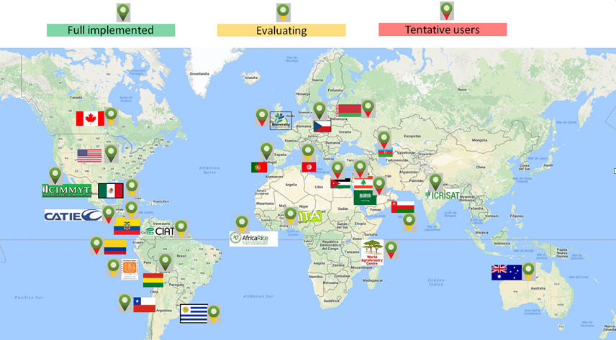
GG is versatile – it can be implemented different ways, ranging from a simple genebank inventory application on a single PC to a widely distributed networked system supporting on-line user searching and germplasm ordering. It is generally used in a networked environment.

What is Needed to Access GRIN-Global?
The GRIN-Global (GG) germplasm information system consists of several distinct components. Typically, the GRIN-Global administrator will install the GG database onto a server. (Note to GG administrators: administrator guides are online at https://www.grin-global.org/admindocs.htm)
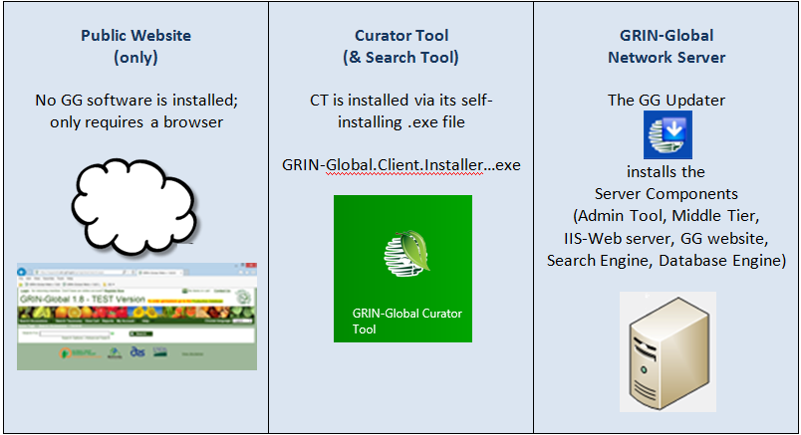

End User Components
The main GRIN-Global components are:
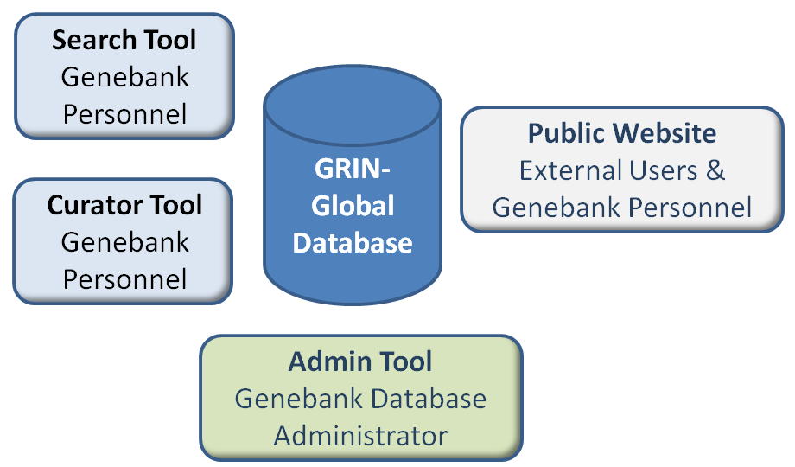
- Curator Tool (CT) – Genebank workers connecting to the server have several GG programs installed on their PCs. The Curator Tool is an application that must be installed on the user’s PC in order to connect to the GG database. The CT is used by internal genebank staff who manage the genebank’s data.
- Search Tool (ST) – the Search Tool is automatically installed when the Curator Tool is installed. The ST can run as a stand-alone application, but generally it is launched from within the CT. (There is a Search button in the CT. This guide documents the CT and ST.)
- Public Website (PW) – the Public Website is accessed via a browser such as Chrome, Internet Explorer, or Firefox. No additional software is installed – the user points to a valid GG URL in a browser window. For example, the U.S. National Plant Germplasm System (NPGS) uses this URL:
https://npgsweb.ars-grin.gov/gringlobal/search.aspx?

GG Administrators Notes
(Most GG users do not need to read this section; feel free to skip!)

IIS
 | [Note for admins and personnel responsible for installing the CT] The CT requires IIS. Without Windows IIS, the Curator Tool (CT) cannot communicate with the GRIN-Global database. Since the Curator Tool cannot communicate with the database directly, the CT needs the GRIN-Global Web Application, which includes the GRIN-Global “Middle Tier,” to communicate with the database. The GRIN-Global “Middle Tier” gui.asmx application runs under the IIS web server.

SQL Server / Server Express
Currently, the CT requires a copy of SQL Server to be installed on the user’s PC. Why? SQL Server manages a set of lookup tables that were installed when the Curator Tool was installed onto the user’s PC.

Crystal Reports Viewer
When the CT is installed, a copy of the Crystal Reports Viewer application is also installed on the Curator Tool user’s PC. This program makes it possible to view existing Crystal Reports, but not create them.

Server Components
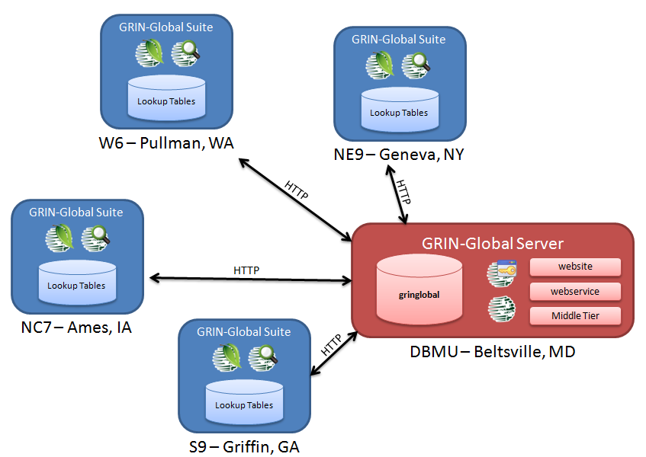

GG Updater (Used only by the GG Administrator)
The GRIN-Global Updater program is used to install the GRIN-Global server software components. Refer to the online documents on the GG documentation website (https://www.grin-global.org/) under the Documentation option.

Public Website
The GRIN-Global Public Website (PW) is designed for anyone who will be querying the GG database for germplasm information or who will be requesting germplasm. Besides researchers, breeders, and other scientists, curators and other internal genebank staff may use the PW to complement the CT for searching for information on Accessions, Orders, Observations, etc. (No GG software installation is required since this is browser based.)

Admin Tool (Used only by the GG Administrator)
This program is used by administrators responsible for managing an organization’s GG database environment on a server. Rarely, in smaller organizations, GG could be installed on a single PC which would serve as the server, where one person may function as both the administrator and the primary user. Users working on a shared, networked GG database will not have the Admin Tool installed on their PCs. (Administrator documentation is online at https://www.grin-global.org/admindocs.htm.)

Database Engine
GRIN-Global requires an underlying database engine to be installed. GG has been designed to work on any of the following four databases: Microsoft SQL Server, Oracle, MySQL, and PostgreSQL. However, for the past few years, only dataviews that are supported by MS SQL Server have been maintained.
In most organizations running GG, a database administrator will be responsible for initially establishing the GRIN-Global database table structures on the organization’s server.
 | GG consists of many tables which relate to each other by key fields. By dividing data into relational tables, the database can grow over time without restructuring the tables. For more background information, read the overview of relational databases in the appendix.

Conventions Used in this Manual
To simplify directions in this manual, “Excel” or “spreadsheet” will sometimes be substituted for “Excel or your preferred spreadsheet program” since the Curator Tool data is compatible with many spreadsheet programs.
The following instructions primarily illustrate how you work within the Curator Tool interface.

Keyboard Shortcuts
The CT adheres to many of the standard Windows conventions. (The following shortcuts work within the CT and Windows, but on non-English keyboards the Windows keyboard shortcuts may be different.) For instance, when you need to copy data on the screen, you can highlight the data being copied and then use the keyboard shortcut Ctrl-C. This notation means “while holding the Ctrl key, tap the ‘C’ key.”
There are other standard Windows keyboard combinations that are frequently used:
Keyboard Combinations | Effect
Ctrl + A | Select all (highlight everything in the current “group”)
Ctrl + C | Copy
Ctrl + D | When a group of cells are selected, the top cell in the group is duplicated down from the top cell to the bottom cell. (Must be in Edit mode; also works when a block of cells across multiple columns are selected.)
Ctrl + E | Edit – when the cell is a text cell, you can display the full text in a separate text window. If the Datagrid is in Edit mode, you can edit or add new text.
Ctrl + N | Create a new record (when in Edit Mode). Select a record to be duplicated; press Ctrl-N (the duplicate record is created below the selected record).
Ctrl + ‘ | Duplicates the contents from the cell directly above into the cell you are currently editing
Ctrl + V | Paste
Ctrl + X | Cut
Ctrl + ~ | Puts the CT into “block select” mode. In this mode, a user can select one cell or a block of cells to be copied and pasted into another program, such as Excel. To exit “block select” mode, complete the copy /paste operation or press any key (Esc, Spacebar, etc.) Under Help/Keyboard Mapping, the user can change their keyboard shortcut for this feature.
F2 | When in Edit mode, you can double-click on a cell to edit it or press the F2 key. If the cell uses a Lookup Picker, F2 will open the Lookup Picker window.
Del(ete) | When in Edit mode, press the Del key to clear the cell

Drag Data
As with other PC applications, such as word processors or spreadsheets, you can drag the mouse to select text or data. To “drag” the mouse involves clicking on some text or a graphic, and then while holding the mouse button, dragging the mouse. The following example illustrates dragging records in the data grid:
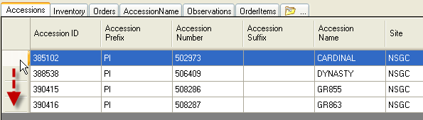
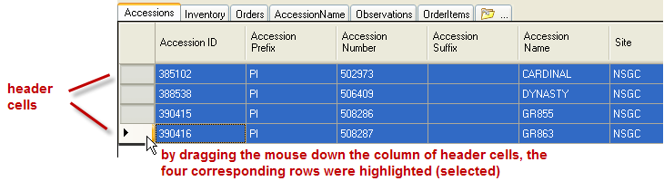

Drag and Drop
The expression “drag and drop” indicates that the mouse is being used to copy data from one location to another. For instance, records displayed in the Search or Curator Tool data grids may be dragged to a spreadsheet. (The detailed specifics will be explained later.) For a “drag and drop” demonstration, see the [ https://www.ars-grin.gov/npgs/gringlobal/videos/interface_basics.mp4 ]
video.
In this example, highlighted rows in the right window (a Search Tool window) are being dragged to a List, “June01,” in the Curator Tool window.
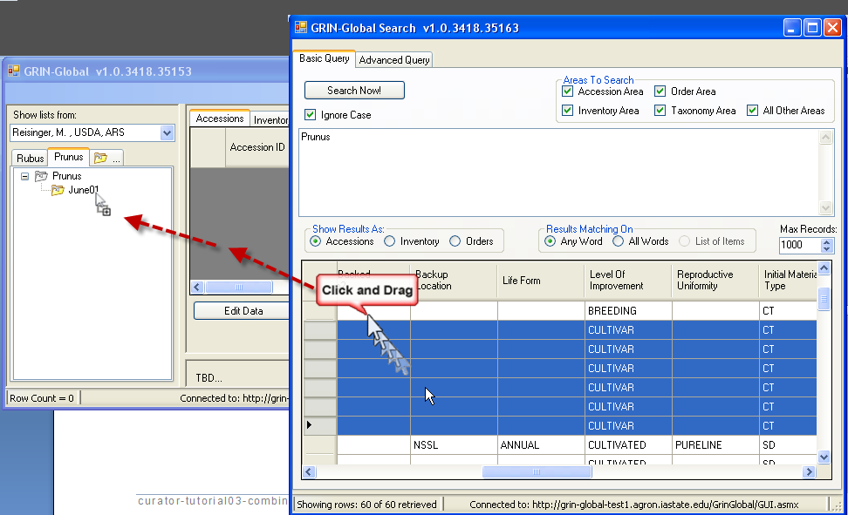
To accomplish this, the person using the Search application selected the rows in the right window, clicked in the highlighted area, dragged the mouse to the left Curator Tool window, and then “dropped” (released the mouse key) when the cursor was over the June01 folder name. This is easier to do than to describe!
The easiest method for accomplishing dragging and dropping is to position both windows on your screen so that they are simultaneously visible.

Selecting Multiple Rows
When working within a grid, you can either highlight (select) multiple records by using the mouse “Drag” method described on page 14, or use the Shift or Ctrl keys to include multiple records.
To Select | Do This
A contiguous group of records | Click the header cell of the first row in the group, and then while holding down the Shift key, click the header cell of the last row in the group. You can scroll to make the last cell visible.
Non-adjacent records | Select the header cell of the first row, and then while holding down the Ctrl key, click on other nonadjacent rows.

Selecting Contiguous Rows
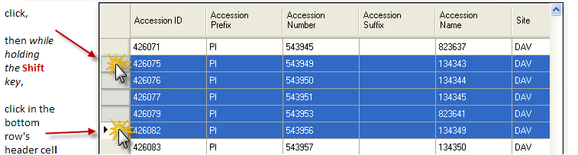

Selecting Non-Adjacent Rows
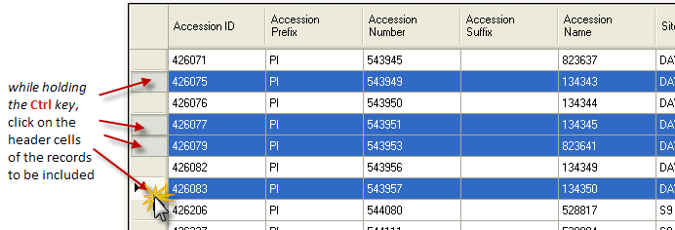

Selecting Cells
“Edit Mode” – the Edit Data button has been clicked. You can then create, copy, update, or delete records in the datagrid (on the right side of the window). The alternative to Edit Mode is Read-Only (or “Display”) Mode – you can only display records in the grid.
In Edit Mode, you can select a single cell or a block of cells and then copy and paste the cells’ contents into a spreadsheet.
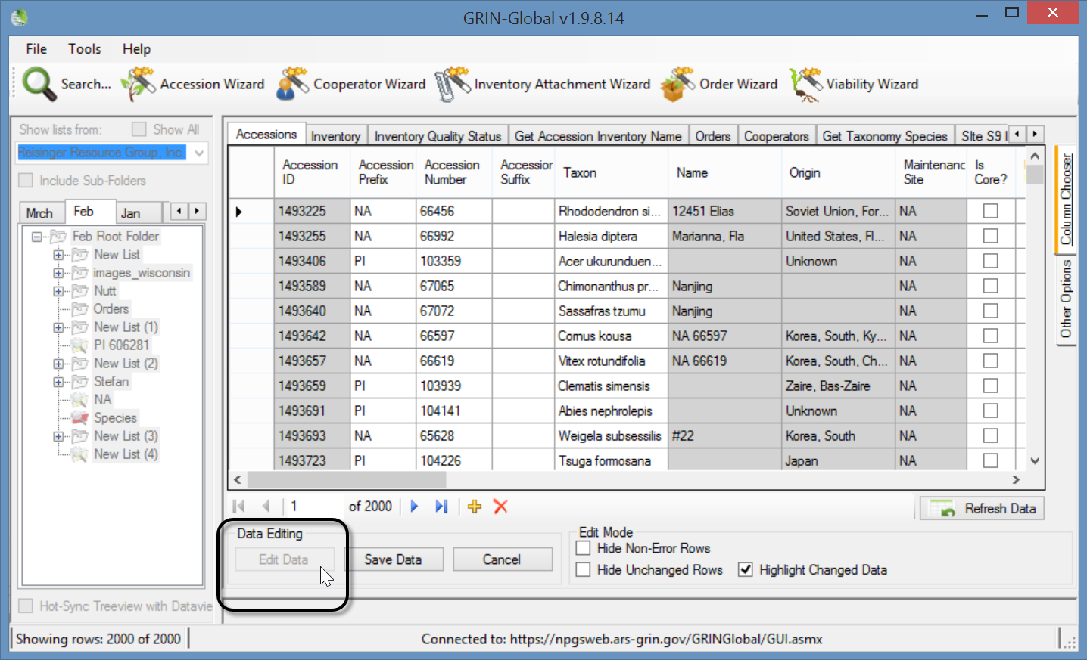

Clicking theCTRL + ~ key combination places the Curator Tool into “block mode.” If you do this accidentally, or no longer intend to copy and paste, press the ESC key or the Spacebar to exit “block mode.”

Curator Tool Overview

Starting the GRIN-Global Curator Tool
The Curator Tool must be installed on your PC.

Starting Up the Curator Tool (CT)
To access the CT, you need a Username and Password. The username is generally your email address; the password is assigned by a GG Administrator.
1. In the Windows start menu, select GRIN-Global Curator Tool program
2. In the CT Login window, input Username and Password.
3. Use the Connect To: box to select the database server’s name; click OK.
Typically, most organizations have their GRIN-Global database on a remote server.
The default (or only) server will be listed in the Connect To: dropdown box. In the following example, the default server is  PROD uction:  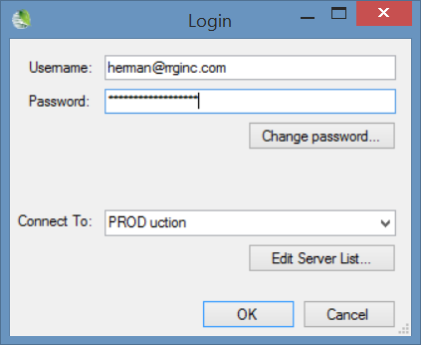 | However, when other servers are available, it is possible to select a different one from the dropdown. This example is from a Curator Tool tester who uses many different servers.  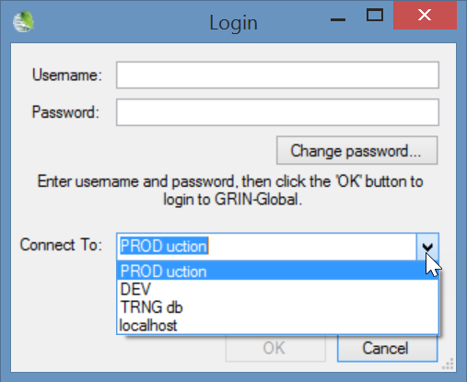

Most organizations typically have only one server listed and users are limited to that server. A stand-alone document is online at https://www.grin-global.org/docs/selecting_gg_server_CT_PW.docx GG administrators can customize this document to include their specific server details.

NPGS Example
In the following example, the user, a tester who accesses multiple databases, has DEV as his default server. (It is listed first.)
The actual server name information for the NPGS production GG database is highlighted. Since NPGS is using Secure Sockets Layer (SSL) security, the Use SSL checkbox has been selected.
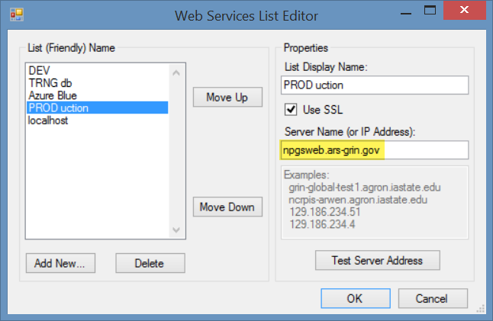
Each organization running GG determines its own Server Name / IP Address. Contact your organization’s GG administrator if you do not know what server name to use. Your organization’s GG administrator will provide the server information and indicate if SSL must be checked (when the organization will be using SSL).

(Optional) To add or delete servers from the Connect To list
Click the Edit Server List button.
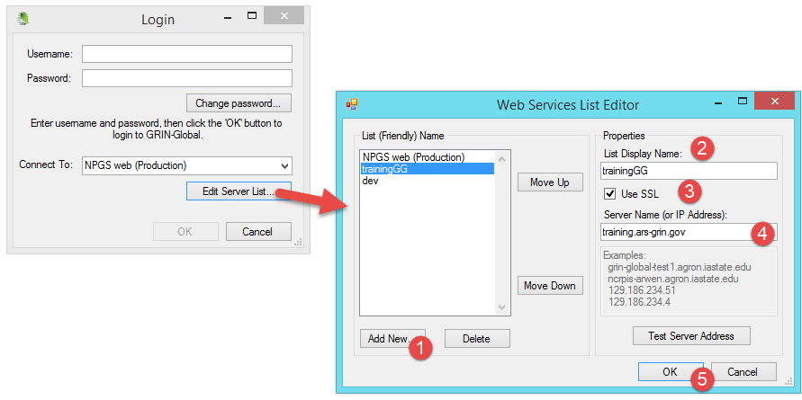
To add a server to the list: in the List Display Name box (2), input a meaningful name; select SSL if your organization is using SSL; input the correct server name or IP address (4); click OK. To delete: click on the name in the list of names in the left box; click the Delete button.
Adjust the list’s order in the left box by selecting a server name and then clicking on the Move Up and Move Down buttons. Position the server which you will use most often to the list’s top. The top server in the will display as the default server when you log in.

Changing Passwords
To change the Curator Tool password, click the Change password button on the Login window or when in the Curator Tool, select from the menu File | Change Password. Complete the Change Password window.
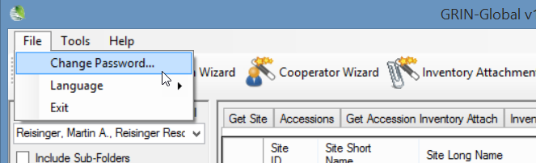

International Password Guidelines
Organizations implementing GRIN-Global can determine their own organization-specific password requirements. The organization’s GG administrator controls the password settings (via the Admin Tool) and should indicate the organization’s requirements to the Curator Tool users.

NPGS Password Guidelines
In NPGS, the user name is the user’s email address.

NPGS Passwords
Passwords must follow the current ARS guidelines:
- 12 characters minimum
- at least one of each are required: upper case, lower case, digit, and special character
- passwords can change only once per day
- five failed logins initiates a temporary lockout for 15 minutes
If a password is forgotten, the GG administrator must be contacted (to create a new one).

Logging on to the CT
For NPGS, VPN or being on the ARS network is not required.

Curator Tool Two Panels
The Curator Tool’s main screen is similar to other Windows programs in that it has menus, buttons, and icons.

Left Panel
We refer to the left panel as the “List Panel.” Some users refer to it as the “Tree View.” Just as Windows Explorer uses folders and subfolders to organize files, so too does the Curator Tool. You can use folders and subfolders to organize your personal lists and review GG records.

Right Panel
The records’ data is displayed in the right panel, also called the “data grid.” The records may be accessions, inventory, orders, observations – any type of GG record.
Curator Tool Window
Essentially empty in this example – similar to the opening screen of any new copy of the Curator Tool. The basic left and right panels are shown.
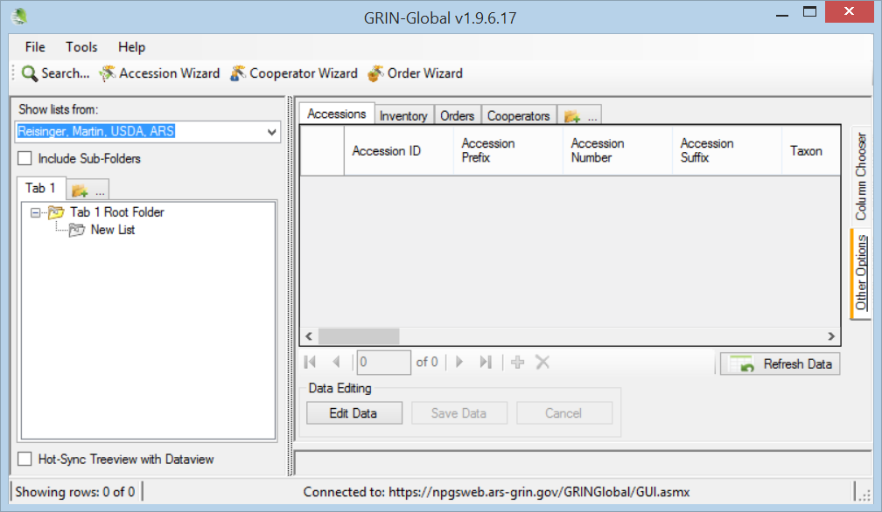
Windows Explorer Window
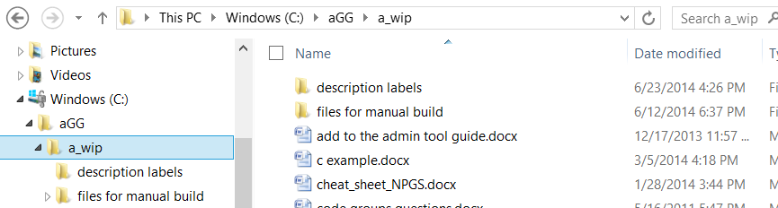
In Curator Tool jargon, a “folder” has the same meaning as “list.” If the directions indicate “...the folder’s name …,” this is equivalent to stating “...the list’s name…”

Data Grid (or “Datagrid”)
The CT’s right panel, the “Data Grid,” is similar to a spreadsheet, with the data displayed in columns and rows. The sample window below displays existing data. We’ll see later how data gets placed here.
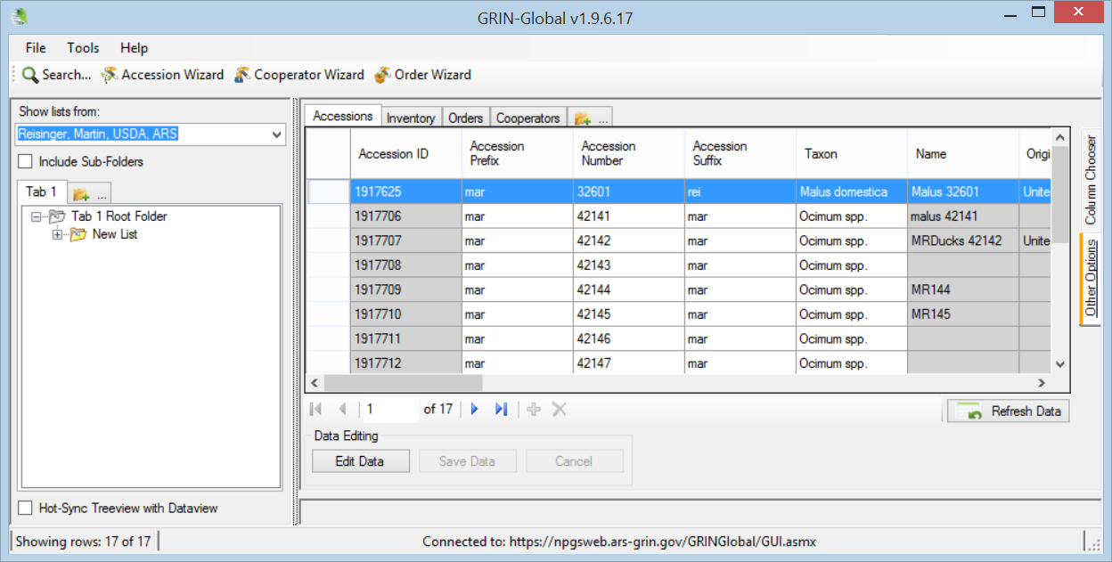

Deleting “Stuff”
List Panel (the left side) | Data Grid (the right side)
These are your lists – it is your call what you do with them.  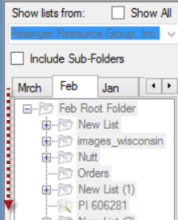  List items are not the actual database records, but pointers to the database records. | Rows in the data grid are database records. In some cases, you can’t delete the records even if you tried. (More later on ownership and permissions.) When you can delete records – once deleted, they are gone!  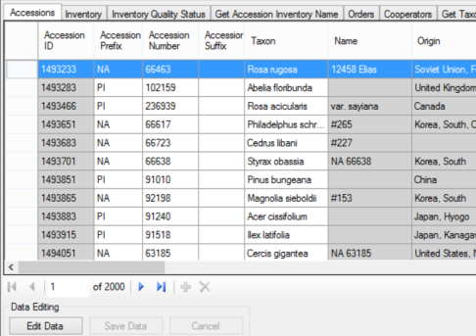

Typical Screen
The image below illustrates a typical Curator Tool screen. In this example, the user has created lists (shown in the left panel) and has opened additional dataview tabs in the right panel:
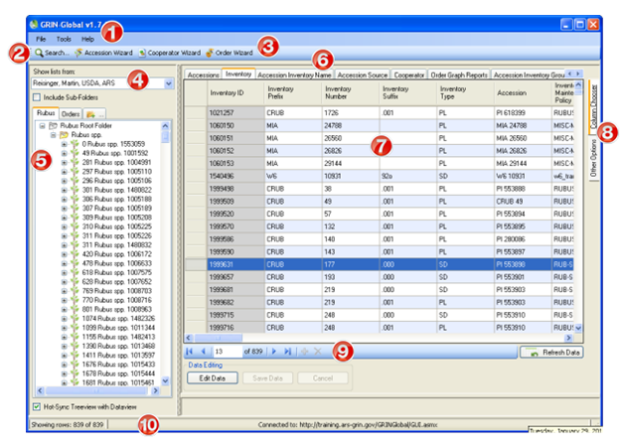
This screen is similar to a user screen when the user has been working with the Curator Tool for some time. When you initially start the Curator Tool, you do not see records listed in the datagrid, nor the number of dataviews that are shown here. As you proceed to use the Curator Tool, you typically create lists in the left List Panel; the lists point to database records displayed in the right data grid.

(The table below relates to the preceding illustration.)
 | Num. |  | Screen Component | Feature
 | 1 |  | Menu | The menu options include features such as changing the interface language or password, resetting lists and the user defaults. The Help option contains an important item for CT administrators to use when setting up user connectivity.
 | 2 |  | Search Button | Opens the Search Tool in its own window for initiating database searches.
 | 3 |  | Wizard Buttons | Start wizards which assist you in supplying data for a new record
 | 4 |  | Show lists from dropdown | Use the dropdown to view other users’ lists. (The owner of the data determines the authorizations for editing lists.)
 | 5 |  | List Panel | You as the user can organize data into lists that are meaningful to you. The List Panel is covered in detail, starting at page 59.
 | 6 |  | Dataviews | Initially four tabs display. The user can display an infinite number of tabs; each tab has a corresponding dataview related to it.
 | 7 |  | Data Grid | Each dataview in this area displays its respective column headings. When data (records) are brought into this area, columns and rows will display.
 | 8 |  | Column Chooser & Other Options | You can select which columns to display in the Data Grid. Under the Other Options tab there are various features that will be explained later.
 | 9 |  | Navigation Bar | Used for moving to different records I the dataview. Also, when in Edit mode, the “+”key initiates the adding of a new blank record; the “x” key deletes a record.
 | 10 |  | Status Bar | Displays information about the records in the data grid (such as count) as well as the name of the current server.
 |  | When you first use the Curator Tool on a PC, both the List Panel and the Data Grid are basically empty. To display data in the Data Grid, you will either create new records or search for existing records in the GRIN-Global database.

Topic | References
Create new records | p. 101; video
Search for existing records | p. 70; video
Copy records into the Curator Tool | p. 54; video
Deleting records | p. 107

Definitions
Data Grid (Also Datagrid) Spreadsheet-like table with columns and rows and header cells.
Dataview A pre-defined, programmed query to the database. Within the Curator Tool, the user can select from various dataviews. Physically, the data may be stored in multiple tables, but it will appear in the dataviews as if it is coming from one table.
Static Folder Synonym for List. A folder is user-defined – a user decides what database records he is interested in reviewing and then creates lists to point to those records. The user decides what lists he needs, what records to point to, and whether the folder should be static or dynamic. (Folders are explained in detail within this document.)
Dynamic Folder A dynamic folder is a hybrid of a query and a folder – you set up criteria in the folder’s properties, so that the displayed records dynamically reflect any database changes. Two folder types exist: static, and dynamic.
List Panel Left-side of the screen where users manage their folders (“lists”) and list items. (Some users refer to this as the treeview, since the folders may have subfolders, which after awhile resemble branches.)
List A list (also known as a “folder”) contains pointers to records in the database. If you delete items in the list, the original database records remain intact. You are essentially deleting the pointers to the records, not the records.
Nulls NULL data is sometimes called "absent" data because there is no data value stored in the field. A NULL is not equal to a space character. NULL data will sort to the bottom if the sort is in ascending order and to the top if the sort is in descending order.

Lists (Folders) Overview
The main focus of the Curator Tool is to provide a tool with which genebank staff can:
- manage their genebank’s accessions
- track their inventory
- review cooperator data
- process germplasm orders
- record observations
With the Curator Tool, users build and maintain lists pointing to database records which interest them and which they may need to periodically review.
The Curator Tool now has two kinds of lists, static and dynamic. This section focuses on static lists; dynamic folders will be explained later. As you get comfortable querying, you will most likely create dynamic lists for managing much of your data.
What are “lists” and how are they different from the database records? This section explains the rationale for creating lists. It also provides a broad overview of the Curator Tool’s interface so you can see how the lists point to the physical database records.

Static Folders (“Static Lists”)
As you continue to work with specific accession records, you will want to access these records, perhaps on a fairly frequent basis. GRIN-Global has a “list” feature that provides a means for pointing to records in the database:
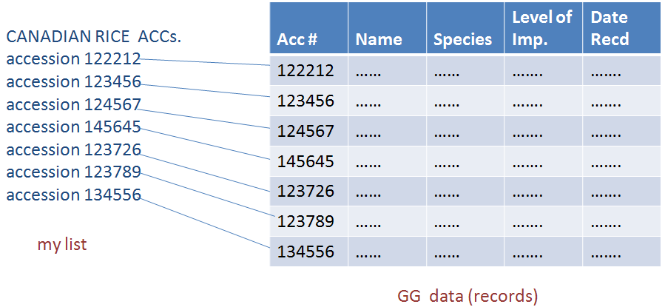
Build as many lists as you want. The lists are personal; you create them as you need them. As a CT user, you can build lists in unique ways to match your particular workflow. Lists can also be shared with other users.
Typically, a static list points to database records that you have grouped together for some reason.
You maintain these lists in your copy of the CT. For example, you may want to keep track of a group of accessions received by a specific donor. Lists can point to other record types besides accessions. With lists, you can easily track inventory records, orders, even people (Cooperator records).
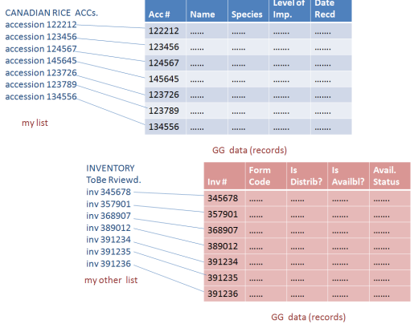
Each time you start up the CT, your lists are displayed giving you a quick way to display the records. Think of lists as shortcuts pointing to specific records. The list items are not the actual database records, but just pointers to the database records.
In the illustration below, the user’s tabs and lists are shown on the screen’s left side in the List Panel. The right side, the Data Grid, displays the actual contents of Accession dataview records.
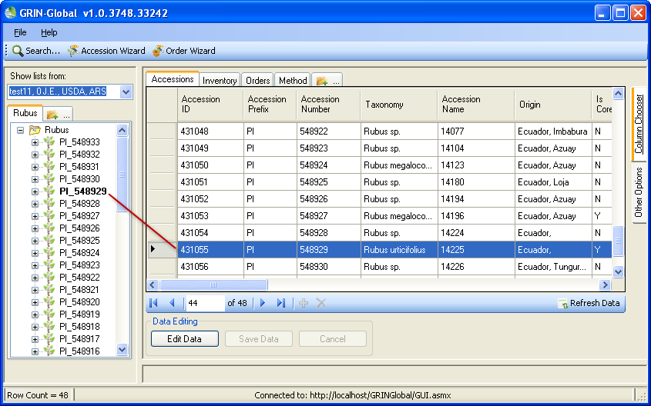

Using Lists to Organize Your Accessions
With the Curator Tool, you can build and arrange lists to meet your specific needs. For example, lists could be used to organize accessions by:
- recently added inventory
- work-in-progress
- dates: review dates
- location: field, shelf, etc.
- utility patents
- group (e.g., cultivated pears vs. wild pears)
- sources, such as material from overseas or by supplier

Using Lists to Organize Your Order Requests
Lists may be used to organize orders by:
- date or by batch
- type of processing needed
- completion status: pending, filled and ready for shipping, shipped, sent to pathologist, etc.
- phytosanitary test results: e.g. tracking accessions with pathogen infections for regulatory considerations
Undoubtedly you will discover additional reasons for building lists.

The List Panel is a File Cabinet
The List Panel on the left side of the Curator Tool may display tabs, folders (“lists”), and items within the folders. What is the difference between a tab and a folder? What is a folder?
Think of the List Panel as your filing cabinet. Most filing cabinets have multiple drawers, and the drawers can store multiple folders. The folders in turn store documents. Just as a filing cabinet can have multiple drawers, the Curator Tool can have multiple tabs. Think of tabs as your “drawers” in which you organize your lists and items. You can create as many tabs as you desire, whenever you need them, to organize your lists that you intend to use. You can hide tabs and redisplay them when needed.
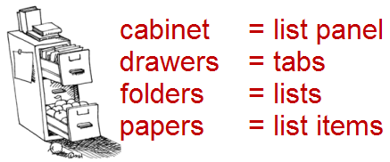

As you use the CT, most likely you will create many lists and tabs. When you have many large lists with many items pointing to many records, the responsiveness of the CT may be affected. Periodically do “house cleaning” and remove lists that are no longer meaningful to you. Alternatively, create dynamic lists when appropriate. (See the Dynamic Folders section for details.)
The Cerasus folder is expanded here showing 10 items in it. The Data Grid on the right side is displaying 10 Accession records; each item in the list points to a database record in the datagrid.
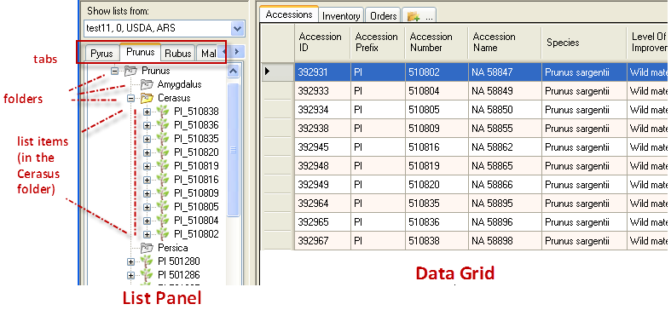
Using their list, the user can now easily review and track these 10 records repeatedly without needing to search the entire database again. Typically, a list points to records that have something in common and which the user intends to track or review again later. In this case, the folder is pointing to 10 specific Cerasus accessions records in the database.

Displaying a List of Accessions
In the example below, the list Rubus points to 48 Accessions items. Each list item points to a record in the Accessions dataview. The bolded item in the list panel corresponds with the Accession row highlighted in the grid. (Note: The Hot-Sync Treeview with Dataview checkbox must be selected in order to invoke the bolding feature.)
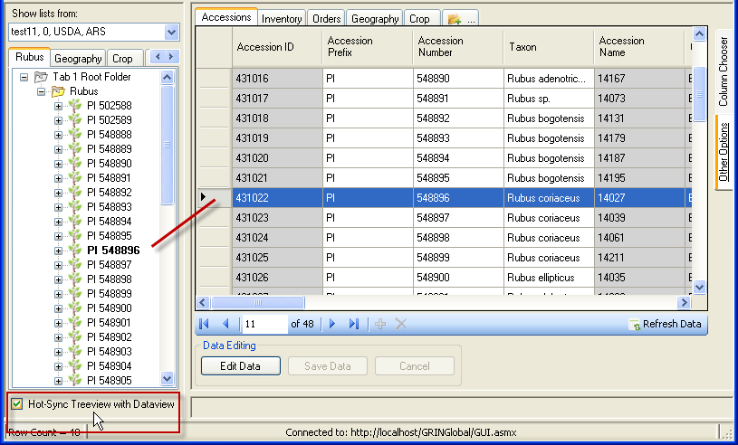

Inventory Items when the Hot-synch Feature is Enabled
When this Hot-Sync feature is on, when an inventory record in the datagrid is selected, the related inventory list item will be underlined and displayed in italics:
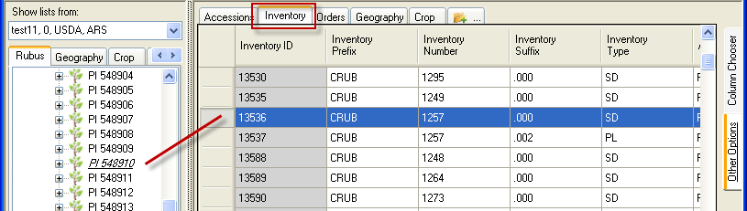

Dynamic Folders ( “Dynamic Queries”)
Basically a dynamic folder uses a query to list records matching the query. A dynamic folder contains embedded search criteria, typically copied from the Search Tool. Records that meet the criteria are displayed on the right side (the datagrid).

Recognizing Dynamic Folders
The dynamic folder below has neither a “+” (plus sign) indicator or any items listed under it. The magnifying glass in the icon also indicates this is a dynamic folder; as shown here, the folder is red because the user had clicked on it to make it the active list.
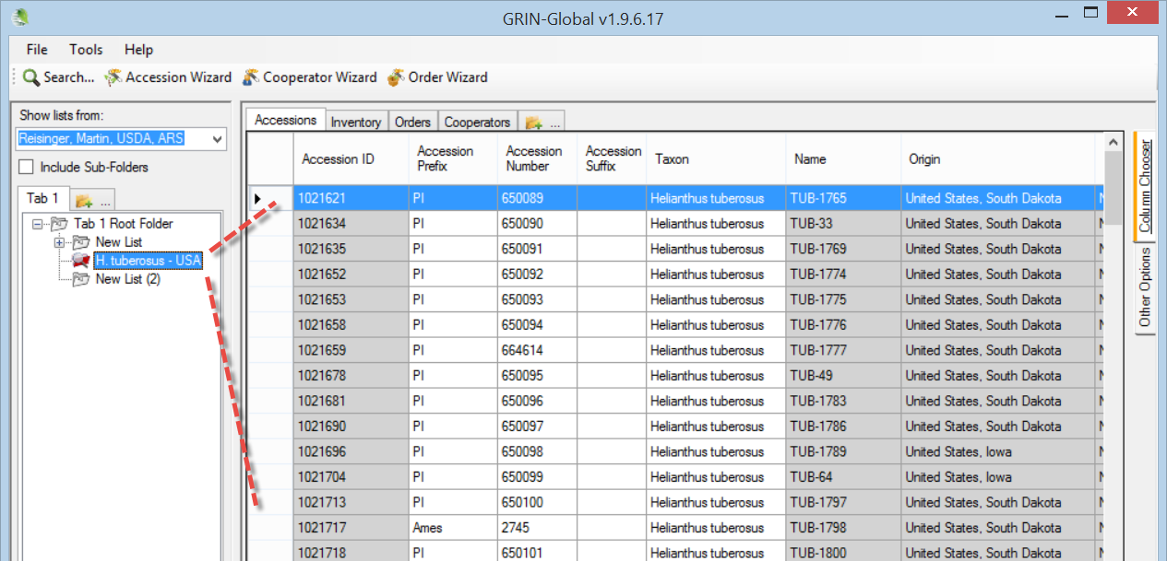

Deciding Which Type Folder to Use
So why ever use a static folder? First, they are simpler in some respect. Secondly, many times you will want to review specific records, and only those records. Listed below are a few examples of when each folder type is preferable:
Situation | Folder Type
Keep track of what you are working on from one day to the next | Static
List of orders processed on a specific day | Static
Maintain a list of all accessions for a specific Taxon | Dynamic
Review a site’s inventory | Dynamic

Steps in Creating Dynamic Folders
There are several methods for creating a dynamic folder. Each starts similarly: In the Curator Tool , create an empty folder.

Method 1 (Recommended method)
Switch to the Search Tool; create a query. Drag the code from the text box (generated by the QBE) onto the empty folder in the Curator Tool.
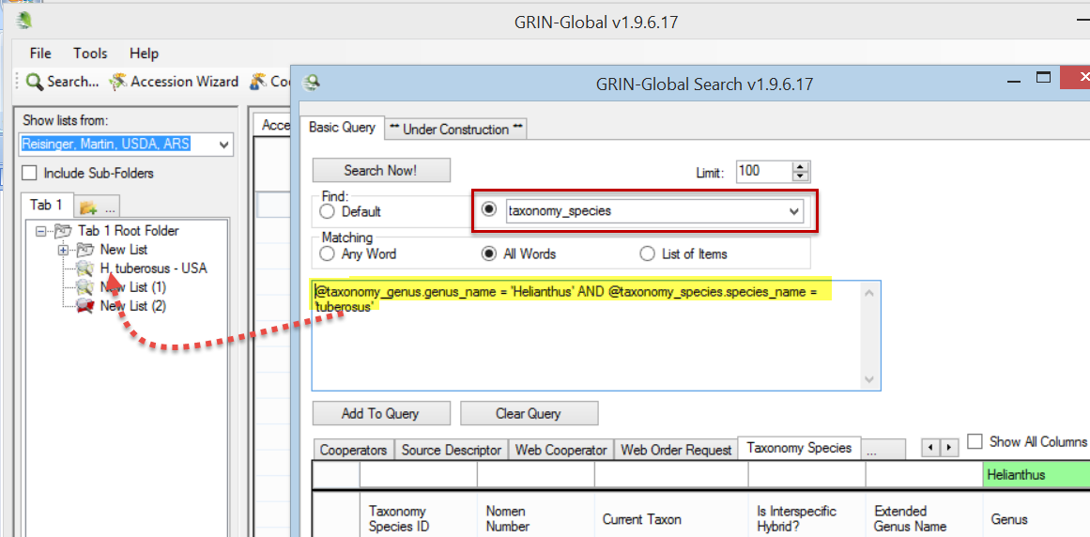
The Dynamic List Options will include the radio button for the Resolve To: option
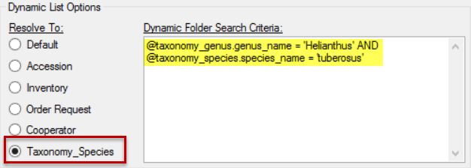

Method 2
While still in the Curator Tool, right-click on the empty folder. Select Properties from the menu. Switch to the Search Tool; create a query. Copy the code in the large text box (generated by the QBE) into the Dynamic Folder Search Criteria box in the Curator Tool.

Method 3
A third method for creating a dynamic folder is to copy the query criteria of an existing dynamic folder and use that code as the basis for a new dynamic folder. Edit the new folder’s criteria as desired.
A dynamic folders lists the same records found by an equivalent search in the Search Tool:
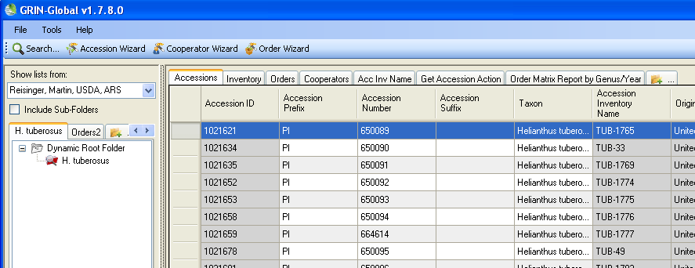

Refreshing a Dynamic Folder
If any new records are added to the GRIN-Global database that meet the folder’s criteria, the records will be displayed when the dynamic folder is the active folder and has been refreshed. You can refresh a dynamic folder by invoking any of the following methods:
- right-click on the folder and select the Refresh List command
- switch to another tab and then back to the tab with the dynamic folder
- switch to another user and return back to the original user
- click the Refresh Data button in the right panel
- press F5
- start the CT

Dataviews
In the Curator Tool, the dataviews serve as camera lenses to the GRIN-Global data. A dataview is a programmed query that displays data stored in the GG tables. These dataviews will have been programmed by someone who coded SQL (Structured Query Language). Fortunately, as a CT user, you do not need to know how to write SQL to use dataviews – you only need to understand the data displayed in the dataviews.
The CT installation provides many dataviews that are used by most genebanks. Additionally, an organization may create supplementary dataviews to match a genebank’s specific needs.

To Display a Dataview Whose Tab is Visible
As a Curator Tool user, you typically display only the dataviews that you intend to use – you do not need to display all of them.
To use a dataview, click on the dataview’s tab:
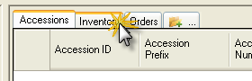
You must be in Read-Only mode to switch dataviews. When your Edit Data button is grayed out, you are in Edit mode. To switch dataviews, you will need to either save your data or cancel (click Save Data or Cancel).
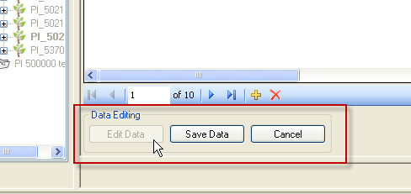

To Display a Dataview Whose Tab isn’t Visible
1. Click the New Tab icon. (When there are many tabs displayed, use the right arrow button to scroll to the right to display the New Tab icon):
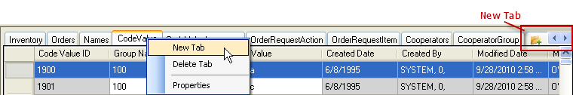
Alternatively, you can right-click on any tab and select New Tab from the menu. However, there is a slight disadvantage if many records are currently being displayed. Generally, it will be quicker to use the New Tab icon.

2. Typically, the Category is “Client.” Rarely will you need to change that option.
The Area must be selected; this assumes that you know which area your dataview is stored under. As you become more experienced, this will become second nature. (Use the online dictionary (column A) if you can’t determine the Area.)
Similar dataviews are grouped under one Area. For example, the Accession area holds the accession-related dataviews: Accession, Accession Source, Accession Action,…
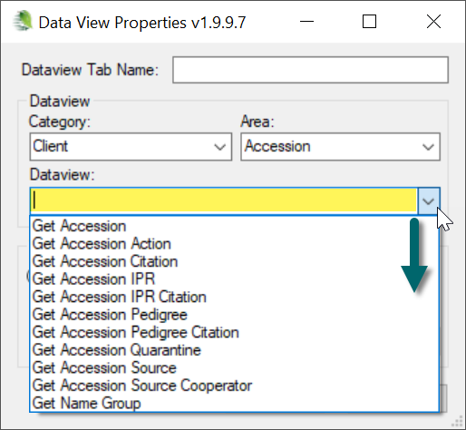
Click OK.

Dataview Naming Conventions
[An older convention: Dataviews designed for use within the Curator Tool were consistently named with Get... such as Get Accession or Get Inventory. You can delete the word “Get” from the Tab name if desired. (“Get” is not always used, depending on the GG installation.)

Children Dataviews
Certain dataviews are considered the parent dataview and the dependent dataviews can be considered as the “children.” Names of the children dataviews are typically prefixed by the parent’s name. Accessions is the parent dataview for various children dataviews such as “Accession IPR” and “Accession Quarantine.” In the example above, the dataviews display records that are children of both the Accession table and the Inventory table, hence the name Accession/Inventory...

Some Dataviews Display Data, Some Do Not
CT dataviews fit into one of two broad groups, explained in more detail below. The dataview…
- has an associated list object -- when the dataview is active, the list in the List Panel points to related records. (typical)
- is designed to show all of the records referenced by the dataview. When looking at the data grid, you see all of the records related to the dataview
In the example below, the Accession dataview is the active dataview, and the list in the left List Panel is pointing to the accession records shown in the data grid on the right side:
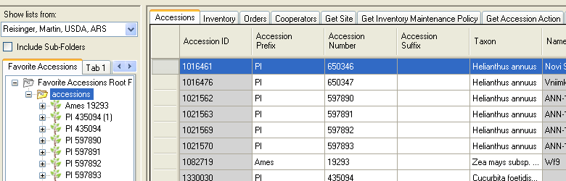
The second group of dataviews displays all of the records in the associated table(s). For example, the Get Site dataview lists all of the records in the Site table when the active list on the left is empty. Crop is another dataview that displays all of the Crop records when the list panel active list is empty.
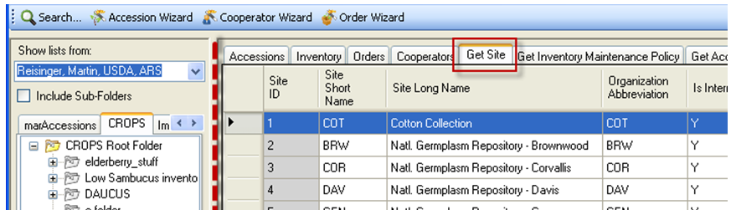

Form View
Only a few dataviews, (Accession, Inventory, Orders, Accession-Inventory Attachments) have associated forms. The forms are alternative means for displaying (or editing) the data records. One record displays individually in a form, as opposed to the grid (spreadsheet) view, where multiple records are displayed. The form and grid can be displayed at the same time, with the form in its own window: 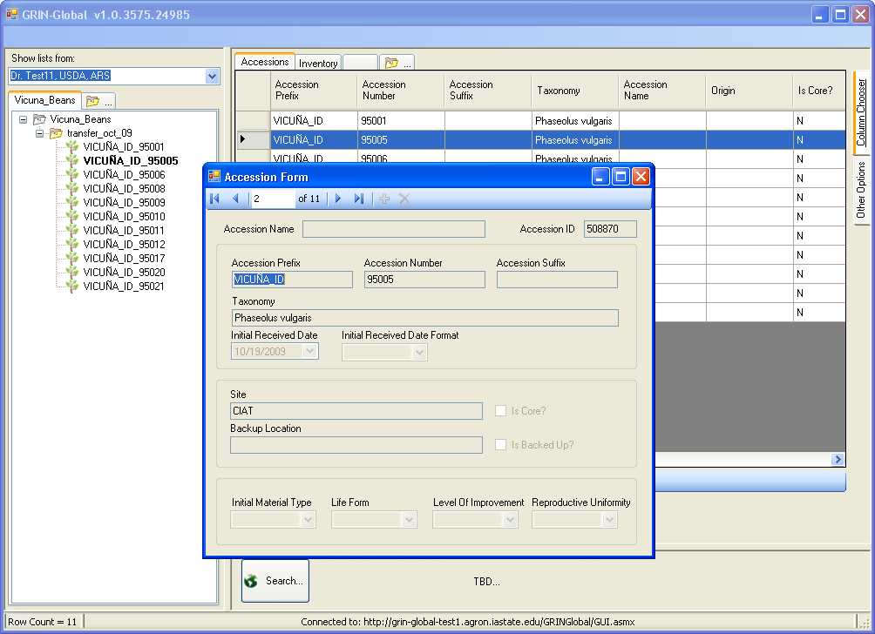

Displaying Forms
To display a form or to switch from a form view to the spreadsheet view, right-click on a tab; select Properties. Currently this feature is available for four tabs: Accessions, Inventory, Order Requests, and Accession-Inventory Attachments. 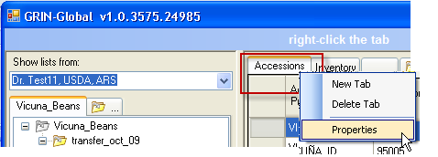 | 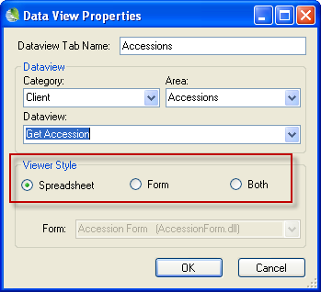  On the Data View Properties window, select the desired Viewer Style.

Accessions Data Form 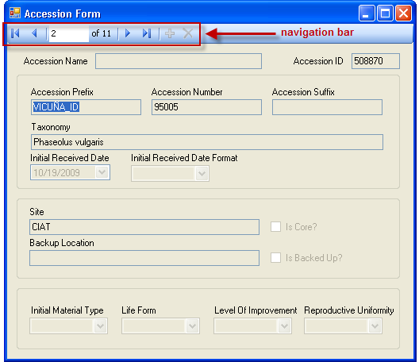 | Navigation Bar  Use the Navigation Bar icons to move through the records. You must be in Edit mode for the Add new and Delete buttons to be active.  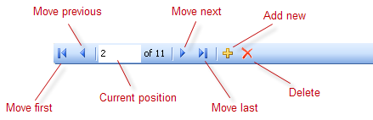

Visual Clues
When selecting an Inventory record in the grid, the record’s corresponding Accession item in the List Panel will be underlined and italicized when the Hot Synch Treeview with Dataview checkbox is checked.
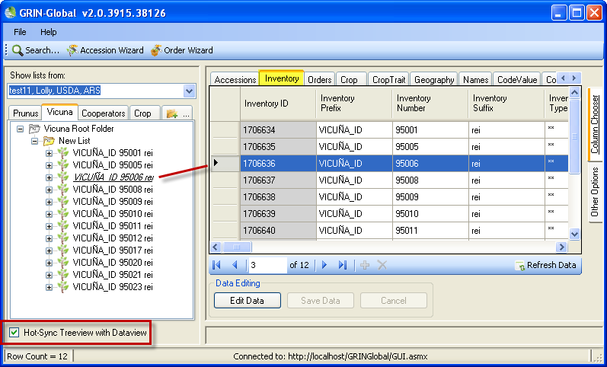

Icon Legend
Each object type has its own unique icon; however, icons are customizable and may be different for your organization. (Two alternatives for each are shown here.)
Accession  Selected* Accession |  | Inventory  Selected Inventory | Order  Selected Order | Cooperator  Selected Cooperator
Crop  Selected Crop |  | Geography  Selected Geography | Genus  Selected Genus
 | Icons and labels for the list items are highly customizable. Detailed information for doing this is included in the Admin Guide. (An AppSettings.txt file on your PC affects the labels for the list items. Most CT users will simply use the settings defined for them by their GG administrator.)

Cell Colors
When changes are being made to database records, the Curator Tool must be in “Edit Mode.” The following table summarizes the implication of the cell’s color when In Edit mode:
Cell Color | Meaning
gray | cell cannot be edited
violet | field is required; a record cannot be saved until all required fields are filled
yellow | when a record is being edited, fields that have changed
blue | current cell

In Edit mode, click to select the Highlight Changed Data option. Another handy option is the Hide Unchanged Rows option.
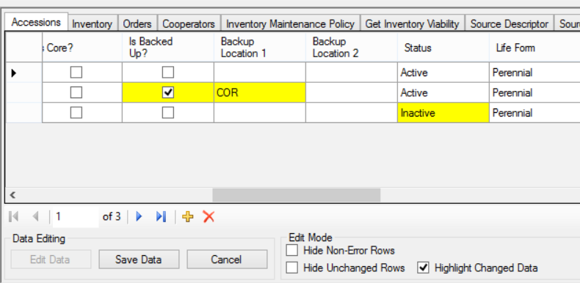

Warning Indicators
This screen example also illustrates a warning indicator. Move the mouse over the ! and the message tooltip will display:
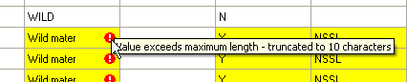

Spreadsheet Similarities

Columns & Rows
The data grid columns and rows are similar to the columns and rows in a spreadsheet. For instance, you can widen and narrow both columns and rows. Drag the mouse on the edge of the column or row when the mouse pointer appears as a double-arrow. Double-click on the column or row edge to return to the original size.
The CT should* remember your view and will display the view in the same manner (same columns, widths, etc.) the next time you use the program. (*Settings are not currently being saved correctly; this is a known a bug that will be corrected.)
You can adjust the widths of columns and the height of rows just as you do with Excel – drag the dividing bar between the headings to adjust column width or between the left row header cells to adjust row height.
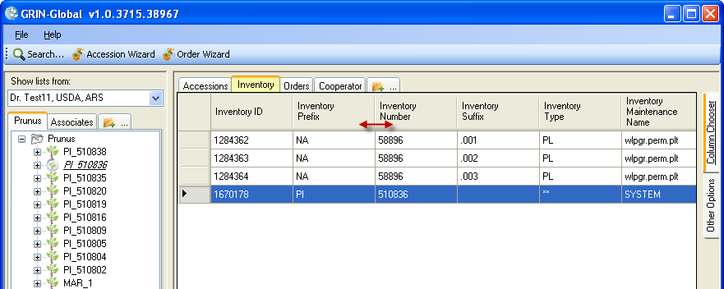
Many of Excel’s keyboard shortcuts and navigation keys also work in the Curator Tool and Search grids. Two that are very useful are Ctrl-D and Ctrl- ‘ – these are discussed in detail later. Refer to the list for others.

Column Order
Reorder the columns by dragging any column heading left or right. Release the mouse and the column will be repositioned in the location where you “drop” it.
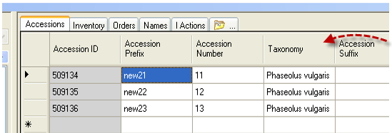
In this example, the Taxonomy column in the Curator Tool was shifted to the left. To reposition a column, drag the column heading left or right as needed.
Demo: See https://www.ars-grin.gov/npgs/gringlobal/videos/datagrid.mp4

Hiding / Displaying Columns
Not only can you reorder columns, but you can also choose which columns to display or not display. For each dataview, certain columns are displayed automatically. However, you can control which columns are displayed (or not).

To Select Which Columns to Hide / Display
Click on the Column Chooser tab near the right edge of the data grid.
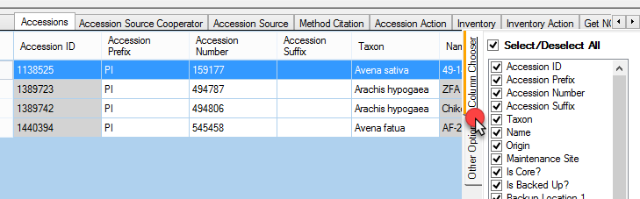
Select which columns to display by clicking in their checkboxes; click anywhere in the data grid to close the Column Chooser Panel.

Personalizing Your Curator Tool: Other Options Tab
The Other Options tab on the right side of the Grid has various settings that can be used to adjust the row colors, the number of rows allowed, and options for highlighting charged data and for hiding unchanged rows. Click on the Other Options tab to open this panel; click anywhere in the Data Grid to close the tab.
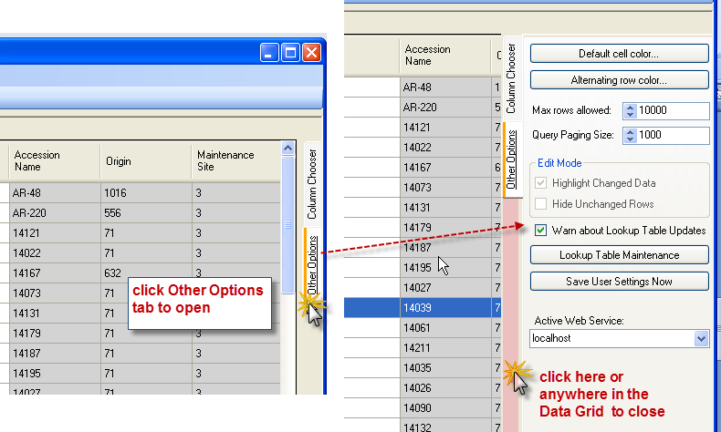

Cell and row colors
Use the Default cell color… and Alternating row color… buttons to change colors. Each dataview can have its own color mix, making it easier to quickly recognize which dataview is currently being displayed.

Max rows allowed
Use this setting to control the maximum number of rows displayed in the Data Grid. (The number must be greater than one.) Be aware that a very large value for Max Rows Allowed could negatively impact the response time when accessing data from a remote server. Typically, 1000 or even 10,000 is okay.
When considering setting the value, remember that the Curator Tool stops displaying rows at whatever maximum level you set. If you import a large number of records, some may not display because the total number of rows has reached the upper limit. It may seem that all of your records did not get imported when in reality they were imported, but they are just not displaying.

Performance Enhancement Option: Query Paging Size
By increasing the Query Paging Size, you can greatly enhance the performance of your PC. By adjusting the Query Paging Size to fit the conditions – keep it lower if slow conditions exist. 1000 is typical.
When increasing Query Paging Size, remember that a large page size means a less responsive Escape Key. If you increase the size too high, you might experience a “server timeout” error indicating that you are asking for so much data in one round trip that the server cannot deliver the volume of data in the allotted time. If that happens, reduce the size.

Save User Settings Now
Click the Save User Settings Now button to save the dataviews’ row colors and column settings (column order, width, and visibility) as well as the Options Tab settings “Max rows allowed” and “Query Paging Size.”
If you are experiencing network issues, before leaving the CT for a length of time, save your settings. Otherwise, you could lose your lists and the dataviews tabs that you had set up.

Active Web Service (Switching to another Database)
Under the Other Options tab, you can switch databases if your PC has been configured to use different databases. Why would you need to do this? In the U.S., in the NPGS, there isn’t a need to do this, but some international organizations may be using different servers to house completely separate GRIN-Global databases.
In the following example, the user has access to multiple servers, primarily for testing and training purposes. More typical for most users would be just one available service.
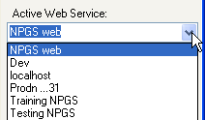

Sorting and Filtering Records
Frequently you will want to sort or filter records to organize and locate specific data easier.

Sorting Data
Select a column heading on which the sort will be based; right-click. Then select the appropriate menu option, Sort Ascending (or Sort Descending).
You can sort by multiple columns. The sequence is important – the column sorted first will be the first level sort, the second column selected will be second, etc.
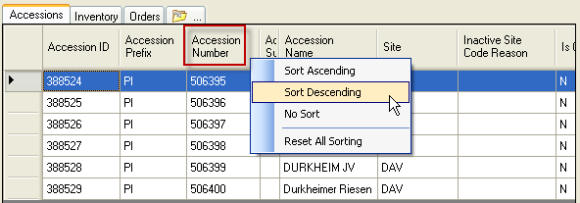

Other Sort Options
Option | Effect
No Sort | “undo” the sorting of one specific column – click on the column heading first; then right click and select No Sort
Reset All Sorting | clears all sorting, returning the records back to their original order

Sort Indicator
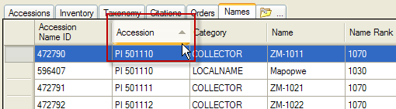

Filtering Records
You can filter the data grid in order to display a subset of the records. Use any cell’s contents as the basis for your filtering criteria. Right-click in the data cell; select the desired filtering choice from the menu.
Before the filter is set:
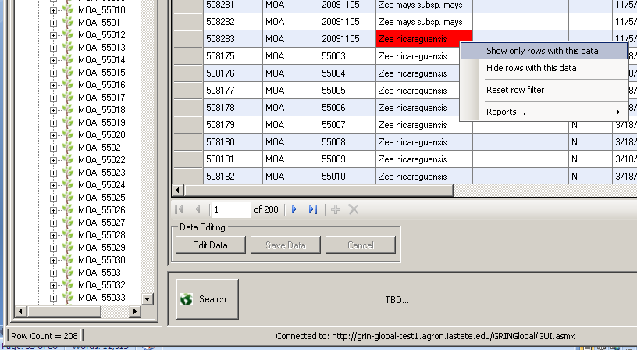
Display after the filter was set:
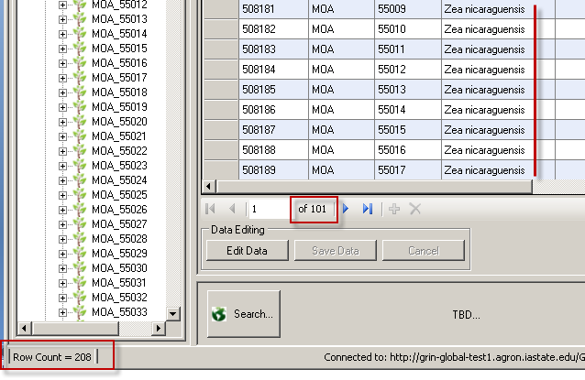
To turn off filtering, right-click in any cell in the grid; select Reset row filter.

Lookup Tables
Please refer to the online Lookup Tables document at:
https://www.grin-global.org/docs/gg_lookups.docx

Code Groups

Background Information
Many of the dataviews in the Curator Tool use dropdowns to assist in selecting a valid entry – the fields do not allow any random text data to be entered, but instead require a value from a pre-populated set of values. Various codes and data values are stored in the Code Group tables by the GG administrator.
For example, the Category in the Accession Inventory Name dataview uses codes:
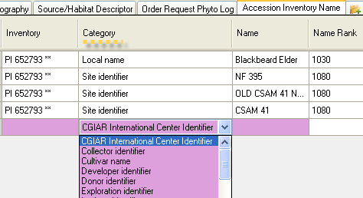
Five fields in the Accession dataview that use Codes are shown below. In the example, the user clicked on the Level Of Improvement to display and then select a code:
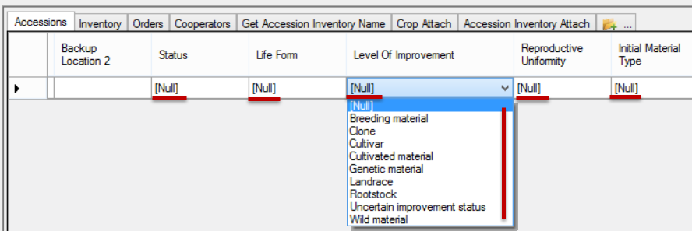
Only the GG administrator can add or edit the codes, ensuring consistency and integrity. As a CT user, if you need a code to adequately describe a record, contact your GG administrator or follow your organization’s procedure for establishing codes.

Importing Your Data from an Existing Database into GRIN-Global

Drag & Drop
The term “drag and drop” is used to describe bringing data from a spreadsheet into GRIN-Global. The following text describes in detail the process for doing this. An important guideline to remember: there are 2 types of drag & drop situations:
1) adding new records
2) updating existing records

When adding new records, you must not include an ID field when dragging records from the spreadsheet (since these are going to be new records, they couldn't possibly have ID fields yet - the ID field is generated by the computer when the record is saved).

When updating existing records, you must include the ID fields of the records you are updating. The software is matching the spreadsheet data with the existing records in the GG database.

Using a Spreadsheet to Import Data into GRIN-Global
The following directions detail how to upload data originally stored elsewhere, such as in a spreadsheet, into the GRIN-Global Curator Tool. (Some people refer to this as “bulk loading” or “mass loading.”) During this process, you will match column names in the Curator Tool with the corresponding column names from your source spreadsheet data.
Why would you copy data from a spreadsheet into the GRIN-Global Curator Tool? There are multiple reasons when you would do this. When initially converting to GRIN-Global, many genebanks have existing data stored in spreadsheets or databases and will want to import their data into GRIN-Global. The genebank will then use GRIN-Global as its information system going forward and will no longer continue keeping data in a spreadsheet.
On an ongoing basis, some GRIN-Global users may opt to keep their data in spreadsheets before it is convenient to upload their data into the Curator Tool. (The same is true for importing data from a database, such as Access or FoxPro.)

Two Importing Methods
The Curator Tool was designed to be compatible with spreadsheets. It is a straightforward process to copy and move data from a spreadsheet to the Curator Tool. There are two alternative methods for doing this.
In the first approach, you will copy the data from a spreadsheet and drop it into the Curator Tool. During this process, the column headings in the spreadsheet are used to match up the spreadsheet data with the respective columns in the Curator Tool.
In the second approach, the “Block-Style” approach, a block of data is copied from the Curator Tool into a spreadsheet. In this method, you will not be including the column headings; in this case it becomes important where you physically place (drop) your data. The step-by-step details are described later, on page 56.)

Copying Data from a Spreadsheet (Including the Column Headings)
To make it easier to visually verify any changes to Curator Tool data, it is highly recommended to select the Highlight Changed Data and the Hide Unchanged Rows options. Changed cells will be displayed in color (see page 38).
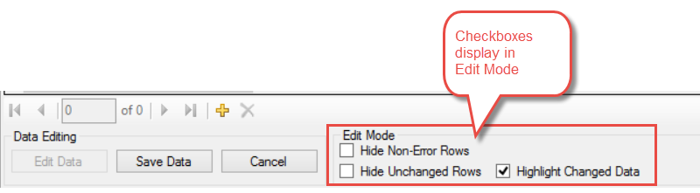

Copy the Data from a Spreadsheet to the Curator Tool
Open the GRIN-Global Curator Tool and your spreadsheet application (e.g. Microsoft’s Excel, OpenSource.org’s Calc, or Google Docs). They both must be open, but ideally not both in full screen. By having both windows at least partially visible, you will be able to drag data from the spreadsheet into GRIN-Global easier than if the screens were full screen. (You will be able to copy data even if the windows are full screen, but you will use the Windows Taskbar to facilitate switching between the two programs.
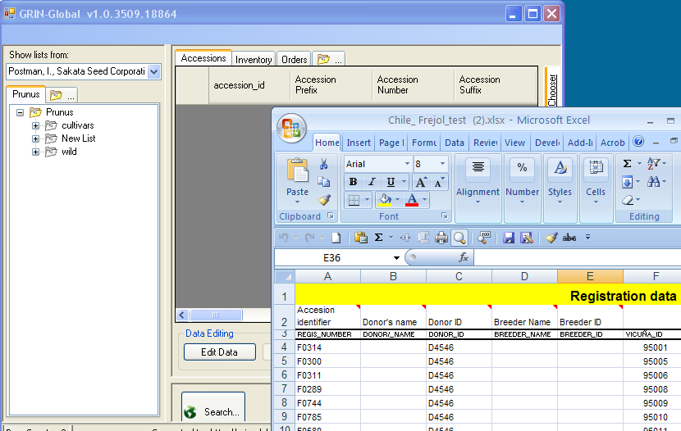
1. In the Curator Tool, locate and click on the folder (list) that will be updated.
2. Also in the Curator Tool, click the Edit Data button (if you are not already in Edit mode).
3. In the spreadsheet, highlight the data that will be copied; it is essential to include a column header row in which the spelling of the column names matches exactly with the Curator Tool column names. (See Importing Column Names if you wish to avoid typing the column names.)
- only the columns with data being updated must be included
- the spreadsheet columns do not need to be in the same order as the Curator Tool columns
- the spreadsheet column names must be spelled identically to the Curator Tool column names
4. In the spreadsheet, using the cursor, grab the box outlining the selected cells, drag the box and drop it anywhere in the GRIN-Global Data Grid.
When dragging from one application to the other, if the target application is not visible on the desktop, drag the mouse to the target application’s icon on the Windows Taskbar. The target application will then display; drop the box outline.
Click to review the video.

5. Any changes made in the spreadsheet should now be visible in GRIN-Global.
6. If satisfied with the data, click Save Data.

Each table has a primary key – for instance in the Accession table it is the Accession ID field. It is important to review the primary key field in the spreadsheet before dragging the data into the Curator Tool. Dragging spreadsheet records with:
- matching key fields will update existing records in the Curator Tool Data Grid
- non-matching (or empty) key fields will add new records in the Curator Tool Data Grid
After dragging data into the CT, and when saving, the data is validated. Whenever fields using codes are involved, if the spreadsheet data does not match any of the field’s valid codes, an “!error!” message will display in the cell. If you later edit that cell, the cell will be appear to be empty. Contact your GG administrator if you think a code is missing or need to be added.
Read-Only Mode a(after a drag and drop where the codes used for the Status field did not match the valid codes)
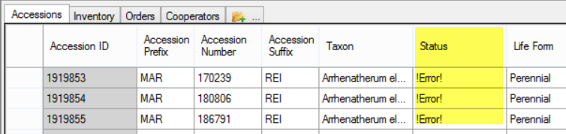
Same data, but in Edit mode:
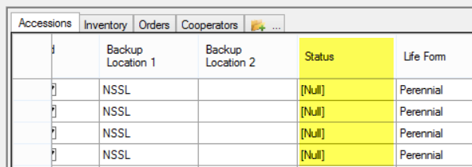

Copying Column Names from the Curator Tool into a Spreadsheet
To ensure that the spreadsheet column names match identically to the Curator Tool column names, drag a row (blank or filled) from the Curator Tool datagrid into a spreadsheet. This technique is also a quick way to start building data in a spreadsheet that will eventually be dropped into the Curator Tool.
(To display the actual database field names, instead of the column headings, depress and hold down the CTRL key before dragging the data into the spreadsheet. “Typical” users will not need to do this, but Curator Tool administrators may find this handy.)
1. In the Curator Tool, start a new list or select an existing list.
2. In the data grid in the right panel, you need to select a row, either empty ( a new record), or already filled with data. You can simply drag a filled row from the CT without even being in Edit mode.
Either select a new blank row by clicking on the row’s header cell; copy (Ctrl-C); paste in a spreadsheet (Ctrl-V). Alternatively, do a “drag and drop.” (See “Drag and Drop” for details.)
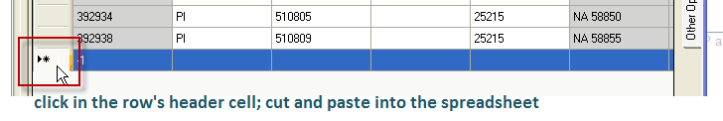

Copying, Block-Style
Use the Block-style copying approach to copy blocks of data from a spreadsheet into the Curator Tool. (This method also works in the reverse direction for copying data from the Curator Tool to a spreadsheet.)

When using this method, since you will not be including the column names, it is critical where you line up the cells when you copy and paste. Open both the Curator Tool and your spreadsheet application, but not in full screen.
1. Determine what data will eventually be replaced in the Curator Tool or what data is to be copied into a spreadsheet. Arrange your spreadsheet so that its columns are in the same order as the Curator Tool’s. (You can rearrange the columns in either the Curator Tool or the spreadsheet.)
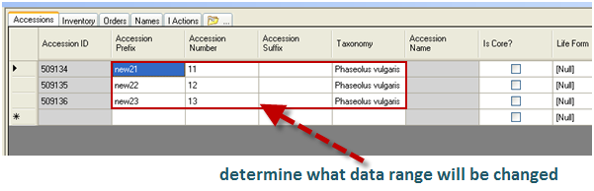
In this example, the Taxonomy column in the Curator Tool is shifted to the left. Remember that to reposition a column, drag the column heading left or right as needed.
2. In the Curator Tool, click the Edit Data button to get into Edit mode.
3. In Excel, highlight the spreadsheet data that will be copied;
use Ctrl-C to copy the block.
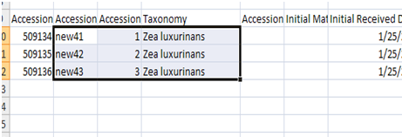

4. In the Curator Tool, position the cursor in the top, left cell of the range of data that will be updated; use Ctrl-V to paste the data.
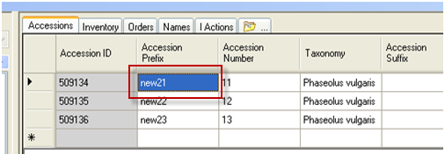

Result of the Block-Copy:
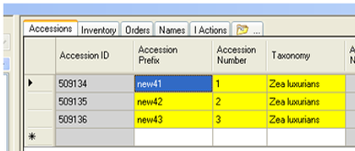
The top left cell is blue because it currently is the active cell; the yellow indicates that a cell‘s content has changed.
Besides using the cut and paste method, the drag and drop method also works. The key is to properly align the block of spreadsheet data with the top, left “target” cell in the Curator Tool.

Copying Curator Tool Data into a Spreadsheet

Copying Curator Tool Data into a Spreadsheet
1. Open both the Curator Tool and the spreadsheet application (e.g. Excel). They both should be open, but not full screen.
2. If necessary, filter the files that will be copied (see Filtering Records).
3. Select the records from the Curator Tool that will be copied into the spreadsheet. See Drag and Selecting Multiple Rows instructions for general directions.
When dragging from one application to the other, if the target application is not visible on the desktop, drag the mouse to the target application’s button on the Taskbar. The target application will then display; drop the box outline.
[Click to review the video.]
Another method for importing data into GRIN-Global requires the Admin Tool, which generally is restricted to database administrators. However, you should be aware of this capability, because the Admin Tool has Import Wizards that were designed specifically for importing data. If you are in a networked environment, your administrator may be able to assist you with this initial loading of data. If your GRIN-Global database resides on your PC, then you can use the Admin Tool Import Wizard to load datasets into GRIN-Global.

Copying Blocks of Data
Press the ALT key (in either Edit or Read-only mode.) Use standard Windows Copy and Paste technique to copy highlighted data from the CT into a spreadsheet. In this type of copy, the column headings are not copied.

Using Lists to Organize Data
This section explains in detail the steps for establishing and maintaining lists for managing data. For an overview on the Curator Tool List feature, refer to page 25.
One of GRIN-Global’s fundamental features is its ability to organize virtual lists of database records that are of particular interest to you. These lists can point to records which you need to track or manage, such as accessions, inventory records, or orders.
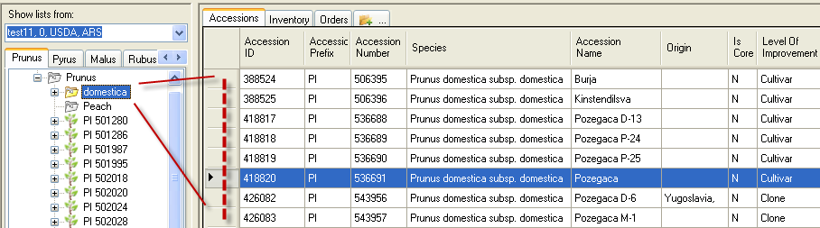
You populate lists by pointing to records in the database. You can set up “dummy” folders which are initially empty, but eventually will include specific records for your unique needs. When you no longer need a folder, you can delete it. You are merely deleting your folder, not the actual database records to which the folder’s list had pointed.
In the introduction to this User Guide, we briefly described using the Curator Tool to manage accessions and orders. (See Using Lists to Organize Your Accessions or Using Lists to Organize Your Orders.)

Tabs
By default, when the List Panel tabs are created, they will have a “root folder” with practically the same name as the tab. In the following example, the Prunus tab has its highest-level folder assigned the name “Prunus Root Folder.”
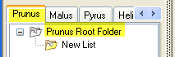
By “highest-level,” think of each tab having a main folder which in turn can hold subfolders. (If you are familiar with Windows Explorer, folders having subfolders is a similar concept.) There is no limit to the number of times a folder can be subdivided.
In addition to creating a “root folder,” the Curator Tool also creates a subfolder with the default name “New List.” It is recommended that the user rename the New List folder to a more meaningful name, one that reflects the database records the list will be pointing to.

To Create a New Tab
1. In the List Panel, click on the New Tab icon with the ellipsis (”…”).
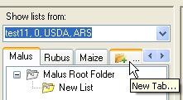
2. In the pop-up window, input a Tab Name; click OK.
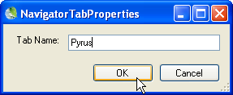
Result:
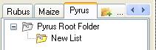

To Rename a Tab
1. Right-click on the tab name.
2. Select Properties
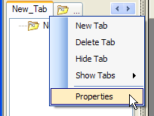
3. Type in the name; click OK.
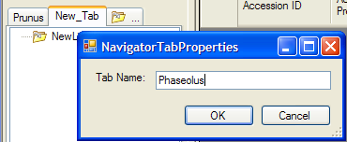

To Hide and Display Tabs
Tabs in the List Panel can be hidden or displayed as desired. This is particularly helpful when you have created many tabs.

To Hide a Tab
Right-click on the tab to be hidden.
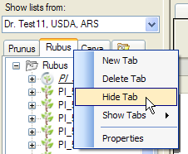

To Display a Hidden Tab
Right-click on any tab that is visible; select Show Tabs from the menu and then click on the hidden tab’s name. (In this example the Rubus tab is hidden and will be displayed again.)
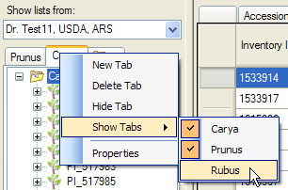

At least one tab must be displayed – you cannot hide all tabs simultaneously. Also, you can rearrange tabs by dragging them left or right.

Lists
Dynamic lists (folders) were introduce in version 1.8.3. See the section on dynamic folders for details. The following directions primarily pertain to static lists.
List items must be individually moved or copied. Hence, consider creating smaller lists and sub-lists to organize your items. By doing so, the items will be better organized, but also can be readily rearranged at a later time. (You can move a list containing many items.)

To Create a New List
1. Right-click on the parent list (the list that will be one level higher than your new list) and select New List.
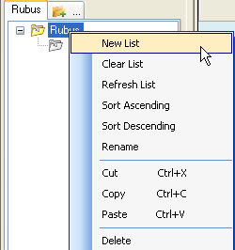
A new, empty list with the name “New List” will be created below the existing list. (Adding items to your list is discussed later.)

If the parent list already contains other items or lists, look below the existing items for the new list. Initially this can be confusing if the list is long; you may need to scroll down to see the newly created list.

To Delete or Clear a List
You can delete lists that are no longer needed or empty lists that you intend to use again. In either case, you are not deleting the actual database records, but rather the record pointers that were stored by your folders. “Delete” removes the folder and items; “Clear List” only empties the list items in the folder.

To Delete a List
Right-click on the list name; select Delete.
Also, use the Refresh List option on the context menu after you have made any changes to the list:
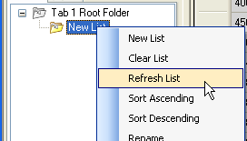

To Clear a List
To remove the items from a list, but retain the list name, right-click on the list name; select Clear List.
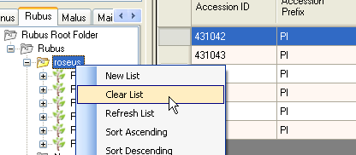
These “Delete” and “Clear List” actions do not delete the database records; they only impact the lists.

To Delete Items from a List
To remove one item from a list, select the item; right-click; select Delete. Use Clear List to empty the list of all items.
Currently you cannot select multiple items within a list in order to delete them simultaneously.
Also, remember that deleting an item from a list does not delete the item’s corresponding record in the database; this action is only deleting the list item.
You can also impact a folder’s sub-folders. For example, if you want to clear a list as well the contents of any lists under that list, select the Include Sub-Folders option
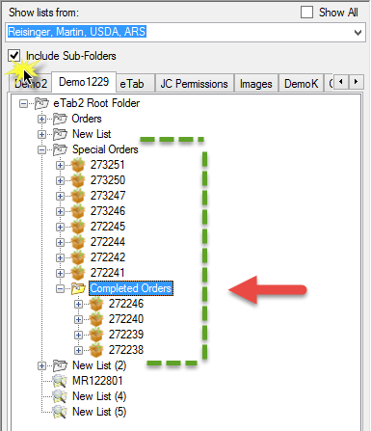

Name a List
Right-click a folder name to rename it with a meaningful name; select Rename from the menu.
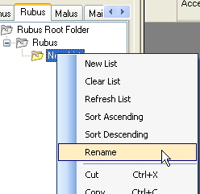

To Move a List
The method for moving a list is similar to moving a folder in Microsoft Explorer and other programs. Depending on your preference, you may opt to move a list using any of the following methods:
- right-click menu
- keyboard shortcuts (Ctrl-X, Ctrl-C, Ctrl-V)
- “drag and drop” (with the mouse)
Note that in addition to moving from one folder to another, you can also move or copy folders or even individual list items from one tab to another. Highlight the list or item being moved; right-click on that folder and select Cut or Copy.
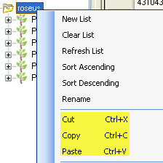
Locate the new parent list; right-click on that folder name and select Paste.
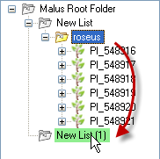

To move a list using the keyboard shortcuts (Ctrl-X, Ctrl-C, Ctrl-V)
Highlight the list name; use Ctrl-X (to move) or Ctrl-C (to copy). Locate the new parent list; use Ctrl-V.

To move a list using the drag and drop method
Highlight the list name; drag to the new “parent” folder.

To Add Additional Items to a List
Additional accession / inventory / order requests, and other records can be added to an existing list at any time using the same methods described in the Creating New Records section, p. 99. You can always drag additional records form the Search Tool to a list that already has some items in it.

Sorting & Custom Naming List Items
You can customize the manner in which the lists are sorted as well as specify how the items are labeled within the lists. These features are available via the Properties command on the List menu (right-click on a folder in the List Panel.)
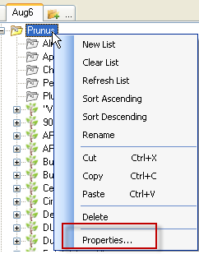

Sorting List Items
You can designate whether a list containing both items and sub-lists has its folders displayed at the top of the list, above the list’s items, or at the bottom, below the items. The following illustrates the Sorting Options section of the Treeview Item Properties window.
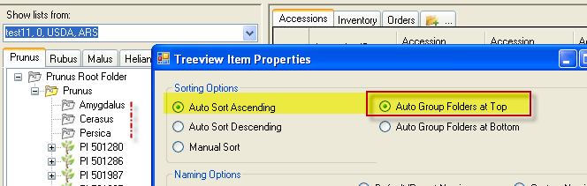

List Items’ Custom Naming Feature
You can change how List items are named.

Default Item Names
By default, the names for accession list items combine the accession prefix, number, and suffix fields from the corresponding accession database record. Similarly, each object type (Accession, Inventory, Order Request, etc.) has a default naming convention.
(In the following example, the accessions have blank suffix fields, so the items’ names include just the Prefix and Number.)
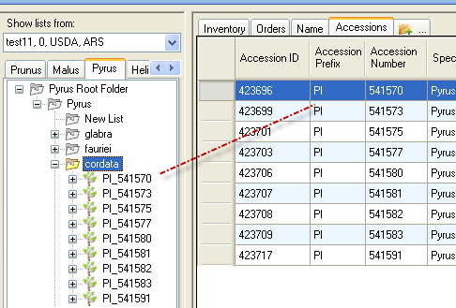
To revert back to their defaults when the list items do not have their default names, highlight the folder, right-click, and then select the Default/Parent Naming option.
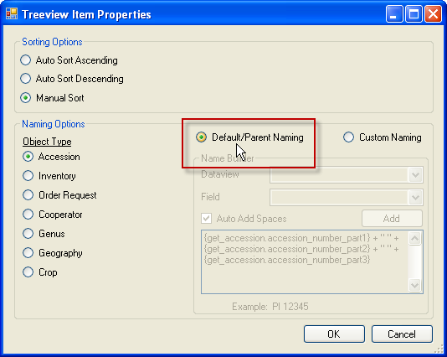

Custom Item Names
Right-click on a folder to create custom item names. In the Treeview Item Properties window:
- Select the desired Object Type. This ultimately determines what field names you can use for the name.
- Click the Custom Naming button.
- Build the custom name by selecting from the list of available fields in the Name Builder frame. Select a Dataview and a Field from that Dataview. Click the Add button as needed to add additional fields; click OK.
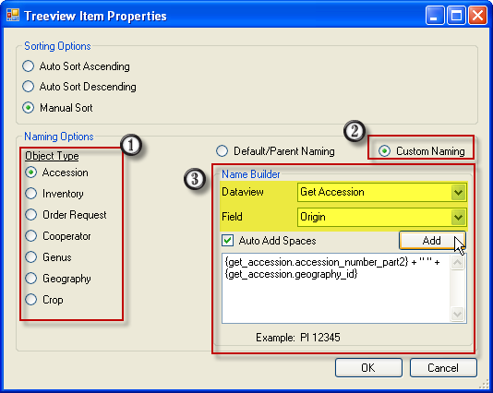
- To see the list items with their custom names, you may need to refresh the list:
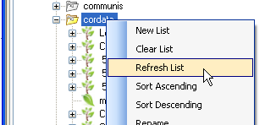
(Certain names will automatically update; if your names do not, invoke the Refresh List command.)
The trailing item for the custom name cannot be text – it should always be a fieldname (this is a known bug).

Inventory Lists
You can make lists of inventory items just as you do with accessions. Most likely you will have many different reasons for building inventory lists. For example, you could create an inventory list to track your current year’s “grow out” and harvest. If you handle thousands of accessions, having this list to aggregate just the current year’s inventory would be very helpful – you can generate labels from the list for your seeds, you can review the year’s results, etc.

Virtual (or System-Generated) Inventory Items
Whenever you review Accessions in the list panel, you will notice an inventory item with a double asterisk (**) next to its name. For every Accession record in the database, GRIN-Global automatically associates a virtual Inventory record.
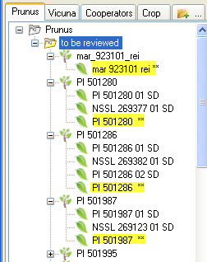
The ** indicates that the inventory item was generated by the system. Because GG needs every Accession record to have at least one Inventory record attached to it, this virtual inventory record ensures that this condition is always met. It is not referring to physical inventory – these virtual Items are not pointing to inventory records of physical germplasm.
In the above screen, the Prunus folder has a subfolder labeled “to be reviewed.” In this folder, the first accession item, mar_923101_rei, has only one inventory item associated with it, and that inventory item is a virtual inventory item. The other accession items shown in the list have multiple physical inventory items as well as one virtual inventory item.
In the Inventory dataview, the Inventory Type for virtual inventory records is also indicated with a ** Since these ** records are virtual, the quantiry fields such as Quantity-on_hand should be empty.
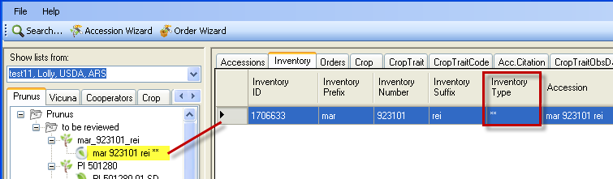

Searching for Records

Search Tool Introduction
Use the Search Tool to search for records from the main GRIN-Global database.
A complete guide focused on searching is online at https://www.grin-global.org/docs/gg_searches.docx
The Search Tool is typically launched from the Search Tool button on the Curator Tool, but it also can be started from the Windows Start screen. Although the Search Tool is completely separate from the Curator Tool, the two programs are greatly intertwined.
From the Curator Tool:
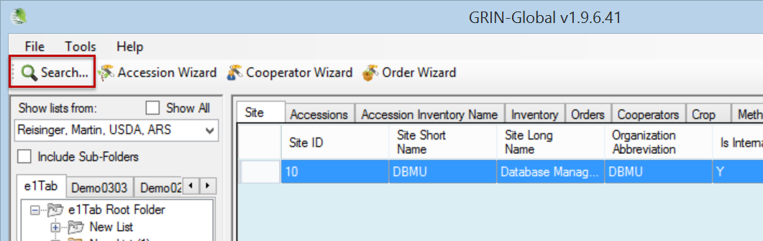

Windows 10 (or 8.1)::
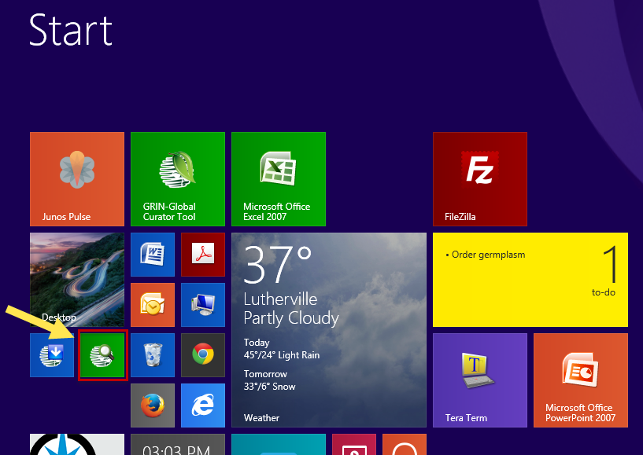

You can search for records meeting specific criteria and then use the search results in various ways. For instance, you can:
- build static lists in the Curator Tool for ongoing tracking of these specific records. Refer to step-by-step details for managing lists. See the Using Lists to Organize Data section.
- build dynamic folders to manage a group of records that may change over time, with records being deleted or added – the Dynamic Folder can manage these records dynamically and remain up-to-date. See the Dynamic Folders section.
- drag the search results directly to a spreadsheet for further review

Search Tool Window
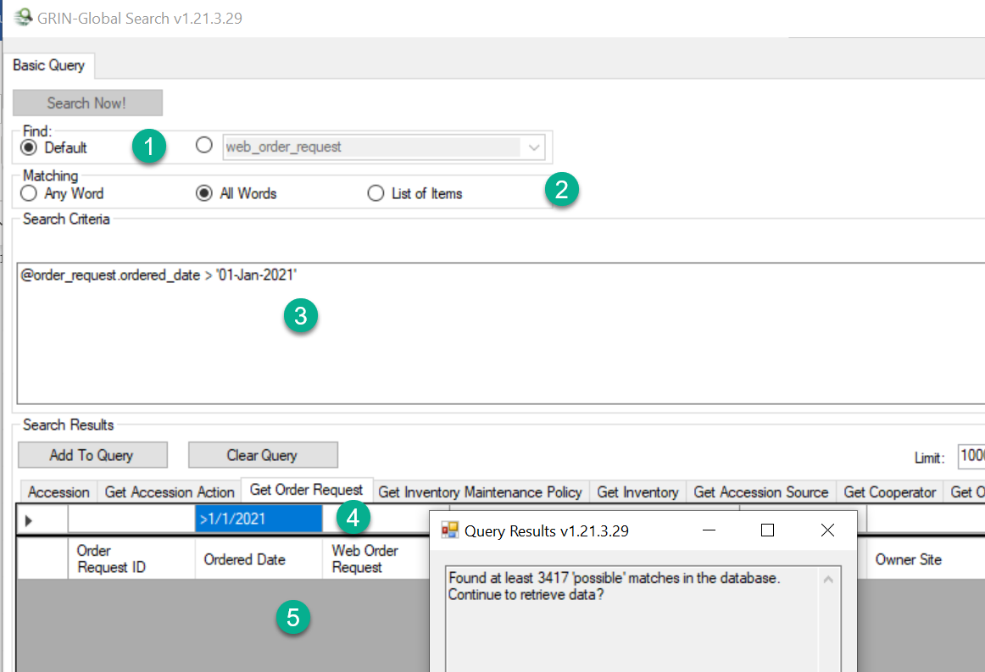
Number | Note
1 | Find Panel: the Default radio button will usually be selected. In relatively rare cases, you will need to select a dataview name from the dropdown button.
2 | Matching: Options for indicating the general type of search. For more details, refer to the online searching guide at https://www.grin-global.org/docs/gg_searches.docx
3 | The Text box: the search criteria are ultimately placed here for review. (You can enter “text” search criteria directly in this box, but “text box searches” are not recommended. See Text Box Searches for details.
4 | QBE (“Query By Example”) Cells: Enter sample search criteria in these cells. This is the recommended way for using the Search Tool. See QBE Searches for details.
5 | Results grid: After the Search Now! button is clicked, the records satisfying the criteria are displayed here.

Two Distinct Search Methods
The Search Tool uses two distinct search methods:
- The user inputs basic criteria “freeform” in the text box. This is not the recommended approach for searches, but in some cases it is convenient.
- The recommended approach is the “query-by-example” search method. The user inputs sample data into the QBE cells directly above the search window’s results area. When you click the Add To Query button, a statement is generated in the text box. The found records will be listed in the results grid.
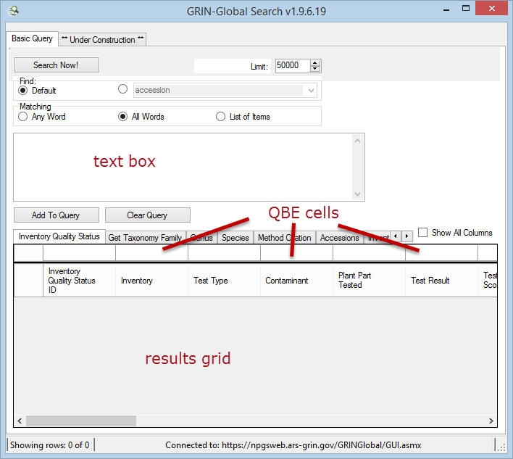

Use QBE as much as possible. After the QBE criteria is entered, you can click either the Add to Query or the Search Now! buttons. We recommend clicking Add to Query, because you can then review the search criteria (or edit the criteria if necessary).
In the background, the GRIN-Global search engine software differentiates QBE searches from the free form text searches by looking for the pattern @table.field -- if the search string doesn’t match that pattern, it isn’t a formatted QBE criteria – in that case, the search string is treated as a text search. (Users often ask if this @search parameter is “SQL” – it isn’t (not exactly).)

Search Tool: Query By Example (“QBE Searches”)

Starting a QBE Search
1. Click the Search button (from within the Curator Tool).
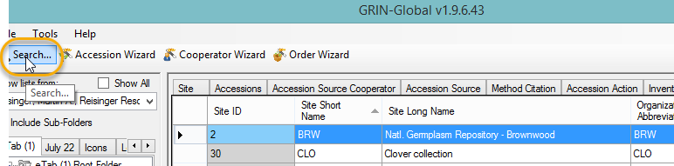
2. A separate Search window displays.
Before invoking the search steps below, increase or decrease the Limit as needed.
(1) Input search criteria in the “query-by-example” (QBE) cells; (2) click the Add To Query button; (3) click the Search Now! button; (4) click OK.
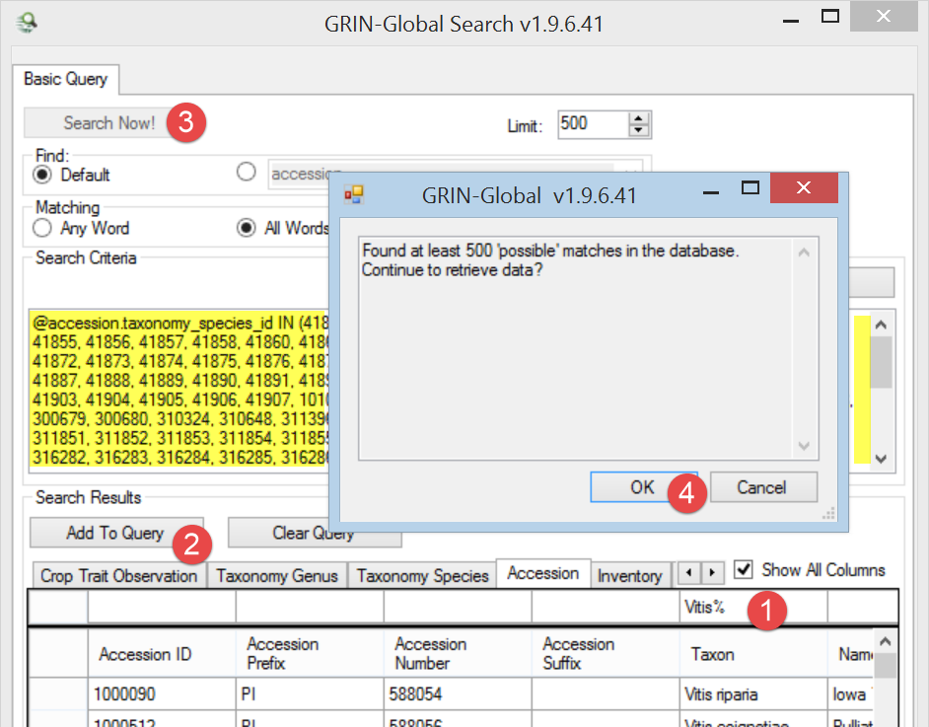
If the database contains records that match your criteria, the text box will be filled with the relevant code generated by your search criteria. (Shown above in yellow highlighting.)
In the following example, the user had entered Allium% in the Taxon QBE cell. The percent symbol (%) and the asterisk (*) are wild card characters indicating any character. 4446 records were returned, all having the genus Allium as the genus component of their taxonomic name:
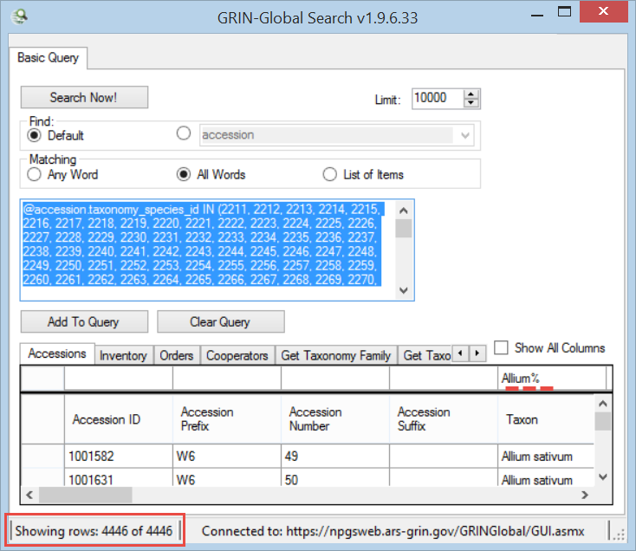

Adding Tabs in the Search Tool
Each tab in the Search Tool is a dataview tab. To display additional tabs, either right-click on an existing tab, or click on the New Tab icon (at the right of the existing tabs).
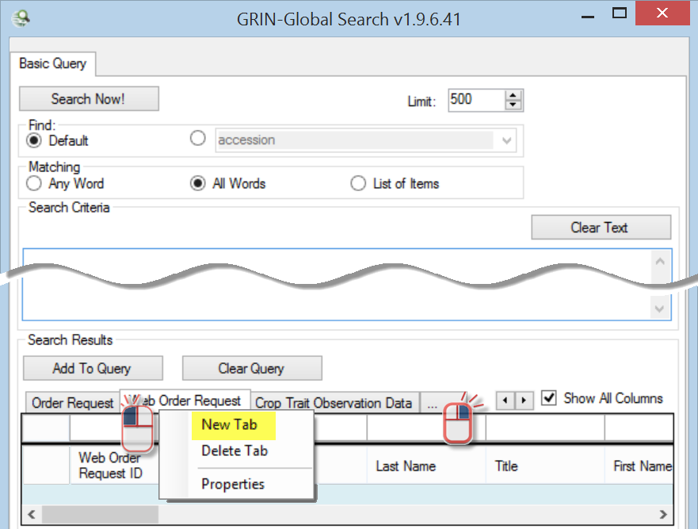

Deleting Tabs in the Search Tool
To delete dataview tabs, right-click on the tab and select the Delete Tab option.

Editing or Saving the Results of a Search
You can read the search results, but you cannot edit the data directly in the Search Tool’s grid. To edit the database records, or to review the same data later, you need to drag the data from the Search Tool grid to somewhere else – either to the Curator Tool, or to a spreadsheet.
In the Curator Tool, you typically build lists to point to these records for future reference. See the Using Lists to Organize Data section for details. Alternatively, you can drag the generated code to the CT to create a Dynamic Folder. See the Dynamic Folders section.
The data found by a search may also be copied into other applications, such as a spreadsheet. In the Search Tool, click in the upper left corner to select all of the found records:
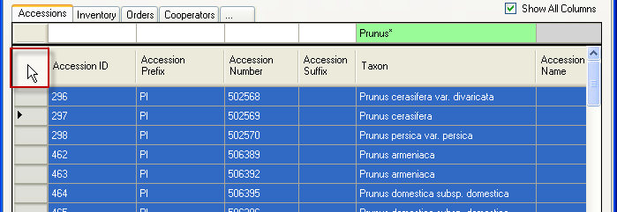
You can select multiple records, using the mouse and Ctrl and/or the Shift keys, just as you can select multiple rows in a spreadsheet.

Search Criteria (QBE)

QBE Search Code
When executing a QBE search, before displaying the found records, the search produces a “coded” text version of your QBE search in the text box. This code can give you an idea of what the QBE search is doing–it will specify the actual database field names, and depending on the fields selected, will sometimes list the primary keys of the records that fit the search criteria.
The following two search examples are similar. The user in both cases inputted a Genus name with a wildcard (Capsicum*). Why is their resulting code so different?

Example 1
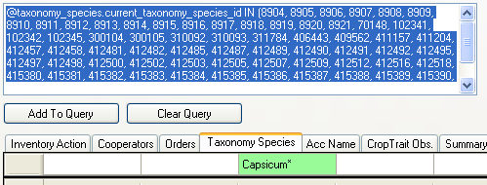

Example 2
@taxonomy_genus.genus_name LIKE 'Capsicum%'
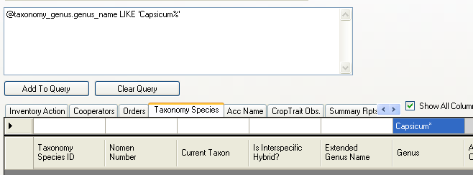
In the first example, the search is looking at key values. The search first uses a related lookup table, in this case taxonomy.species.lookup, and does a comparison for Capsicum%. It then returns all of the corresponding keys that match: “ ...IN (8904, 8905...)” (This all happens even before the user hits the OK button to proceed.)
In the second case, where genus.name is being looked at in the taxonomy.genus table, genus_name is a text field, hence the “LIKE” operator.

Case Sensitivity
Generally, all characters entered in a query are used. The case sensitivity of your search will depend on how the GRIN-Global database is set up:
- If the database is installed as case-sensitive (this is the default for the Oracle and PostgreSQL database engines), the queries will be case-sensitive.
- If the database is installed with settings to make the database case-insensitive (this is the default for Microsoft SQL Server and MySQL database engines), then the queries will be case-insensitive too. (For example, the U.S. National Plant Germplasm System uses MS SQL Server.)

Special Characters
Special characters and letters with diacritical marks and accents (such as á) can be entered in the Search text box.
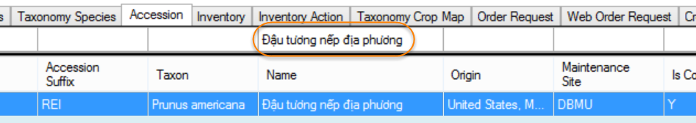
You can copy special characters from the Windows clipboard. Another method is to enter the character using the Windows “Alt key – numeric codes” method. Refer to the following webpage for the common codes: http://tlt.its.psu.edu/suggestions/international/accents/codealt.html
This website also contains directions for loading and using international keyboards which provide the special characters directly on the keyboard, using specific key combinations.

Wildcards
The QBE cells accept wild card characters. (See wildcard table.)

General guidelines:
- do not use quotes in QBE cells
- use the % or * to broaden a search; preferably the %. Date fields require the %. They can be used to substitute for any character and any number of characters.
- The underscore character (_) is a single-character wild card. If you need to specifically search for an underscore character, enclose the underscore within brackets [_]
Example: @inventory_action.action.name_code LIKE ‘INS[_]%’
Example: Prunus% is appropriate when searching by Prunus in the QBE Taxon cell since the Taxon includes the genus and species: 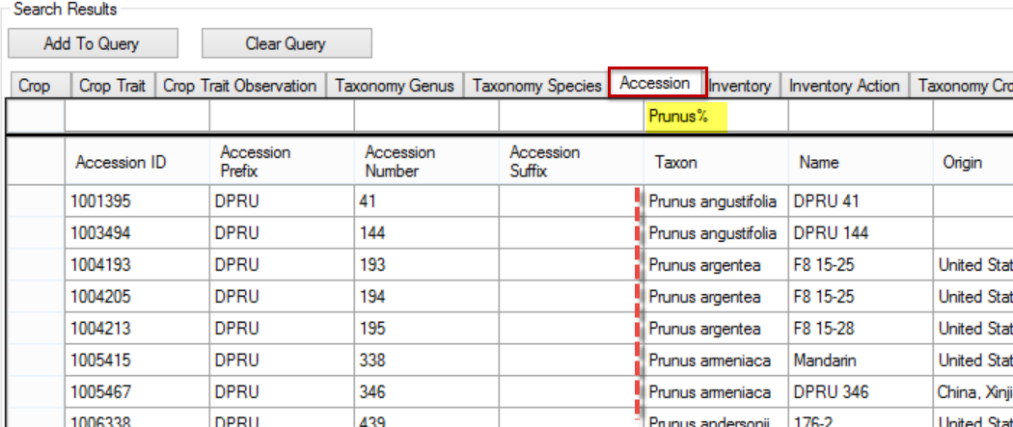

Date Fields
Date fields physically store the date and the time of day. The search also uses Greenwich Mean Time. When searching, your search string in the QBE box needs to mimic the internally-stored version, which is based on the database engine on which GRIN-Global is running. (GG can run on any one of four database engines – each organization decides which to use.
For example, in the U.S., the NPGS is using Microsoft SQL Server.

Microsoft SQL Server
Internally a date is stored in the yyyy-mm-dd time... format, although in the U.S. English version the user sees the date displayed in the mm/dd/yyyy format. Searching for dates can be tricky because the date field includes the time of day as well.

In the following example, the results may not be what you would have expected:
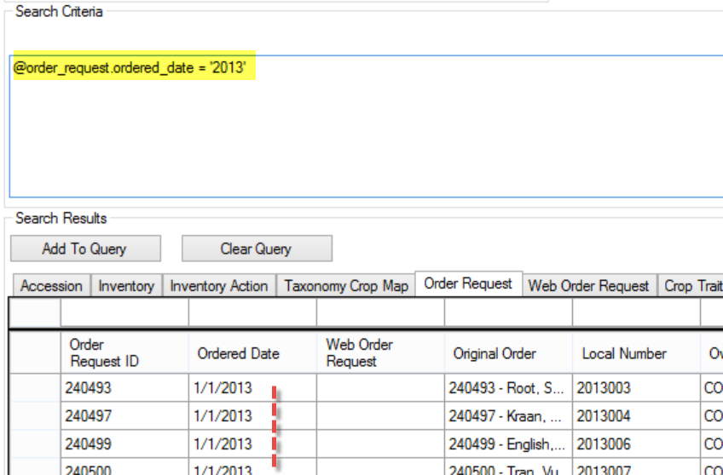

When reviewing the results, you will see that all of the found records had the date January 1, 2013. Just specifying the year was not sufficient.

Date Ranges
For date range, there is no BETWEEN option, but you can specify a beginning and ending date. The search works when you use the complete year, day, month, and year, such as:
( @order_request.ordered_date >= '14-Jan-2011' AND @order_request.ordered_date <= '17-Jan-2011' )
Specifying <=2014 includes all of 2013.
Example:
(@order_request.ordered_date > '2012-12-31' AND @order_request.ordered_date <= '2014' )
2nd Example:
( @order_request.ordered_date > '31-Dec-2014' AND @order_request.ordered_date <= '31-Jan-2015' )
returns January 2015 records.
Note: when using the QBE cell to generate the code, you can use the slash date format:
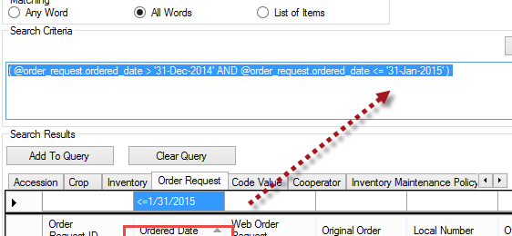

The Wildcard (%) is permitted
If a wildcard is used anywhere, also be sure to use a trailing % wildcard on the end of the string to pick up the time component. NOTE: using wildcard for just day or year, the month must be uppercase or the query will fail. Most other useful formats: MM/DD/YYYY or MM/DD/YY or YYYY-MM-DD are supported, but they do not accept wildcards. Use the % - not the *
.
Example:
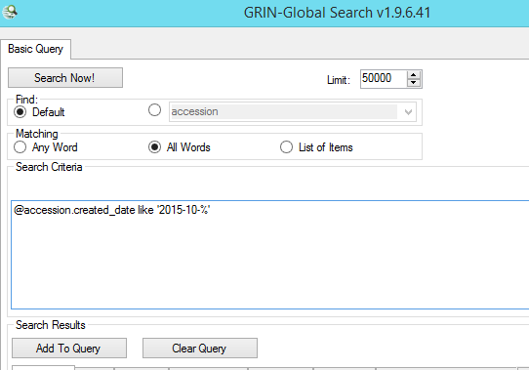
Returns the records for October 2015 (the 10th month)

Best query is in the format: YYYY-MM-DD (Trailing wildcard is required or the query will fail.)
No other date formats are supported. So the following are valid searches:
@accession.created_date like '2015%'
@accession.created_date like '2015-09-%'
@accession.created_date like '2015-09-05%'
@accession.created_date like '2015-%-05%'
For consistency, time is converted to Greenwich Mean Time (GMT). For example, records added on the East Coast at 10 pm may be found showing the next day’s date.

Manually Modifying the Search Text
The coded search text can be manually modified. For example:
Run this query first:
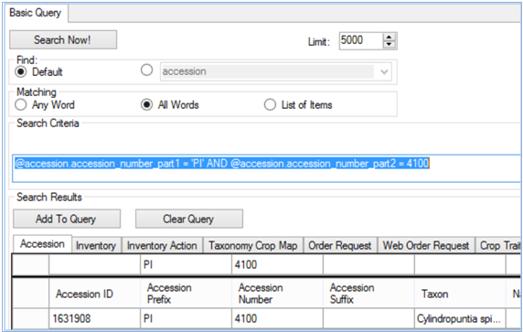
Then use the Clear All to empty the QBE cells:
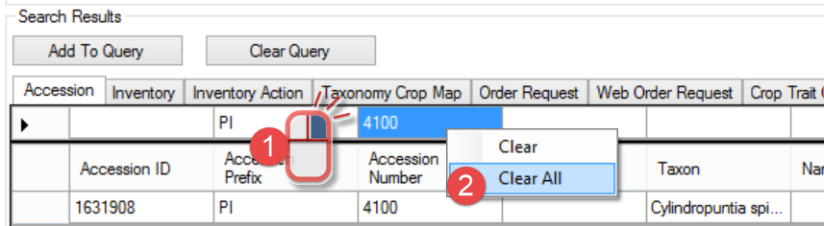
… and manually edit the text as shown below. (The Accession Number field is numeric, but by using the word LIKE, the data and the wildcard in quotes ( ‘4100%’ ), records were found:
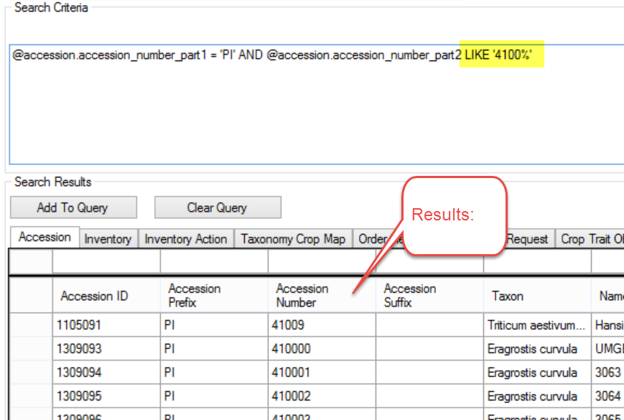

Any Word vs. All Words (“OR” and “AND” in the QBE Search Method)
Use the Matching radio buttons to specify how the text in the search criteria text box should be treated:
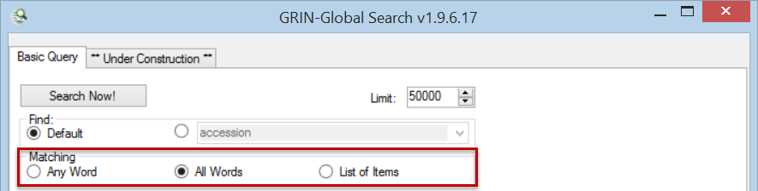
When inputting search criteria in two or more cells, the search condition that is created depends on whether you have selected the radio button All Words or Any Word:
- Any Word – less restrictive, records are returned whenever any word in the search box is matched; the criteria in multiple QBE cells work together as an “OR” …when any one of the search criteria are met, records will be found
- All Words – more restrictive, all of the words used in the search text must match (see the first example below); this creates an “AND” condition

Example:
In a test database, using the search string Rubus glaucus*, with “All Words” -- only four records were found. With “Any Word,” selected, 48 records were found – 4 of the 48 are the Rubus glacus. So the other 44 records found had either Rubus or glaucus in their name. (42 happened to be Rubus, including the four Rubus glaucus, and six were Elymus glaucus.)
No records were found in the following query. The succeeding query illustrates what happens when “AND” is edited to an “OR.” (The key value 859 in this lookup is the key value for the species Prunus persica.)
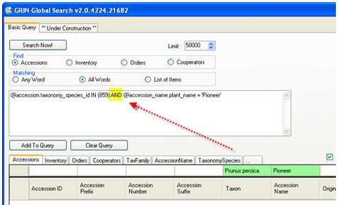

In this case, one record was found:
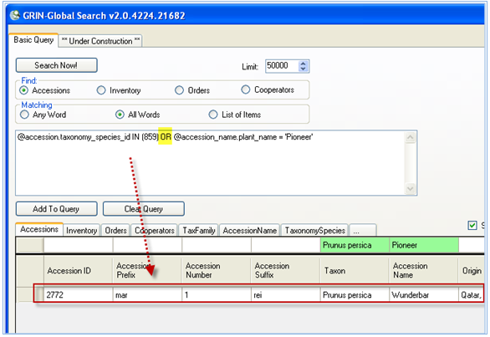

Adding Criteria
Add criteria to your search with the Add To Query button. When doing so, pay attention to the construction of your search statement in the text box. “AND” is generated when the All Words radio button is selected and you have selected items from different QBE cells. But when you add items one at time from the same QBE cell, the ST correctly inserts an “OR.” If you think about this, it is logical to do so, since if you were to supply first Prunus* in the Taxon cell and then Rubus* - it would only be sensible that this is an “OR situation.
Remember that you can use the Clear or Clear All options to empty one or all of the QBE cells:

Criteria Code Explained
Read the following section if you are interested in the technical details of a QBE search. We include this section in the User Guide primarily because some users will be creating dynamic folders in the Curator Tool, and having a basic understanding of QBE code is helpful.
In creating your QBE searches, you will notice code being generated in the text box as we have seen in the search examples above.
Let’s look at two QBE examples that on the surface seem to be similar searches. In this first example, the user will open the Taxonomy Species dataview and look for records whose Genus is Capsicum. As recommended, the user will include a wildcard (%) in the QBE text to broaden the search. After the user clicks the Search Now button, the Search Tool generates the code (illustrated below). The result of the successful query is shown here. A Capsicum (Taxonomy Species) record was found:
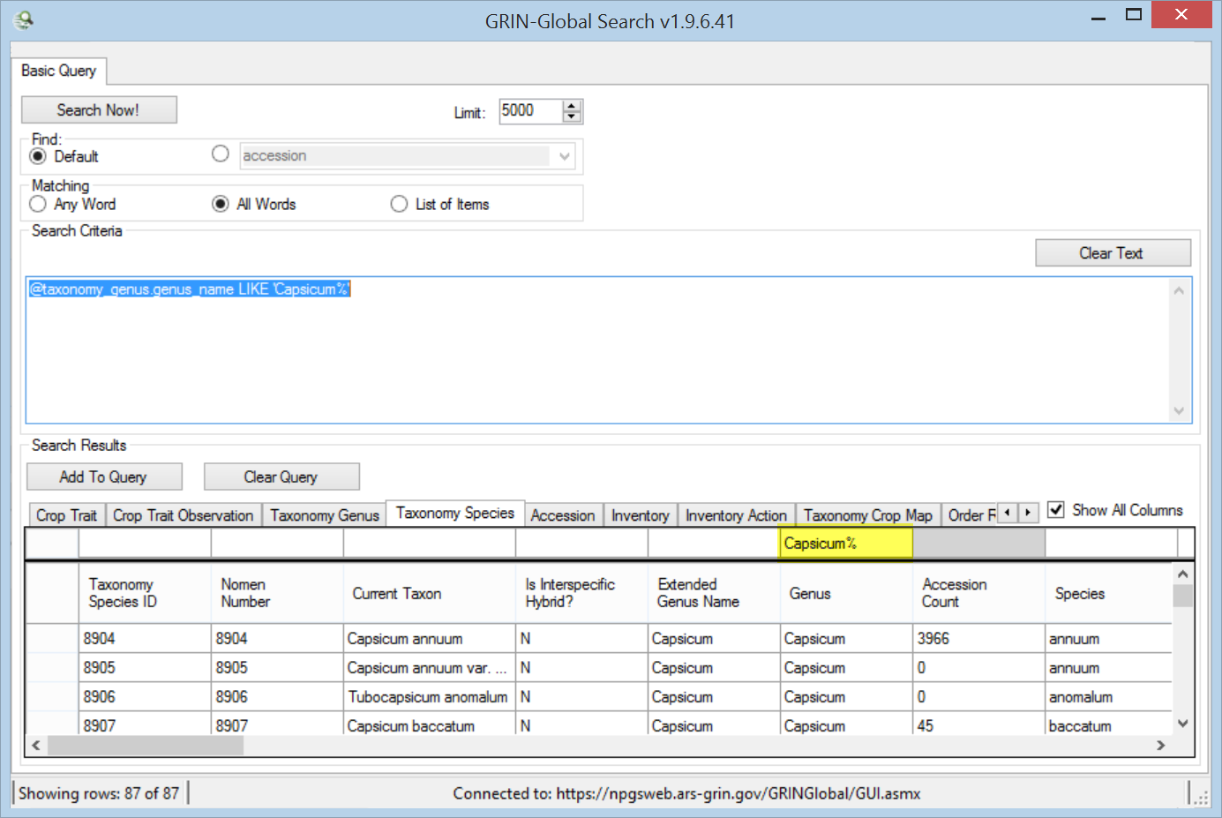
@ taxonomy_genus.genus_name LIKE ‘CAPSICUM%’ Let’s break out this code into three components:
Code | Indicates...
@taxonomy_genus | the table; the taxonomy_genus in the database will be searched
genus.name | the field name in the table
LIKE ‘CAPSICUM%’ | The LIKE operator is used to search for a specified pattern; in this case the QBE is saying find any text that begins with “capsicum.” The trailing asterisk indicates that any records with any text after “capsicum” should be included if found.

In this next example, the user has the Accession dataview open. Again , the user is looking for Capsicum:
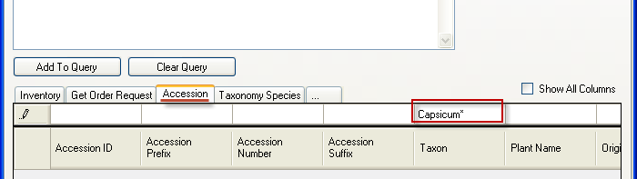
The resulting code generate by the QBE is shown on the following page. The code is quite different and does not resemble the code we just saw in the previous example.
@accession.taxonomy_species_id IN (8904, 8905, 8906, 8907, 8908, ...
Code | Description
@accession | the table; the accession table in the database will be searched
taxonomy_species_id | the field name in the table
IN (8904, 8905, 8906, 8907, 8908, ... | Since the taxonomy_species_id field is a key field, the search will use the related lookup table, taxonomy.species.lookup, to do a comparison and return all of the corresponding keys that match (8904, 8905, 8906, ...)

The illustration below is showing that records were found, as should be expected since the QBE had generated code with key values in the large text box:
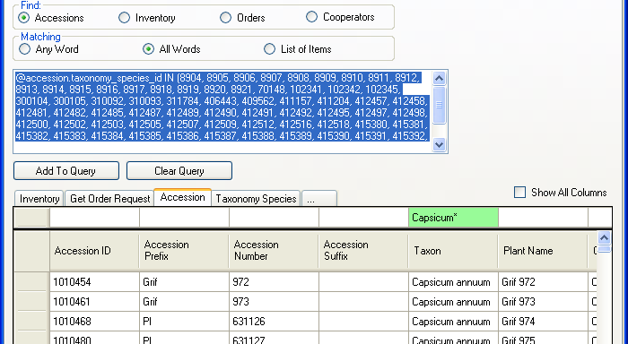
So you may be asking the question “Why is the code so different?” In both examples the user had typed the string “Capsicum*” –but the resulting code was not similar. In the first example, the Genus field is a text field – so the search was for any text similar to (LIKE) “Capsicum.” In the second example, in the accession dataview, the search is using a field in a lookup table to find the numeric matches that correspond to Capsicum (IN 8904, 8905, 8906, 8907, 8908, ...)
Fortunately, as a Curator Tool user, you will not need to be too concerned about the actual code generated when you do a QBE search, but this overview should provide enough background for you to understand at a basic level the construct of these search statements.

Text Box Searches
In text box searches, the Search Engine only searches certain database fields. (This is one reason why a text box search is not the preferred type of search. That said, you can do text searches. The “typical” searchable fields are listed in the table below the screen example. These are the fields used for text box searches:*
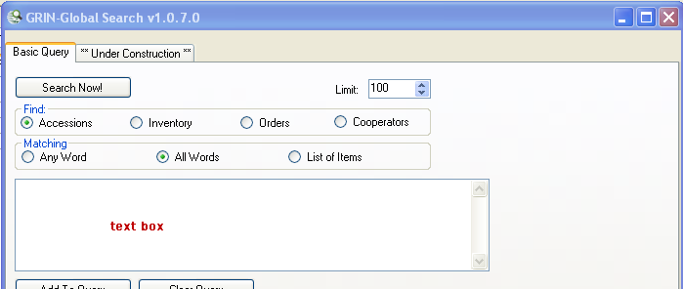
Table Name | Field Name
accession | accession_number_part1, accession_number_part2, accession_number_part3, note
accession_ipr | ipr_number, ipr_crop_name, ipr_full_name, note
accession_inv_name | plant_name
accession_pedigree | description
cooperator | last_name, first_name
crop | name
geography | adm1, adm2, adm3, adm4, country_code
inventory | inventory_number_part1, inventory_number_part2, inventory_number_part3,
taxonomy_common_name | name, simplified_name
taxonomy_family | family_name, alternate_name
taxonomy_genus | genus_name
taxonomy_species | nomen_number, species_name, name, alternate_name
code_value_lang | title
* these fields are configured by the GG DBA administrator to met the institute’s unique needs. The fields are maintained by the DBA in the sys_search_autofield table.
The text search behaves similar to Google searches (“similar,” but not “exactly”). For information on Google searches, see: http://www.google.com/support/websearch/bin/answer.py?answer=134479

Case Sensitivity
Generally, all characters entered in a textbox query are used.
The case sensitivity of your search depends on how the GRIN-Global database is set up:
- If the database is installed as case-sensitive (this is the default for the Oracle and PostgreSQL database engines), the queries will be case-sensitive.
- If the database is installed with settings to make the database case-insensitive (this is the default for SQL Server and MySQL database engines), then the queries will be case-insensitive too. For example, the U.S. NPGS GRIN-Global system will be using SQL Server, so the searches will be case-insensitive.

Filtering the Search Results
You can filter the search grid in order to display a subset of the records. Use any cell’s contents as the basis for your filtering criteria. Right-click in the data cell; select the desired filtering choice from the menu (“Show only…” or “Hide rows…”).
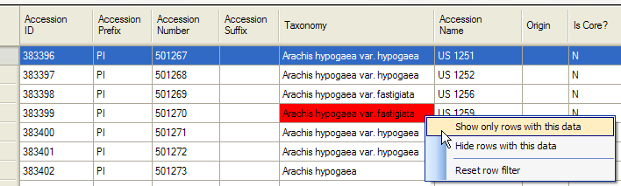

Record Counter
Notice that the record counter in the lower left corner indicates the number of records being displayed and the total number that were retrieved.
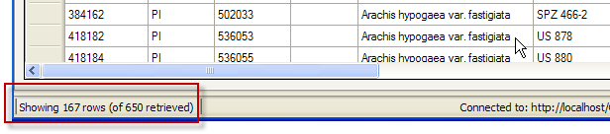

Displaying all Rows in the Grid (Turn off Filtering)
Right-click in any cell in the grid. Select Reset row filter.
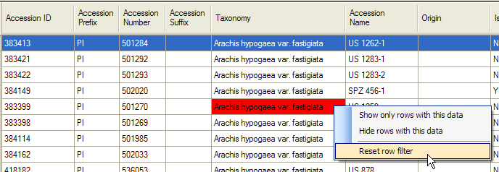

Searching a List of Items
This option is used typically when a list, such as a list of accessions, is copied from a spreadsheet into the search text box.
When using this “List of Items” search, the Search Engine is restricted to finding matches in these columns:
accession_number_part1
accession_number_part2
accession_number_part3
inventory_number_part1
inventory_number_part2
inventory_number_part3
form_type_code
plant_name
order_request_id

Example:
List of Items: (example)
PI 500501
PI 612346
PI 612347
In the following example, accession identifiers were pasted into the text box and after the user clicked the Search Now button, she had 14 records displayed in the grid:
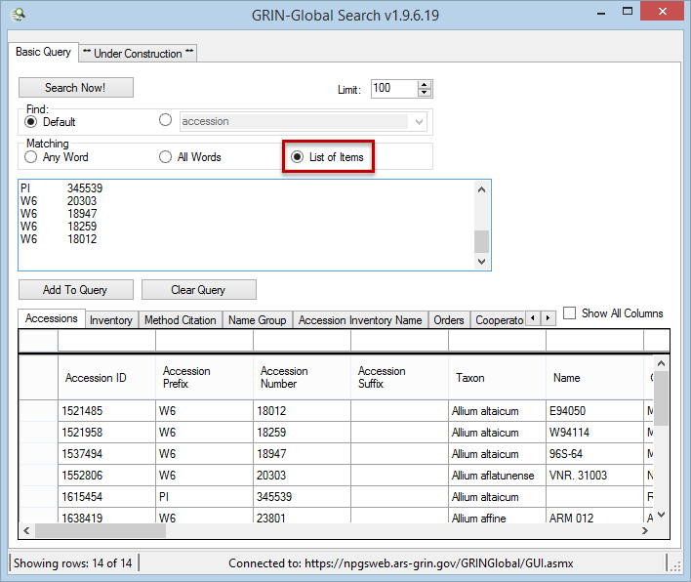
Currently, when producing the list, the drag and drop method doesn’t work – you must copy and paste the list of accessions or inventory into the text box. Also, remember to click on one of the other radio buttons after doing a “List of Items” search; otherwise, your search will not work as you expect.
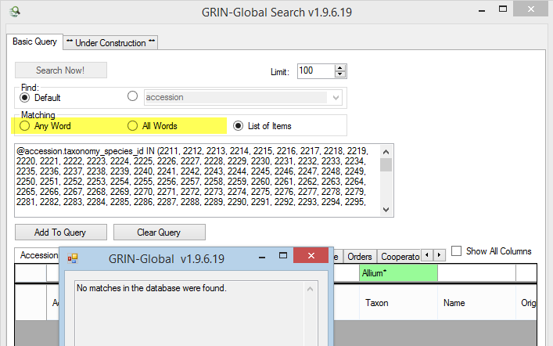

Moving Records from the Search Grid to the Curator Tool Data Grid
After using the Search tool to locate and filter records in the database, you can copy those records into the Curator Tool. Why do this? CT users build lists to manage or track specific records. (Beginning with the Curator Tool version1.8.3, users have an alternative method for managing records, using the dynamic folders. )

To Move Records from the Search Tool to the Curator Tool
1. In the Curator Tool, create a new list name or ensure that an existing list name is visible.
2. Confirm that you are not in Edit mode – the Save Data button is gray (disabled).
3. In the Search Tool, perform your search.
4. Select the records found that are to be copied. It could be all of the records found, or you could select a subset of the records by highlighting specific records in the Search Tool’s grid. (See “Selecting Records in a Grid” for details.) To select all the records in the Search grid, use Ctrl-A (in English keyboards).
5. In the next example, 50 records were found, but only 19 “Cultivars” will be selected. The user clicked in the selected area; held the mouse button and dragged the selected records into the Curator Tool, and dropped the records on the list name (in this example, ”Cultivars”).
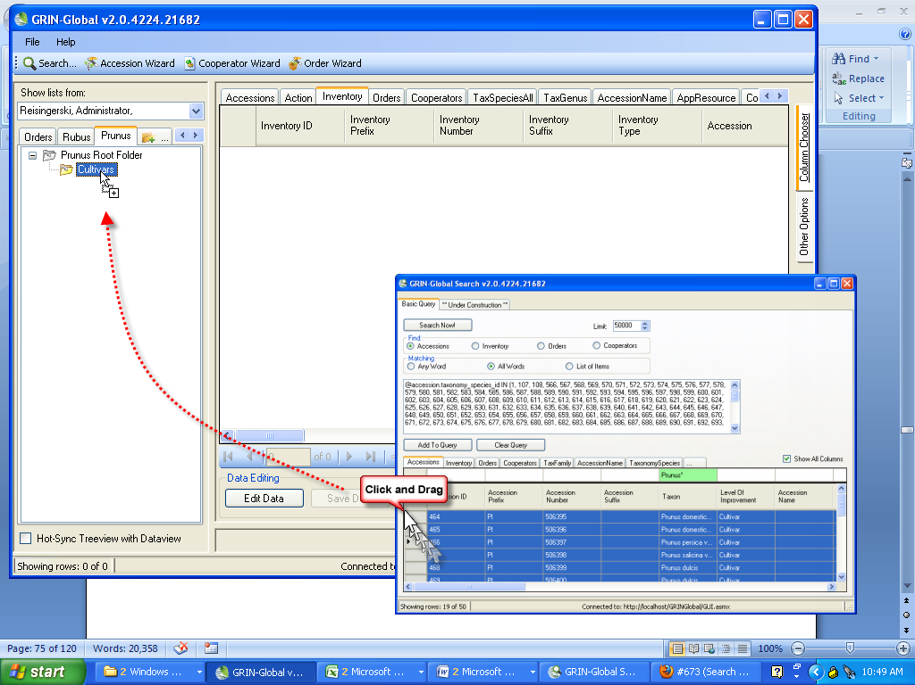
The Cultivar list now points to 19 Prunus cultivar records.
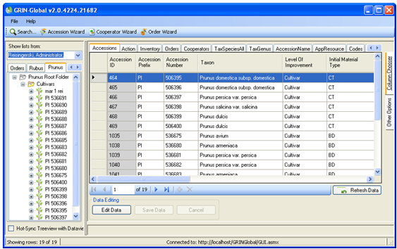

Creating, Updating, and Deleting Records
You create new records, update data, and delete records when working in Edit mode. For example, to create new inventory records, you display the Inventory dataview and then click the Edit button to enter edit mode.
Besides the many Curator Tool dataviews, currently there are a few wizards that have been designed to facilitate the editing of Accessions, Orders, and Cooperator records. See Wizards for details. The wizards use forms. They also facilitate the inputting of data into parent and child tables – for example, in the accession wizard you can input a new accession and at the same time and add source and name data which are stored in separate tables.
Before adding a record, we recommend first searching the database to determine if the record already exists. However, if you do attempt to add a record when the record is already in the database, you will receive a warning and will be prevented from duplicating the record.
(A duplicate is based on the key identifier field(s) – for example, each accession must have a unique prefix, number, suffix combination.)

Overview

Required Fields
In order for data to be saved, the data must meet certain rules. Some fields may be required – that is, required fields must be filled, in order for the record to be saved. When inputting a new record, the color violet indicates a required field.
A message window will display if you attempt to save a new record that doesn’t have all of the required fields completed.
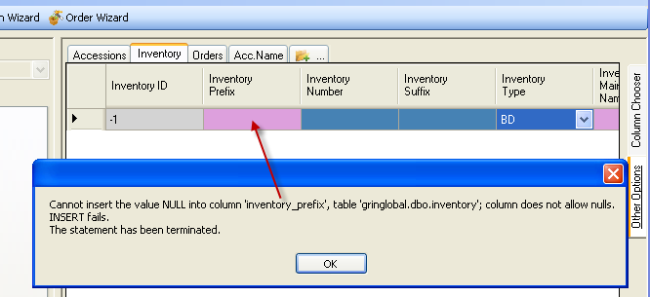

Cell Colors
Other colors can be used to assist with data inputting. You can set up your Curator Tool options to use colors to indicate when a field’s contents have been changed during your current editing session. On the Other Options tab, select the Highlight Changed Data so that you visually see any changed fields in Edit mode. 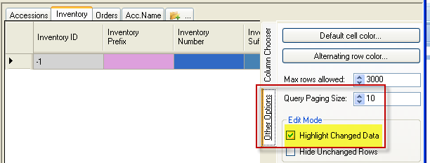
The following table summarizes the significance of the cell’s color when In Edit mode (assuming you had selected the Highlight Changed Data option):
Cell Color | Meaning
gray | cell cannot be edited
violet | field is required; a record cannot be saved until all required fields are filled
orange | when doing an add, these cells have new data
yellow | when a record is being edited, fields that have been changed display in yellow
white | data hasn’t changed in the cell when a record is being edited
dark blue | dark blue cells display when a record is being added and data in the cell is the same as the cell’s default value
light blue | light blue cells display when a record is being added and data in the cell differs from the cell’s default value
blue | current cell

Creating New Records
The Curator Tool has wizards which facilitate creating new records as well as editing existing ones. The directions below are generic directions for manually creating and editing any record type.

To Create a New Record
1. In the left (List) panel, either select an existing list or create a new list.
2. In the right Datagrid panel, click on the appropriate dataview tab
3. Click the Edit button to switch to Edit Mode.
4. Click the Add New button on the Navigator Bar.
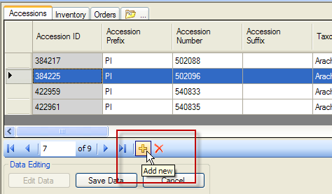

or…
click on the row indicator and press Ctrl-N to insert a new row in the dataset, after the selected row. Data is automatically copied from the selected row into the new row, except for restricted fields (fields in gray). In the example below, the Name data is not copied into the new record.)
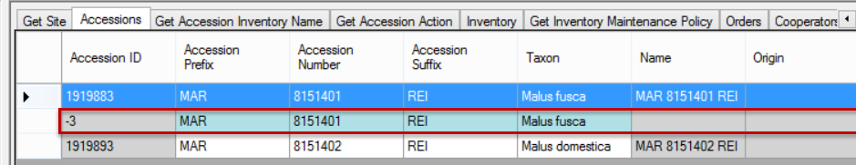
The colors indicate whether the cell blocks data input (gray), requires data (violet), or accepts data (blue). Light blue cells indicate the data was copied from the cell above; dark blue cells await your input.

Beginning with GG server Release 1.10.1, a trigger was modified to facilitate automatic assigning of new "PI" identifier numbers to accessions. The trigger works when adding new accessions and non-PI series as well, but the main goal was to convert existing local identifiers to the PI series. [To be determined – this applies to USDA NPGS only]
Assuming you have the proper permission, to use the trigger you edit the Prefix and set to PI. The accession numbers are set to -1. (Use CTRL-D to copy down when modifying multiple records.) When saved, the accessions receive the next available PI numbers. After the save, another trigger modifies the system inventory record to match the newly-assigned PI identifier (rather than the former identifier).
(Note to GG Admins: the trigger is AccessionDataTrigger.cs)

5. Input data in the cells. (Some cells are restricted. That is, when you input data in a restricted field, the Curator Tool does not allow you to just type an entry. See Restricted Fields for details.)
6. Click Save Data.
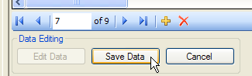

Whenever an accession record is created, a system default Inventory record is created as well. This system inventory record is required due to schema requirements to enforce database integrity. It does not represent any physical inventory.
All system inventory records use the code ** for their Inventory Type field. 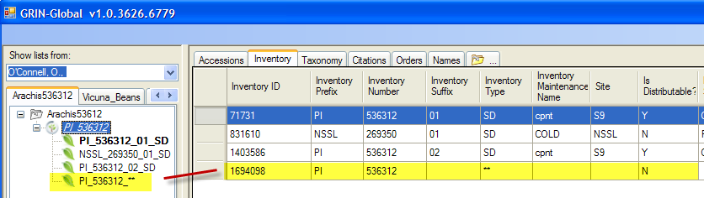

Keyboard Shortcuts in Edit Mode
Remember that there are many keyboards available and each have their own Windows keyboard combinations. However, the keyboard shortcut combinations written for GRIN-Global will work on all keyboards. (See Keyboard Shortcuts.)

Copying from the Cell Above
When inputting data in Edit mode, the Ctrl-‘ combination copies the contents of the cell that is directly above the current cell.
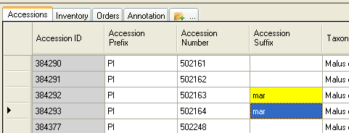

The Curator Tool has an ALT feature to facilitate copying. Press the ALT key once; use the mouse to drag the mouse over any cell range which you intend to copy; use the Ctrl-C keyboard combination to copy the highlighted data.

Duplicate Data (Ctrl-D)
The Ctrl-D combination duplicates data from the top cell to the cells directly below it within a column.
1. Click in the top cell of a range of cells. Input the data that will be duplicated. 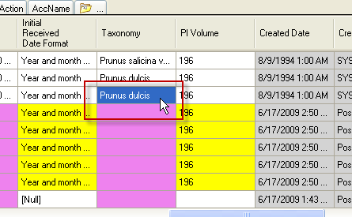
2. Select the cell with the data and the cells directly below which will be populated; press Ctrl-D. The data is duplicated in all of the selected (highlighted) cells.
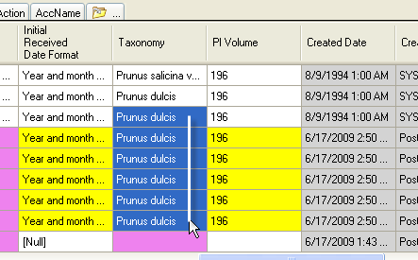

Restricted Fields (Lookup Picker)
Almost all dataviews have some fields that are “restricted.” In any restricted field, you cannot input the data, you must select the data from a list of possible items. A “LookupPicker” window pops up.
When in read-only mode, a restricted field will look similar to any other text field. However, in edit mode, when you move the cursor over the field, the cursor changes to a different style, similar to the following: When you input the first character, the LookupPicker window will display. (Clicking in the cell also opens the LookupPicker window.)
The following example illustrates using the LookupPicker for the Taxonomy field. In this example, the user typed “Ru” – the entries were filtered to those items in the table beginning with “Ru.”
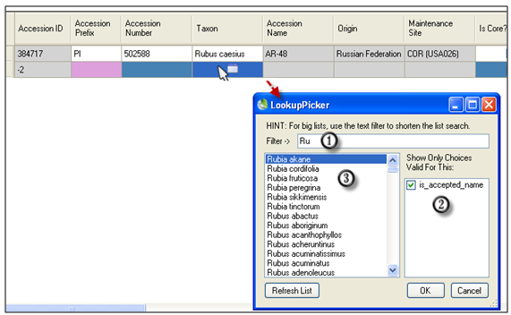

Using the Lookup Picker
1. Click in a cell where data is required; start typing. As you type more letters in the Filterbox (#1 in the screen image), the filtering becomes more specific. Use the mouse to click on the desired entry in the list box #3; click OK to select that item.
You can also use wildcards when inputting in the filter box. In the following example, the user was looking for accessions having “rei” somewhere within the prefix-number-suffix fields, so the user typed a “%” wildcard before typing the “rei”
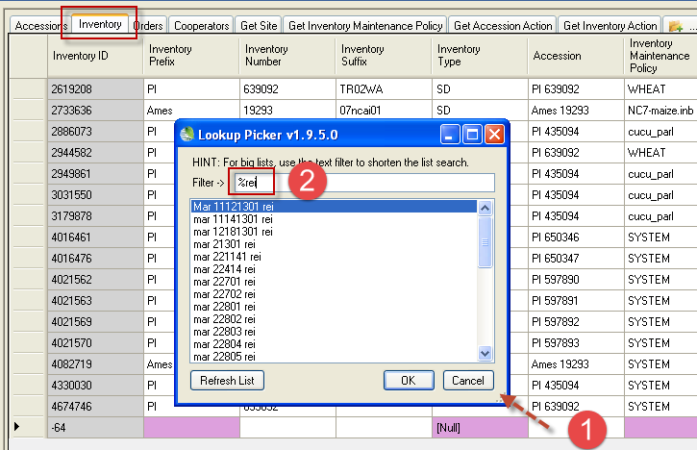
2. Lookups can have different options for restricting (filtering) what choices are valid. These items are listed in the box on the right side of the window. In the example below, one is displayed: is_accepted_name. You can constrict or expand the search by selecting or deselecting the check boxes. Keeping this box selected in this example will limit the Taxons to those considered to be the accepted names.
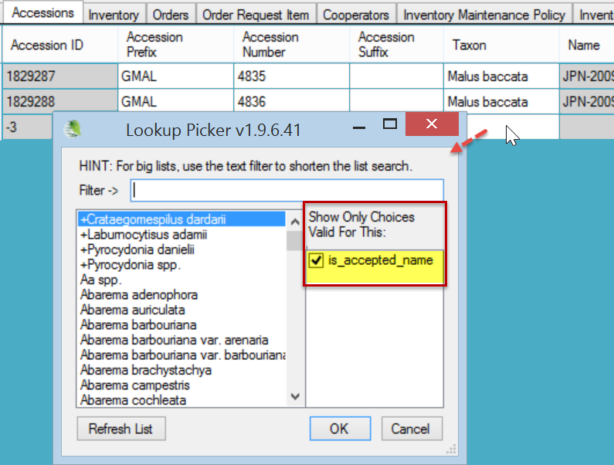

Updating (Editing) Data
GRIN-Global uses ownership and permissions to regulate who can add, update, or delete records. If you have the proper security rights to edit data, you can edit the data. To do so, click the Edit button.
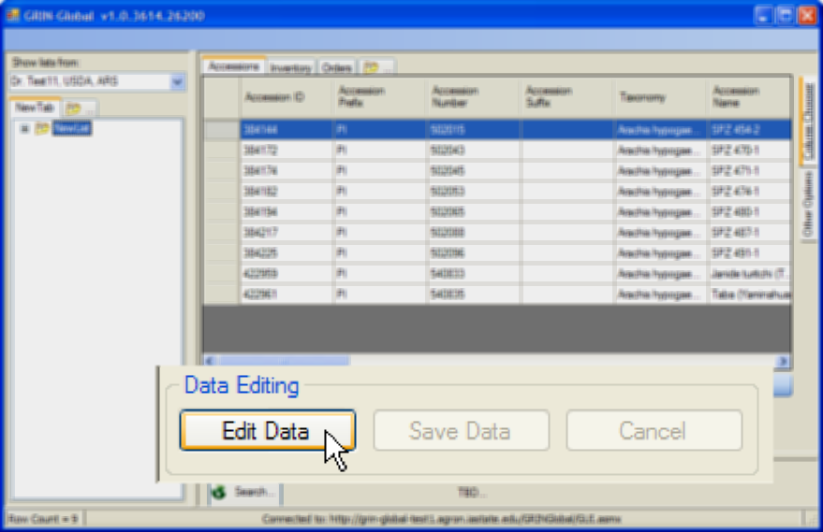
While in Edit mode, you can make changes to the data. In Edit mode the Edit Data button is inactive (grayed out). If at some point you need to disregard the changes and revert to the original Browse (display only) mode, click Cancel; otherwise, to save the changed data, click the Save Data button.
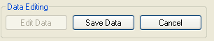

When in Edit mode, all records in the Data Grid can be edited. A “"indicates the current record:
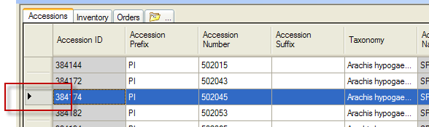

Highlight Changed Data Option
In Edit mode, click to select the Highlight Changed Data option. Another handy option is the Hide Unchanged Rows option.
If you are in Edit mode and select the Hide Unchanged Rows option, and haven’t made changes to any records, all of the existing records will be hidden. This behavior is logical when you think about it, but it could be a bit alarming if you don’t see any records when you expected many!

Warning Indicators
The following screen example illustrates a warning indicator. When these indicators are present, move the mouse over the and a message tooltip will display.

Deleting Records
In Edit mode, you can select one or multiple records to delete.
If a record has any dependent children records, you cannot delete the parent without first deleting the child records. For example, if an Accession record has related Accession Inventory Name records, the Name records must be deleted first.
Another important consideration is whether you have authority to delete a record. Only record owners and those users with permission granted to delete a record can do so. (See permissions.)

Delete One record at a time
The red-x deletes only one record at time. You do not receive a warning that the record is to be deleted. In this example, the 5th record only will be deleted.
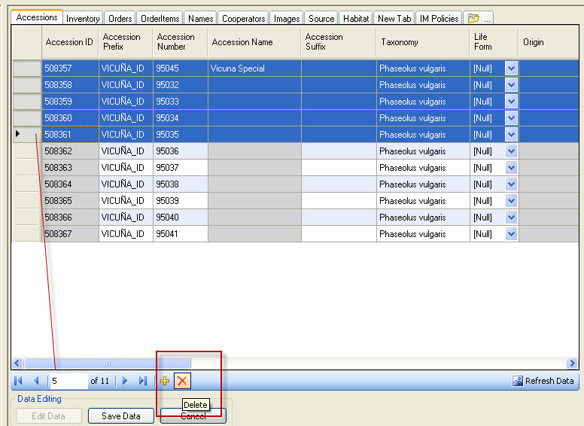

Delete one or more records
Select the records in the data grid; press the Delete key. You will be prompted:
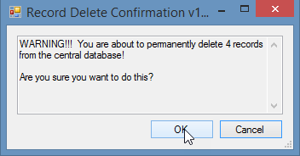
Deleting items in the left List Panel is not the same thing as deleting the database records (in the right datagrid panel); the list simply provides pointers to records in the database. If you delete a list or items on a list, you are only removing the pointers to the database records.

Security (Ownership & Permissions)
Organizations typically have very unique security needs; GRIN-Global is flexible enough to accommodate these needs. When speaking of security, there are two concepts that intersect: ownership, and permissions.

Owner Concept
Every record in GG has an owner – and only one owner. Generally, when you create a record in the Curator Tool, you own the record and will be able to read, update, and delete the record which you have created. But that is not always the case. In some cases, the record ownership may be determined by programming logic (or a “trigger”) – and then the creator of the record may not necessarily be the owner.
In the following example, the Created By, the Modified By, and the Owned By fields all have the same user:
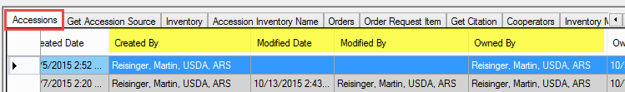

To Transfer Ownership to a Different User
In the Curator Tool, record owners can transfer ownership rights of the records, and optionally the records’ children records, to another user.
In a dataview, select the rows (records) that you intend to transfer ownership; right-click and select Change Owner…
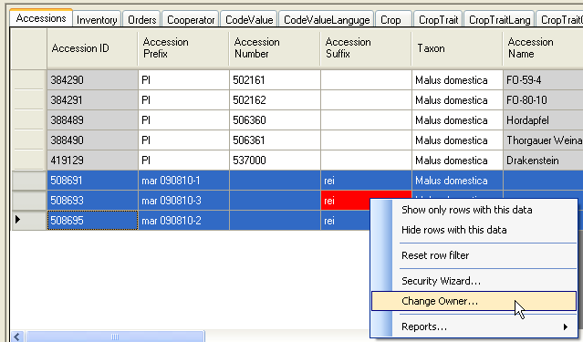
In the Change Ownership box, select the appropriate button and click OK:
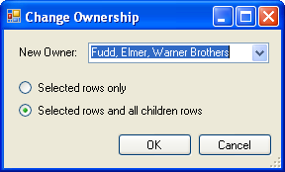
In this example, the ownership of the highlighted records and any children records are impacted by this change in ownership.

Parent and Owner Relationships Between Dataviews
In the Admin Tool, relationships are mapped between dataviews. For instance, there is a relationship from accession to accession_inventory_name with the Relationship Type defined as "Parent and owner."
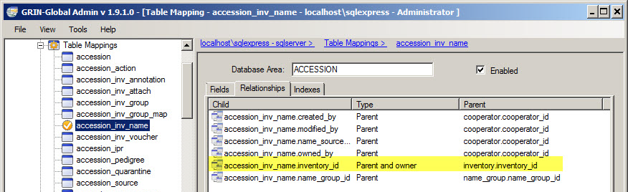
When relationships are mapped between dataviews, the children tables inherit the security settings of the parent. This means if someone creates a record in accession_inventory_name, the owner is the same as the owner of the parent record, in this case the accession record. When no relationship of "Parent and owner" has been defined, then the creator is the owner. When doing ownership calculation, relationships are taken into consideration.

Permissions
You can use the security wizard to establish permission levels to protect specific record types from accidental (or intentional) deletion. For example, you can establish security permissions so that employees will be able to update specific accession_quarantine records but not delete them.
A permission restricts or grants access to a resource in GRIN-Global ; for a Curator Tool user, a resource is typically a row (a record) displayed within a dataview.
Even if you create a record, it is possible that you might not have permission to update or delete it. You could have the situation where a student technician will be uploading (creating) observation information or creating action records on an accession or inventory, but the student should not be altering the accession or inventory data. Hence he can create new observation or action data, but not update or delete accessions or inventory records. A permission policy can be established to ensure that this happens.
Currently the inheritance only cascades one level. This implies that it may be necessary for you to establish certain permissions at the accession level, and then again at the inventory level.

Assigning Permissions to Other Users
Typically you will first open a dataview, such as Accessions, and then right-click, selecting the Security Wizard option:
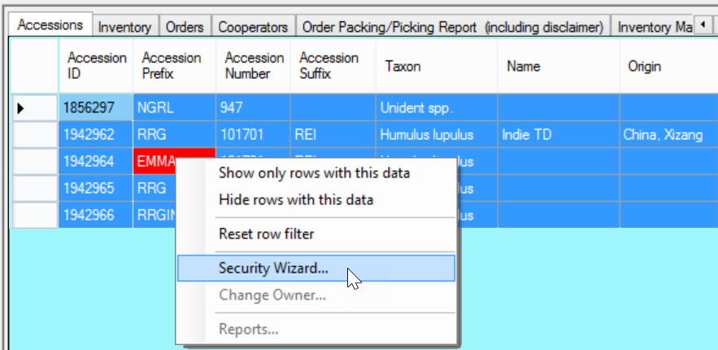
The Security wizard displays a screen in which you can grant permissions to specific users. initially the permissions are shown as “Inherit.”
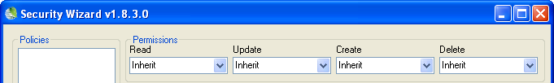
When working in the Security Wizard, it is helpful to work from left to right. Create a name for this Policy; click the Add Policy button (right-click to edit the name). Edit the Permissions in the dropdowns.
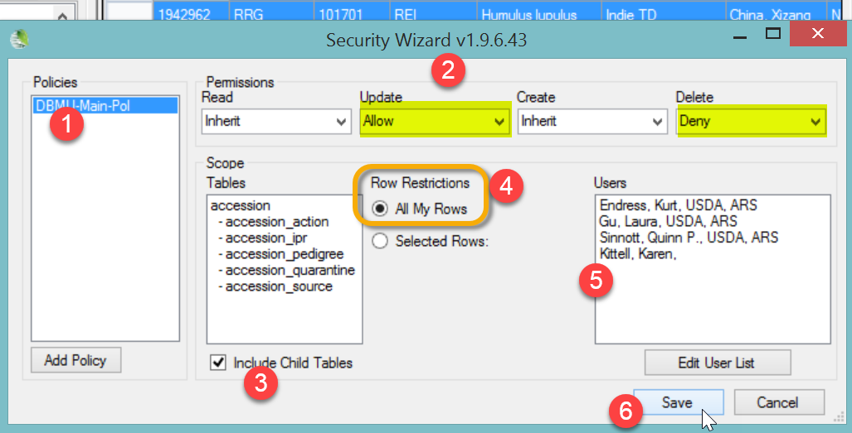
In the Row Restrictions option (labeled #4), select All My Rows to guarantee that records created in the future will also be governed by this policy.
The permission definitions are defined in the tables below. To simplify all of this, remember that most special permission situations involve allowing or denying users to do certain things – reading, deleting, or updating records. Example: may want certain users to be able to update “my” inventory records, but never delete them.

Permission Defined
A permission restricts or grants access to a resource in GRIN-Global. A resource is defined as a specific table, dataview, or row. A permission defines four kinds of rights:
A permission of type: | Has the ability to:
Read | Read existing data
Update | Update existing data
Delete | Delete existing data
Create* | Insert new data
* ignore this option – it really doesn’t apply; typically you will set the Update and Delete options since usually withinb an organization everyone internally should be able to read the records
Each right can have one of three values:
Value | Description
Allow | Allows access
Deny | Denies access
Inherit | Neither allows nor denies access; access is situational; it is inherited from a previous definition (typically the permission value of the parent table)

Image Handling (Attachments)
Images can be associated with (“attached to”) accession and inventory records.
The accession_inv_attach dataview was first implemented in GG version 1.5. In the Curator Tool Release 1.9.8.14 (initially released in the USDA in Dec, 2017), an Inventory Attachment Wizard was introduced. Refer to the online documentation at https://www.grin-global.org/docs/gg_inventory_attachment_wizard.docx

Reports

Report Overview
GRIN-Global has several types of reports. Since this is the Curator Tool User Guide, we are primarily describing reports designed to run in the Curator Tool. However, genebank CT users should be aware that two other kinds of GG “reports” may be available:
- Public Website Reports
- SQL Query Reports
A separate document focused on reports is online at https://www.grin-global.org/docs/gg_reports.docx

Wizards

General Notes about Curator Tool Wizards

Wizards
When installed, the Curator Tool is bundled with several wizards:
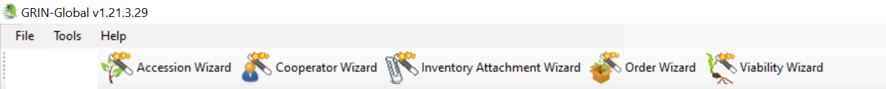
Wizards have some common characteristics:
- wizards can be used to create a new record or to find and edit existing records; use wizards rather than the straight dataviews whenever possible since wizards generally have been programmed with more features and functionality than the dataviews. For example, the wizards will have embedded triggers to validate data or make specific calculations. One example is the Order Wizard’s ability to deduct from existing inventory any amounts shipped within the order.
- as you work in the wizard’s forms, periodically save your work (click on the Save icon)
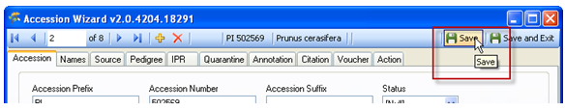
- use the window’s close button to cancel when necessary. However, any data not yet saved will be dropped, not just for the current tab screen, but for any of the tabs. (This is why the previous point is so important.)
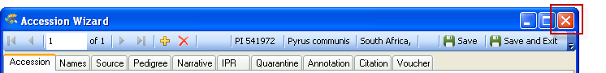
- when reviewing the wizard’s screens, notice that the screen’s header displays certain important fields that indicate what record you are working with
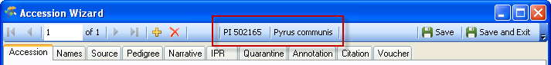

Accession Wizard Overview
The Accession Wizard facilitates the inputting of new accession data across the parent accession and its related child records.
Remember that accession data is stored in multiple related tables (not all are shown here):
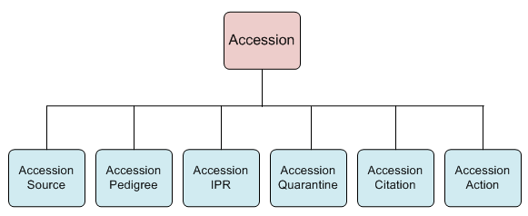
The wizard can also be used to modify the children records as well as the data stored in the parent accession table.
For information about fields used in the accession dataviews, refer to the online data dictionary.
In GRIN-Global, accession data, including the multicrop passport descriptors (MCPD) data, is distributed across multiple tables that are linked to each other. (Inventory tables contain information about the physical germplasm such as quantities available for distribution, whereas the accession tables contain, among other items, the passport information.)
In the Curator Tool, many related dataviews have been designed for inputting and editing accession data in these tables. In fact, there are at least 10 accession-related dataviews. However, many of the tables’ fields are optional and may never be used by some organizations. (GRIN-Global was designed to be flexible and accommodate different organizations and genebanks with unique requirements.)
Please refer to two separate documents that pertain to accession and passport data:
https://www.grin-global.org/docs/gg_accessions_and_passport_data.docx
https://www.grin-global.org/docs/gg_multi_crop_passport_descriptors_MCPD.docx

General Accession wizard concepts
When you invoke the Accession Wizard, the Accession dataview displays:
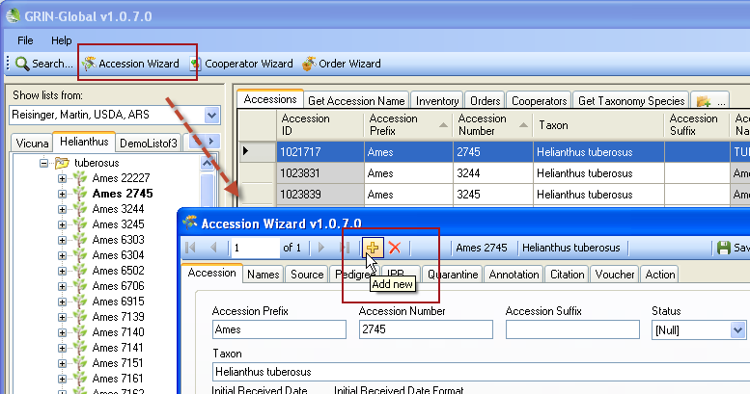
The accession wizard consists of 10 dataviews tabs; the tabs shown below illustrate this:
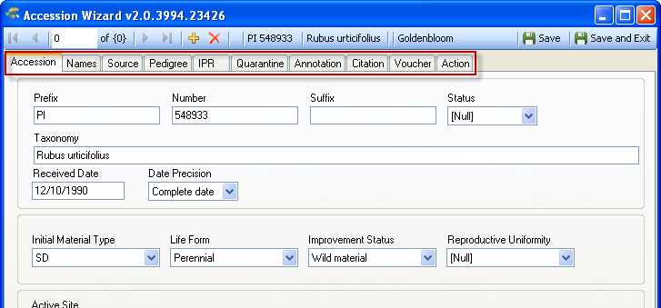
While using the wizard, the user can click on any of the tabs to display that tab’s corresponding dataview. In this example, the Names tab has been selected.
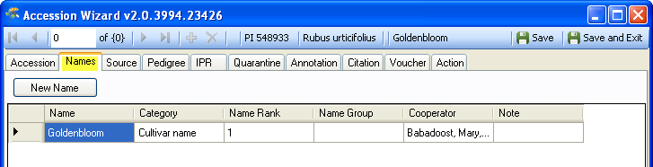

Saving the Data
In any window in which you enter data, in order to save the record, you must input data in the required fields’ data. You do not need to complete each window, since they are dataviews to different tables.
When completing (or partially completing) a dataview, before proceeding to the next tab, click the Save button as you continue inputting in the wizard.
Use the Save and Exit button when you are finished using the wizard. (Since you can use the wizard to edit existing data, you can always return later and edit the data.)
The Save and Exit button will close the accession wizard and return to the Curator Tool, but first it will indicate that you were successful and also prompt you to add an item to the current list folder (if it is a new item). If you select Cancel, the record will be created, but no item will be generated in the current list folder.
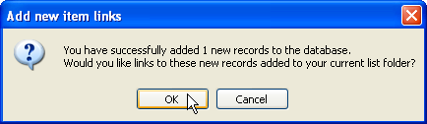

Deleting Accession Records
In a relational database where there are parent and children tables, the general principle is that a parent record cannot be deleted if it has any children records. In order to delete an Accession record, (which should be a rare occurrence), you must ensure that all of its children records are first deleted.
The Accession Wizard is useful for helping you to do this. First, select the Accession record in the Curator Tool Accession dataview that you intend to delete; click the Accession Wizard button:
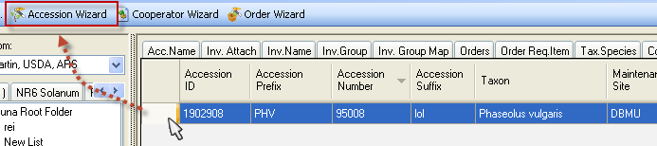
In the Accession Wizard, review for children rows. If the Accession has a child record, you can delete that record by selecting it and then clicking the keyboard’s Delete key. In the example here, the Accession has a Name record; the user selected the row by clicking on the left margin; then the user presses the Delete key. Before exiting this tab, the user needs to click the window’s Save button:
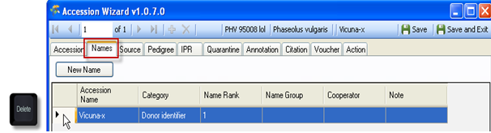

Subordinate Accession Dataviews
The subordinate (or “child”) dataviews have their respective tabs. On each of these windows, there is a New dataview button. When clicked, the Curator Tool displays a new row on the dataview grid for inputting data. Shown here is the New Name button on the wizard’s Names form.
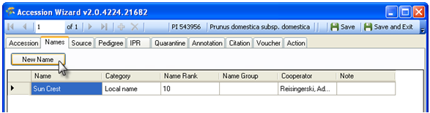
In moving through the various subordinate Accession wizard windows, you may have clicked a New button without intending to do so. When you click on Save and Exit, you will be prompted with an error message, in which you should click No:
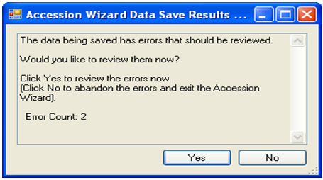
On the next window, click Yes:
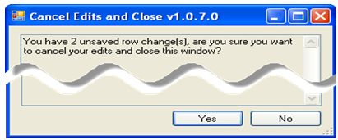
There are several fields in the Accession wizard dataviews which are unique and will be explained in detail here.
Remember to save each view as you move from one window to another.

Cooperator Wizard
Use the Curator Tool’s Cooperator Wizard whenever you wish to add a new cooperator to the GRIN-Global database or edit an existing cooperator record. One advantage of using the wizard, rather than using the cooperator dataview, is that you can search the database before inputting a new cooperator.

Background Information
Note that there are two kinds of cooperator records:
- web cooperators
- “ordinary” GRIN-Global(GG) cooperators
We will always distinguish between the two types of cooperator records by including “web” when referring to “web cooperator records” and by stating only “cooperator records” when speaking of GRIN-Global cooperator records.

Web Cooperators
A user on the GRIN-Global public website has an opportunity to self-register – during this registration process the user’s contact information is stored in a web cooperator record. This web cooperator record is not the same thing as the GG cooperator record.

GRIN-Global Cooperator Records
In addition to the web cooperator records, GRIN-Global maintains cooperator records that are records containing data on individuals and organizations involved with germplasm activities (donors, collectors, breeders, requestors, etc.) Besides storing active address and organization data, cooperator records can be used to store historic data containing the previous addresses of a person or institution.
Also, all users of the GRIN-Global Curator Tool have a cooperator record. When the administrator adds them as Curator Tool users, a GRIN-Global cooperator record is also generated.
Whenever working with or searching cooperators or web cooperators, it is recommended that you update the cooperator lookup tables. Specifically, the three lookup tables are:
- Cooperator
- Cooperator (Big)
- Web Cooperator
Why three cooperator lookup tables? (Cooperator), Cooperator (“Big”), and “Web.”? The Cooperator lookup has a display field formed by cooperator last name, first name, and organization. It is a simple string used as a lookup on the GG records’ audit fields such as owned_by. It doesn’t need to be too defined because it is used for displaying which curator owns a record.
The “Big” lookup includes many more fields in the display string so that curators can distinguish public cooperators with similar names. That lookup is used when the cooperator is used in a field such as original requestor or donator. You need more detail there, hence the two lookups are used for different needs.
The “Web” Cooperator lookup organizes the Public Website users. When a PW user makes an order, his Web ID is associated with the web order.

Using the Curator Tool Cooperator Wizard
The Cooperator Wizard id detailed in the online document:
https://www.grin-global.org/docs/gg_order_and_cooperator_wizard_v1.9.9.4.docx
Refer to this document for more details on Cooperators in general or if using a CT version earlier than 1.9.9.4: https://www.grin-global.org/docs/gg_cooperators.docx

Use the Cooperator Wizard to add new cooperators or edit existing ones. If you intend to edit an existing cooperator record, use the Cooperator Wizard to quickly locate the desired cooperator record.

Appendix A: Document Revision Notes

– December 2, 2025
- Minor edits in wording to reflect current software version

– April 20, 2021
- removed redundant material detailed in other focused documents
- added / updated links to the documents

– September 21, 2020
- removed the Lookups table section and saved this information under a stand-alone document; included link to the new document
- edited first 40 pages to reflect current version

– July 12, 2018
- edited the login window section

– May 9, 2018
- minor editing pertaining to searches
- minor wording changes throughout

– March 13, 2018
- added notes pertaining to IIS
- added diagram with indicating important GG tables
- extensive edit changes throughout to improve clarity

– December 27, 2017
- added many notes to the Search section to include search features now possible in the release CT 1.9.8.14
- extensive edit changes throughout to improve clarity

– December 1, 2017
- added a note pertaining to the inventory attachment wizard that was released with CT 1.9.8.14
- corrected links to external documents whose URLs changed due to the USDA’s HTTP over SSL requirements

– October 25, 2017
- added text and examples related to search engine changes implemented in released in server release 1.9.9.2

– March 24, 2017
- for clarity regarding the updating of lookup tables, rearranged the subsections under the Lookup Table section

– October 31, 2016
- edited the security section;
- replaced several images there

– July 25, 2016
- images in document that were missing were added back in
- release notes removed; now appendix contains the link to the online release notes

– May 11, 2016
- tip regarding Refresh List enhanced

– March 14, 2016
- tip regarding Refresh List added to lookup section

– March 11, 2016
- extensive rewrite of the Lookup Table section based on recent findings

– January 14, 2016
- edited text and included a new screen related to the Include Sub-folders option in the List Panel

– January 13, 2016
- corrected link to online Frequently Asked Questions (FAQ) document

– December 29, 2015
- added summary note regarding drag and drop

– November 30, 2015
- moved Appendix of GG documentation resources to the front of this document

– November 5, 2015
- edited text regarding ownership & permissions

– October 5, 2015
- edited text for dates when searching with the % wild card

– June 10, 2015
- added an example for a text search

– April 30, 2015
- minor edit added to the Reports section regarding the link to the online list of current reports

– April 8, 2015
- edited the Reports section

– March 9, 2015
- extensive editing of the Search section – especially the table of valid search parameters

– January 14, 2015
- edited Lookup table information

– January 6, 2015
- edited the Reports Mapping section

– November 18, 2014
- added the version notes for 1.9.6.38, …39. 41

– October 21, 2014
- added more details for IS NULL / NOT NULL and IN / NOT IN in the Search section

– June 23, 2014
- rearranging the content of the entire User Guide to emphasize “How To…” with the background and release information moved to the Appendices
- edited references to the CT installation to reflect that the CT is now installed via InstallShield (and not the GG Updater)

– June 17, 2014
- extensive editing of the Reports section

– May 6, 2014
- added developer notes for versions 1.9.6.x

– April 8, 2014
- added an example for manually modifying the search text in order to use a wildcard with a numeric field (such as Accession Number)

– April 4, 2014
- inclusion of Appendix with links to GG supporting documents Wizard
- general updating of several revised windows and inclusion of 1.9.4 and 1.9.5 notes

– November 11, 2013
- included new text regarding the revised Order Wizard

– August 14, 2013
- multiple edits including adding information on dynamic folders, source dataviews, and other features added since version 1.5
- substantial edit of the introductory explanation of GRIN-Global components
- minor edits to the lookup and permissions sections

– April 2, 2013
- initial document for the Curator Tool 1.8.3 release.

Appendix: Database and GRIN-Global Basic Concepts

GRIN-Global Overview

GRIN-Global is a Relational Database
The GRIN-Global data is stored in many tables; this type of database is referred to as a relational database. Each table relates to other tables by key fields. A single spreadsheet, on the other hand, may be considered a database, but because the spreadsheet stands alone, it is not relational and is sometimes referred to as a flat file database. Generally, relational databases:
- are easy to use
- reduce redundant data
- consist of many tables that are used together to quickly find desired information
- are easier to expand when data needs change
In GRIN-Global the accession data is stored across more than 103 related tables. The illustration below lists the tables by their actual table names. (This is not a Curator Tool screen shot, but was taken from the database tool in which the developers designed the tables. As a Curator Tool user, you will not typically see the names shown here.)
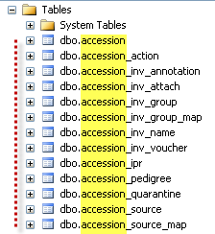
Each record in the accession table has a unique accession_id. (The accession_id field is the table’s primary key.)The subordinate tables that relate to the main accession table do this by pointing to the main accession table’s accession_id. 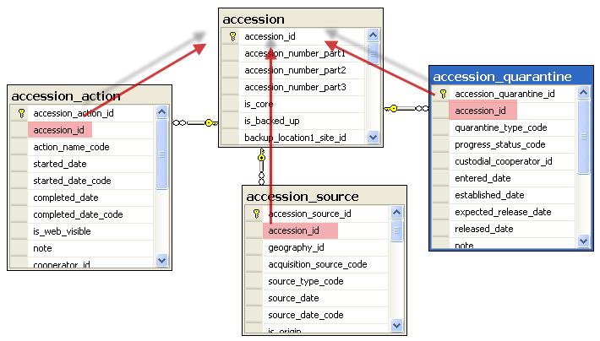
(Not all of the accession tables are shown in this illustration.)
Fortunately, as a GRIN-Global Curator Tool user, these relationships are managed for you in “dataviews” – dataviews mask these raw data descriptions and relationships.

Relational Database Example: Accessions and Inventory
The following example illustrates how combined Accession and Inventory data would look in a non-relational database, such as a spreadsheet:
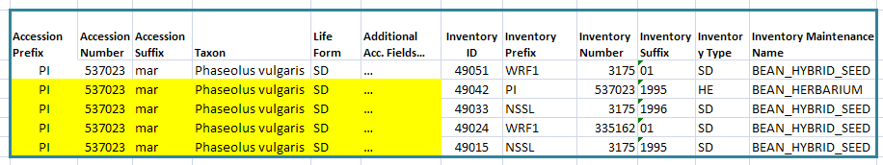
The data highlighted in yellow is redundant Accession data; for every inventory record, the Accession data is duplicated. By splitting out the data into relational tables as shown below, the data is not duplicated. Besides saving storage space, there are other advantages including less chance of data entry errors and preventing accidental deletion of records having related data.
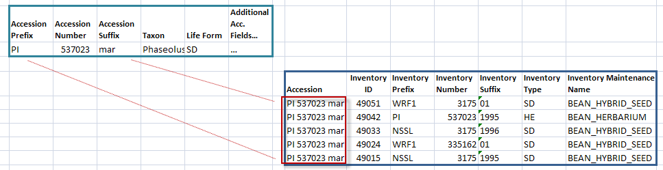
(In GRIN-Global, the Inventory records relate to the Accession records by the combined Prefix, Number, and Suffix fields. Every accession record must have a unique combination of those three fields.)
The following graphic illustrates how an accession record relates to inventory records. These are Curator Tool accession and inventory dataview images. In this example, the five inventory records are considered to be children of the accession record because the inventory records are linked to a prerequisite accession record.
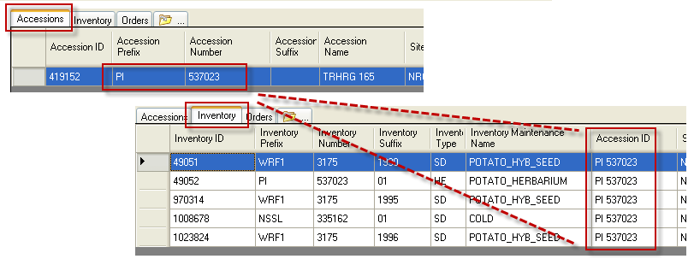
For more background information on relational databases, see http://en.wikipedia.org/wiki/Relational_database.

Schema
When GRIN-Global is installed, most organizations typically choose to use the schema as defined by the GRIN-Global developers. The term “schema” is basically the definition of the tables, the fields, the relationships, the dataviews, the indexes, and other components that comprise the complete database system. An organization can modify the schema if desired; for example, sometimes an organization may add an additional table because of its unique needs. The organization can also modify the headings displayed in dataviews to meet their specific usage, including their primary language.

GRIN-Global Tables
All data for GRIN-Global is stored in its many tables. The following diagram is only showing some of the more important tables used to store the GG germplasm curatorial data.
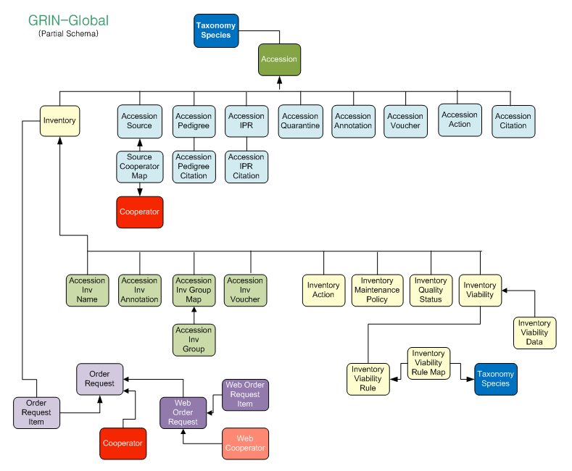

Dataviews
GRIN-Global consists of many dataviews which are used to display data – some were designed to work specifically within the Curator Tool (and others for the Public Website). The dataviews are used to display data in the database – they have been coded so that you as the end user do not need to write SQL code to access the data in the database.
Within the Curator Tool, dataviews are grouped into Areas; each area may hold multiple dataviews. To the end user, having the dataviews organized by Area makes it easier to locate a dataview – the areas simply subdivide the full set of dataviews into smaller subsets.
The dataview areas are shown in this screen capture:
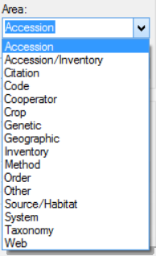
In the process of selecting a dataview to display in the CT, after you select an area, only the dataviews categorized in that area will be listed. Two examples:
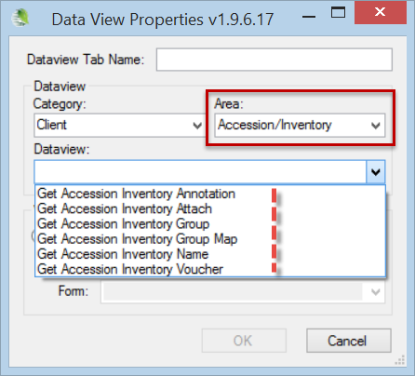 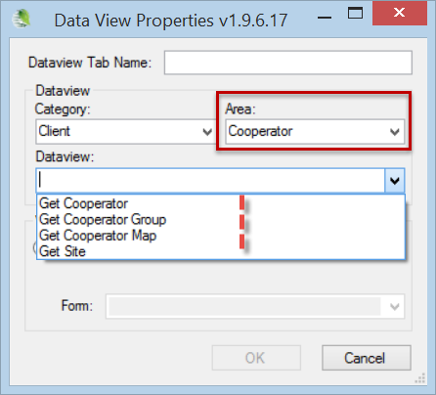
The GG Administrator can produce a list of all the dataviews currently in your GG installation by previewing the get_dataview_list dataview. Use this link to display a generic list representative of many dataviews used within the Curator Tool.

A dataview essentially retrieves data from tables via a programmed query. Fortunately, these dataviews have been created for you. You can display many dataviews and switch back and forth by clicking on their tabs. Shown below are nine dataview tabs – the Accessions dataview is currently selected, therefore the datagrid is displaying Accessions-related data:
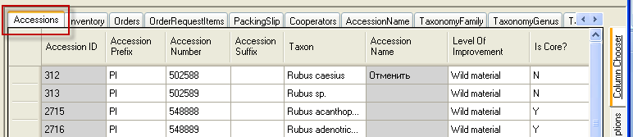
When the programmer created the Accessions dataview, she selected specific fields to be displayed. Note that a dataview’s fields are not restricted to one table in the database. For example, in the Accessions dataview, the Taxon data originates in the dbo_taxonomy_species table and the Accession Name data comes from the dbo_accession_inv_name table.

Technical Overview of a Dataview
The following explanation is intended for those readers interested in a brief explanation of the technology behind the dataviews: A dataview is a SQL SELECT statement embedded within the Curator Tool. The programmed logic uses some pre-defined criteria to select related records from the database’s many tables. The dataview fields correspond to fields in one or more database tables. Language-specific “friendly” names are assigned to each dataview field, which in turn are displayed as the field column titles in the Curator Tool. Although the data displayed in the Curator Tool appears as a single table of rows and columns, it most likely originated from several related tables.)
Many dataviews are included when the Curator Tool is installed. For example, the three main dataviews, Accessions, Inventory, and Orders, are displayed by default. Other dataviews are not initially displayed, but are available and can be easily selected. Over time, your organization may develop additional dataviews for specific purposes. Eventually you will become familiar with certain dataviews and have a basic understanding of what data is displayed in each one. Some you may use frequently, and others perhaps rarely (if ever), depending on your position and interests.

Some Dataviews Show All Records and Some Do Not
The data displayed in a dataview may transcend multiple tables. As a Curator Tool user, you should be aware that some dataviews show all records in a table, whereas most of the dataviews do not because they filter the data based on certain programmed criteria. (The dataview programmer codes the dataview so that each time the dataview is invoked by the Curator Tool user, program parameters are applied, thus filtering the records. The programmer would say that the parameters were “resolved.”)
Although most dataviews are designed to work with parameters and display just a subset of the entire database, a few dataviews show all of the records for a given table and do not use any parameters.
This illustration is showing a snapshot of the Curator Tool, with its List Panel on the left and the dataviews on the right. The get_site dataview is a dataview that displays all of the site records in the GRIN-Global database and is independent of the lists in the List Panel.
The GRIN-Global developers have created a data dictionary which describes what type of data is accessed by the many dataviews. (See: GRIN-Global data dictionary.) Complete step-by-step directions for working with dataviews begin on page 33.

GRIN-Global’s Table Relationships
The following diagram illustrates the relationships between the primary GRIN-Global tables:
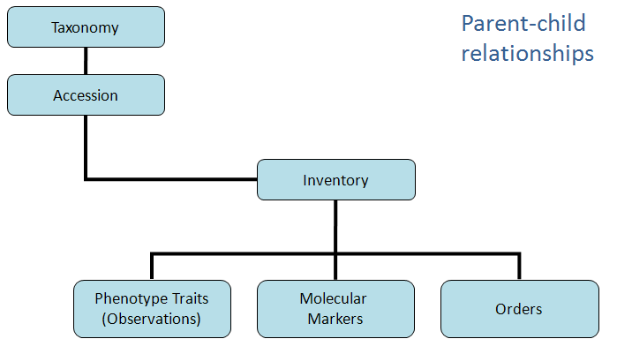

There are many other tables in GRIN-Global which are not represented in the previous illustration. Data such as geography, cooperators, crops and descriptors, codes, etc. are stored in ancillary tables. For example, there are many accession-related child tables. These tables support the main accession table. Customized dataviews, accessible from the Curator Tool, obtain their data from these tables.

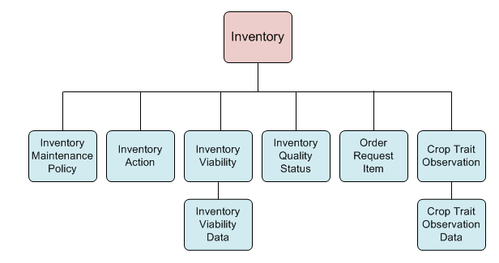

Keys: Primary and Foreign
The partial schema GRIN-Global diagram below illustrates the relationship between some of the main GRIN-Global tables. (The primary key (PK) and foreign key (FKn) are used by the GRIN-Global program designers to indicate key fields. The relationships have also been established by the program designers. 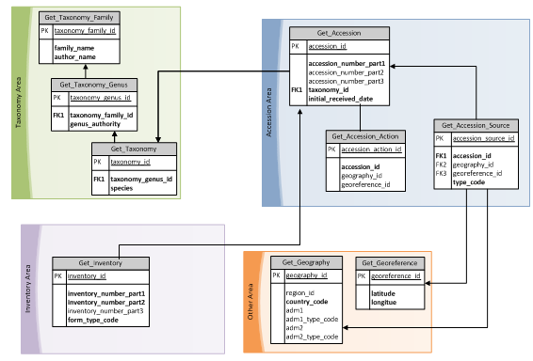

Primary Keys
A primary key is system generated. In the Curator Tool, every dataview by default displays the primary key in the left column:
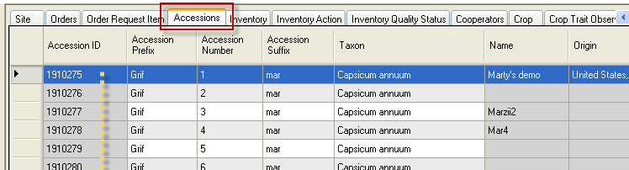
Notice that the Accession ID field is gray – the gray color indicates that this is a read only field. When you add a new record to the GRIN-Global database, the system will generate the next available number.
In the process of creating a new record, you will notice a temporary primary key (the Accession ID):
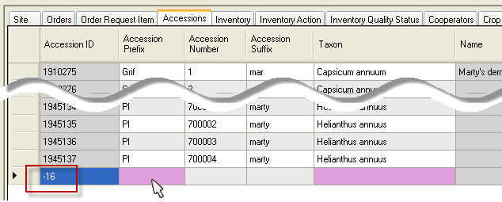
After the data is saved, the temporary number changes to a permanent number.

Secondary (or “Alternate”) Keys and Foreign Keys
Most users will not remember data by the record’s primary key, since the primary key is system generated and is not actual curatorial data. Instead, most genebank users will know their data by the records’ secondary keys. For example, in the U.S. NPGS, every permanent accession in the system has an identifier that is commonly referred to by the users as the accession’s “PI Number.” In GRIN-Global, the permanent PI number is stored in two fields: Accession Prefix and Accession Number. (PI is an acronym for “Plant Introduction” – the USDA starting assigning PI numbers to the accessions in their collection many years before the advent of computers.)
Many sites will first add their accession data into the GRIN-Global database, but use a temporary number – in many cases these sites will use three fields: Accession Prefix, Accession Number, and Accession Suffix. These three fields collectively comprise the accession secondary key. The combination of these three fields must be unique – no two accession records can have that same combination. (In cases where an accession record only uses two of the three fields, that combination must be unique.)
A foreign key is one field (or a collection of fields) in one table that uniquely identifies a row of another table. In other words, a foreign key is a column or a combination of columns that is used to establish and enforce a link between the data in the parent and child tables. When creating a new child record, the child’s foreign key must match the parent’s secondary key.
Refer to the GRIN-Global Data Dictionary which contains detailed information on the GRIN-Global dataviews, tables, and fields.

Getting Started with the Curator Tool
Because GRIN-Global will be adapted by diverse organizations, diverse approaches may be taken for getting started. As mentioned previously, some organizations may run GRIN-Global on a single PC, whereas the more typical configuration will be in a networked environment with one server and multiple user PCs.
The organization will need to determine how existing data will be populated into GRIN-Global. Will the data be manually entered, or assuming the organization has substantial data already, will an GRIN-Global administrator import the data into the GRIN-Global database? Organizations may have stored their data in spreadsheets or other database formats and will need to convert that data into the GRIN-Global schema. On the other hand, some organizations may need to input data stored in paper format into the GRIN-Global database.
To work with the GRIN-Global database, you will need to learn the mechanics of the Curator Tool which is explained in detail in the remainder of this document.

Appendix: Updating the Curator Tool
Starting with Curator Tool 1.9.x, the CT uses its own separate installer; the GRIN-Global Updater program should not be invoked to update the Curator Tool.
Users only need to install the Curator Tool on their PCs. Typically an organization will have a remote server, to which the CT connects. A GRIN-Global administrator with full admin privileges will install the server.

In some organizations, such as the USDA (NPGS), a PC user cannot install software on his PC, so someone with network administrative rights must install the CT. Installation directions for installing the CT in the NPGS are available online under the Documentation link – see https://www.grin-global.org/. General installation directions for other organizations can be found there as well.

