## Curator Tool Installation Instructions



Document Revision Date

March 28, 2025

Author

Martin Reisinger

|  |  |
| --- | --- |
|  | We know from experience that the person who installs the Curator Tool (CT) is not likely the CT user. This guide was designed for an IT person who is familiar with installing programs on a PC. (In most genebanks, the Curator Tool user typically does not have the requisite Windows elevated privileges to do software installations.)  These directions recognize the scenario where the IT person installing the CT is likely not the person who will be using the CT. The point of this note is to warn the IT person installing the CT that *this is not a typical installation*. During the CT installation, at one point *both* the IT person and the CT user must work in tandem to correctly install the CT. Whenever you see the following graphic in this guide, pay close attention! A couple of men on a tandem bicycle  Description automatically generated |

The Appendix contains change notes pertaining to this document.

Comments/Suggestions:

Please contact Marty Reisinger at [marty.reisinger@usda.gov](mailto:marty.reisinger@usda.gov) or [mar@rrginc.com](mailto:mar@rrginc.com) with any suggestions or questions related to this document. This and other GRIN-Global documentation can be downloaded from the GRIN-Global project’s website at <https://www.grin-global.org/>.

Support Contacts

The National Plant Germplasm System (NPGS)’s National Germplasm Resources Laboratory (NGRL) supports GRIN-Global and should be contacted when questions arise or support is needed with respect to the CT installation process. Use either [gringlobal.feedback@usda.gov](mailto:gringlobal.feedback@usda.gov) or marty.reisinger@usda.gov.

Table of Contents

Version Information 3

Current Version – as of January 30, 2025 – 1.23.8.17 3

Determining an Installed Curator Tool’s Version 3

Older versions 4

Overview – Read before Installing! 5

Network Security Requirements 8

Curator Tool Installation Page 8

Reports Installation 8

SQL Server (Express) Installation 8

Installation Steps (with Screens) 10

Explorer (Browser) 10

Firefox (Browser) 11

Chrome (Browser) 12

Continuation of the Installation Directions 13

Continuation: Ensuring all PC Users Can Access the PC’s Local Database 15

Connect the CT to the Correct Server 16

This “Make database accessible to all users” is the Critical step! 18

Password Resetting 20

Password Notes 20

Useful Information Related to Installing the CT 20

Printing Reports Error 20

Installing the CT on a PC with the Curator Tool p*reviously installed* 21

Permissions 22

Curator Tool folders & files locations 23

WebServiceURL.txt 23

Appendix A: Using SSMS to create SQL permissions on the PC 24

Use SSMS when the installing person does not have a CT account 24

Appendix B: Older Versions 26

File Locations – A major change with versions 26

Versions 1.23.1.26 and later 26

Versions < 1.23.1.26s 27

Appendix C: Revision Notes 29

#### Version Information

##### Current Version – as of January 30, 2025 – 1.23.8.17

The Curator Tool installation file (.exe) is publicly available from the Curator Tool (CT) Installation page at <https://www.grin-global.org/download_ct.html>.

We recommend using the most recent release. In this case, **1.23.8.17** Release notes are online at <https://www.grin-global.org/docs/CT_Release_Notes.pdf>.

##### Determining an Installed Curator Tool’s Version

You can determine the installed version by starting the Curator Tool (CT); the version is displayed in the CT’s title bar:

You can also determine the program’s modified date. This can be accomplished by locating the Curator Tool .exe program file in Windows Explorer, as shown below. Right-click on the file to display its **Properties**; select the **Details** tab:  
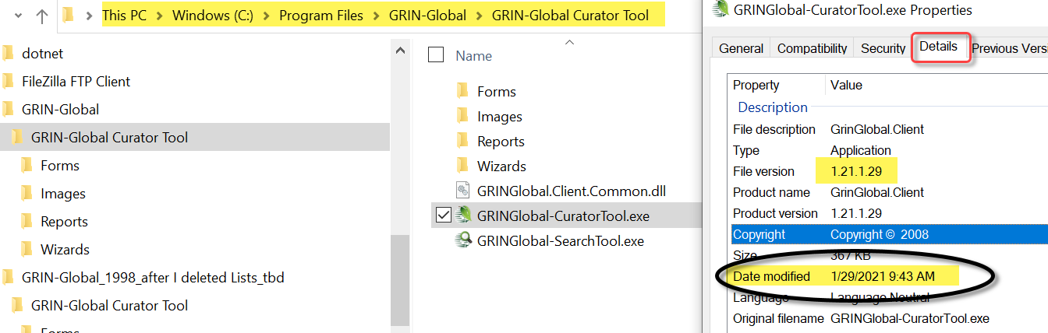

##### Older versions

Some details on older versions are provided later in this document’s *Older Versions* section. Release notes are [available online](http://grin-global.org/docs/CT_Release_Notes.pdf). Contact the author if an older release is needed.

#### Overview – Read before Installing!

Please read pages 4 through 8 before installing the Curator Tool.

The key to a successful install is following this guide, but especially when it comes to a critical step that requires the ***IT person with the elevated Windows privileges to remain logged into Windows under his Windows account while the CT user logins into the CT using the CT user’s Curator Tool account credentials.***

Please read on first, but know that the CT installation page is online at <http://grin-global.org/download_ct.html>

###### Downloading the CT Installation File

You may need to revamp the installation file’s Properties. In Explorer, right-click the installer EXE filename. Select **Properties**. On the **General** tab, click the **Unblock** button.

|  |  |
| --- | --- |
|  | In NPGS, and perhaps other organizations, you may need to use Microsoft Edge to download the CT installation .exe file. |

Release notes detailing all Curator Tool releases are online at:   
<https://www.grin-global.org/docs/CT_Release_Notes.pdf>

|  |  |  |  |
| --- | --- | --- | --- |
|  | Ensure that the Windows Folders’ View options are set to **Show hidden files, folders, and drives** (Hidden is the default).   |  |  | | --- | --- | |  |  | |
|  | Some screen images used in this guide may indicate a different version, but your installation should indicate the **current release**. |
|  | If you are upgrading from **1.9.8.17** or above, the existing CT version does not need to be uninstalled. If upgrading from a version older than **1.9.8.17,** refer to the *Older Versions* section for details. |

##### Network Security Requirements

In organizations such as the USDA, with Enterprise Active Directory (EAD) network security requirements, ***only*** ***someone with Windows administrative elevated privileges*** should install the Curator Tool. However, before considering the installation complete, while the IT / elevated Windows account is logged into the PC, a Curator Tool user must logon in the CT and execute a step. See ***critical step***for details.

|  |  |
| --- | --- |
|  | Note to a CT user: Unless you have elevated Windows administrative privileges and a CT account, you cannot install the CT by yourself.  **Note to the IT person installing the CT: Unless you include the CT user in a critical step, the CT will not operate properly on the PC.** (See ***critical step***for details. ) |

(I apologize for this red ink, but 99 of 100 failed installations occur because this step is skipped. )

In NPGS, please contact [marty.reisinger@usda.gov](mailto:marty.reisinger@usda.gov) for assistance or if you have any questions.

Follow the detailed steps below. Note: some security packages, such as Symantec, may create a “hiccup.” The following directions will show an example of this.

##### Curator Tool Installation Page

Curator Tool new releases are available and can be downloaded at the GRIN-Global downloads page:   
<https://www.grin-global.org/download_ct.html>

##### Reports Installation

The Curator Tool uses reports. Beginning with version 1.23.1.26, a Report Manager was embedded within the Curator Tool application. Complete instructions for using this Report Manager are online at [Installing CT Reports.pdf](http://grin-global.org/docs/gg_installing_CT_report_files.docx) This is mentioned here for information only and is not part of the CT installation.

##### SQL Server (Express) Installation

The Curator Tool needs a copy of SQL Server to be installed on the PC. The SQL Server database engine is required to be installed on the CT computer. It manages the Lookup Tables that are installed by the CT on the user’s PC.

The version of SQL Server doesn’t matter as long as it is 2008r2 or later. SQL Server Express or Community Edition is commonly used, but any fairly recent version of SQL Server will do.

|  |  |
| --- | --- |
|  | **If a copy of SQL Server (Express or otherwise) has been previously installed, whether by the CT or some other means, you do not need to reinstall it.** |

If you do need to install a copy of SQL Server (Express, Community Edition, etc.) the CT installation should guide you through that. However, you can manually install SQL Server Express by searching on the internet for a Microsoft website that provides a SQL Server download.

|  |  |
| --- | --- |
|  | Microsoft also makes the *SQL Server* *Management Studio* available for free. That is a useful tool install, but is not essential for running the Curator Tool. |

#### Installation Steps (with Screens)

Versions shown in the images below do not reflect the current version that is being installed.

Since each browser behaves slightly differently, the following documentation has directions pertinent to the respective browser:

Microsoft’s Explorer / Edge

Firefox

Chrome

##### Explorer (Browser)

1. Close the Curator Tool if open.
2. Download the CT installer file from <https://www.grin-global.org/download_ct.html>.
3. Click the desired version’s .exe file:  
   Graphical user interface, text, application, chat or text message

   Description automatically generated
4. Click **Run**

Follow the remaining installation directions – see Remaining Installation Directions

##### Firefox (Browser)

Versions shown in the images below do not reflect the current version that is being installed.

1. Close the Curator Tool if open.
2. Download the CT installer file from <https://www.grin-global.org/download_ct.html>.
3. Click the desired version’s .exe file:  
   Graphical user interface, text, application, chat or text message

   Description automatically generated
4. Click **Save File\***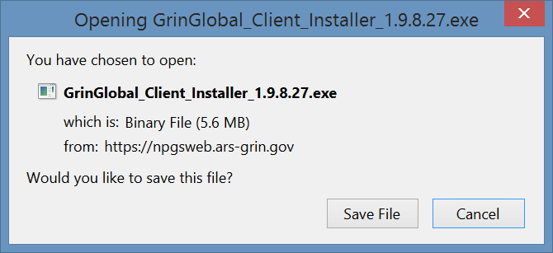  **\* screen shots version may not be the actual current version**
5. (1) Click the Download icon; (2); click the file:  
   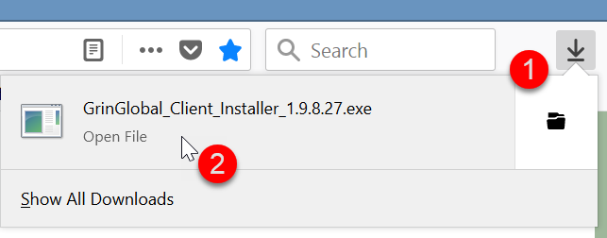

Follow the remaining installation directions – see Remaining Installation Directions

##### Chrome (Browser)

Versions shown in the images below do not reflect the current version that is being installed.

1. Close the Curator Tool if open.
2. Download the CT installer file from <https://www.grin-global.org/download_ct.html>.
3. Click the desired version’s .exe file:  
   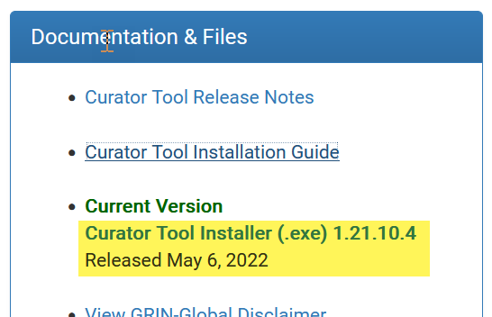

4. In ***Chrome***, click the filename at the bottom left of the screen. Just click on the filename:  
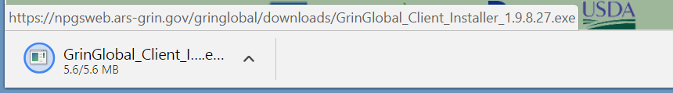

Follow the remaining installation directions – see Remaining Installation Directions

#### Continuation of the Installation Directions

Depending on the security package on your PC, you will need go though some screens in order to proceed.

If …click on **More Info**;

And several “Next” … windows…

If Symantec is installed …click **Allow this file\***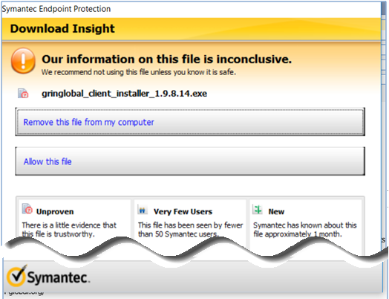 **\*the version # will be different than the one shown**

Proceed with the installation windows – click **Next** or **Install** when prompted  
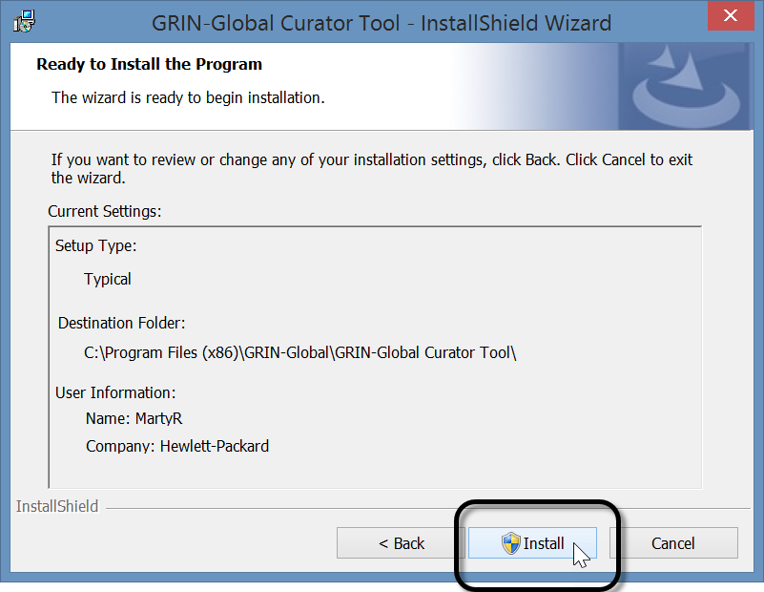

Depending on the CT release already on your PC, you may see the following window.   
Select: **Remove |** **Next | Remove**  
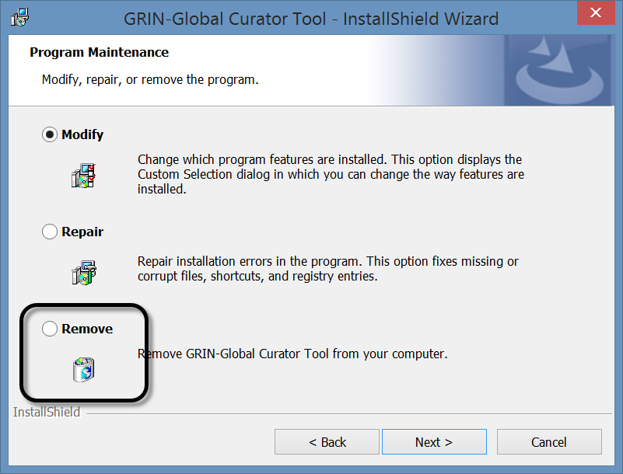When this is the case, you will need to start the installation process again.

|  |  |
| --- | --- |
|  | Do not use the **Repair** option |

#### Continuation: Ensuring all PC Users Can Access the PC’s Local Database

Following the respective browser steps above, Windows should eventually indicate that the CT program was successfully installed. As with other programs, there should now be an icon for the CT program in the Windows Start screen. Most likely, you will need to locate it under the **More** option:

**Now for the tricky part…**

Although the CT was installed, connections still need to be made to the remote server where the GRIN-Global database is stored *and on the user’s local PC*. The CT user needs to have SQL rights to a local SQL database on their PC. This local database is installed during this CT installation. Separately, the GG DBA is responsible for granting the CT user a GG account to access the remote server.

To complete step 2 below, the CT user must know his GRIN-Global CT account credentials as assigned by the GG DBA – the user needs to know his CT username and password.)

|  |  |
| --- | --- |
|  | It takes two people simultaneously to ride a tandem bike. We empathize that it will take two people to complete the next steps. Why? One person with elevated Windows privileges must be logged onto the PC. ***While the IT person (the person with the elevated Windows privileges) is still logged into Windows, the CT user will login to the Curator Tool using his CT credentials.***  A couple of men on a tandem bicycle  Description automatically generated |

Unless the IT ***software installer*** also has a CT account, the IT software installer (***someone with elevated administrative privileges***), must complete a few more steps ***with the cooperation of the CT user.***

|  |  |
| --- | --- |
|  | It is not usually the case, nor is it expected, that the person installing the CT .exe installation file has a CT user account. That is what complicates the full installation of the CT. In the appendix A, we have an alternative, but this requires the installation of another Microsoft program, SQL Server Management Studio. For details, see Using SSMS to create SQL permissions on the PC. |

In summary: (assuming the steps described in 9 through 13 have been completed)

1. The *elevated Windows privileges account (IT person)* reboots the PC and logins with their elevated Windows account.
2. *while the elevated privileges account is still logged in,* *the CT user with his CT account (username and password credentials), will start up the Curator Tool and connect the CT to the server (details below)*
3. *the CT account user* must make the database accessible to all users
4. *the CT account user reboots* the PC (a cold boot) and then *the CT user logins in using his Windows account*

|  |  |
| --- | --- |
|  | An alternative to the four steps above is to use Microsoft’s SQL Server Management Studio (SSMS). SSMS is not part of the CT installation, but can be done separately. When SSMS is installed, then the person installing the CT can complete an equivalent to step 3 and will not need to involve the CT user in completing step 3. Refer to Appendix A for details.  However, after the SSMS alternative method has been completed, the CT user will need to set up their CT connection to the server as described in step 2. At that point the CT user should have full access to their GG database. |

##### Connect the CT to the Correct Server

(step 2)

The *CT user starts* the PC, logins into Windows, and then starts the CT.

|  |  |
| --- | --- |
|  | The CT must be connected to the correct server.  For NPGS, the server name is: **npgsweb.ars-grin.gov** Detailed server connection directions (if needed) are online at <http://grin-global.org/docs/gg_connecting_to_servers.pdf> A brief summary using an NPGS example is shown below. |

Start the Curator Tool. When the Curator Tool starts running, its Login Screen will display. You should immediately click on the **Edit Server List** button. The table directly below these images has details.  
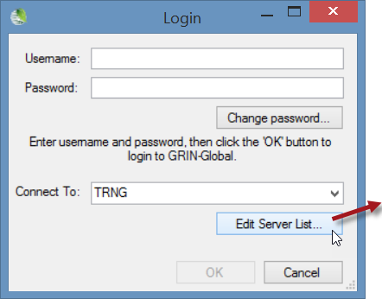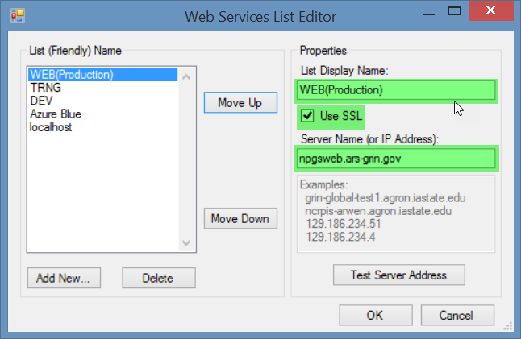

| **Steps** | **Description** |
| --- | --- |
| 1. | Input a name that you will recognize – this name will display on the Connect to box on the Login window. |
| 2. | Check the SSL box |
| 3. | **NPGS staff**: Input server name: **npgsweb.ars-grin.gov** (Each organization has its own server. The GG admin will indicate the Server Name and whether the Use **SSL** checkbox needs to be selected.) [Complete directions for the servers are online](https://www.grin-global.org/docs/CONNECTING_TO_NPGS_DATABASES.docx). |
| 4. | Click the **Test Server Address** button – you should receive a positive confirmation that the connection was successful |
| 5. | You may have additional server names listed in the left box – use the Move Up button to have this **npgsweb** server be listed first (therefore becoming the default server)  The WebServiceURL.txt file determines what servers are listed. Refer to the WebServiceURL.txt section. |
| 6. | Select OK. |

##### This “Make database accessible to all users” is the Critical step!

(step 3)

Follow step 3 as described below. ***Ensure the PC was started by the IT person.***

1. The elevated Windows privileges account (IT person) reboots the PC and logins with their elevated Windows account.
2. *while the elevated privileges account is logged in*,
3. *the CT account user* must make the database accessible to all users:

* The **CT account user** starts up the CT and logs into the CT
* The **CT account user** clicks on the “**Tools**” menu option on the top menu-bar and selects the “**Make database accessible to all users**” menu option.    
  A screenshot of a computer

  Description automatically generated
* The CT user closes (logs out of) the Curator Tool
* Reboot

That’s it. Reboot.

1. *the CT account user reboots* the PC (a cold boot) and then *the CT user logins in using his Windows account*

T**he Curator Tool account user should be logged into the PC with his/her real Windows/Network ID.** That same person should then use his/her Curator Tool user account and start up the CT.

The user’s name should be listed in the top left **Show Lists from…** dropdown.

|  |  |
| --- | --- |
|  | If the user’s name is not immediately displayed in the **Show lists from:** box, something is not correctly set up. Stop. Don’t start creating tabs, lists, and making other changes because the settings will not be retained. In NPGS, please contact [gringlobal.feedback@usda.gov](mailto:gringlobal.feedback@usda.gov) for assistance. If another GG organization, contact your GG administrator. |

##### Password Resetting

The user’s password may have expired if he hasn’t used the CT in some time; in that case he can use the CT Password Reset Utility at <https://npgsweb.ars-grin.gov/ggtools/Login/RequestPasswordReset>

##### Password Notes

1. When changing the CT password…
   1. You must use the correct user account name. It may be the fname.lname ***or it*** might be the email address used when you were initially added to the GG as a CT user (typically… FirstName.Lastname@usda.gov)
   2. ***after*** the password has been changed, you can use the fname.lname format to login:   
      e.g. ***marty.reisinger***
2. If you enter the password incorrectly ***n*** times, your account is locked – it unlocks after 15 minutes
3. A bad password can be reset by the GG DBA

|  |  |
| --- | --- |
|  | A GG user working at a genebank may have two separate GG accounts – one for the Curator Tool , and one for the Public Website (PW). These accounts are not the same! (although the GG DBA can link them to provide certain PW enhanced capabilities) |

#### Useful Information Related to Installing the CT

##### Printing Reports Error

A common error that happens because of a not-quite-properly-completed installation is the following – the CT user does not see all of the reports in the Order Wizard dropdown:  
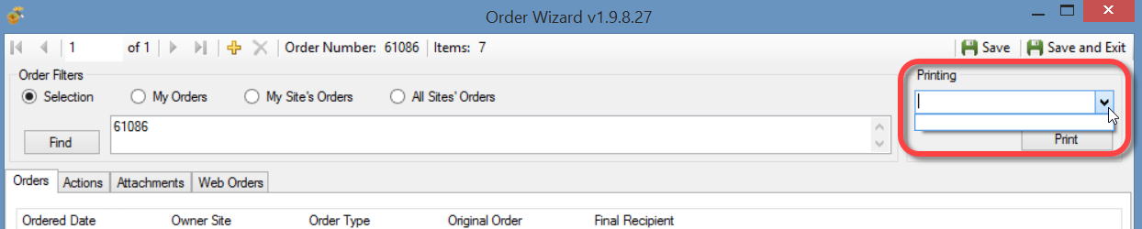

When Correctly Setup:  
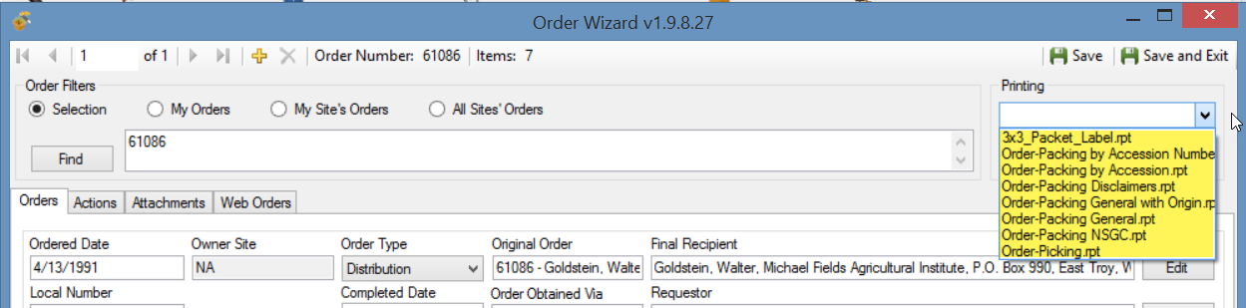

The typical reason why that happens is because the **AppSettings.txt** and **ReportsMapping.txt** files from a previous CT version were installed and had not been deleted.

To remedy this,

1. close the CT
2. refer to the online documentation for CT Reports at <https://www.grin-global.org/docs/gg_installing_CT_report_files.pdf>

##### Installing the CT on a PC with the Curator Tool p*reviously installed*

You typically do not need to uninstall either the CT or MS SQL Server when installing a newer version of the Curator Tool.

|  |  |
| --- | --- |
|  | The CT’s installation file sometimes displays the **Repair** option. Do not use this option. Unistall; then install. |

##### Permissions

You may need to modify the permissions of this folder before modifying any of the .txt files.  
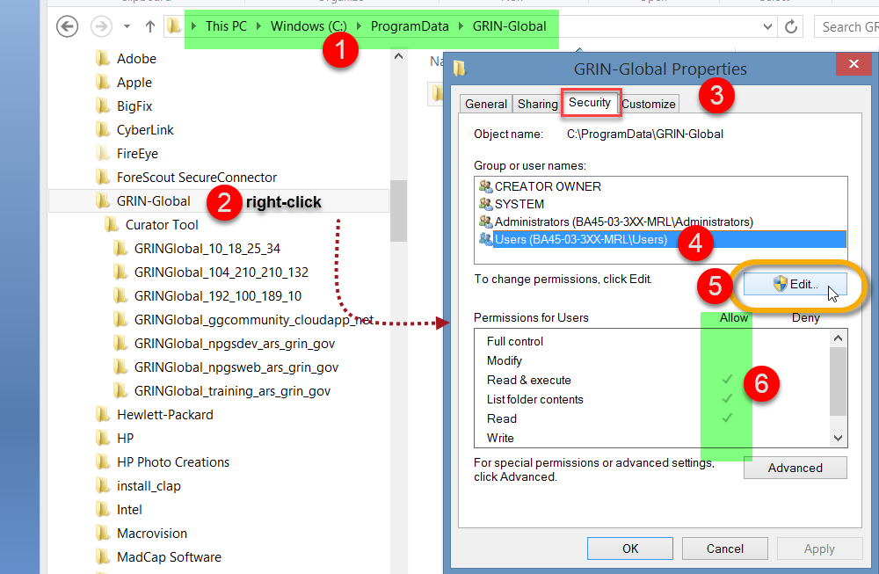

|  |  |
| --- | --- |
|  | Windows OS admin rights don’t translate to MS SQL Server admin rights. |

##### Curator Tool folders & files locations

###### Curator Tool .txt files (AppSettings, ReportsMapping, WebServiceURL)

When the Curator Tool is installed, three .txt files are installed. Where they are installed depends on the CT version. For older versions prior to 1.23.1.26, refer to the Older Versions section.

Beginning with CT v. 1.23.1.16, the folder for the CT’s three .txt files is located under the PC user’s **Roaming** folder, as shown below:

##### WebServiceURL.txt

In the following example, the CT user (at NPGS) below is set up for 5 different GG servers. However, most users will just need one line.   
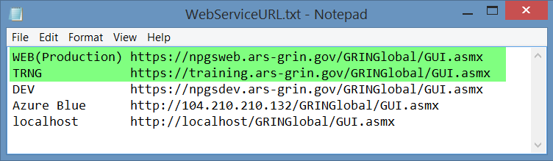

Each organization using GG has its own server information.

The **ReportsMapping.txt** and **AppSettings.txt** files are fully explained in the [Installing CT Reports Guide](https://www.grin-global.org/docs/gg_installing_CT_report_files.pdf)

### Appendix A: Using SSMS to create SQL permissions on the PC

In the CT installation, a key critical step is often ignored. When that critical step is not done properly, later, when the CT user attempts to use the Curator Tool, the user will see this message displayed “… User access to the local … database is denied… cannot open database GRINGlobal_npgsweb_ars_grin_gov …”

This message is suggesting that the local database is not available for all users. It pertains to SQL Server login rights and has nothing to do with Windows directory permissions. It pertains to permissions inside SQL Server. When SQL Server is installed, by default SQL Server only gives access to the user installing it. Other users on the PC aren't allowed to use SQL Server.

One solution is to have the original installer (with extended Windows privileges) run and install the CT .exe file, but then, while this Windows privileged installer is still logged into the PC/Windows, the CT user makes the database accessible to others. (See “critical step” step 3.) Technically, what that does is to assign BUILTIN\Users, a windows user category, a SQL Server login with ***sysadmin*** rights. Then everyone using that PC is a DBA for local databases, allowing the CT to run properly.

##### Use SSMS when the installing person does not have a CT account

If Microsoft SQL Server Management Studio (SSMS) is installed on the PC, the person installing the .exe file (the Windows extended privileges “admin” person – can also make the local database accessible to all users by selecting the following. (This is an alternative workaround when the CT user is not conveniently available and the IT admin (privileged) person installing the CT doesn’t have a valid Curator Tool account.) Since the IT admin can't run and log into the Curator Tool and follow step 3, as an alternative when SSMS is installed, the IT person can use SSMS and create a SQL Server Role login for BUILTIN\Users on the PC and give that login ***sysadmin*** rights.

|  |  |
| --- | --- |
|  | This guide is assuming the IT person is familiar with SSMS. If not, then follow the earlier method that involves the CT user working in tandem with the IT person. |

Alternatively, in SSMS, the specific PC user could be given the login ***sysadmin*** rights:

### Appendix B: Older Versions

Any Curator Tool version starting after version 1.9.8.14 is a 64-bit application; the earlier versions were 32-bit. The more recent builds were configured using Visual Studio to a target 64-bit platform environment.

|  |  |
| --- | --- |
|  | If upgrading from **1.9.8.14** or below, *it is recommended to uninstall the older (32-bit) version before installing 1.9.8.30 (or 1.9.9.4).* |

##### File Locations – A major change with versions

When the Curator Tool program is installed on the user’s PC, certain requisite CT files are also installed. A comparison below illustrates the former location used by previous CT releases and the location used by releases beginning with version 1.23.1.26.

|  |  |  |
| --- | --- | --- |
| **File or Folder** | **Version < 1.23.1.26** | **Versions >= 1.23.1.26** |
| **AppSettings.txt** **ReportsMapping.txt** **WebServiceURL.txt** | **C:\ProgramData\ GRIN-Global** | **Users*username*\AppData\Roaming\ GRIN-Global\Curator Tool** |
| All Crystal Report and SQL Server Report files |
| Lookup files |

##### Versions 1.23.1.26 and later

##### Versions < 1.23.1.26s

|  |  |
| --- | --- |
|  | Beginning with v. 1.23.1.26, the folder where user files are stored has been changed to **Users*username*\AppData\Roaming\GRIN-Global\Curator Tool**.  The following directions pertaining to **C:\ProgramData\GRIN-Global\** are only needed for versions prior to 1.23.1.26. |

The final step: the **PC administrator** needs to bring up Window’s File Explorer and navigate to “**C:\ProgramData\GRIN-Global\**” folder.  Grant “**All Users**” *full* permissions (read/write/delete) to that folder:

### Appendix C: Revision Notes

– March 28, 2025

* added support /contact information paragraph

– January 29, 2025

* added more emphasis / major edits on the critical initial CT login step
* added SSMS alternative

– January 3, 2025

* added additional emphasis on the critical initial CT login step

– December 18, 2024

* Updated references to version 1.23.8.17
* Updated minor text revisions
* Updated a few images

– April 21, 2023

* Updated references to version 1.23.1.26
* Updated references to file and folder locations due to changes implemented in version 1.23.1.26

– July 27, 2022

* More warnings re unblocking and the approved filename expected by the CEC (for NPGS)

– April 22, 2021

* updated version references

– February 9, 2021

* added instructions and screens regarding the issue related to installing an older version of the CT which pointed to a location no longer used by SAP for its Crystal Reports runtime file

– December 14, 2020

* added link to CONNECTING TO GG DATABASES