Languages and GRIN-Global

Revision Date
December 12, 2023

This guide explains how to modify GRIN-Global to include languages other than English in the Curator Tool. These directions can also be used to edit the default English headings and descriptions.
Change notes pertaining to this document are summarized in the appendix.
Review the Table of Contents which contains links to the document’s topics.

Contents
GRIN-Global and Languages 3
Overview 3
Language-related Database Items in GRIN-Global 3
Adding a Language to GRIN-Global 5
Overview 5
Language-Friendly Column Headings 6
Overview 6
Storing Language-Friendly Column Heading Names at Two Levels 6
Using the Admin Tool to Override a Dataview’s Default Column Heading Names 7
SQL for Displaying Table Field Names 9
SQL for Displaying Dataview Field Names 10
Tables Used to Store the Language-friendly Column Heading Names (& their related dataviews) 10
Descriptions 11
Reviewing the Entries in the sys_dataview_field_lang Table 11
Directions for Updating the sys_table _field_lang Table 13
Directions for Updating the sys_dataview_field_lang Table 13
Application Resources 14
Overview 14
Correcting an Individual AppResource Item 16
Mass Editing AppResource Items (or Adding Items When Adding a New Language) 17
Dataview Properties (Titles and Descriptions) 18
Overview 18
Exporting Titles and Descriptions 19
Importing Titles and Descriptions 20
Code Groups 22
Overview 22
Determining Where Code Groups are Used 22
English vs.ENG 24
Background 24
ENG Example 25
English Example 25
How does the user switch language? 26
Where does the text for these codes come from? 26
Spanish Example 27
Updating the Lookup Tables When Switching Languages 28
Codes That Have Identical Values and Titles 29
SQL Statements for Adding a New Language and Cloning the Friendly Names for Fields and Dataviews 30
Appendix 32
Deleting a Dataview 32
Overview 32
Step-by-step Directions 32
Appendix: Changes in this Document 35
– June 5, 2015 35
– October 28, 2014 35
– October 2, 2014 35

GRIN-Global and Languages

Overview
The default GRIN-Global (GG) software and interface is in English; however, GG was designed to handle an unlimited number of languages. GRIN-Global stores the language information in its database in the same way that it stores curatorial data. For example, if an organization wanted to display the column headings in Portuguese, the English headings must be translated into Portuguese. These headings are then imported into GG. After this is completed, users can then designate Portuguese as their preferred language, and the Portuguese column headings would display (rather than the English headings).
The language used for the interface is distinct from the language used to store the curatorial data. For example, you can run the system in English, but store all of your data in Spanish. Conversely, you could store your data in English, but use Spanish for your preferred interface language.
You can decide to store the data in one language, such as English, and initially use the English interface. Later your genebank could add a second language. After the second language has been added, your users can then use either language as their preferred language.

Language-related Database Items in GRIN-Global
Initially, if the language to be used is already installed, your organization should review the translations for that language. If necessary, to meet specific organizational needs, the administrator may need to manually edit some of the language translations. If many items need translating, the GG administrator can export the complete set of translations from GG and then re-import them back into the GG database after editing them.
To review the column heading translations, consider involving experienced genebank staff and walk them through the dataviews, making notes. Column headings can be changed and the various options for doing so are described in detail in this document.

The following language-related items are stored In the GG database:
- Table & Dataview Field Name Titles
These field name titles are the “language-friendly names” that display as the column headings in the Curator Tool. (These names are stored in two tables: dbo.sys_table_field_lang and dbo.sys_dataview_field_lang. Detailed information explaining why two tables are used for storing the table field translations is in a subsequent section of this document.)
- Application Resources
This table stores the “language-friendly text” for the buttons, check boxes, radio buttons, text objects, error messages, labels and titles for all GG user applications such as the Curator Tool or the Public Website, so that these applications can display their interface in any language. (These interface objects are stored in the dbo.app_resource table.)
- Titles and Descriptions for Dataviews
In the Curator Tool, a user can select a dataview from a list when adding a tab for that dataview to the grid. The titles are displayed in the user’s currently-selected language. (These titles (and descriptions) are stored in the database in the dbo.sys_dataview_lang table.)
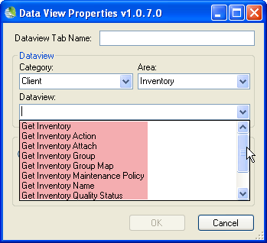
- Code Group Names & Code Values
Some GRIN-Global fields restrict the user to selecting from a set of possible values. These code values are stored in the dbo.code_value and dbo.code_value_lang tables.
After editing, when a curatorial record is stored, the value selected from the code table is stored in the record’s field. For example, the inventory record has a Pathogen Status field. There are four possible statuses: FREE, INFECTED, TESTED, or UNTESTED. For the user to complete this field, one of these four values must be selected.

Summary of Language Tables
Table | Stores data for the…
sys_table_field_lang  sys_dataview_field_lang | Column headings displayed in the dataviews
app_resource | Interface elements: buttons, etc.
sys_dataview_lang | Dataviews’ Titles & Descriptions
code_value  code_value_lang | Codes that display in the dropdowns
sys_lang | Languages installed in GG

Adding a Language to GRIN-Global

Overview
Five installed languages were included in the GG 1.0 database. If one of these is the language that you intend to run GG under, then this section can be skipped. (There is no compelling reason to remove the “extra” languages. Even if never used, they do not impact run time or create any additional overhead.)
If a language that is intended to be used is not installed, then the organization’s administrator will add the language to the GG sys_lang table via the get_sys_language dataview.

The System Language Dataview
The following screen ilustrates the fields that are defined for a language. In this example, eight languages have been set up and a ninth language record is being added:
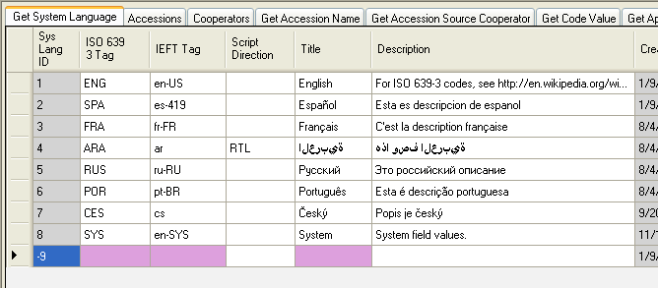
By default, the get_sys_language dataview is stored in the System category. In order to review/edit the dataview in the CT, the GG Admin needs to change the dataview’s Properties, changing the category to Client. After making any language record changes, change the dataview’s Category property back to System.
To include a new language in GRIN-Global, in the Curator Tool open the Get Sys Language dataview and add a new record. (The dataview fields are described below.)

From the Data Dictionary
Field | Description
ISO 639 3 Tag | The ISO 639-3 representation for the language. e.g. “ENG” See http://en.wikipedia.org/wiki/ISO_639-3 and http://www.sil.org/iso639-3/codes.asp?
IEFT Tag | The value in this field must be unique for every language row in the table. The value in this field represents the IETF language tag for the language. e.g. “en-US” See http://en.wikipedia.org/wiki/IETF_language_tag
Script Direction | Direction in which the language is displayed. “RTL” means “right to left.” All other values are interpreted as “left to right.”
Title | A human-friendly title for the language, e.g. “English”
Description | A human-friendly description for the language, e.g. “United States English”

Language-Friendly Column Headings

Overview
The actual database names for the column headings are more technical than friendly; fortunately the Curator Tool user doesn’t normally see the database names as shown here:
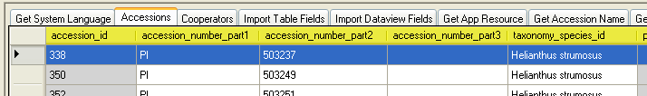
Instead, the CT user sees “language-friendly names” displayed. Some of the English friendly names for the Accessions dataview are shown here:
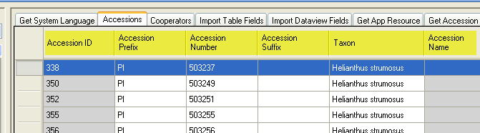
This is the same Accession dataview, but it is displaying its Spanish column heading names:
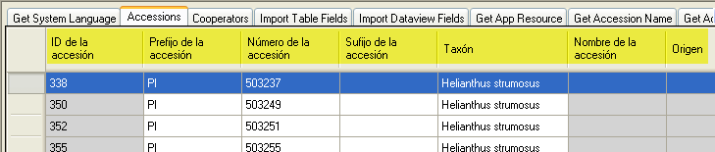
These column headings in the Curator Tool are modifiable since they are stored in records in the GG database. (This data is referred to as system data in contrast to curatorial data which is used for accession management.)

Storing Language-Friendly Column Heading Names at Two Levels
Organizations can decide what specific text will be displayed for each column heading.
For example, in the main accession dataview, when viewing in English, the user will see “Status” as the heading for the status_code field (“status_code” is the actual database field name.) For each language, “status_code” is replaced with a language-specific name. In Spanish, the language-friendly translation is “Estado,” and in French it is “Statut.”
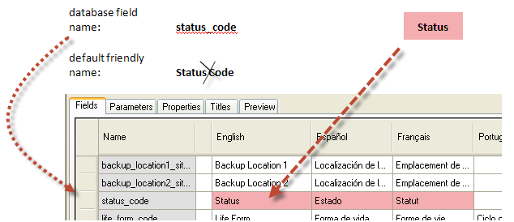
(This screen is a partial screen capture of the Accession dataview taken from the Admin Tool dataview editor.)
When an organization adds a new language to GRIN-Global, then the language-friendly, column-heading names for that language need to be added to the database by the administrator.
As background, “friendly” heading names can be defined at two levels:
- table field level
- dataview field level
The table field friendly heading name serves as the default heading name whenever a new dataview is created. For example, any new dataview that includes accession.accession_id for one of its columns will automatically receive “Accession ID” for its English friendly name.
However, an administrator can override a default heading by modifying it in the Admin Tool’s dataview editor. For example, in the Accession dataview, there is a field titled “Name.” The data in that column is stored in the accession_inv_name table. In the dataview designed for that table (Accession Inv Name), the field is titled “Name.”

Using the Admin Tool to Override a Dataview’s Default Column Heading Names

Overriding the Default Friendly Column Heading Names
Using the AT dataview editor, a GG admin can rename any field for a specific dataview. In the case above, the admin could title the field “Plant Name” in the Accession dataview. In the Accession Inv Name dataview, the field would still be displayed as “Name.”
The record for the overriding name is saved to the database in the sys_dataview_field_lang table.
Note that the value of the heading stored at the table/field level is left unchanged –only the value of the heading stored at the dataview/field level is changed.
Why the apparent duplication? The table/field friendly name is a fallback if nothing is specified at the dataview/field level. Almost all of the GRIN-Global dataviews currently use table/field as the friendly name source. One important reason for using the table/field level translations as the primary translation storage place is this: if a change is made to the translation of a heading at this level, it will flow down to all of the dataviews using the default heading translation –none of those dataviews will need to be modified.
To edit a single dataview’s language-friendly name and to override the default language-friendly heading name, use the Admin Tool‘s dataview editor. As an example, a portion of the get_accession dataview is shown:
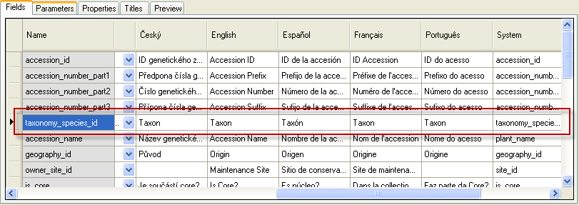
If for some reason your organization did not want “Taxon” as the heading, the administrator could edit the heading by using the dataview editor in the Admin Tool and modify the text used for the heading. Note that the dataview editor displays the friendly names for every installed language.

Input the new heading text under the respective language column; click the Save button. In the example shown here, the Spanish heading for the _note field is being changed:
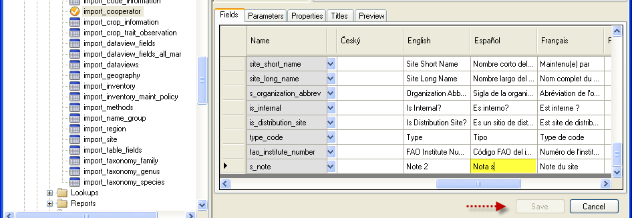
Note that manually editing a dataview’s language-friendly column heading name in the dataview editor as explained above does not change the heading of the same field when it is used in other dataviews. If you want to change the table field’s language-friendly heading-name for all dataviews, follow the directions described in the Directions for Updating the sys_table _field_lang Table section.
To display the table (or dataview) field names, use the following SQL code in the Public Website Tools | Query feature (explained in the online document Library of Dynamic Folders & SQL Examples):

SQL for Displaying Table Field Names
/*
SQL displays the table and field names in the database as well as the field titles (column headings) and descriptions. Note that the sl2.sys_lang_id = 1 in the WHERE clause indicates the English language; substitute the respective value to display another language
*/
USE gringlobal;
SELECT
st.table_name,
stf.field_name,
sl2.title as language_title,
stfl.title as field_title,
stfl.description as field_description
FROM
sys_table st
inner join sys_table_field stf
on st.sys_table_id = stf.sys_table_id
left join sys_table_field_lang stfl
on stf.sys_table_field_id = stfl.sys_table_field_id
left join sys_lang sl2
on stfl.sys_lang_id = sl2.sys_lang_id
left join sys_table_lang stl
on st.sys_table_id = stl.sys_table_id
left join sys_lang sl1
on stl.sys_lang_id = sl1.sys_lang_id
WHERE
sl2.sys_lang_id = 1
/* and
st.table_name = 'accession_inv_name'
*/
ORDER BY
st.table_name, stf.field_ordinal

/* comments */

(The sl2.sys_lang_id = 1 references English; see the Adding Languages section for details on determining the Language ID values.)

SQL for Displaying Dataview Field Names
/*
(Primarily used by GG administrators; displays data stored in sys_dataview_field_lang)
*/

USE gringlobal;
SELECT
sd.dataview_name,
sdl.title AS dataview_title,
sdf.field_name,
sl.title as language_title,
sdfl.title as field_title,
sdfl.description as field_description
FROM
sys_dataview sd
inner join sys_dataview_field sdf
on sd.sys_dataview_id = sdf.sys_dataview_id
left join sys_dataview_field_lang sdfl
on sdf.sys_dataview_field_id = sdfl.sys_dataview_field_id
left join sys_lang sl
on sdfl.sys_lang_id = sl.sys_lang_id
left join sys_dataview_lang sdl
on sd.sys_dataview_id = sdl.sys_dataview_id AND sdl.sys_lang_id = sdfl.sys_lang_id
WHERE
sl.sys_lang_id = 1 AND sd.category_code IN ('Client')
ORDER BY
sd.dataview_name, sdf.sort_order

Tables Used to Store the Language-friendly Column Heading Names (& their related dataviews)
The …field_lang tables are the tables where the language-friendly column heading names and descriptions are stored:
Table | Dataview | Description
dbo.sys_table_field_lang | get_sys_table_field_lang | The default column names and descriptions
dbo.sys_dataview_field_lang | get_sys_dataview_field_lang2 | The “alternative” column names and descriptions
Before using these dataviews, ensure that the language you are using is in the database. (Refer to the Adding a Language to GRIN-Global section for details.)

Descriptions
In the CT, when the user positions the mouse over a column heading, if the field has a Description defined, the user will see the field’s Description text in a temporary rollover tag:
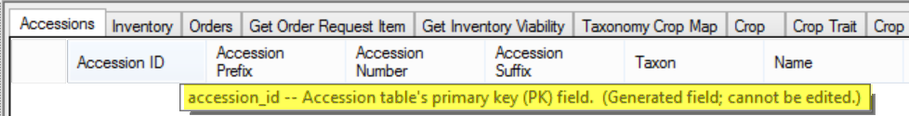
Descriptions are stored in two different tables – the standard descriptions are stored in the sys_table_field_lang table, and the “alternative” descriptions are stored in the sys_dataview_field_lang table. (The English versions were created by using the data dictionary descriptions.)

Reviewing the Entries in the sys_dataview_field_lang Table
As mentioned previously, the default language-friendly column names are stored in the sys_table_field_lang table and can be manually overridden by the administrator using the Admin Tool’s dataview editor. When friendly names of specific columns are manually edited, these names are stored in the sys_dataview_field_lang table. For example, shown is the get_accession dataview:
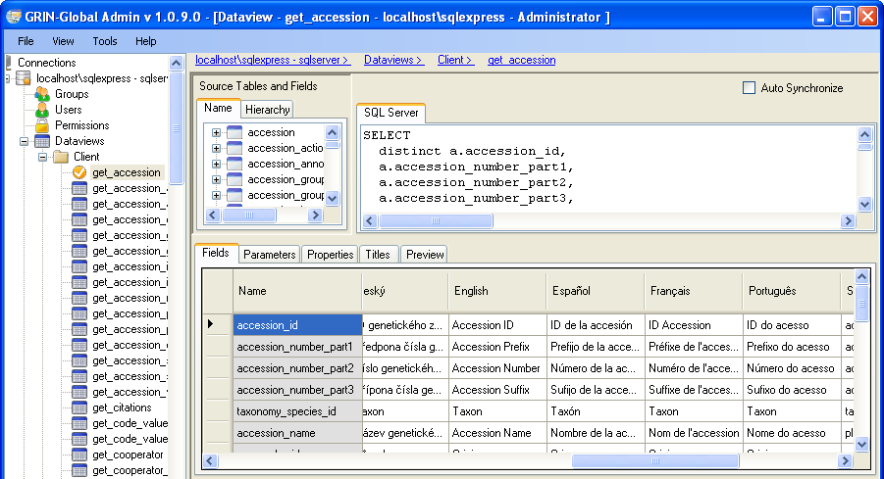
In a new installation, it may be desirable for the organization’s administrator to review all existing entries in the dbo.sys_dataview_field_lang table that were provided in the installation. Refer to the SQL for Displaying Table Field Names section for directions explaining how to review the table.

Something that can be confusing is that the AT dataview editor Fields tab doesn’t indicate whether you are seeing the underlying (default) sys_table_field_lang (STFL) heading name or the overriding sys_dataview_field_lang (SDFL) heading name. For example, in the above screen, in the English column, we don’t know if “Accession Prefix” is the default name stored in the sys_table_field_lang or overriding heading stored in the sys_dataview_field_lang table.
In any case, you can use the AT dataview editor to replace the default heading. When you do, a record is inserted in the database with that heading in the title field in the sys_dataview_field_lang table.
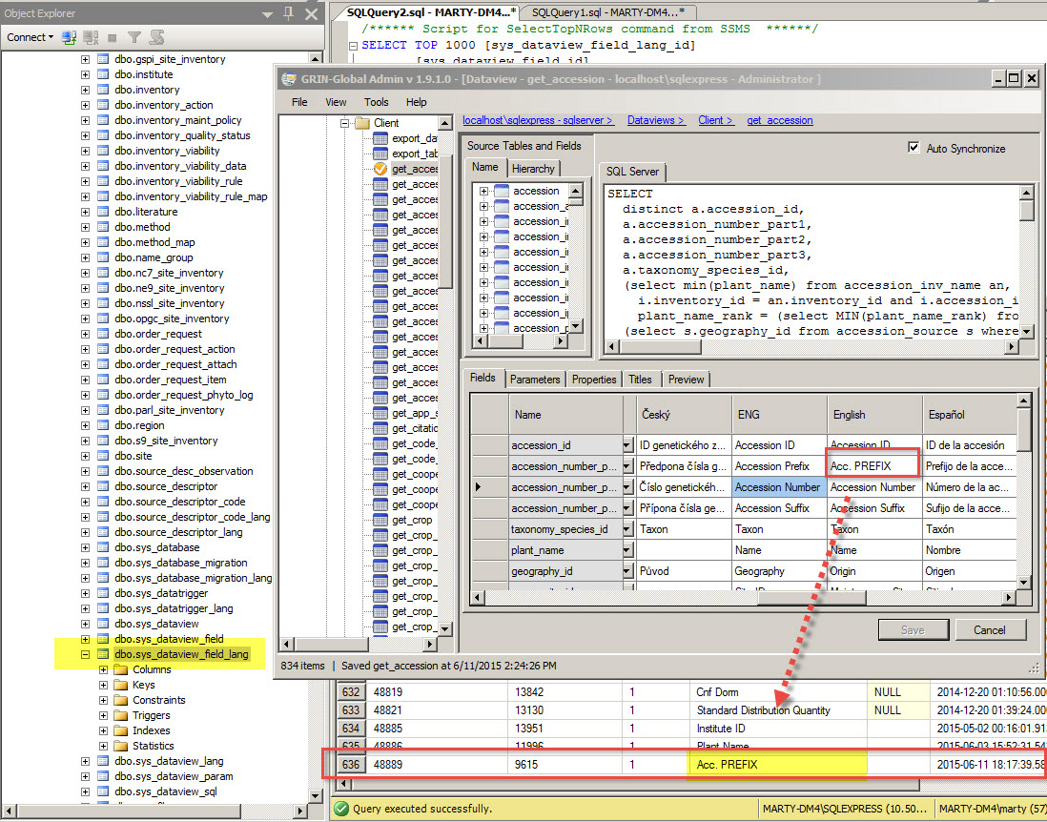
This graphic illustrates a smaller AT dataview editor window in front of the larger SQL Server Management Studio (SSMS) window (with the database records) in the background.

When you make any change to a title using the AT dataview editor, an SDFL entry is created. Later, if you decide to delete the changed title and revert back to the default title, simply use the editor and remove the heading.
Using the AT Table Mapping tool, you can review the default headings. Select a dataview, double-click on the field – the Titles and Descriptions will be listed.
You can edit Title or Description here.

Directions for Updating the sys_table _field_lang Table
The dataview get_sys_table_field_lang can be used to update the table field “friendly” names for a specific language. Mentioned earlier, this document has sample SQL that can be run on the Public Website to review the existing names (see SQL for Displaying Table Field Names).
In order to use this dataview in the Curator Tool, its Category Property needs to be set to “Client.” (Depending on the GG build version, it may already be set to “Client” by default. Since this dataview should only be used by the GG administrator, when not working with this dataview, change the Category to System (so that a user can not access the dataview).)
Ensure also that the dataview is not Read-Only and that the individual fields have their individual “Read Only?” check boxes unchecked.
In the CT, login as the administrator. Set up a Dynamic Folder with the following criteria:
@ sys_table _field_lang. sys_table _field_lang_id > 0 AND
@ sys_table _field_lang. sys_lang_id IN (1)
Supply the desired language_id in place of the 1 above. Refer to the The System Language Dataview section which discusses the language records.
Ensure that the get_sys_table_field_lang dataview is the active dataview.
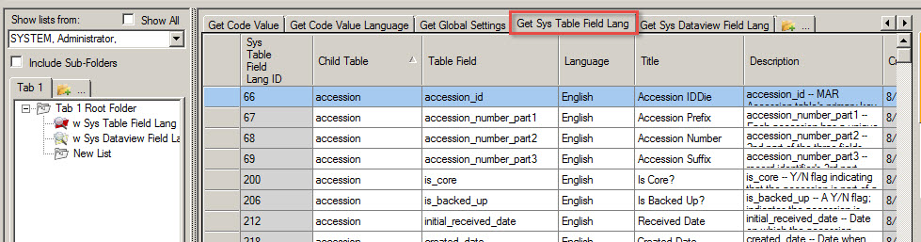
In Edit mode, you can modify or add new records as needed. Remember that the Description is visible when the user rolls the mouse over the column heading.

Directions for Updating the sys_dataview_field_lang Table
The dataview get_sys_dataview_field_lang2 can be used to update the dataview field “friendly” names for a specific field in a dataview. Refer to the Overriding the Default Friendly Column Heading Names section for a complete description of the records stored in the sys_dataview_field_lang table. Briefly, the names stored sys_dataview_field_lang table override the default names that originate from the parent accession.
It is likely that you will never need to open the get_sys_dataview_field_lang2 dataview in the Curator Tool. Why not? The default column heading names rarely need to be changed (overridden). When they do, the GG admin can simply use the Admin Tool’s dataview editor, and make the change manually. If a list of all of the fields that have been overridden is desired, in the Public Website you can run the SQL code for displaying the records (refer to the SQL for Displaying Dataview Field Names section).

If for some reason you do wish to open this dataview in the CT, the directions are similar to the directions above for using the sys_table_field_lang dataview. The Category must be set to “Client,” the dataview must not be Read-only, and the fields must not be Read only.
To display the records, use a similar dynamic folder query – in the CT, login as the administrator. Set up a Dynamic Folder with the following criteria:
@ sys_ dataview _field_lang. sys_dataview_field_lang2_id > 0 AND
@ sys_ dataview_field_lang. sys_lang_id IN (1)

Application Resources

Overview
When defining a new user, the administrator also assigns a default language for the user. Throughout the Curator Tool and Admin Tool interface, text items can be displayed in the user’s default (ideally his preferred) language. However, in the CT, the user can also select a different language via File on the main menu:
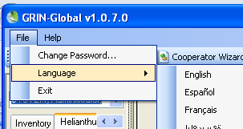
Each language displays its respective labels in the windows, boxes, and buttons. For example, the label above the treeview on the Curator Tool window displays “Show lists from:“ in English and “Mostrar las listas de:” in Spanish:
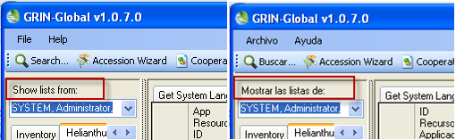
You can have multiple CT windows open – this is very helpful when determining the system name of an (application resource) object:
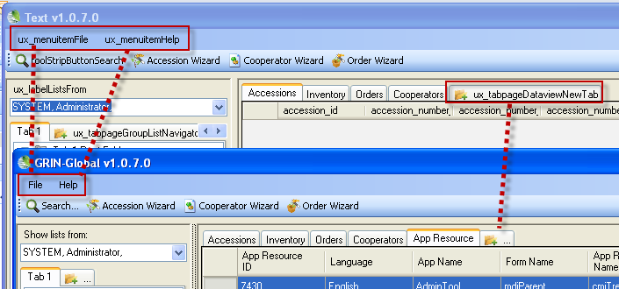

So where are these CT interface labels stored? In GRIN-Global’s dbo_app_resource table.
As the administrator, you can edit these text items to meet your organization’s needs. To be able to use the get_app_resource dataview in the Curator Tool, in the Admin Tool you will need to temporarily change the dataview’s Category to Client. You can use this dataview to copy the text data into a spreadsheet for further editing or quick mass updating. 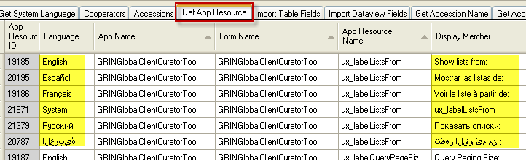
This updating is not generally done often, but is definitely necessary whenever an organization introduces a new language to be used within the GG software.
To determine the item’s App Resource Name, switch to System in the Curator Tool (Select File | Language | System).
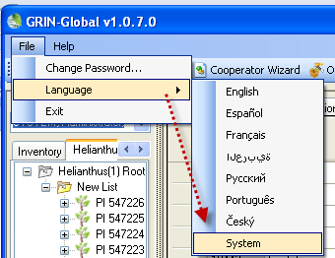
The interface will then display the system names which usually only the software developer uses:
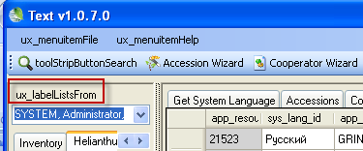

Correcting an Individual AppResource Item
If you need to correct an AppResource item, open the get_app_resource dataview in the Curator Tool. This DV is not normally available to users, so first, using the Admin Tool, you will need to change its category to Client (or Reports, since these are the only two Categories that can have their dataviews displayed. )
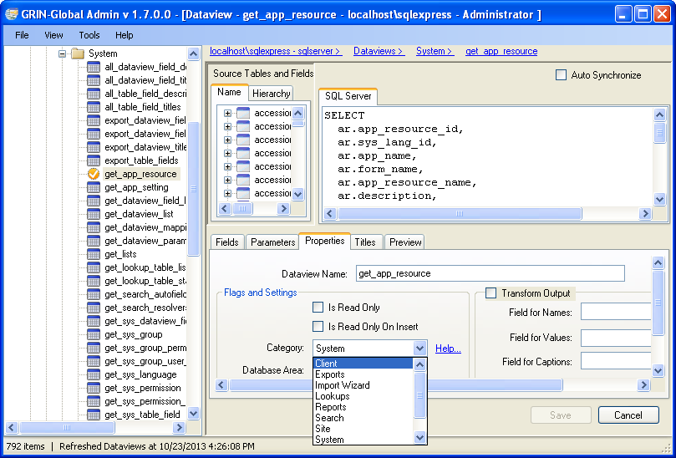
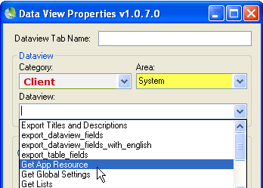
Locate the respective row in the grid, and edit and save the record:
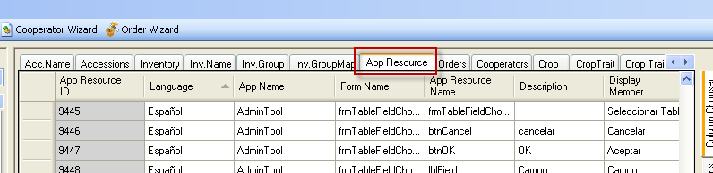

Mass Editing AppResource Items (or Adding Items When Adding a New Language)
Copy the AppResource data from the Curator Tool into a spreadsheet.
When editing existing data, consider sorting the data by app_name, then form_name, app_resource_name, language, etc. Edit the data in the spreadsheet, and then copy back into the CT as you would with any new data.
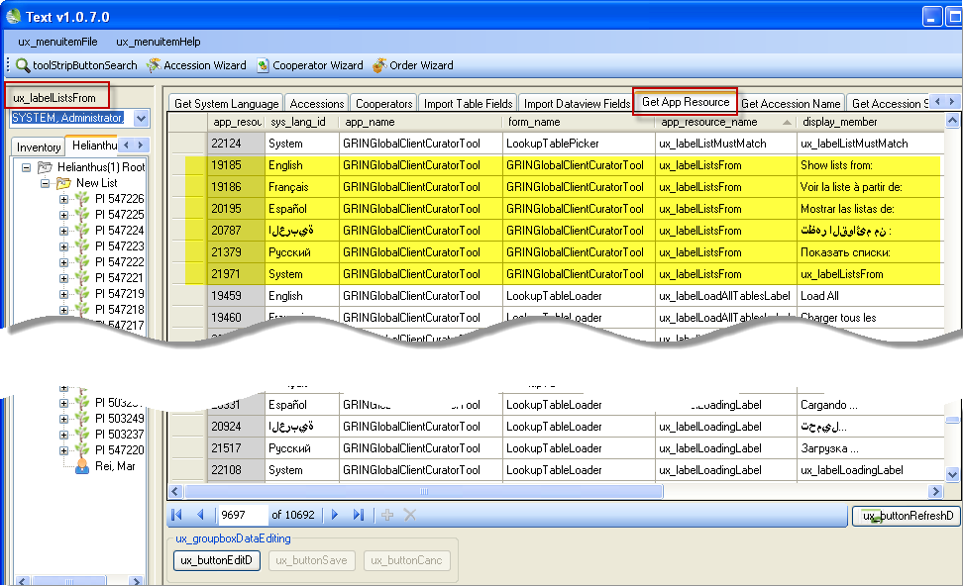

Adding a New Language’s App Resource Records
If you are adding a new language, you could filter the CT for just one existing language, such as English, and then drag those records into Excel.
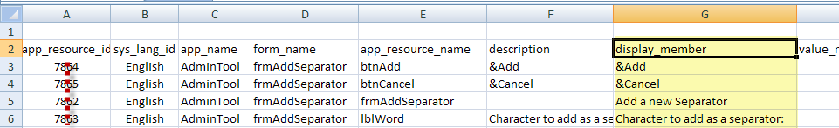
You will need to edit columns A, B, and G. In column...
- A – delete the existing app_resource_id’s (since these will be new records and will have their id’s assigned by the software)
- B – change the language to match the new language (see Adding a New Language section)
- G – using the language, edit the display_member fields (It might be easier to insert a new column adjacent to G, input your entries, and then delete the original column G entries, and ensure the heading of the new column is display_member

Dataview Properties (Titles and Descriptions)

Overview
Each dataview can be described with a Title and Description in each of the languages defined in the system. The get_accession dataview is shown here in the Admin Tool: 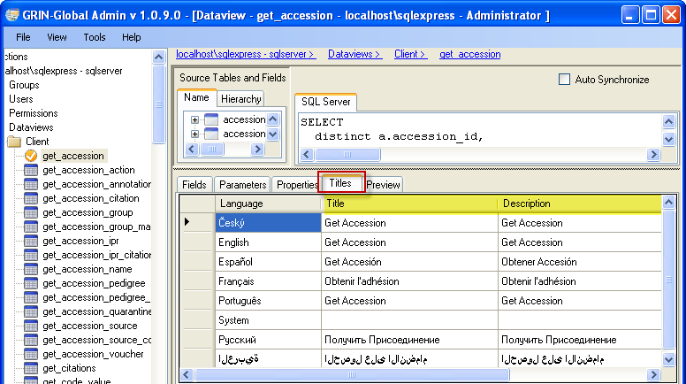
The Curator Tool users see the dataview titles in the Data View Properties window when they open a new dataview tab:
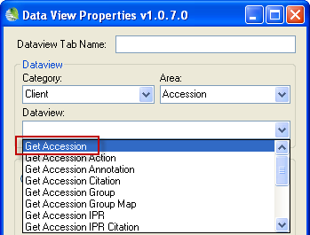
In the Admin Tool dataview editor, you can manually change a dataview’s Title and Description. If you need to edit many dataview titles and descriptions, rather than edit them one-by-one, you may prefer to edit them en masse using two companion dataviews that can be used to review and edit the Titles and Descriptions using the following directions.

Exporting Titles and Descriptions
Open the export_dataview_titles_and_descriptions dataview. To extract the titles and descriptions; select the Preview tab:
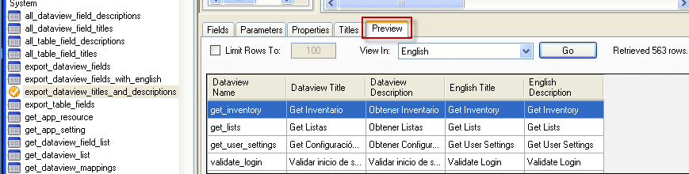
Uncheck the Limit Rows To: checkbox; click Go; input the value for the desired language (see page 4 for values); input 1 for the viewallrows parameter:
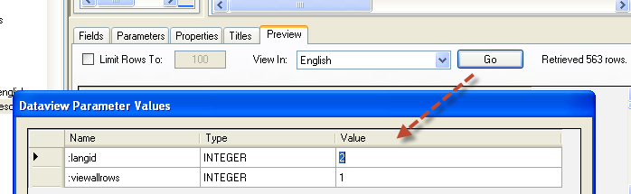 “2” indicates Spanish (Espańol)
The resulting display will list the Titles and Descriptions as well as their English equivalents:
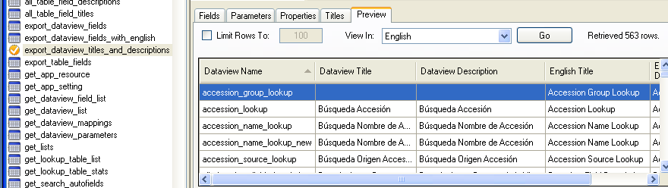
Copy these entries into a spreadsheet for review and editing. After editing, the next step is to import the data back into GG.

Importing Titles and Descriptions
Use the Import Wizard Import Dataview Titles and Descriptions dataview to import the Titles and Descriptions from the spreadsheet. Start the Import Wizard; select Import Dataview Titles and Descriptions from the dropdown menu; select the desired language:
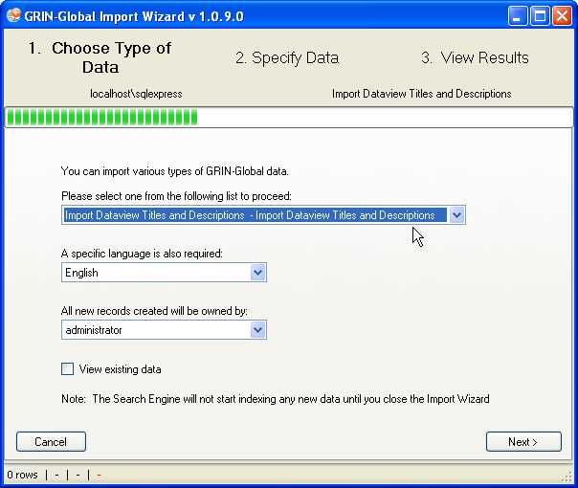
Click on the top left corner to select the headings; drag the translated headings into your spreadsheet:
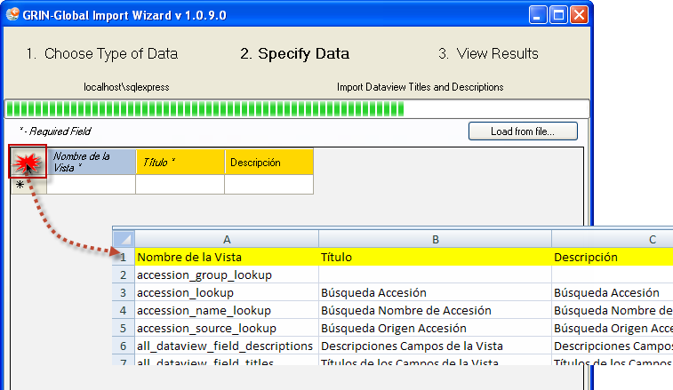

Drag the spreadsheet’s first three columns into the Import Wizard grid; click the Import button:
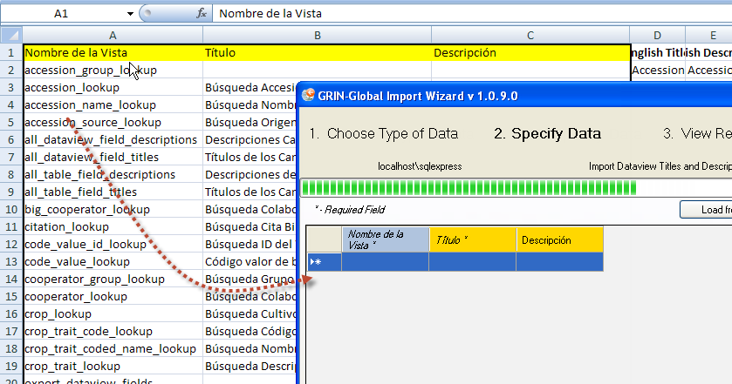

Code Groups

Overview
Many of the dataviews in the Curator Tool use dropdowns to assist the user in selecting a valid entry – the fields using dropdowns do not allow any random text data to be entered, but instead require a value from a pre-populated set of values. These values can be set up for each installed language in GRIN-Global.

Determining Where Code Groups are Used
Use the Code Groups tool in the Admin Tool to review the values for each group and also to review which dataviews use the code groups.
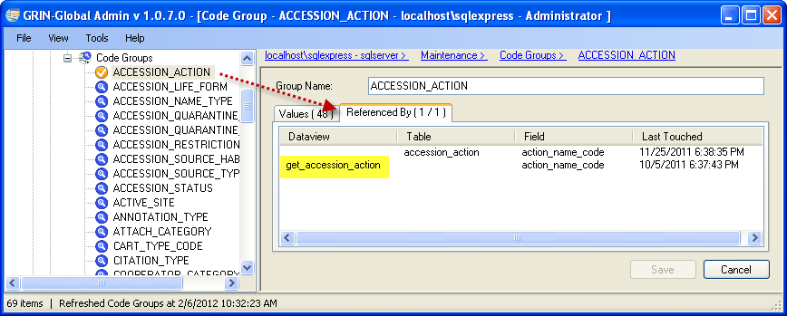
In the CT, open a dataview in Edit mode to review how the codes are being used:
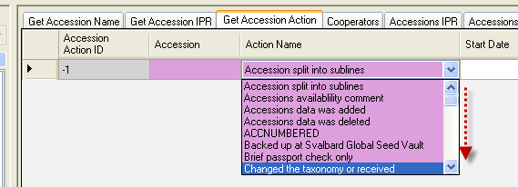
Further below, there is a section that explains why there is an English and an ENG language in versions post 1.0 (See English vs. ENG)
Example of a dropdown based on Codes:
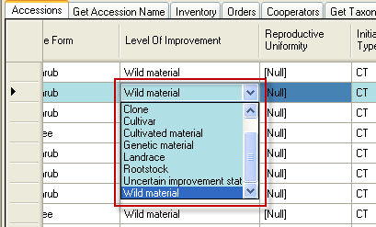
In the Database Code Groups & Values GRIN-Global section of the Setup Guide Cookbook, there is a detailed example illustrating how one Code Group, “IMPROVEMENT_LEVEL,” is set up in the Admin Tool and then used in the Curator Tool. You can easily edit or add codes manually using the Admin Tool Code Group editor, but when you desire to update many at one time, follow the “Loading en Masse” directions further down.

Editing Codes Individually
In the Admin Guide, there is a section titled Code Groups. There you will find detailed instructions for editing an existing code value. The section also explains how to quickly create a spreadsheet of code values for any Code Group, using the Admin Tool Code Group editor. This list can be modified, and then imported back into GG via the Import Wizard.
The Import Wizard doesn’t delete records, so any codes that need to be deleted must be deleted via the Admin Tool editor.

Loading en Masse
Directions are also included here for initially bulk-loading Code Groups and Code Values, using the Import Wizard. Basically, groups of codes can be copied and pasted via the Import Wizard (IW). This IW dataview displays in the dropdown:
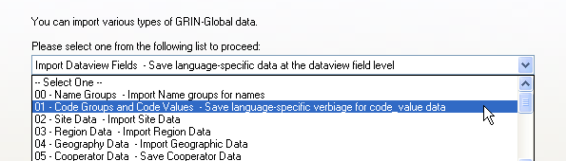

There are four fields that are imported, as shown in this example:
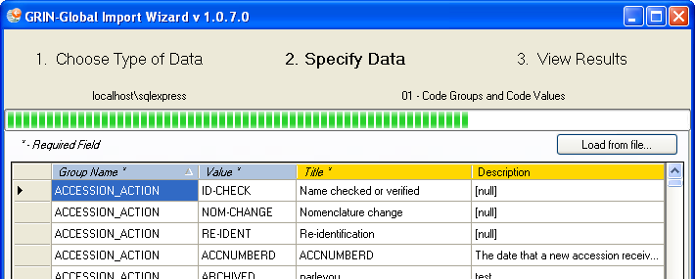

English vs.ENG

Background
Many Curator Tool dataview fields use dropdowns to assist the user in selecting a valid entry. To ensure data integrity, the dropdowns restrict the inputting of random text data, but instead require the user to select a value from a pre-populated set of choices. The organization’s GRIN-Global administrator sets up the values and titles for these codes. (The standard GRIN-Global installation supplies a base set of codes based on the codes used in the U.S. National Plant Germplasm System (NPGS). The codes have been translated into five languages (English, Spanish, French, Russian, and Arabic). )
The code values are typically short (less than under 20 characters). Various tables in GG (mainly code_value_lang) convert the internal codes to their lengthier titles, which are language specific. For example, the Order Item Status Code which is stored internally as “SHIPPED” can be displayed as ”Shipped order item” in English and “Envíe item del pedido” in Spanish.
NPGS GRIN-Global users seem to be in two camps. Some prefer seeing the shorter internal code values displayed rather than the longer titles. To accommodate both preferences, in the post-1.0 version of GG, an additional “language” (ENG) was included with the installation of GG. Users who set their language to ENG will see the code values displayed in a number of places (after reloading the appropriate lookup tables). For example, when using ENG as their language, they will see the code SHIPPED, whereas users with English as their language will have the Code’s English title displayed “Shipped order item.” NPGS users are initially setup with English as their default language, but they can switch back and forth as desired. (Switching languages)
Other organizations may also decide to create two versions of some of the dataviews so that users could decide to work with the codes rather than the titles. Use the ENG dataviews as a model.

ENG Example
In the following example, when adding a new order request item record in the Curator Tool, with ENG selected for his language, the user will see the shorter codes:
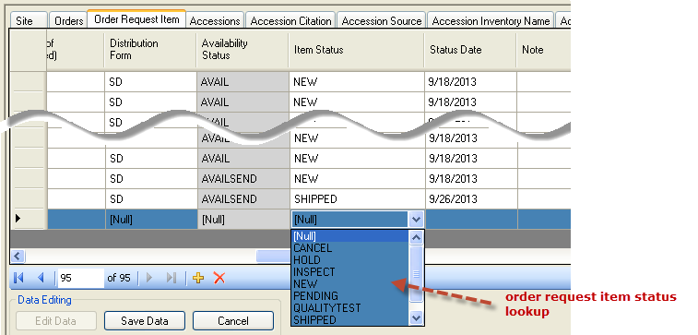

English Example
When the user’s language is English, user will see the lengthier Titles:
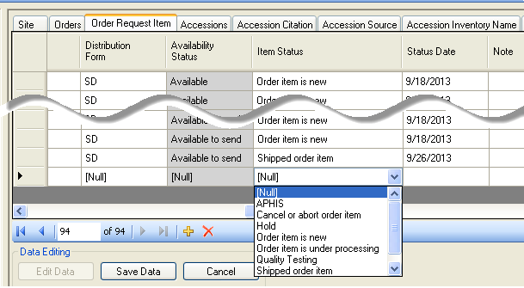
The GRIN system used a convention where the Codes were always spelled in upper case. This has been carried over to GRIN-Global, but other organizations may establish their own convention.

How does the user switch language?
On the CT’s menu, the user needs to select File | Language and then select the desired language from the languages displayed on the menu.
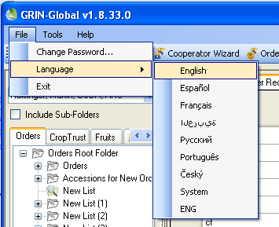

Where does the text for these codes come from?
The administrator controls what text is stored with each code. The screen below was copied from the Admin Tool, which only the organization’s GRIN-Global administrator (or users with administrative privileges) will have access to. If you review the ENG and English described earlier, you can see the Value is displayed when ENG is the user’s selected language; Title is displayed when English is set for the user’s language.
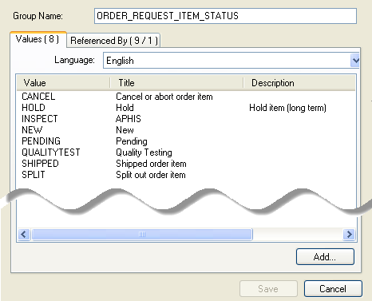
Administrators can reference two documents for updating codes. The Admin Guide has directions for using the Admin Tool’s Code editor; the Import Wizard Cookbook has details for bulk loading codes (initially done when the administrator is initially setting up the organization’s database).

Spanish Example
In the following example, Spanish was selected for the language. It appears that in this situation, there is a mixture – for some codes, some values are displayed, and for others, titles.
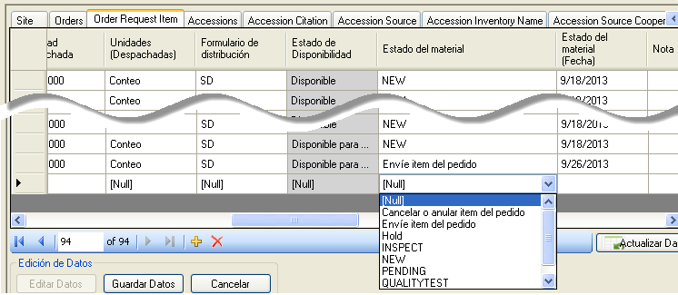
The following Admin Tool screen shows how the Spanish data was installed:
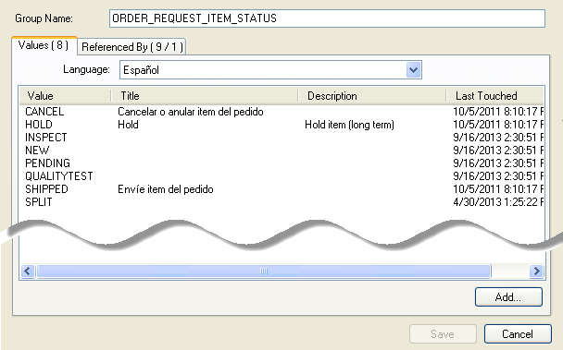
You can conclude that the Title trumps the Value, that is, if the code has an associated Title, the Title will display in the Curator Tool , otherwise, the Value displays when the user is selecting from a lookup.

The following two screens illustrate how English and ENG are working. The English codes have associated Titles; the ENG codes do not. When the user is using English as his language, he will see the Titles displayed, when in ENG, only the Values.

English
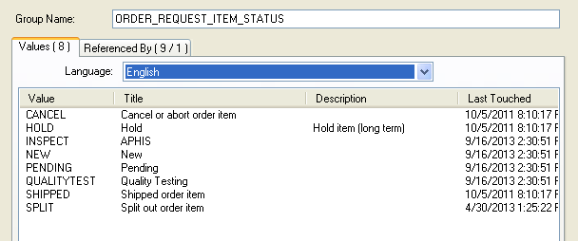

Eng
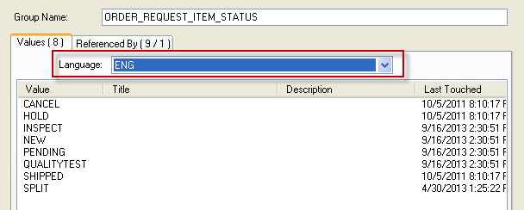

Updating the Lookup Tables When Switching Languages
Curator Tool users do not need to reload all of their lookup tables after switching languages, but they will be prompted that their tables are not up to date. Normally a user will rarely switch languages, but he can. The user may only need to reload few lookup tables if he is mainly concerned with seeing codes in a particular context.

Lookup tables that may need updating when a user switches languages
- Code Value Lookup
- Cooperator (Big) Lookup
- Crop Trait Code Lookup
- Crop Trait Lookup
- Geography Lookup
- Inventory Lookup
- Mailing Geography Lookup
- Source Descriptor Code Lookup
- Taxonomy Geography Map Lookup

Codes That Have Identical Values and Titles
There are a few Code Groups that have identical titles and values. The primary reason the codes were set up in this fashion relates to the original GRIN nomenclature used by the NPGS. Organizations adapting GG for their database will most likely wish to review the titles and change them to meet their specific needs.
As a reminder, in a new GG installation where the organization is starting with fresh data, the organization can establish which codes they intend to use and delete those that they will not use. For example, in the NPGS, there are 312 codes for the code group PATHOLOGY_TEST in GG version 1.9.
group_name | value | title
ACCESSION_STATUS | INACTIVE | Inactive
CART_TYPE_CODE | FAVORITE | Favorite
CART_TYPE_CODE | ORDER ITEMS | Order Items
COOPERATOR_STATUS | ACTIVE | ACTIVE
COOPERATOR_STATUS | DEAD | DEAD
COOPERATOR_STATUS | HISTORICAL | HISTORICAL
COOPERATOR_STATUS | INACTIVE | INACTIVE
GERMPLASM_FORM | ** | **
GERMPLASM_FORM | BD | BD
GERMPLASM_FORM | BL | BL
GERMPLASM_FORM | CA | CA
GERMPLASM_FORM | CL | CL
GERMPLASM_FORM | CM | CM
GERMPLASM_FORM | CT | CT
GERMPLASM_FORM | DN | DN
GERMPLASM_FORM | ER | ER
GERMPLASM_FORM | FI | FI
GERMPLASM_FORM | FR | FR
GERMPLASM_FORM | GS | GS
GERMPLASM_FORM | HE | HE
GERMPLASM_FORM | HS | HS
GERMPLASM_FORM | IO | IO
GERMPLASM_FORM | IV | IV
GERMPLASM_FORM | LA | LA
GERMPLASM_FORM | LV | LV
GERMPLASM_FORM | MF | MF
GERMPLASM_FORM | MI | MI
GERMPLASM_FORM | MS | MS
GERMPLASM_FORM | PD | PD
GERMPLASM_FORM | PF | PF
GERMPLASM_FORM | PL | PL
GERMPLASM_FORM | PO | PO
GERMPLASM_FORM | PR | PR
GERMPLASM_FORM | RH | RH
GERMPLASM_FORM | RN | RN
GERMPLASM_FORM | RT | RT
GERMPLASM_FORM | SC | SC
GERMPLASM_FORM | SD | SD
GERMPLASM_FORM | SG | SG
GERMPLASM_FORM | SP | SP
GERMPLASM_FORM | ST | ST
GERMPLASM_FORM | TC | TC
GERMPLASM_FORM | TU | TU
LITERATURE_TYPE | ARTICLE | Article
LITERATURE_TYPE | BOOK | Book
LITERATURE_TYPE | JOURNAL | Journal
LITERATURE_TYPE | PERIODICAL | Periodical
LITERATURE_TYPE | URL | URL
TAXONOMY_NOXIOUS_TYPE | AQUATIC | Aquatic
TAXONOMY_NOXIOUS_TYPE | SEED | Seed
TAXONOMY_NOXIOUS_TYPE | TERRAIN | Terrain
TAXONOMY_NOXIOUS_TYPE | TURF | Turf
TAXONOMY_SUPRAFAMILY | CLASS | Class
TAXONOMY_SUPRAFAMILY | DIVISION | Division
TAXONOMY_SUPRAFAMILY | KINGDOM | Kingdom
TAXONOMY_SUPRAFAMILY | ORDER | Order

SQL Statements for Adding a New Language and Cloning the Friendly Names for Fields and Dataviews

“9“ is used in the sample SQL code below as the ID value for the new language. You need to determine for your GG installation what the next language_id value is and substitute that for the 9’s in the examples below. You’ll also need to replace the 1 for English with the number of whatever language you are cloning.
“ENG” was the new language in this example. You will need to replace the text strings in the first INSERT statement with your information. (Refer to the Adding a Language to GRIN-Global section for details. Also, see http://en.wikipedia.org/wiki/IETF_language_tag.) Since private-use language tags beginning with an “x- prefix,” consider using x- for the prefix to your ietf-tag.

INSERT INTO sys_lang
(iso_639_3_tag, ietf_tag, title, description, created_date, created_by, owned_date, owned_by)
VALUES('ENG', 'x-en-CODE', 'ENG', 'English with short codes', GetDate(), 1, GetDate(), 1)
SELECT * FROM sys_lang
INSERT INTO sys_table_field_lang
(sys_table_field_id, sys_lang_id, title, description, created_date, created_by, modified_date, modified_by, owned_date, owned_by)
SELECT
sys_table_field_id, 9, title, description, created_date, created_by, modified_date, modified_by, owned_date, owned_by
FROM sys_table_field_lang WHERE sys_lang_id = 1
INSERT INTO sys_dataview_field_lang
(sys_dataview_field_id, sys_lang_id, title, description, created_date, created_by, modified_date, modified_by, owned_date, owned_by)
SELECT
sys_dataview_field_id, 9, title, description, created_date, created_by, modified_date, modified_by, owned_date, owned_by
FROM sys_dataview_field_lang WHERE sys_lang_id = 1
INSERT INTO sys_dataview_lang
(sys_dataview_id, sys_lang_id, title, description, created_date, created_by, modified_date, modified_by, owned_date, owned_by)
SELECT
sys_dataview_id, 9, title, description, created_date, created_by, modified_date, modified_by, owned_date, owned_by
FROM sys_dataview_lang WHERE sys_lang_id = 1

You can test this by starting the Curator Tool, click on the File menu at the top left, click on Language, then click on ENG (your “new” language) at the bottom of the list instead of English. You will get a message about needing to reload your lookup tables, but you only need to reload several: Code Value Lookup, Crop Trait Code Lookup, and Crop Trait Lookup. Those should be quick to reload.

Appendix

Deleting a Dataview

Overview
Whenever a dataview has a friendly name added or edited, a record is added to the dbo.sys_dataview_field_lang table in the database. If for some reason the intent is to have that friendly name removed from this table, it will be necessary to delete the modified dataview and then import the dataview back into GG.

Step-by-step Directions
These directions guide you through making a copy of a dataview before editing the original one. This ensures that the original can be restored if needed for any reason. In the process, you will have two similar dataviews, the original and a copy.
- In the AT, select the dataview that is to be corrected. (For example, a dataview with redundant language-friendly column names.)
- Right-click the dataview that is to be repaired; select Copy To:
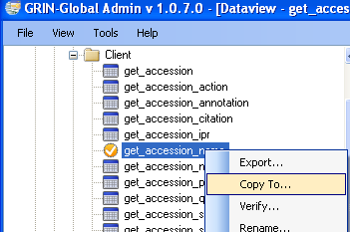
and provide a temporary name for this copy:
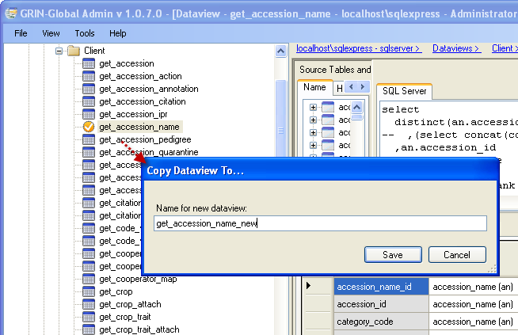
- Select the new (copied) dataview. Make your corrections to the copy.
In any dataview, each language-friendly column heading name must be unique.

- Keep both dataviews, the original and the copy, until you are certain everything is working as you expect it to. To do that, in the list view (the right grid,) select both dataview names, right-click, and select Export...
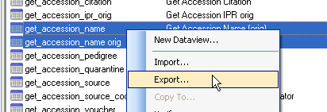
The dataviews will be saved on a drive with the extension “dataview.” When you save a dataview for the first time, specify a dedicated folder that can serve as the holding place for any GG dataviews saved in the future. (The folder can hold other items, but it will be easier to view the dataviews if that is the sole purpose of the folder.) After the first save, GG by default will display that folder again as the potential folder whenever you attempt to save a dataview file.
- Delete both dataviews. To do that, in the list view (the right grid), select both dataview names, right-click, and select Delete
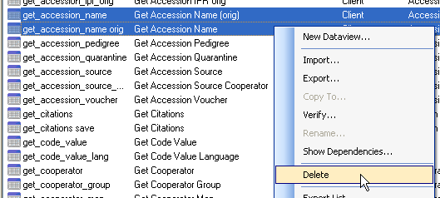
- Now import the corrected dataview. At the Dataviews level, select Import...
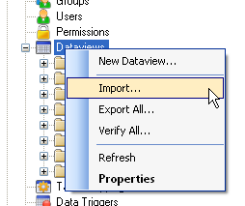
- Select the dataview with the corrections:
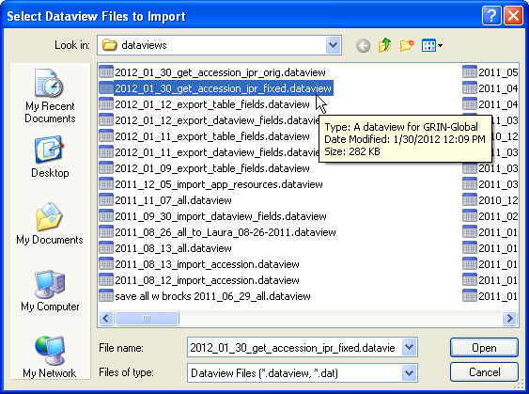
- In the AT dataview editor, rename the corrected version with the original dataview name.
When you are satisfied with the new dataview, there is no need to keep storing the original dataview file. You can delete it from your drive or just hold onto it for awhile as a backup of the original.

Appendix: Changes in this Document

– December 12, 2023
- Edited get_system_language to get_sys_language

– June 5, 2015
- major revamping of this document;
- completely changed the process for modifying the field titles and descriptions (no longer using the Import Wizard method)

– October 28, 2014
- two new dataviews were created to facilitate the updating of the column Titles and Descriptions – one for the Table entries and one for the and the override fields

– October 2, 2014
- edited the information about the filenames used to import/export the table field names
- refreshed some screens related to import/export the table field names

