Order & Cooperator Wizards

Versions 1.9.9.4 and later

Revision Date
October 1, 2020

Comments
Curator Tool version 1.9.9.4 includes significant enhancements to the Cooperator Wizard and the Order Wizard. This document is focused on these enhancements. For complete background and details of any Curator Tool features, please review the respective guides that are online and available at the GG Project website.
The Release Notes for 1.9.9.4 are online at https://www.grin-global.org/docs/CT_Release_Notes.pdf.
The Appendix contains this document’s revision notes. Review the Table of Contents which contains links to the document’s sections.

Author
Any questions regarding this document may be forwarded to Marty Reisinger at marty.reisinger@usda.gov or mar@rrginc.com.

Table of Contents

Versions 1.9.9.4 and later 1
Cooperator Wizard 3
Cooperator Tab 3
Web Cooperator 5
Match 6
Web Order 8
Order Wizard 1.9.9.4 (and later) 9
Background 9
Cooperator Already in the Database 11
New Cooperators 13
Ship to Address Differs 20
Other Changes in Release 1.9.9.4 and later 25
Merging Orders 25
Canceling Orders 25
Phyto Log 26
SMTA Warning 27
Appendix: Document Revision Notes 28
– October 1, 2020 28
– September 24, 2020 28
– July 24, 2020 28

Cooperator Wizard
In release 1.9.9.4, the Cooperator Wizard was significantly changed in appearance and functionality. Many of the Cooperator Wizard enhancements facilitate finding existing matching Cooperator records with the incoming web order’s Web Cooperator data when using the Order Wizard. However, the Cooperator Wizard can be used on its own, to simply find cooperator or web cooperator records.
GRIN-Global has two distinct “cooperator” tables. A user of the Public Website, when the user registers, creates a Web Cooperator record. When completing their profile, the user can indicate a shipping address. a user also has the opportunity to provide a different shipping address when submitting an web order.
Separately, a Cooperator table exists. This is a more inclusive table, containing records for the GG organization’s staff members, germplasm donors, institutes and organizations, and web cooperators whose information has been copied into the cooperator table.
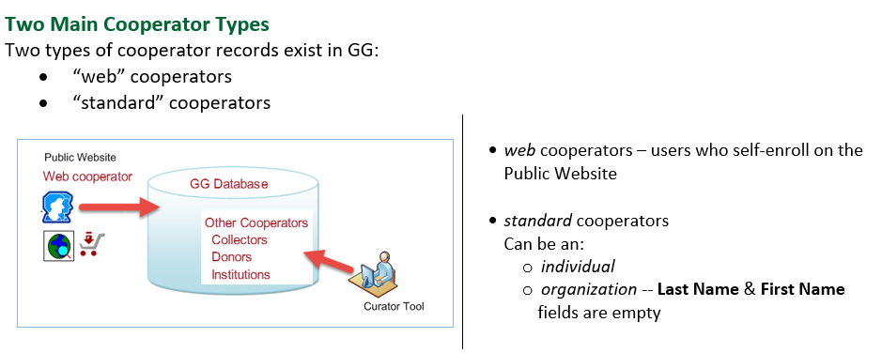

Cooperator Tab
Search fields are listed in the left panel. The Match radio buttons make it possible to find contents with exact or partial matches. The Exact radio button is more flexible than its name implies, since when selected, you can use wild cards (% * and -) to find partial matches.
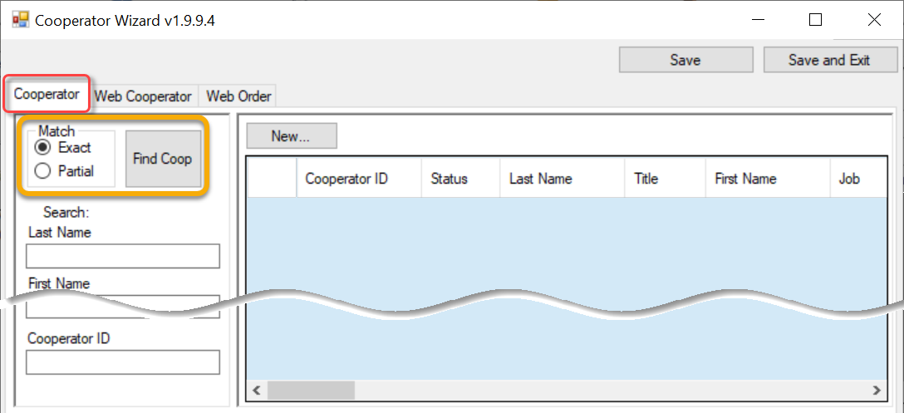
Wildcards in GG are the three special characters: % * _

The % and * are essentially equivalent: any character, any number of characters. However, the underscore _ means any one character. The broadest searches can use leading and trailing %, surrounding a text string, such as %RRG%

Exact Match Example 1
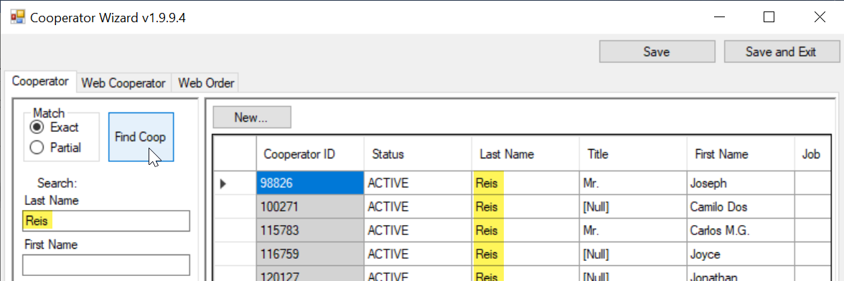

Exact Match Example 2
An Exact match is illustrated below, but the database is case insensitive, so the lowercase “r” works. Additionally, a wildcard is show being used to illustrate an exact match can work with wild cards.
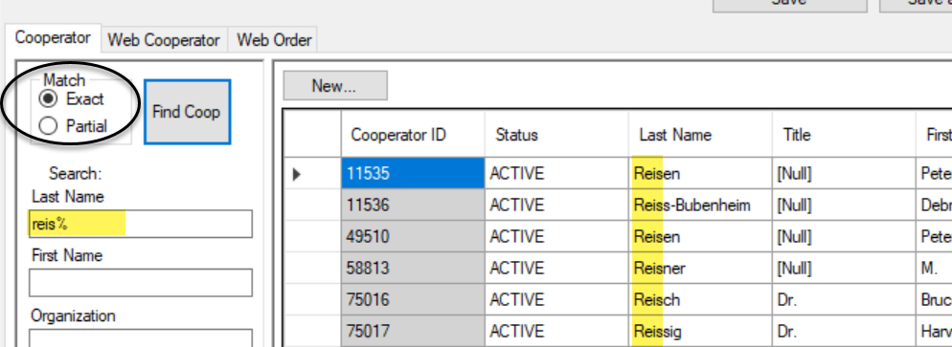

Partial Match 1
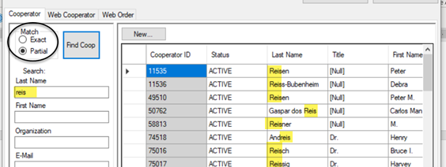
is the same as:
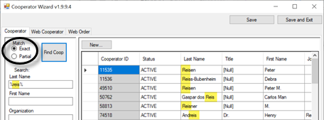

Web Cooperator
As a reminder, a web cooperator is a user who has self-enrolled on the Public Website. (Refer to the online Cooperators Guide for details.)
When the Web Cooperator tab is selected, the two panels on the right show web cooperators in the top frame, and cooperators in the bottom. More details follow this image.
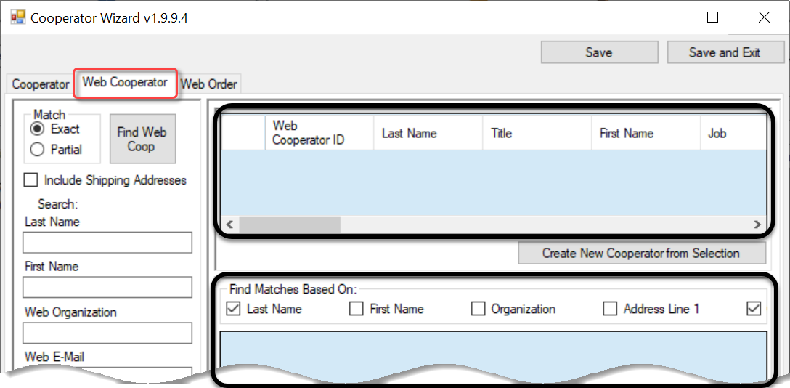

Match
Exact/partial radio buttons - work similar to the Cooperator tab’s – use the radio buttons to switch between exact and partial matches. However, in this case, the Find button is Find Web Coop. In this top right frame, the search is looking through the web cooperator table.

Example 1:
Many web cooperator records were found whose last name = “reisinger” (top right panel) The bottom right panel shows that multiple cooperator records exist that match by Last Name and Geography fields.
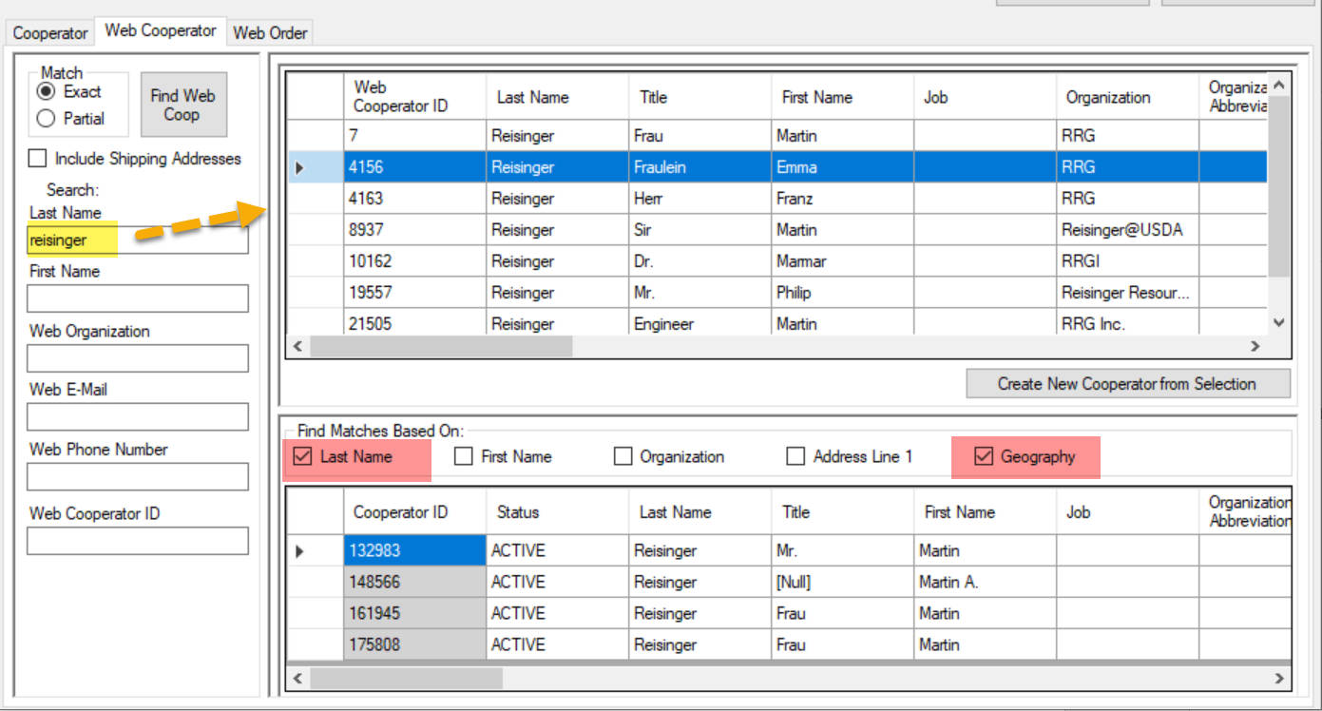
The results can be confusing at first, until you scroll to the right to see the highlighted web cooperator’s Geography field. Scrolling to the right on the bottom panel, we can see better what is happening – there are four cooperator records whose Last Name is= “reisinger” and whose Geography field’s contents match the highlighted record in the top panel:
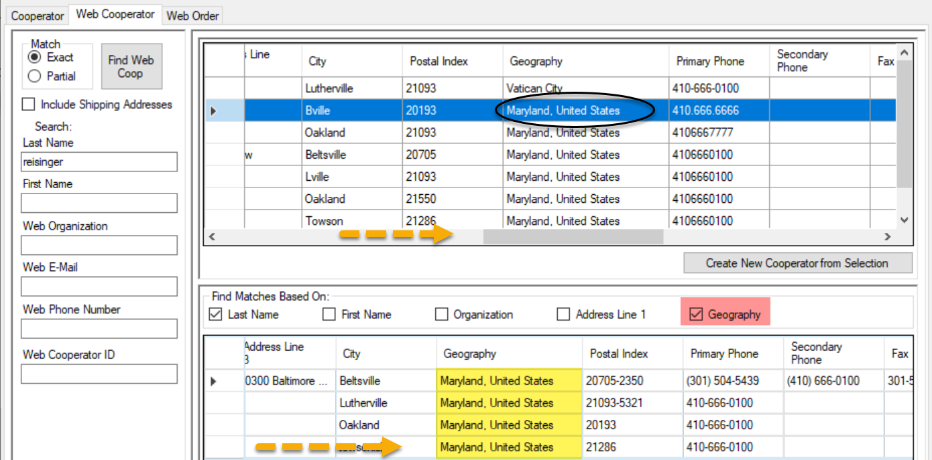
Example 2:
No cooperator records were found when selecting for matches by the Last Name and First Name fields. This indicates a Web Cooperator exists for an Emma Reisinger, but the database does not have an Emma Reisinger Cooperator record.
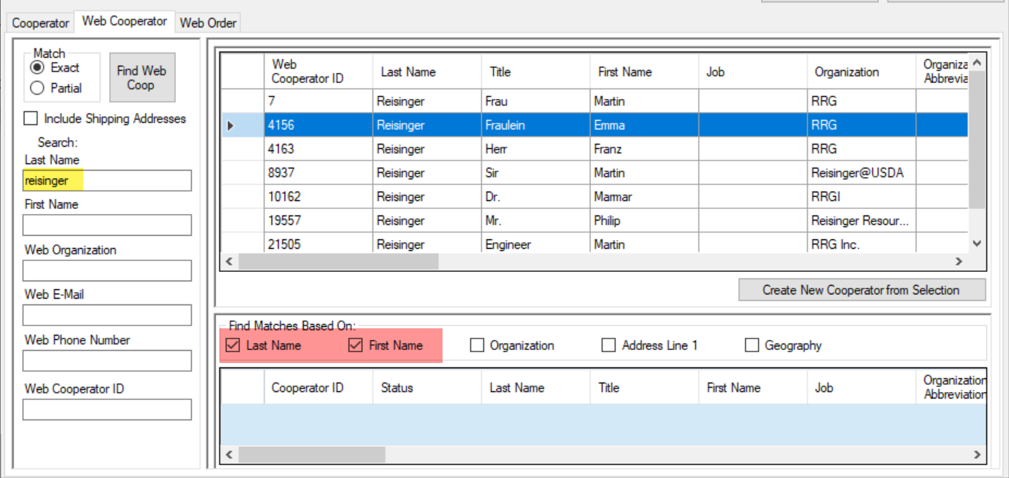

Include Shipping Addresses
When searching the web cooperators, the option to Include Shipping Addresses will list shipping addresses for a web cooperator when a match exists. In the search below, the search was looking for “reisinger” and “martin.” Apparently there are three shipping addresses in the database that match. (The negative IDs indicate these three records were found in the Shipping Address table.)
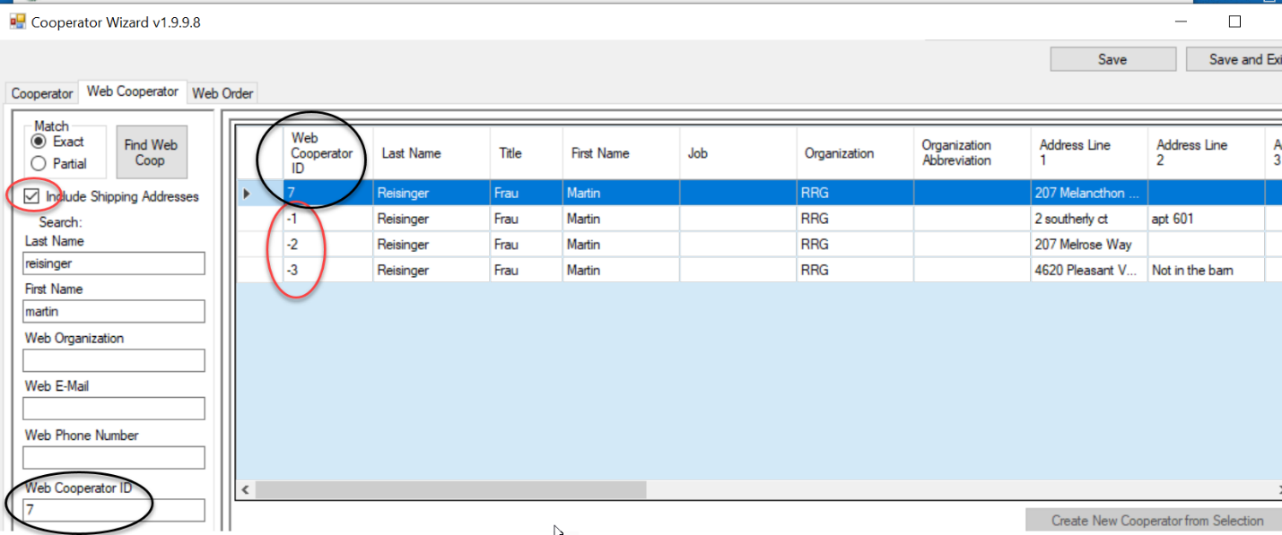
When a public user edits his profile, if he deletes a shipping address, it will no longer be listed.

Web Order
The Web Order tab was primarily designed to work in conjunction with the Order Wizard. Details for this tab are explained in the Order Wizard section.
However, you can use the Cooperator Wizard in a standalone fashion to find out web cooperator information corresponding to a web order.
The scroll bars has been disabled when using the Cooperator Wizard in this fashion. The Primary and Shipping address information can be viewed in the left panel.
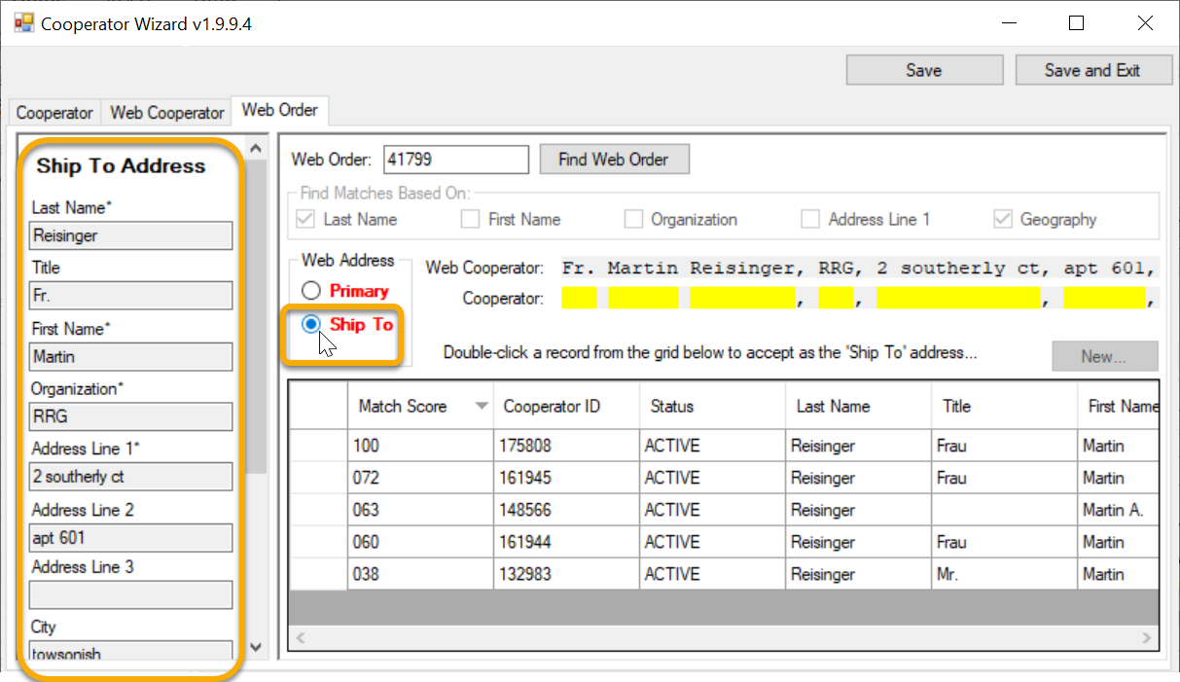

Order Wizard 1.9.9.4 (and later)

Background
In explaining the Order Wizard, the discussion also involves the Cooperator Wizard and cooperators. Version 1.9.9.4 and later makes it easier for the staff person processing a germplasm request to determine if there is a possible match between the incoming cooperators on the web order and the cooperators in the database. The Order Wizard interacts with the Cooperator Wizard to accomplish this comparing / matching.

Two Cooperator Tables
Two distinct cooperator tables exist in GG: Web Cooperator and Cooperator. They have entirely different origins. A web cooperator is a user who has self-enrolled on the Public Website. (Refer to the online Cooperators Guide for more details.) The following is extracted from that guide:
GG’s Cooperator table has a legacy dating back to GRIN. (Some may question the current structure of that table and the fact that the Web Cooperator table has a different structure. Besides their structures, record ownership is also distinctly different.)
When the web order is processed within the Order Wizard, during the process, an Order is generated. A public website user who creates his or her profile is the owner of his/her Web Cooperator record. The Order Wizard needs to convert the web order’s current Web Cooperator data into the Cooperator table because the Order Request uses three fields - Final Recipient, Requestor, and Ship To fields - that relate to records in the Cooperator table, not the Web Cooperator table.
The intent of the CT 1.9.9.4 Order Wizard is to enable the person managing the order to readily determine if the Cooperator table already has records similar to the incoming web order information.

Requestor’s Profile
When a requestor completes his profile, he can initially supply two different addresses. He may list his “primary address,” but distinguish it from a shipping address. Over time, it is possible for a requestor to create additional shipping addresses or to edit his primary address. Shown here is the Public Website’s User Profile page:
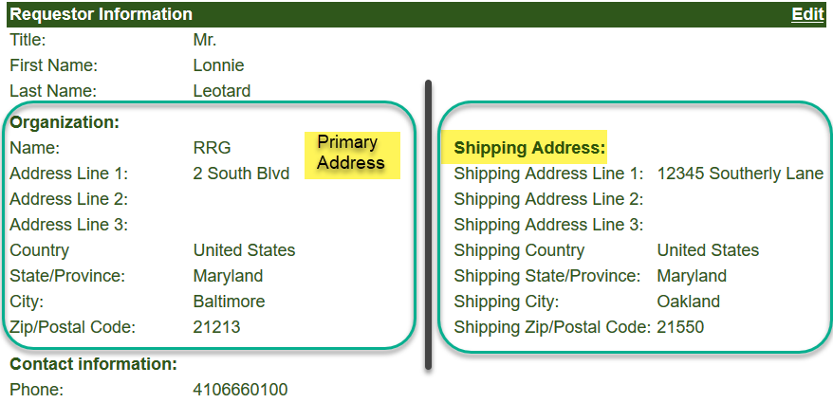
Different distinct cases are possible regarding requestors who have submitted a web order to GRIN-Global:
- the germplasm requestor is already in the database and his addresses on his germplasm request match the addresses on his existing cooperator record
- the germplasm requestor is completely new to the GG database – the database has no corresponding Web Cooperator record, and therefore no corresponding Cooperator record exists in the Cooperator table. This new web cooperator may be using the same address for his Primary and his Shipping addresses, but in some cases the Shipping Address differs.
- the germplasm requestor is already in the database, but one or both of his addresses do not match his existing cooperator record. When an address is different, it usually is the Shipping Address, but sometimes it could be a change made to correct a previous typographical error, or to add additional address information such as a Building number.

Cooperator Already in the Database
In the following example, the web cooperator is already in the database.
After the Create New Order Request button is clicked, the Web Order tab of the Cooperator Wizard window displays. Existing Cooperator records that might match the Web Cooperator are listed in the bottom frame. The grid lists one with a score of 100 (A). To use this cooperator record for the Primary address, double-click on the row.
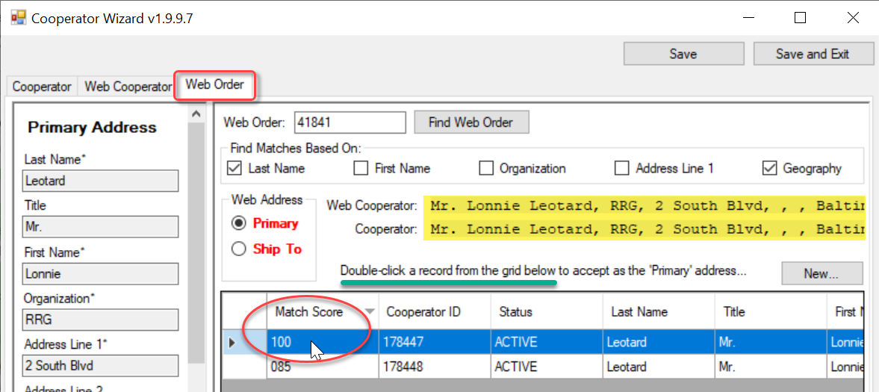
After the double-click, notice that now the Primary button heading has black text, indicating that the cooperator will be used for the Primary address fields on the order. (The Final Recipient and the Requestor fields on the Order Request will eventually use this Primary address.)
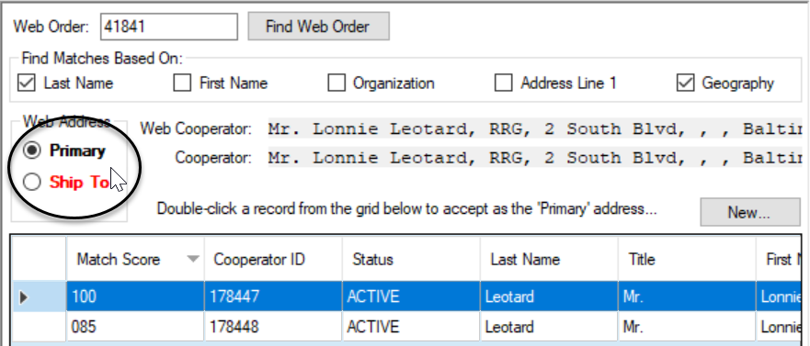
Click on the Ship To button and repeat the process. In this example, the shipping address is different from the Primary address, but there is already a cooperator record in the database that matches perfectly (score is 100). So as before, double-click the row to accept that cooperator record for the shipping address:
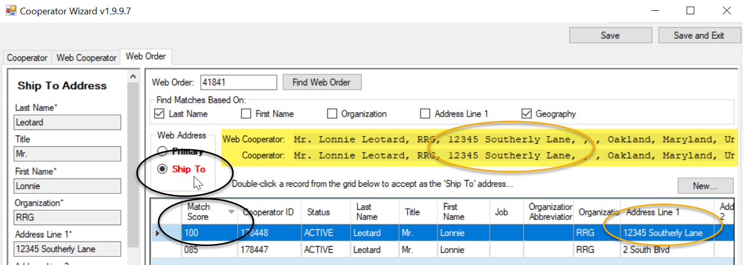
As before, the Ship To label will change from red to black.
Since you have found matching cooperator records for both the Primary and Shipping addresses, you should now click the Save and Exit button at the top right. A confirmation message will pop up indicating you were successful, and after a few second delay, the Order tab on the Order Wizard will display. Click the Save button because at this point because an order number has not yet been assigned. It will do so after this new order is saved.
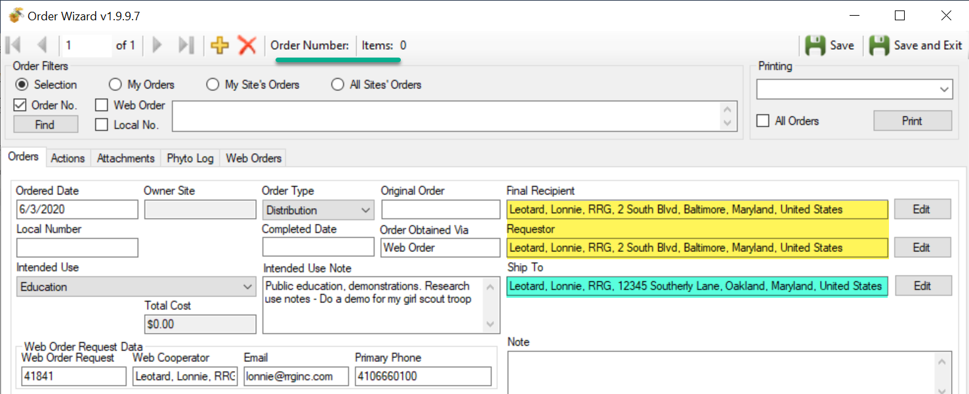

New Cooperators
In this example, the web cooperator is completely new – there is no match in the cooperator table. The following pages will illustrate the steps involved to create a new cooperator record. A video demonstrating these is available at:
https://www.grin-global.org/videos/newcoop1994/newcoop1994.html
the Create New Order Request button is clicked: 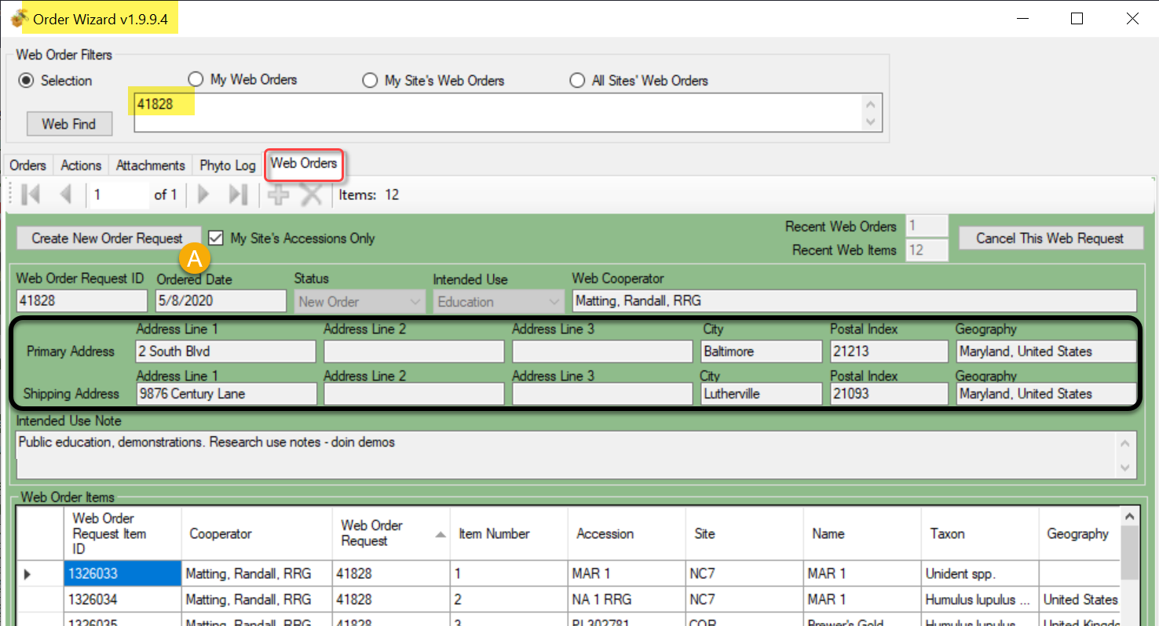

After the Create New Order Request button is clicked, the Web Order tab of the Cooperator Wizard window displays. Existing Cooperator records that might match the Web Cooperator are listed in the bottom frame.
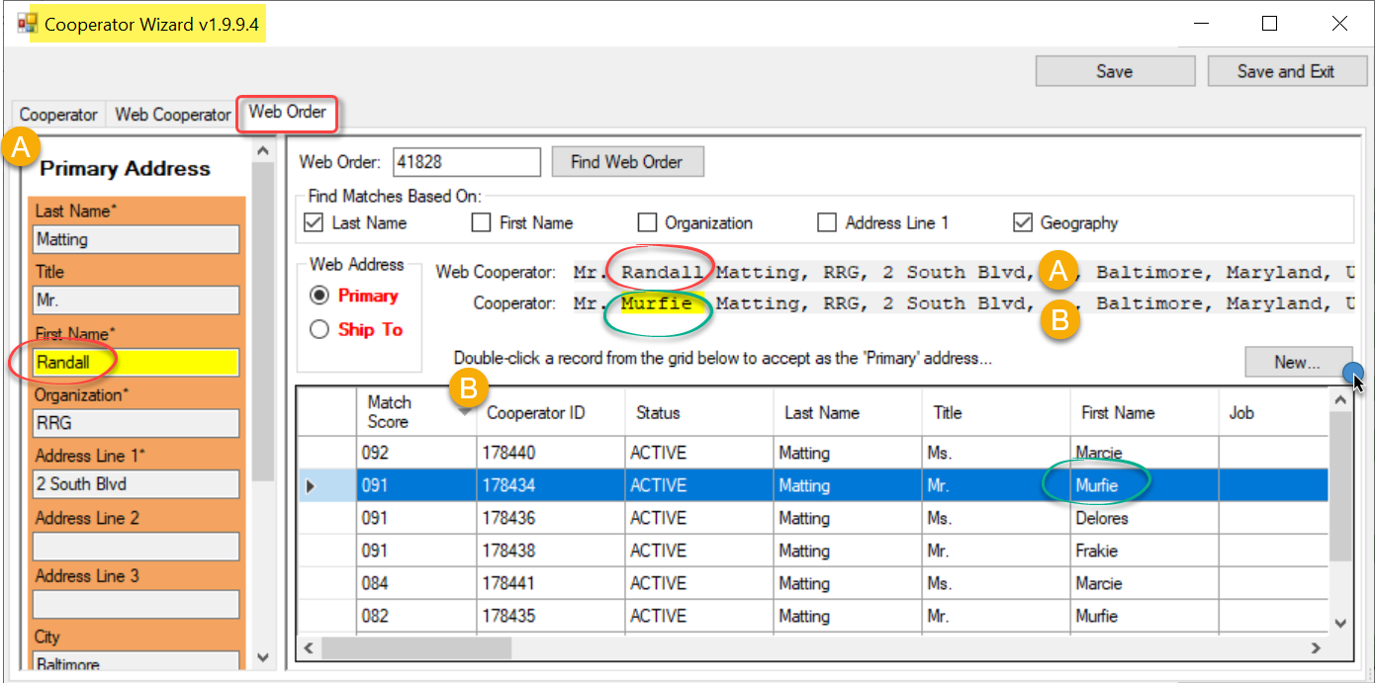
The potential matches are assigned a score – a 100 would be a perfect match. In this example, there isn’t a “perfect” match, that is, an existing Cooperator with all of the more important fields matching. The highest match score shown is 92. One big difference here is the First Names are different. Not shown in the image because the field is further to the right out of view, the Street Address (Address Line 1) differs for the bottom two records, hence the lower Match scores. It is probably safe to assume then that this is a different person because of the different first name, so a new Cooperator record most likely should be created. The user clicks on the New button…

the window flips to the Web Cooperator tab:
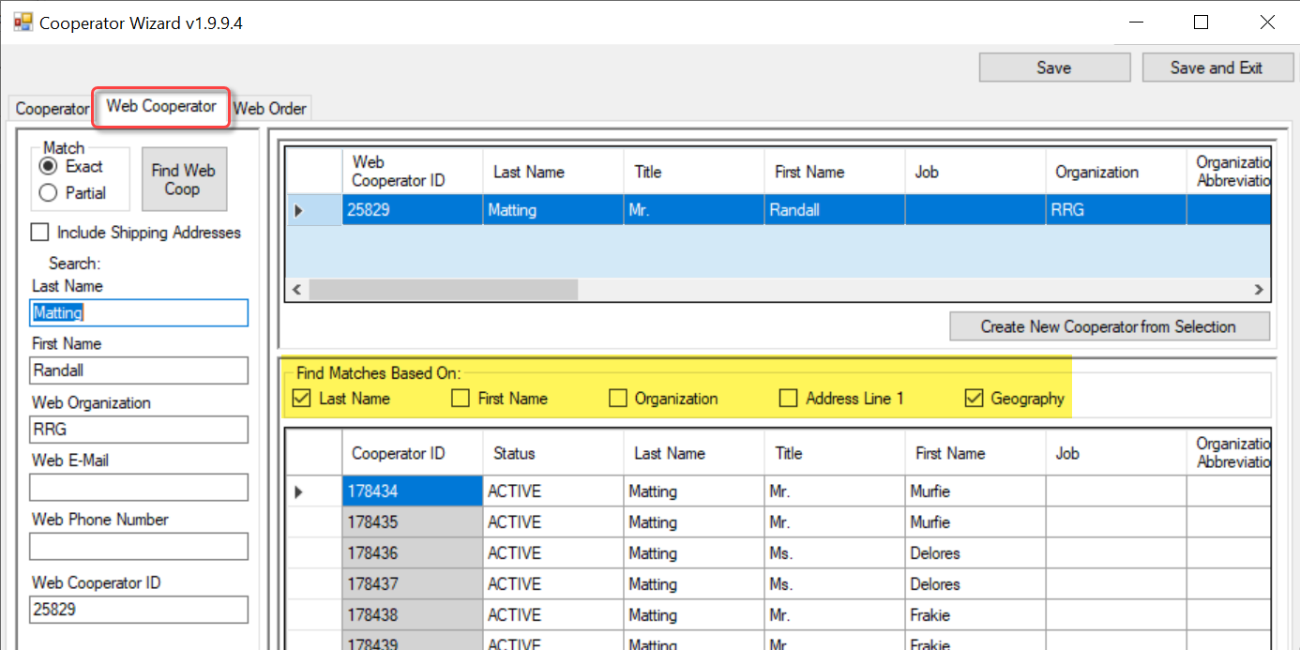
On the Web Order tab (the previous screen), we saw there wasn’t a match between the web cooperator and the cooperator records. However, you can fine tune searching in this tab, with the checkboxes (highlighted).
In our example, we had noticed a different shipping address, so we could also compare that as well:
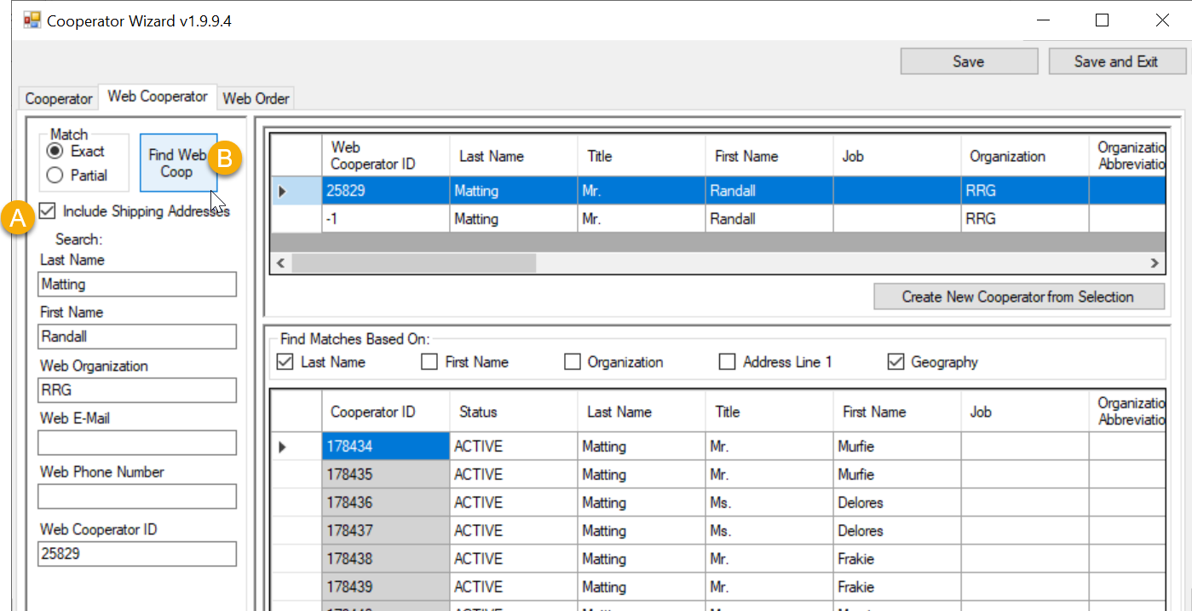
Of course, there still isn’t a good match, because of the First Name difference.
(To avoid a lengthy explanation, just realize shipping addresses are always displayed with negative “ID’s in the Web Cooperator ID column, as illustrated here with the -1.)
When a new cooperator record is needed as in this case, click the Create New Cooperator from Selection:
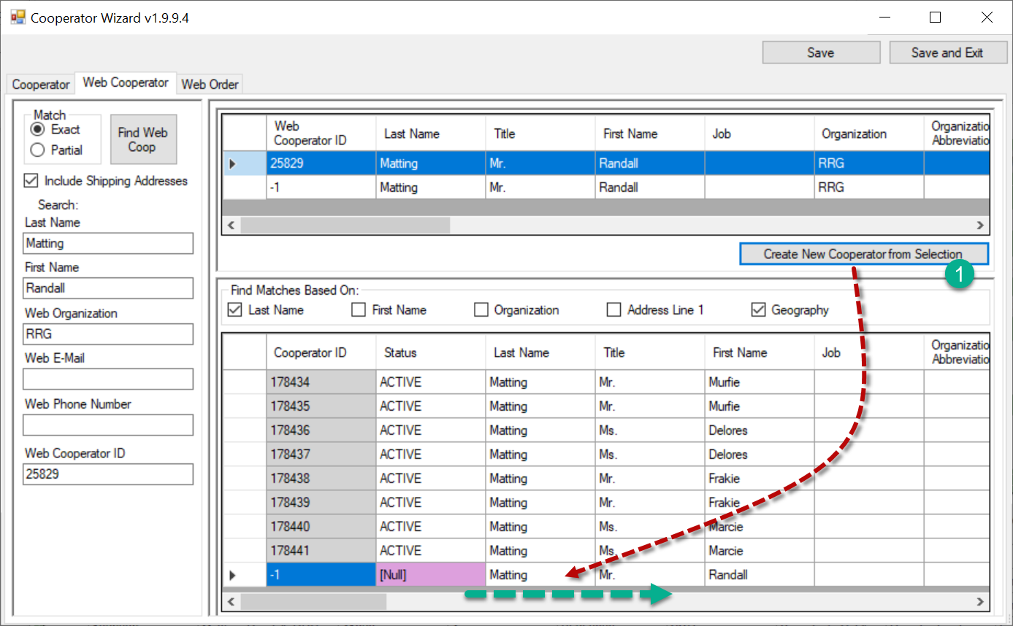
In the bottom frame, proceed to complete the new Cooperator record. At least three fields will need to be filled: the Status, the Category, and the Language.
Currently, for technical reasons, only two fields are shown in pink: Status and Language. The Order Wizard was programmed to fill in ACTIVE and English for the two fields, respectively.

Category, while not displaying with the pink color, is also required later when processing the order so fill that field now.

Highlight the new record in the bottom frame and click Save:
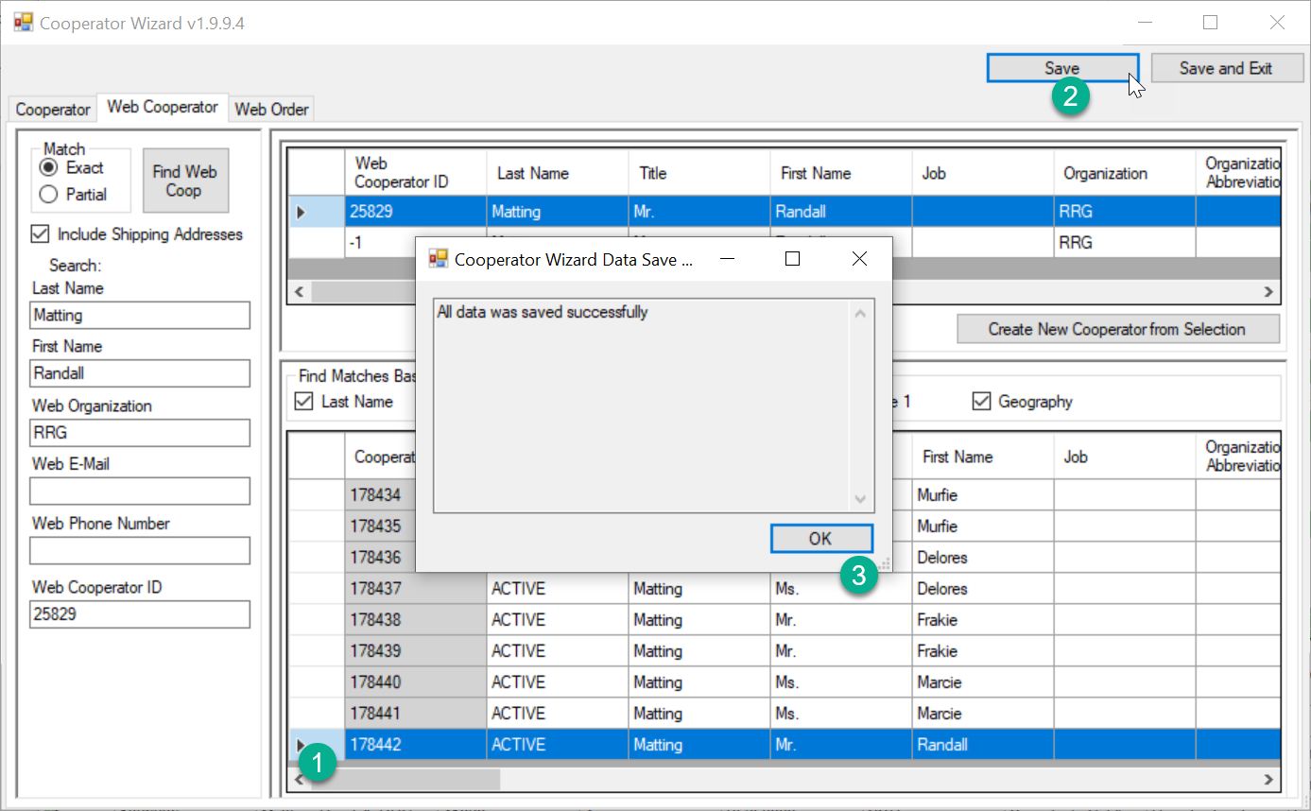
The bottom record displays with its Cooperator ID number. At this point, click the Web Order tab:
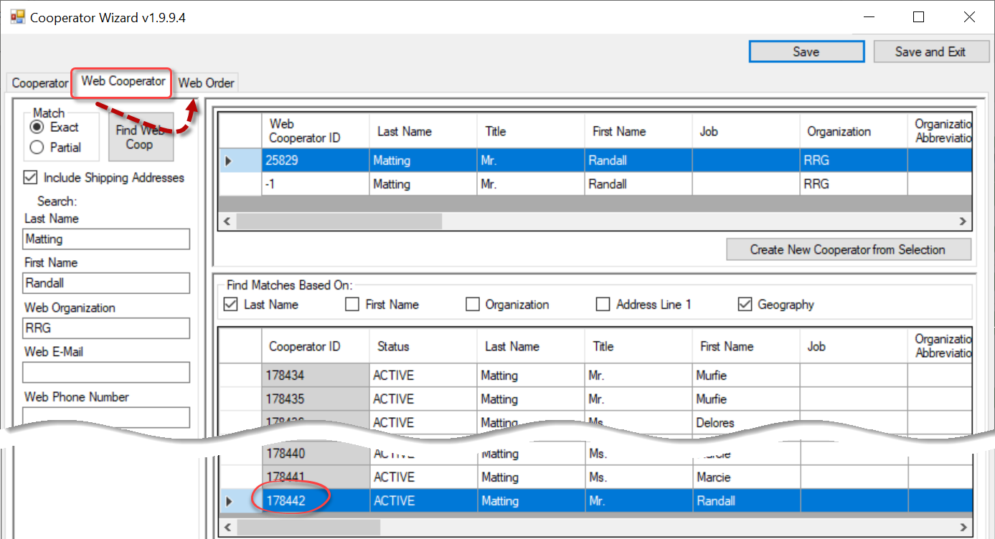
The top record in the bottom grid is the new Cooperator record you just created. 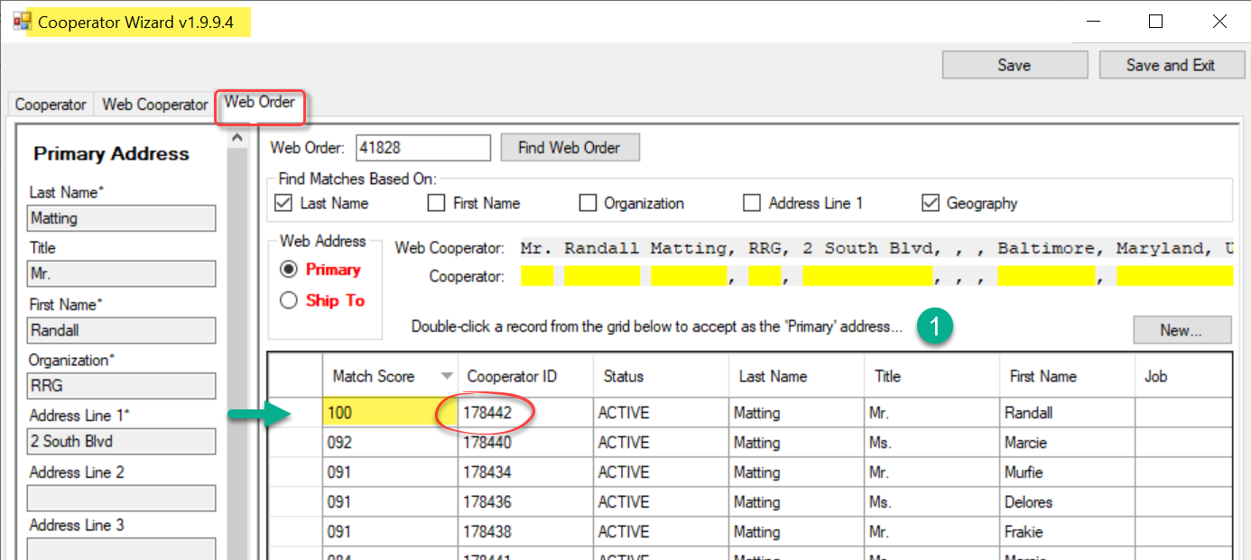

Select that row. Notice the Primary button’s text is red. Double-click:
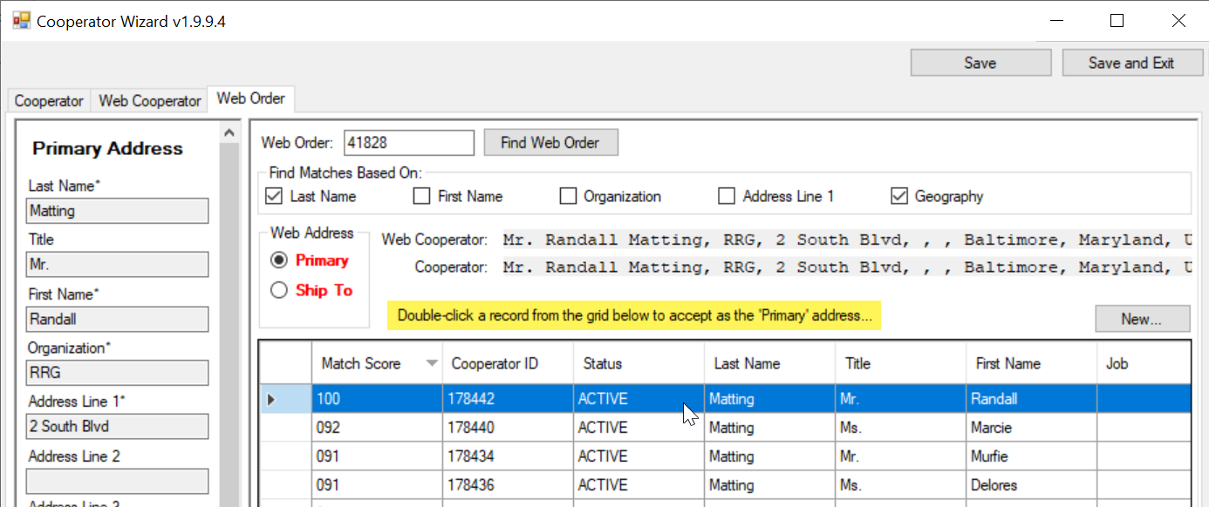
After the double-click, the Primary button text changes to black, indicating that the Primary address is set.
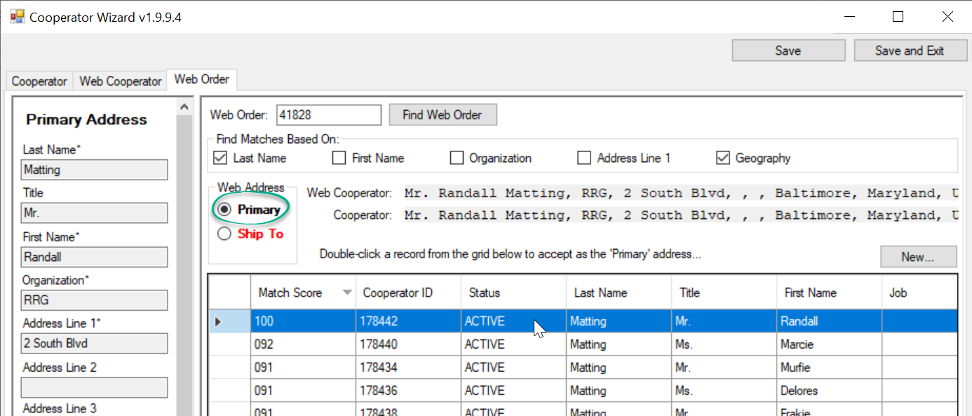

Ship to Address Differs
The Ship To Address needs to be set up. When the Ship To button is clicked, it is using the Web Order’s shipping address to find a matching cooperator in the Cooperator table. In this example the best match only had a Match Score of 85, and that was for the new Cooperator record created in the steps above. Since we had noticed the Shipping Address was different on the web order, we will need to create a new Cooperator record with the shipping address.
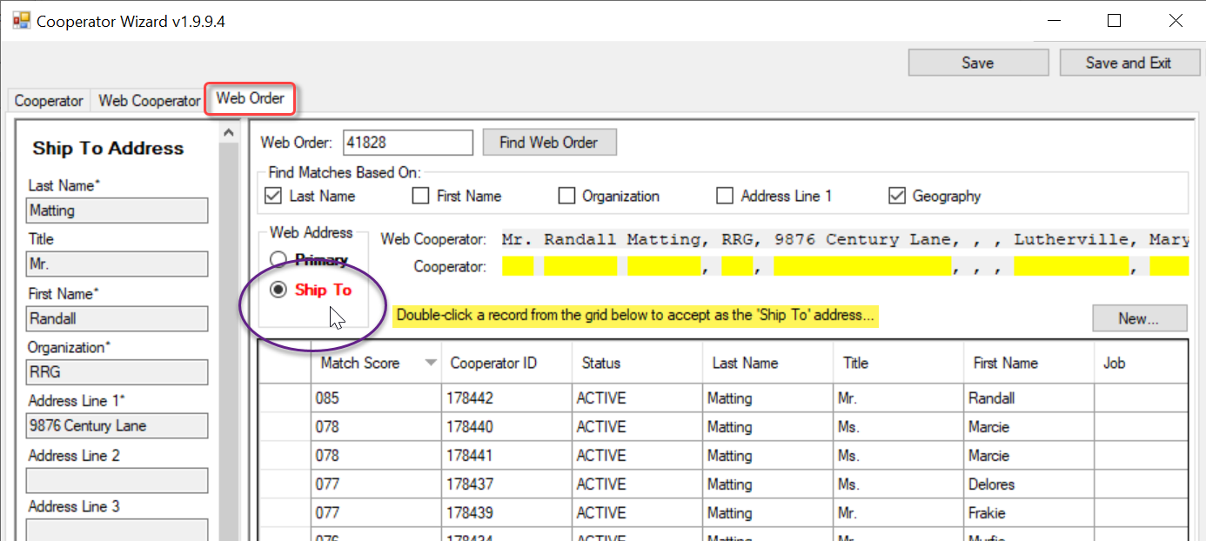
The New button is clicked: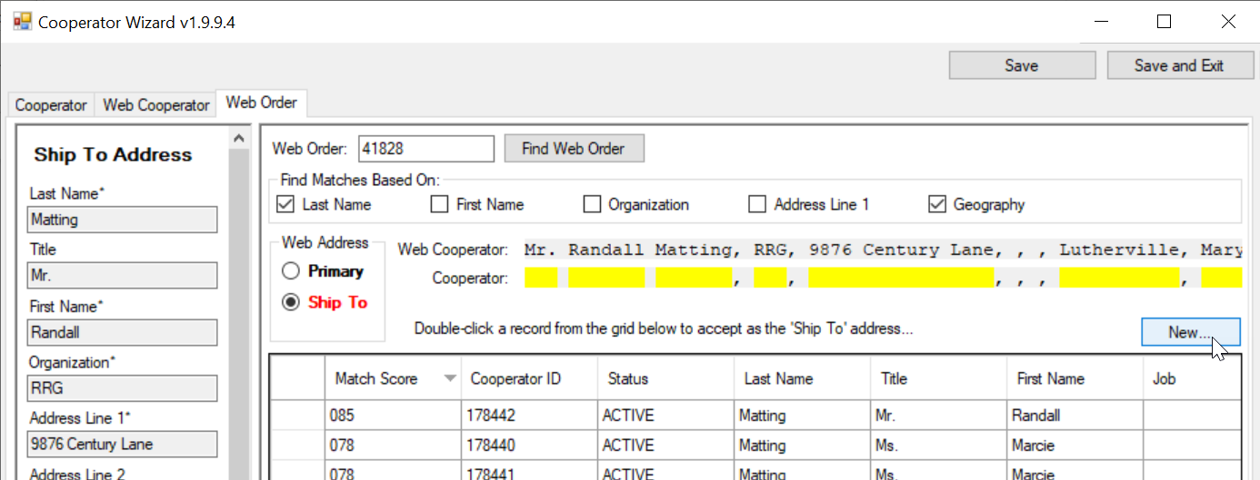
Clicking New flips to the Web Cooperator tab.
The Include Shipping Addresses box was selected. Also, the Address Line 1 was selected, and no matches were found from the existing Cooperators. At this point, the second record in the top table is selected, which has the correct shipping address, and then the Create New Cooperator from Selection button is clicked:
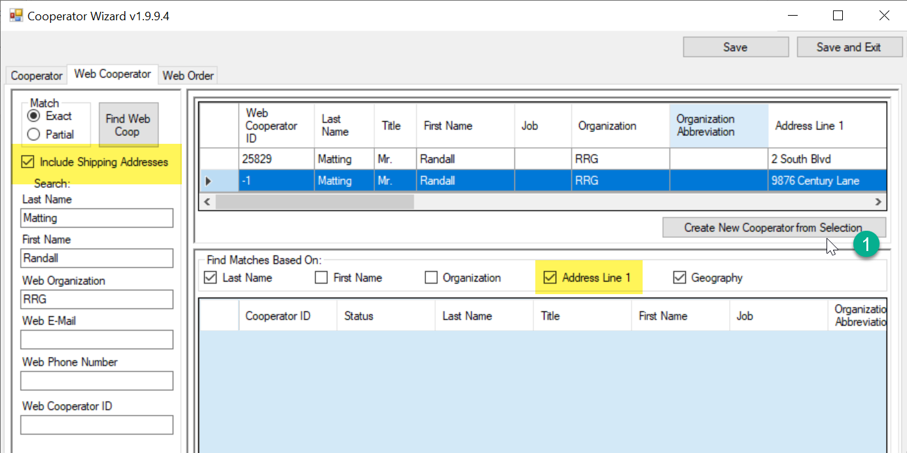

As before, three fields must be filled in: Status, Category, and Language. (The Status and Language will automatically fill in for you, even though they are displayed in pink.) Save.
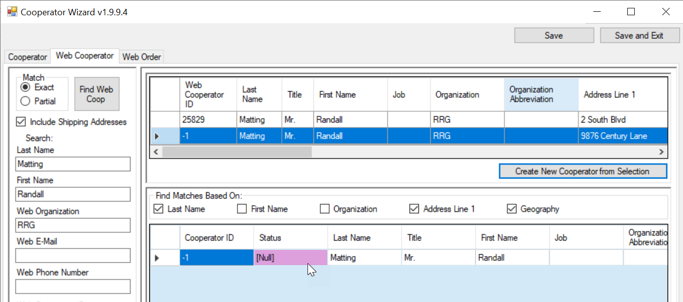

Switch tabs, back to the Web Order tab. Your new cooperator record, this time with the shipping address, should be listed at the top. 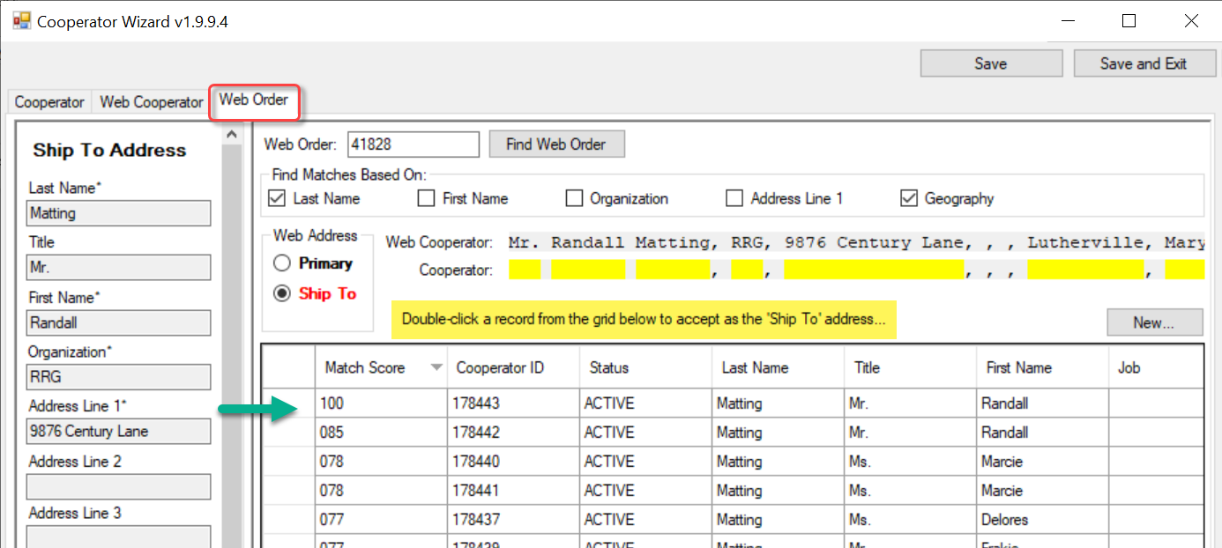

Select it, and then double-click.
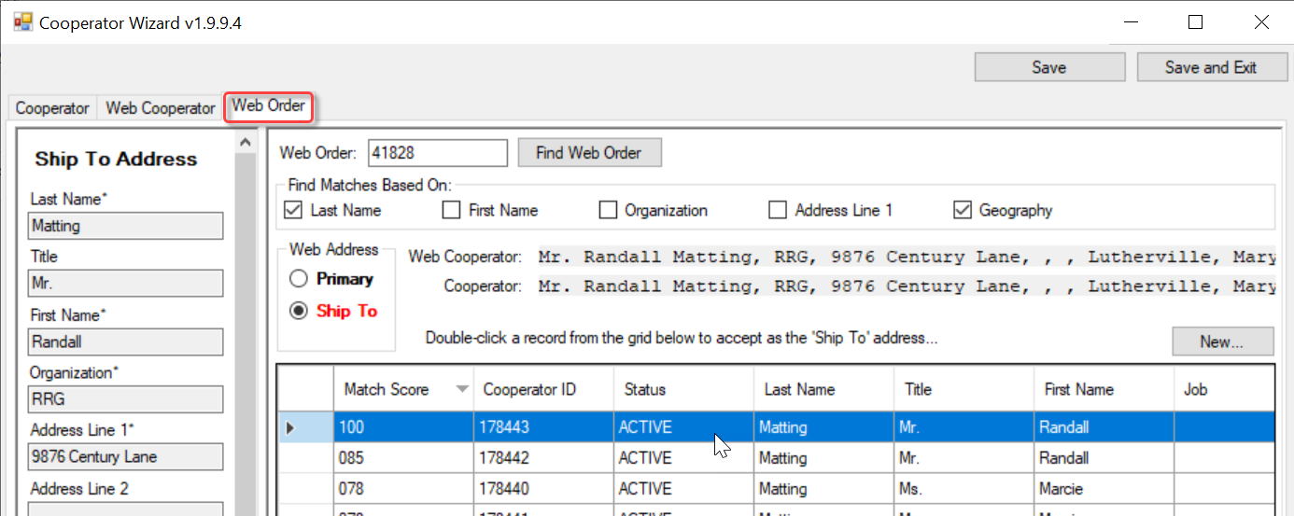

The Ship To button’s label should now be displayed in black text. Click the Save and Exit button.
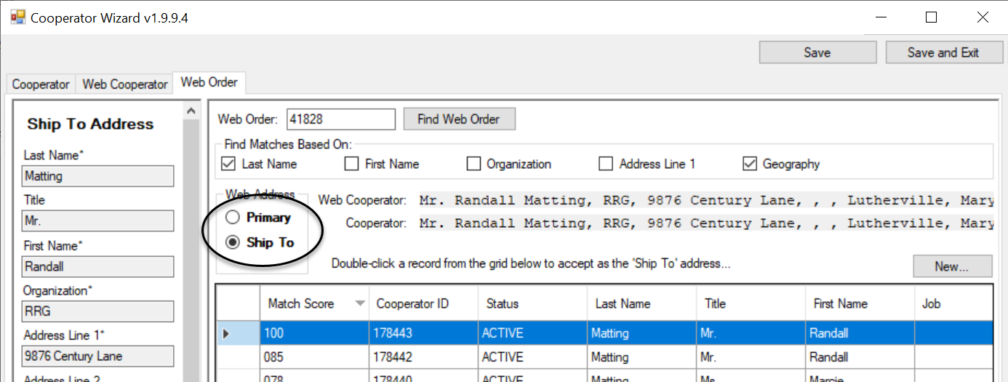
A “successful” message should display. Click OK and…
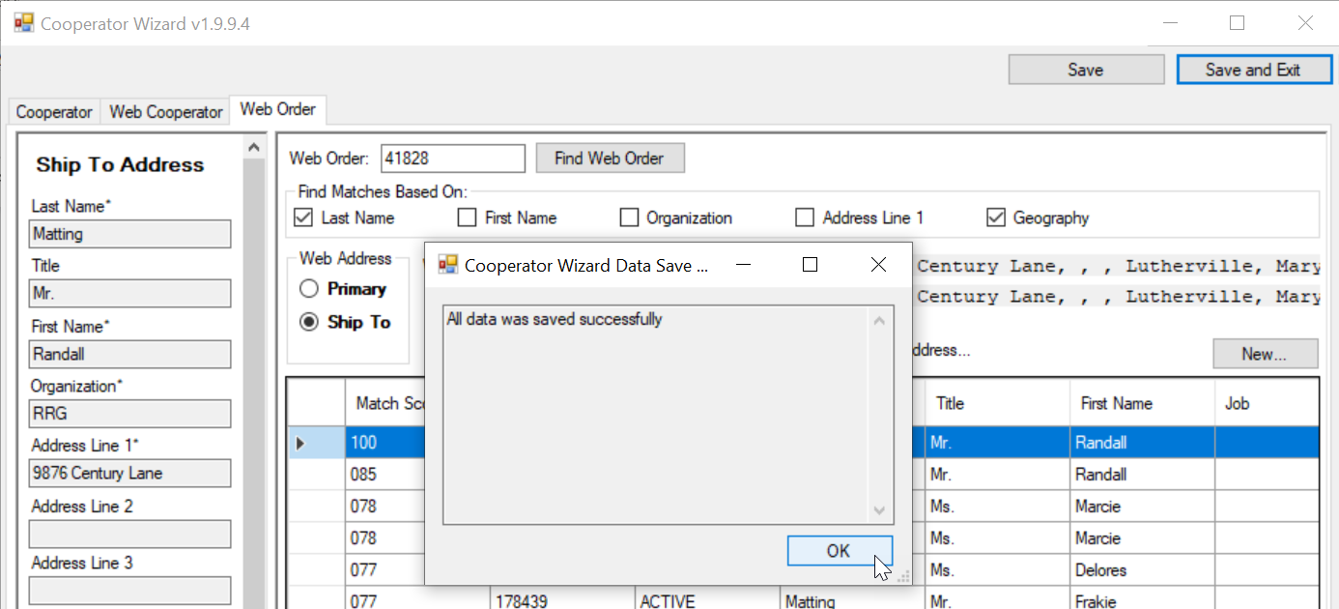
the Order Wizard screen displays, with the correct cooperator information in the three fields:
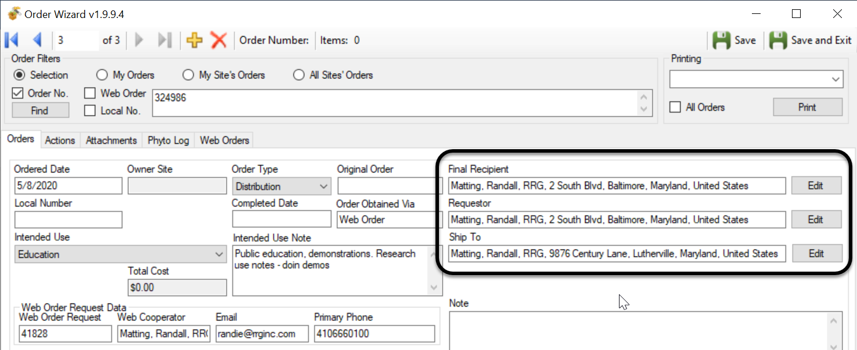

Other Changes in Release 1.9.9.4 and later

Merging Orders
The Order Wizard now recognizes when incoming web orders arrive for a cooperator who currently has open orders. A Merge With: button will display under that condition. The order processor can merge the orders, or proceed as normal with the incoming web order and simply create a new order request. The feature is able to recognize when the cooperator has multiple open orders and presents them with a drop down box.
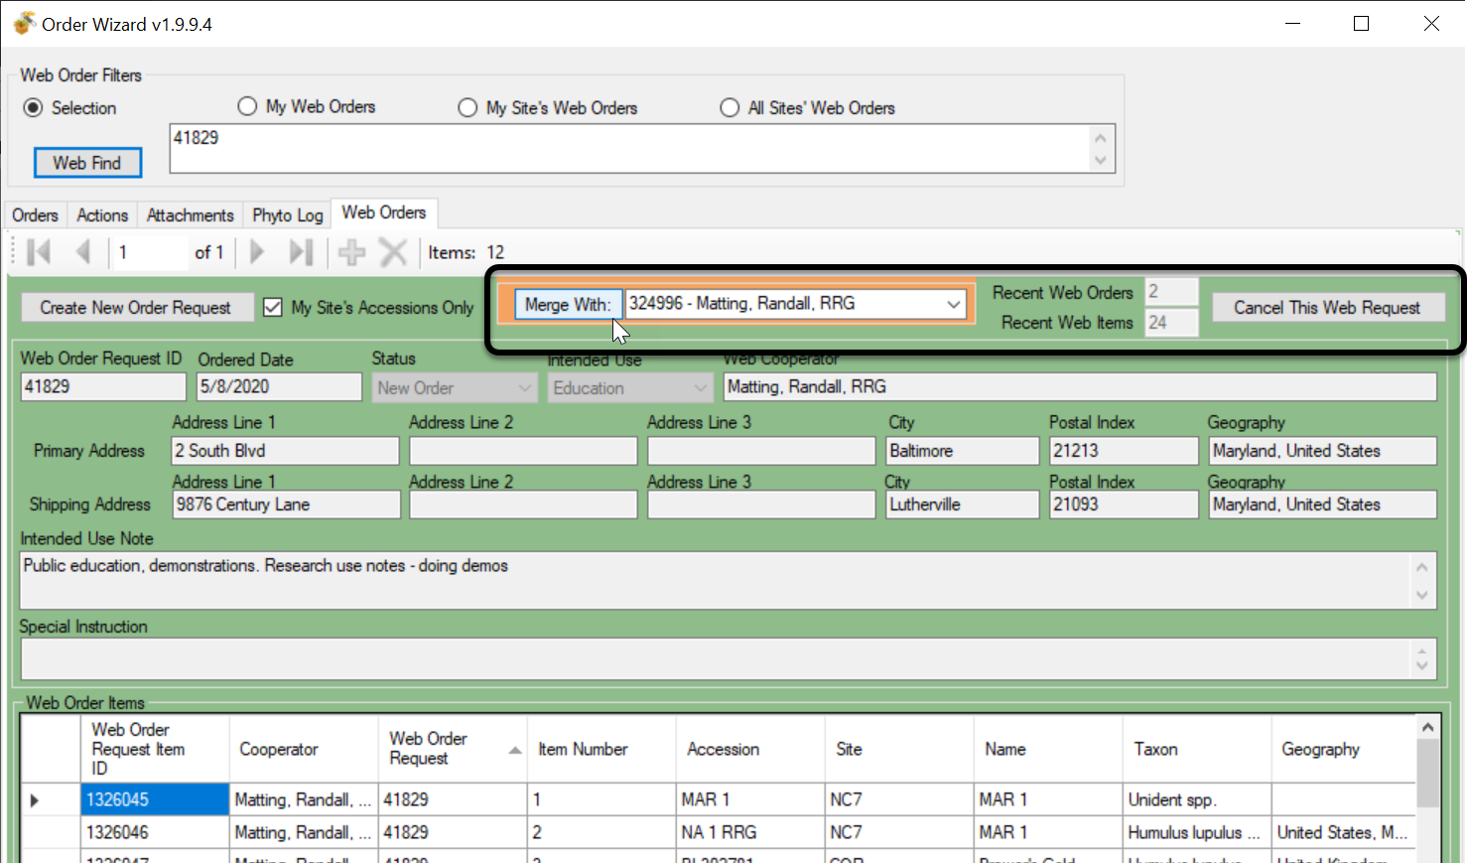

Canceling Orders
Use the Cancel This Web Request button to cancel the Web Oder. Note that cancelling is only cancelling your site’s portion of the web order when the incoming web order has requested accessions stored at multiple sites.

Phyto Log
A new tab was added to the Order Wizard. It is useful when your order has had items that were sent to the inspection office. When that occurs, when the germplasm is received, an entry will be in the Phytolog table. That entry will then be visible under the order’s Phytolog tab.
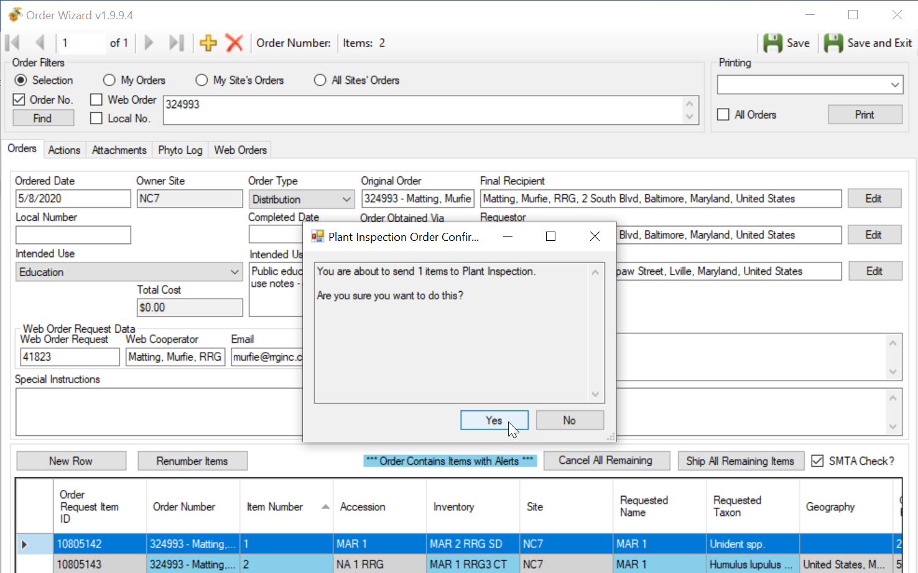
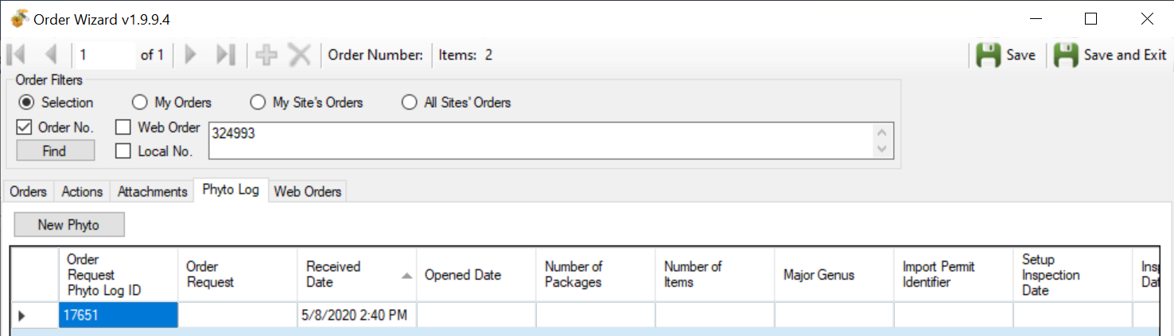

SMTA Warning
This warning can be turned off by deselecting the SMTA checkbox.
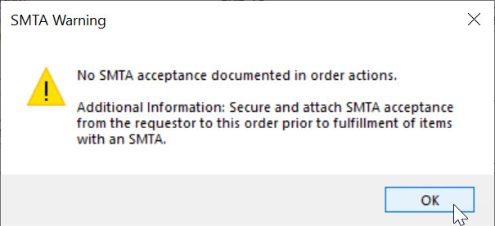

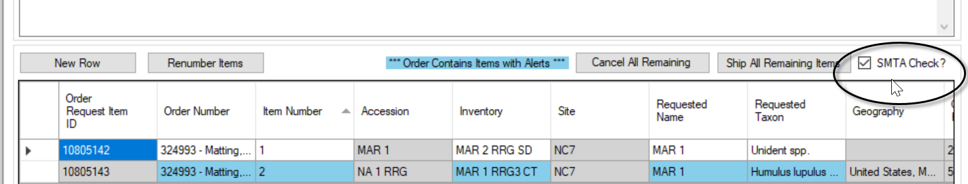

Appendix: Document Revision Notes

– October 1, 2020
- replaced a screen and added minor text revisions to the Shipping Address information

– September 24, 2020
- added tip regarding the three “required” fields in the cooperator record

– July 24, 2020
- initial document

