Order Processing

Revision Date
April 7, 2023

CT version 1.9.8.30 and above

This guide provides an overview to order processing in GRIN-Global (GG).
Detailed, step-by-step directions on the latest Order Wizard are given in a separate document:
http://grin-global.org/docs/gg_order_and_cooperator_wizard_v1.9.9.4.docx

A video online also demonstrates the many steps that are involved:
https://www.grin-global.org/videos/orderwiz2.mp4

The Appendix contains this document’s revision notes. To review the Curator Tool’s version changes, please refer to the online Curator Tool User Guide.
Review the Table of Contents which contains links to the document’s sections

Author
Martin Reisinger

Comments/Suggestions:
Please contact feedback@ars-grin.gov with any suggestions or questions related to this document. This and other GRIN-Global –related documentation can be downloaded from the GRIN-Global Training page.

Table of Contents
Orders Overview 3
Relationship of Orders to Web Order Requests (WORs) 3
Canceling Incoming Web Orders 5
Finding Orders via… 6
Displaying Lists of Weborders 8
Web Cooperators and GG Cooperators in the Curator Tool 8
Order request-related dataviews 9
Order Wizard 10
Processing Incoming Web Order Requests 10
Using the Order Wizard to Create an Internal Order 13
Deleting (Removing) Items from an Order 15
Actions (Order Request Actions) 16
Item Status Codes 17
Order Attachments 18
Splitting an Order 22
How to Split an Order 22
Partially Filling Orders 23
Duplicating an Order 25
Undo a Canceled Web Order 26
Reports 28
Appendix A: Canceling Web Orders 29
A Web Order is Submitted 29
Displaying Lists of Weborders 30
Example – Two Sites Cancel Their Respective Portions of the WebOrder 35
Appendix B: Document Revision Notes 36

Orders Overview
Genebank clients request germplasm through various means:
- GRIN-Global public website (PW)
- email
- telephone
- Genesys
Each organization using the GRIN-Global software will determine their respective criteria and methods for accepting orders. This document describes how orders can be processed in GRIN-Global, with the emphasis on receiving orders via the GG Public Website (PW). Typically, germplasm requesters create a user profile and search for accession or inventory items before adding them to their shopping carts – eventually submitting their cart for order processing. (Detailed information on setting up and modifying a PW user profile can be found in the Public Website Help feature.)
The “shopping cart” feature is modeled after other websites – the user can continue “shopping” and add items (in this case accessions or inventory items) into the cart. Assuming the user is logged in, she can also add items to My Favorites (a “wish list”) and decide later to order from the list. (The cart can also be left with items in it, and the user can log out and return later to update or send the order.)
In GG, the germplasm requesters generally submit their orders via the GG Public Website. Using the Curator Tool’s Order Wizard, genebank staff responsible for order fulfillment can review those incoming web order requests (WORs) and convert them into standard GRIN-Global orders.
During the order processing, genebank staff will use the Curator Tool (CT) Order Wizard to manage and monitor the order’s status. Several order-related CT dataviews can be used, but the Order Wizard with its business rules facilitates the order tracking process.
An online video: https://www.grin-global.org/videos/orderwiz2.mp4 illustrates the steps involved in processing a web order request submitted from the GG public website.

Relationship of Orders to Web Order Requests (WORs)
Because the Curator Tool and the Public Website (PW) are independent programs – you do not need one to run the other – the requests submitted into the PW by researchers / requesters are not stored directly in the GG (main) Order Request table. Instead, the incoming PW requests submitted by external users are stored in a Web Order Request table. In this document, to differentiate the two tables, we will use the term “Requests” or “WORs” to denote the incoming Web Order Requests. When the genebank’s staff person starts processing the request using the Order Wizard, they will save essentially a copy of this request in a separate table; we will refer to that as “the order.” (At the USDA NPGS, the genebank staff often refer to this as the GRIN order, because their database system prior to GG was “GRIN.”)
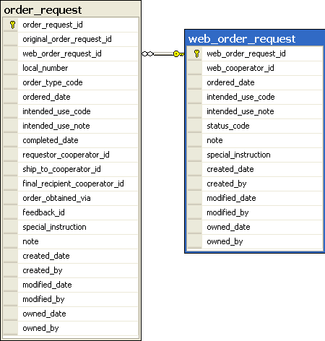 | Shown here are partial table structures for the two order types. Notice that the order_request contains the web_order_request_id field so that it can link to a web_order_request. (Conversely, the web_order_request does not contain a key to the order_request. If a germplasm requester refers to an order number, she would be referring to her web_order_number.)  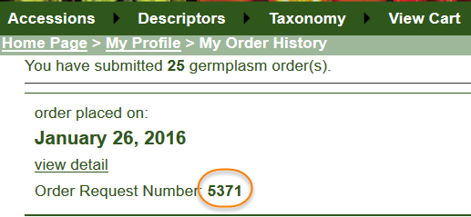

Public Web Orders to Orders Conversion (Diagram)

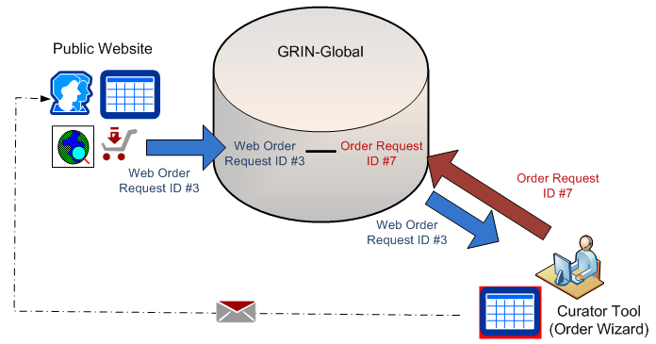
During this order process, the incoming Web Order Request record becomes the basis for a GRIN-Global Order record. The Web Order Request record’s ID is its primary key field; the GG Order Request record created from it will have its own unique record ID. Although the records are inter-related, the two record IDs (and the records) are distinct.

Canceling Incoming Web Orders
A requester cannot cancel their PW request.
Beginning with server 1.9.9.2, a genebank staff person can use the Order Wizard’s Cancel button to essentially prevent any processing of the WOR and change its status to “Cancelled.”
Some sites decide to simply not process the web order and ignore it. This can be a bit of a nuisance because the web orders will still be considered “new” and will be found by the order wizard:
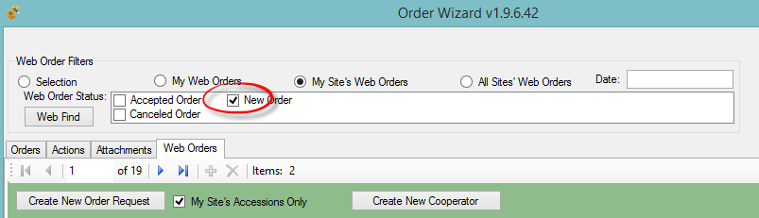
The easiest way to cancel an incoming WOR is to find it in the order wizard, and then use the Cancel button. Done!
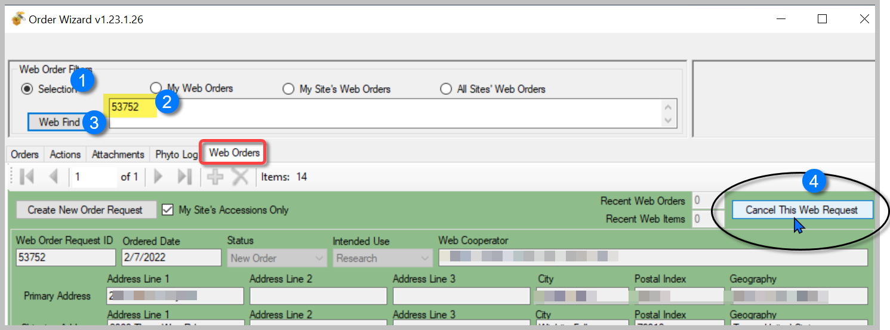
GG Administrators: NPGS implemented a utility that is not bundled in the GG build. This utility can be implemented to set up a filtering process before the submitted WOR’s enter the genebank’s order pipeline. For more information, contact the USDA developers via GRIN.Global.Orders@usda.gov.

Finding Orders via…

Public Website
Genebank staff who have a PW with extended privileges have available to them extra reports including a report for searching web orders:
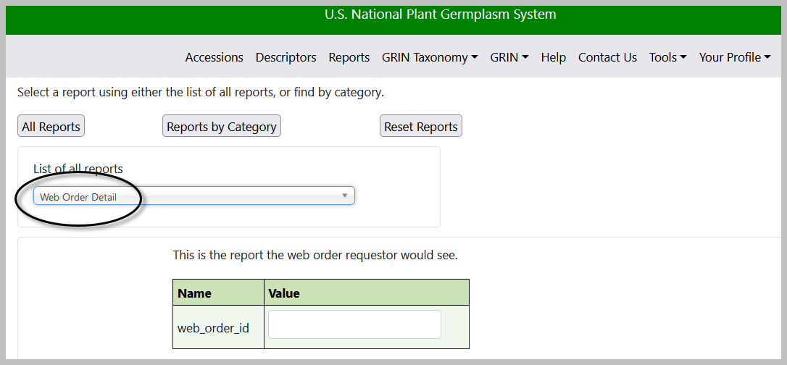

Order Wizard
The CT Order Wizard can search for web orders also, but only if the web order request has a corresponding order. In the following screen showing the Order Wizard, why is the OW not finding WOR 54655 that is in the database? Because the OW tab Orders is the current tab.
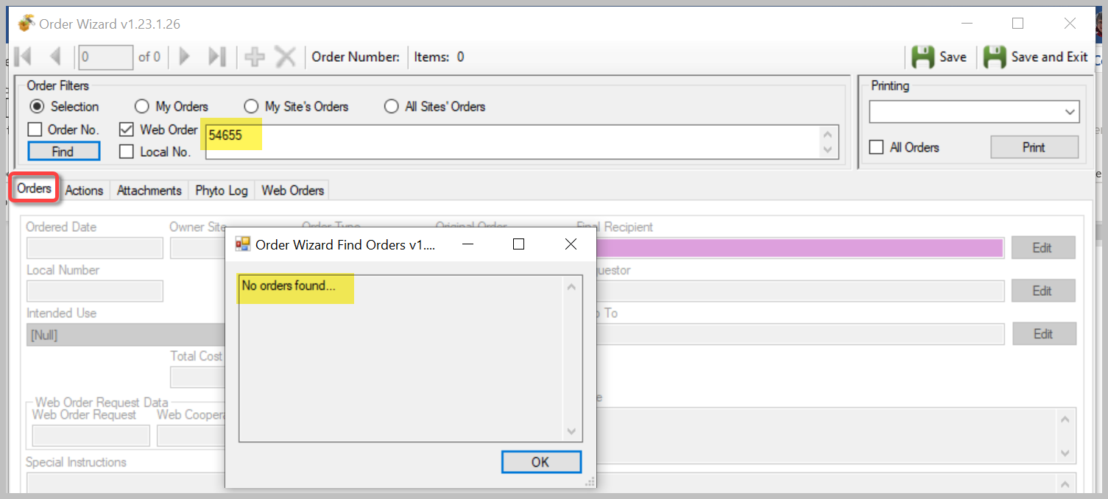
The wizard is searching the Order table for an Order that has a related WOR #54655. Every Order record has a field, the Web Order Request field, that relates the two records from the two tables. 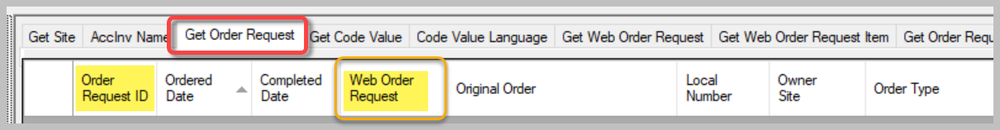
When in the OW, using the Orders tab, you are searching the Order Request table. The OW was designed so that you could specify the Web Order Request number, but search the Order Request table. In the example above and below, Web Order Request # 54655 exists, but there is no corresponding Order yet.
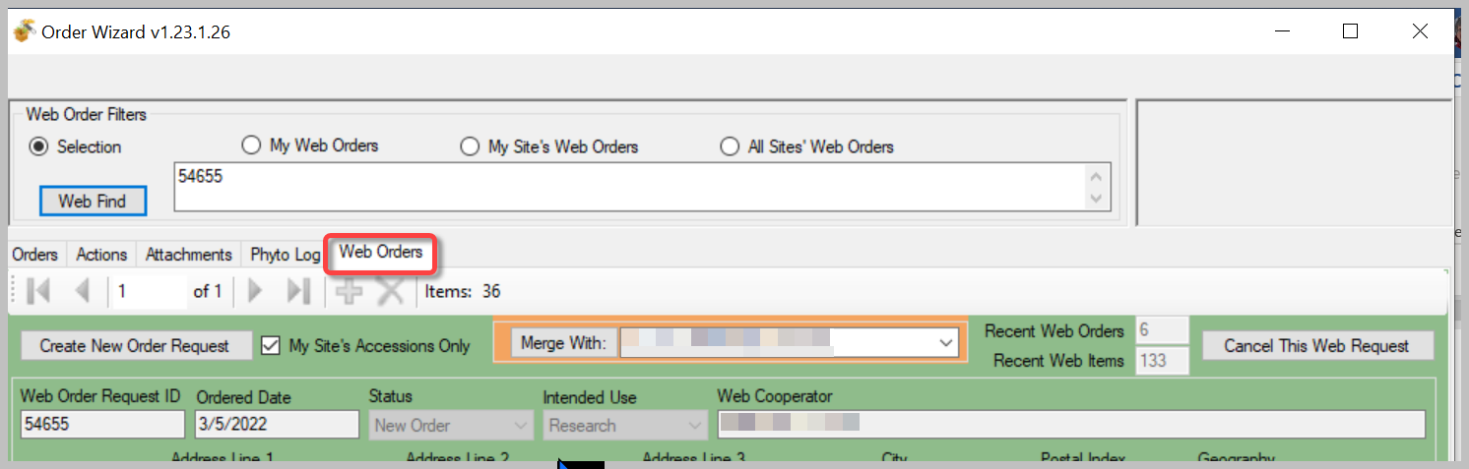

via Search Tool (and Curator Tool) Dataviews
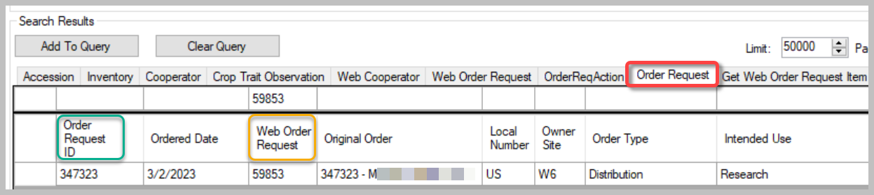
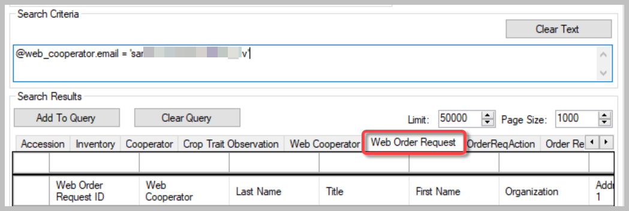

Displaying Lists of Weborders
In the Curator Tool, establish a folder and use the following code as the basis for your Dynamic Folder’s query: @web_order_request.web_order_request_id = 17695
The number shown in red is the weborder.
Alternatively, more involved criteria could be set up for your dynamic query. For example, use a query based on a date range:
@web_order_request.ordered_date BETWEEN '8/1/2017' AND '8/11/2017'
or your site code, and the web_order_request_item.status_code:
@site.site_short_name = 'NC7'
AND @web_order_request_item.status_code = 'NEW'
You can of course use the Search Tool to search, using the web_order_request dataview, to find the web order. Then drag the web order record into the Curator Tool.
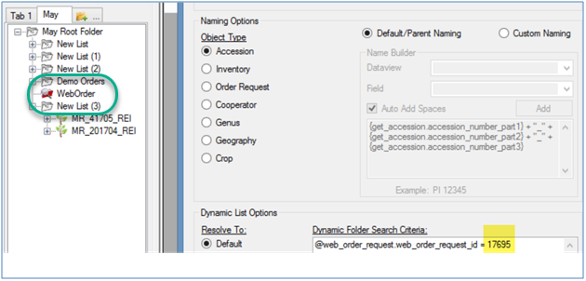

Web Cooperators and GG Cooperators in the Curator Tool
Two types of cooperator records exist in GRIN-Global: web cooperator records and standard (used within the CT). These two cooperator record types are stored in two different GG tables. Generally, the public website requester creates his or her own record, stored in the Web Cooperator table. Genebank staff, working within the Curator Tool, create and edit records in the main Cooperator table.
Using the Order Wizard, when processing an incoming request, a genebank employee can easily create a standard cooperator record from a web cooperator record or relate an existing standard cooperator record to a web cooperator record.
To differentiate the two kinds of cooperator records throughout this document, we will specifically state “web” when referring to a web cooperator record. References to the standard GRIN-Global cooperator records will omit any prefix or may state “... standard cooperator record.”

Order request-related dataviews
In the Curator Tool, there are several order-related dataviews used to display the order information. Since most order related work is handled via the Order Wizard, working directly in the dataviews is discouraged. However, listed here for reference are some of the main GRIN-Global order-related dataviews:
Dataview | Description
order_request | Provides general information about the order such as the date and type of order, requester, final recipient, etc.
order_request_item | Lists the specific data about the material used to fill the order such as the Accession and Inventory IDs for the material, the Quantity On Hand, the Quantity Shipped, the form of distribution (seeds, grams, etc.) and the storage location from which the order was filled.
order_request_action | Every time the status of the order is changed, an Order Request Action record is generated. Statuses that are built into GG include Shipped, Cancelled, Partially Shipped, Filled, and so on. (Each organization can determine what ORDER_REQUEST_ACTION codes they need for their organization’s order fulfillment process.)
web_order_request_attach | Attachments (.pdf, .docx, jpg, xlsx files, etc.) can be submitted with a web order (before the order is converted to a standard GG order). (Additional programming work needs to be done to allow additional documents be attached after the order is processed in the CT.) Attachments can also be directly dragged and dropped into this dataview in the CT.
web_order_request | Provides general information about web orders such as the date and type of order, requester, final recipient, etc. This web order request is generated by a requester using the GRIN-Global Public Website.
web_order_request_item | Lists the specific data about the web order material (this is the details portion of the web orders coming from the GRIN-Global Public Website)

Order Wizard
Recommended: a genebank’s staff should use the Order Wizard to review and manage web order requests (rather than use the order-related dataviews.)
Note that a genebank may also initiate internal orders via the Order Wizard. This is frequently done for various reasons; the image below shows the types of orders done at the USDA’s NPGS. Remember that a genebank’s GG administrator can modify these dropdown lists and in this case could add or remove entries from the list.
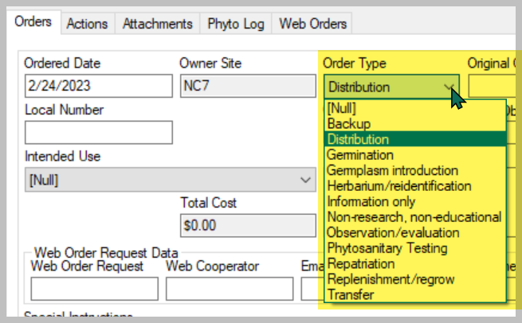

Processing Incoming Web Order Requests
Many, if not most of an organization’s germplasm requests from external requesters, will be coming from the GRIN-Global Public Website. Use the Order Wizard to convert these web order request (WORs) into GG order requests.

Start the Order Wizard
Although not absolutely necessary, before invoking the Order Wizard, in the Curator Tool, decide what list folder in the left panel will be your active list. Then, as you create and save new orders, you will be prompted to add corresponding orders to your active list. Another consideration not essential (but recommended), before clicking the Order Wizard button, open the Order Request dataview as the active dataview. In the following example, the user’s active folder in the list panel is labeled “FEB ORDERS”:
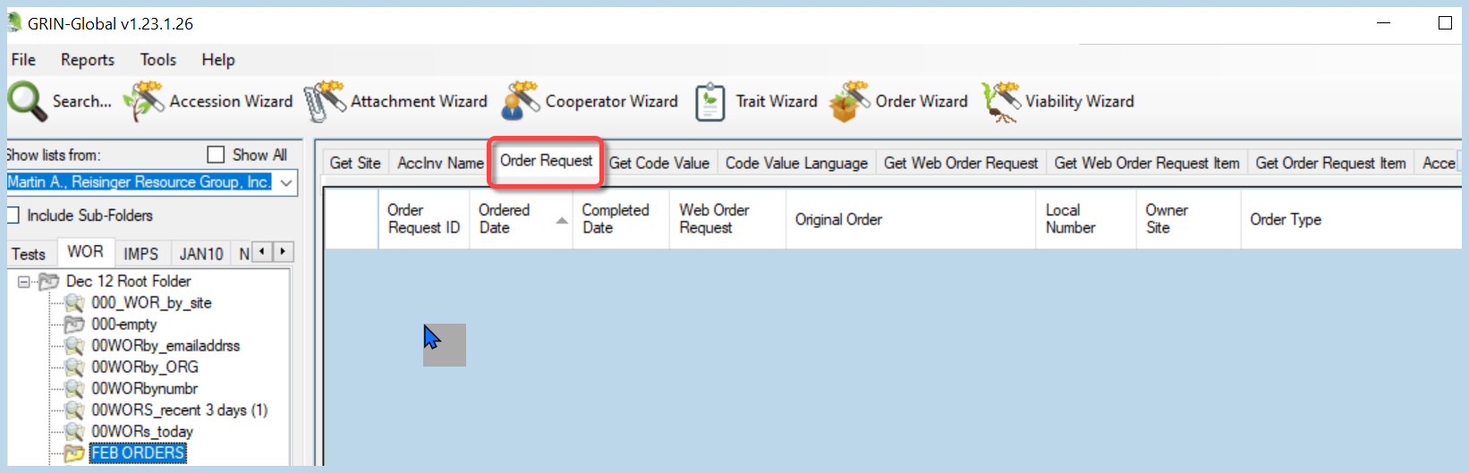
A user can organize his incoming orders by the day, week, month, or some other criterion, such as by genus or species. Alternatively, the folders may be set up for new orders, pending orders, completed orders, etc.

Start 1
Start the Wizard by clicking the Order Wizard button:
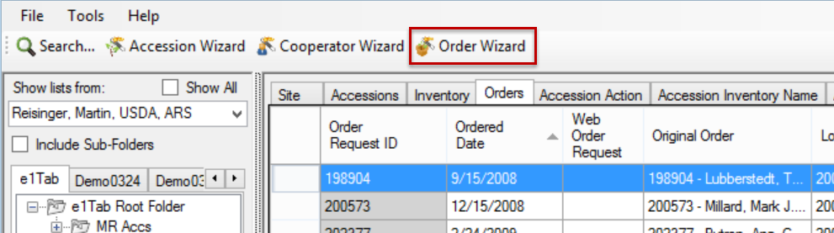

Step 2
Click the Web Orders tab; select the appropriate radio button: (Selection, My Web Orders, My Site’s Web Orders, or All Sites’ Web Orders); for processing new orders the New Order checkbox should be checked. Since the incoming web order generated an email message that includes Web Order Request number , use the Selection radio button and then input the request number into the Web Find box.
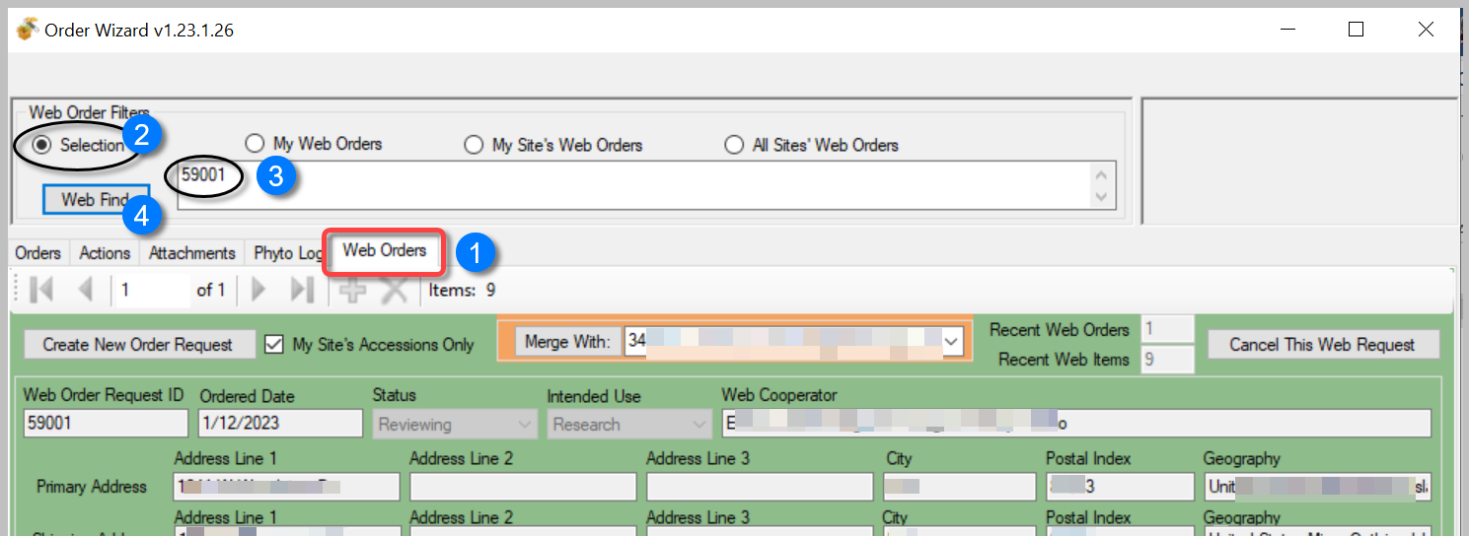
Use the Selection radio button and the Web Order Request number (found in the email message) to avoid potential issues when incoming orders are sent to multiple sites. With multiple site requests, one site may accept the order before you do, and then when you search for “new” orders, the Wizard will not find it because the request is no longer considered “new.”
You can find details about an incoming web order on the Public Website if you are logged in.
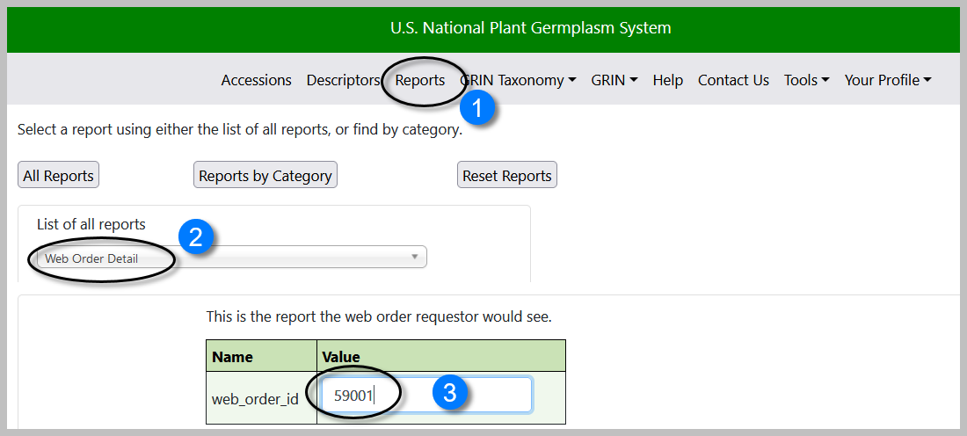

Step 3
The Order Wizard by default is designed so that when you generate an order, only your site’s accessions will automatically be included in the order. Remember that the incoming request may include accessions from other sites. Generally, the checkbox indicating this default should remain checked.
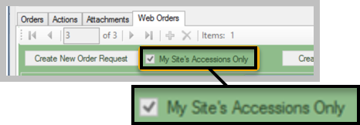
Click the Create New Order Request button to initiate a new GRIN-Global order. If the incoming web order request did not have a valid cooperator associated with it, you will be prompted to create a new cooperator:
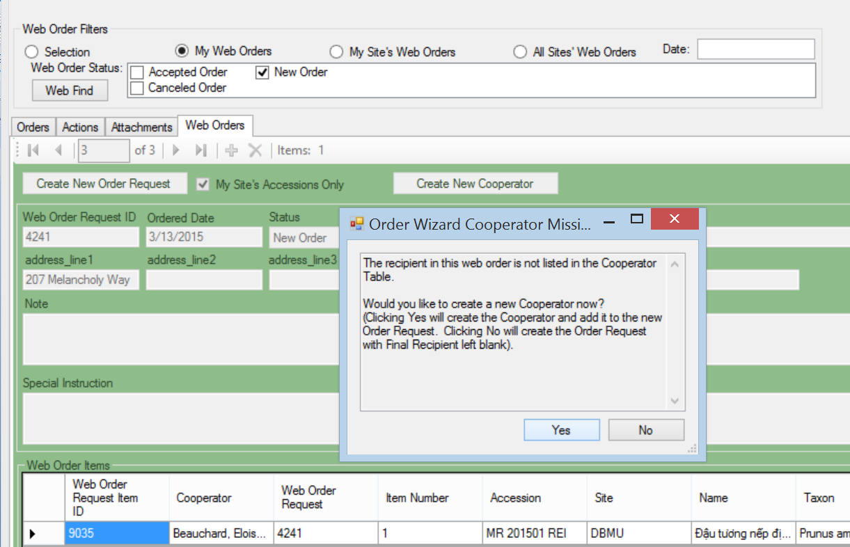

Detailed, step-by-step Order Wizard directions are given in a separate document:
http://grin-global.org/docs/gg_order_and_cooperator_wizard_v1.9.9.4.docx

A video online also demonstrates the many steps that are involved:
https://www.grin-global.org/videos/orderwiz2.mp4

Using the Order Wizard to Create an Internal Order
The Order Wizard can be used to create new germplasm order requests that come to the genebank via emails, phone calls, or other means. New orders can also be internal genebank orders, such as for regeneration, selecting specific inventory for viability testing, etc.
The wizard can be used to manage any existing order regardless of how the order originated.
When starting up the Curator Tool, the left tab in the list panel will be active and display the lists under that tab. Consider setting up your folder hierarchy under that left tab so that the lists help with tracking your orders by status or date received or some other criterion. Although not necessary, when working with orders in the Curator Tool, have the folder active in which you intend to use for pointing to orders. Also helpful but not required, in the right grid, you may want to select the Get Order Request dataview as your active dataview.
Save frequently, and save often! (when using the Order Wizard). Also, use the Save button when initially creating the order; otherwise you will receive an error message.

Adding Items Manually to an Order – using the Inventory Picker
There are multiple approaches that can be taken to include additional items to a an order. In the Order Wizard, at the Order tab, you can use the New Item button to invoke an Inventory Picker window. In that window, input using one of the boxes – locate the desired item an then click OK.
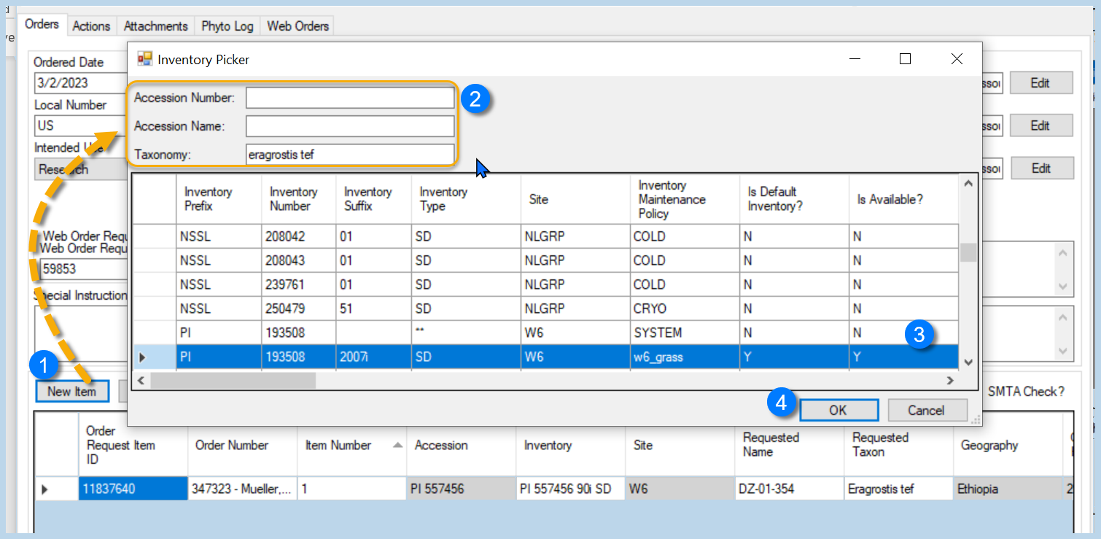By combining criteria, you can find a desired inventory record. You may also use the % wildcard to cast a broader net for possible matches.
Beside using the Inventory Picker method above, there are several other manual methods that involve dragging data from elsewhere:
Approach | Description
Drag either accession records or inventory records from the Search Tool grid | Dragging inventory records rather than accession records will perform somewhat better (when selecting accessions, the software must perform additional processing to select the inventory)
Drag accession key(s) or inventory key(s) from a spreadsheet, Word doc, or an email | An accession key is comprised of three fields:  Accession Prefix Accession Number Accession Suffix  The wizard interprets an inventory key based on four fields:  Inventory Prefix Inventory Number Inventory Suffix Inventory Type
Drag accession or inventory records from the Curator Tool | The wizard will find all the inventory related to the accession and will highlight the inventory that is available and ready for distribution.

Deleting (Removing) Items from an Order
In the Order Wizard, use either the Cancel All Remaining button when appropriate, or select individual items in the item grid, using the leftmost column to select desired rows, and then use the Canceled order item option from the menu’s Item Status option.
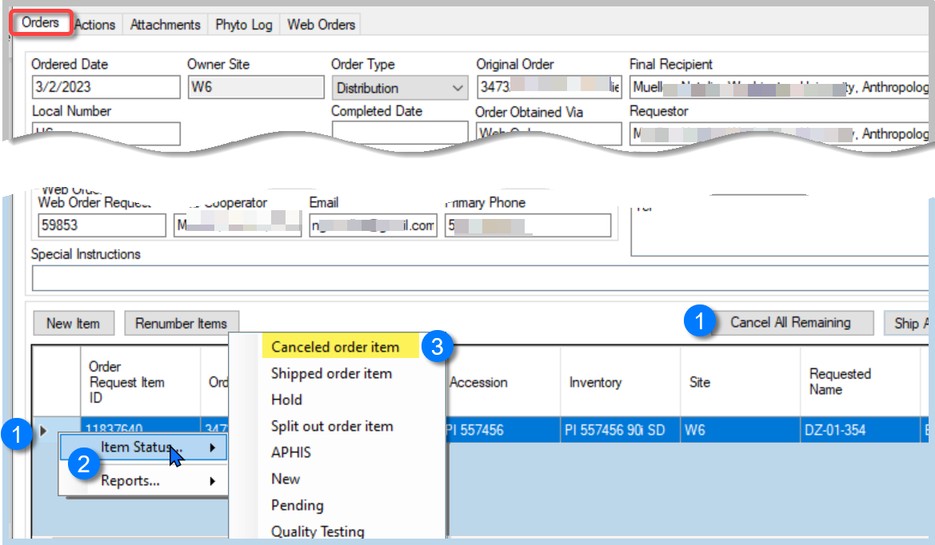

Actions (Order Request Actions)

Include Order Actions
Use the Order Wizard Actions tab to add any appropriate actions. By doing so, a site can keep track of the progress of the request to ensure timely processing. These actions are stored in the Order Request Action table and the CT respective dataview can be used to search and review if desired.
The following example illustrates an order that was well managed and its induvial actions were recorded.
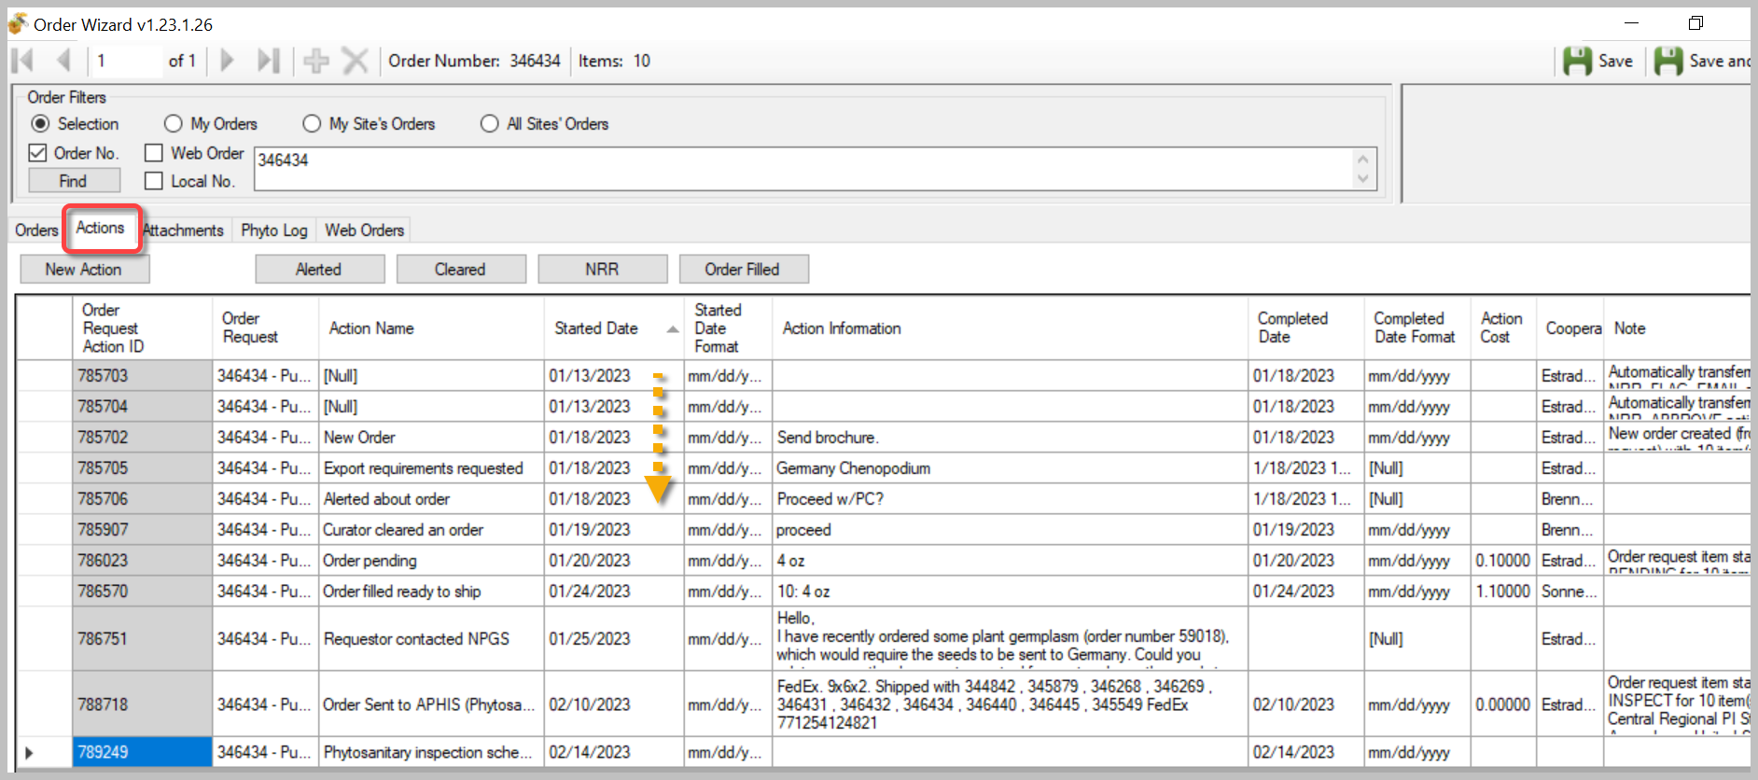
Many actions may be applied to an order request; essentially an action indicates that some event related to the order has occurred. In some cases, the action record is automatically generated, such as when the incoming web order request is converted to a standard order. Similarly, an action of Order Shipped is automatically generated when an order is shipped.
Order Actions are used to document the processing and current status of the order. Each genebank will follow their own unique standard operating procedures in completing workflows – the action records are used to document actual workflow.
Action Code | Title
NEW | New Order
PENDING | Order pending
APHISASKED | Export requirements requested
CURALERTED | Curator alerted about order
CURCLEARED | Curator cleared an order
PATHSEED | Path test needed and sent
PATHPASSED | Pathologist approved the order
ORDFILLED | Order filled ready to ship
APHIS | Order sent to APHIS (Inspection)
Since only a GG administrator can add Codes, contact the administrator if additional codes are needed.
Note to GG Administrators: Order Request Action codes are stored in the ORDER_REQUEST_ACTION code group which is maintained by the GRIN-Global administrator.

Tracking Expenses
If desired, you can assign expenses with an action. The Order Wizard will tabulate the total expense associated with the order’s cumulative actions. (Most genebanks do not really have an accurate method for identifying the expense, but they may record a specific cost, such as the shipping expense.) 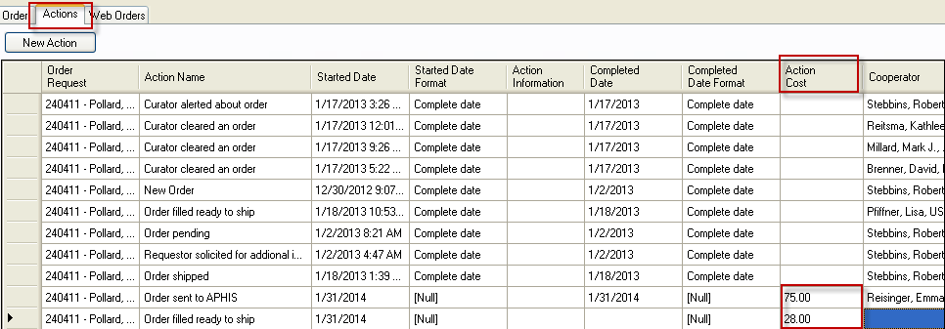
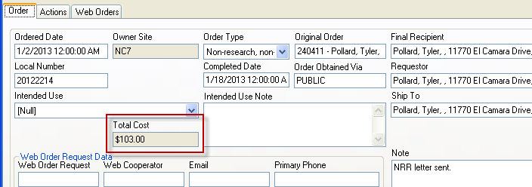

Item Status Codes
In the Order Wizard grid, each requested item is listed. Each item has its own status. (These status codes are stored in the Code Group ORDER_REQUEST_ITEM_STATUS. (The GG administrator can modify these codes to match the codes to the organization’s needs.)

Order Item Status Codes:
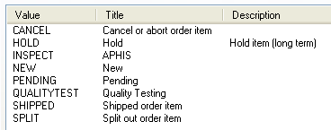
For all items in the grid, when the status is NEW or PENDING in the Item Status column, clicking on the Ship All Remaining Items button will change the status to SHIPPED.
Whenever the status is something other than NEW or PENDING, the Ship All Remaining Items button has no effect.
To change the status of one or more items in the grid, right click on the item(s) and then select a status from the Item Status menu (or select the Item Status cell(s) in the grid and right click):
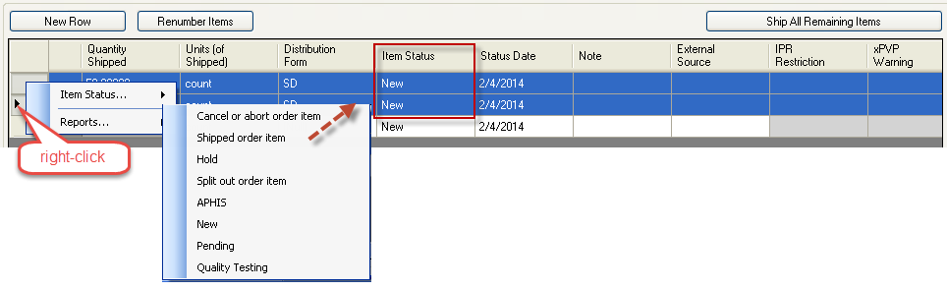
As with other CT grids (similar to Excel), you can select multiple items using the Ctrl+ and the Shift+ techniques or by dragging down the header column:
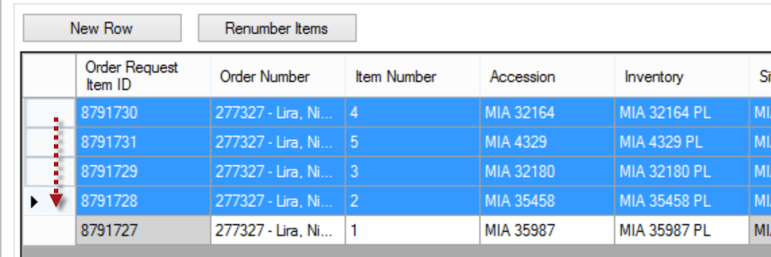

Order Attachments
Attachment files can be submitted by the germplasm requester when he submits his order or later. (Note the ability to add when submitting a new order was introduced in later releases of the GG website.)
To enter later, he must go to his Order History and click on the order’s view detail link:
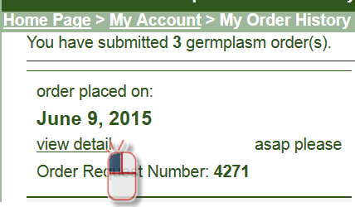
To upload a file, the requester must first click on the Browse… button:
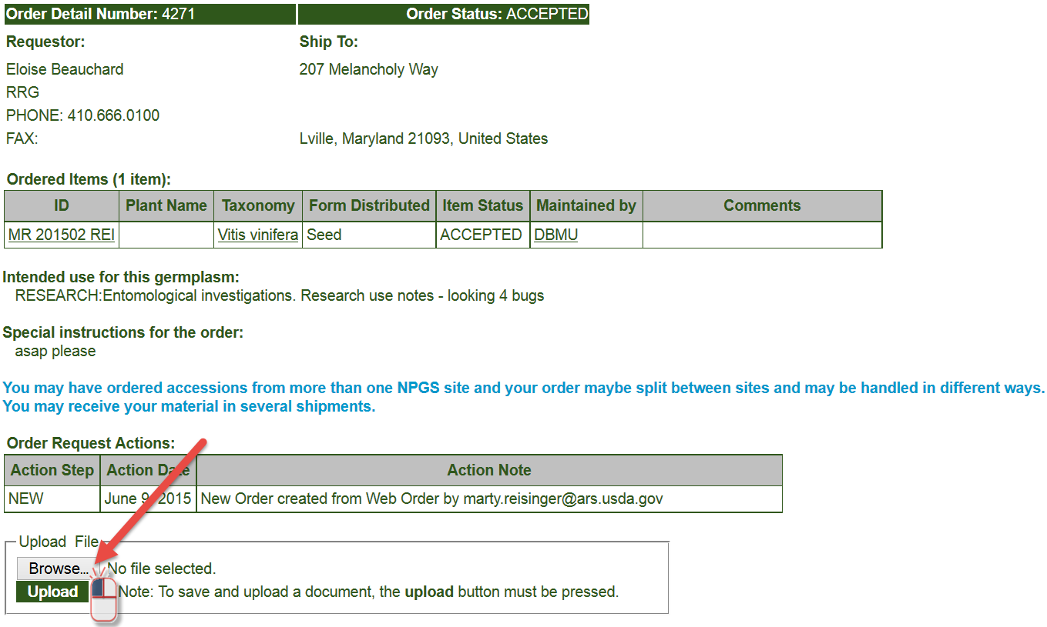

In the window, he then locates and selects the source file:
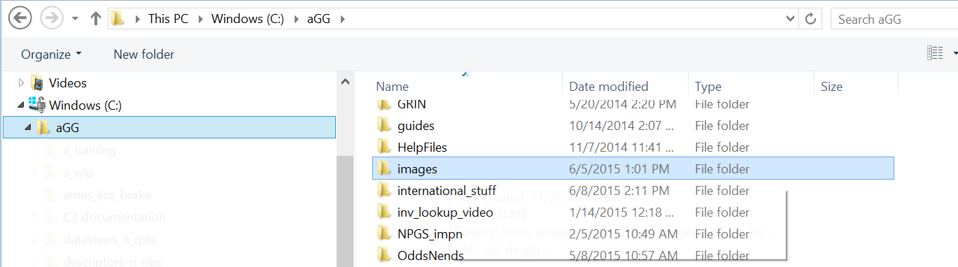
and will ultimately click on the Upload button to load the file: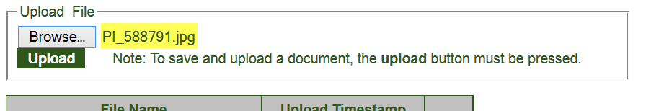
The requester can continue to upload additional files until the order has been shipped.
Whenever an attachment has been added, the genebank receives an email indicating that the order has had an attachment added:
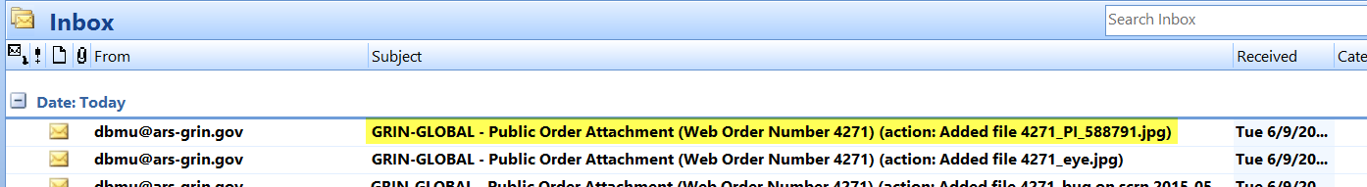
A requestor can only see documents which she has uploaded to the webpage for her order. On the PW page, those files attached are stored in the web_order_request_attach table.
A staff person can add documents on the OW’s attachment screen, but these attachments cannot be viewed by the germplasm requestor. During the OW processing, the user-submitted attachments are ultimately copied into the order_request_attach table.
Within the CT’s Order Wizard, the genebank person filling the order needs to click the Update button on the Attachments tab:
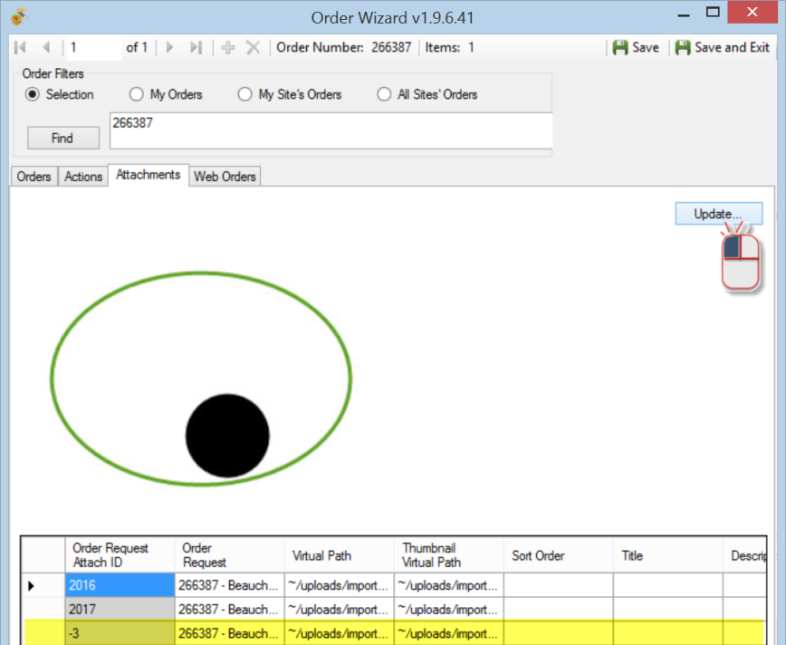
If the software viewer recognizes the file, it will display in the window.
When it doesn’t, it launches the program that recognizes the file. (For example, the Microsoft Word program would launch a .docx file.)
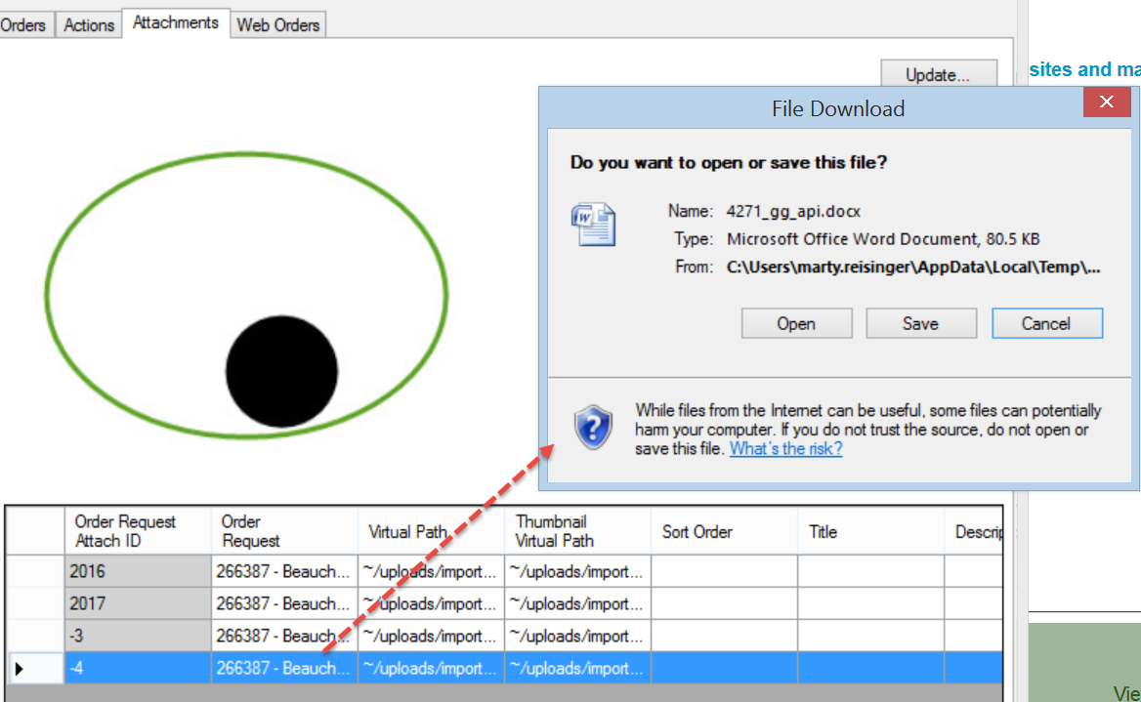
However, after the web order has been shipped (completed) in the CT, the Browse button on the Public Website is no longer available and the requester cannot attach additional files or documents. If the requester needs to include additional files with his order, he would need to contact the genebank and email the file(s) directly to the genebank. The genebank person processing the order can still attach documents to a shipped order.
The Order Wizard has an Attachments tab page which supports the attachment files. In the Order Wizard, attachment files can be manually dragged onto the Order Wizard Attachments page’s datagrid:
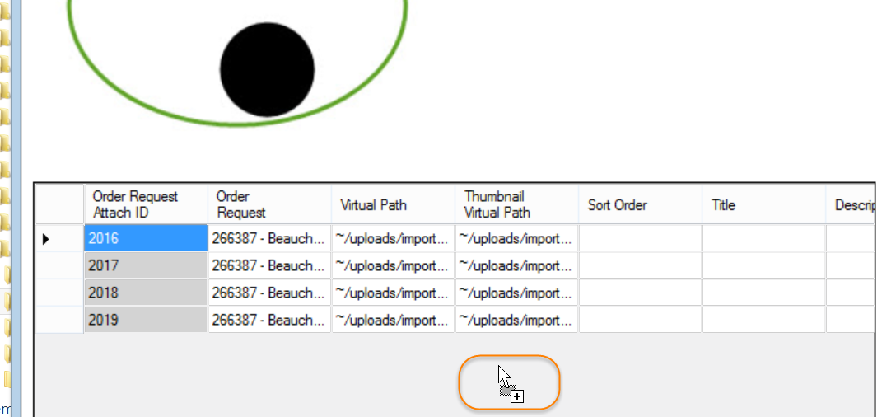

Splitting an Order

How to Split an Order
When discussing “splitting an order,” there are two primary ways of speaking about this, splitting:
- Incoming web orders
- Partially filled orders when not all of the germplasm is currently available (the unavailable germplasm is moved to a new order to be processed at a later date)

Incoming web orders
Incoming web orders may have requests for germplasm stored at multiple sites – the first site to process that order will split out their site’s items from the incoming order. Later, the other involved sites will select their parts of the order. A “site” as used here is a GRIN-Global internal site. For example, in NPGS there are approximately 20 physical genebanks that store and distribute germplasm. In other GG organizations, there may be just one site.
Some genebanks may decide for logistical purposes to split the genebank in more than one site, perhaps to keep handle different crops by different genebank departments. The staff responsible for seed distribution may be assigned to one site, and the staff involved with clonal / in-vitro collections may be assigned to a different site.
On the Web Order tab, select the My Site’s Accessions Only checkbox when the incoming order needs to be split:
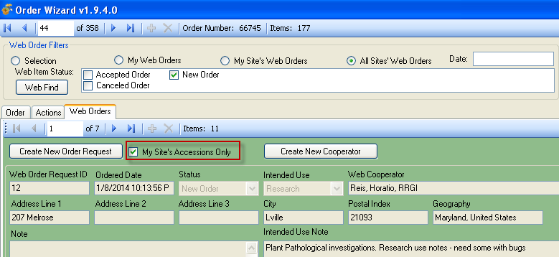
When an incoming web order contains requests for germplasm from multiple sites, the first site to process the order will be processing a new order. Other sites that later process the order, will need to look for the order by its Web Order Number (its status will no longer be new).
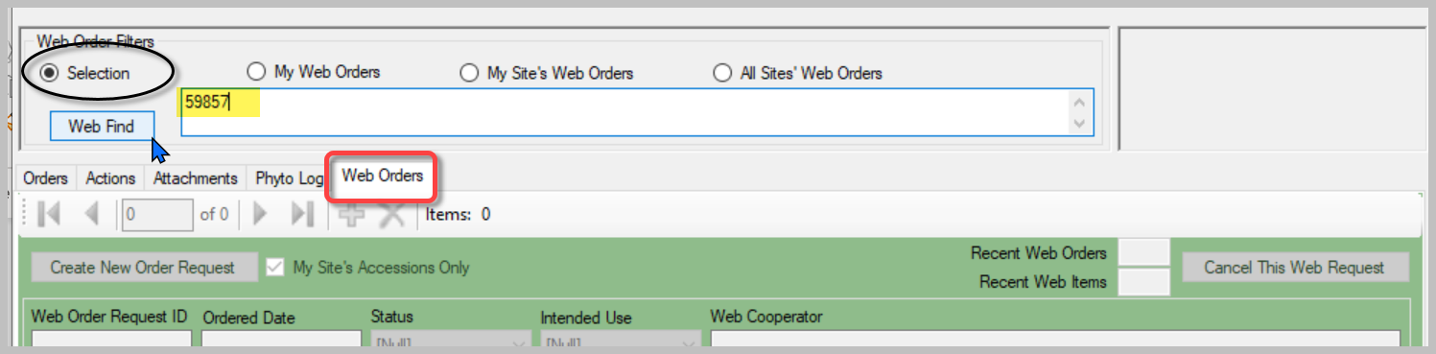

Partially Filling Orders
The second reference to “splitting an order” refers to an order processor being split for some reason, such as germplasm not available for part of the order. The order cannot be completely filled, but rather than wait for all the requested germplasm to become available, the processor will “split the order” and send a partial order. (And later send the other germplasm when it becomes available.)
Before splitting, remember that you can select items (accessions) that in the grid by pressing or holding the Ctrl or Shift keys and clicking the row header cells.
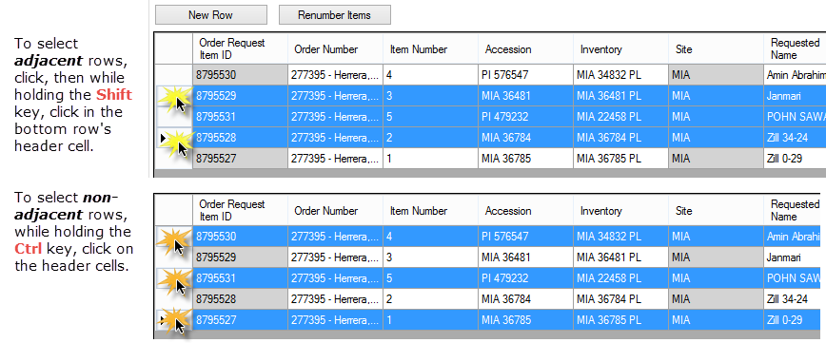
In the Order Wizard, under the Order tab, select the order item(s); right-click. Select Item Status... then select Split out order item; select Yes on the Split Order Confirmation window.
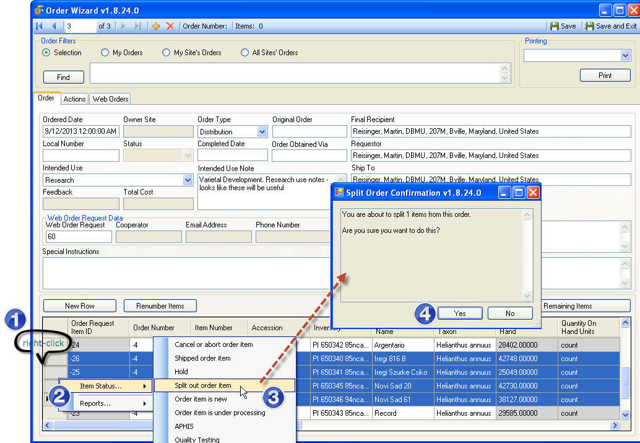

Duplicating an Order
To duplicate an existing order, the following steps can be followed:
- Find the original order in the Search Tool
- Move the order to the CT
- Select that order, using the Order dataview
- Start the Order Wizard
- Select all of the requested items in the grid;
- Right click – select Quality Testing
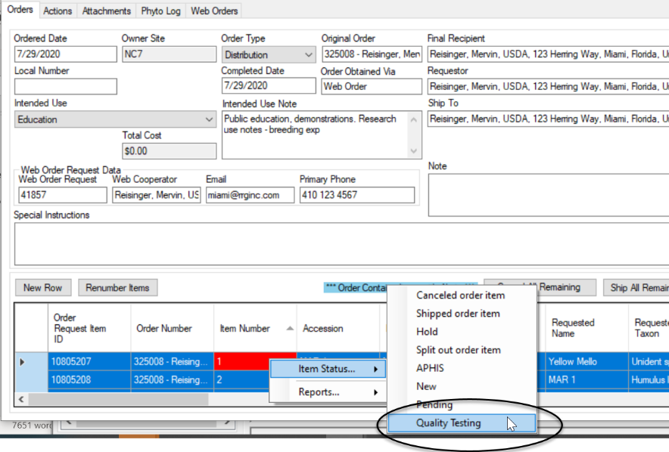
- 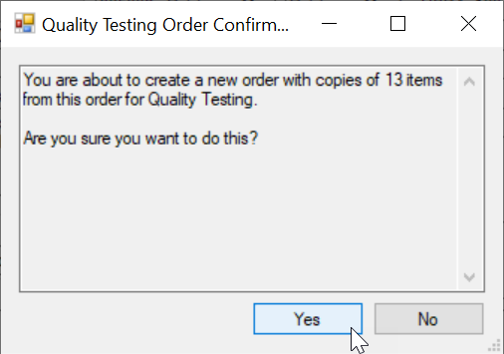

- In the Order Wizard, Save and Exit. You will be prompted to add an item to the active list. If you affirm that you do, the new order item will be displayed:
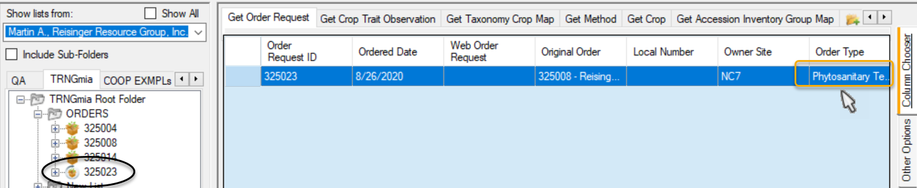
The Order Type will be “Phytosanitary Testing.” You most likely will want to change to Distribution.

Undo a Canceled Web Order
If you accidentally cancel a web order, you don’t have an UNDO feature directly, but you can easily recreate the order. Use the Order Wizard. Search for the original Web Order Number, in the example below it was 17704. Verify that the items are the ones you want placed into an order, and click the Create New Order Request button:
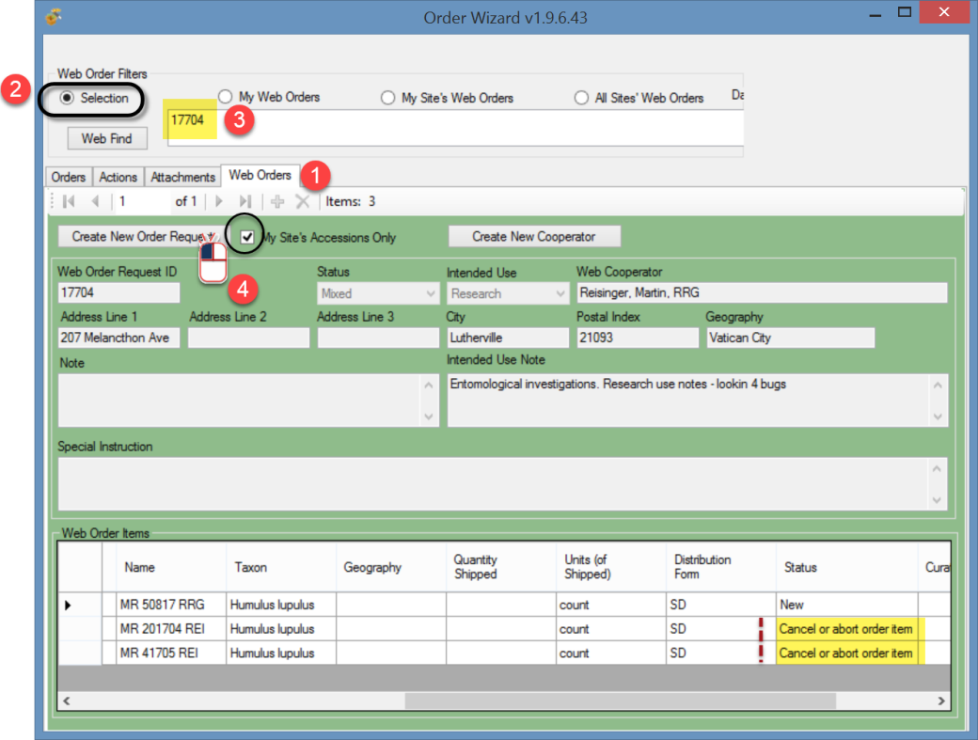
The Order Wizard will switch to the Order tab and display the same web order request items. Save the order; the new order will be assigned its own unique number.
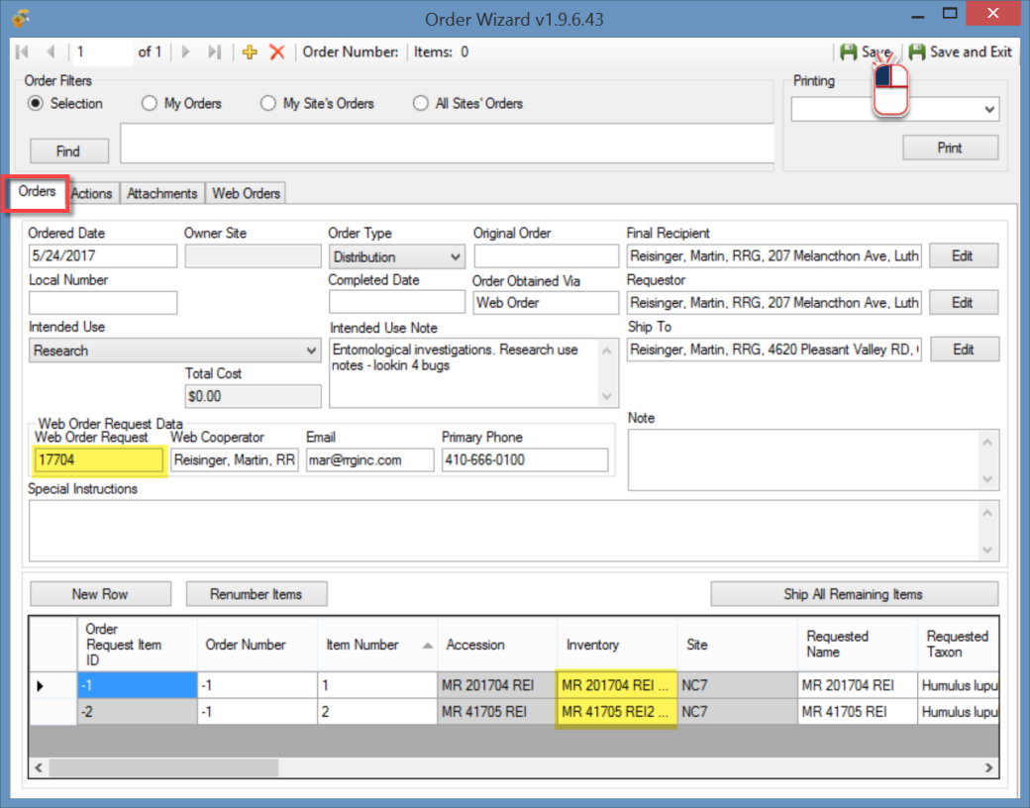

Reports
Beginning in CT v 1.9.4, when selecting reports in the grid, only reports that can be printed for selected individual items will be listed in the menu. Packing slips, picking slips, and other order-related reports may be launched via the Order Wizard Printing dropdown shown in the second illustration).
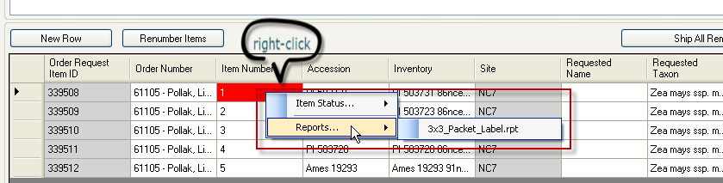
Beginning in CT v 1.9.4, the Printing dropdown has a list of relevant reports from which to select. 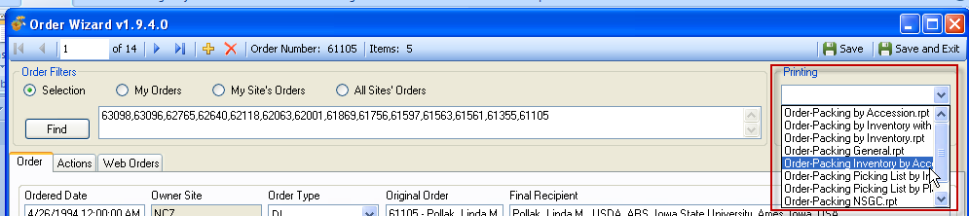

Appendix A: Canceling Web Orders
(This functionality was added to server versions 1.9.9.0 and higher.)
The following method circumvents using the Order Wizard to open an incoming weborder when you simply intend to cancel items. The method can be used to cancel an incoming web order, even when the web order is being sent to multiple sites.
When you complete the steps in the following directions, your site’s portion of the web order will have each of its items marked as CANCELLED. On multiple site orders, the web order record’s status will display as MIXED. Depending on how many sites have received the web order, the individual items may have many different statuses.
The advantage of this method, rather than process the order thru the Order Wizard, is that several steps may be avoided, saving some time. If the requestor is a new requestor, a new cooperator record is not unnecessarily created. Later, when using the Order Wizard to find New Web order, it will display web orders with a MIXED status.

A Web Order is Submitted
As usual, after an order has been submitted on the Public Website, the user can check the status of their order under their Profile | My Order History. A new order is displayed with a SUBMITTED Order Status:
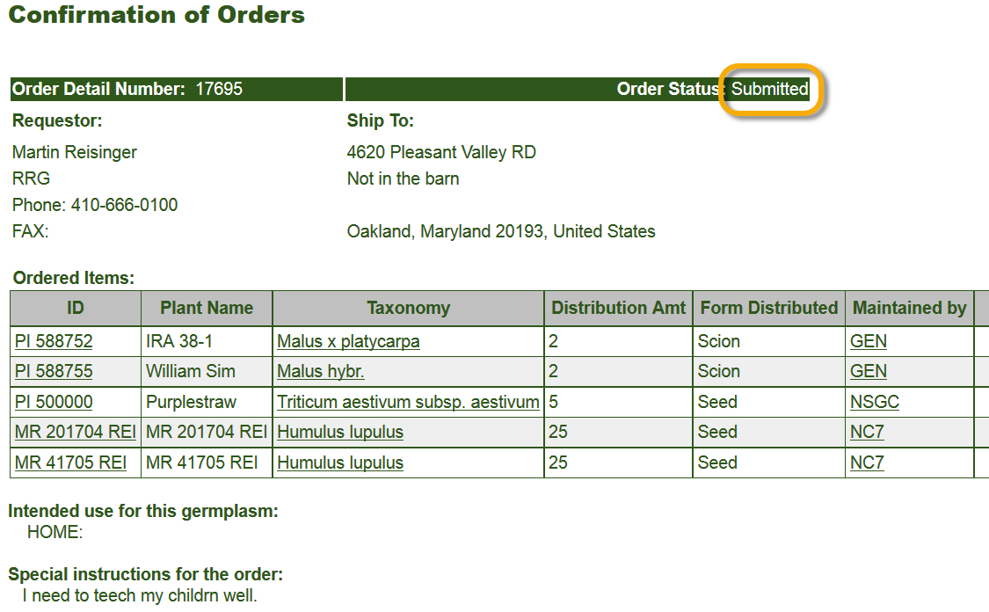
The site’s germplasm staff person processing incoming weborders receives the email confirming the weborder and items being requested:
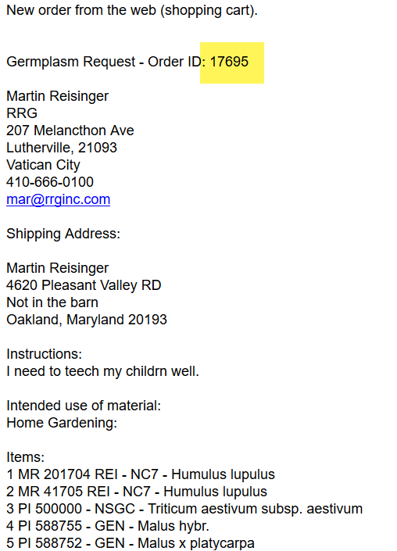

Displaying Lists of Weborders
In the Curator Tool, establish a folder and use the following code as the basis for your Dynamic Folder’s query: @web_order_request.web_order_request_id = 17695
The number shown in red is the weborder.
Alternatively, more involved criteria could be set up for your dynamic query. For example, use a query based on a date range:
@web_order_request.ordered_date BETWEEN '8/1/2017' AND '8/11/2017'
or your site code, and the web_order_request_item.status_code:
@site.site_short_name = 'NC7'
AND @web_order_request_item.status_code = 'NEW'
You can of course use the Search Tool to search, using the web_order_request dataview, to find the web order. Then drag the web order record into the Curator Tool.
Open/Use the Get Web Order Request dataview:
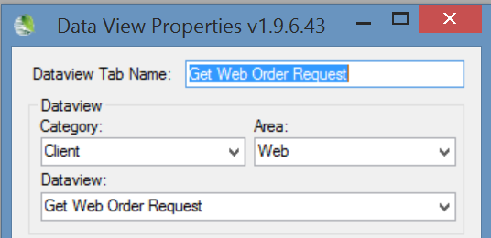
The weborder will initially be displayed with a New Order Status:
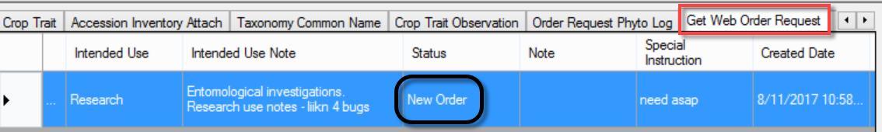

In Edit mode, open the Status dropdown and select Canceled Order:
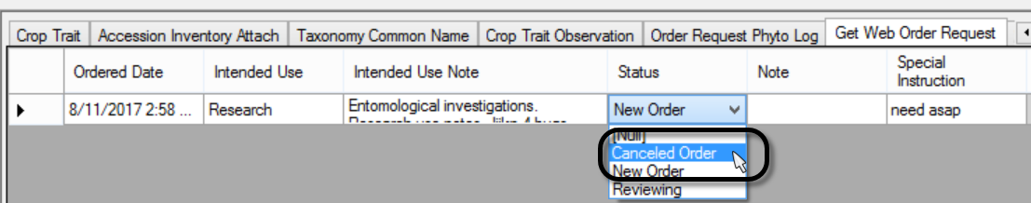
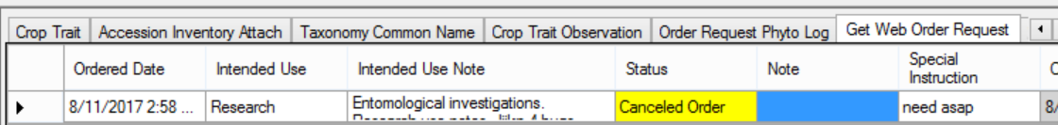

When saved, the Web Order Request Status changes to Canceled Order or MIXED, depending on whether the order was a single-site or multiple-site order:
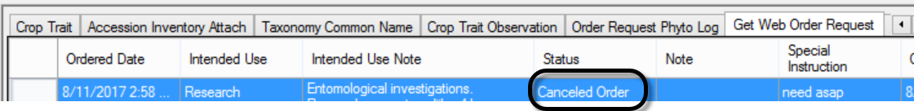
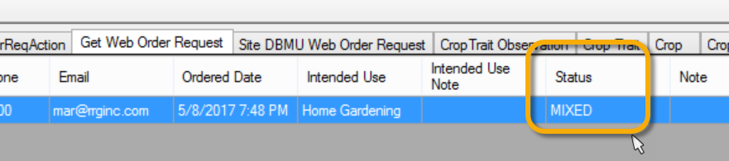
The germplasm requestor will see this status if he checks his order on the Public Website. The site’s individual items will be listed with their Item Status as CANCEL. A relevant Action record will also be
generated.
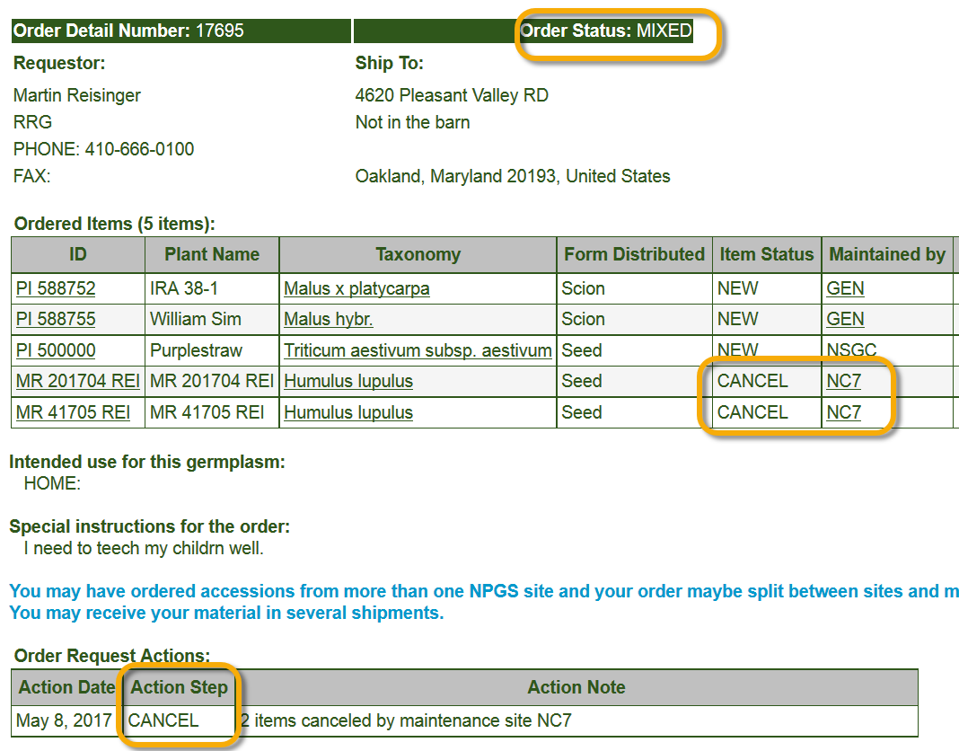

Changing the Status field in the Web Order Request to “Canceled Order” changes the Status to MIXED after the Web Order Request record is saved, but only the items in the web order for your site have their individual item status changed to CANCEL.
If you have searched using the code:
@site.site_short_name = 'NC7'
AND @web_order_request_item.status_code = 'NEW'
(using your site’s code)
and the status of the corresponding Web Order Request is already “MIXED,” you can still use this method to also cancel your site’s items.
Edit the MIXED status, and select
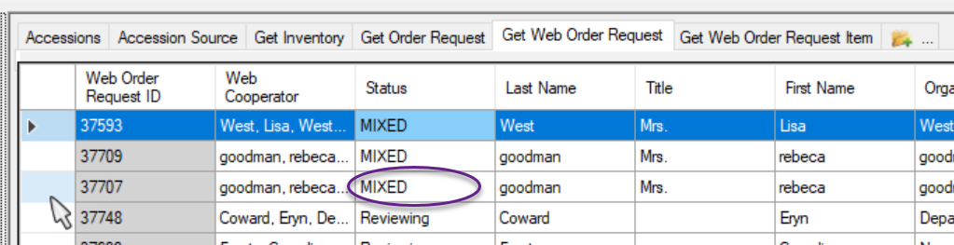
In Edit mode, the status will show as [null]. Select Canceled Order and save the record(s):
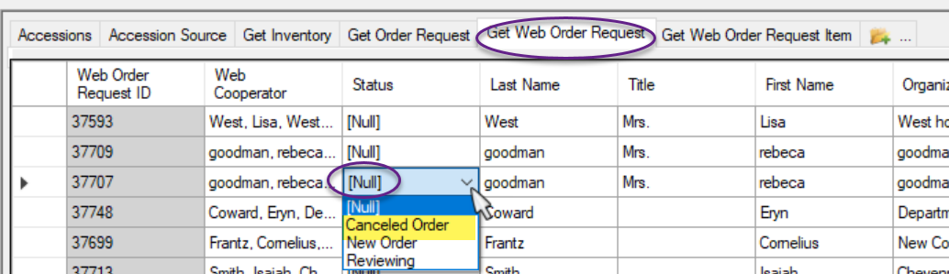

As discussed above, a MIXED Web Order Request may have individual items with different statuses. The following code could be used to find an extensive list of incoming web orders. The results of the above query will include all of the Web Order Request statuses:
(
@web_order_request.status_code = 'SUBMITTED' OR
@web_order_request.status_code = 'ACCEPTED' OR
@web_order_request.status_code = 'CANCELED' OR
@web_order_request.status_code = 'MIXED')

AND @web_order_request.created_date > '31-Dec-2019'
AND @web_order_request.created_date <'1-Jan-2021'
AND
@web_order_request_item.status_code = 'NEW'
AND
@site.site_short_name = 'NA'
Using this code, substituting your site code and desired date, will find all of the incoming web orders.

Listing Web Orders Using SQL
In the Public Website’s Tools | Web Query utility, use the following SQL to look for incoming web orders with a status of MIXED
SELECT wor.web_order_request_id, o.order_request_id, wor.ordered_date, wu.user_name, wc.last_name, wc.first_name
FROM web_order_request wor
JOIN web_cooperator wc
ON wor.web_cooperator_id = wc.web_cooperator_id
JOIN web_user wu
ON wor.created_by = wu.web_user_id
LEFT JOIN order_request o
ON wor.web_order_request_id = o.web_order_request_id
JOIN web_order_request_item wori
ON wor.web_order_request_id = wori.web_order_request_id
JOIN accession a
ON wori.accession_id = a.accession_id
JOIN cooperator c
ON a.owned_by = c.cooperator_id
JOIN site s
ON c.site_id = s.site_id
/* Edit date and site */
WHERE wor.ordered_date >= '2017-07-30'
/* AND wor.ordered_date < '2016-06-01' */
AND s.site_short_name = 'GEN'
AND wor.status_code = 'MIXED'
/* or change to search by username (email address of requestor
WHERE wu.user_name = 'requestor email address' */
GROUP BY wor.web_order_request_id, o.order_request_id, wor.ordered_date, wu.user_name, wc.first_name, wc.last_name
_____________

Example – Two Sites Cancel Their Respective Portions of the WebOrder
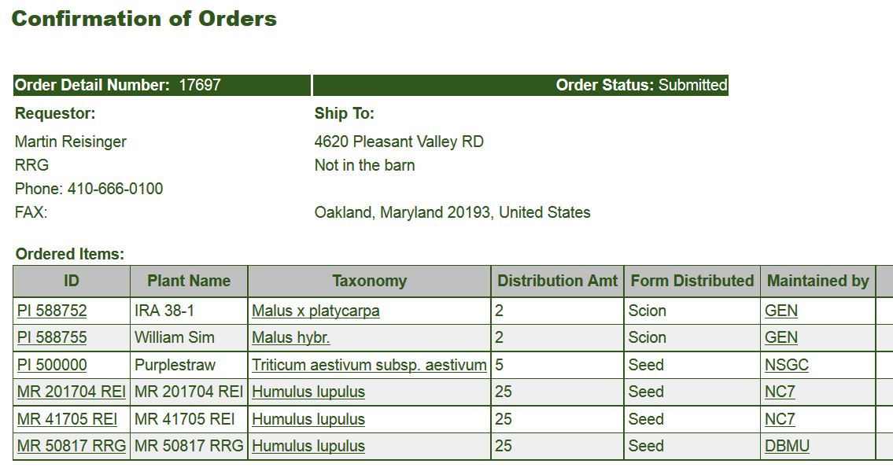

1st Site Cancels
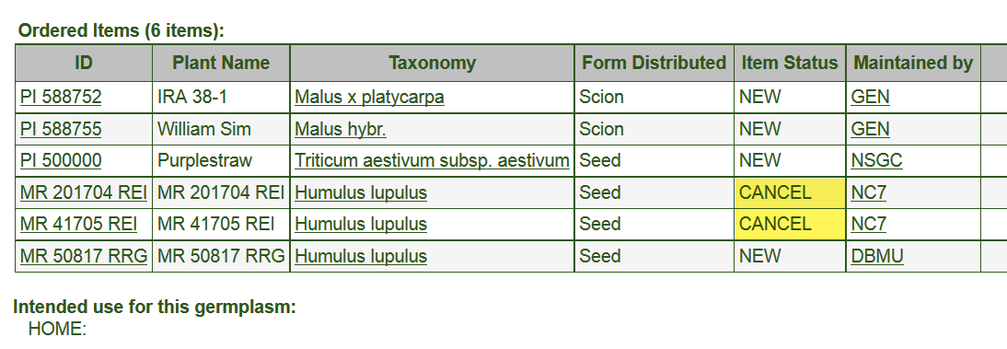

2nd Site Cancels
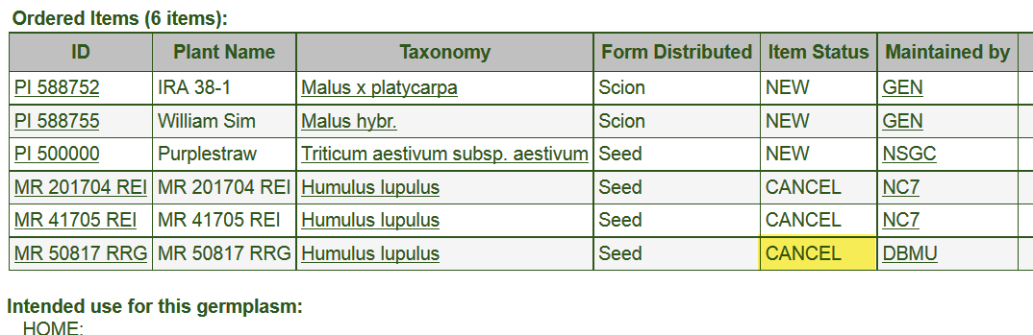

Appendix B: Document Revision Notes

– April 7, 2023
- Added tip regarding the Order Wizard’s default My site’s accessions only checkbox

– March 3, 2023
- Major revamping of document to include recent screen changes and options

– March 2, 2021
- added screens regarding using the Inventory Picker to select specific inventory

– July 31, 2020
- added references to the revised Order Wizard from v. 1.9.9.4
- add a tip regarding duplicating an order

– March 31, 2020
- provided more code and screen examples for the canceling process when not using the Order Wizard

– February 20, 2020
- added note regarding attachments – users can only see attachments they have added to their order

– September 29, 2017
- link added in the Canceling Incoming Web Orders section in the main body of text to point to the Canceling Web Orders section (Appendix B)

– August 11, 2017
- added Canceling Web Orders section (Appendix B)

– November 8, 2016
- added more examples for finding orders using the Public Website (Appendix A)

– June 9, 2016
- added canceling web orders section

– May 27, 2016
- added graphic and note for selecting multiple items

– February 19, 2016
- added detailed search instructions for listing web orders and orders

– February 17, 2016
- added detailed information and notes pertaining to drag and drops
- included additional screens
- added a section on searching for the Completed Date

– June 9, 2015
- added detailed information about order attachments

– May 28, 2015
- added information about editing items in the grid

– March 13, 2015
- extensive editing
- screen captures included from 1.9.6.41

