GRIN-Global Server Changes



Revision Date
July 27, 2015

Versions
1.9.4.1 2
1.9.4 2
1.9.3 2
1.9.2 4
1.9.1 8

1.9.4.1
6/18/2015
Changes made were for addressing ARS OCIO 06-05-2015 dynamic scan’s four Cross-Site Scripting Issues (reported issues are on search.aspx pages, the general search page)
This new PW version prevents a script alert from happening, whereas in previous versions, if the user typed “<script>alert('here!')</script>” in the search box, the script would run and you would see it coming back as an alert.
Changes added more security protection to GG PW application, by adding sanitation to the user input, applying read-only SQL server connection, and using parameterized query in various areas.
No GRIN-Global PW function was affected by these changes.

1.9.4
12/29/2014
Recent changes were coded to process/handle the is_web_visible field added to accession_action. This release corrected one of the changes that had missed a quotation mark.

1.9.3
12/19/2014
DB Schema change:
- removed taxonomy_species_id from inventory_viability_rule; renamed 2 columns, different unique key
- app_setting value expanded to [nvarchar](max)
- accession_inv_name plant_nam expanded to [nvarchar](200); also is_web_visible is not null
- cooperator organization length expanded from 70 to 100

DB base data:
- deleted 40 inventory_status_code codes
- added 3 geography country codes
- added descriptions for 3 missing MTA IPR codes
- modified/added app_resource/app_setting values for menu items, help prompt text, disclaim content…
- added same descriptions as English for ENG lang in sys_table_field_lang table

GG PW:
- added new taxonomy economic search page
- added taxonomy crop wild relative search page
- fixed error that < 1 distribution quantity not showing on accession_detail page
- added link so ‘not able to add to cart’ item can be seen
- added ‘not equal to’ operator for text box search in accession advanced search
- accession action note show/no show will only depend on is_web_visible flag on accession_action table
- fixed error descriptor detail page image link display blank image
- add inventory ids… into fieldbook report from Reports menu
- when is_web_visible is N for accession record, it will not be searchable
- contact us page now send cc email to the sender
- user could chose not to enter ‘state’, then program just use ‘country’ during registration
…

Dataview changes: (see screen shot below)
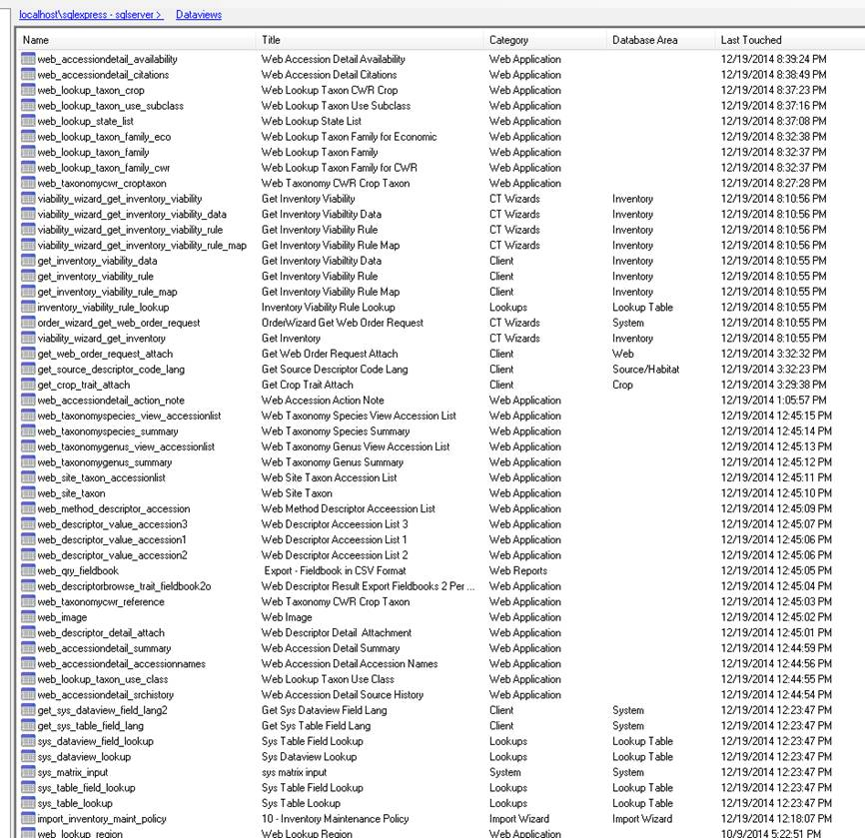

1.9.2
(10/14/2014)

Schema/data:
- added English descriptions to client tables fields (sys_table_field_lang) (CT user would see this description data for each table’s column from the Grid column heading)
- added 'ACTIVE' to the ACCESSION_STATUS code group
- set status_code column with default value ‘ACTIVE’ in the accession table mapping
- added back ‘DONE’ code in ORDER_REQUEST_ACTION
- CURATOR code under ORDER_REQUEST_ACTION group title is changed to ‘Curator assigned’
- add is_web_visible to table accession_inv_name
- updated to DATE_FORMAT code group titles/descriptions
- disabled OrderRequestCoopCatDataTrigger by default
- from AT table mapping, added drop downs for citation table (type_code), web_cart table (cart_type), web_order_request_item table(distribution_form_code , status_code, unit_of_shipped_code), web_order_action table (action_code)
…

GG PW/Middle tier
- Added new items under Taxonomy menu:
  - taxonomy simple search
  - taxonomy advanced search
  - family and genus search
  - about taxonomy
- Added original Plant Inventory data (PI Book) and Plant immigrant series data info/pdf link on the accession detail page
- Added the distribution unit for the available accession in accession detail display;
- Fixed bugs such as: display image when the URL is embedded in the note field of trait;
- Removed duplicate obs value from the observation display;
- Show unique state only once when choosing location;
- Display citation URL link in accession detail if there is any;
- Added the function to export only displayed trait in the descriptor search result export page;
- No validation on zip code entry, and move the country up above state in address entry page;
This build has newly created taxonomy pages that basically follow the GRIN style, but with certain behavior changes, such as when no record returns, the user will stay in the same page (while GC displays a different page, then when user choose back, all their previous entered search criteria are gone) , user could see and fine tune the search condition right on the page, and there are some added drop down lists such as on advanced search page, when one country is selected, then the state/province list for the country is shown in the list …)
New and modified dataview
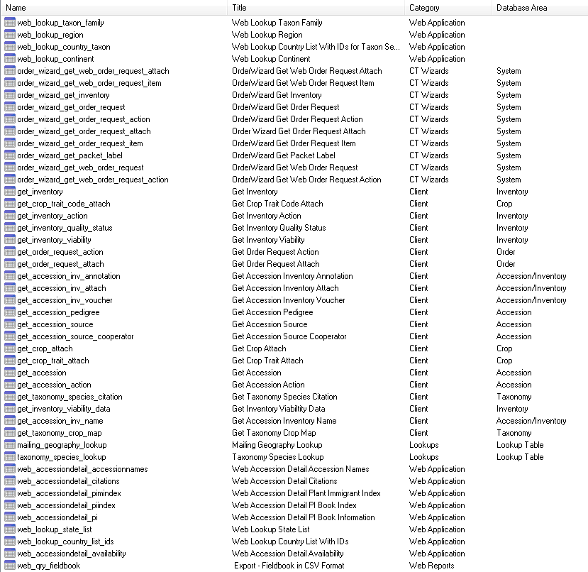

A: New taxonomy menu items:
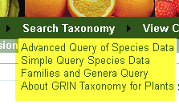

B: Taxon advanced search page: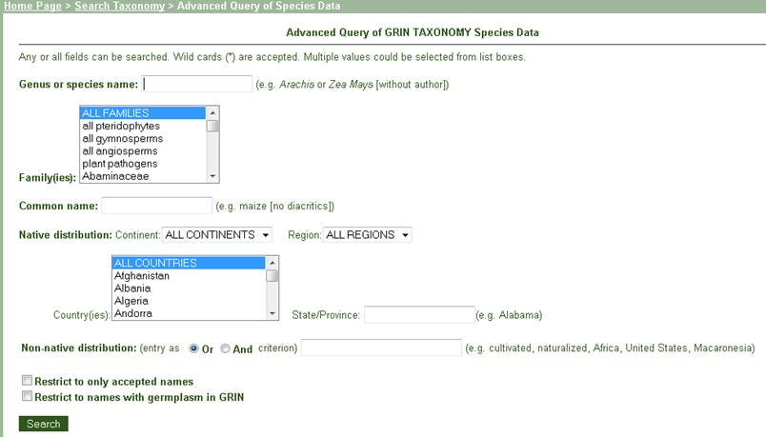

C: Taxon simple search page:
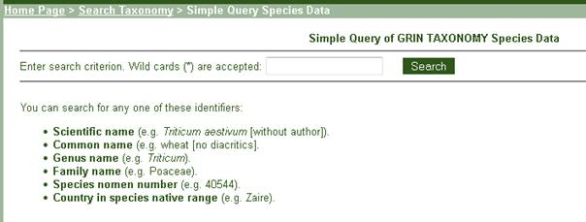

D: About taxonomy header page:
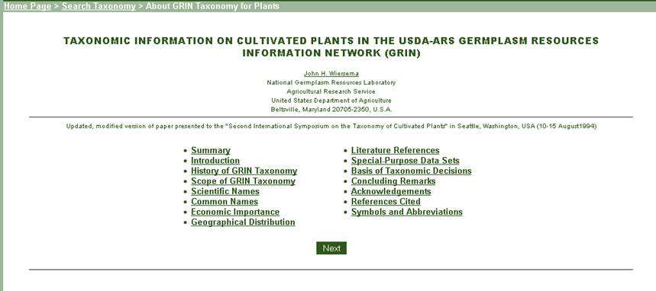

1.9.1
July, 2014
 | Current CT V1.9.6.35 must be coupled with Server 1.9.1 to work optimally.
- Added missing SE RegEx pattern item into web.config;
- Fixed a disconnected link in the new web order detail report page;
- Slightly modified taxon species lookup dataview to compare using current_taxonomy_species_id instead of synonym_code;
- Added the missing sys_table_field_lang for the 5 altered/added table columns from v1.9.0 build, see below (listed them as table name→column name):
  - inventory_maint_policy→quantity_on_hand_unit_code
  - genetic_marker→poly_type_code
  - taxonomy_common_name→citation_id
  - taxonomy_use→citation_id
  - taxonomy_geography_map→citation_id
- Added citation_id to the uniq index of tables taxonomy_common_name, taxonomy_use and taxonomy_geography_map;
- Added a new ‘CT Wizards’ dataview category code, and moved all 10 ‘Order Wizard’ dataviews to this new category with database_area_code as ‘Order’;

