## GRIN-Global Server Installation

#### Using the GG *Updater* Program



Revision Date

March 2, 2020

### Overview

In early 2018, the GRIN-Global server components installation process was significantly changed:

* The GG server installer was improved to work on Windows operating systems greater than Windows 7 and SQL Server versions greater than SQL Server 2008
* It is now possible with the GG Updater to upgrade an existing GRIN-Global database server with a new GG software environment without overlaying the existing curatorial data in the database

This document contains instructions for both a *new* installation of GRIN-Global server software (see Directions for a New GG Installation) and for the *updating* of the GG database environment from an older to a newer GG software version (refer to Updating the GG Database Environment).

The multi-purpose Installer/Updater:  
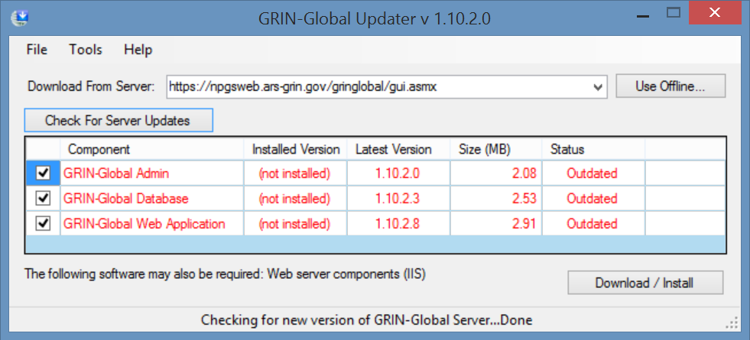

Appendix B contains this document’s revision notes.

Contents

Overview 1

Directions for a New GG Installation 3

Install SQL Server (and SSMS) 3

Basic Install 3

Set the security to SQL Server and Windows authentication mode 3

Custom Install 5

Install .Net 4.6 (or higher) 5

Install Internet Application Server (IIS) 6

GRIN-Global Updater Download and Install 8

Security Note Regarding gg_search and gg_user 9

Updating the GG Database Environment 10

Main Steps to Update the GG Environment 11

Step 1. Back up your database before attempting an upgrade 11

Step 2. Uninstall the previous GRIN-Global database software 11

Step 3. Update the GRIN-Global Updater to 1.10.2.0 12

Step 4. Update the GG Database Software 13

Appendix A 18

Adding Missing gg_search and gg_user Accounts 18

Changing gg_search and gg_user Passwords 18

Appendix B: Document Revision Notes 19

– March 2, 2020 19

– May 2, 2018 19

– April 11, 2018 19

### Directions for a New GG Installation

To install a new GRIN-Global database and web server application follow the following steps.

Install:

* SQL Server (and SSMS)

• .Net 4.6.2 (or higher)

* IIS (Microsoft Internet Information Services Web Server)
* GRIN-Global Updater

#### Install SQL Server (and SSMS)

Install a version of Microsoft SQL Server and SQL Server Management Studio (SSMS). See the SQL Server home page for what version is applicable to your system:

<https://www.microsoft.com/en-us/sql-server/sql-server-2017>

If your database is less than 10GB you can use the free SQL Server Express version under the downloads option.



the installation of SQL Server can require an initial reboot and second install attempt. For ease of installation, use the Basic install. When the installation completes, select the **Install SSMS** button to install SQL Server Management Studio (SSMS).



##### Basic Install

If you chose the Basic install, you must use SSMS to set the login authentication mode and enable the **sa** account.

##### Set the security to SQL Server and Windows authentication mode

In SSMS, right click on the instance, select **Properties**. Under **Security,** select the option for **SQL Server and Windows authentication mode**.

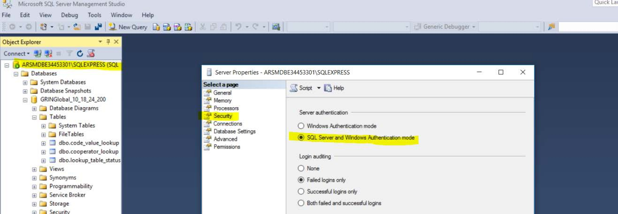

Enable the **sa** account and set the password (needed later for the GRIN-Global install)

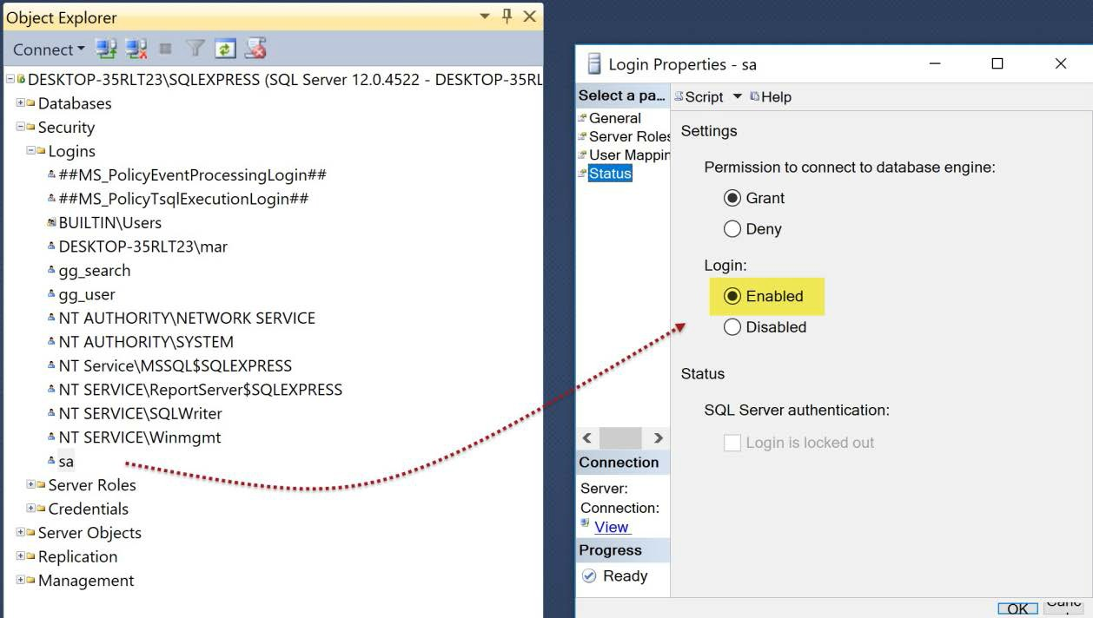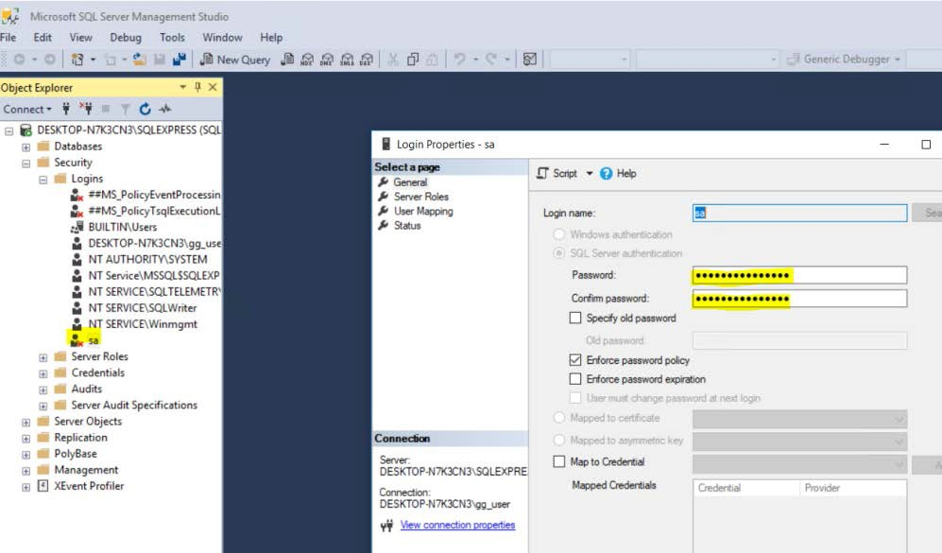

You must restart SQL Server for these changes to take place. This can be done by restarting the service or simply rebooting the computer.



##### Custom Install

If you selected the Custom install, you can set these features during the installation, but the overall installation is more complicated.

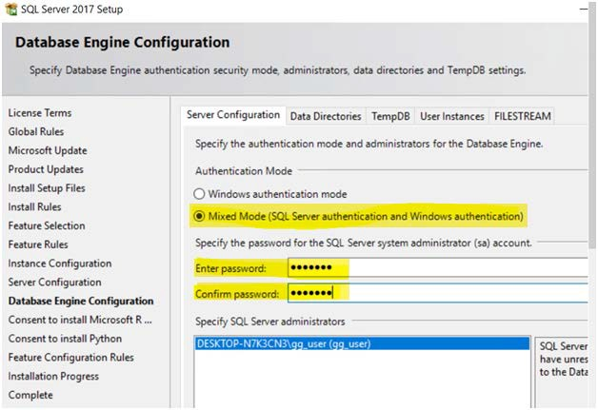

#### Install .Net 4.6 (or higher)

Manually install .Net 4.6 if it is not already installed: <https://www.microsoft.com/en-us/download/details.aspx?id=53345>

|  |  |
| --- | --- |
|  | 4.6 is the minimum version now required for the current GG software. Microsoft is now providing 4.7.1 as of April 11, 2018. |

|  |  |
| --- | --- |
| **image2449.png** | If you are unsure if .Net 4.6 is installed or not, try installing it. It will either install itself or indicate that it has been previously installed. (You can also type **regedit** at the **Start-->Run** prompt to determine the version level.) |

#### Install Internet Application Server (IIS)

Install Internet Application Server (IIS) if not already installed. By default, it is not installed. (You can also type **inetmgr** at the **Start-->Run** prompt to determine the version level.)

Install IIS through the Windows’ **Add Roles and Features** option. Select **Turn Windows Features** **on or off**:

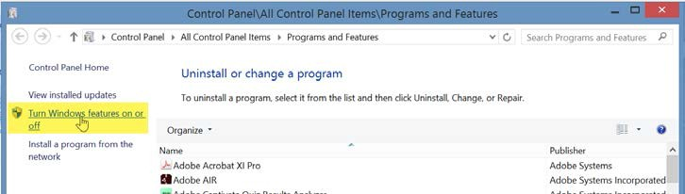

Several sub items under IIS (Internet Information Services) need to be installed with IIS. If the base IIS was previously installed, ensure the extra options as shown below are selected (in newer versions of Windows 10 the choice may be .NET 4.7)

*Windows 10*:

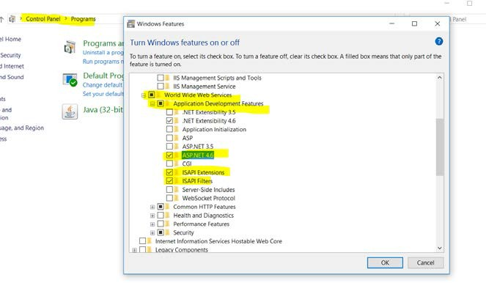

*Server2016*:

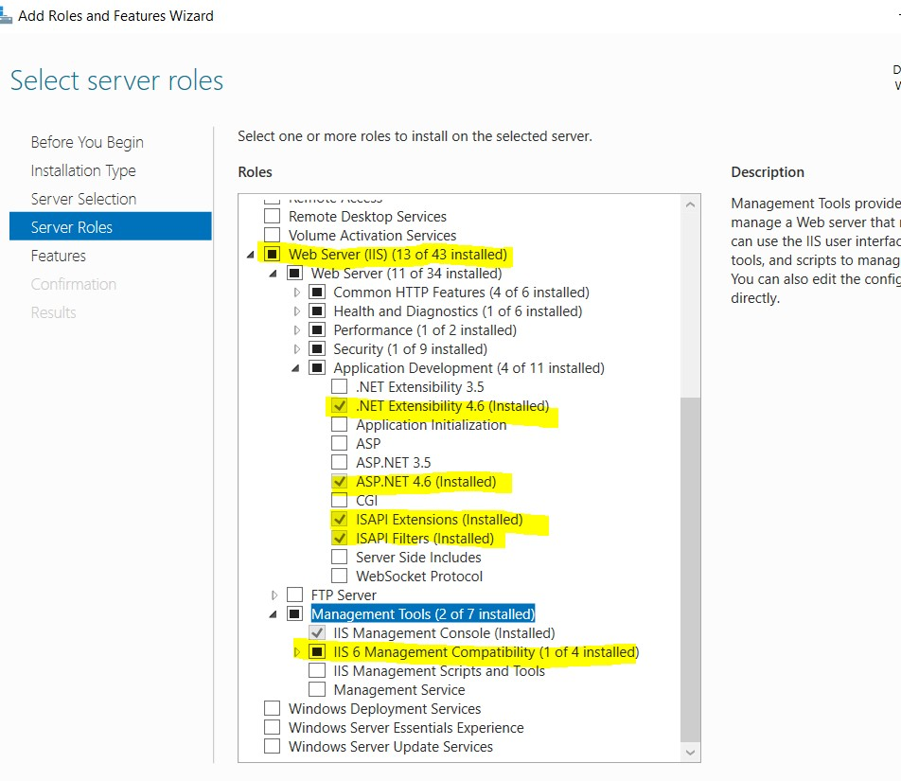

#### GRIN-Global Updater Download and Install

1. Download and save the two **Updater Tool** Setup files:

<https://npgsweb.ars-grin.gov/gringlobal/uploads/installers/latest/GrinGlobal_Updater_Setup.msi>

<https://npgsweb.ars-grin.gov/gringlobal/uploads/installers/latest/GrinGlobal_Updater_Setup.exe>

1. Run the .exe file [to install the **GG Updater Tool**]
2. Start the **GG Updater.** Point it at [https://npgsweb.ars-grin.gov.](https://npgsweb.ars-grin.gov/) In this is a new GG install, all components should be selected for installation.

|  |  |
| --- | --- |
| **image2449.png** | Download the Taxonomy and Geography data that was copied from the U.S. GRIN system. **This option is highly recommended.** |

(Shown below the **Admin** and **Web Application** components were previously selected. It is apparent because the rightmost cells provide the Uninstall option.)

The following directions are optional, but recommended, for downloading the Taxonomy and Geography tables.   
  
Select the **GRIN-Global Database** checkbox.

Press and hold the **Ctrl + Shift** keys *before clicking* the **Download/Install** button. (If you do not want to load the Taxonomy and Geography data, skip the **Ctrl** + **Shift** technique. )

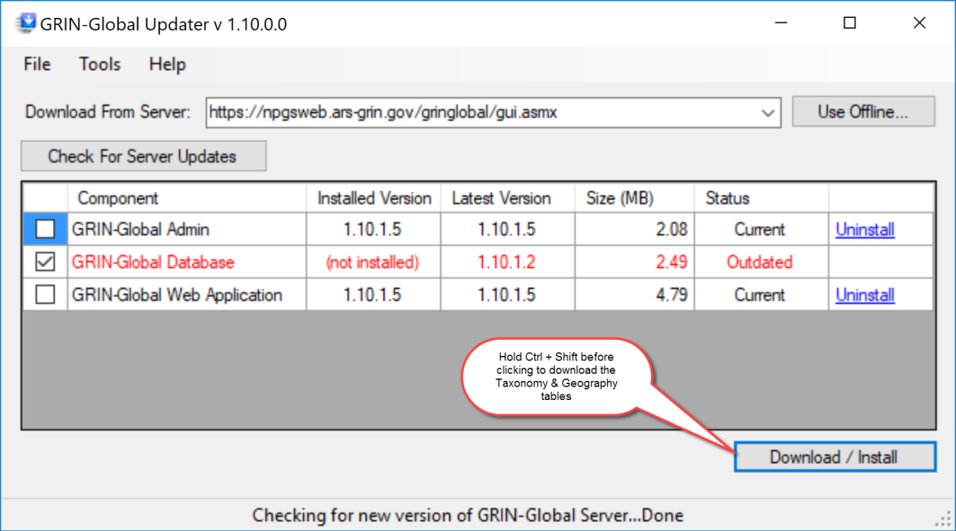

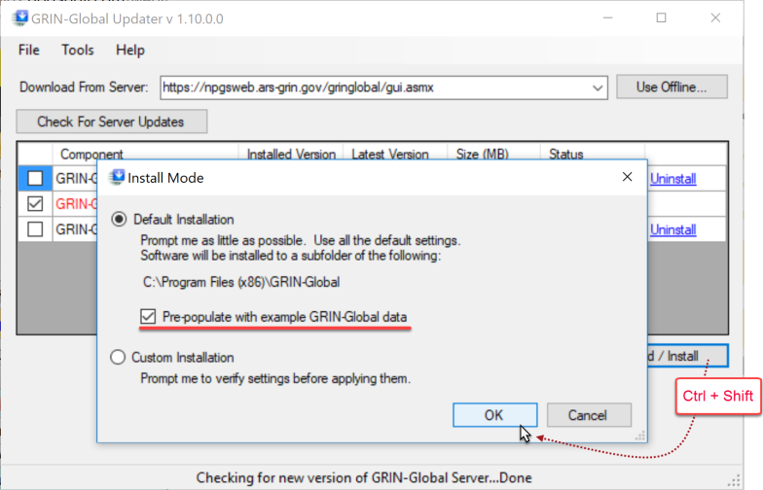

At this point you should be able to test a connection to the database from the computer it was installed on via the Public Website at <http://localhost/gringlobal/search.aspx>.

Connections from other computers need to use either the server’s IP address or host name.

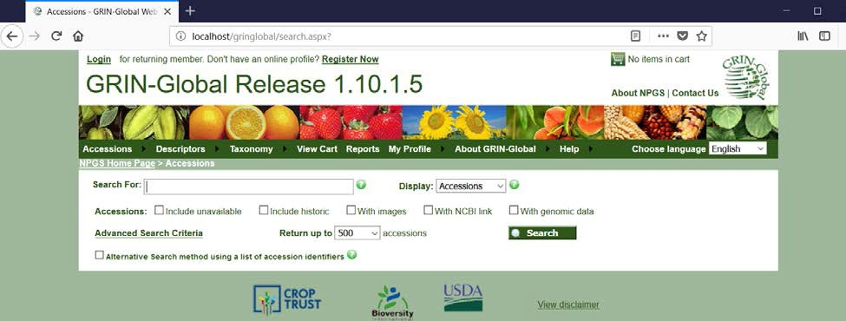

#### Security Note Regarding gg_search and gg_user

The Public Web Site uses 2 SQL Server logins, **gg_search** and **gg_user**.

|  |  |
| --- | --- |
|  | If these two accounts are not in the database, add them. See the section “Adding Missing gg_search and gg_user Accounts” in Appendix A. |

1. Change the passwords for these two accounts in SSMS.
2. Edit **C:\inetpub\wwwroot\gringlobal\Web.config** to coordinate the new passwords you just changed:

a.png

To launch the Curator Tool or Admin Tool, refer to their respective documentation.

### Updating the GG Database Environment

(Leaving the Existing GRIN-Global Database Intact)

The GG database **Updater**, beginning with the 1.10.2 GRIN-Global server release, can upgrade any GG installation ***from version 1.9.1 and later***. Using this tool, you can upgrade to a new version of GRIN-Global and keep the GRIN-Global database intact that had been running.

You can update the Taxonomy portion of the GG database to include any new entries supplied by the USDA while keeping your organization’s taxonomy records if you have any in your current database. Geography can also be updated.

Note that none of these update processes delete any records (except maybe dataview fields). More importantly, local records are not deleted.

When the Updater detects an existing GG database, it will be able to update the GG *environment* (schema changes, dataviews, language tables, and triggers) *without deleting the existing data in the database*.

|  |  |
| --- | --- |
|  | The GRIN-Global **Updater** window looks similar to the following:    The three server components can be installed separately.   * When **Admin** is selected, the GG Admin Tool is installed. * **Web Application** is a bit of a misnomer, because besides the public website, the middle tier web services are also installed. * The middle component, **Database** actually can mean different things, depending on the situation: * When installing GRIN-Global *initially*, the database component will include the database tables (most of which are empty) as well as the other database environment components such as dataviews, triggers, codes, and language data. * When an organization already has data in an *existing* GG database, selecting the GRIN-Global Database component will provide an option to update the peripheral GG “environment” components, but also keep the germplasm data unaffected. |

|  |  |
| --- | --- |
|  | Current version 1.10.6 has two known issues. It doesn’t:   1. create gg_user account if missing 2. handle custom nchar field schema additions in the existing database |

#### Main Steps to Update the GG Environment

Four Main Steps

1. Back up your database before attempting an upgrade (for safety reasons – see below)

2. Uninstall the previous database software

3. Update the GRIN-Global Updater to 1.10.2.0 (optional)

4. Update the GG Database software

#### Step 1. Back up your database before attempting an upgrade

Use Microsoft SQL Server Management Studio to backup your database.

#### Step 2. Uninstall the previous GRIN-Global database software

The previous database *software* needs to be removed before using the new version. You can delete the database software without deleting your existing *database* by using either Windows Control Panel or the GRIN-Global Updater.

In either case, when the connection information window prompts for the **sa** password, do not supply the password, but instead click the **“Skip Database Actions”** button. This prevents your existing database (data) from being removed when the GG database software is removed.  
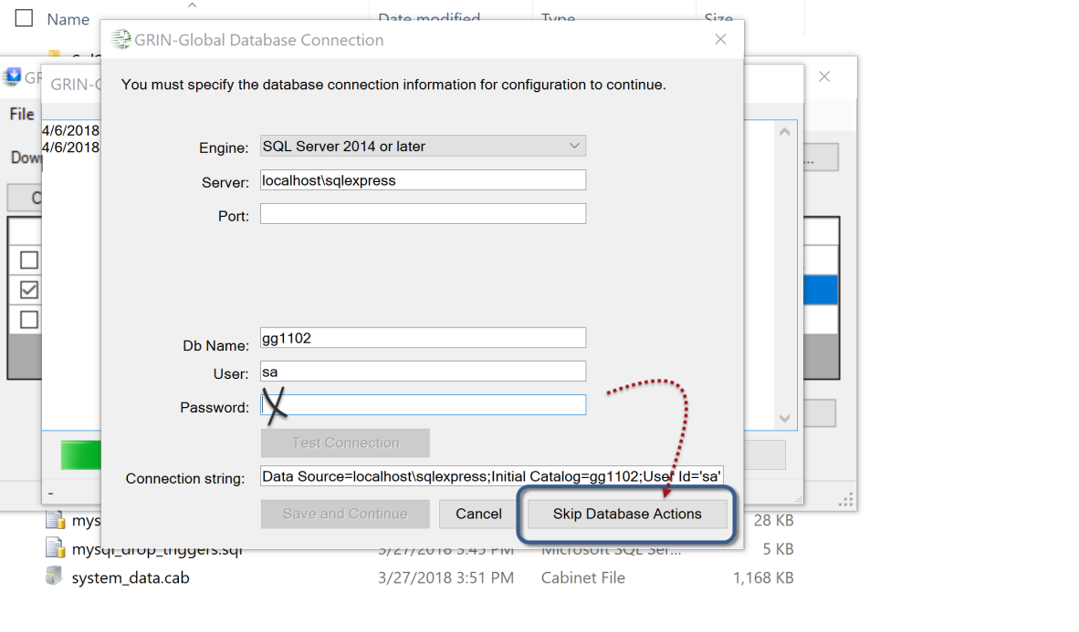

To remove the gg Database software, either use the:

* Windows Control Panel; uninstall “GRIN-Global Database”
* GRIN-Global Updater, click on the Database component’s **Uninstall** link: 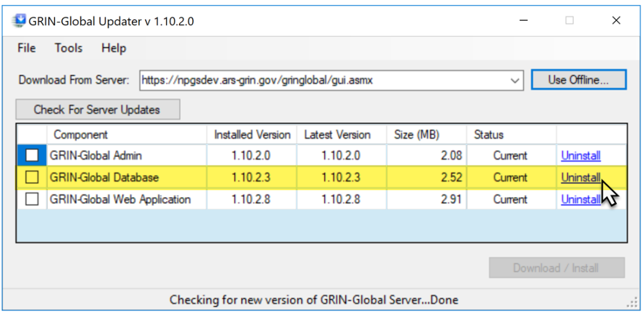

#### Step 3. Update the GRIN-Global Updater to 1.10.2.0

This is an optional step that allows you to specify a database name other than “gringlobal” during installation or upgrade. (This can be useful for test runs.) Direct the GRIN-Global Updater at <https://npgsweb.ars-grin.gov/gringlobal/gui.asmx>

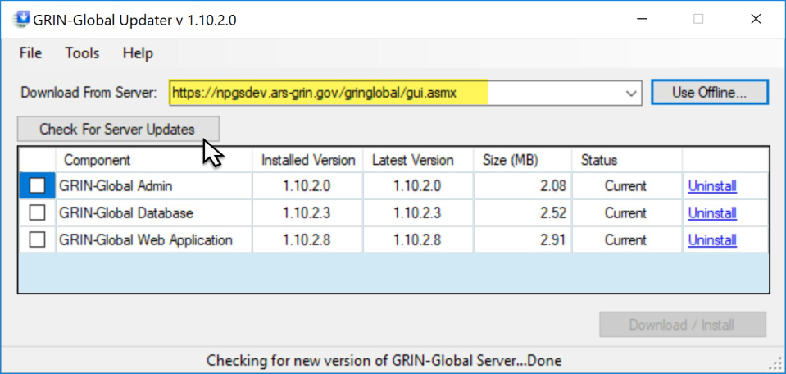

Click the **Check for Server Updates** button; the three components should be listed.

At some point while using the Updater, you may be prompted about updating the **Updater**. If it doesn’t prompt, try closing the Updater and then try connecting a second time. (Notice the Updater’s version is displayed in its Title Bar.)

(Image below shows the latest versions as of 2020, March 2.)  
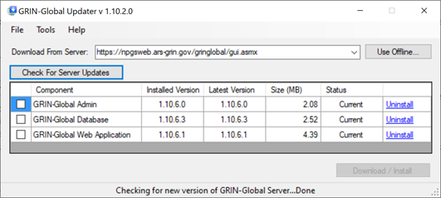

#### Step 4. Update the GG Database Software

Use the GRIN-Global Updater 1.10.2 with **Download From Server** set to  
<https://npgsweb.ars-grin.gov/gringlobal/gui.asmx>

Ideally you have removed the database software as discussed previously in step 2. There should be no installed version of the GRIN-Global Database component*, if there is, perform step 2.   
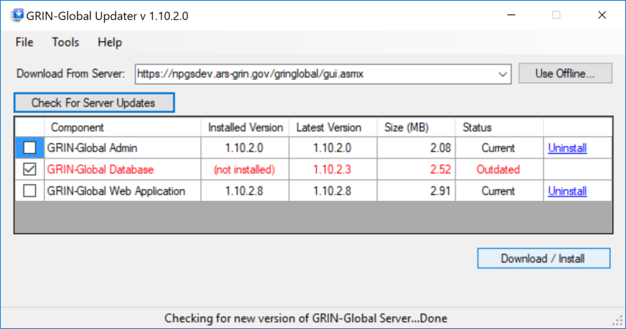  
* Although the component is labeled “GRIN-Global Database,” remember that it is the database *environment* (including schema changes, dataviews, language tables, and triggers)

1. Category “table and field information (st, stf, stfl)” covers tables:"sys_table", "sys_table_field", "sys_lang", "sys_table_field_lang"
2. Category "dataviews" covers tables: "sys_dataview", "sys_dataview_lang", "sys_dataview_field", "sys_dataview_field_lang", "sys_dataview_param", "sys_dataview_sql"
3. Category "datatriggers" covers tables: "sys_datatrigger", "sys_datatrigger_lang"
4. Category "trigger" covers tables: "code_value", "code_value_lang"
5. Category "geography" covers tables: "geography", "region", "geography_region_map", "site"
6. Category "taxonomy" covers tables: "taxonomy_family", "taxonomy_genus", "taxonomy_species"
7. Category "taxonomy detail" covers tables: "taxonomy_alt_family_map", "taxonomy_author", "taxonomy_noxious", "literature", "citation", "taxonomy_common_name", "taxonomy_geography_map", "taxonomy_use"

Check only the GRIN-Global Database component and click the **Download / Install** button.

|  |  |
| --- | --- |
| image2449.png | Use the desired database name (Db name). (Formerly **gringlobal** was the required name, but that is no longer the case.) |

After supplying the database **sa** password on the connection page, click **Test Connection** and then **Save and Continue**.

**Select Custom Installation**  
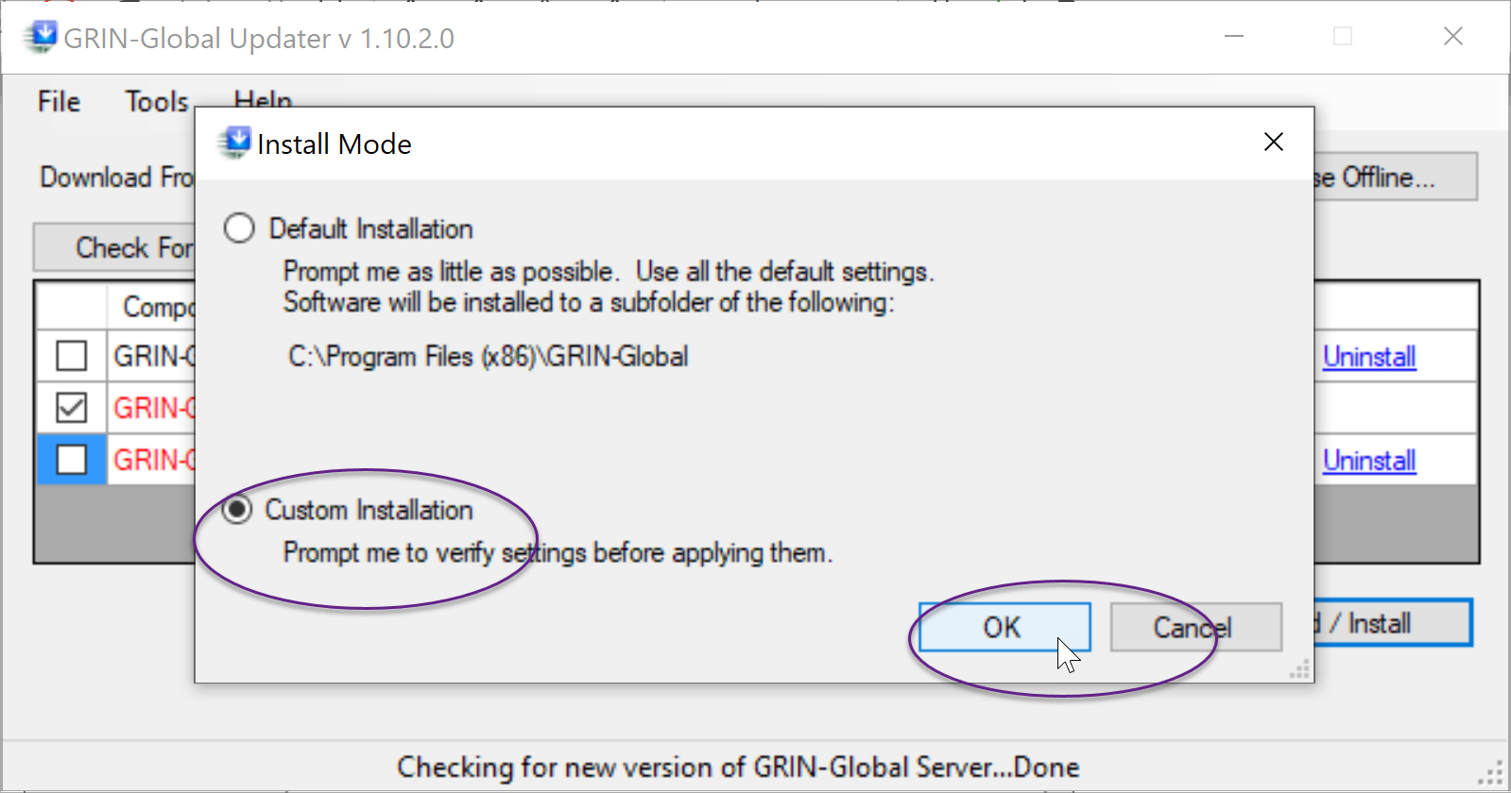

Select **Next** several times:  
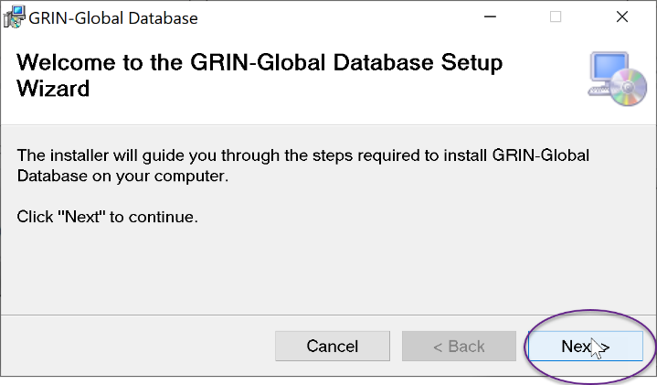

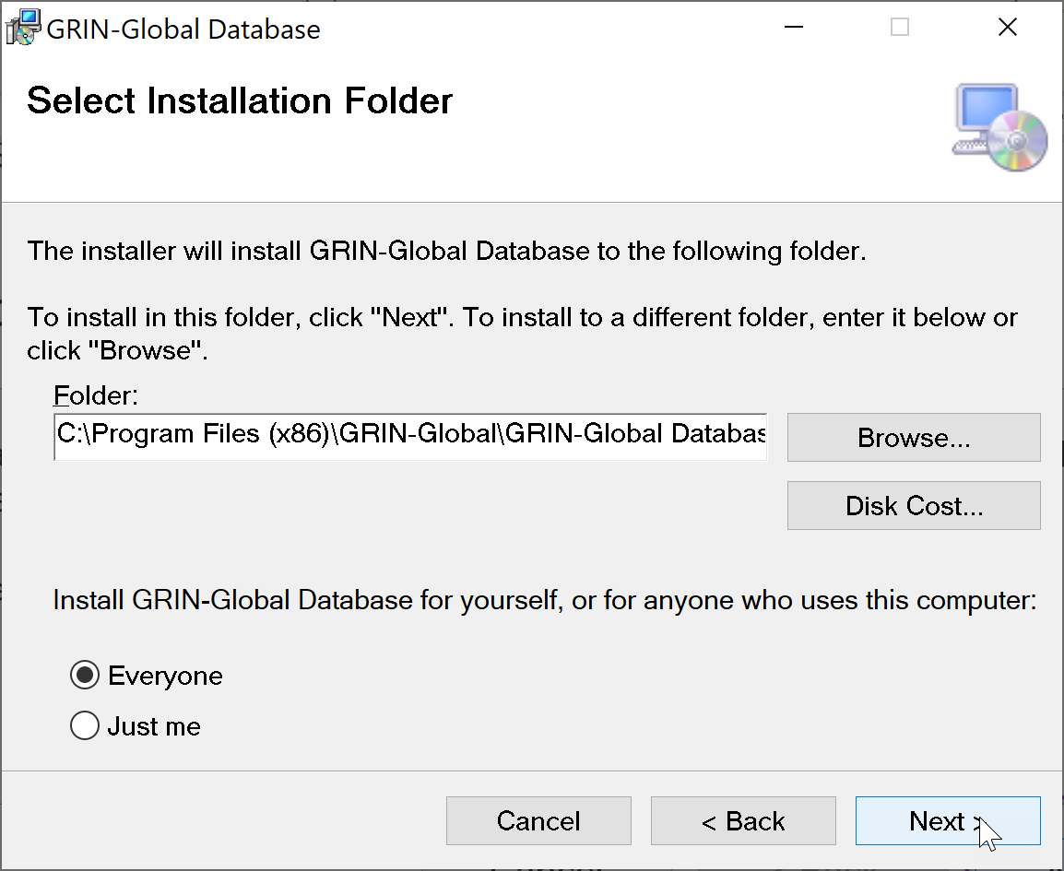

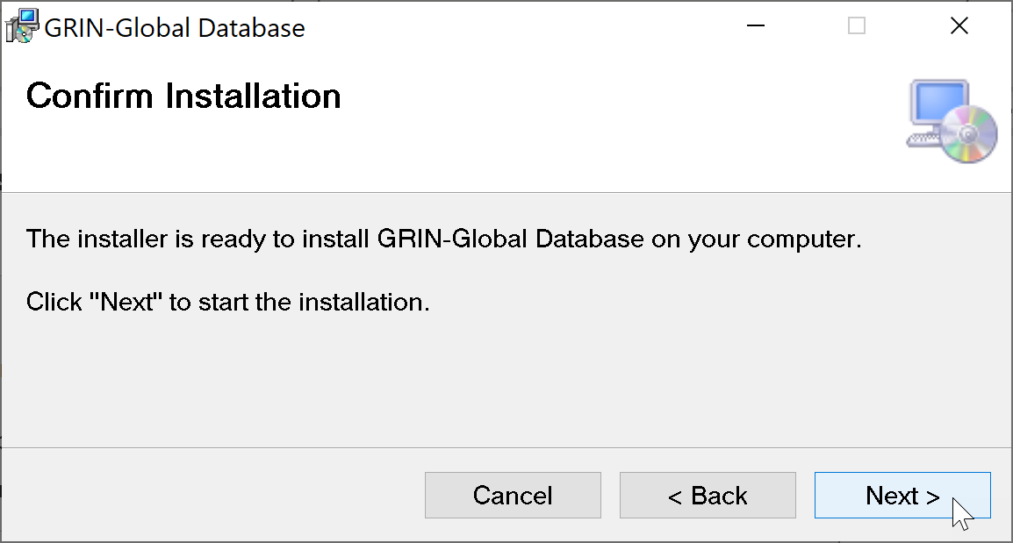

The following screen is a little misleading. The only optional data currently is **Taxonomy**. The other check boxes presently do not affect anything:  
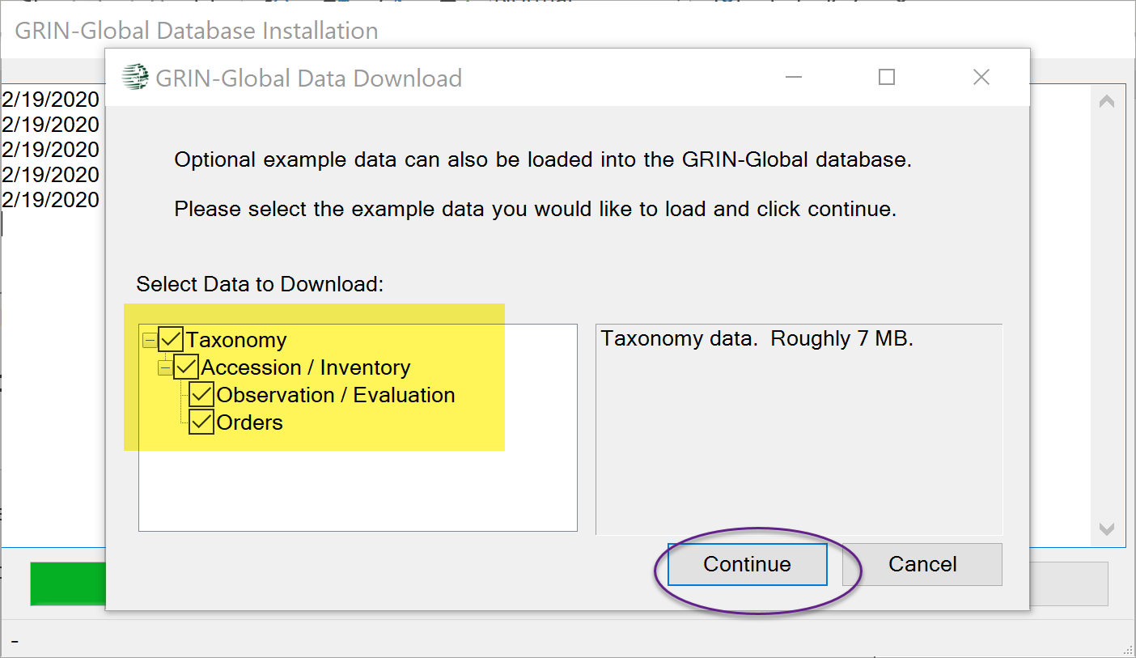

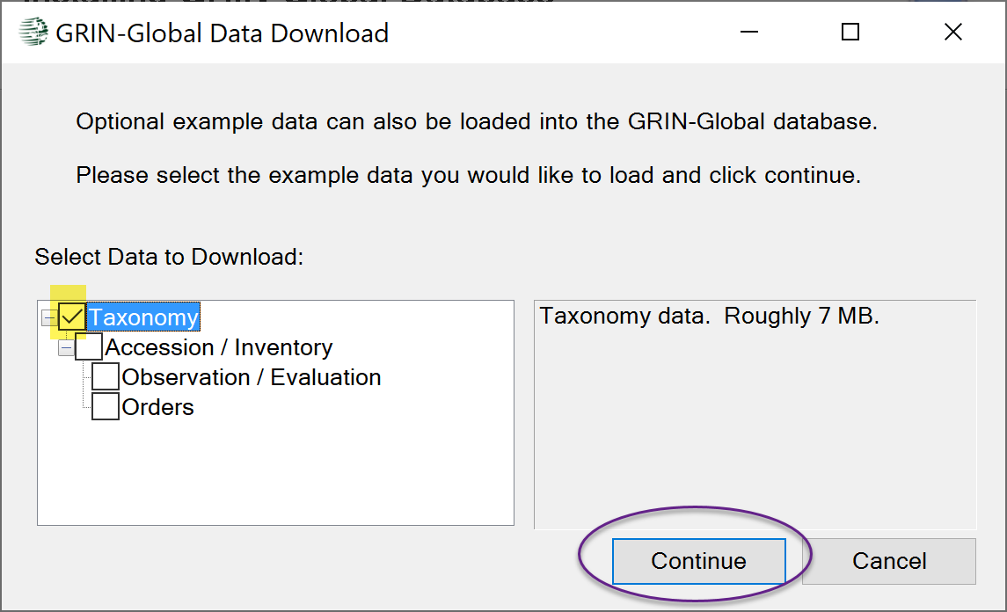

During this process, your existing database (environment) should be detected. You will be prompted to upgrade it:   
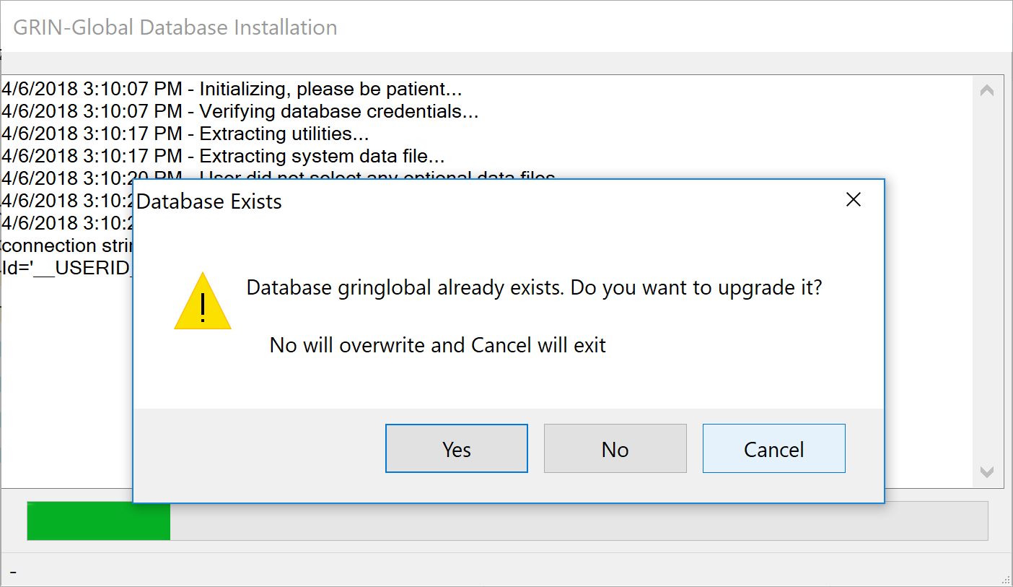

If you select Yes, it will then display the prompt “**Do you want to automatically apply all upgrade scripts and data**? **No will prompt for each step**"  
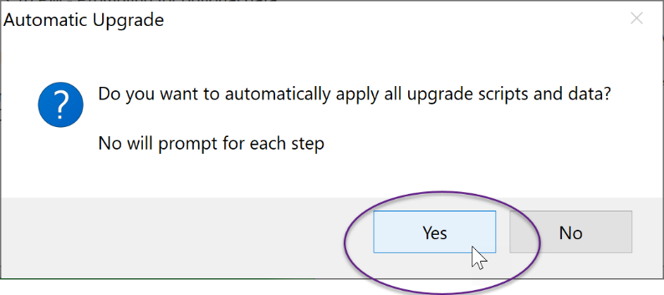

Answering…

* **Yes** - allows the process to automatically apply any relevant upgrades.
* **No -** means you will then be prompted about each step it will take. This may be as many as a dozen steps or more in some cases, but for a recent version database there may be half as many. (This allows you to decide whether to apply scripts and upgrade data, in case there is a reason you want to avoid one or the other, in whole, or in part.)

An example of a prompt when you answer **No** to the **“**“**Do you want to automatically apply all upgrade scripts and data**?...”:  
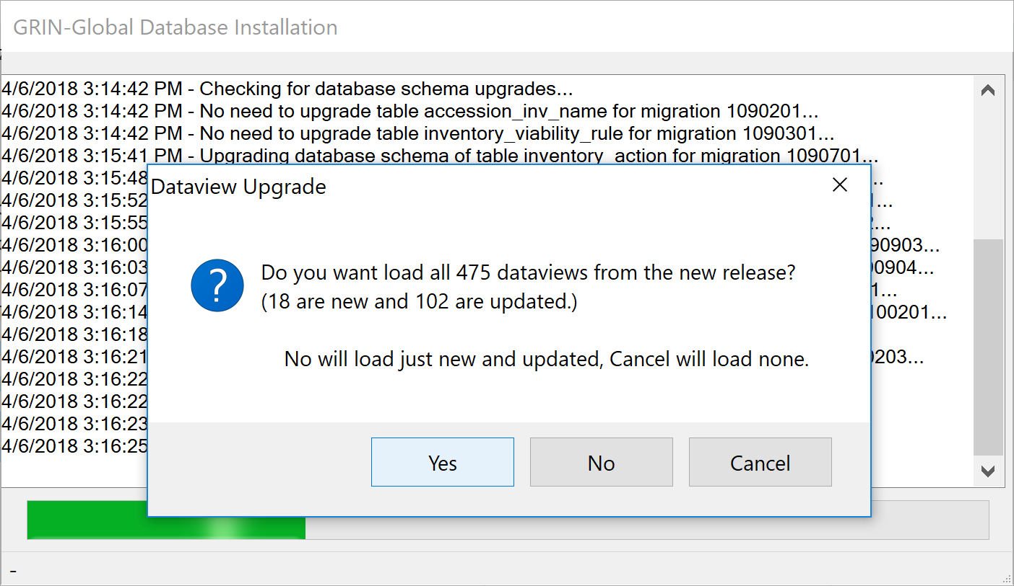

|  |  |
| --- | --- |
| image2449.png | The SQL upgrade scripts are found in the **C:\Program Files (x86)\GRIN-Global\GRIN-Global Database\SqlServer** directory if you want to examine them. It also adds rows to the sys_database_migration table recording the filenames of the scripts it runs on a database. |

### Appendix A

#### Adding Missing gg_search and gg_user Accounts

Use the following SQL to create any missing accounts needed by the current version:

USE gringlobal -- change database name if desired

GO

-- If LOGIN accounts don't exist create new ones...

IF NOT EXISTS (SELECT loginname FROM master.dbo.syslogins WHERE name = 'gg_search') CREATE LOGIN gg_search WITH PASSWORD='ggsPA55w0rd!!11'

IF NOT EXISTS (SELECT loginname FROM master.dbo.syslogins WHERE name = 'gg_user') CREATE LOGIN gg_user WITH PASSWORD='gguPA55w0rd!!11'

-- If database USER account don't exist create new ones with correct privileges to the database

IF NOT EXISTS (SELECT * FROM sys.database_principals WHERE name = 'gg_search') CREATE USER gg_search FOR LOGIN gg_search

EXEC sp_addrolemember 'db_datareader', 'gg_search'

IF NOT EXISTS (SELECT * FROM sys.database_principals WHERE name = 'gg_user') CREATE USER gg_user FOR LOGIN gg_user

EXEC sp_addrolemember 'db_datareader', 'gg_user'

EXEC sp_addrolemember 'db_datawriter', 'gg_user'

____________

#### Changing gg_search and gg_user Passwords

The Public Web Site uses 2 SQL Server logins, **gg_search** and **gg_user**.

1. Change the passwords for these two accounts in SSMS.
2. Edit **C:\inetpub\wwwroot\gringlobal\Web.config** to coordinate the new passwords you just changed:

a.png

### Appendix B: Document Revision Notes

#### – March 2, 2020

* added more installation screens and supplementary text

#### – May 2, 2018

* added reference and link to Appendix A re the two gg_ accounts

#### – April 11, 2018

* combined two documents