SQL* Quick Guide with GRIN-Global

Revision Date
May 30, 2023

Author
Martin Reisinger

This document is a summary of an NPGS Question and Answer session where we focused on the genebank user who is not familiar with SQL basics. Explained here are the basics of running SQL queries in the Public Website and creating custom queries using GRIN-Global table and field names. Tips are also included for joining multiple tables.

Goals
- Use the Public Website to run SQL statements
- Review the basics of SQL coding
- Determine how to locate GG table and column names
- Determine how to create simple queries, accessing data from multiple tables
* “SQL” – Structured Query Language

Refer to the excellent tutorial online if you want additional explanations to any of the SQL reserved words. See https://www.w3schools.com/sql/ Refer to the page: http://www.grin-global.org/sql_examples.htm for additional GRIN-Global SQL examples and resources.

TOC

Overview: SQL and the Public Website 3
SQL – 3 Basic Components 4
Syntax 4
Two Simple GG Queries 5
The LIKE Operator & Wildcards 5
When Do You Use Quotes? 5
ORDER BY 5
Determining Table and Field names? 6
COUNT 7
DISTINCT 8
The IN operator allows you to specify multiple values in a WHERE clause. 8
NOT IN is also valid 8
Multiple Tables 9
ALIASES 10
JOINs: Relating Tables to Obtain Data 10
JOIN Example: Table Code Value and Code Value Lang 12
JOIN Example: Web Cooperator 13
JOIN Query for Crops with Observations at a Site 14
Source and Source Cooperator Example 14
EXISTS Operator (and Subqueries) 15
Appendix A: Frequently Used JOIN Statements 16
Appendix B: Document Change Notes 18

Overview: SQL and the Public Website
Genebank staff who have had their Public Website account connected to their Curator Tool account,* when logged into the Public Website, will have the Tools option visible on the menu. From there, select Web Query to display the box for inputting SQL:
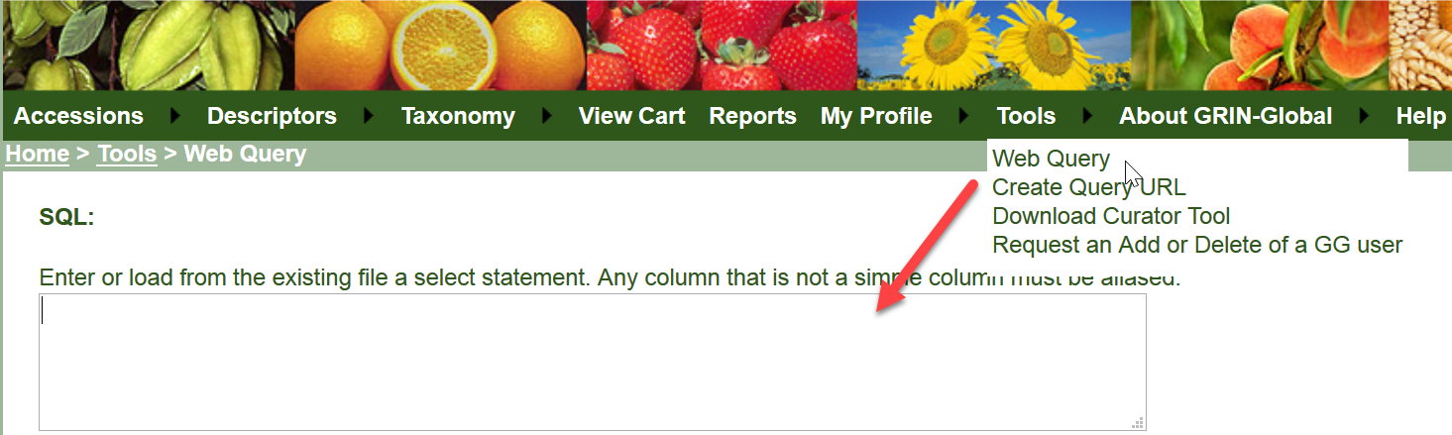
* The organization’s GRIN-Global administrator is the only person with the authority to connect the two accounts (via the GG Admin Tool).
Log in; select Tools | Web Query You can copy or type valid SQL in the box as shown:
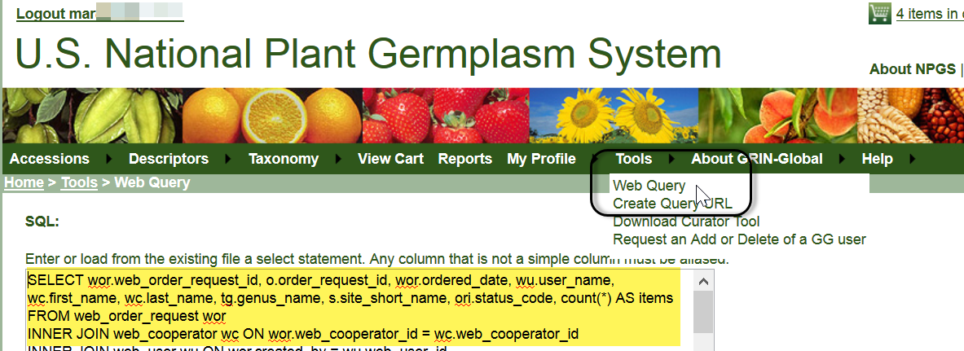
In the Public Website, it is possible to open a .txt file in which SQL has been stored. You can also save your SQL for future reuse. The how-to should be fairly intuitive – click Browse to find the file on your hard drive or network locations, then click the Open File button. When you have a working SQL statement which you may possibly use again, click the Save SQL to File button.
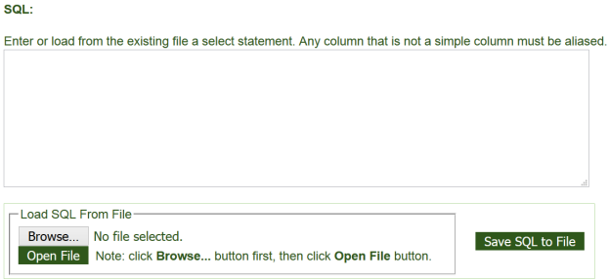

SQL – 3 Basic Components
SELECT – what columns to display
FROM – what tables to search
WHERE – what criteria
In general, in GRIN-Global, most SQL statements will use these three words. In a valid command, you indicate what data you want to display and the conditions. In the GRIN-Global Public Website, a user cannot modify data – only read. Statements such as INSERT or DELETE do not work on the PW page.

Syntax
It is often easier to create SQL by using the Search Tool. Set up a search, with the desired dataview, and begin the query with the following statement:
--dumpsql
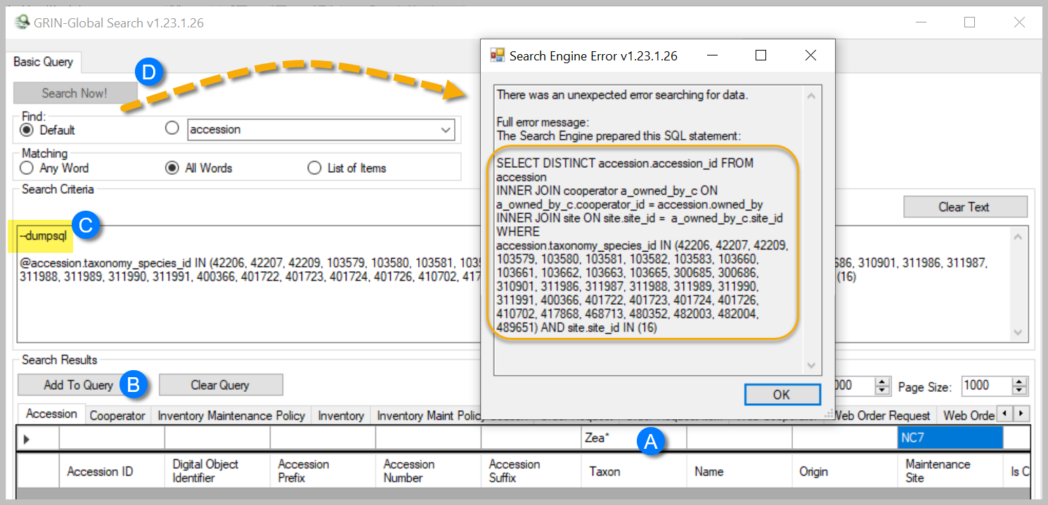

- not case sensitive
- use comments for readability
  - when you use a double dash -- on a line, anything after the double dash is treated as a comment
  - to comment multiple lines, start with /* and then end your comment with */
- commas are needed between items in a list
- use * for all
- the wild cards % and _ are valid. % for any number of characters; the underscore for a single character
- use single quotes, not double, when referring to string literals
In the following examples, items in red can be edited and changed to indicate real data.

Two Simple GG Queries

Find email Address when Web Cooperator Last Name is Known
SELECT last_name, first_name, email
FROM web_cooperator
WHERE last_name = 'Reisinger'

Find Web Order # when Web Cooperator Email is Known
SELECT web_cooperator_id, first_name, last_name, email, created_date
FROM web_cooperator
WHERE email = 'mrducks@rrginc.com'

The LIKE Operator & Wildcards
The LIKE operator is used in a WHERE clause to search for a specified pattern in a column.
There are two wildcards used in conjunction with the LIKE operator:

Find email Address when partial spelling of the cooperator’s Last Name is known
SELECT *
FROM web_cooperator
WHERE last_name LIKE 'Reis%'

When Do You Use Quotes?
Use quotes when the fields have text (non-numeric) data.
…WHERE accession_id = 1927546
…WHERE s.site_short_name = 'S9'
BETWEEN '10-01-2014' and '9-30-2015'
Most of the examples in this document can be copied directly onto the Public Website page and then be executed. However, the ‘ used by Word is invalid in SQL. You will often need to edit the apostrophes to ensure that the SQL is valid and replace with '

ORDER BY
ORDER BY is used to sort the results in ascending or descending order. By default, in ascending order;
use ORDER BY DESC to sort the records in descending order.

Find Site Information
SELECT site_id, site_short_name, fao_institute_number
FROM site
ORDER BY site_id

Determining Table and Field names?
The INFORMATION_SCHEMA.COLUMNS view
SELECT table_name, column_name, ordinal_position, data_type, character_maximum_length
FROM information_schema.columns
SELECT table_name, column_name
FROM information_schema.columns
WHERE table_name LIKE 'accession%'

Use the Curator Tool to Determine Field Names
A Curator Tool dataview often has fields from more than one table; in fact, when editing in a dataview, the CT user should be aware that the gray fields are not editable for various reasons – often because that column is a derived (calculated) field or comes from another table. Remember that users of the Curator Tool work with dataviews, not directly with tables. However, in the CT, when using the CTRL key when you drag and drop a row to an Excel sheet, you can determine the actual database fieldnames:
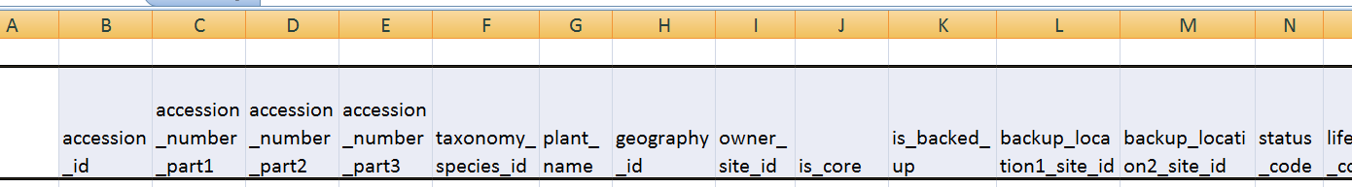
Even when using the CTRL drag & drop method to display field names, the tables names are not displayed, so some deduction is in order. In the example here for the Accession dataview, the taxonomy_species_id field is a good example. We don’t know for sure what table this came from, but the name gives us a good idea. The naming convention used throughout GRIN-Global was to name the primary key field with “_id” – preceded by the table name. In this case, the table is taxonomy_species. When you cannot determine the table by deduction, familiarity, or reviewing the data dictionary, contact your GG administrator who can use additional tools, such as the GG Admin Tool.

Data Dictionary is also a Source for Table and Field Names
Also, the online data dictionary is another alternative which can be used to display column names.
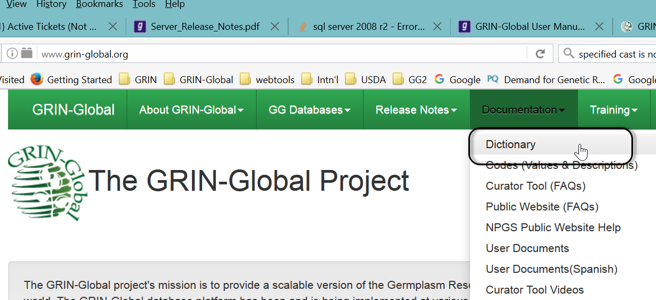
shortened URL direct to the dictionary: https://goo.gl/z2y1gh

COUNT
The COUNT() function returns the number of rows that matches a specified criteria.

Two GRIN-Global Examples
SELECT
COUNT(*) AS Order_Items
FROM order_request_item ori
SELECT
COUNT(*) AS Active_Accessions
FROM accession a
WHERE status_code = 'ACTIVE'

DISTINCT
The SELECT DISTINCT statement is used to return only distinct (different) values.

The IN operator allows you to specify multiple values in a WHERE clause.
The IN operator is a shorthand for multiple OR conditions.
SELECT column_name(s)
FROM table_name
WHERE column_name IN (value1, value2, ...);

GRIN-Global Example
… AND ori.status_code IN ('INSPECT','PSHIP','SHIPPED')
…
JOIN site s ON s.site_id = c.site_id
WHERE s.site_short_name IN ('NR6', 'S9')

NOT IN is also valid
SELECT accession_number_part1, accession_number_part2, accession_number_part3, c.last_name, c.first_name, s.site_short_name
FROM accession a
JOIN cooperator c ON a.owned_by = c.cooperator_id
JOIN site s ON s.site_id = c.site_id
WHERE s.site_short_name NOT IN ('NR6', 'S9')

Multiple Tables
GRIN-Global has many tables by design. Database designers do this for multiple reasons, generally, by doing so, they make the database more flexible and capable of handling future data needs. But having the data spread across multiple tables requires more finesse when writing your SQL. You will frequently find that in order to display data that you want, your SQL statements will include JOIN clauses.
For example, if you were interested in searching for accessions with a certain Taxon, such as Triticum%, at first glance the following may appear valid:
SELECT *
FROM accession
WHERE taxonomy_species_id = ‘Tri%’
But the system will respond:
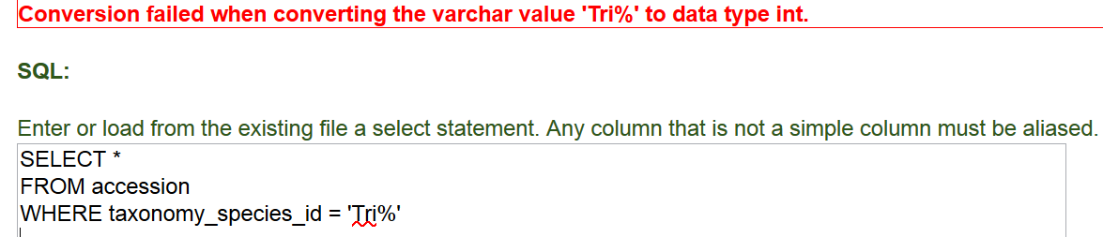
The taxonomy_species_id field is numeric (data type Integer). In fact, all of the GG _id fields are numeric. If we want to specify the species name (or partial name) in our WHERE criterion clause, we need to have SQL use two tables, the accession, and the taxonomy_species.
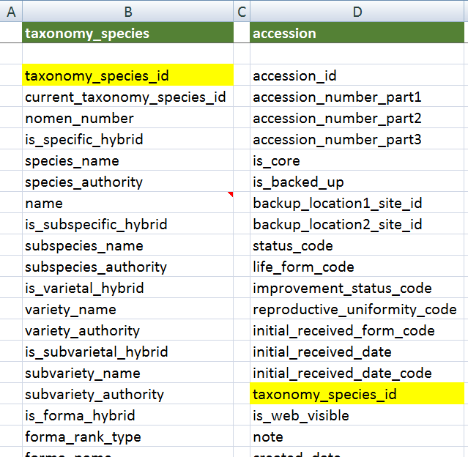
(see the tax-acc spreadsheet on file join_examples.xlsx )
The field that is common to both tables is the taxonomy_species_id field. It is the primary_key field for the taxonomy_species table; each record in that table has a unique taxonomy_species_id. The WHERE clause needs to point to the name field in the taxonomy_species table.

ALIASES
An alias is simply an alternative name for either a table or a field. In the following example, aliases will be created for the two tables, accession, and taxonomy_species. An alias is typically a shorter name, making it easier to code, and also making the code clearer because you can quickly see which table the field is in. The renaming is temporary; the actual table names do not change.
In the following SELECT clause, a is the alias for accession, and ts is the alias for taxonomy_species. These aliases are actually defined in the FROM and JOIN clauses, which follow the SELECT clause. (Aliases typically use letters from the original table name, but they are not required to do so.)
SELECT
a.accession_number_part1, a.accession_number_part2,
a.accession_number_part3,
ts.name
FROM taxonomy_species ts
JOIN accession a ON ts.taxonomy_species_id = a.taxonomy_species_id
WHERE ts.name LIKE 'Trit%'
AND a.status_code = 'ACTIVE'
In this case, it did not matter which table’s taxonomy_species_id field was listed first. We could have written
JOIN accession a ON a.taxonomy_species_id = ts.taxonomy_species_id

JOINs: Relating Tables to Obtain Data
A “JOIN” in SQL returns rows where there is at least one match on both tables. Assume we want to search for accession records whose name is SORGHUM… Let's assume that we have the following tables:
(see spreadsheet: tax-acc-inv-name)
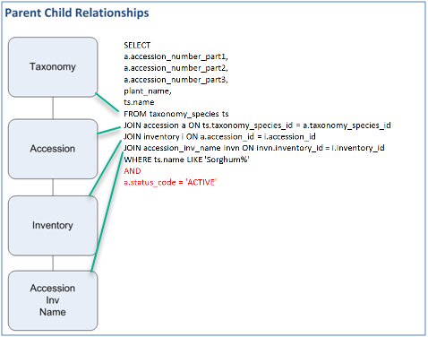
SELECT
a.accession_number_part1, a.accession_number_part2,
a.accession_number_part3, plant_name, ts.name

FROM taxonomy_species ts
JOIN accession a ON ts.taxonomy_species_id = a.taxonomy_species_id
JOIN inventory i ON a.accession_id = i.accession_id
JOIN accession_inv_name invn ON invn.inventory_id = i.inventory_id

WHERE ts.name LIKE 'Sorghum%' AND a.status_code = 'ACTIVE'

You may find it very helpful to first list the fields from each table into a spreadsheet, similar to the following:
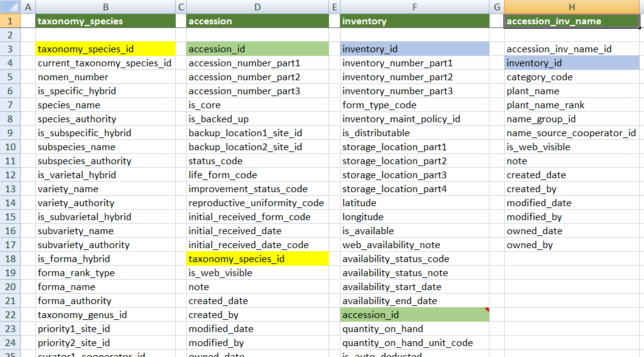
(see the tax-acc-inv-name spreadsheet on file join_examples.xlsx )

The fields linking the tables were highlighted to show how the tables relate to each other. The four tables were required for this SQL statement because the user wanted to display the data in the plant_name field in the accession_inv_name table. Since that table relates indirectly to the accession table via the inventory table, we needed the four tables. (We saw in the previous example why we needed the taxonomy_species and the accession tables.)

JOIN Example: Table Code Value and Code Value Lang
Another example when JOINING tables is necessary is the Code Value table. IN GG we don’t store the titles and descriptions for the Codes used in dropdowns because it is possible to use different languages in GG. The codes that display in drop downs in the CT display in the user’s preferred language. For example, in the U.S. NPGS, all users have their languages set to English when they are given a CT account.
The following spreadsheet graphic shows how the Code Value and the Code Value Lang tables relate to each other, via the common code_value_id field. Following the illustration is sample SQL code.
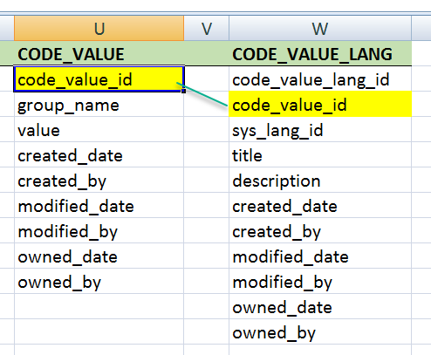
SELECT cv.code_value_id, group_name, value, title
FROM code_value_lang cvl -- language table
JOIN code_value cv ON cv.code_value_id = cvl.code_value_id -- join w/ the code_value table
WHERE cvl.sys_lang_id = 1
/* AND group_name = 'IMPROVEMENT_LEVEL' */
(see the Codes spreadsheet on file join_examples.xlsx )
In many of the GG databases, default languages were installed; English happened to be the first language, hence cvl.sys_lang_id = 1 is indicating the English language.
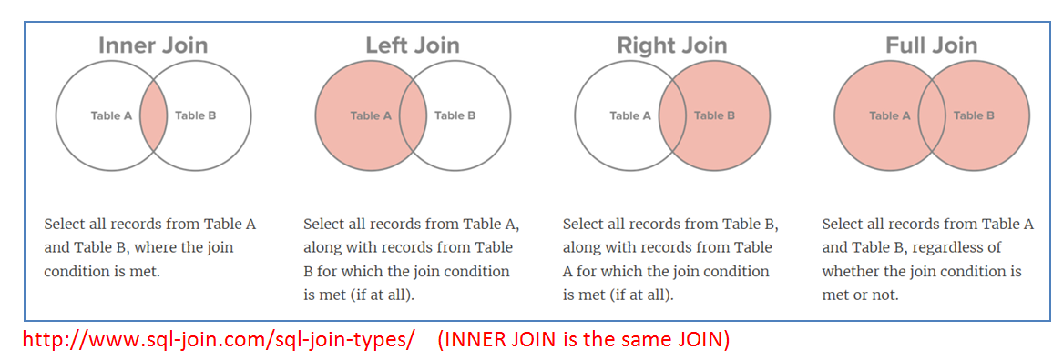
“The first table mentioned is the left side and the second table is the right. When you’re joining from parent to child (FROM parent JOIN child ON…), the parent is the left side. If you don’t want to see childless parents use an (INNER) JOIN. If you do want to see childless parents, then you need a LEFT JOIN. Whenever I’m joining in the reverse direction from parent to child, I’m usually focusing on the children so an INNER JOIN is fine because GG doesn’t have parentless children.”
-- a SQL guru
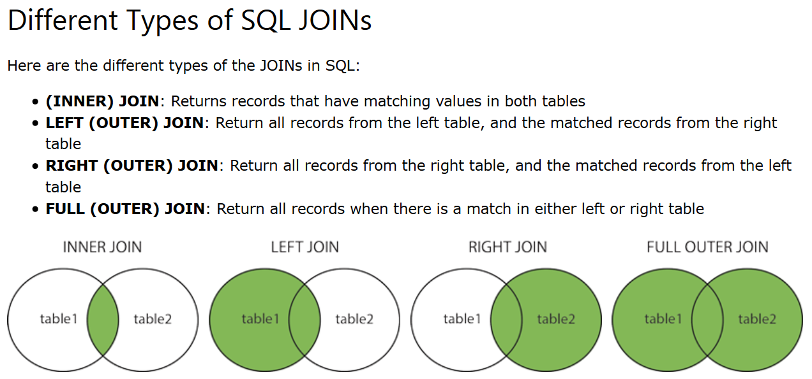
https://www.w3schools.com/sql/sql_join.asp

JOIN Example: Web Cooperator
SELECT c.last_name, c.first_name, c.email, c.address_line1, c.address_line2, c.address_line3,
c.city, c.postal_index, g.country_code, c.web_cooperator_id
FROM cooperator c
JOIN geography g ON c.geography_id = g.geography_id
JOIN web_cooperator wc ON wc.web_cooperator_id = c.web_cooperator_id
WHERE
/* substitute name */
c.last_name LIKE 'Reisinger' AND c.first_name LIKE 'Mar%'

ON vs. WHERE
Regarding ON “I quickly came to appreciate how they closely associated the conditions for joining each table. Previously I would often find myself untangling all the conditions in the WHERE section trying to determine which were used to join the tables and which were about getting the right data. With the JOIN and ON, those conditions are arranged in an orderly fashion.”
For in-depth comparison of ON and WHERE, see: http://stackoverflow.com/questions/2722795/in-sql-mysql-what-is-the-difference-between-on-and-where-in-a-join-statem.
"…The ON clause defines the relationship between the tables. The WHERE clause describes which rows you are interested in (the criteria). Many times you can swap them and still get the same result, however this is not always the case with a left outer join.
- If the ON clause fails you still get a row with columns from the left table but with nulls in the columns from the right table.
- If the WHERE clause fails you won't get that row at all."

JOIN Query for Crops with Observations at a Site
The following query will display a count of the observations under each crop in a specified site. It relates five tables to get the results:
SELECT crop.name AS Crop,
COUNT(*) AS Total_obs
FROM crop
JOIN crop_trait ct
ON crop.crop_id = ct.crop_id
JOIN crop_trait_observation cto
ON ct.crop_trait_id = cto.crop_trait_id
JOIN cooperator c
ON ct.owned_by = c.cooperator_id
JOIN site s
ON c.site_id = s.site_id
WHERE s.site_short_name = 'S9'
GROUP BY crop.name
ORDER BY crop.name
(see the SiteCropObs spreadsheet on file join_examples.xlsx )

Source and Source Cooperator Example

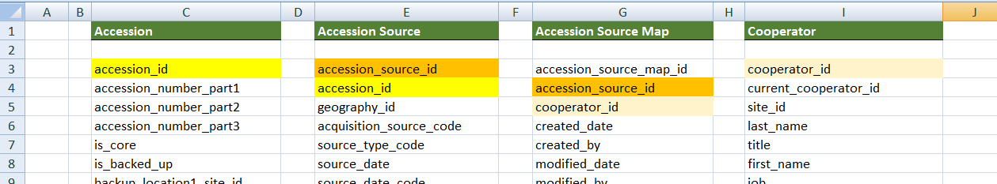

(see the Source spreadsheet on file join_examples.xlsx )

EXISTS Operator (and Subqueries)
The EXISTS condition is used in combination with a subquery. The EXISTS operator returns true if the subquery returns one or more records.
To answer the question: “How do I query for unavailable accessions?” you must look at the related inventory records. (There isn’t an availability flag field at the accession level. Accessions are considered unavailable when none of their related inventory records are both distributable and available.) By using a subquery, the SQL first searches for that condition and then uses the results to resolve the main query.
In the following example:
SELECT a.*
FROM accession a
JOIN taxonomy_species ts ON ts.taxonomy_species_id = a.taxonomy_species_id
WHERE ts.name like 'Glycine%'
AND NOT EXISTS (SELECT * FROM inventory I
WHERE i.accession_id = a.accession_id
AND is_distributable = 'Y' AND is_available = 'Y')
the subquery is
(SELECT * FROM inventory I
WHERE i.accession_id = a.accession_id
AND is_distributable = 'Y' AND is_available = 'Y')

using NOT EXISTS (SELECT condition) excludes the records found in the subquery condition. In this example, when the inventory records have two fields both equal to “Y” , the condition is met -- the accession records would be available. But the question was asking for those accessions that are not available, hence the SQL uses NOT EXISTS (subquery).

Appendix A: Frequently Used JOIN Statements
The following SQL can be used to generate JOIN statements for common child tables:
SELECT pt.table_name Parent, ct.table_name Child, ' JOIN ' + ct.table_name +' ON ' +ct.table_name +'.'+ cf.field_name +' = '+ pt.table_name +'.'+ pf.field_name AS join_clause
FROM sys_table_relationship str
JOIN sys_table_field pf ON pf.sys_table_field_id = str.other_table_field_id
JOIN sys_table pt ON pt.sys_table_id = pf.sys_table_id
JOIN sys_table_field cf ON cf.sys_table_field_id = str.sys_table_field_id
JOIN sys_table ct ON ct.sys_table_id = cf.sys_table_id
WHERE relationship_type_tag = 'OWNER_PARENT'
ORDER BY 1,2

Parent | Child | join_clause
accession | accession_action | JOIN accession_action ON accession_action.accession_id = accession.accession_id
accession | accession_ipr | JOIN accession_ipr ON accession_ipr.accession_id = accession.accession_id
accession | accession_pedigree | JOIN accession_pedigree ON accession_pedigree.accession_id = accession.accession_id
accession | accession_quarantine | JOIN accession_quarantine ON accession_quarantine.accession_id = accession.accession_id
accession | accession_source | JOIN accession_source ON accession_source.accession_id = accession.accession_id
crop | genetic_marker | JOIN genetic_marker ON genetic_marker.crop_id = crop.crop_id
crop_trait | crop_trait_code | JOIN crop_trait_code ON crop_trait_code.crop_trait_id = crop_trait.crop_trait_id
inventory | accession_inv_annotation | JOIN accession_inv_annotation ON accession_inv_annotation.inventory_id = inventory.inventory_id
inventory | accession_inv_attach | JOIN accession_inv_attach ON accession_inv_attach.inventory_id = inventory.inventory_id
inventory | accession_inv_name | JOIN accession_inv_name ON accession_inv_name.inventory_id = inventory.inventory_id
inventory | accession_inv_voucher | JOIN accession_inv_voucher ON accession_inv_voucher.inventory_id = inventory.inventory_id
inventory | crop_trait_observation | JOIN crop_trait_observation ON crop_trait_observation.inventory_id = inventory.inventory_id
inventory | genetic_observation | JOIN genetic_observation ON genetic_observation.inventory_id = inventory.inventory_id
inventory | geneva_site_inventory | JOIN geneva_site_inventory ON geneva_site_inventory.inventory_id = inventory.inventory_id
inventory | inventory_action | JOIN inventory_action ON inventory_action.inventory_id = inventory.inventory_id
inventory | inventory_quality_status | JOIN inventory_quality_status ON inventory_quality_status.inventory_id = inventory.inventory_id
inventory | inventory_viability | JOIN inventory_viability ON inventory_viability.inventory_id = inventory.inventory_id
inventory | nc7_site_inventory | JOIN nc7_site_inventory ON nc7_site_inventory.inventory_id = inventory.inventory_id
inventory | ne9_site_inventory | JOIN ne9_site_inventory ON ne9_site_inventory.inventory_id = inventory.inventory_id
inventory | nssl_site_inventory | JOIN nssl_site_inventory ON nssl_site_inventory.inventory_id = inventory.inventory_id
inventory | opgc_site_inventory | JOIN opgc_site_inventory ON opgc_site_inventory.inventory_id = inventory.inventory_id
inventory | parl_site_inventory | JOIN parl_site_inventory ON parl_site_inventory.inventory_id = inventory.inventory_id
inventory | s9_site_inventory | JOIN s9_site_inventory ON s9_site_inventory.inventory_id = inventory.inventory_id
inventory | w6_site_inventory | JOIN w6_site_inventory ON w6_site_inventory.inventory_id = inventory.inventory_id
inventory_maint_policy | inventory | JOIN inventory ON inventory.inventory_maint_policy_id = inventory_maint_policy.inventory_maint_policy_id
order_request | order_request_action | JOIN order_request_action ON order_request_action.order_request_id = order_request.order_request_id
order_request | order_request_item | JOIN order_request_item ON order_request_item.order_request_id = order_request.order_request_id
taxonomy_family | taxonomy_genus | JOIN taxonomy_genus ON taxonomy_genus.taxonomy_family_id = taxonomy_family.taxonomy_family_id

Appendix B: Document Change Notes

– May 30, 2023
- added notes and image re --dumpsql

