GRIN-Global
translating &
documentation tools

Revision Date
March 27, 2015

GRIN-Global was designed to be used by organizations around the world. Unfortunately, the primary documentation is written in English only. This document provides an overview on the translating of the GG documentation and provides a brief overview on the language aspects of GRIN-Global. Also included are some recommendations for tools that are either free or fairly inexpensive for capturing screens, editing graphics, etc.

Comments/Suggestions:
Please contact feedback@ars-grin.gov with any suggestions or questions related to this document. This and other GRIN-Global–related documentation can be downloaded from the GRIN-Global Training page. For example, the Curator Tool User Guide contains detailed information on the GRIN-Global Curator Tool.

Table of Contents

Translating the Documentation 3
Tools 5
Languages within GRIN-Global 6
Overview 6

Translating the Documentation
The source user documentation for GRIN-Global was written using Microsoft Word. The documents are posted on the GG wiki and are freely available. See the GG Training Page at
http://www.grin-global.org/index.php/Training
Word has a very good translating feature which people typically do not need to use. It is very helpful when a genebank or an institute needs the documentation translated.
The Translate button is on Word’s Review ribbon:
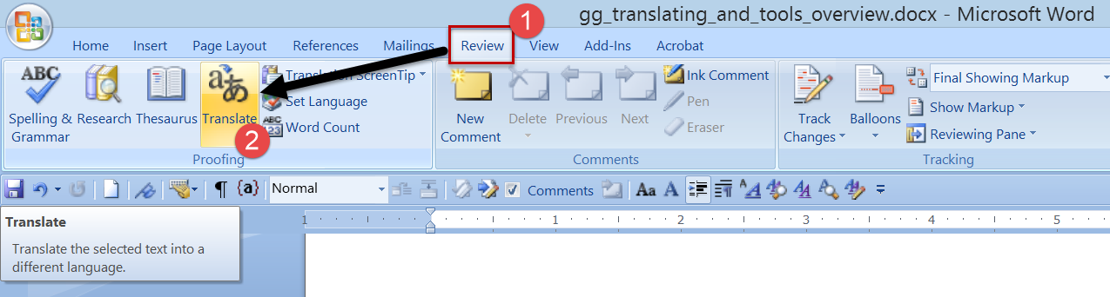
After you click on the Translate button, the Research panel displays. Click on the green arrow:
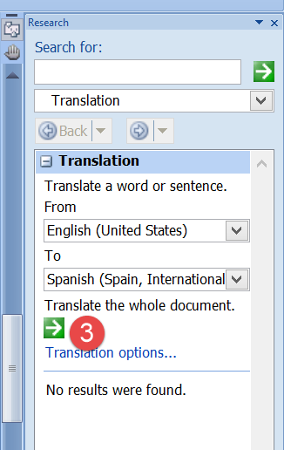
Click on Yes:
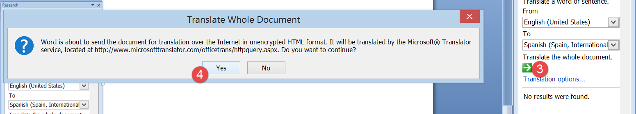
After some time, depending on the document’s size, the results are displayed in a browser window:
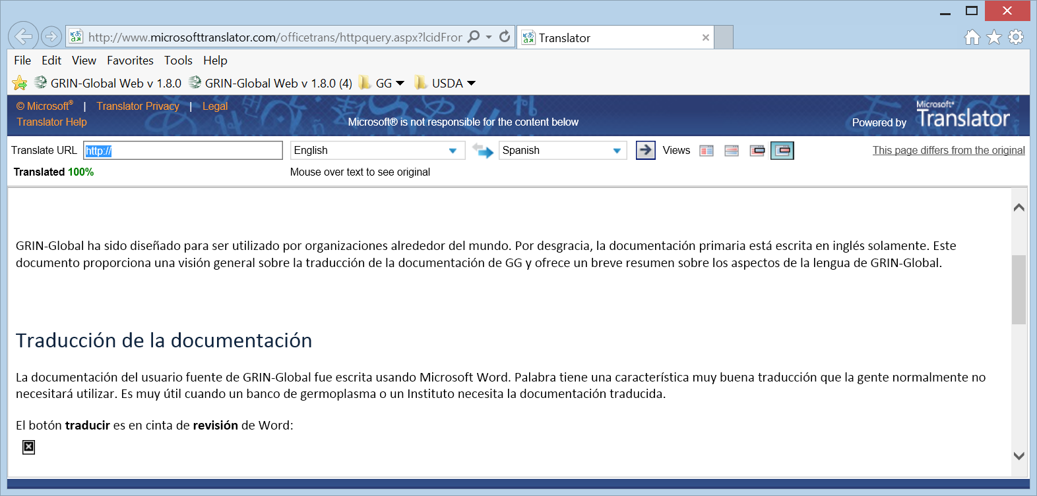
Unfortunately (and impossible to do!) the graphics in the document do not get translated. But the text can be used as the basis for the translated document. At this point, the editor may wish to embed the translation in the English source document, and then go through the process of (a) validating the text, and (b) capturing the GG screens in the desired language. (Running GG in other languages is an entirely separate topic, but in this document we’ll provide a quick overview. For more details on incorporating other languages into the GG database, see the GG Language Guide document posted online.)
Whenever creating screen captures of the software, it is recommended that you not embed text on the graphic, primarily because ant text in a graphic will not translate.

Tools
Purpose | Tool / Source | Comments
Screen Capturing | SnagIt  techsmith.com | tool for capturing screen segments; also includes an editing tool for including annotations highlighting, and graphics
Screen Capturing | Greenshot  getgreenshot.org | open source alternative to SnagIt – both are excellent tools, greenshot has less features, but it’s free!
Graphics Design & Editing  (vector) | inkscape  https://inkscape.org/en/ | open source vector graphics editor, with capabilities similar to Illustrator and CorelDraw
Graphics Design & Editing  (raster) | gimp  gimp.org | open source software alternative to PhotoShop for editing raster images
Graphics Catalog | Picasa  (google) | a great tool for organizing & retrieving graphic files (free)
Diagrams | Visio  microsoft.com | especially handy for showing relationships between tables
Help Files | Flare  madcapsoftware.com | used for documentation especially online help with context sensitivity reference books, manuals
Translating the documentation | Word  microsoft.com | built-in Word
Video Recording & Production | Camtasia  techsmith.com | easy-to-use suite of tools for recording “demos” – incorporates video and audio; outputs video files in common formats including .swf, .mov, and .avi
Video & Sound Editing | AVS Suite  avs4you.com | relatively inexpensive “Swiss army knife” utility software for video, audio, and image editing

Languages within GRIN-Global

Overview
The default GRIN-Global (GG) software and interface is in English; however, GG was designed to handle an unlimited number of languages. GRIN-Global can store language information in its database, in the same way that it stores curatorial data. Your organization can work with GG in any language, but you must first import the language data into GG.
After this is completed, users can then interact with GG in their preferred language. For example, you can include column headings and descriptions in the Curator Tool in any language.
The GG Language Guide provides Step-by-Step directions on how to use GRIN-Global’s language capabilities.

