GRIN-Global Workshop

Instructor’s Guide

Updated July 13, 2015

Abbreviations:
- AT – Admin Tool
- CT – Curator Tool
- DV – Dataview
- GG – GRIN-Global
- IW – Import Wizard
- NPGS – National Plant Germplasm System (the primary network in the U.S. that manages publicly held crop germplasm (multi-institutional)
- PW – Public Website
- USDA – United States Department of Agriculture

GRIN-Global User Types
GRIN-Global users can be categorized into the following three groups:
- Curator Tool users – users such as curators or technicians who handle germplasm accessions, inventory, and orders. Also, taxonomists may want to use the Curator Tool.
- Public Website users – anyone interested in the GRIN-Global data; the Curator Tool users described above will typically use the Public Website as well to search for specific accessions, etc.
- GRIN-Global administrators – personnel responsible for the installation of the GRIN-Global software and for the establishing of user accounts and permissions, as well as the maintenance of GRIN-Global system data (such as Code Groups and values) and dataviews.
This workshop is designed for the curators or genebank technicians who will be handling an organization’s GG data.

Notes / Assumptions:
- When possible, allow time to review the database and the setup of the participants’ CT accounts before the workshop begins. The participants should also be able to have PW access to the database. See the Preparation section for more details.
- Each training day will run from 08:30 – 16:00
- Lunch each day 12:00 – 12:30; (many organizations may need one hour because of logistics, or routines); shorter breaks during morning and afternoon sessions
- Instructional time is (6.5 hours / 390 minutes) (7.5 hours minus .5 hour for lunch and minus .5 hour for breaks )
- Times are a guide –adjust as needed per organization (determine the host’s preference)
- In the following agenda, supplementary files and links are cited. The file gg_curator_workshop.docx is the participant guide for the Curator Tool workshop.
- The instructor should have a projector.
- Participants will be connected to a networked GG database pre-populated with data.

Every workshop is unique – the classroom setting; the amount of available time; the participants – their genebank, PC, and database experience and skill levels; language; etc. This instructor guide was designed to work in tandem with a participant guide for a 4-day workshop. A conscious attempt was made to minimize duplication of existing GG documentation that is available online, while at the same time providing a useful handout for the workshop.

I recommend not overwhelming the participants with the existing GG documentation – do not print out – save trees! – but ensure that they know where they can find the documentation resources online. The current documents are stored on the GRIN-Global wiki on the Training Page.

Ideally the instructor will have access to that database as a user, but also will have access to a complete GG (“localhost”) database (on the instructor’s PC).

As with all of the GG documentation, this is a work-in-progress, so all contributions are welcome! Please feel free to send comments, questions, or suggestions to Martin Reisinger (marty.reisinger@ars.usda.gov).

What To Do When There is Less Time
This workshop design assumes four full days of instruction time. When four days is not possible, some topics can be eliminated or substantially reduced, but that is not ideal. The four days allows basically enough time to cover the GRIN-Global system from the perspective of an experienced genebank employee (user). Besides learning the user interface, a big part of learning GRIN-Global is becoming familiar with the dataviews and understanding how the data is stored in the many tables. The four days allows enough time to keep a pace that does not feel rushed and provides adequate time to allow for classroom discussion, hands-on exercises, guided and un-guided practice, and address ad hoc questions.

If you only have three full days, eliminate much of the content suggested for day 4. On the first day, cover the Accession Wizard and eliminate the User Settings and Cooperators sections. On the third day, reduce the total time for inventory, orders, and images – but be sure to include time to cover observations. To cover the other topics, consider supplementing the workshop with follow-up instructor-led sessions, webinars, self-paced exercises, or videos.

Table of Contents
Preparation 6
Workshop Agenda 7
Welcoming Remarks & Introductions 12
Workshop Objectives 13
GG Environment 14
Starting Up the Curator Tool 14
Keyboard Shortcuts / Dragging Data 15
Schema 15
Curator Tool Interface 16
Introduction to Lists & Tabs 17
Dataviews 18
Creating a Single Accession Record 18
Editing a Record 20
Displaying Other Dataviews 21
Dictionary 22
Search Tool Basics 22
List Management 24
Using Tabs and Lists to Manage Records 24
“Drag & Drop” Records from Excel 25
Importing Records from a Spreadsheet 25
Copying, Block-Style 26
User Settings 27
Cooperators – Management of Cooperator Records 27
Background Information 27
End of Day 1: Review 28
Morning Two: Review of Day 1 28
Lookup Tables 29
Updating the Lookup Tables 29
Accession Wizard 30
General Notes about the Accession Wizard 30
Adding Passport Data 30
Names / Name Rank / Categories / Name Group 30
Other Accession “Children” Dataviews 31
Bulk Modifying/Updating Existing Accession Records 32
Searches (…more) 33
Text Box Searches 33
Query-by-example (QBE) Searches 34
Wildcards 34
Criteria Code Explained 35
Dynamic Folders 35
Public Website 36
End of Day 2 38
Morning 3: Review of Day 2 38
Inventory 38
Virtual (or System-Generated) Inventory Items 38
Prerequisites 39
Purpose of the Inventory Maintenance Policy 40
What Determines Accession Availability? 40
Availability Status 40
Visibility 41
Miscellaneous Inventory Topics 41
Viability Testing & Inventory Quality Status (Pathology) 42
Orders (Germplasm Requests) 43
Overview 43
Order Wizard 43
Processing Web Orders / Converting Web Orders to Orders 44
Actions (Order Actions) 46
Deleting Orders 47
Order Dataviews 47
Image Handling 48
Importing Images into the Curator Tool 48
End-of-Day 3: Review 49
Day 4 Morning: Review of Day 3 49
Observations & Descriptors 49
Recording Observations Using Existing Traits 49
Descriptors: Searching / Exporting / Determine the Crop’s Descriptors 50
Searching for Descriptors / Set up the CT with the Descriptor List(s) by Crop 50
Curator Tool: Creating Descriptors (Optional) 51
Reports 51
Curator Tool Reports 51
Public Website Reports 52
SQL Reports 52
Security 52
Ownership & Permissions 52
Code Groups 54
Background Information 54
Taxonomy 55
“Other” Dataviews 56
Source Habitat Descriptors 56
Workshop Closing 59
Review 59
Full Case (optional; if time allows) 59
Debrief / Final Evaluation / Closing 59
Files 59

Preparation
The classroom networking environment should be reviewed in preparation for the workshop. Verify:
- each PC has a browser installed and internet access
- each PC has CT access and is mapped (the Login window) to the GRIN-Global server (Refer to the Complete GRIN-Global Installation Guide (.PDF))
- each student’s login has been tested: Username / Password
- data has been loaded (see the online document: “Recommended Procedures for Preparing for the Organization’s GG Installation”).
- ensure that the organization’s GG Public Website is available to each classroom PC – bookmark the URL (or at least determine what it is before beginning the workshop)

Ideally the organization will have loaded its own sample data with which the participants are familiar. When that is not possible, sample data is available online which can be loaded via the Admin Tool’s Import Wizard. The Cookbook for Data Importing …Import Wizard contains links to sample data which can be loaded.

During the initial loading process, consider disabling security to facilitate ease of inputting and editing. Before the workshop begins, verify that the security feature has been enabled (assuming that the organization will operate GG with security enabled).

The current Import Wizard has not been configured to load Source/Habitat Descriptors; however the Source/Habitat Descriptors Guide references a spreadsheet file which can be used for loading S/H Descriptors.

Walk through the creation of an accession, inventory, order, and observation. Each has required fields, so by completing the creation of these records you should uncover any gaps. For example, you cannot enter an Observation unless Traits and Methods have been previously supplied; Taxonomy is required for Accessions; Inventory Maintenance Policies must be provided before an Inventory record can be created, and so on.

Workshop Agenda

Day 1 Morning
Topic | Time | (min) | Description / Files/ Links
Introductions |  | 30 | Welcome  Welcoming Remarks & Introductions;  Workshop Objectives (& Logistics)
The GRIN-Global Environment |  | 60 | GG Environment  GG Programs
Curator Tool (CT)  Starting Up |  | 15 | Starting Up  Selecting a server / adding a server to the list  Changing passwords / password rules  (Optional Demo: Select Server / Password)
Database | Schema
Relational databases vs. spreadsheets
Dataview and tables
Dictionary / GG Online Materials
Dataview Basics  (CT) |  | 45 | Keyboard Shortcuts /  Dragging Data  CT Screen Overview  Creating Lists & Tabs  Dataviews  Creating a Single Accession Record  Required / Read-only / Audit fields  Inventory items (virtual nodes)  “System” inventory  Editing an Accession Record  Displaying / Hiding Fields (Columns) Changing column order, width, and sort order  Switching to the Grid Form (Accessions only)  Displaying Other Dataviews  Tables / Dataviews / (Category / Area)  Brief survey review of all dataviews (dictionary)
Search Tool Basics  (ST) |  | 60 | Basic Search for an Accession Record (Search Tool Basics)  Search Tool Interface  Filtering the Search Results / Status info  Drag & drop from the ST to the Curator Tool  Find: Default vs. DV dropdown  All / Any / List of items  Searching for “everything”  Wildcard basics  Switching Dataviews within the ST  Selecting multiple rows w/ Ctrl & Shift; Selecting all rows

Day 1 Afternoon
Topic | Time | (min) | Description / Files/ Links
Lunch |  | 30
Search Tool Basics (continued) &  List Management |  | 60 | Dragging Records to Lists  List menu options:  Properties / Clear / Refresh / Rename / Sorting  Deleting:  records: one or many  list items: clearing; deleting  Folders (advantages of having many)  Lists (“Treeview”)  Adding Tabs in the List Panel  Sharing lists (Show all; Copying lists)
Drag & Drop Records to & from Excel |  | 60 | Importing Records from a Spreadsheet  Adding multiple new accession records  Updating multiple existing accession records
Other Options |  | 15 | User Settings  Change Query Paging Size  Change colors  Save  Reset commands  Change password  Change languages
Cooperators  (Management of Cooperator records) |  | 30 | Cooperators  Overview: Cooperators & Web Cooperators  Why 3 Cooperator lookups?  Institutions  Coop Wizard: Searching & Adding Cooperators
 |  | 15 | End-of-Day 1 Review

Day 2 Morning
Topic | Time | (min) | Description / Files/ Links
Review of Day 1 |  | 30 | Review identified topics or features from yesterday  Today’s Objectives
Lookup Tables |  | 15 | Lookup Tables  Overview  Recognizing when not current  Updating lookup tables
Accessions |  | 90 | Accession Wizard  Mechanics – saving records and editing existing records  Adding Passport data: Where is the passport information stored in GG?  Names / Categories / Name Rank / Name Group  Pedigree information  IPR information  Quarantine  Annotations  Vouchers
Accessions |  | 60 | Bulk modifying/updating existing accession records  Update existing accession records  Bulk add Accession_Inventory Name records

Day 2 Afternoon
Topic | Time | (min) | Description / Associated Files
Lunch
(ST) Search Tool Searches |  | 60 | Searches (…more)  QBE vs. freeform searches  Wild cards | Resolvers | Date fields  Comparisons and ranges  Wild cards with numeric fields  QBE text field cell vs. Lookup table cell
(CT) Dynamic Folders |  | 60 | Dynamic Folders  Advantages / When to use (vs. Static Folders)  Creating a basic query  Modifying criteria to be “readable”  DF library (Sharing)
(PW) Public Website (PW) |  | 75 | Public Website  Finding an accession  PW Interface (excluding Germplasm Requests)  Descriptors – brief introduction  Exporting & Drag and Drop
 |  | 15 | End-of-Day Review

Day 3
Topic | Time | (min) | Description / Files/ Links
Review of Day 2 |  | 30 | Review identified topics or features from yesterday  Today’s Objectives
Inventory  PW & CT |  | 120 | Inventory Overview  System inventory  Why Inventory & Accession/Inventory Areas?  Inventory Maintenance Policy  Adding new inventory  Adding inventory for germplasm regeneration / parent inventories | Suffix naming conventions  Identifying accessions with critical available weights  [Inventory Triggers]  Inventory visibility on the Public Website  Adding inventory names – avoiding duplication  Inventory  actions | annotations | attachments | groups | vouchers  Impact of Inventory Fields on the Public Website  Inventory viability  Viability dataviews  Creating lists of accessions for viability testing  Updating viability data
Orders  (Germplasm Requests) |  | 180 | Orders  Overview  Creating New Web Orders  Public Website: Creating Requests / Shopping Cart  Processing Web Orders / to Orders  Finding Orders: Filled / Unfilled  Creating New Orders Manually  Adding Items to an Order  [Handling Orders from Multiple Sites]  Managing and Finding Order Requests  Deleting Orders  Order Dataviews
Image Handling |  | 45 | Images  Importing images into the Curator Tool  Displaying image records on the PW  Reordering the images on the PW
 |  | 15 | End-of-Day Review

Day 4 Morning
Topic | Time | (min) | Description / Files/ Links
Review of Day 3 |  | 30 | Review identified topics or features from yesterday  Today’s Objectives
Observations & Descriptors (Traits) |  | 60 | Observations & Descriptors  Recording Observations Using Existing Traits  Public Website – Descriptors: Searching / Exporting  Search Tool: Searching for Descriptors  Set up the CT with the Descriptor List(s) by CROP  Determine the Crop’s Descriptors  ST: QBE by Descriptor, by Trait Code or Value  Curator Tool: Creating Descriptors
Reports |  | 60 | Reports  CT Reports  PW Reports  SQL Query Libraries for the Public Website
Security |  | 60 | Security  Ownership  Permissions

Day 4 Afternoon
Topic | Time | (min) | Description / Files/ Links
Lunch
Codes and Code Groups |  | 15 | Code Groups  Review / Administration of the Code Groups
Taxonomy  (optional) |  | 30 | Taxonomy  How does a Taxon get added?  Taxonomy Dataviews
“Other” Dataviews  (optional) |  | 30 | Other Dataviews  Viability  Literature references  Citations  Methods  Genetic Markers
Source Habitat Descriptors |  | 15 | Source Habitat Descriptors  Overview  Review Accession Wizard: Adding Source Habitat Observations to an Accession  Creating Source Habitat Descriptors
Open Review |  |  | Open Review  Review of GG with focus on participant questions
Final Case (alternative to Open Review) |  |  | Full Case  Participants will create and manage a list of new accessions that have been introduced to the genebank… inventory… orders… observations… viability…
Workshop Closing |  | 30 | Workshop Closing  Debrief / Final evaluation / Closing

Welcoming Remarks & Introductions

Key Points:
- Keep this introductory section as brief as possible, while at the same time be sure to take steps to create a welcoming environment. Thank the participants for taking time, traveling, etc. Explain any classroom management concerns.
- Allow the host to make any necessary “housekeeping” announcements regarding the restrooms, breaks, lunch, emergency phone numbers, security, safety, specific facility concerns, etc.
- Briefly explain any classroom “rules” – explain that during the workshop, sometimes you will want them to watch a demo before they practice, and other times you may have them try something simultaneously while you demo.
- Always allow enough time for questions and time for reviewing / clarifying.
- In many software training room situations, the environment is often less than ideal. A 1-to-1 ratio of PCs to participants is not necessarily a bad thing since students can help each other, answer each other’s questions, and “bounce” ideas. However, if there is PC sharing, suggest that each partner should get “hands-on“ time on the keyboard, (and that you as the classroom leader have the prerogative to switch partners or roles if need be).

Instructional Approach
Trainers often use the “go around the room” and introduce yourself routine. With a small group this is okay, but consider some alternative/variation of this.

For example, maybe just have them each say their name and location, but after each break have one person take responsibility for getting the next session started. In the workshop’s beginning, use some method for selecting the speaking order by birthdays in the year, seating position, and so on. Explain that at the end of a break, the next person must get the group assembled and ready for the session. The person will briefly relay to their classmates their reason for attending the workshop, organization, info , etc. Limit this to 3 minutes or so.

Workshop Objectives

Curator Tool Workshop Objectives
Participants will be able to…
- explain the GRIN-Global (GG) jargon, terms, and programs’ interface
- determine where data is stored – locate dataviews (table) and fields by using the online dictionary
- former GRIN users will be able to relate GRIN fields to their GG equivalents by using thr online dictionary
- create and change passwords in both the Curator Tool and the Public Website; create a user account in the Public Website
- manipulate and navigate through the GG Curator Tool and Public Website in order to add, update, and search for germplasm data
- use the Curator Tool to manage accessions, inventory, germplasm orders, and accession evaluation data
- also use the GG Public Website as a tool to manage the organization’s germplasm data
- create static and dynamic lists (folders)
- fulfill germplasm orders
- import and export bulk data between a spreadsheet and the Curator Tool
- manage security ownership and permission settings to facilitate a site’s workflow and processing
- explain to an institute’s germplasm requestors how to use the Public Website

Instructional Approach
Use file:

gg_objectives.pptx

Participants will be able to…

Slide1
- use the Curator Tool to manage accession, inventory, germplasm orders, and accession evaluation data
- add, update, and search for data
- fulfill germplasm orders
Slide 2
- become comfortable with the GG jargon, terms, and the GG programs’ interface
- manage security ownership and permission settings to facilitate a site’s workflow and processing
Slide 3
- use the GG Public Website as a tool to also manage the organization’s accession data
- explain to an institute’s germplasm requestors how to use the Public Website

Administrator Workshop Objectives
[Note: This section is only included here for reference. The objectives of an GG admin are separate and distinct. CT users only need to know that there are functions reserved for an administrator, such as adding new users, adding codes and code groups, and updating dataviews.]

Participants will be able to…
- use the GG Admin Tool to manage users, code groups, dataviews
- manage the auxiliary files that are integral to the GG such as the ReportMapping. txt file
- handle basic GG troubleshooting for CT installations
- install GG in networked or stand-alone PC environments

GG Environment

Instructional Approach
Use file:

gg_environment_what_is_grin_gobal.pptx

Key points to Emphasize:
GG is …
- based on a predecessor system – the USDA GRIN (started 25+ years ago; pre-PC era)
- a series of programs that are used to control the input of a genebanks’ Plant Genetic Resource information
- comprehensive for managing accession inventory, characterization data, and germplasm orders,
- open source – the programs can be modified
- adaptable; can handle different languages
- a “typical setup” is to have one server connected by multiple PCs – each PC has the Curator Tool and the Search Tool installed. The server maintains the database and the GG server software
- an external user, such as a researcher who may wish to order germplasm, can use a standard browser and using the genebank institute’s GG public website, can look up accession information and make germplasm requests

Starting Up the Curator Tool

Main Objectives
Participants will be able to login, change their password, and connect to a GG server.

Key Points to Emphasize:
- The PC must point to the correct GG server. Since in most organizations the server information is already set up and there is only one choice, keep the server discussion to a minimum.

- Walk through the password and selecting server options on the Login window.
The workshop guide has the following screen:
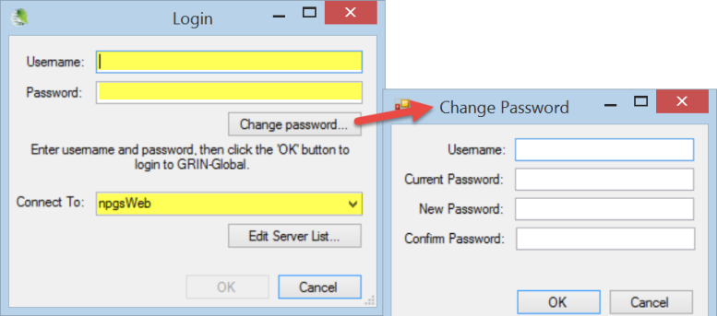

Instructional Approach

Have them login:
Login, using the server, username. and password that are provided to you.
Server (Connect To:)
Username:
Password:

Keyboard Shortcuts / Dragging Data
Briefly skim over this section(table) in the workbook initially; just mention that this is included as a reference and you will cover these topics during the workshop, when relevant.

Schema

Main Objectives
Participants will be able to explain at a high level how the GRIN-Global data is stored in many tables which relate by keys. They will be able to describe how “parent” records cannot be deleted if the parents have “children” records.

Instructional Approach
Use file:

gg_schema.pptx

Instructor’s Note
This section can be covered at various times. It may be covered before or after demonstrating the Curator Tool Interface (below). The timing will depend on the audience questions and the flow. By completing the interface section first, the advantage would be to break up the less interactive material with hands-on opportunities.

Key points to Emphasize:
- discuss the advantage of breaking a database into multiple tables so that redundant data is eliminated while data integrity is maintained –something you cannot accomplish by keeping data in miscellaneous spreadsheets
- each record has a key value; the values of primary key shall be unique (i.e., no duplicate value)
- keys make it possible to relate records to each other
- records that are parents to children records cannot be accidentally deleted if the children records exist
- Accession Passport information, quantities of inventory on hand, and germplasm orders can all be managed via GG
- the GG database has hundreds of tables – each table can hold an unlimited number of records
- a data dictionary is online which provides details for the fields and tables. However, in the CT, the user accesses data via “dataviews,” not the tables directly.
- a dataview is a window to a table and many times will include data from related tables

Instructional Approach
Walk through the slides – there are instructor notes on the slides.

Curator Tool Interface

Main Objectives
Participants will be able to identify/recognize lists, tabs, dataview tabs, and other basic components of the CT interface.

Key Points:
- main CT interface (ideally the initial screen that you discuss is similar to the participants’ screens – no data, only the four basic dataview tabs)
- define terms: dataview, folder, list, null

Instructional Approach
Refer to the participant workshop guide —walkthrough items 1-10 using a live classroom CT screen if possible: (Menu, Search Button, Wizard Buttons, Show lists from dropdown, List Panel, Dataviews, Data Grid, Column Chooser & Other Options , Navigation Bar, Status Bar)

Illustration from the workshop guide:
In this example, the user has created lists in previous Curator Tool sessions and included additional dataview tabs in the right panel:
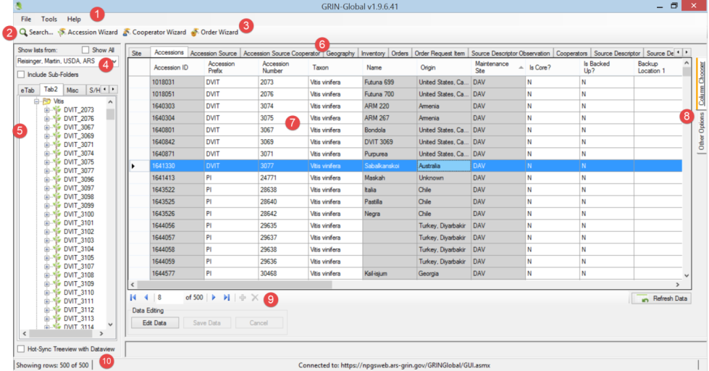

Introduction to Lists & Tabs
[Later today there is a List Management hands-on section; for now, you need to explain the basic ideas about tabs and lists.]

Key Points to Emphasize:
- Lists are totally flexible, very individualistic – can be created for any purpose
- Lists can be shared and copied – users in the same site automatically share lists
- Selecting the Show All checkbox makes all of the organization’s users’ lists available (but a user can only permanently alter his / her own lists)
- Tabs provide an additional level of organization – you can have one tab or 100 tabs (Tabs and Lists are similar to Windows Explorer folders – some users have many folders whereas other use just a few)
- Make the analogy: in Windows Explorer, some PC users create many folders to organize their PC files; similarly, in the CT, lists can be used to organize one’s records
- A folder’s items can vary – if accessions were used to make the list, then the accession items are listed; orders have order items, and so on. Also, a list can have multiple item types.
- Dataviews are SQL code programmed to display data from primarily one table. However, data from other tables may also be included. In Edit mode, the gray data is typically not stored in the main table which the dataview is accessing.

(1) It is better to have more lists than less, since you can move and copy lists which may have many items, whereas you can only select, move, or copy single items

(2) The CT always opens to the tab that is on the left of your tabs –to expedite the starting up process, use a tab that doesn’t access too much data (I use one that contains no lists). On the right, my left-most tab is get_sites (which accesses only a few records) or get_crops

Background Information:
Originally there were just seven item types. Each had a graphical icon associated with it. In later GG versions, it became possible for any record to have a corresponding type. The new icons are less graphical and use letters. (An organization can change any of these icons if desired.)

Dataviews

Key Points to Emphasize:
- Users “see” their data in the CT via dataviews which serve as their lenses
- Each dataview has been programmed for a specific purpose – to display data from one or more tables
- An organization’s GG administrator can add or modify dataviews, but a CT user cannot
- A CT user can open (or close) any dataview as needed
- In Edit Mode, the user can edit the records displayed by the dataview

Instructional Approach
Demonstrate opening a dataview tab (one that isn’t visible yet). Discuss.

Creating a Single Accession Record

Instructional Approach
Demo creating a new record. Ideally you will have created a folder on the left panel where the new accession item will be listed. If time allows, you may want to demo completely one new record, and then guide the participants in creating a second record; otherwise, walk together through the accession creating process.
Give directions for creating a new accession record. Indicate that they should try using their preferred taxon. (If you aren’t sure what taxonomy is in GG, start manually adding a single new record in the CT. In Edit mode, click in the Taxon field to determine what valid taxonomy are in the database.)

Key Points to Emphasize:
- The Curator Tool must be in Edit mode; click the yellow add (+) icon (below the datagrid)
- Not all fields are editable. Colors have significance:
  - violet – required field
  - white – data can be inputted
  - gray – “read-only fields; cannot be edited (emphasize – briefly explain why. For example, Name. This field is created in another dataview where the main table used by that dataview is the accession_inventory_name table. In the accession dataview, this field is referring to any related names – a new accession would not have any yet.)
- Audit fields are displayed near the far right. (They are gray fields, therefore are read-only.) Security rules will be discussed in detail at a later time. (Ownership and permissions determine who may be given permission to modify a record.)
- In some situations, there are additional requirements, either because of the database rules for the data, or because the organization has imposed a “data trigger” which may do some editing and can enforce certain programmed logic.
- In the accession dataview, the combination of the Prefix, Number, and Suffix must be unique. If an Organization doesn’t use the Suffix field, then the Prefix and Number combination must be unique. (Explain triggers when discussing inventory.)
- Each record has a unique ID, its key field, assigned sequentially to it by the database software, when the record is saved. This is the record’s “primary key.”
- Demonstrate (and briefly explain fields using lookup tables) –
- How to recognize them
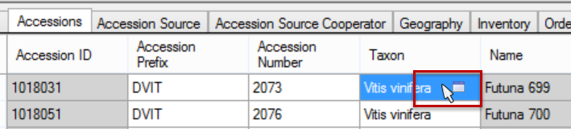
- Explain how to use the filters:
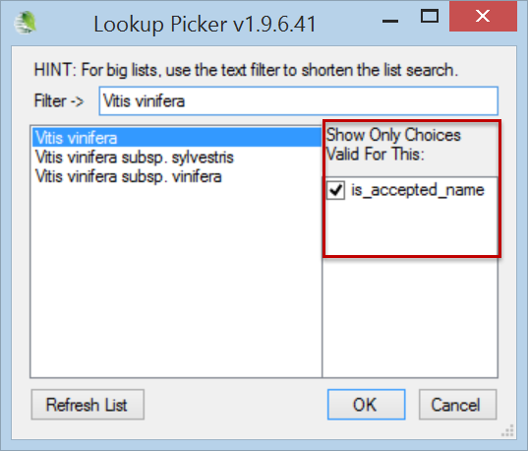
- Discuss what steps to take if a needed value isn’t available (Example: Taxon for Accessions – relies on the data in the Taxonomy Tables. In order to be listed in the Taxon lookup, the corresponding taxonomy records must already exist in the database.) Briefly mention “security” – some tables can be restricted to certain people – Taxonomy tables probably should be restricted, to avoid including taxonomies with typos or having unacceptable taxons.
    - Demonstrate and explain fields that use Codes
    - How to recognize them:
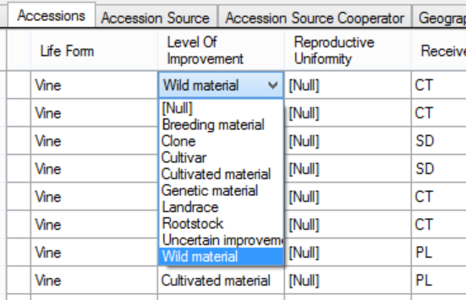
    - What to do if a needed code is not available in the list
(contact the GG administrator; example: Level Of Improvement)
- Explain setting the Date Format field
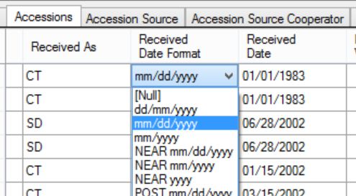
When saving a new record, the CT prompts to include an item under the current folder in the List Panel.

- the Accession Wizard will be used later to see how to create an accession record and its children records at the same time. Children accession records contain some of the accession’s passport data. (Remind them of the ”relational database” concept –related data is stored in multiple tables, allowing for flexibility and expandability)

Inventory items (virtual nodes)
When an accession item is created in a list, the accession’s inventory items are automatically displayed:
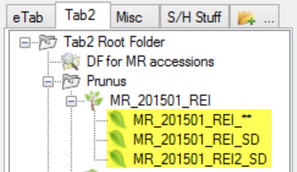
(A similar illustration is in the participant’s workshop guide, in the Inventory section).

System inventory
System inventory is fully documented in the Inventory Guide.

Key Points to Emphasize:
- When a user creates an accession record, a default inventory record with the Inventory Type ** is automatically generated.
- These system-generated inventory records are used by GG so that child records can be associated with the accession rather than to a specific physical inventory
- Physical inventory is “real” inventory. When entering data about physical inventory, do not use the ** for the Inventory Type code.

Editing a Record

Instructional Approach
Demonstrate getting into Edit mode / saving changes:
- Press the Edit key
- Discuss Edit mode options:
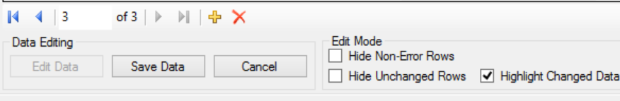
- Demonstrate:
  - Displaying / Hiding Fields (Columns)
  - Changing column order, width, and sort order
  - Switching to the Grid Form (Right-click; Properties) (Only Accessions, Inventory, and Attachment DVs currently have a grid form – other dataviews may eventually be designed with grid forms)
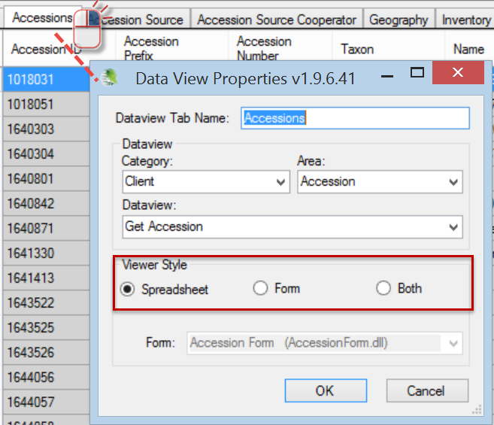

- Verify that they know how to show/hide/rearrange columns.

Displaying Other Dataviews

Instructional Approach
Demonstrate opening another dataview tab.
Show how to start a new tab by either right-clicking on a dataview tab or by clicking on the new tab icon
Discuss the Category and Area dropdown boxes
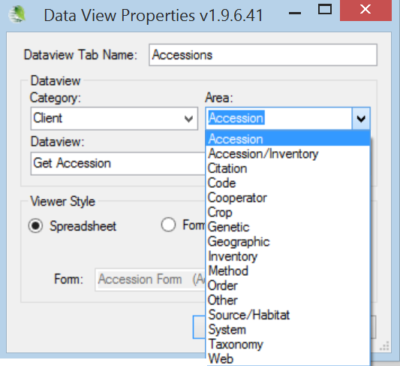
Demonstrate copying the Dataview name into the Dataview Tab Name boxes and editing the Tab name
Briefly look at the various Areas
Demonstrate rearranging (moving) the dataview tabs
Close a dataview tab

The leftmost dataview will be the one that displays when the CT is started (Recommend possibly using Site as the leftmost dataview – the CT will open quickly since it does not need to retrieve many site records as compared to a DV tab that might be displaying thousands of records)

Dictionary

Key Points to Emphasize:
Bookmark the GG training page
Display the online dictionary and the Training Resources (videos, documents, etc.) on the GG wiki
Briefly examine the GG online dictionary (use the leftmost worksheet labeled “DataDictionary”)

Instructional Approach
(Briefly) access the online data dictionary and use it to review several fields.

Search Tool Basics
Search Tool Interface
Filtering the Search Results / Status info
Drag & drop from the ST to the Curator Tool
Find: Default vs. DV dropdown
All / Any / List of items
Searching for “everything”
Wildcard basics
Switching Dataviews within the ST
Selecting multiple rows w/ Ctrl & Shift; Selecting all rows

Key Points to Emphasize:
The Search Tool is a separate program – accessed from the CT or from Windows; records displayed in the Search Tool can only be viewed – hence these records are typically dragged or copied into the CT or a spreadsheet
Search Tool Interface: Contrast the Text Area vs. the QBE cells; advantages of doing a QBE Cell (indicate that a text search searches through only 31 fields; with a QBE search you can use basically any dataview and any field)

Discuss: Search Tool Window
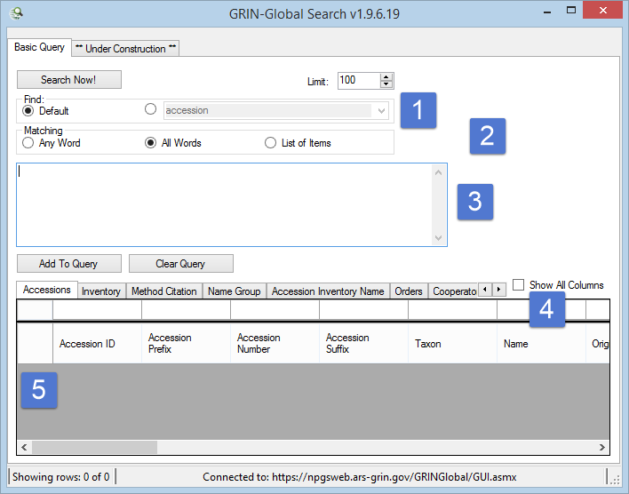

The Search Tool text box is not equivalent to a “google-like” search. The text box only works with 31 fields. (Listed in the participant guide.)

Instructional Approach
Explain/demo:
The buttons: Clear Text, Add to Query, Clear Query
Clearing a QBE cell (right-click in a QBE cell – select Clear or Clear All)
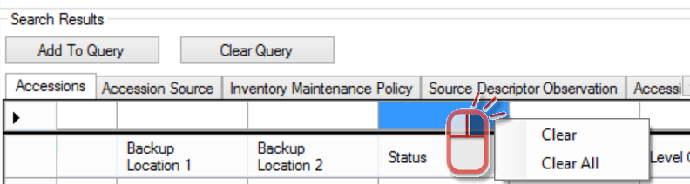
Adding another dataview tab when needed
Filtering the Search Results / Status info (Right-click in a results cell; select Show only… or Hide rows… Point out the Showing Rows message on the Status bar at the bottom of the window
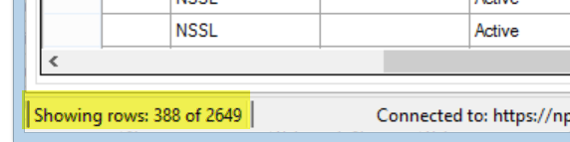
Dragging & dropping records from the ST to the Curator Tool (First set up an empty folder in the CT. Execute a successful search – drag the records to the CT.)
Explain:
- the Find: Default vs. dataview dropdown (Briefly mention that you usually can leave the setting to Default – will be discussed in more detail when Searches are discussed later.)
- All / Any / List of items (Demo how OR and AND are inserted when you include more than one criterion and how All and Any control the OR and AND.
- wildcard basics (in this section, only explain the basics; using % or * (multiple characters) and the underscore (single character (_));
- using the % (internally less translation occurs for the % as compared to the *) when searching for the actual underscore character, enclose the underscore within brackets [_]
- how to search for “everything” (Input >0 in the left ID field. Caution them to set the Limit setting also.)
Show how to use the List of Items option.
Switching Dataviews within the ST (Demo what happens. For example you find 100 Accessions, but then may see 1000+ Inventory records.)
But not all dataviews are related -- In the ST you can only flip to a different dataview after querying if the new dataview supports the ID type of the search. (Note: The CT and ST operate differently.)
Selecting multiple rows w/ Ctrl & Shift; Selecting all rows (Demonstrate selecting multiple records in the grid.)

List Management

Using Tabs and Lists to Manage Records

Instructional Approach
Walk them through making several tabs and lists. Also explore the options on the List Menu.

Key Points to Emphasize:
The difference between deleting items in a list and deleting the records in the datagrid (on the right). List items are the user’s – they are not the curatorial data and can be deleted, whereas the records shown in the grid (in the right panel) are the database records. Records deleted in the datagrid are permanently deleted.
Creating multiple tabs, folders, and sub-folders is a good practice – since items in a list can be selected individually – only one list item at a time can be moved or deleted, whereas you can move a list (cut and paste), copy, or clear the list (with the list containing many items)

List Menu options
Discuss/Demonstrate
New | Clear | Refresh
Sort
Rename
Cut | Copy | Paste
Delete (Discuss advantages of having many folders since you can only select one item at a time, (and therefore only move or delete one item when selecting items). Creating folders and sub-folders is helpful when you need to delete or move multiple items.)
Properties (Do not spend too much time here; avoid the dynamic folder discussion at this point)
Clear the folder

Tabs
- Demo: Adding Tabs

- Right-click to demo the Tab options (New, Delete, Hide, Show)
- Sharing lists (Demo the Show all option (all users in the organization vs. the users in your site; Copying lists – but you cannot permanently alter lists belonging to another user). Have them do this also.

“Drag & Drop” Records from Excel

Importing Records from a Spreadsheet

Key Points to Emphasize:
When copying data from a spreadsheet into the Curator Tool, the column headings in the spreadsheet are used to match up the spreadsheet data with the respective columns in the Curator Tool. (You can use either the Column Headings or the actual table field names. )
Users can copy the headings or the actual field names into a spreadsheet. (To copy the actual fieldnames, when you drag, press and hold the Ctrl key at the same time.)
The order of the columns does not matter when copying.
You do not need to copy all of the columns, but when making new records by importing from a spreadsheet, new CT records must have all required fields filled.
When updating existing records via “drag-n-drop,” the existing ID field data must be included.
To determine required fields: Open the dataview in Edit mode and start to add a new record – the required fields are violet colored; gray fields cannot be added or updated from the current dataview.

Instructional Approach
Hands-on exercise: participants will create new accessions and then update them
- Demonstrate adding multiple new accession records
- Demonstrate updating multiple accession records

1. Have the users manually create several accession records in the CT. Instruct them to use a consistent prefix, such as their initials, so that as the class evolves, the records will be unique and the source will be relatively easy to identify. Recommend that they also use some sort of numbering system to assist them in their accession naming.

Remind them of the shortcut keys so that they can practice using these during the process. (Their workshop guide has a section listing the keyboard shortcuts.)
(GG does not have a method for assigning new accession identifiers – this is a question that is often asked. In the USDA, the database manager provides a site with a block of identifiers when the site requests – that way each site will have unique identifiers for their new accessions. For example, the DBA might indicate to the Davis California site that they have the range of identifiers from PI 650000 through 650099; later the next site requesting a block, such as Corvallis Oregon, may be given values from 650100 through 650199.)
2. After making several records manually within the CT, they are going to drag and drop these into a spreadsheet. Have them change some of the identifier data (prefix, number, and suffix – so that the new records will be unique), and drag back into the CT, without the Accession ID field. This will create five new records. Save in the CT.

3. Using the new accession records, drag them to a spreadsheet. Edit some fields, and this time drag back to the Excel but update the records in the CT. To do so, the Accession ID field must be included during the drag process.

4. At some point, have them do a “drag and drop” while holding the Ctrl key – this produces the actual database field names (not the “friendly” heading names.)

Copying, Block-Style
Sometimes you need to copy just a cell or a range of cells.

Key Points to Emphasize:
- use the ALT key to invoke Block-Mode
- you do not need to be in Edit mode to copy from the CT;
you do need to be in Edit mode to copy into the CT

To copy data back into the CT, arrange your spreadsheet data in the same order as the Curator Tool’s. In the CT, click the Edit Data button to be in Edit mode before you paste into the CT.

When using this method, since you will not be including the column names, it is critical where you line up the cells when you copy and paste
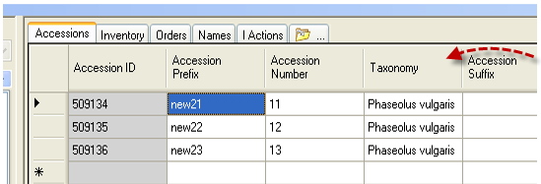

Instructional Approach
Have the participants practice using the Alt key technique.

User Settings

Be brief!

Key Points to Emphasize:
Change Query Paging Size
Change colors
Save
Reset commands
Change password
Change languages

Instructional Approach
Explain / demo:
Quickly review the options available on the Other Options tab; walk through the options.

Cooperators – Management of Cooperator Records

Background Information

Key Points to Emphasize:
You want to avoid having duplicate records of cooperators. Using the Cooperator Wizard helps in this regard, because you can easily search first for a cooperator before adding a new one.
Overview: Cooperators & Web Cooperators
Two distinct cooperator records (and tables) in GG:
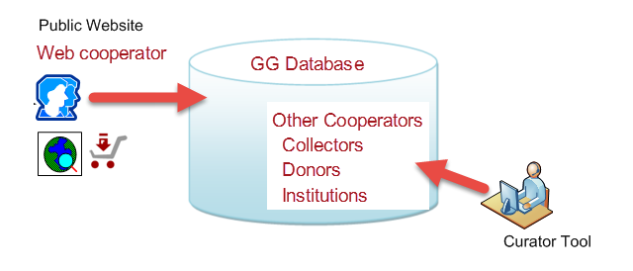
Why 3 Cooperator lookups? There are separate lookups for different needs. There is a Web_Cooperator Lookup Table for the web cooperators. The Cooperator lookup has a display field simply formed by cooperator last name, first name, and organization. It is a simple string used as a lookup on the owned_by etc. It doesn’t have to be complete because it’s just for displaying which curator owns a record.
The Big lookup includes many more fields in the display string so curators can tell apart all these public cooperators with similar names. That lookup is used when the cooperator is involved something other than the three audit fields (owned_by, created_by, modified_by). You need more detail there

Institutions: Cooperator records can be a record for one individual or one institution. Typically, when creating an institution cooperator, the last name and first name fields are left empty.

Cooperator Wizard: Searching & Adding Cooperators
Use the cooperator wizard whenever you add a new cooperator. By doing so, it helps to avoid entering a duplicate record. (The cooperator may already be in the database, but perhaps has a typo in one of the name fields.)

Instructional Approach
Have participants use the cooperator wizard to look for existing (people) cooperator records; then use it to create a few new records.

End of Day 1: Review

Instructional Approach
Spend a few minutes to determine the participants’ comfort levels with the concepts covered so far and the mechanics of using GRIN-Global. Consider having a few specific questions ready to ask or simply facilitate a general discussion about the main topics that were covered during the day..

Morning Two: Review of Day 1

Instructional Approach
Use file:

review_of_day1.docx

Have them follow the exercise. Allow 15-20 minutes. Determine if participants were able to do the exercise and are comfortable with the topics covered yesterday. Avoid simply asking the question ”Are you comfortable with what we covered so far”? Instead, consider asking some specific questions that will require more than yes/no answers. For example, ask for someone to explain what a dataview is, how to display one, etc. Determine if they understand the permanence of deleting a record from the data grid as opposed to deleting items from a list.
Review any topics from yesterday where they may have seemed confused.

Lookup Tables
The first time you open the Curator Tool you will be prompted to update your lookup tables. After all lookup tables are updated, the lookups will maintain themselves fairly automatically.

Key Points to Emphasize:
- how to recognize when a lookup table isn’t current

Recognizing Fields that use a Lookup Table (in the CT)
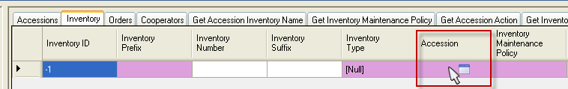

Lookup Table Warnings
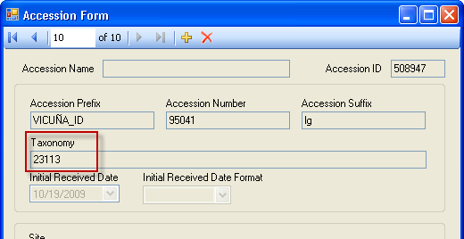

Updating the Lookup Tables

Instructional Approach
- Discuss: You can update the Lookup tables when you start the Curator Tool or at any time while the CT is running.
- Demonstrate using the Lookup Table Maintenance button (under Other Options). The participant guide has an image.

Load All and Load Buttons
Load All: When using the Load All button, you may need to do this twice. The first time the Load All button will update, that is, load only new records into the Lookup tables. Wait until the progress activity is visibly complete before clicking the Load All button a second time. The second time will cause each lookup table to be dropped and re-added (effectively loading the lookup table from "scratch" (from the beginning) – this may require one hour or so, depending on the size of your data).

Accession Wizard

Key Points to Emphasize:
The Mechanics – saving records and editing existing records
Adding Passport data: Where is the passport information stored in GG?
Names / Name Rank / Categories / Name Group
Pedigree information
IPR information
Quarantine
Annotations
Vouchers

General Notes about the Accession Wizard

Instructional Approach

Discuss the “Mechanics”
The wizard contains nine dataview tabs which make it possible to input data (records) considered to be children of the main parent (accession) record. As you move from tab to tab, click the Save button to ensure that the inputted data is saved in the database.

You can move from tab to tab to review the accession’s associated data. However, in the following screen, the accession is new –so you must input the accession record data before inputting any of the other records.
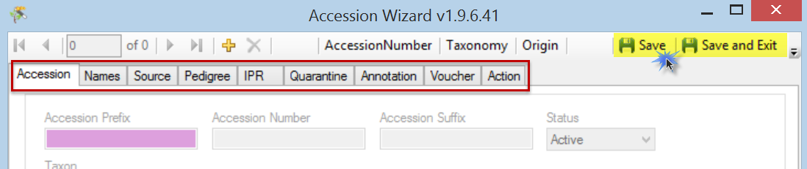
The navigation bar and the information directly below the window’s Title Bar indicate what record you are working with and make it possible to move through the records (assuming that prior to invoking the wizard, the user had selected multiple accession records.)

Adding Passport Data
GG is a relational database and as such, is segmented into many tables. The passport data is saved among many different tables. There is an document online that provides details on each passport field:
Multicrop Passport Descriptors link

Names / Name Rank / Categories / Name Group
The accession_inv_names dataview accesses the accession_inv_names table -- these names can be applied to specific inventory records or at the accession level. The accession / inventory can have multiple names which can represent cultivar names, institute identifiers, collector numbers, breeder lines, etc.

When an accession has more than one Name record associated with it, the name whose Name Rank field has the lowest value will be displayed in the Accession dataview (in the Name field). (As shown below, when there is tie, the name that is alphabetically first is displayed as the top name.)
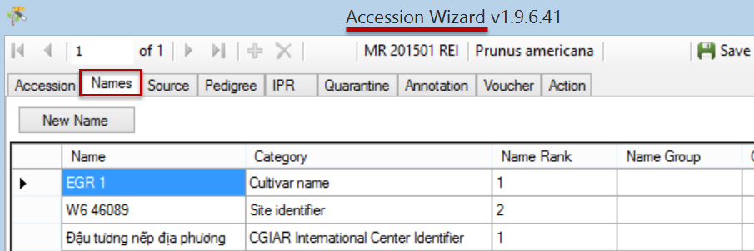

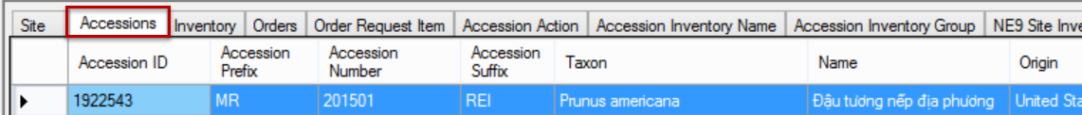

Categories
Categories are added to the database by the GG administrator. Categories are stored in the ACCESSION_NAME_TYPE code group.

Instructional Approach
Have the participants create several names for one accession, using different name ranks.

Name Group
The Name group field is optional. Name Groups are used to associate specific names to certain groups, such as CIMMYT names, SINGER names, or NPGS names. By grouping, later you can search and filter accessions for names within a specific group. If you do not need to track names, then the Name Group field doesn't need to be used. In this dataview it cannot be edited. (Use the inventory_name_group dataview to edit or create a name group.)

Other Accession “Children” Dataviews

Instructional Approach
Walk through the accession wizard together. Have participants create children records for an accession.

Pedigree Information
Displays table of pedigree information. Although standards are not used for pedigrees, individual entries should be clear and consistent throughout each crop. Each accession record may have only one pedigree record associated with it.

In the GRIN system there was just a single text column to hold the pedigree. In GRIN-Global we still have this text box (called description) but have added male and female parent columns as well. The text box can still be used when the parents are not in the current system. Use the parent columns when the accessions are in the system. (The USDA NPGS wheat curator said that his pedigrees are so complex and possibly non-standard that he will continue to use just the text string column and leave the parents empty.)

IPR information
Primarily displays the accession's intellectual property rights (IPR). One accession can have several IPR records since the accession can be covered by several IPRs. IPR accession records will be highlighted whenever they are involved in orders.

Quarantine
Accesses accession quarantine table. When an accession is restricted by several types of quarantine, the accession will have multiple quarantine records; however each accession can have only one occurrence of a particular type of quarantine.

Annotations
Dataview displays fields from the accession_annotation table (verifications, official taxonomic name changes, re-identifications and received as) related to the taxonomic names for each accession.

Vouchers
Dataview accesses the table of herbarium vouchers for accessions or inventory samples. A voucher is a herbarium specimen used to document a taxonomy. The voucher record holds the information on that herbarium specimen -- what accession/lot it applies to, location of the specimen, etc. (A herbarium is a collection of plant specimens (vouchers) arranged systematically…) A herbarium specimen can be seed or a fruit.

Bulk Modifying/Updating Existing Accession Records

Key Points to Emphasize:
How to:
- bulk add Accession_Inventory Name records

Instructional Approach

Discuss:
Frequently the user will need to change many records at one time. Records can be copied from GG to a spreadsheet where changes will be made. When copying the data back into GG, the user needs to consider whether this is an update, or if new records are being added. The main thing to remember is that when records are being updated, any drag and drop from the spreadsheet to GG must include the record’s ID field, whereas when adding new records, the ID fields for the new records are left blank (since GG will assign the IDs when the new records are saved).

Participants need to practice this “dragging and dropping” several times throughout the workshop. The exercise here will involve bulk adding new records , and then updating the records.

Instructional Approach

Ensure that the participants have the Highlight Changed Data checkbox checked. (This is only visible in Edit mode): 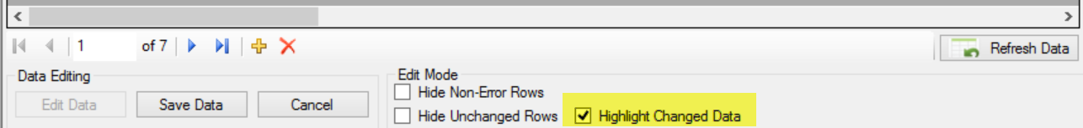

Their instructions state: “Practice this “dragging and dropping” several times throughout the workshop. The exercise here will involve bulk adding new records, and then updating the records.”
Have them create at least 10 accession records. Have them use an existing record for the basis. Show them how to drag from the CT to a spreadsheet. At some point, demonstrate using Ctrl while dragging to show how they can see the actual table field names.

After they complete the exercise above, have them bulk add accession inventory names. Demonstrate how.

Searches (…more)
This section should be accomplished primarily with an exercise. Demonstrate how to use the editor (for example you can clear the text) and redo a query by changing a QBE criterion without needing to start from scratch.

Key Points to Emphasize:

Text Box Searches
Remind the participants that the Search Tool text box is not equivalent to a “google-like” search. The text box only works with 31 fields. (Listed in the participant guide.)

Table Name | Field Name
accession | accession_number_part1, accession_number_part2, accession_number_part3, note
accession_ipr | ipr_number, ipr_crop_name, ipr_full_name, note
accession_inv_name | plant_name
accession_pedigree | description
cooperator | last_name, first_name
crop | name
geography | adm1, adm 2, adm3, adm4, country_code
inventory | inventory_number_part1, inventory_number_part2, inventory_number_part3,
taxonomy_common_name | name, simplified_name
taxonomy_family | family_name, alternate_name
taxonomy_genus | genus_name
taxonomy_species | nomen_number, species_name, name, alternate_name
code_value_lang | title

Query-by-example (QBE) Searches

Search Tool Interface: Contrast the Text Area vs. the QBE cells
Recommend doing a QBE
Show how to use the Clear Text, Clear, and Clear All choices

Wildcards

Instructional Approach

Walk through topics in the student workshop handout
- Every word matters
- Have them complete the search exercise of walking through the table of wildcards/operators
- QBE text field cell vs. Lookup table cell
Compare a search using a Lookup field such as Taxon in the Accession DV with the text field in Taxonomy Species. Species. Another quick example is Site. SiteShortName compared to the Inventory Maintenance Site file in Inventory.

The question comes up frequently when do you use the radio button to select a Dataview
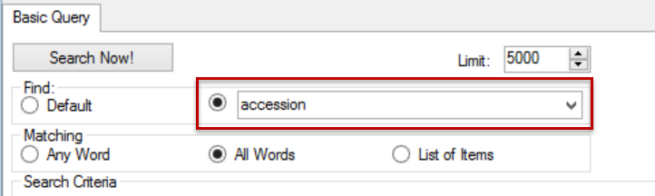
The answer is, “not that often.” Usually the Default button will be selected. However, if a search doesn’t find expected results, switch the radio drop down to the main DV from which you are searching

In the next session, you will cover creating dynamic folders. The “readability” the text fields makes it easier to understand a Dynamic Folder, especially later.

In the Search Tool, some dataviews do not resolve as they do in the CT. For example, if you start a search by Crop, and then switch to the Accession dataview, no records will be listed. But if you drag the Crop record to the CT, and then switch to the Accession dataview, you will see accession records that relate to that crop.

Criteria Code Explained
This section is optional, but ideally it should be covered if time allows. Understanding this section is helpful when the participants explore the Dynamic Folders section.

Key points:
- the criteria generated by the QBE will insert the actual table field names.
when a filed using a lookup table generates the (IN nnn, nnn, …) construct, you can often generate “more readable text” by using an the equivalent text field (Example: accession has the Taxon field which uses a lookup.
@taxonomy_genus.genus_name = 'Helianthus' AND
@taxonomy_species.species_name = 'annuus'
This search clause is essentially doing the same as
@accession.taxonomy_species_id IN (27923)
but the first statement is much easier to understand than the other.

Instructional Approach
The participant guide states: “Follow the directions on the Searches (…more) Exercise.”
Use file:

exr_searches_more.docx

Dynamic Folders
Advantages / When to use (vs. Static Folders)
Creating a basic query
Modifying criteria to be “readable”
DF library (Sharing)

Key Points to Emphasize:
- So why ever use a static folder? First, they are simpler in some respect. Secondly, many times you will want to review specific records, and only those records. Listed below are a few examples of when each folder type is preferable:
Situation | Folder Type
Keep track of what you are working on from one day to the next | Static
List of orders processed on a specific day | Static
Maintain a list of all accessions for a specific Taxon | Dynamic
Review a site’s inventory | Dynamic

Examples of dynamic folders may be reviewed online in the document located on the GRIN-Global website at http://www.ars-grin.gov/npgs/gringlobal/docs/gg_library.docx.
- text for a dynamic query can be copied into a folder’s properties box, or you can drag the code generated in a search from the ST to the folder (similar to how you drag records from the ST to a CT folder)
- whenever possible, change the query so that the code is readable. For example,
@taxonomy_genus.genus_name = 'Rubus' AND @site.site_short_name = 'COR'
is much easier to read than
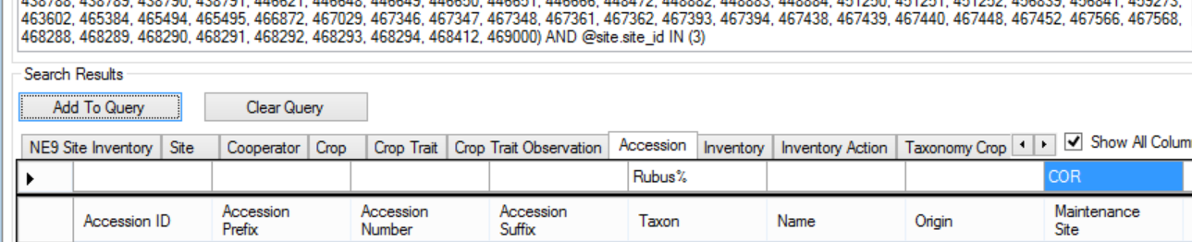

Instructional Approach
- discuss the idea of setting up a organizational “library” where search queries can be saved for others to share

Practice by creating several dynamic folders.
Examples:
Find a range of accessions. ( @accession.accession_number_part2 > 500000 AND @accession.accession_number_part2 < 500100 )

Find inventory records created within a specific date range – for example, the range was between May 10 and May 16, 2015.

Optional:
Demonstrate how to convert a dynamic folder that original has a lookup value in it to something more readable. For example:
@taxonomy_genus.genus_name = 'Helianthus' AND
@taxonomy_species.species_name = 'annuus'
This search clause is essentially doing the same as
@accession.taxonomy_species_id IN (27923)
but the first statement is much easier to understand than the other.

Public Website
Remind the participants that the Public Website is primarily an external, end-user tool, but that it is complementary to the Curator Tool as a tool for internal users (genebank staff).

Instructional Approach
Explain / demonstrate:
Finding an accession ( / using different search criteria)
the PW Interface
Descriptors – brief introduction
Exporting & Drag and Drop

Key Points to Emphasize:
- users need only a browser to use the Public Website; the GG admin makes the site available to the GG database
- the Public Website is primarily an external, end-user tool, but that it is complementary to the Curator Tool as a tool for internal users (genebank staff); staff may opt to have both tools open simultaneously
- different fields in the database help to determine what is visible to the public
- currently there are some known issues with the grouping of data; under My Favorites there is a Usage dropdown that is not functional

Instructional Approach
Review:
- Registering in the Public Website
  - edit the account info
  - add/edit/changing the default shipping address (My Account / My Address Book)
  - review the “My Favorites” (wish list) option (the Usage dropdown is currently non-functional)
- Practice using the Public Website (PW) to search for material. Search…
  - for an accession by its identifier
  - using a wildcard
  - change the default Web Search Overview to Web Search Observation
  - under Search Options, use the Allow Multiple Lines and input or copy several identifiers
  - using some of criteria under the Advanced Search options
    - show how you must select an operator
  - briefly demo the Help File
- Explore (briefly) the various options on the Accessions List: Actions…, Select:, the Group By, the Nav bar
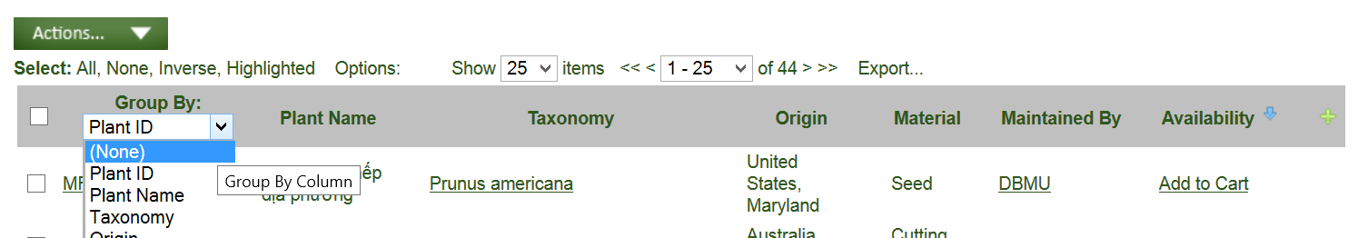
- Export results to a spreadsheet
- Practice making Queries based on Observations
  - search by Descriptors | select a Crop – then select some descriptors
- Practice using My Favorites and the Shopping Cart
  - select accessions for an order (but don’t order yet)
  - review the Shopping Cart page (View Cart) displayed
  - send the order; note the WebOrder ID
  - after sending the order, review detail history; use the Upload feature to attach a document, a PDF, a .doc. .xlsx, etc.

Note: later we will discuss orders in detail, so really only cover the germplasm requestor creating and sending the order. Later we will cover the entire cycle of the order being sent and then processed (filled) by the genebank.
- Briefly explore the Taxonomy pages (via the Taxonomy dropdown)
- Reports
  - only one report is currently available to the public
  - when logged in, and if your web ID is associated with your CT user Account, you will be able to see other (“internal to the genebank staff”) reports
  - when logged in, the Tool feature allows for submitting SQL for displaying data only (you cannot update data)

End of Day 2

Instructional Approach
Briefly summarize the main topics of the day: Lookup Tables, Accession Wizard, Search Tool, Dynamic Folders, and the Public Website. Determine if there are any concepts that need further explanations or possible demonstrations tomorrow.

Morning 3: Review of Day 2

Instructional Approach

Use file:

review_of_day2.docx

Determine if participants are comfortable with the topics covered so far, especially yesterday’s.

Inventory
The Inventory Guide is available online.

Key Points to Emphasize:

Virtual (or System-Generated) Inventory Items

- System inventory: every accession automatically has one inventory record – a virtual, system-generated inventory records. It is not physical inventory – it exists simply to tie together accessions with inventory (its type is always designated with a “**” (When using the CT, users can hide these records (or not).)

Prerequisites
- There are prerequisites for adding inventory – one of the important prerequisites is the Inventory Maintenance Policy.
In order to input inventory, you must first have an accession to which the inventory relates. When inputting a new inventory record, there are five required fields:
- accession (the taxonomy and passport information is stored in the parent accession table and its related children tables)
- inventory prefix (in most organizations, because of organizational requirements, you may also be required to input an inventory number and/or a suffix)
- inventory type (The Code Group used to store the inventory type is called GERMPLASM _FORM) Example germplasm form codes include BD (Budwood), CT (Cutting), and SD Seed. (Each organization can edit the code list to meet its organizational needs.)
The combination of prefix, number, suffix, and type must be unique – the combine four fields compose the Inventory Identifier
- inventory maintenance policy (a method for assigning a name to a rule for handling orders. For example, the rule can indicate how many units (propagules) the genebank site will distribute for an order of a given taxon and germplasm form.)
- availability status – must be one of the INVENTORY_AVAILABILITY_STATUS Code Group values in the Code Value table.
- Why are there two areas for inventory-related dataviews? Some inventory dataviews apply only to inventory, such as Inventory Viability or Inventory Quality Status, whereas some apply to either the Accession as whole or to individual inventory lots. For example, the Accession Inventory Name dataview can be used to assign a name to an individual lot or to the system inventory record (which would therefore apply to that accession).

Inventory Area | Accession/Inventory Area
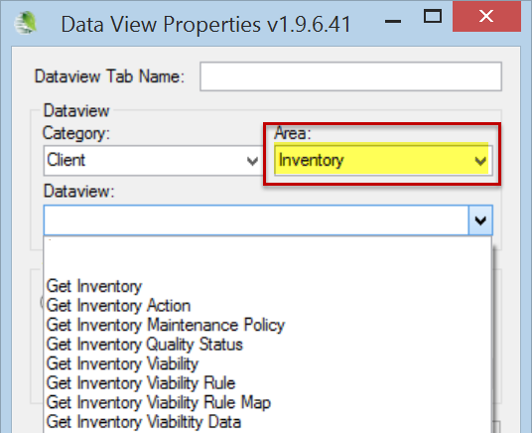 | 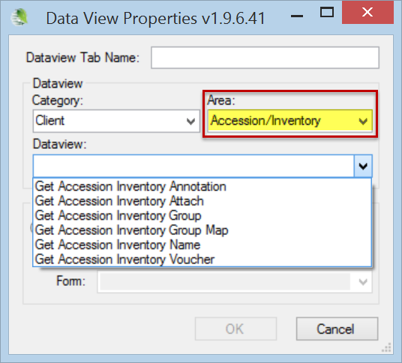

Purpose of the Inventory Maintenance Policy

- There are time saving benefits in applying an Inventory Maintenance Policy to a new inventory record – the policy provides defaults for the amount of germplasm that will be distributed for a germplasm order, the form of the germplasm (seed, cutting, etc.), and whether or not the amount distributed in the order will be automatically deducted from the inventory. The policy also indicates the curator responsible for the inventory, as well as the distribution and replenishment thresholds (“critical amounts). It also has a field for the regeneration method.
Note: existing inventory records are not overwritten by a change in the Inventory Maintenance Policy. Also, after an inventory record has been successfully saved, the user can edit any of the fields initially supplied by the policy.

Instructional Approach

Use file:

exr_inventory.docx

What Determines Accession Availability?
Condition | Dataview / Field | Value
Historic accessions,  never available | Accession /  Status | INACTIVE
Accession is an active accession in the genebank's collection | Accession /  Status | ACTIVE
Accessions displayed on the PW | Accession /  Is Web Visible? | Y - will be displayed  N - will not be displayed
Inventory is Available | Inventory /  Is Available? | Y – is available  N – unavailable
Preferred inventory lot for distribution (since this is the "preferred lot," only one inventory lot should be marked with a "Y.") | Inventory /  Is Default  Inventory? | Y – preferred lot (selected by the Order Wizard by default)

Availability Status

Increasing Inventory when it is Low
To determine what inventory is low: - search for your inventory maintenance polices and low amounts of germplasm. Set up dynamic folders to do this:
Example:
@inventory_maint_policy.maintenance_name LIKE 'MAR%' AND
@inventory.availability_status_code = 'LOW' AND
@inventory.form_code_type = ‘SD’

After determining what inventories are low, they can be added to the Order Wizard and a “Replenishment/regrow” order started. A complete description on handling low inventory and regenerations is in the Inventory guide. (There is also an Oder Wizard guide.)

The Availability Status field obtains its values from the INVENTORY_AVAILABILITY_STATUS Code Group. By searching this field, you can look for specific inventory situations, such as low inventory, young plants not available, etc.

A trigger exists for the Availability Status field. Also, in the Search Tool, Availability Status codes makes it possible to search for a particular group of records, based on a common status.
Fields | Value Before | Action | Value After
 |  | Order is Filled (standard quantity is shipped)
Quantity on Hand | 80 |  | --> 70
Distribution Critical Quantity | 75 |  | 75
Is Auto Deducted? | Y |  | Y
Standard Distribution Quantity | 10 |  | 10
Availability Status | Available |  | --> Low
Is Available? | Y |  | --> N

Visibility

Instructional Approach
Discuss “visibility” on the Public Website vs. “availability.” Accessions have an Is Web Visible? field. An accession can be visible, but not available. One example would be historical records – where information exists in the genebank, but no physical inventory.

Miscellaneous Inventory Topics

Instructional Approach
Explain these main topics (details below):
- How to add inventory for germplasm regeneration
- concept of parent inventories
- suffix naming conventions
- there is a thorough Inventory guide with details about the inventory dataviews

Parent Inventories
When regenerating, the new inventory lot has a parent. The parent inventory name is easily obtained from the Inventory field in the predecessor record.

Naming Conventions
Use the example of some NPGS sites which have sophisticated naming guidelines for the inventory suffixes in order to track the heritage of the Inventory. Refer to the Inventory guide appendix.

Inventory Triggers
Briefly discuss: Inventory triggers help with data integrity. For example, one trigger checks inventory quantity fields to ensure none are negative.
The following is a brief summary of these triggers:
- Sends email when web_availability_note is updated.
- Adjusts inventory status based on the critical amount threshold (when the quantity goes less than the critical amount, the availability status changes to “LOW”).
- Auto-populates inventory data with corresponding default values from associated inventory_maint_policy data. Does not override custom-filled values provided by the user. Applies only on insert.
- Checks to ensure inventory units fields are filled out if quantities are specified.
- Checks inventory quantity fields to ensure none are negative.
- Ensures only one inventory is set to distributable.
- Does not allow insert, update, or delete of a system inventory record.

Discuss other Inventory dataviews
- Inventory Actions

Discuss Accession/Inventory dataviews:
- Annotations | Attachments | Groups | Vouchers
(Attachments – images – will be discussed after we cover Orders. Save any discussion for attachments until then.)

Viability Testing & Inventory Quality Status (Pathology)
Complete details on viability are included in the online Inventory document.

Key Points to Emphasize:
- the viability dataviews are in the Inventory area
- the viability data dataview is currently not tied to the viability
(it will be and a viability wizard is being developed)

Discuss Viability dataviews
- Inventory viability
- Creating lists of accessions for viability testing
- Updating viability data

Discuss Inventory Quality Status
Pathology information goes in the Inventory Quality Status Dataview

Orders (Germplasm Requests)
The Order Processing Guide is available online.

Key Points to Emphasize:
- use the Order Wizard as much as possible to manage incoming web orders and to create orders
- web orders and standard orders are two kinds of records (different tables, etc.)
- currently attachments may be added after the order is initially submitted

Overview
Germplasm orders may come to GG via:
- the web -- GG Public Website
- telephone or
- email

Instructional Approach
Explain the following diagram. Because the GG CT and the PW are separate programs, there are two kinds of orders.

Using the Curator Tool’s Order Wizard, genebank personnel responsible for order fulfillment can review those incoming web orders and convert them into standard GRIN-Global orders.
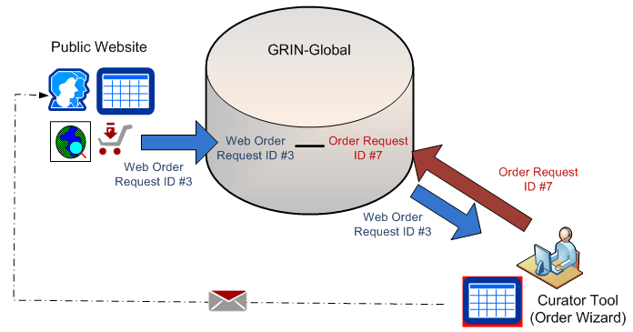
During this order process, the Web Order Request record becomes the basis for a GRIN-Global Order record. The Web Order Request record’s ID is its primary key field; the GG Order Request record created from it will have its own unique record ID. Although the records are inter-related, the two record IDs (and the records) are distinct.

Order Wizard
- Although not absolutely necessary, before invoking the Order Wizard, in the Curator Tool, decide what list folder in the left panel will be your active list.
- Another consideration (not essential, but recommended), before clicking the Order Wizard button, open the Order Request dataview as the active dataview. In the following example, the user has a folder labeled “Friday’s Orders” ready:
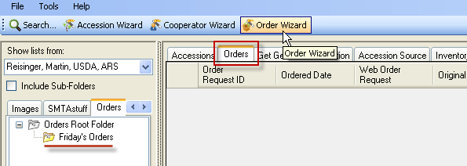

Creating New Web Orders / Shopping Cart

Instructional Approach
Walk through the process of the germplasm requestor creating a web order. Emphasize that the participants are now “wearing a different hat” – that of a germplasm requestor, not of a genebank staff person)
If they haven’t already, have the participants create a web order which includes several of their accessions. Have them write down the web order number.

Review the shopping cart. After the order has been submitted, review the Order History and the order’s details page.

Review the Order History and Details.
Add an attachment only after an order has been submitted (and before it is completed). (Any PDf,s, Word or Excel files may serve here for practice. Samples files can be used – see the folder: sample_files)

Currently, to add an attachment, the order must first be submitted. The user must go to his Order History page and view the Order’s corresponding Details page, where he can then Browse/Upload files from his PC:
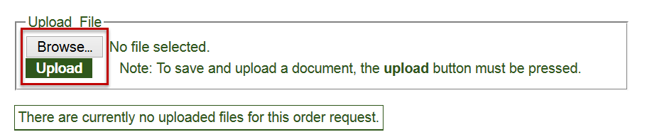

Processing Web Orders / Converting Web Orders to Orders
Demonstrate how to process a web order. Have the participants do likewise with their order(s). Remind them that they are “now wearing a different hat,” that of the genebank person fulfilling the incoming germplasm orders.

Key Points to Emphasize:
- When using the Order Wizard, save frequently.
- The Order Wizard is used to manage incoming web orders, but it also can be used to create new orders. Germplasm requestors may send emails, make requests by mail, or even make phone calls – the genebank personnel can easily enter these requests in the Order Wizard to facilitate the ordering process. There are multiple ways to drag data into the Order Wizard.

Instructional Approach
- Demo/explain: the Web Orders tab – use the Order Wizard to find incoming web orders; create new cooperator; use the My Site’s Accessions Only checkbox; create a new order;
- Demo/explain: the Orders tab – Save; demo editing a requested item (in the grid, double-click in the Inventory field of a record); demo/explain the Inventory Picker window;
- Demo/explain: the Actions tab – certain actions automatically generate an action record; action records can also be manually created; (they have an “Actions” section in their workshop guide)
- Demo/explain: the Attachments tab – as long as the order has not been completed, attachments can be added by the germplasm requester by accessing their order from their Order History page;

Finding Orders: Filled / Unfilled
Start the Order Wizard and find unfilled web orders. Also demonstrate finding filled (“shipped”) web orders.
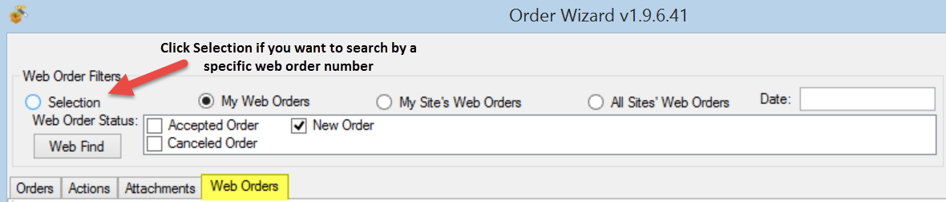
When you switch to the Web Orders tab, the New Order checkbox is selected (checked). This is okay when looking for new orders; otherwise, use the other checkboxes to find accepted or cancelled web orders.

Instructional Approach
Have the participants find an incoming web order and process it. (Depending on the time and the class, you may opt to have them follow along with you as you demo, or ideally, if time allows, you demo first and then they process an order with your guidance as needed.)

Save frequently, and save often! (when using the Order Wizard). Also, use the Save button when initially creating the order; otherwise you will receive an error message.

Creating New Orders Manually

Instructional Approach
Have participants create a new order manually using the Order Wizard (not using the Public Website). There are various methods to do this – they are listed in a table in their workshop guide.

There are multiple approaches that can be taken to assign inventory to the order.
Method | Approach | Description
a | Input an Accession key, an Accession Name, or a Taxon in the Order Wizard’s inventory Picker window | Use this approach when you know the desired Accession ID, Name, or Taxon information. The wizard’s Inventory Picker will accept any one of these three fields. If there is a match, you then decide and select which inventory to apply to the order.
b | Drag either accession records or inventory records from the Search Tool grid | Dragging inventory records rather than accession records will perform somewhat better (when selecting accessions, the software must perform additional processing to select the inventory)
c | Drag accession key(s) or inventory key(s) from a spreadsheet, Word doc, or an email | An accession key is comprised of three fields:  Accession Prefix Accession Number Accession Suffix  The wizard interprets an inventory key based on four fields:  Inventory Prefix Inventory Number Inventory Suffix Inventory Type
d | Drag accession or inventory records from the Curator Tool | The wizard will find all the inventory related to the accession and will highlight the inventory that is available and ready for distribution.

As of version 1.9.5, Order Request Items in the Order Wizard grid can be copied (using Ctrl-C) into a spreadsheet. However, you cannot (currently) paste Order Request Items into the OW grid.

Actions (Order Actions)
Various actions may be applied to an order request; essentially an action indicates that some event related to the order has occurred. For example, a New Order action is automatically generated when the web order is converted to a standard order. Similarly, an action of Order Shipped is automatically generated when an order is shipped. Order Actions are used to document the processing and current status of the order.
Action Code | Title
NEW | New Order
PENDING | Order pending
CURALERTED | Curator alerted about order
CURCLEARED | Curator cleared an order
PATHSEED | Path test needed and sent
PATHPASSED | Pathologist approved the order
ORDFILLED | Order filled ready to ship
The action codes are stored in the ORDER_REQUEST_ACTION code group which is maintained by the GRIN-Global administrator.

Deleting Orders

Instructional Approach
In the Order Wizard, review the difference between deleting an order vs. an order item.

Deleting an Order Record
Click the delete button on the record’s navigation bar to delete the current order record:
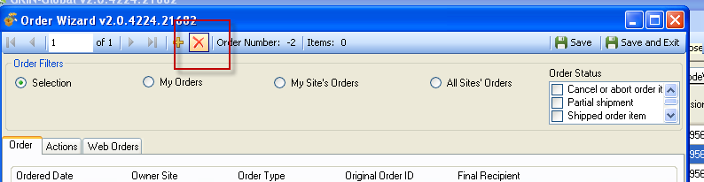

Deleting an Order Item
If you need to delete an order item, select the item’s row (click on the left row header cell) in the order item grid at the bottom of the wizard window, and then press the keyboard’s Delete key.
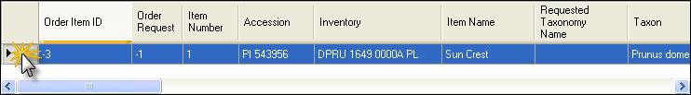

Order Dataviews

Instructional Approach
Review the Order Request and Order Request Items dataviews. Remind the participants that they are not restricted to always using the Order Wizard, but it does simplify order handling. They can still add multiple orders in bulk by adding them directly to the Order Request dataview.

Handling Orders from Multiple Sites

Instructional Approach [Optional]
- Discuss the advantage of an organization having multiple sites with the Order Wizard. By establishing multiple sites, an organization can easily separate incoming orders. For example, one site could be responsible for in-vitro orders and another for seed orders. The My Site’s Accessions Only checkbox can be used in that case to pull off just one site’s items.

Image Handling

Key Points to Emphasize:
- the Image wizard is used to manage the attachments of images to accessions or inventory
- the interrelationship (and immediacy) of the accession’s detail page in the Public Website (During this lesson, have the PW open as well as the CT.) The image records will be added to the Curator Tool. You can see them immediately in the Public Website by refreshing the accession’s detail page.
- there are other “attach” dataviews, but they do not have similar wizards
- the accession_inventory dataview has a form associated with it
The image wizard has been targeted for improvements.

Importing Images into the Curator Tool

Instructional Approach
Demonstrate dragging several images at one time onto an accession item. (Drag from Windows Explorer image files – drag them directly onto the item in the Curator Tool list panel.
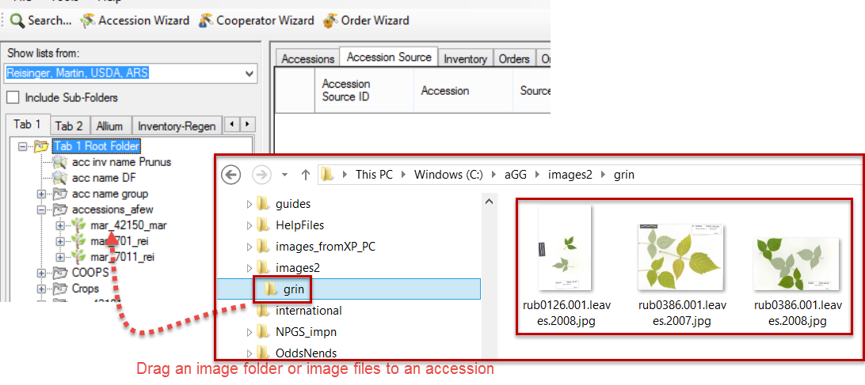

Displaying Image Records on the PW
When adding image records to the Curator Tool, after they are added, switch to the Public Website to demonstrate the effect. You need to display the accession’s details page.

Reordering the Images on the PW
The Sort Order field is used to control the ordering of the images. #1 is the default image when the accession is first viewed. This sort order field is only visible in the image attach grid – not in the dataview form.

End-of-Day 3: Review

Instructional Approach
Summarize the main concepts regarding Inventory and Order Processing. Discuss what determines whether an inventory lot is the default lot or not; how an Inventory Maintenance Policy fills in many of the fields for inventory, but perhaps more importantly determines ownership and the maintenance site. Quickly review the general idea of web orders and standard orders and the use of the Order Wizard.
Ask specific questions to solicit their responses.

Day 4 Morning: Review of Day 3

Instructional Approach
Have the participants create an order from the Public Website using some of their accessions. They should then completely process the order using the CT’s Order Wizard.

Also, have them create another order directly from the Order Wizard – have them change the Type to Replenishment and select several inventory lots. After the participants complete this task, consider discussing how new inventory will be created as a result of the regeneration and that the original inventory will be the parent inventory of the new inventory lots. (Refer to the Regenerating Inventory
section in the Inventory guide.)

Observations & Descriptors

Key Points to Emphasize:
- all observations are organized by crops
- institutes define their own crops
- crop traits and their codes (if a coded trait), must be defined before observations can be recorded
- observations are attached to inventory records – when the observation applies to the accession, use the system inventory record (such as observations being recorded for historical data where the inventory data does not exist)

Recording Observations Using Existing Traits

Instructional Approach
Use the Crop Trait Observation dataview to record observations. (In a new system, the Traits and Code must be established before any observations can be made.)

Indicate what Crop and Crop traits to use. The participants will record some observations. In advance, before the workshop, some traits (and codes need to be set up).

After they have created some observations for accession in the Curator Tool, have the participants use the Public Website to find these.

Descriptors: Searching / Exporting / Determine the Crop’s Descriptors

Public Website

Instructional Approach
Demonstrate by selecting a Crop listed under the Descriptor menu option. Demonstrate how to use the descriptors to find accessions.

Searching for Descriptors / Set up the CT with the Descriptor List(s) by Crop

Search Tool

Instructional Approach
Show how you can either selecting a Crop in the Search tool and drag that to an empty list in the CT or with an empty list, in the CT, select the Crop dataview. In the later option, you can then drag the desired Crop (record) to a second empty list in the CT, and that can become the basis for examining the database by any of the traits; the traits will be listed as nodes under the Crop in the List Panel.
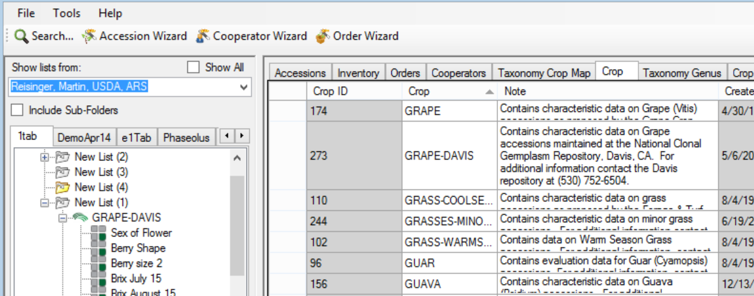

With the Crop Trait dataview active, you can see the Trait’s record, which includes its Description, etc.
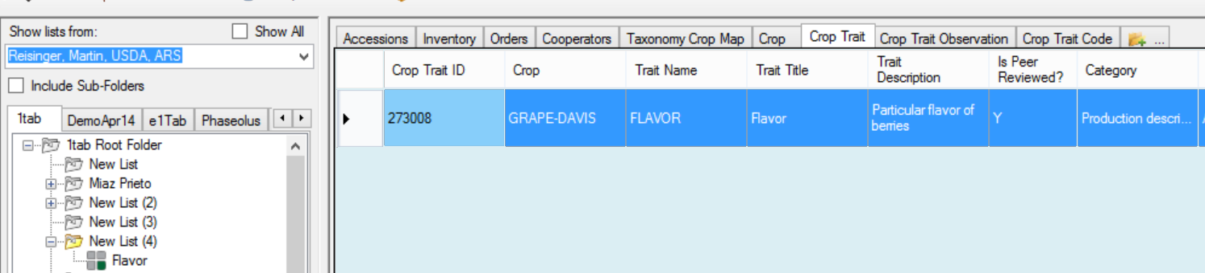

With the Crop Trait Observation dataview active, you can see all of the Observation records that have been recorded for that trait:
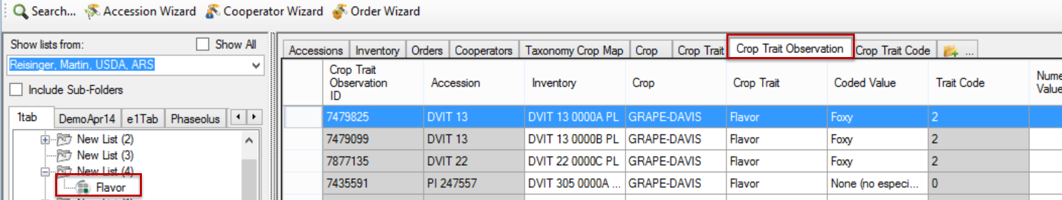

Curator Tool: Creating Descriptors (Optional)
- Many organizations will limit who can create the Traits. Ideally only the GRIN-Global administrator will input these descriptors, to ensure consistency.

Instructional Approach
Depending on the audience, and the amount of time available, walk through the process of creating a descriptor. The guide
http://www.ars-grin.gov/npgs/gringlobal/docs/gg_observations_and_descriptors.pdf has the step-by-step directions.

Create a Coded Trait and create several codes for it. Before you can use the trait to make observations, you will need to update the Lookup tables for Crop Traits & Codes.

Reports

Key Points to Emphasize:
- the Curator Tool reports are embedded in the CT – they were made using Crystal Reports
- the reports are designed to work with specific dataviews, so it is important that you know which reports go with which dataview
(see http://www.ars-grin.gov/npgs/gringlobal/docs/gg_reports.xlsx )
- these embedded reports can be modified, but not within the CT – the organization or admin needs a copy of the Crystal Reports editing tool

Curator Tool Reports
When an organization installs GRIN-Global, Curator Tool report files that are bundled with GG can also be installed. Additionally, each organization has the capability to create its own custom reports to meet its specific needs.

In the CT, reports have been designed to work with specific dataviews to display specific data.
(see http://www.ars-grin.gov/npgs/gringlobal/docs/gg_reports.xlsx )

One tool used to create these .rpt files is Crystal Reports (from SAP). These files all have an .rpt file extension.

Instructional Approach
Demonstrate how five inventory reports are displayed under the Reports option when the Inventory dataview is the active dataview (the menu was invoked with a right-click action by the user).

Public Website Reports
Additionally, there are reports designed to work within the Reports feature on the Public Website. The Public Website also has a Reports menu option - all PW users will see reports that are publicly available. Currently only one report is available to public users. However, additional PW reports are also available, depending on two conditions: the genebank user must be logged in and the user account must have been given access to these “internal” reports.

Reports Available to all PW Users | Reports Available to a Logged-in User
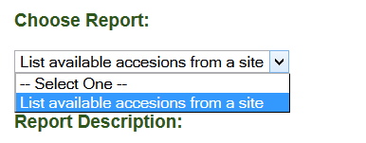 | 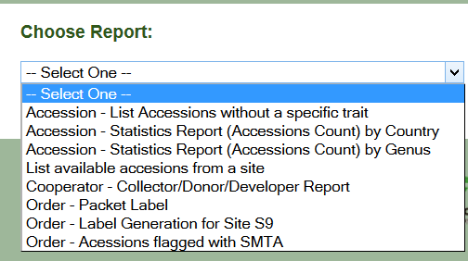

SQL Reports
A third group of “reports” are the results of read-only SQL queries. Users added by the GG Admin to the Web Query Users Group will be able to run SQL read-only queries to extract data.

Instructional Approach
Access the online document GG Library, which has a section containing SQL examples. (see http://www.ars-grin.gov/npgs/gringlobal/docs/gg_library.pdf ) Demonstrate copying one of the basic SQL queries into the PW Query Tool.

Security

Ownership & Permissions

Key Points to Emphasize:
- security has two aspects: besides ownership, there is a permissions feature. As the owner, you can define what permissions someone may have to “your” records. As needed, you can establish Create, Read, Update, and Delete permissions for records – you can assign different permissions
- only one owner per record
- ownership can be transferred to another owner at any time
- the ownership of the record is not always determined by who created the record. This is a key point to emphasize – there are ownership “rules” embedded within GG. For example, the Crop Trait Observation records are owned by the Inventory records which the observations were related to. Furthermore, the owner of the Inventory Maintenance Policy that was used when creating the Inventory record owns the Inventory record.
- (The GG Admin can disable/enable security universally with the DisableSecurity switch in the AT Web Application parameter)

An owner typically can update or delete records which she has created.
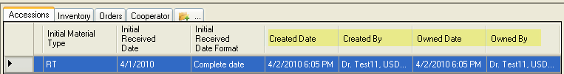
In the current CT security model, there can be only one owner per record. However, the owner can provide permissions (Read, Update, Create, Delete) to multiple users.

An owner can also transfer ownership to another user. This is especially useful in specific situations. For example, the Inventory record, by default, is assigned the same owner as the owner of the Inventory Maintenance Policy that was used to create the Inventory record. Similarly, Trait Observations inherit the ownership from the Inventory (and hence the Inventory Maintenance Policy records). Someone who creates an observation may not be the owner, and if he needs to change the record, hen eeds to be either given ownership, or permission by the owner to update the record.

In a dataview, select the rows (records) that you intend to transfer ownership; right-click and select
Change Owner…
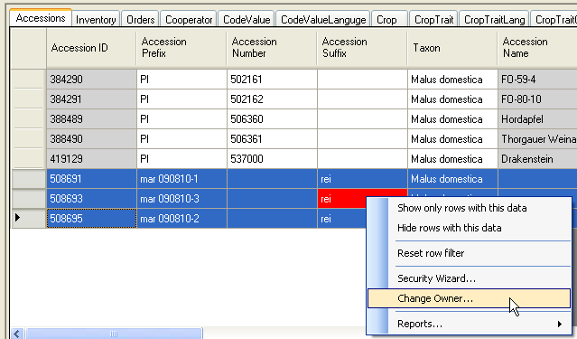

Instructional Approach
Review & change the ownership information for one or two accessions. Assign ownership to another workshop participant. Alternatively, if time allows, complete the following exercise:

exr_ownership_and_permissions.docx

Code Groups

Key Points to Emphasize:
- Codes are used throughout GG to assist with data entry – instead of text fields, codes are used to provide dropdowns from which to select a valid item
- Only the GG administrator can edit the Code Groups and their codes

Background Information
Many of the dataviews in the Curator Tool use dropdowns to assist in selecting a valid entry – the fields do not allow any random text data to be entered, but instead require a value from a pre-populated set of values. These codes and their values are stored in the Code Group tables and maintained by the GG administrator.

Instructional Approach
Brief review of codes (below – participants have the same illustrations)

Discuss how to get new codes added: GG Administrator uses the AT to edit/add Code Groups. Demo (Optional -- if possible – demonstrate how the GG administrator would do this using the Admin Tool Code Group editor if this is available to you in the workshop.)

For example, the Category in the Accession Inventory Name dataview uses codes:
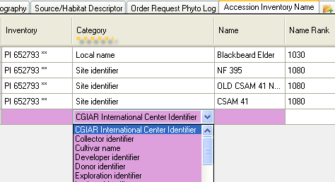

Five fields in the Accession dataview that use codes are shown below. In the example, the user clicked on the Level Of Improvement to display and then select a code:
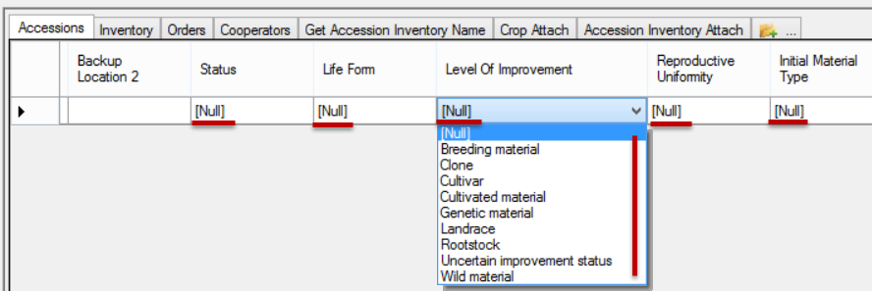

Only the GG administrator can add or edit the codes, ensuring consistency and integrity. As a CT user, if you need a code to adequately describe a record, contact your GG administrator or follow your organization’s procedure for establishing codes.

Taxonomy

Key Points to Emphasize:
- an organization can load the GRIN Taxonomy when it installs the GG database (recommended)
- this GRIN taxonomy can be complemented with additional taxonomy records supplied by the organization
- someone in the organization should have the primary responsibility for the taxonomy data
- to load Taxonomy, you need to have the Family, the Genus, and the Species at a minimum (At a minimum, every Species record must have a parent Genus which in turn must have a parent Family record.)
- the AT's Import Wizard can be used by the GG Admin to load Taxonomy data
- you must have the Taxonomy in the DB before you can add an accession
- Lookup tables - need to be current …

Note: As a reference, in the U.S., only one user, the taxonomist, has responsibility for managing the taxonomy dataview. A taxonomy wizard was written to assist him in his work.

Instructional Approach
- Discuss how taxonomy gets added
- Briefly review the main taxonomy dataviews: Family, Genus, Species
- Relate to Lookups: in the Accession dataview, if the Taxon is not in the dropdown, the corresponding taxonomy records need to be added

“Other” Dataviews

Instructional Approach
If time allows, walk through these “minor” dataviews.

Literature References
This dataview accesses the table of valid books and journals used in literature citations for genera, taxa, accessions, methods, etc. in the database. The abbreviations used should follow recognized standards either from the library field or from taxonomy.

Citations
Table of valid books and journals used in literature citations for genera, taxa, accessions, evaluations, etc. in the database. The abbreviations used should follow recognized standards either from the library field or from taxonomy.

Methods / Method Map
The Methods dataview accesses the table of methods and procedures which are used in determining the crop specific attributes of the germplasm. Each environment used in an evaluation should have its own record. The method is primarily used for crop trait evaluations. (The inventory_viability tables are used to store germination /viability procedures and the viability test results.)

Method Map
The dataview accesses the method_map table which can handle a many-to-many relationship between the cooperator(s) who participated and the methods. (More than one cooperator can be involved with a method.)

Genetic Markers
Table of genetic markers that are crop-specific. Ideally, markers are published (link to citation table) and have data for known standard controls available. The data in this table is general in nature, and not specific to a specific experiment or evaluation.

Source Habitat Descriptors

Key Points to Emphasize:
- “core” site/habitat data is in the accession_source table (latitude, longitude, number of plants sampled, etc.)
- five source_habitat tables are in the schema: genebank personnel can create custom habitat source descriptors and descriptor codes as needed to record collection site data; unlimited descriptors can be added
- use the Accession wizard to add Source Habitat Observations to an Accession
- it is recommended that one person in the organization (the GG Admin or someone designated) should be solely responsible for entering the Source Habitat descriptors (and codes)

Instructional Approach
Present an overview on source_habitat
Demo / have the participants select some Source Habitat observations for an accession using the accession wizard:
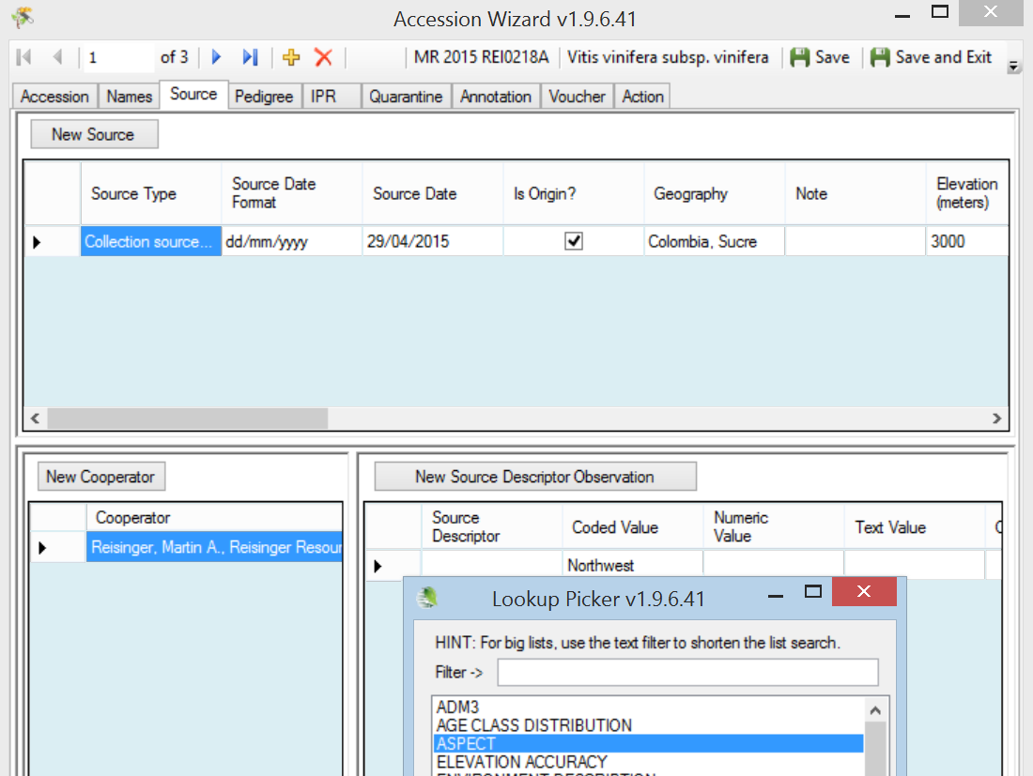
Briefly describe: How to Create Source Habitat Descriptors. (In the USDA, either the DBA or a designated person will be creating these descriptors. The typical user will not. Use the analogy of “Codes” -- the participants should understand know how the Source Habitat Descriptors can be added, just as Codes are and Code Groups are added.
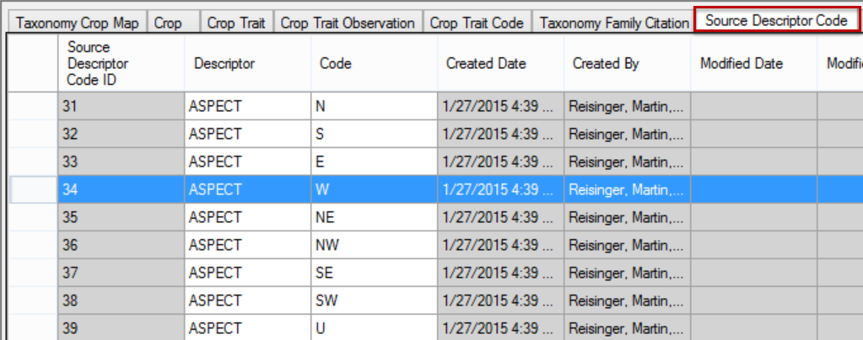
A complete guide to GG Source Habitat Descriptors is online.
http://www.ars-grin.gov/npgs/gringlobal/docs/gg_source_habitat_descriptors.pdf
The spreadsheet with descriptors that will be used by the USDA are also online.

Example:
Within a category called Soil Descriptors there could be sub-descriptors such as Moisture, Texture, Magnesium Content, etc. The level of detail and range of descriptors is up to the database managers. An organization could record Source/Habitat descriptors such as Slope, Aspect, Soil pH, and Soil Texture.

The following example illustrates the table for SOILTEXTURE as described in the Bioversity’s Developing Crop Descriptor Lists (Technical Bulletin #13, 2007):
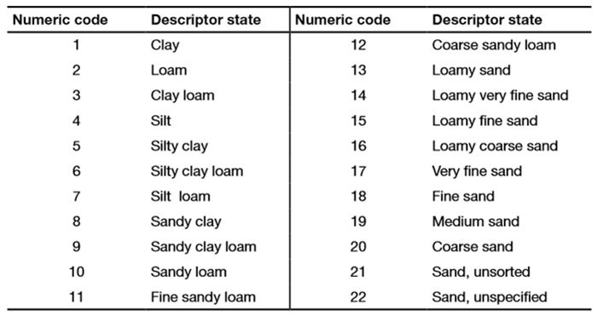

This screen capture illustrates the GG English implementation of the SOILTEXTURE descriptor:
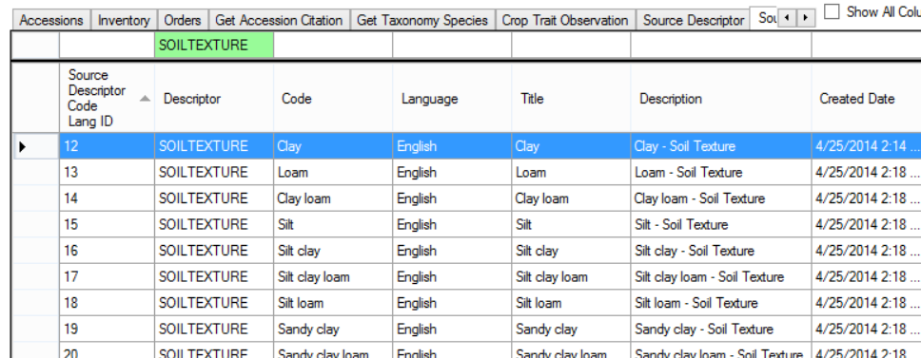

Workshop Closing
Every workshop is different. Many factors affect the workshop’s progress and overall success, including such factors as genebank operational knowledge, PC and communication, as well as the number of participants. If the class has been spending ample time with the exercises and the participants are capable of creating, finding, and editing various records, especially accessions, inventory, cooperators, orders, and trait evaluations, then instead of doing a full case as suggested below, focus on specific student questions.

Review
Review of the GG system with focus on participant questions; reviews as needed

Full Case (optional; if time allows)
Participants will create and manage a list of new accessions that have been introduced to the genebank…

Debrief / Final Evaluation / Closing

Instructional Approach
Use the

final_reaction.docx

Files
gg_objectives.pptx 13
gg_environment_what_is_grin_gobal.pptx 13
gg_schema.pptx 15
review_of_day1.docx 27
exr_searches_more.docx 33
review_of_day2.docx 36
exr_inventory.docx 38
exr_ownership_and_permissions.docx 51
final_reaction.docx 56

