Viability Wizard

Revision Date
July 13, 2021
Appendix D contains revision notes pertaining to this document.
This document is online at https://www.grin-global.org/docs/gg_viability_wizard.docx Please consider not printing, as these GG documents are periodically updated.

Author
Martin Reisinger

Table of Contents

Background 3
Retrieve (Get) an Existing Test 5
Get Test 5
Viability Test Details 7
Show All Rules 7
Print Labels Button 8
Save 8
Radio Buttons – Create a New Count Row 9
Notes 10
Create New Viability Test 11
New Test Window 13
Printing Labels for Tests 14
Searching for Viability Records 15
Appendix A: Installing the Viability Wizard 17
Detailed Installation Instructions 17
Step 1: Download and Unzip the .zip File 17
Step 2: Copy the Viability Wizard .dll file to the Wizards Folder 17
Step 3: Add a line to the App Settings.txt file 18
Step 4: Copy the Viability Wizard Report (.rpt) files to the PC 18
Step 5: Restart your Curator Tool 18
Appendix B: Viability-related Dataview Examples 19
Inventory Viability Rule 19
Inventory Viability 19
Inventory Viability Data 20
Inventory Viability Rule Map 20
Appendix C: Pure Live Seed 21
Pure Live Seed (Calculating Live Seed by Using Germination Test Rates) 21
Appendix D: Revision Notes 22

Background
Seed or plant viability is the measure of how many seeds or how much plant material in a lot are alive and could develop into plants that will reproduce under appropriate field conditions. Viability testing is crucial for the monitoring of seed conservation. CGIAR has a detailed discussion of viability testing online.
The GRIN-Global Viability table family has several interrelated tables:

In GRIN-Global, four Inventory viability-related dataviews are particularly important. The wizard is used to record the raw data results from germination tests into a results (summary) table.
Dataview | Purpose
get_inventory_viability | Summary table that aggregates (“rolls up”) the individual results of seed germination tests.
get_inventory_viability_data | Contains the raw data results of seed germination tests
get_inventory_viability_rule | Specifies the conditions used in a germination test – the lighting conditions, optimal temperature, the substrata, days between counts, number of replicates, etc. Generally, protocols have been developed that work best for different taxa. Viability rules are stored in their own table; when a new viability test is to happen, the rule that is relevant can be selected, rather than spell out the individual conditions of the test every time a viability test is to be given.
get_inventory_viability_rule_map | The map table makes it possible to link multiple taxons (species_IDs) with multiple rules. (One viability rule may apply to many taxa.)

Dataview Examples are in shown in Appendix B.
The Viability Wizard consists of one main window from which you can either retrieve an existing viability test (Get Existing Viability Test) or create a new test (Create New Viability Test)
Click one of the links above, depending on your interest.
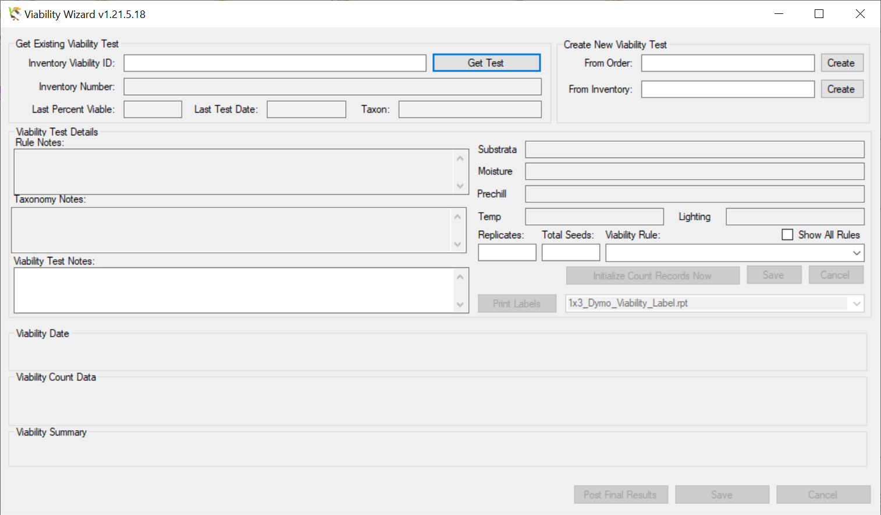

Retrieve (Get) an Existing Test

Get Test
To retrieve an existing viability test, use the textbox adjacent to the Inventory Viability ID: label.
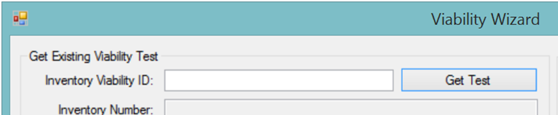
Input one of the following valid alternatives:
- an existing viability test ID (Ex: 1984882)
- a viability test’s specific replicate # (Ex: 1984882.1 , Ex: 1984882.2 …)
- an inventory number (Ex: Ames 20217 REI SD)
Entering a viability test’s specific replicate is the preferred method. A replicate is designated by a suffix. For example, 1984882.1 indicates the first replicate of test 1984882, 1984882.2 the second, and so on. When inputting a specific replicate, you are restricted to editing that replicate’s data only, which helps avoid data entry errors. (You will still be able to see the other replicates’ data.)
Entering the inventory number is useful when investigating concerns regarding the viability of seeds in a packet. When entering an inventory number, the most recent viability test for that inventory will be retrieved. (If that inventory does not yet have a viability test, presently the wizard does not display any feedback.)
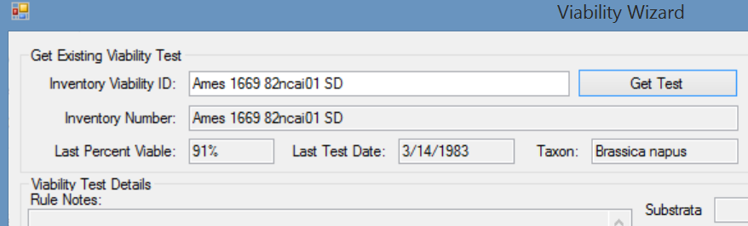
When you scan the inventory number barcode from a seed packet, the latest viability test will be displayed. You can then review everything about that test including specific counts, method, notes (including rule, taxonomy, test, and individual replicates notes), pre-chill, and any other viability test information.
Viability test labels generated by the Viability Wizard contain 2D barcodes which include the specific replicate or the viability test. When one of these labels are scanned, the Viability Wizard will retrieve the data for that respective viability test or replicate. You can then edit that data.
Inputting the viability test with a replicate number displays the count data for the one replicate: 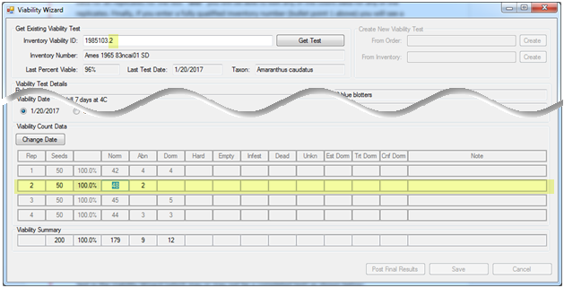
When entering the viabilty_ID, all of the replicates can be edited:
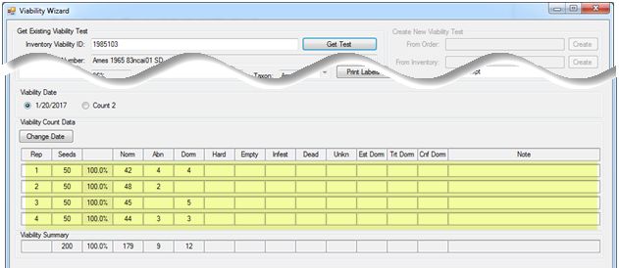
When entering an inventory_ID, the most recent Inventory Viability test is displayed:
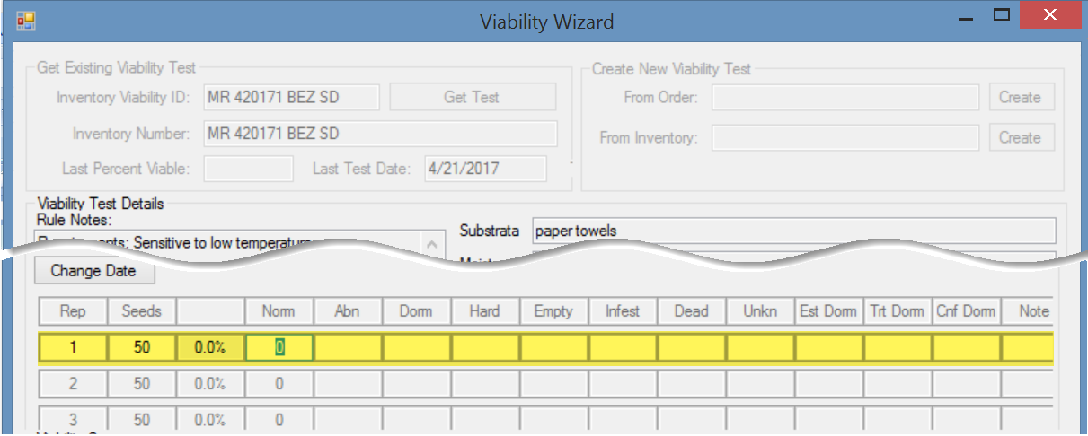

Viability Test Details
On the main window, the ‘Viability Test Details’ section displays the viability test parameters for the viability rule currently selected for the viability test being edited:
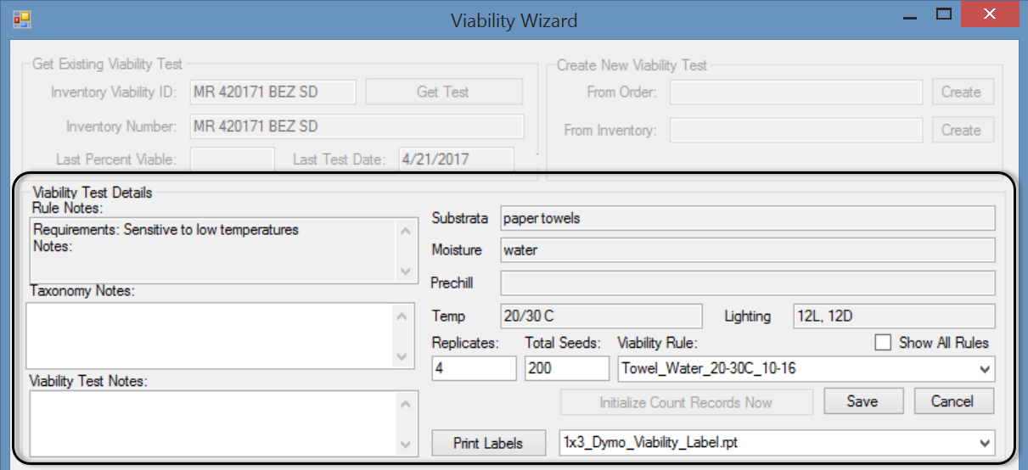
The information on the Viability Wizard main page includes testing procedure parameters and other useful information from several GG tables.
GRIN-Global Table | Fields
inventory_viability_rule | Substrata, Moisture, Prechill, Temp, Lighting, Replicates, Total Seeds, Rule Notes
inventory_viability_rule_map | Taxonomy Notes
inventory_viability | Viability Test Notes

Show All Rules
By default, the Show All Rules checkbox is unchecked. Only viability rules currently associated with the taxonomy species being tested are displayed in the Viability Rule dropdown list. When selected, the Show All Rules checkbox will display all available viability rules. 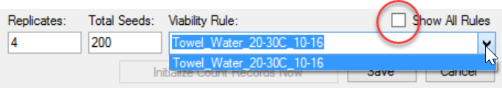
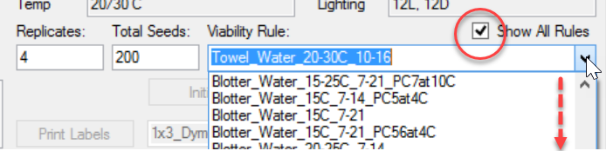

Print Labels Button
Click the Print Labels button as needed. Also, note that the label has a barcode symbol.
Later, this symbol can be scanned and be used to invoke the Viability Wizard to display the corresponding replicate’s data. The technician can immediately begin recording new counts specifically for that replicate.
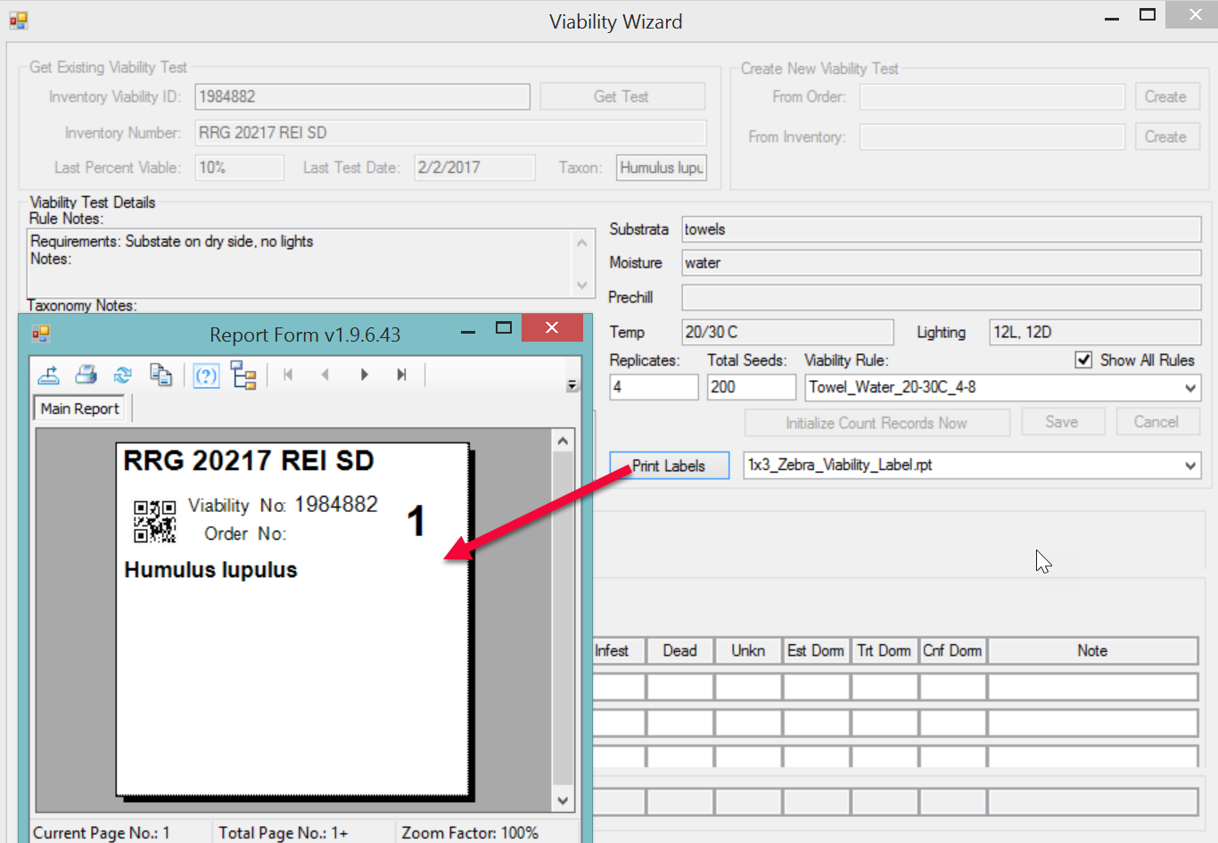

Save
When the user has changed information regarding the viability test, the Save button inside the Viability Test Details section will be enabled. Often this will be the viability rule being applied to the test. Generally this is a trivial task – simply click Save. However, when a viability rule has been chosen that is not associated with the taxonomy species of the current germplasm being tested, a dialog box displays:
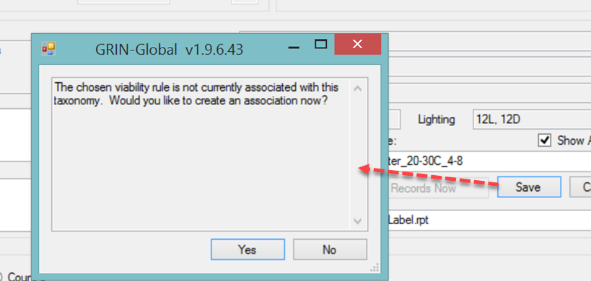
If you click Yes, an association will be made between this rule and the taxonomy species; in future tests this rule will show up in the short list of rules for this taxonomy. (A record is created in the inventory_viability_rule_map table linking the taxonomy species ID with the inventory viability rule ID.)

Radio Buttons – Create a New Count Row
During viability testing, multiple counts of the replicates are performed. By default, the first time the barcode is scanned to initiate entering count data for that inventory sample, the Viability Wizard creates a new radio button with the current date.
That initial date becomes the test’s start date. No count rows are displayed. When seeds are pulled out of the growth chamber to conduct a subsequent first count, typically 4-7 days later, a new radio button will be created and will become the count date for that data that is being recorded on that date.
If less than 24 hours has elapsed since the latest count, the wizard will not create a new radio button; instead, the wizard will return the data that is less than 24 hours old so that you can inspect/modify the data as needed. If you intend to conduct two counts less than 24 hours apart and need an additional radio button, click on the right-most button (labeled Count n). When this radio button is clicked, a new set of count rows will be created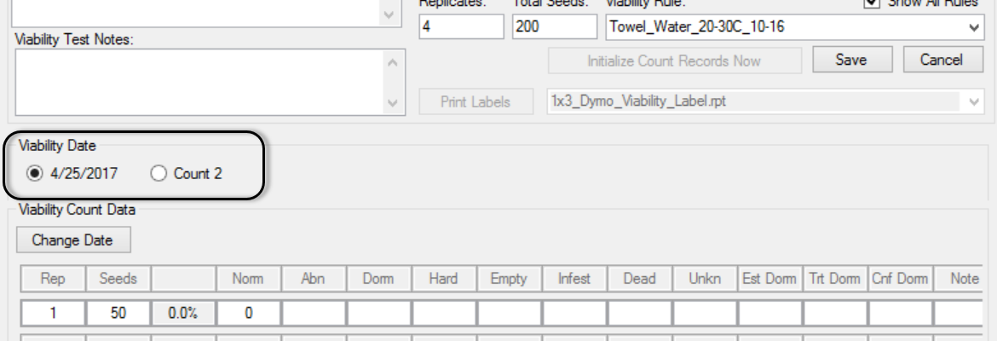.

The Tested Date in the Viability record is reserved for the date when the germination test is completed. However, the wizard inserts the date when the wizard is used to set up the test parameters. When the testing is completed, that date will be updated.
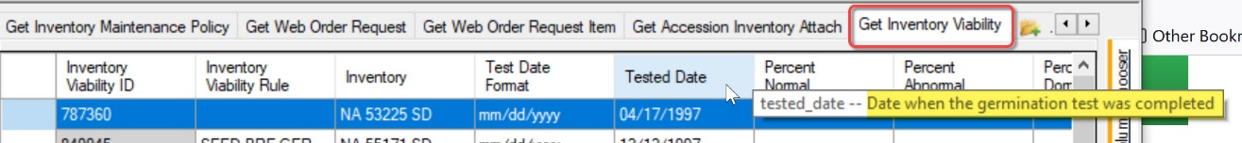

The second counting of a test will be reflected in the total % of the first date:
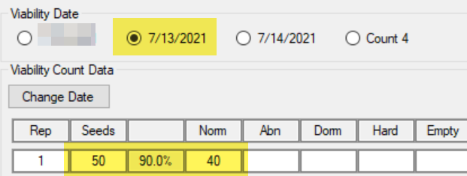
How did 40/50 get converted to 90% ? The second count had 5 more normal germinations:
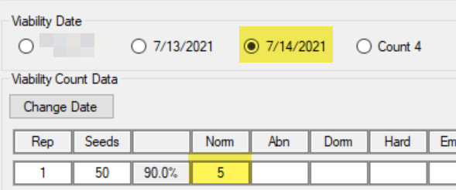

Notes
Four different note boxes are on the main Viability Wizard window:
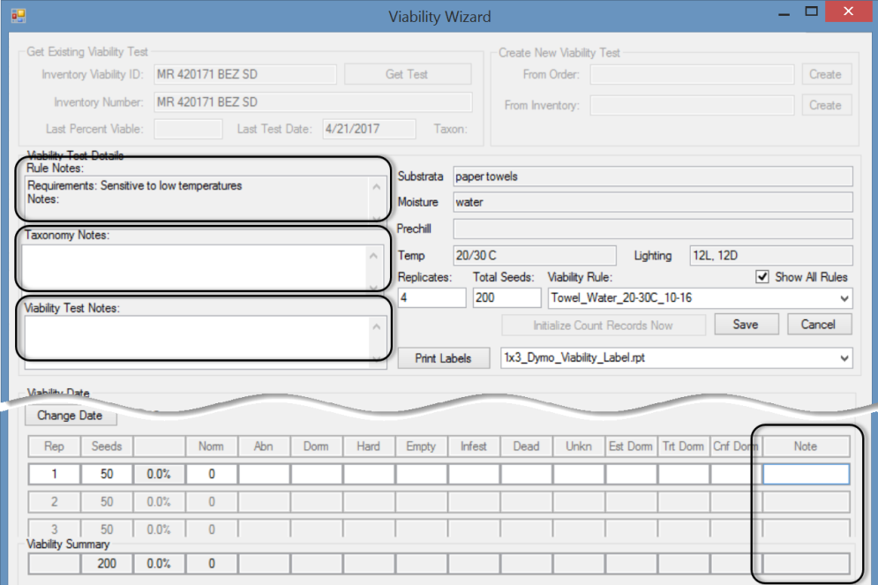
Note Fields Available on the Viability Wizard
Display Name | Table | Function
Rule Notes | inventory_viability_rule | General notes about the test procedure. Applies across all taxonomy species samples which use this rule.
Taxonomy Notes | inventory_viability_rule_map | Notes detailing how the viability rule test procedure should be applied to this specific taxonomy species.
Viability Test Notes | inventory_viability | General notes about the testing process as it was applied to this particular inventory sample.
Notes on the Replicate Records | inventory_viability_data | Specific notes about the test procedures and observations for a specific replicate on a specific count day.

Create New Viability Test
The wizard can set up inventory viability tests from either an Order or an Inventory record. When an Order is selected, tests will be established for each inventory item included in the order.
Use the Germination value for the Order Type when creating an order for viability testing.
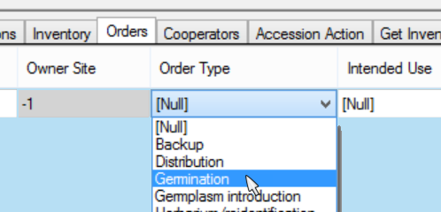
In the Viability Wizard window, in the top right panel, enter the order or inventory value in the appropriate box; then click the respective Create button:
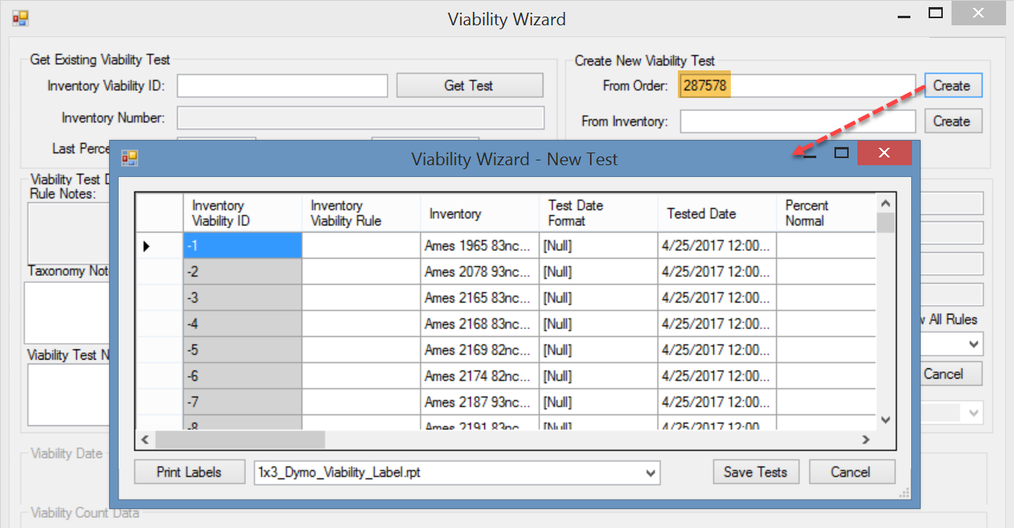

Creating a New Test from an Inventory
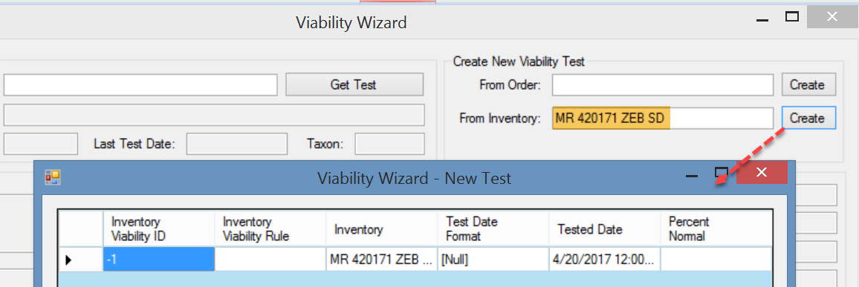

When selecting Order, each order item in the germination order will generate a test; otherwise, when indicating Inventory, only one test will be generated. If an open test hasn’t been completed for that order or inventory, you will be reminded with a prompt. You can ignore the prompt and continue in creating a new test, or you can proceed with an existing test:
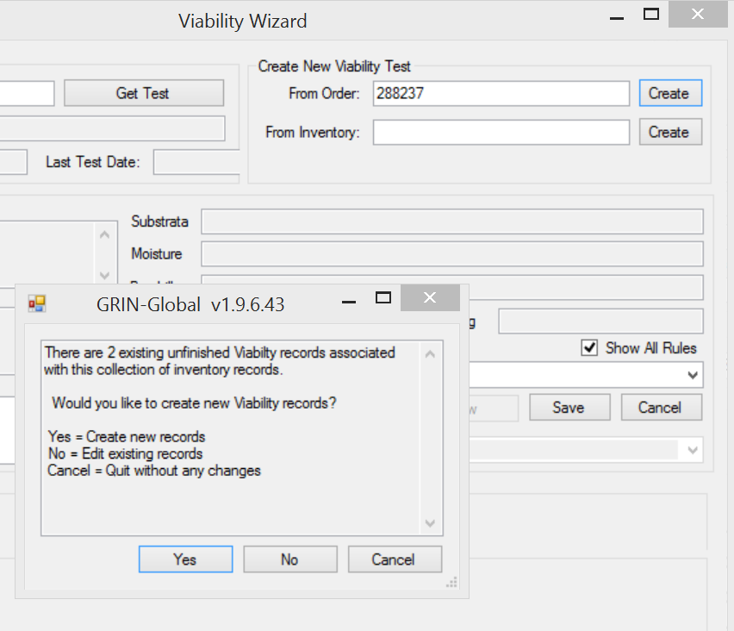

New Test Window
When the wizard creates a new test, the wizard initially displays a New Test window. Enter the viability test parameters. Some fields are filled in with defaults, whereas other must be entered to indicate the test’s parameters. Typically, you will complete the Inventory Viability Rule field by selecting a rule from a dropdown picker. If the rule has been established with a Sample Count and Replication Count fields, these fields will be filled in automatically when you save the record, but they can be overridden when different values are more appropriate for your test situation. You can also modify any of the other fields in this table.

Selecting a Rule from the Lookup Picker
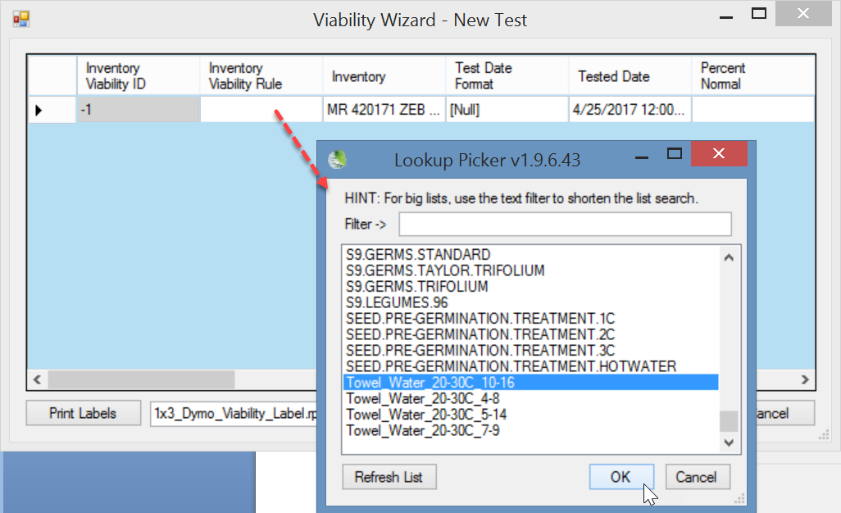
The Created and Owned fields are filled in when you save the record. In the current version of the VW, they are displayed in pink, but input is not required – they will automatically fill in. 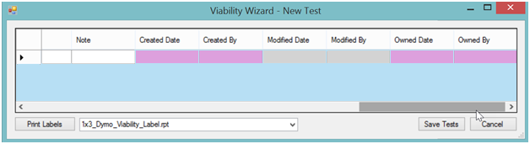
Click Save Tests.
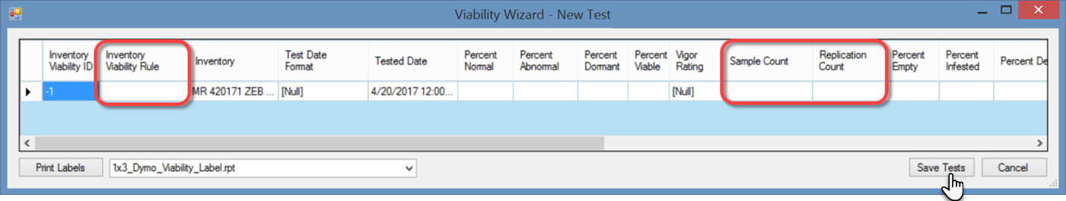

Printing Labels for Tests
The new Viability record will be generated and have its ID. Click Print Labels.
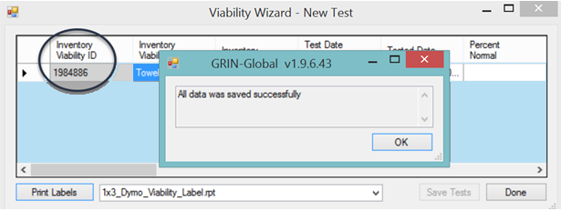
If the Print Labels button is not enabled after having saved your test parameters, the Replication Count field most likely contains invalid or missing data.
Clicking the Print Labels button displays the Crystal Reports Report Form viewer window with one label page per replicate for each test.
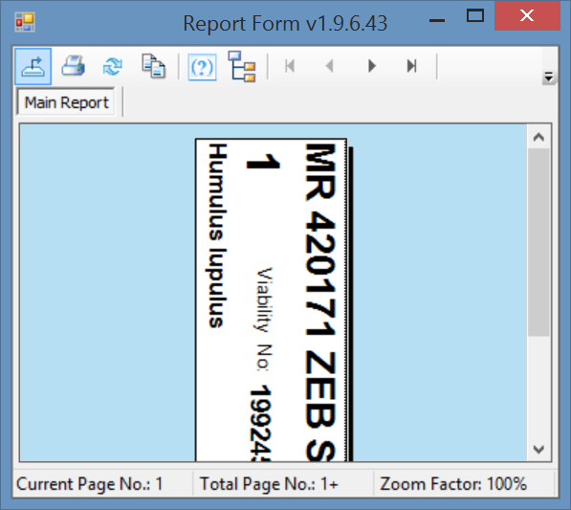
Click Done:
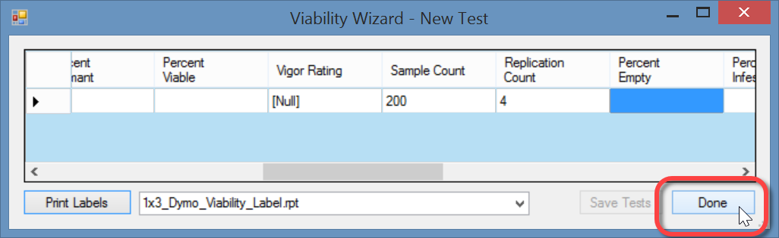
If you click the Done button instead of Print Labels after saving your data, the wizard will display a prompt:
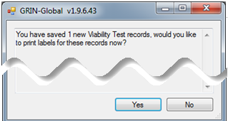
Clicking Yes button will display the Viability Wizard – New Test dialog window; you can then click Print Labels. If you click No, returns you to the main Viability Wizard window.

Searching for Viability Records
Use the Search Tool to find Inventory Viability records.
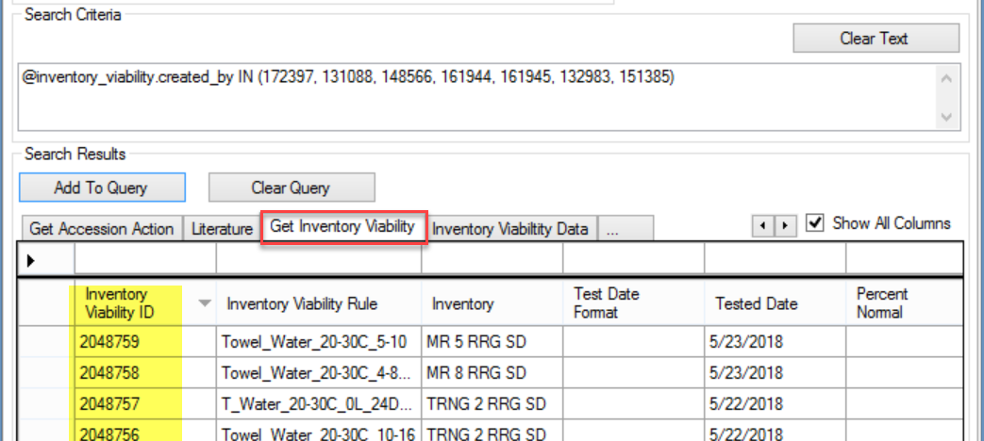
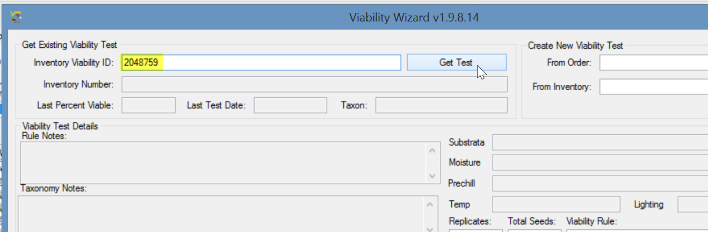

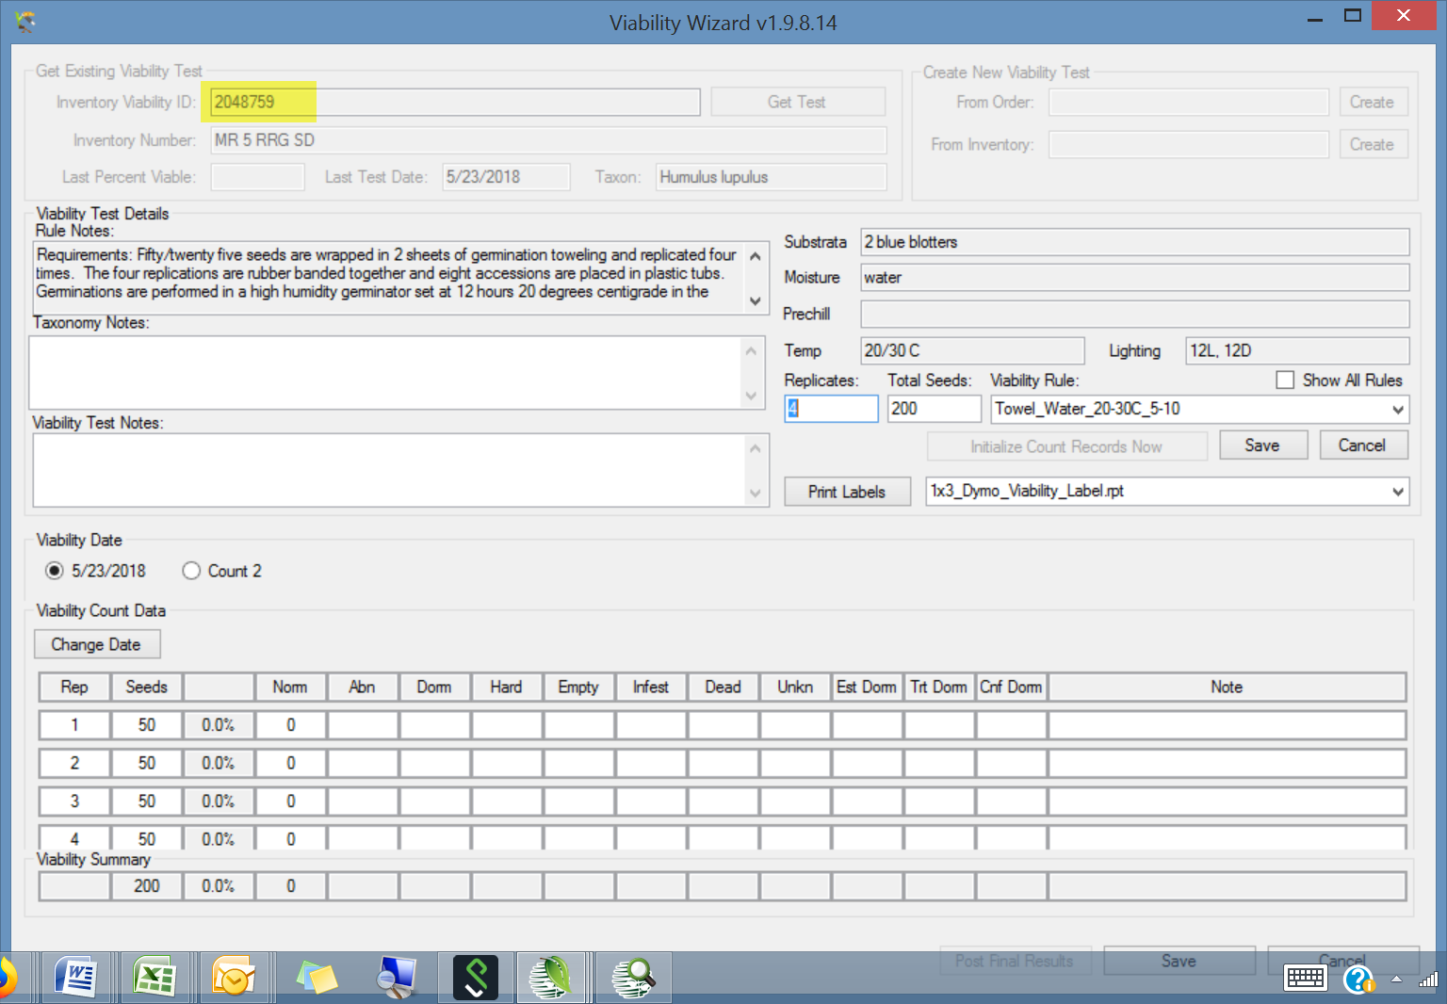

Appendix A: Installing the Viability Wizard

Overview
The Viability Wizard is available for testing; four steps must be followed. The steps are summarized here and then detailed on the following pages.
- Unzip the zip file (Step 1)
- Copy ViabilityWizard.dll --> C:\Program Files (x86)\GRIN-Global\GRIN-Global Curator Tool\Wizards (Step 2)
- The existing AppSettings.txt file needs to be edited and have one line added (Step 3)
- Two .rpt files need to be copied to your C:\Program Files (x86)\GRIN-Global\ GRIN-Global Curator Tool\Reports folder (Step 4)

Detailed Installation Instructions

Step 1: Download and Unzip the .zip File
You need to unzip the file in order to get the respective files to be loaded on a folder on your PC. The zip file is located at http://www.ars-grin.gov/npgs/gringlobal/files/viability_wizardfiles_2017feb06.zip
Files included in the zipfile are:
- ViabilityWizard.dll
- AppSettings.txt
- two .rpt files: 1x3_Dymo_Viability_Label.rpt and 1x3_Zebra_Viability_Label.rpt
In Windows Explorer, you should be able to right-click on the zip file name, and then select Extract All… to load the four individual files on a folder on your PC.

Step 2: Copy the Viability Wizard .dll file to the Wizards Folder
Using Windows File Explorer, copy ViabilityWizard.dll to
C:\Program Files (x86)\GRIN-Global\GRIN-Global Curator Tool\Wizards
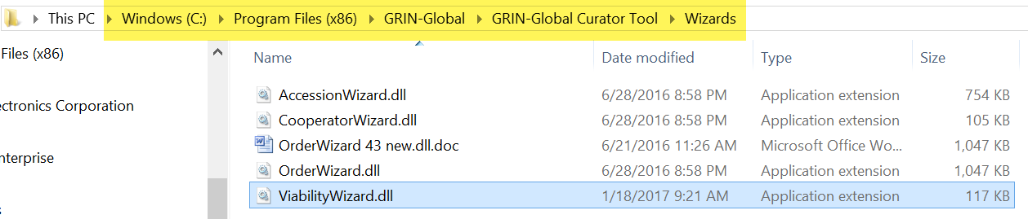

Step 3: Add a line to the App Settings.txt file
Edit your existing AppSettings.txt file which is located in the folder:
C:\Users\yourusername\AppData\Roaming\GRIN-Global\Curator Tool
Add the lines:
# Viability Wizard
ViabilityWizardCrystalReports = 1x3_Dymo_Viability_Label.rpt; 1x3_Zebra_Viability_Label.rpt
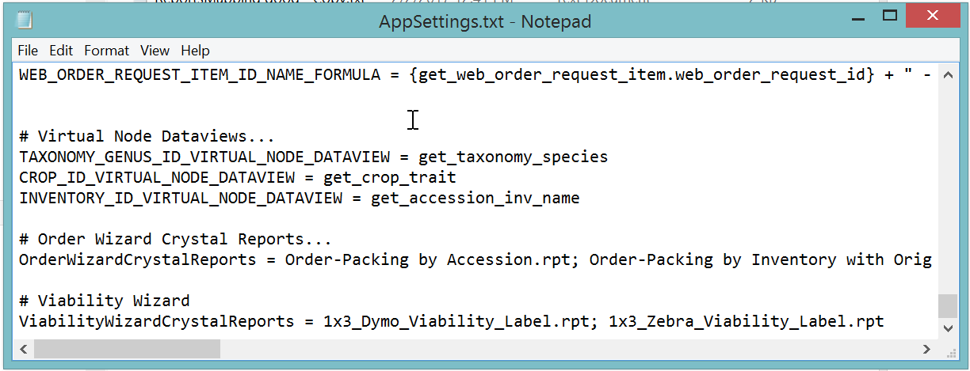
(Any line with a # preceding it is a comment line)

Step 4: Copy the Viability Wizard Report (.rpt) files to the PC
Two .rpt files need to be copied to your C:\Program Files (x86)\GRIN-Global\ GRIN-Global Curator Tool\Reports folder.
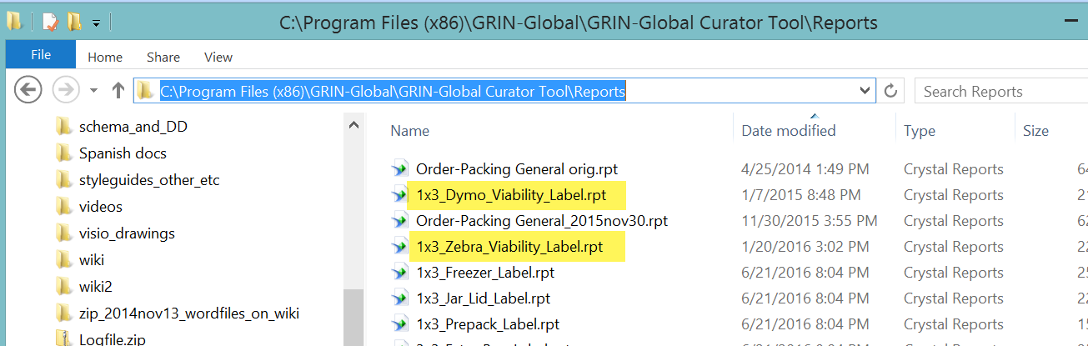

Step 5: Restart your Curator Tool

Appendix B: Viability-related Dataview Examples

Inventory Viability Rule
Specifies the conditions used in the germination tests.
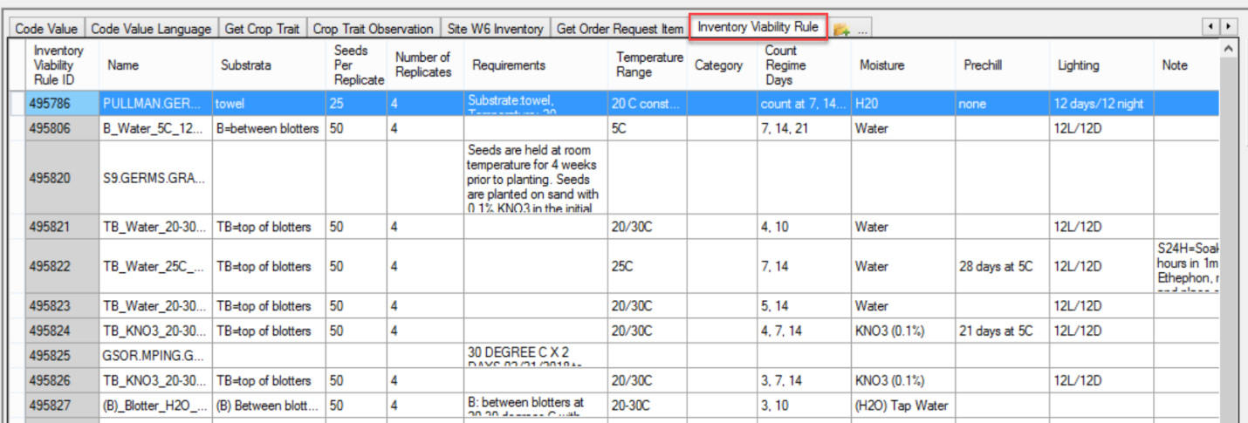

Inventory Viability
These are the viability summary records that have the combined data from their respective Inventory Viability Data records.
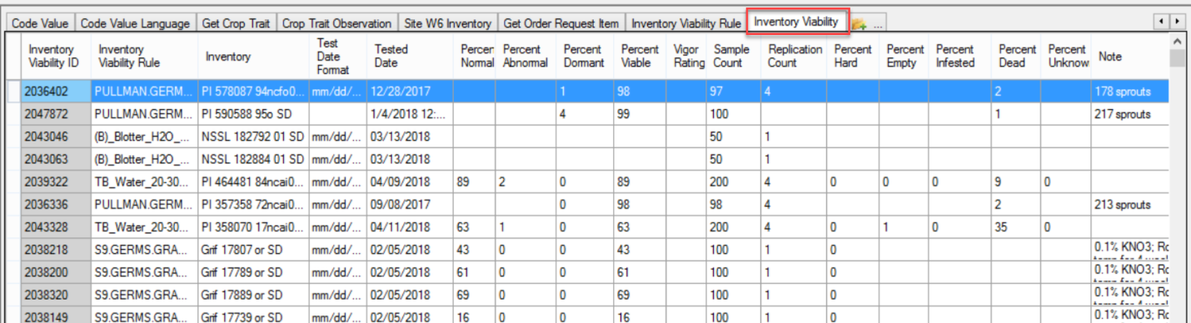

Inventory Viability Data
Each record in the Inventory Viability Data table represents one replicate of a test.
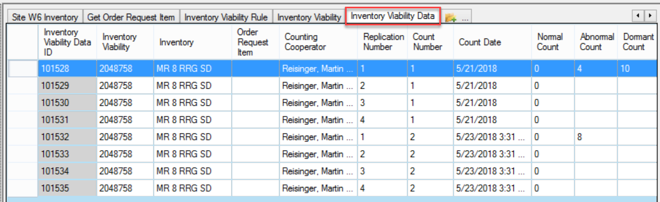

Inventory Viability Rule Map
This dataview reflects the mapping of a viability rule mapped to multiple species records.
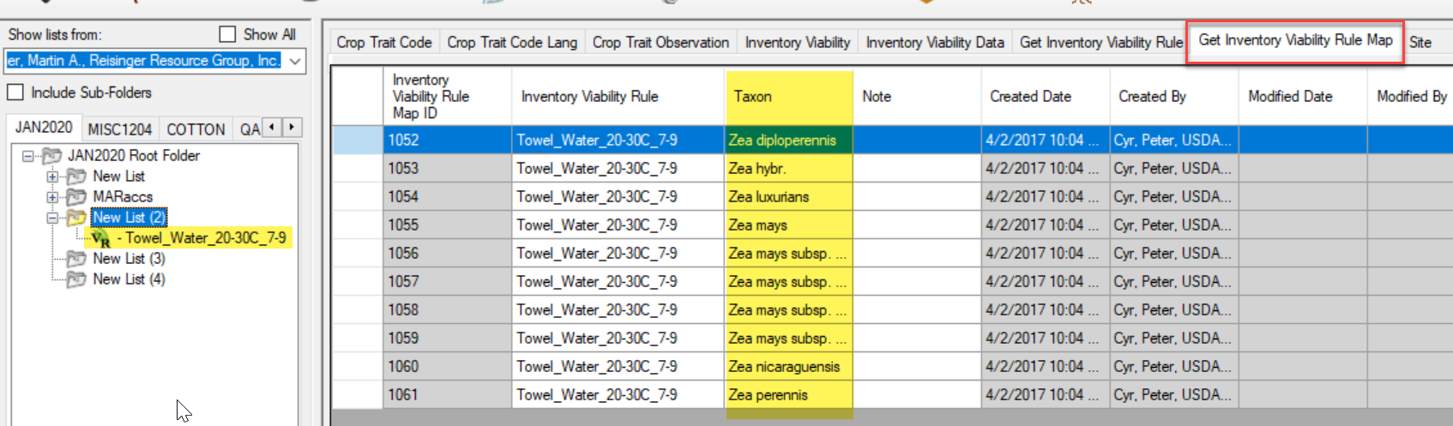

Appendix C: Pure Live Seed

Pure Live Seed (Calculating Live Seed by Using Germination Test Rates)
In server release 1.10.3, a calculated field was added to the Inventory dataview. The calculation is derived by multiplying the quantity on hand with the latest germination percentage to get “pure live seed” (the actual number of viable seed propagules).
For example, if you have 1000 seeds and the germination test says 50%, then you only have 500 seeds that are viable.
The following code can be used in the Search Tool:
WHERE inventory_number_part1 = 'Ames'
AND quantity_on_hand > regeneration_critical_quantity
AND inventory_viability.inventory_viability_id IS NOT NULL
AND dbo.fn_i_pureliveseed(inventory.inventory_id) < regeneration_critical_quantity
(Ames is used here as an example)
Refer to the online Search document https://www.grin-global.org/docs/gg_searches.docx for an expanded illustration.

Appendix D: Revision Notes

Changes in this Document

– July 13, 2021
- multiple wording changes to reflect recent changes to the wizard

– October 18, 2019
- a few, minor very wording changes

– July 22, 2019
- minor edits regarding searching by inventory ID

