GRIN-Global Workshop



Workshop Participant Guide

Revision Date

2018, May 16

|  |  |
| --- | --- |
| image2449.png | This workbook was developed as a summary reference to be used in a workshop covering the GRIN-Global Curator Tool and Public Website, as used by genebank personnel. Discussions of the Admin Tool and other administrative topics will be raised at appropriate points. Review the Table of Contents which contains links to the document’s sections.  Complete documentation on many aspects of GRIN-Global is available online at the GRIN-Global website: <https://www.grin-global.org/> We recommend specifically that you bookmark the User Documentation webpage: <https://www.grin-global.org/userdocs.htm> where many GG guides are stored here. Because these documents are under an ongoing revision process, consider using the online versions and avoid printing. |

Comments/Suggestions

Please contact Marty Reisinger at either marty.reisinger@ars.usda.gov or [mar@rrginc.com](mailto:mar@rrginc.com) with any suggestions or questions related to this document.

Table of Contents

Workshop Objectives 4

GG Environment: Software, Schema, & Supporting Materials 4

Primary Dataview Relationships 5

Online Resources 5

Curator Tool (CT) & Dataview Introduction 6

Keyboard Shortcuts 7

Dragging Data 8

Curator Tool (Overview) 9

Dataview Introduction 10

Accessions – Creating / Editing Records 11

Edit a Record 11

Display Other Dataviews 11

Dictionary 11

Search Tool Basics 12

Creating Lists & Tabs 13

“*Drag & Drop*” Records to and from Excel 16

Static and Dynamic Folders 17

Accession & Related Tables / Accession Wizard 20

General Notes about the Accession Wizard 20

Drag & Drop: Bulk Updating Accession Records 21

Cooperators - Management of Cooperator Records 21

Background Information 21

Lookup Tables 22

Lookup Table Warnings 22

Indicators When a Lookup Table Isn’t Updated 23

More on Searches 24

Query-by-example (QBE) Searches 24

QBE Searches 25

Criteria Code Explained 27

Inventory 28

System Inventory Items 28

Prerequisite Data 29

Purpose of the Inventory Maintenance Policies 29

What Determines Accession Availability or Visibility? 29

Availability Status 30

Miscellaneous Inventory Topics 32

Viability Testing 32

Public Website (PW) 33

Processing Germplasm Requests (Orders) 34

Overview 34

Order Wizard 34

Actions (Order Actions) 36

PW Tools – SQL Queries 37

Recording Characterization Data: Observations & Descriptors (Crop Traits) 38

Attach Observations to the Accession or Inventory? 38

The Crop “Family” of Dataviews - Overview 38

Source Habitat Descriptors 39

Codes and Code Groups 41

Image and Document Handling 42

Reports 42

Curator Tool Reports 42

One More .txt File 43

SQL Reports 44

Public Website Reports 44

Security: Ownership and Permissions 44

Overview 44

Security Wizard 45

Security: Enabling 46

Taxonomy Overview 46

Taxonomy 46

“Other” Dataviews 47

Literature References | Citations | Methods 47

Brief Overview of GG Administration 47

Admin Tool 47

Preparing for an Organization’s GG Installation 49

### Workshop Objectives

Participants will be able to…

* use the Curator Tool to manage accession, inventory, germplasm orders, and accession evaluation data
* add, update, and search for data
* fulfill germplasm orders
* get comfortable with the GRIN-Global(GG) jargon, terms, and the GG programs’ interface
* manage security ownership and permission settings to facilitate a site’s workflow and processing
* use the GG Public Website as a tool to also manage the organization’s accession data
* explain to an institute’s germplasm requestors how to use the Public Website

### GG Environment: Software, Schema, & Supporting Materials

|  |  |
| --- | --- |
|  |  |
|  |  |

#### Primary Dataview Relationships

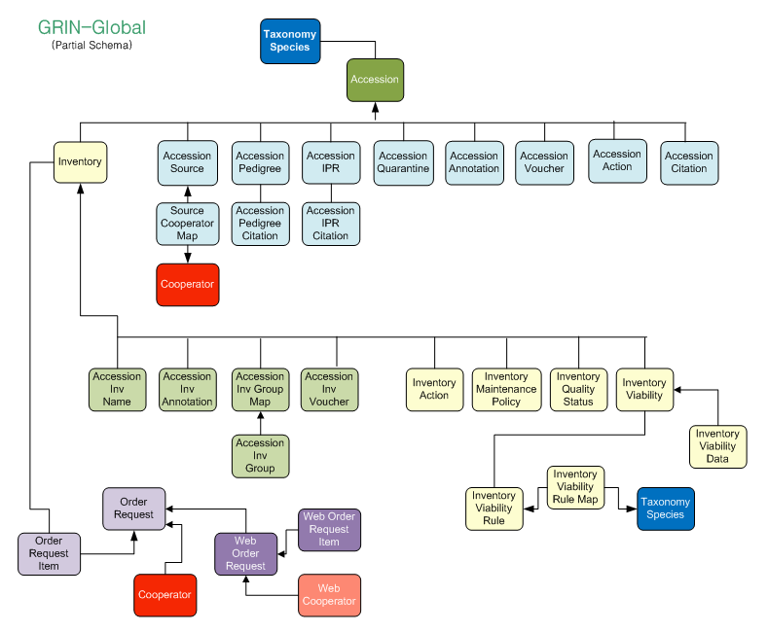

#### Online Resources

|  |  |
| --- | --- |
| **Resource** | **Link** |
| **GG Documentation Website** | [**https://www.grin-global.org/**](https://www.grin-global.org/) |
| **Tables spreadsheet (w/ fieldnames)** | [**https://goo.gl/GJX35W**](https://goo.gl/GJX35W) |
| **Online Dictionary of Dataviews** | [**https://goo.gl/2PynPg**](https://goo.gl/2PynPg) |

##### Abbreviations Used in this Document

|  |  |
| --- | --- |
| **Abbreviation** | **Meaning** |
| CT | Curator Tool |
| DB | database |
| DBA | Database Administrator (usually the GG administrator) |
| GG | GRIN-Global |
| PW | Public Website |
| SQL | Structured Query Language |

### Curator Tool (CT) & Dataview Introduction

##### Starting Up the CT

To access the CT, you need a **Username** and **Password**. The username is generally your email address; the password is assigned by a GG Administrator.

1. Select **GRIN-Global Curator Tool** program icon  
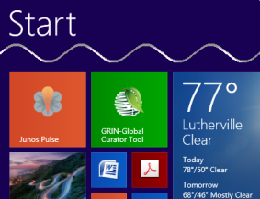

2. In the **Login** window, input **Username** and **Password**.  
In the **Connect To:** box, select the database.  
Click the **OK** button**.** 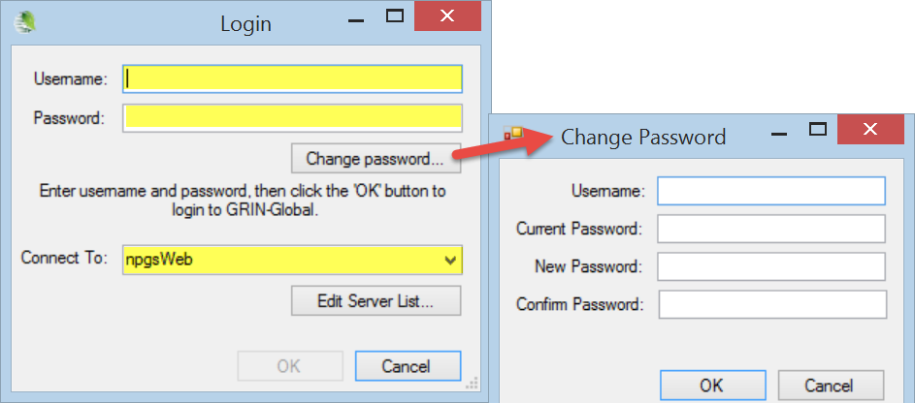

**(**To change the password,click the **Change Password** button.)

In a networked environment¸the server name will be a DNS Server Name or an IP address of the GRIN-Global database. Directions are described below for selecting our workshop server.

##### Selecting a Server

In most organizations, a GRIN-Global administrator typically installs the GG database on a remote server. In small genebanks, the entire GG suite could be installed on a single PC. (On a single PC, the server name is always “**localhost**.”)

|  |  |  |  |
| --- | --- | --- | --- |
|  | |  |  | | --- | --- | |  | Login, using the server, username, and password that are provided to you. |   Username:  Password:  Server (Connect To:) |

#### Keyboard Shortcuts

The GRIN-Global Curator Tool adheres to many of the standard Windows conventions. For instance, you can highlight data being copied and then use the keyboard shortcut **Ctrl-C**.

| **Keyboard Combinations** | **Effect\*** |
| --- | --- |
| CTRL + A | Select all (highlight everything in the current “group”) |
| CTRL + C | Copy |
| CTRL + D | The top cell in a selected group is duplicated *down* from the top cell to the bottom cell. (Edit mode) |
| CTRL + E | Displays text fields in an “expanded” window; in Edit mode you can change the text. |
| CTRL + N | Create a *new* record. (Edit mode) Select a record to be duplicated; press CTRL-N (the duplicate record is created below the selected record). |
| CTRL + V | Paste |
| CTRL + X | Cut |
| CTRL + ‘ | Duplicates the cell contents from above into the cell you are editing |
| ALT | Puts the CT into “block select” mode. In this mode, you can select cells (one cell or a block) to copy and paste into another program, such as Excel. To exit “block select” mode, complete the copy /paste operation or press ESC. (Note: the CTRL or ALT keys will not exit the “block select” mode.) |
| F2 | (Edit mode) You can double-click on a cell to edit it or press the **F2** key. If the cell uses a Lookup Picker, F2 will open the Lookup Picker window. |
| Delete | When in Edit mode, press the **Del** key to clear the cell. Also use the Delete key to delete multiple rows in the datagrid |

* On non-English keyboards the Windows keyboard shortcuts may be different.

#### Dragging Data

[This is for reference here. During the workshop, you will have many opportunities to “drag and drop.”]

To “drag” the mouse involves clicking on some object on the screen, either text or a graphic, and then *while holding the mouse button*, you drag the mouse

##### Drag and Drop

In the following example, *existing* database records highlighted in the Search Tool window on the right, are being dragged to the List “June01” in the left Curator Tool window.  
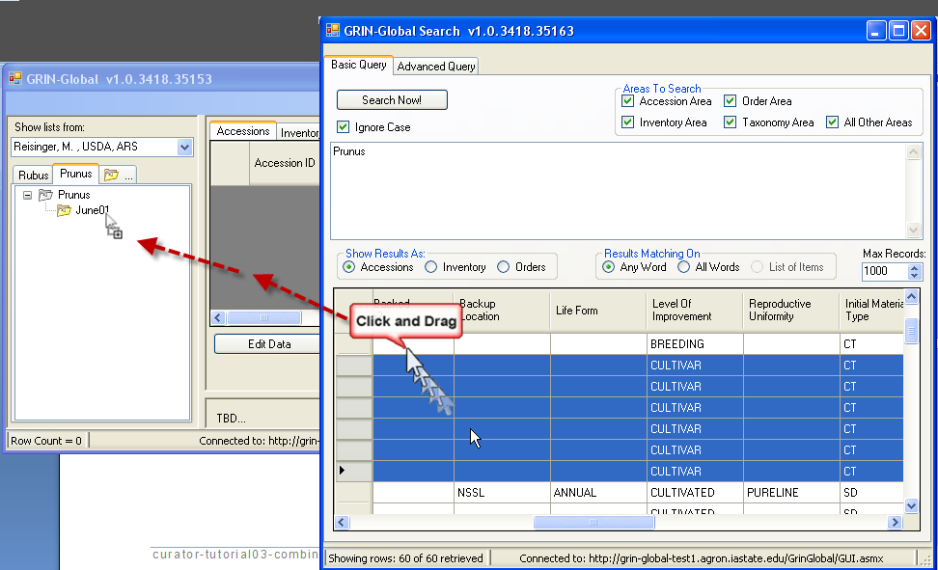

When using the drag & drop to create *new* records from a spreadsheet, the CT must be in edit mode (click the Edit button first before starting the drag & drop). In that case, the highlighted rows from the spreadsheet are dragged into the Curator Tool’s gray datagrid.

##### Selecting Cells

In the CT, in Display Mode, you can select a single cell or a block of cells and then copy and paste the cells’ contents into a spreadsheet. Click **ALT** *once*, then copy and paste.   
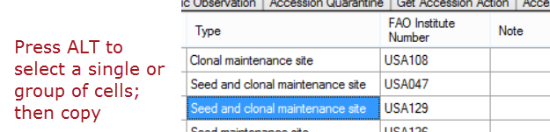

#### Curator Tool (Overview)

The following illustrates a Curator Tool which has been used for some time; a new user would not see many of the objects shown here.   
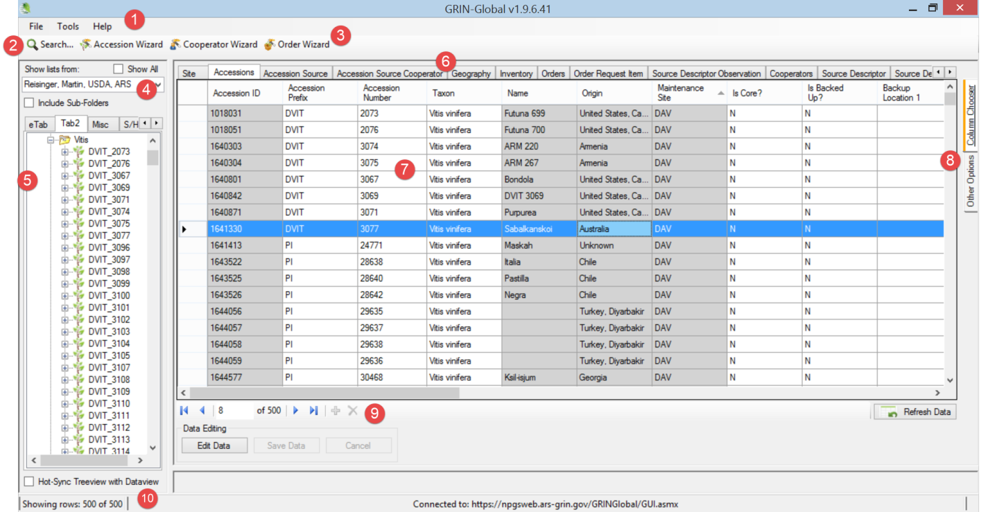

(The table below relates to the preceding illustration.)

| **Num.** | **Screen Component** | **Feature** |
| --- | --- | --- |
| 1 | **Menu** | Includes features such as changing the interface language or password, resetting lists and the user defaults. |
| 2 | **Search Button** | Opens the Search Tool window |
| 3 | **Wizard Buttons** | Start wizards which assist you in specific tasks |
| 4 | **Show lists…** | Use the dropdown to view other users’ lists. |
| 5 | **List Panel** | Use to organize data into lists – for reasons meaningful to you. |
| 6 | **Dataviews** | Initially four tabs display. A dataview is used to display the actual database records |
| 7 | **Data Grid** | Data is displayed in this area, similar to a spreadsheet. |
| 8 | **Column Chooser…** | Used for selecting which columns to display |
| 9 | **Navigation Bar** | Used for moving to different records. When in Edit mode, (after pressing the **Edit Data** button), the “+”key initiates the adding of a new blank record; the red “x” key deletes a record. |
| 10 | **Status Bar** | Displays information about the records in the data grid (such as count) as well as the name of the current server. |

#### Dataview Introduction

Dataviews serve as “camera’s lens” to the GRIN-Global data. With different dataviews, you focus on different parts of the database. A dataview is a SQL query which displays data matching certain criteria.

##### To Display a Dataview Whose Tab is Visible

To use a dataview, click on the dataview’s tab.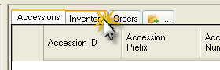

|  |  |
| --- | --- |
| image2449.png | *You must be in* ***Read-Only*** *mode to switch dataviews.* When the **Edit Data** button is grayed out, you are in **Edit** mode. To switch dataviews, you will need to either click **Save Data** or **Cancel**). |

##### To Display a Dataview Whose Tab *isn’t* Visible

1. Click the **New Tab** icon. (When many tabs are displayed, scroll to the right to display the **New Tab** icon). Alternatively, right-click on any visible tab; select **New Tab** from the menu.  
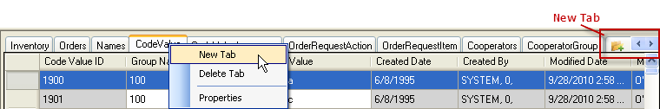

2. To choose a dataview: Select (1) Area* (2) a dataview from the list. (3) Name the dataview, such as **Cooperator** for the **get_cooperator** dataview.  
 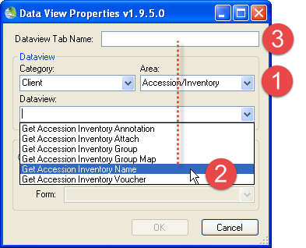  
* the online dictionary has a worksheet with the tab “Dataview List” which can be referenced to find the area of any dataview

Dataviews are programmed to display data primarily from one table. However, data from other tables may also be included.

##### Cell Colors in Edit Mode

When changes are being made to database records, the Curator Tool must be in “Edit Mode.”

| **Cell Color** | **Meaning** |
| --- | --- |
| gray | cell cannot be edited in the current dataview |
| violet | required field; a new record must have all required fields filled |
| yellow | indicates that the data in the field has changed |
| blue | current cell |

### Accessions – Creating / Editing Records

|  |  |
| --- | --- |
|  | Follow the instructor’s directions for creating a new accession record. For the taxon, select one that displays in the lookup. (When in Edit mode, click in the **Taxon** field to determine what valid taxonomy are in the database. At this point in the workshop we cannot add additional taxonomy.) |

There are several main ways to add and edit accessions:

* “manually” – one at a time, in the Accession dataview
* one at a time, via the Accession Wizard (the subordinate child records can also be added)
* many at a time – by dragging data from a spreadsheet into the Curator Tool

|  |  |
| --- | --- |
|  | Describe how to recognize a “system inventory record.” |

###### References

In GG, an accession’s passport is not stored in just one table. GG uses multiple tables to store the passport data. [ Read later: the reference document which explains passport data is stored in GRIN-Global: [Accessions and Passport Data](http://www.ars-grin.gov/npgs/gringlobal/docs/gg_accessions_and_passport_data.pdf)  
<https://www.grin-global.org/docs/gg_accessions_and_passport_data.docx> ]

#### Edit a Record

|  |  |
| --- | --- |
|  | Follow the instructor’s directions: Edit one or more of your records. Make some changes to the data. Practice getting into Edit mode / saving changes. Change column order, width, and sort order. For an Accession record, switch to the Grid Form (Right-click; Properties). |

#### Display Other Dataviews

|  |  |
| --- | --- |
|  | Display several dataviews, such as:   * Accession Inventory Name * Inventory Maintenance Policy * Crop |

#### Dictionary

|  |  |
| --- | --- |
|  | * Display the online dataview dictionary:  **Documentation Website:** [**https://www.grin-global.org/**](https://www.grin-global.org/) **Dictionary:**  [**https://goo.gl/2PynPg**](https://goo.gl/2PynPg)-- bookmark it |

### Search Tool Basics

Use the Search Tool to search for records from the main GRIN-Global database. Refer to the online Searching document at <https://www.grin-global.org/docs/gg_searches.docx>

##### Search Tool Window

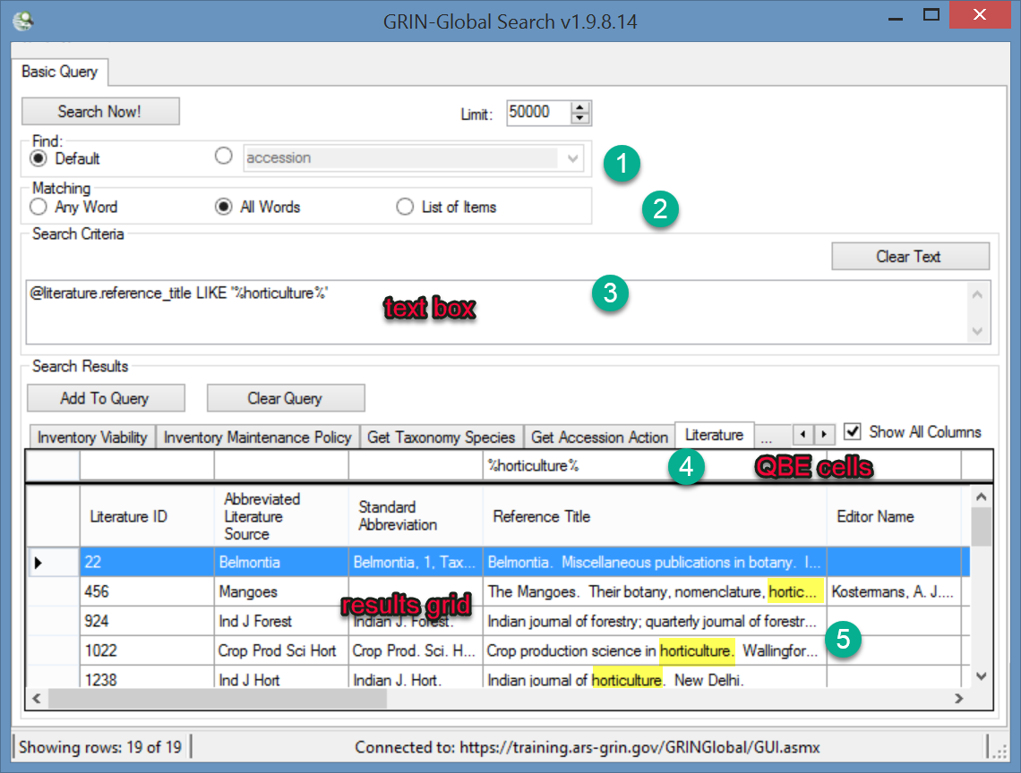

| Number | Note |
| --- | --- |
| 1 | Find Panel: for most searches, the default radio button will be selected. In some cases, you will need to select a dataview name from the dropdown button to resolve to the dataview QBE criterion. |
| 2 | Matching: Options for indicating the general type of search. |
| 3 | The text box: the criteria for the search are ultimately placed here for review before the search is invoked |
| 4 | QBE (“Query By Example”) Cells: Enter sample search criteria in these cells. |
| 5 | Results grid: After you click the **Search Now!** button, matching records are displayed here. |

##### The Search Tool uses two distinct methods:

* Freeform text (not recommended) (Also, a freeform text search is not a true “Google” search; also only certain fields are searched)
* Query-by-Example (“QBE”) (preferred method)

##### Displaying Additional Query-By-Example (QBE) Tabs

To display additional dataview tabs from which to invoke QBE searches, click on the ellipsis tab and select the desired dataview.

#### Creating Lists & Tabs

##### Key Points - Lists:

* are used to display database records
* create them as needed -- assign names meaningful to you
* the words “lists” and “folders” are used interchangeably
* two kinds of lists: static & dynamic
  + static: display a consistent collection of records (Note: large static lists can impact performance)
  + dynamic: display more or fewer records at any point in time, depending on the criteria used for selecting the records

##### Overview of Lists

Using lists, the genebank staff can:

* manage their genebank’s accessions
* track inventory
* process germplasm orders
* record observations
* …

##### Tabs & Lists

Tabs are created and used as needed to organize your lists.

###### To Create a New Tab

1. In the List Panel, click on the **New Tab** icon with the ellipsis (”…”).   
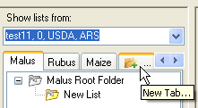

2. In the pop-up window, input a **Tab Name**; click **OK**.  
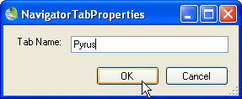

|  |  |
| --- | --- |
| To Hide and Display Tabs Tabs in the List Panel can be hidden or displayed as desired. This is particularly helpful when you have created many tabs. Right-click on a tab; select **Hide Tab** /**Show Tab** from the menu as desired: | To Create a New List Right-click on a list and select **New List.** A new, empty list with the name “New List” will be created below the original list. |

##### List Items

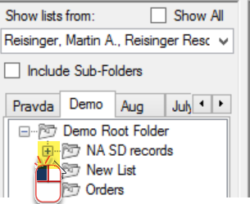 Click the + to expand the list: 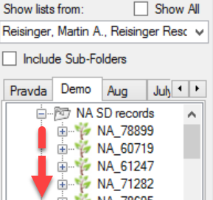

##### Accession Items

When accessions are displayed in the grid, they will have corresponding items in the list in the left panel, *unless the folder is a dynamic folder*.  
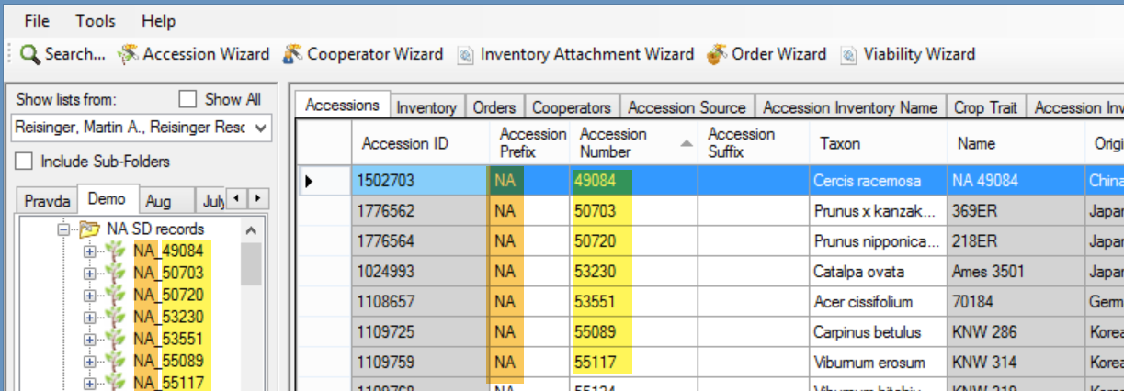

###### System-Generated Inventory Items

For *every* Accession record, GG automatically creates a “system” Inventory record. System inventory items are marked with a double asterisk (**) next to their name.   
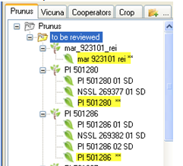

In the **Inventory** dataview, the **Inventory Type** for virtual inventory records is also indicated with a ** Since these ** inventory records do not represent physical inventory, the quantity fields should be empty.  
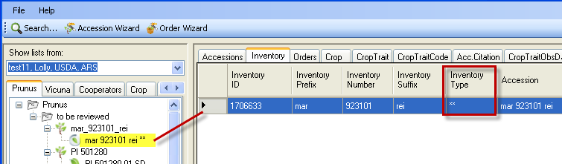

|  |  |
| --- | --- |
|  | Create at least one more tab. Create several lists on your tabs. The following example shows three tabs: “Prunus Reviewed 2011,” “Prunus 2012,” and “Rubus.” |

### “*Drag & Drop*” Records to and from Excel

##### Key Points:

When copying data from a spreadsheet into the CT, remember:

* the *spelling* of the *column headings* in the Excel sheet and in the CT dataview *must match*
* the column order does not matter
* you do not need to include all columns, but always include the left _ID column

|  |  |  |
| --- | --- | --- |
| To ensure you have correctly spelled column headings in Excel, drag an empty record from the CT. To do so, with the Accession dataview active, click the **Edit Data** button; click the **Add New** button; | | … then select the row SNAGHTML1644eb9b and drag to Excel: |
|  | Create five new accession records. Use *your initials for the prefix or suffix*, so that as the workshop evolves, the records will be unique and identifiable. The **Accession Number** field must be numeric – assign numbers sequentially. Save your spreadsheet workbook before dragging the data into the CT. SNAGHTML16523cd9 | | |

##### Copy the Data *from* a Spreadsheet *to* the Curator Tool

Open *both* the GRIN-Global Curator Tool and Excel.

1. In the Curator Tool, click on the folder that will be updated; click the **Edit Data** button (if you are not already in Edit mode).

2. In the spreadsheet, highlight the data that will be copied; *include the column header row and the data.* Using the cursor, grab the selected cells outline box, drag the box, and drop it anywhere in the CT’s datagrid (in the right panel).

3. In the CT: If satisfied, click **Save Data**. (If not, edit the data, or Cancel)

|  |  |
| --- | --- |
| image2449.png | Each table has a primary key field – in the Accession table, it is the **Accession ID** field. When dragging spreadsheet records, you *always include the ID column* --   * *empty* _ID fields will *add new* records * *matching* _ID fields will *update* *existing* records |

#### 

##### Copying, Block-Style

Blocks of data can be copied to and from a spreadsheet and the Curator Tool.

When copying *from* the CT, you do not need to be in Edit mode. Press the keyboard’s **ALT** key (once!) Using the mouse, highlight a cell range; copy (Ctrl-C); and paste (Ctrl-V) in Excel, email, etc.

When copying *to* the CT, click the **Edit Data** button to ensure the CT is in Edit mode. In the spreadsheet, copy a cell range and paste into the CT. For example, if you were replacing data in the **Note** column of accessions, you would only drag note data into the appropriate accession **Note** cells.

|  |  |
| --- | --- |
| image2449.png | When using this method, since you will not be including the column names, so *it is critical where you line up the cells* when you copy and paste. |

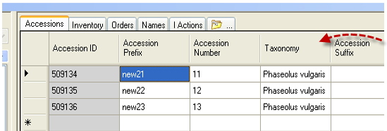

|  |  |
| --- | --- |
|  | Practice using the **ALT** key technique. |

### Static and Dynamic Folders

A static folder contains a list of items. A dynamic folder contains search criteria. Think of the dynamic folder as a stored query.

|  |  |
| --- | --- |
| A dynamic folder is recognized by a magnifying glass superimposed on the folder icon. Here three are shown; the red one is currently being used. | To review the dynamic folder’s criteria, right-click on a dynamic folder icon to display the **Properties** window. SNAGHTML16c37028 |

###### Records Listed by Dynamic Folder

So why use a static folder? First, they are simpler in some respect. Secondly, many times you will want to review specific records, and *only those* records. Listed below are a few examples of when each folder type is preferable:

|  |  |
| --- | --- |
| **Situation** | **Folder Type** |
| Keep track of what you are working on from one day to the next | Static |
| List of orders processed on a specific day | Static |
| Maintain a list of all accessions for a specific Taxon | Dynamic |
| Review a site’s inventory | Dynamic |

A detailed description of Dynamic Folders is online at  
<https://www.grin-global.org/docs/gg_dynamic_folders.docx>

##### Steps in Creating Dynamic Folders

Two methods for creating a dynamic folder are explained here. Each method starts the same way -- in the CT, first create an empty folder.

###### Method 1 (Recommended method)

Switch to the Search Tool; create a query. Drag the *code* in the large text box (generated by the QBE) onto the empty folder in the Curator Tool. 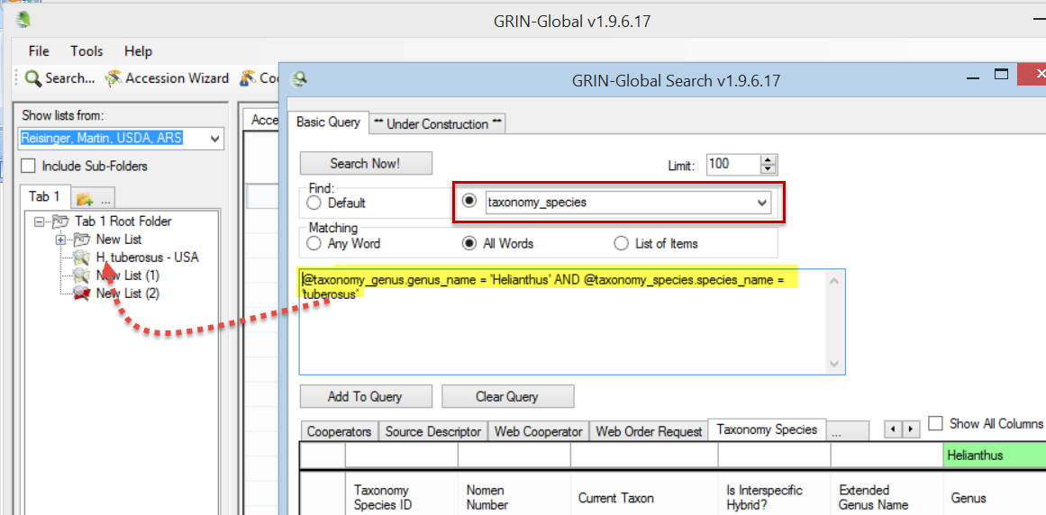

###### Method 2

While still in the Curator Tool, right-click on the empty folder. Select **Properties** from the menu. Switch to the Search Tool; create a query. *Copy* *the code* in the large text box (generated by the QBE) into the **Dynamic Folder Search Criteria** box in the Curator Tool.  
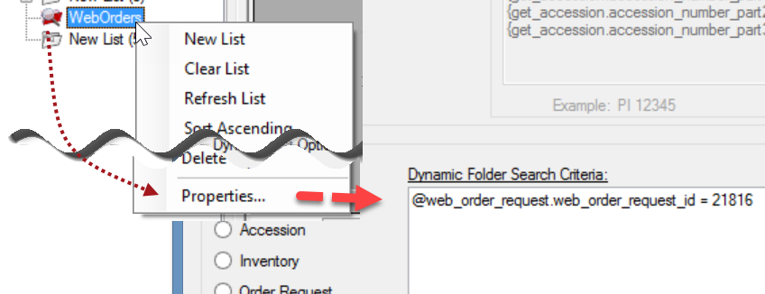

##### Refreshing a Dynamic Folder

If any new records are added to the GRIN-Global database that meet the folder’s criteria, the records will be displayed when the dynamic folder is the active folder and has been refreshed. You can refresh a dynamic folder by invoking any of the following methods:

* right-click on the folder and select the **Refresh List** command
* switch to another tab and then back to the tab with the dynamic folder
* click the **Refresh Data** button in the right panel
* press F5
* start the CT

|  |  |
| --- | --- |
|  | Practice by creating several dynamic folders. Example:  Find a range of accessions. ( **@accession.accession_number_part2 > 500000 AND @accession.accession_number_part2 < 500100** ) |

### Accession & Related Tables / Accession Wizard

#### General Notes about the Accession Wizard

When working with one accession at a time, use the Accession wizard since it contains 9 accession-related dataview tabs. Move from tab to tab to review an accession’s associated data.

Some guidelines:

* as you work in the wizard’s forms, save your work often (click on the **Save** icon)
* use the window’s close button to cancel when necessary. *However, any data not yet saved will be dropped, not just for the current tab screen, but for any of the tabs*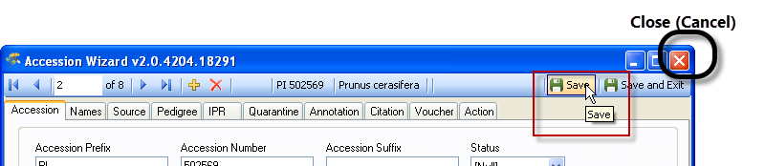
* the screen’s header displays certain fields that indicate what record you are working with   
  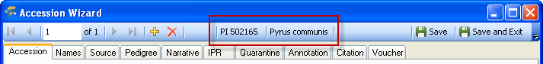

##### Passport Data

GG is segmented into many tables. Also, the passport data is saved among different tables. There is an online <https://www.grin-global.org/docs/gg_multi_crop_passport_descriptors_MCPD.docx> [Multi-Crop Passport Data](http://www.ars-grin.gov/npgs/gringlobal/docs/gg_multi_crop_passport_descriptors_MCPD.pdf) document that provides details on each passport field. Many of these passport data fields can be seen in the various children records.

###### Example: Names

The **accession_inv_names** dataview makes it possible to have multiple names for an accession – they can be cultivar names, institute identifiers, collector numbers, breeder lines, etc.

When an accession has more than one Name record associated with it, the name whose **Name Rank** field has the lowest value will be displayed as the top name. As shown below, in the case of a tie, the name that is alphabetically first is displayed as the top name.  
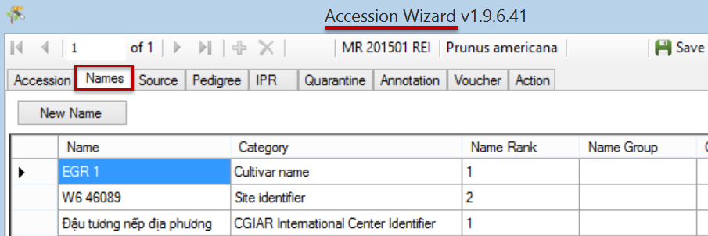

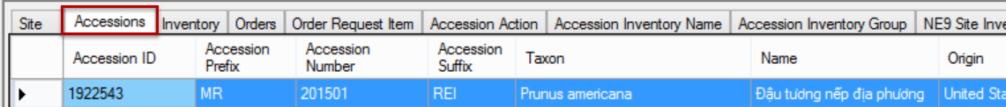

### Drag & Drop: Bulk Updating Accession Records

You may need to change *many* database records at one time. Records can be edited directly in the CT or copied to a spreadsheet and then copied back again after being edited in the spreadsheet.

Remember:

– when *adding* *new* records, leave the ID field empty for the new records

– when *updating* *existing* records, include the ID field data when dragging & dropping from the spreadsheet

|  |  |
| --- | --- |
|  | Practice this “dragging and dropping” several times throughout the workshop. The exercise here will involve bulk adding new accession records, and then bulk updating the records. |

### Cooperators - Management of Cooperator Records

For complete details, review the Curator Tool User Guide’s *Cooperator Wizard* section.

##### Key Points:

Two distinct cooperator records (and tables) in GG:  
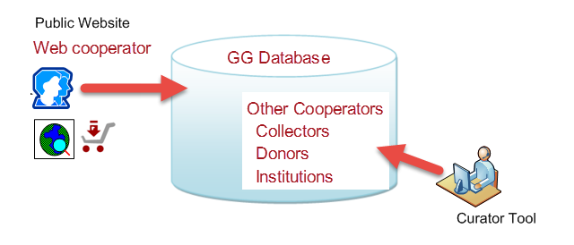

#### Background Information

Two kinds of cooperator records:

* *web* cooperators – users who self-enroll on the Public Website
* GRIN-Global (GG) cooperators

A cooperator can be an *individual* or an *organization*. Typically, when creating an institutional cooperator record, the last name and first name fields are left empty. Internal genebank staff input and own these cooperator records.

Use the Curator Tool’s Cooperator Wizard whenever you wish to add a new cooperator to the GRIN-Global database or edit an existing cooperator record. One advantage of using the wizard, rather than using the cooperator dataview, is that you can search the database before inputting a new cooperator.

###### GRIN-Global Cooperator Records

In addition to web cooperator data, the GG database maintains records containing data on individuals and organizations involved with germplasm activities (donors, collectors, breeders, requestors, etc.) Besides active data, cooperator records can store historic data containing the person’s or institution’s previous addresses.

###### Cooperator Wizard

Use the Cooperator Wizard to add new cooperators or edit existing ones. In the following example, while the user had the **Accessions** dataview as the active dataview, he clicked on the **Cooperator Wizard** button and began searching for cooperators with a last name beginning with “n”:  
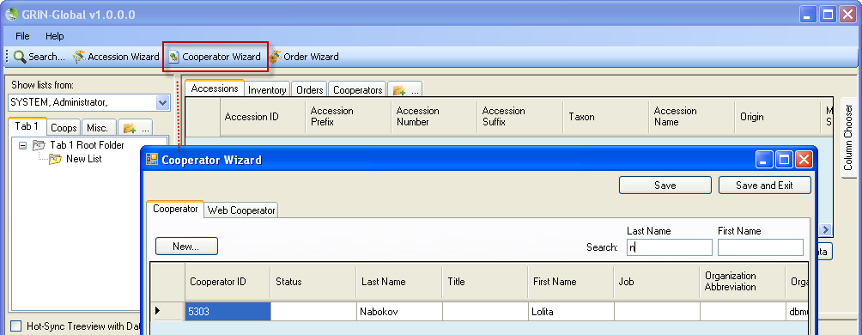

Use the “_” (single character) and the % (multiple characters) wildcards to broaden the search.

|  |  |
| --- | --- |
| **image2449.png** | The current wizard only searches by last name and first name fields, so use the Search Tool when looking for institutes. |

### Lookup Tables

Any time you see a pointer similar to the one below, recognize this field as one that is using a lookup table. You never type something in this cell, but rather you must use the Lookup Table window   
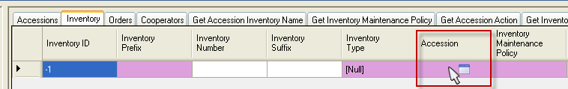

#### Lookup Table Warnings

|  |  |
| --- | --- |
| **image2449.png** | The first time you open the Curator Tool you will be prompted to update your lookup tables. After all lookup tables are updated, the lookups will maintain themselves fairly automatically. |

#### Indicators When a Lookup Table Isn’t Updated

As an example, when the Taxonomy Lookup table needs updating, you may notice numbers displaying in a dataview’s **Taxonomy** field or a search window’s **Taxon** field instead of the actual taxonomic name.   
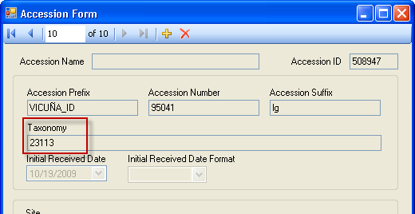

##### Updating the Lookup Tables

The Curator Tool automatically updates the lookup tables every time it is started. When the CT is running, you can manually update the lookups at any time.

Method 1: Click the **Refresh Data** button under the datagrid.  
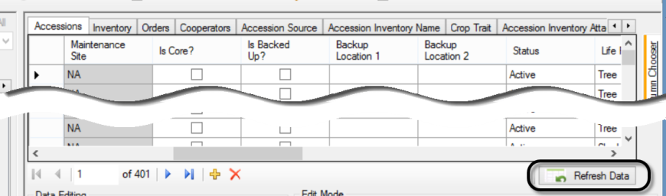

Method 2: Click the **Other Options** tab; then click the **Lookup Table Maintenance** button:  
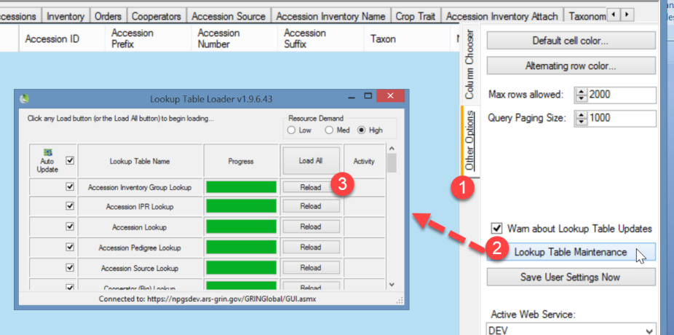

|  |  |
| --- | --- |
| image2449.png | In the **LookupTable Loader** window, any lookup tables needing to be updated are highlighted in orange. Click on all of the **Update** buttons: SNAGHTML1370db3 |

##### Load All and Load Buttons

|  |  |
| --- | --- |
| image2449.png | Only click the **Load All** button when you have a new copy of the Curator Tool or when the database has been replaced by the GG administrator with a new database. **Load All** causes all lookup tables to re-load – this may require one hour or so, depending on the size of your data.   To ensure that the Lookups are fully updated, ­use the **Load All** button *twice*. (Wait until the progress activity is visibly complete before clicking the second time.) |

### More on Searches

The complete GRIN-Global Search Guide is online at <https://www.grin-global.org/docs/gg_searches.docx> In some organizations, the GG administrator will set up specific fields using Microsoft’s Full Text Indexing feature. Also, he or she can indicate specific fields in the GRIN-Global **autofields** table.

#### Query-by-example (QBE) Searches

Recommended over text box searches. QBE can search fields throughout the GG database.

The QBE cells accept wild card characters. (See wildcard table.) For example, **Prunus\*** is appropriate when searching by **Prunus** in the QBE Taxon cell since the Taxon includes more than genus. 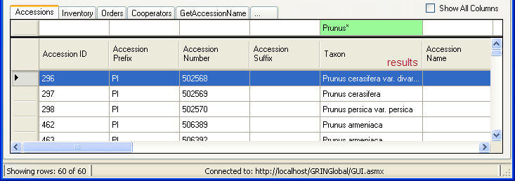

##### Every word matters

Case sensitivity of searches depend on how the GRIN-Global database is set up:

* If the database is installed as case-sensitive (this is the default for the Oracle and PostgreSQL database engines), the queries will be case-sensitive.
* If the database is installed with settings to make the database case-***in***sensitive (this is the default for Microsoft SQL Server and MySQL database engines), then the queries will be case-insensitive too.

##### Case Sensitivity

Case sensitivity depends on how the GRIN-Global database is set up:

* If the database is installed as ***case-sensitive*** (this is the default for the Oracle and PostgreSQL database engines), the queries will be case-sensitive.
* If the database is installed with settings to make the database *case-insensitive* (this is the default for SQL Server and MySQL database engines), then the queries will be case-insensitive too.

##### Text Boxes and Special Characters

**Special characters** and letters with diacritical marks and accents (such as á) can be entered in the Search text box.

|  |  |
| --- | --- |
| **image2449.png** | You can copy special characters from the Windows clipboard. Another method is to enter the character using the Windows “**ALT** key – numeric codes” method. Refer to websites which explain special characters. |

#### QBE Searches

The following table is a subset of a table in the online guide, illustrating some types of QBE searches:

| **Wildcard / Operator** | **Examples /  Notes** |
| --- | --- |
| %  (percent symbol)  *  (asterisk) | Broaden searches, especially when the exact spelling is unknown. The field must be a text field. Both wildcards allow a match of any string of any length (including zero length)  Example: **Prunus%var** will locate any Prunus with “var” included;  **%var%** will locate any accessions with the text “var” as part of its taxon |
| IS NULL /  IS NOT NULL | NULL values represent missing unknown data. By default, a table column can hold NULL values. NULL and 0 are not equivalent. |
| LIKE | The LIKE operator is used to search for a specified pattern.  Example: **LIKE ‘CAPSICUM%’** In this case the QBE is saying find any text that begins with “Capsicum.” |
| “BETWEEN”  (implemented server version 1.9.9.2) | BETWEEN is now a valid operator. When a range of values is needed, construct your criteria using a range.  Example:  @order_request.ordered_date BETWEEN  '2015-01-31' AND '2015-03-01' (finds the orders for February, 2015) |
| Date Fields Microsoft SQL Server Internally a date is stored in the **yyyy-mm-dd *time*...** format | Searching for dates can be tricky because the date field includes the time of day as well.*    The following are valid searches:  @accession.created_date like '2015%' @accession.created_date like '2015-09-%'  @accession.created_date like '2015-09-05%'  @accession.created_date like '2015-%-05%' |

*Date Fields

When searching, your search string in the QBE box needs to mimic the internally-stored version. For example, when searching for February records from 2014, enter the search string ‘**2010-02%’**

@accession.created_date LIKE '2014-02%'

End the search string with a wildcard (%), because the date fields also store time in the field. Most other useful formats:  **MM/DD/YYYY** or **MM/DD/YY** or **DD-Mon-YYYY** or **DD-Mon-YY** are supported, but *do not accept* wildcards.

##### Any Word, All Word, and List of Items

Use the Matching radio buttons to specify how the text in the search criteria text box should be treated:   
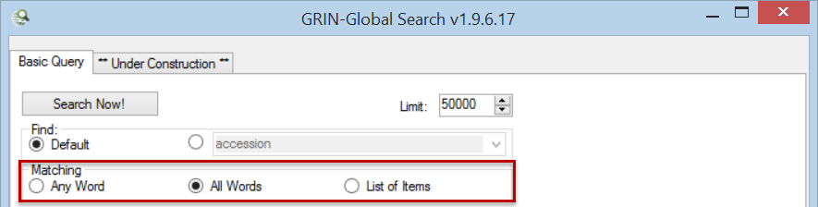

* ***Any* *Word*** – less restrictive, records are returned whenever any word in the search box is matched; the “OR” operator will be used
* ***All Words*** *–* more restrictive,  *all* of the words used in the search text must match; this creates an “AND” condition

###### Example:

In a test database, the search string **Rubus glaucus*,** with “*All Words*” finds four records, but with “*Any Word*,” selected, 48 records are found.

* ***List of Items*** *–* used when a list, such as a list of accessions, is copied into the search text box.

When using this “List of Items” search, the Search Engine is restricted to finding matches in these columns:

accession_number… _part1 _part2 _part3

inventory_number…_part1 _part2 _part3, and form_type_code

plant_name

order_request_id

###### List of Items Example:

PI 500501  
PI 612346  
PI 612347

#### Criteria Code Explained

In creating QBE searches, you will notice code being generated in the text box. Let’s look at two QBE examples that on the surface seem to be similar searches.

**@ taxonomy_genus.genus_name LIKE ‘CAPSICUM%’**   
Let’s break out this code into three components:

|  |  |
| --- | --- |
| **Code** | **Indicates...** |
| @taxonomy_genus | the table; the taxonomy_genus in the database will be searched |
| genus.name | the field name in the table |
| LIKE ‘CAPSICUM%’ | The LIKE operator is used to search for a specified pattern; in this case the QBE is finding any text beginning with “capsicum.” |

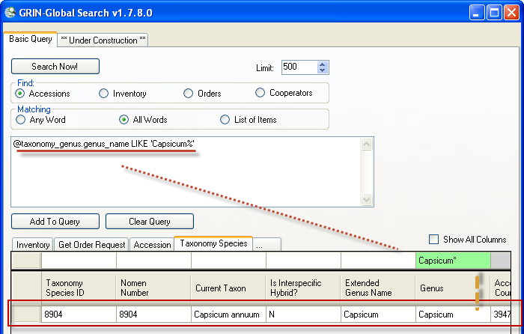

However, when in the Accession dataview, looking for Capsicum, the ST generates code that uses the lookup table ID numbers:  
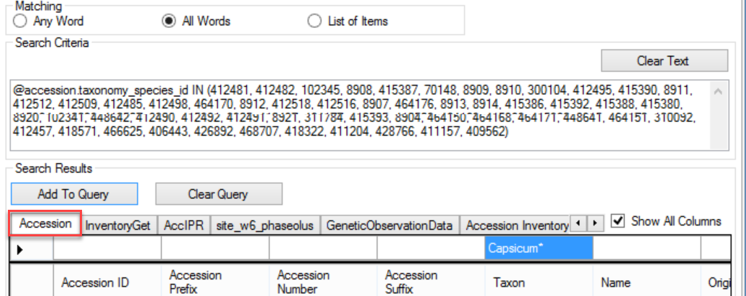

### Inventory

A complete guide to GG Inventory is online. <https://www.grin-global.org/docs/gg_inventory.docx>

The Public Website lists accessions, but it also indicates inventory types recorded in the database:  
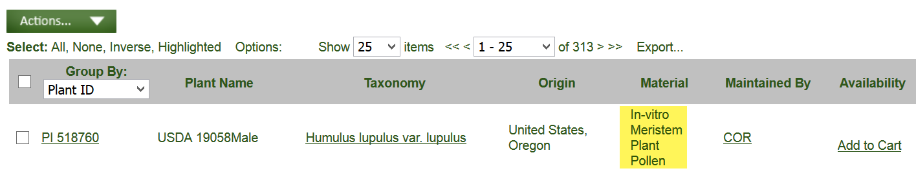

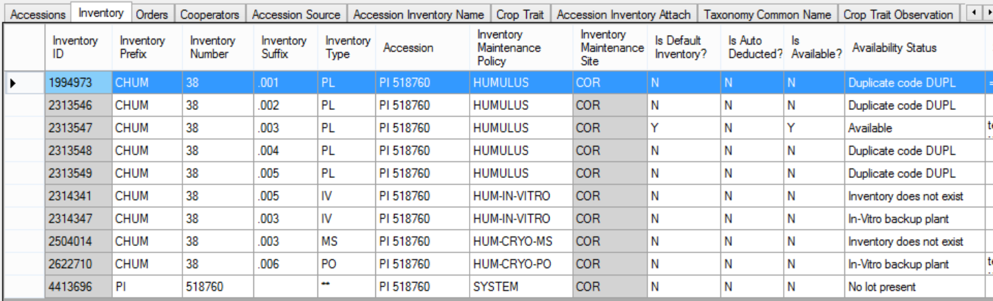

#### System Inventory Items

Every Accession record in the database automatically has an associated system inventory record; system inventory records always are indicated with ** for the type.   
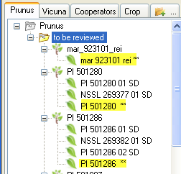

###### Zea Maize Inventory Example: Inventory records for one sample accession

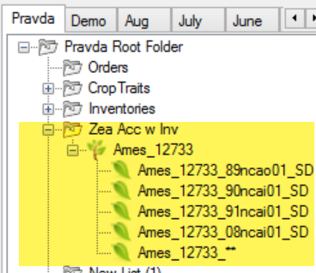

#### Prerequisite Data

In order to input inventory, you must first have an accession to which the inventory relates. When inputting a new inventory record, there are five required fields:

* **accession**
* **inventory prefix** (in some organizations, because of organizational requirements, you typically are required to input a number and/or a suffix)
* **inventory type** – Example: BD (Budwood), CT (Cutting), and SD Seed. (Each organization’s DBA can edit the GERMPLASM_FORM code group to meet the organizational needs.)
* **inventory maintenance policy** (the policies indicate how many units (propagules) the genebank site will distribute for an order of a given taxon and germplasm form.)
* **availability status** – must be one of the codes in the INVENTORY_AVAILABILITY_STATUS Code Group.

#### Purpose of the Inventory Maintenance Policies

Basically, an inventory maintenance policy determines how inventory will be processed for incoming germplasm orders that will use that inventory. **Inventory Maintenance Policy** records are added in the Curator Tool via the **Inventory Maintenance Policy** dataview.   


|  |  |
| --- | --- |
| **image2449.png** | The **Inventory Maintenance Policy** determines the owner of the Inventory record. (The cooperator in the **inventory_maint_policy.owned_by** field becomes the owner of any **Inventory** records that are created when using that policy**.)** |
| **image2449.png** | Use a consistent naming convention when naming policies. For example, begin with a prefix, such as your site’s code (examples: NC7-daucus, NC7-portulaca, NC7-quinoa...) Consistent naming conventions are easier to search for, etc. |

#### What Determines Accession Availability or Visibility?

| Condition | Dataview **/ Field** | Value | Result |
| --- | --- | --- | --- |
| Accession is displayed on the PW | Accession  / **Is Web Visible?** | **Y**  **N** | Accessionwill be displayed  Accessionwill not be displayed |
| Historic accessions, never available | Accession  / **Status** | **INACTIVE** | Accession listed as **Not Available** |
| Accession is an active accession in the genebank's collection | Accession  / **Status** | **ACTIVE** | Can be listed as **Available,** or **Not Available** depending on other conditions (below) |
| Inventory is Available | Inventory /  **Is Available?** | **Y N** | Listed as **Available** Listed as **Not Available** |
| Preferred inventory lot for distribution (since this is the "preferred lot," only one inventory lot should be marked with a "Y.") | Inventory / **Is Default  Inventory?** | **Y** | preferred lot (automatically selected by the Order Wizard by default) |
| When the value in the **Distribution** **Critical Amount** field is less than the value in the **Quantity On Hand** field, a trigger will force the **Is Available?** field to "N." When the critical amount is greater than the quantity on hand, the trigger forces the **Is Available?** field to "Y."  (This trigger may be enabled or disabled by the GG Admin for the organization.* | Accession /   **Quantity On Hand < Distribution** **Critical Amount** |  | **Not Available** |
| The Taxonomic Species record for the Accession has one of the following values in the species’ **Restriction** field: | Taxonomic Species /  **Restriction**  **NOXIOUS RARE WEED** |  | **Contact Site** |

* The trigger also works with **Is** **Auto Deducted?** (When is_autodeducted) is set to “Y” the **Availability Status** (availability_status_code) value is set to **LOW** when the qty on hand goes below the critical distribution qty. (The trigger ignores any other status codes -- the assumption is you are handling the availability manually.)

#### Availability Status

The **Availability Status** field obtains its values from the **INVENTORY_AVAILABILITY_STATUS** Code Group. By searching this field, you can look for specific inventory situations, such as low inventory, young plants not available, etc.

|  |  |  |  |  |
| --- | --- | --- | --- | --- |
| Fields | | Value Before | Action | Value After |
|  | |  | Order is Filled (standard quantity is shipped) |  |
| **Standard Distribution Quantity** | | 10 |  | 10 |
| **Quantity on Hand** | | 80 |  | --> 70 |
| **Distribution Critical Quantity** | | 75 |  | 75 |
| **Is Auto Deducted?** | | Y |  | Y |
| **Availability Status** | | Available |  | --> Low |
| **Is Available?** | | Y |  | --> N |
|  | Create an inventory maintenance policy. Create two inventory records, using that policy. | | | | |

##### Sample Inventory Records (Images are showing all of the fields in an Inventory Dataview)

keep scrolling to the right, to see more fields!

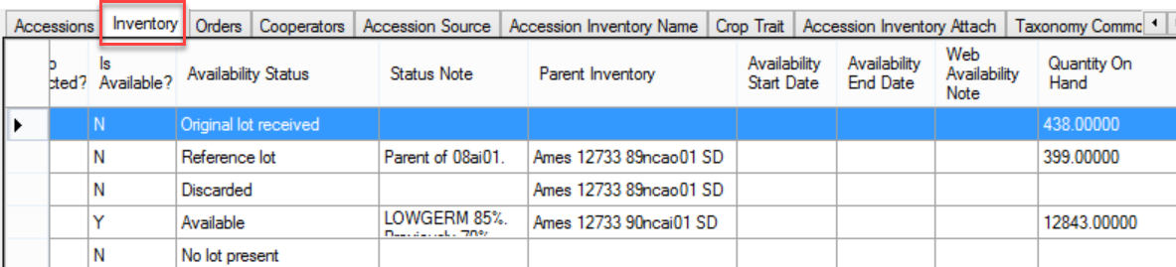

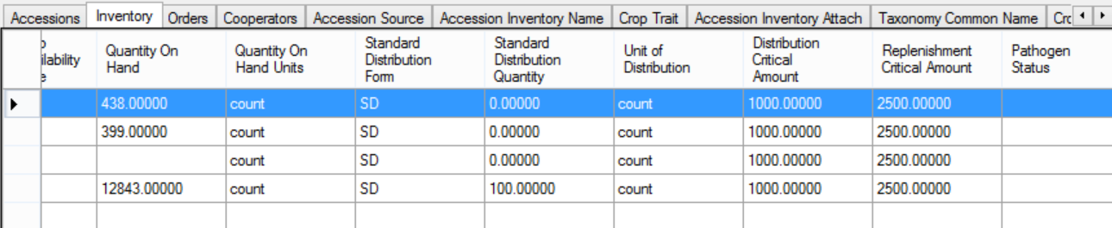

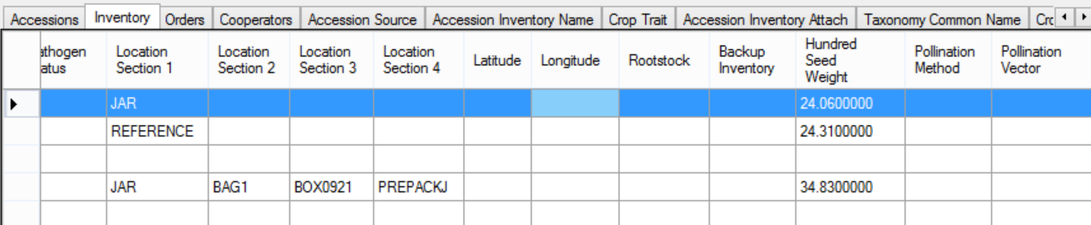

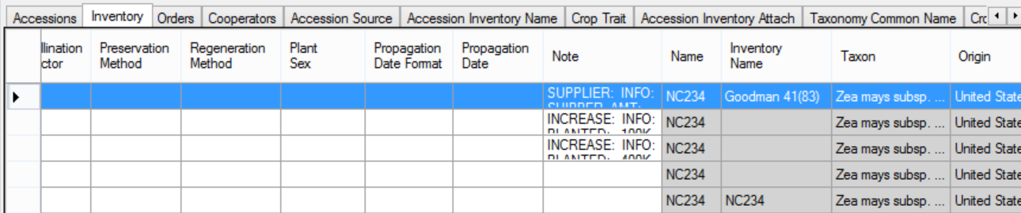

#### Miscellaneous Inventory Topics

(The online Inventory Guide (<https://www.grin-global.org/docs/gg_inventory.docx>) describes the inventory dataviews in detail.)

###### Parent Inventories

When regenerating, the new inventory lot has a parent. The parent inventory name is easily obtained from the **Inventory** field in the parent inventory record.

###### Naming Conventions

See the examples which some USDA sites use. They follow naming guidelines for the inventory suffixes in order to track the heritage of the Inventory. Refer to the online Inventory Guide ***Appendix***.

###### Inventory Triggers

Inventory triggers help with data integrity. For example, one trigger checks inventory quantity fields to ensure none are negative.

###### Other Inventory dataviews

* **Inventory Actions**
* **Annotations** | **Attachments** | **Groups** | **Vouchers**

(Attachments – images – will be discussed after we cover Orders. Save any discussion for attachments until then.)

* **Viability** dataviews (below)
* Creating lists of accessions for viability testing
* Updating viability data
* **Quality Status**

#### Viability Testing

Viability testing is typically done when:

* a new seed sample arrives at a genebank (and the sample has enough seed to be germinated)
* newly regenerated seed samples are being prepared for storage
* periodically to assure viability of seed lots (“maintenance testing”)

The **Inventory Viability** dataview uses the table of seed germination results and other viability tests. Actual test procedures are contained in the **Method** table. There are three viability dataviews in the Curator Tool: **Inventory Viability**, **Viability Rule**, and **Viability Data**.

|  |  |
| --- | --- |
| image2449.png | A Viability Wizard has been created at the USDA NPGS. Documentation is online at <https://www.grin-global.org/docs/gg_viability_wizard.docx> |

For the storage germination test, a germination order is prepared when all the lots in a particular crop are ready for storage. This is usually done once a year after the material has been cleaned and is ready for storage (i.e. all the cucumber that were grown in 2014 will be germinated all at the same time – after which they are ready for storage).

For the maintenance germination tests, a germination order is usually prepared after reviewing a particular collection (such as maize) and checking which lots need testing (in the case of maize, it’s every ten years).

##### Inventory Viability Rule

The **Inventory Viability Rule** describes the germination test conditions including the temperature range, the moisture, lighting, etc. (Note to GRIN users – in GRIN, this was the **Environment** name.)  
  
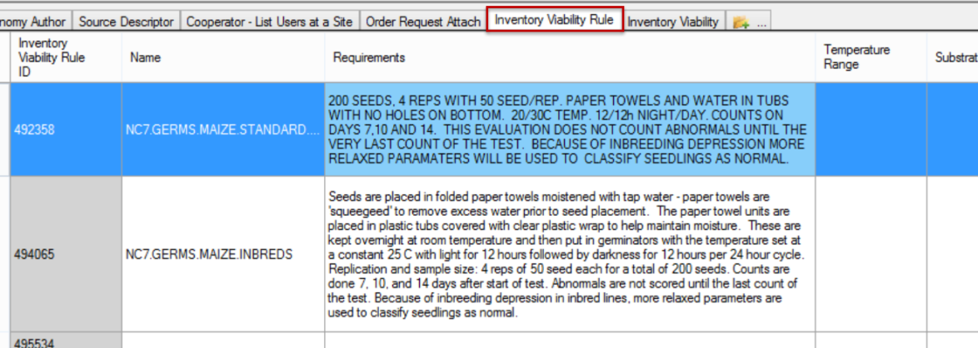

##### Inventory Viability

Refer to the GG online [dictionary](https://docs.google.com/spreadsheet/ccc?key=0AvdWZS-UqEE7dHFaRnRsR1RxOUx0em9KZmhNZTVlRnc&hl=en#gid=2) for descriptions of each field (or when viewing the dataview, roll the mouse over the heading to display the column description).  
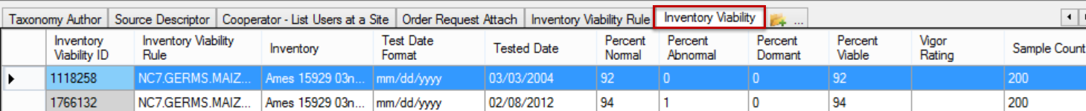

### Public Website (PW)

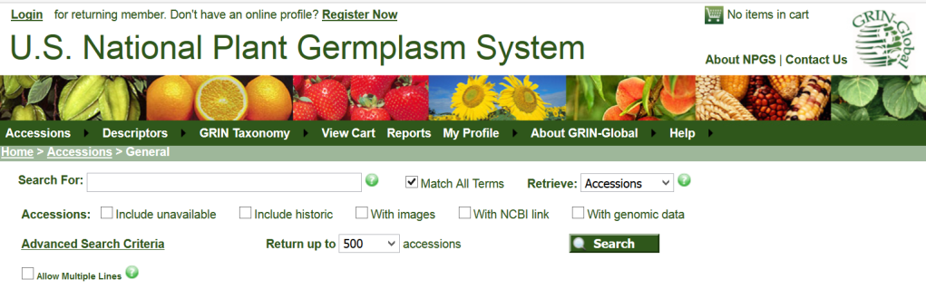

The Public Website (PW) is used by germplasm requestors to review and order germplasm. However, genebank workers will use it to search for accessions, observations, taxonomy, etc. Additionally, internal genebank workers can select reports not available to the public and use a query tool in which you can submit SQL commands.

The **Tools** option is available only when you are logged in and the GG administrator has linked your Curator Tool account with your Public Website account.   
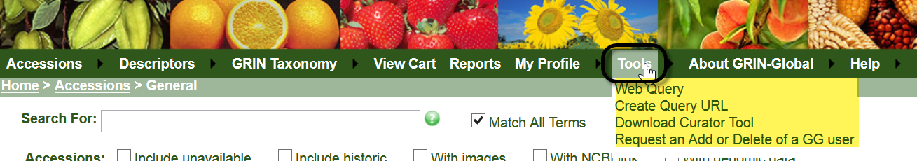

|  |  |
| --- | --- |
|  | Submit an order request for germplasm from the Public Website. You must be logged in. |

### Processing Germplasm Requests (Orders)

A complete guide to GG Order Process is online:  
<https://www.grin-global.org/docs/gg_order_processing.docx>

#### Overview

Germplasm requestors submit their *web* orders via the GG Public Website. Using the Curator Tool’s Order Wizard, genebank personnel review the incoming *web* orders and convert the *web* orders into *standard* orders.

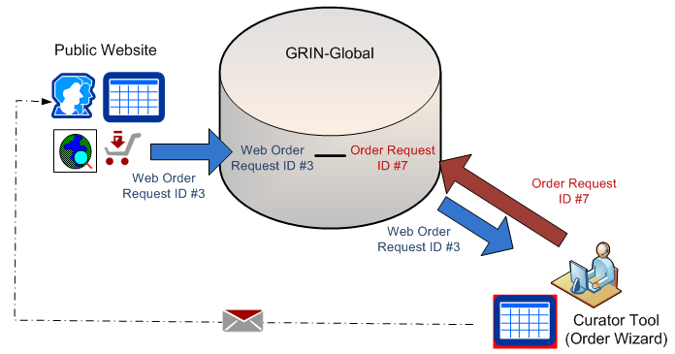

Although the records are inter-related, the two record IDs (and the records) are distinct.

#### Order Wizard

Recommended:

* decide on and select a list folder in the left panel to be your active list for orders
* before clicking the Order Wizard button, open the **Order Request** dataview as the active dataview.

In the following example, the user has a folder labeled “Friday’s Orders” ready:  
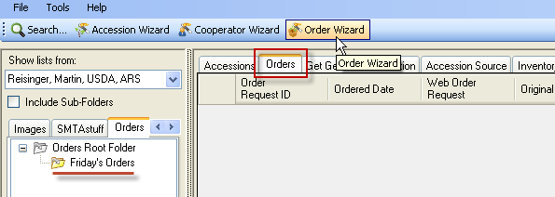

Below, there are 3 new web orders. (The Navigation Bar indicates “3 of 3.”) (The orders do not need to be processed in any specific sequence.)  
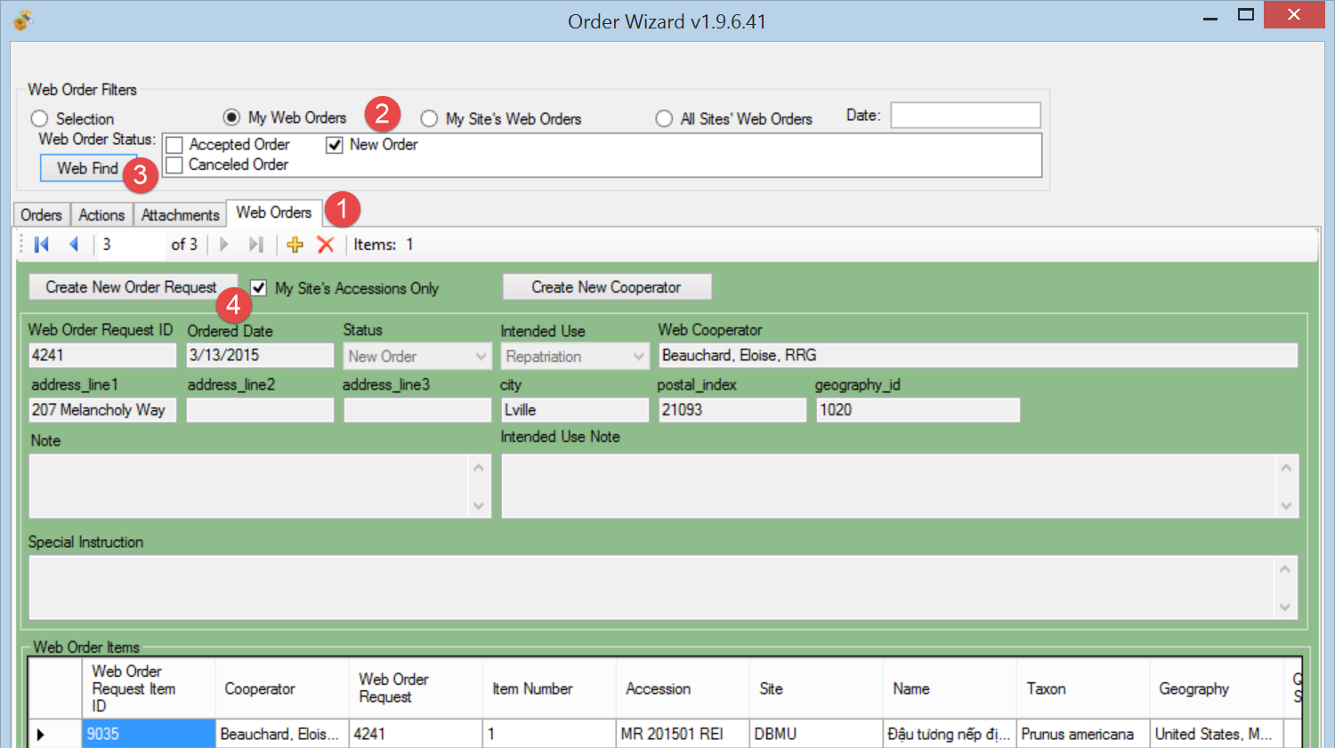

|  |  |
| --- | --- |
| **image2449.png** | Save frequently, and save often! Also, use the **Save** button when initially creating the order; otherwise you will receive an error message. |

The Order Wizard selects inventory to satisfy the request. The inventory must be available, sufficient quantity, etc. See the section “*What Determines Accession Availability or Visibility?*” on page 32. If you are not satisfied with the OW’s selection, you can override the default selection.

|  |  |
| --- | --- |
| image2449.png | As of version 1.9.5, **Order Request Items** in the Order Wizard grid can be *copied (using Ctrl-C) into* a spreadsheet. At this time, you cannot paste **Order Request Items** *into* the OW grid. |

#### Actions (Order Actions)

Various actions may be applied to an order request; an action indicates some event related to the order. Genebank personnel can keep track of where the order is in their procedures by recording appropriate actions. For example, when the order person contacts the curator before proceeding with the order – that can be considered an order action. The action codes are stored in the **ORDER_REQUEST_ACTION** code group which is maintained by the GG DBA.

Examples:

| **Action Code** | **Title** |
| --- | --- |
| NEW | New Order |
| PENDING | Order pending |
| CURALERTED | Curator alerted about order |
| CURCLEARED | Curator cleared an order |
| PATHSEED | Pathology test needed and sent |
| PATHPASSED | Pathologist approved the order |
| ORDFILLED | Order filled ready to ship |

##### Deleting an Order *Record*

Click the delete button on the record’s navigation bar to delete the current order record:  
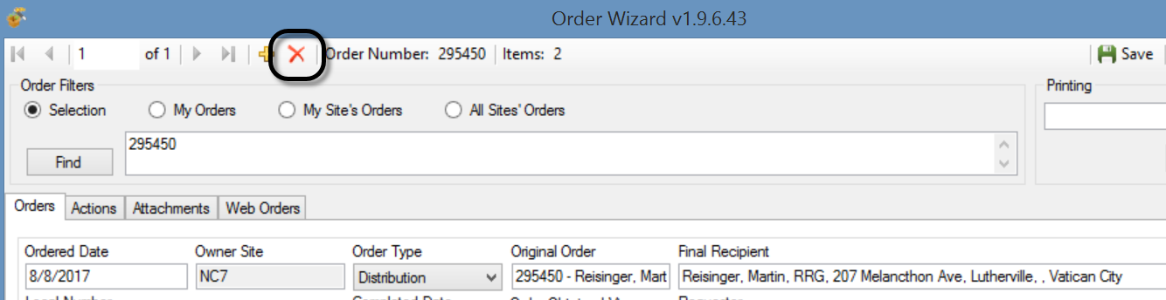

##### Deleting an Order *Item*

If you need to delete an order item, select the item’s row (click on the left row header cell) in the order item grid at the bottom of the wizard window, and then press the keyboard’s **Delete** key.   
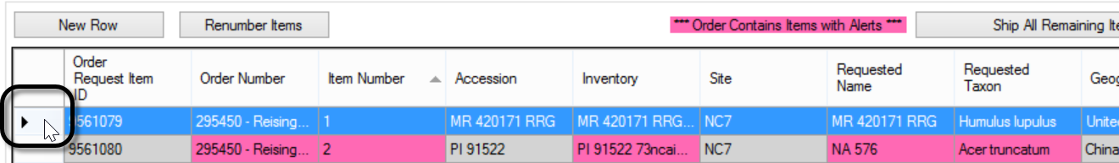

##### Attachments

A germplasm requestor can include attachments (files) when she submits the order or even later, as long as the order has not yet been shipped. In the Curator Tool, the genebank order processor can also add attachments to the order, using the attachment tab in the Order Wizard.

|  |  |
| --- | --- |
| Public Website **Order Detail** page displaying the attachments submitted with the web order: | Order Wizard Attach tab for an order in the process of having 2 attachments added: |

### PW Tools – SQL Queries

Refer to the online page <https://www.grin-global.org/sql_examples.htm> for SQL resources including a brief tutorial, as well as relevant GRIN-Global examples.

Genebank staff who have had their Public Website account connected to their Curator Tool account, when logged into the Public Website, will have the **Tools** option visible on the menu. From there, select **Web Query** to display the box for inputting SQL:  
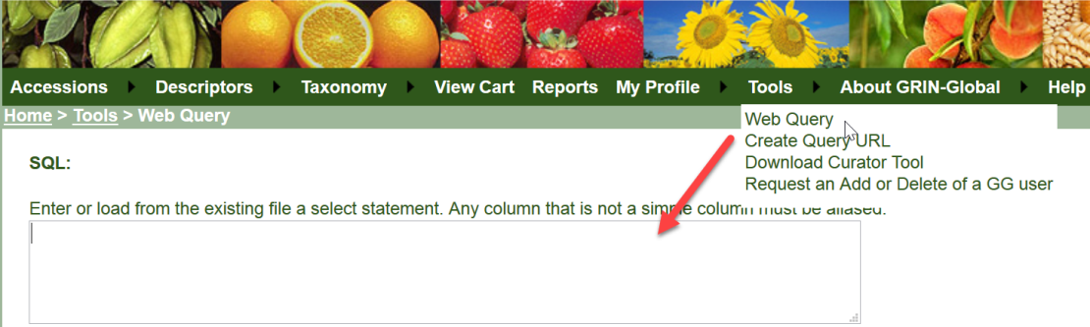

##### Determining Table and Field Names

The **INFORMATION_SCHEMA.COLUMNS** view

SELECT table_name, column_name, ordinal_position, data_type, character_maximum_length  
FROM information_schema.columns

SELECT table_name, column_name

FROM information_schema.columns

WHERE table_name LIKE '**accession**%'

##### Queries Can Involve Multiple Tables

Queries can display data from multiple tables, via JOIN clauses and using aliases. In the following SELECT clause, **a** is the alias for **accession**, and **ts** is the alias for **taxonomy_species.** These aliases are actually defined in the FROM and JOIN clauses, which follow the SELECT clause. (Aliases typically use letters from the original table name, but they are not required to do so.)

SELECT  
a.accession_number_part1, a.accession_number_part2, a.accession_number_part3,  
ts.name   
FROM taxonomy_species ts   
JOIN accession a ON ts.taxonomy_species_id = a.taxonomy_species_id  
WHERE ts.name LIKE 'Trit%'  
 AND a.status_code = 'ACTIVE'

### Recording Characterization Data: Observations & Descriptors (Crop Traits)

A complete guide to GG Observations & Descriptors is online at:  
<https://www.ars-grin.gov/npgs/gringlobal/docs/gg_observations_and_descriptors.pdf>  
Examples of NPGS trait descriptors and codes: <https://www.grin-global.org/docs/gg_coded_trait_examples.docx>

##### Crop Trait Observations

When adapting GRIN-Global, the genebank needs to set up their crops, traits, and for coded traits, their respective codes, before a user can record evaluation results (“observations”). Assuming the descriptors (“crop traits”) have been added for the crops for which you are recording observations, as a Curator Tool user, you will use the **Observation** dataview to enter your evaluation results.

|  |  |
| --- | --- |
| **image2449.png** | The observation requires a Method to be indicated, so ensure that the relevant methods have been defined first before attempting to add observations. (Use the **Get Method** dataview.) |

#### Attach Observations to the Accession or Inventory?

Observations are typically associated with a specific inventory record; however, it is possible to associate an observation with *either* a physical inventory record (a specific “lot”) *or* with the accession (using the accession’s system inventory record (type = “**”)

#### The Crop “Family” of Dataviews - Overview

There are five crop-related dataviews that need to be considered when setting up the crops and crop traits for your organization *before Observations can be recorded*. The DBA generally sets these up.

The following illustrates the general flow in inputting the data in the crop-related dataviews – this flow should be followed in establishing any new crop trait:

|  |  |  |
| --- | --- | --- |
| **Step** | **Input Data for the...** | **Dataview to use** |
| 1 | Crop | Crop |
| 2 | Trait | Crop Trait Crop Trait Lang |
| 3 | Code | Crop Trait Code Crop Trait Code Lang |

##### Example of Meaningful Codes for a Descriptor (USDA Crop: Peanuts; Trait: Plant Size)

Public Website display:  
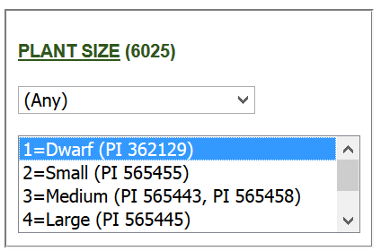

###### Database:

###### Crop Trait



###### Crop Trait Code / Language

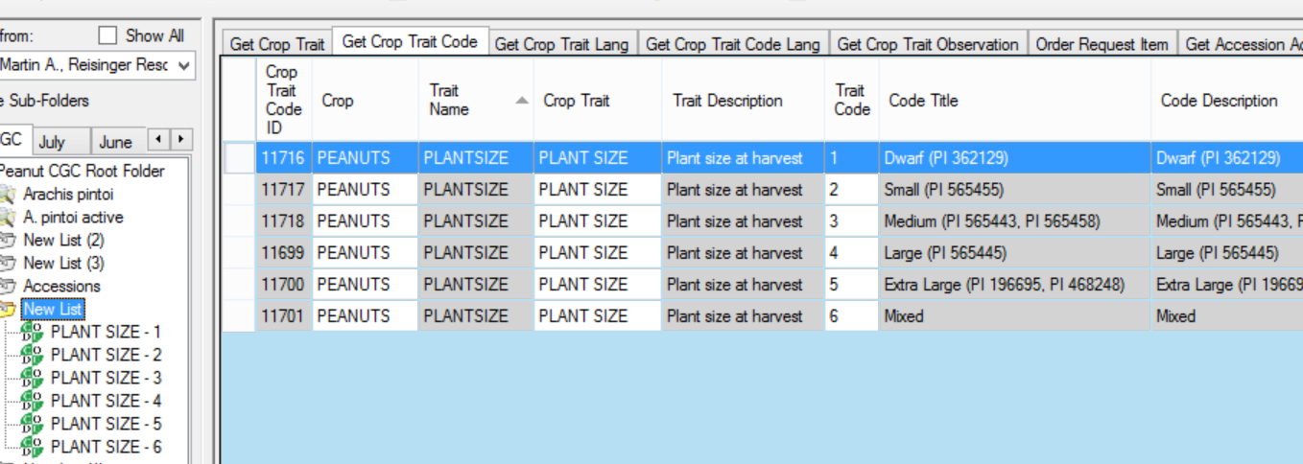

|  |  |
| --- | --- |
|  | The instructor will indicate what Crop and Crop traits to use. You will record some observations. |

### Source Habitat Descriptors

A complete guide to GG Source Habitat Descriptors is online:   
<https://www.ars-grin.gov/npgs/gringlobal/docs/gg_source_habitat_descriptors.pdf>

In the GG schema, a core set of collection site/habitat data is recorded in the accession_source table such as elevation, latitude, and longitude. When recording source events, you can also record supplementary observation data pertinent to the collection.

In setting up GG, the organization should agree on a table of common source descriptors that can be used; this list can be expanded as needed when the collection source data is being recorded. For example, descriptors such as Moisture, Soil pH and Soil Texture, Magnesium Content, etc. can be recorded. (Only the GG Administrator should create the Descriptors.)

Shown here is a source record being recorded within the Accession Wizard; the user is also recording some specific source descriptors:  
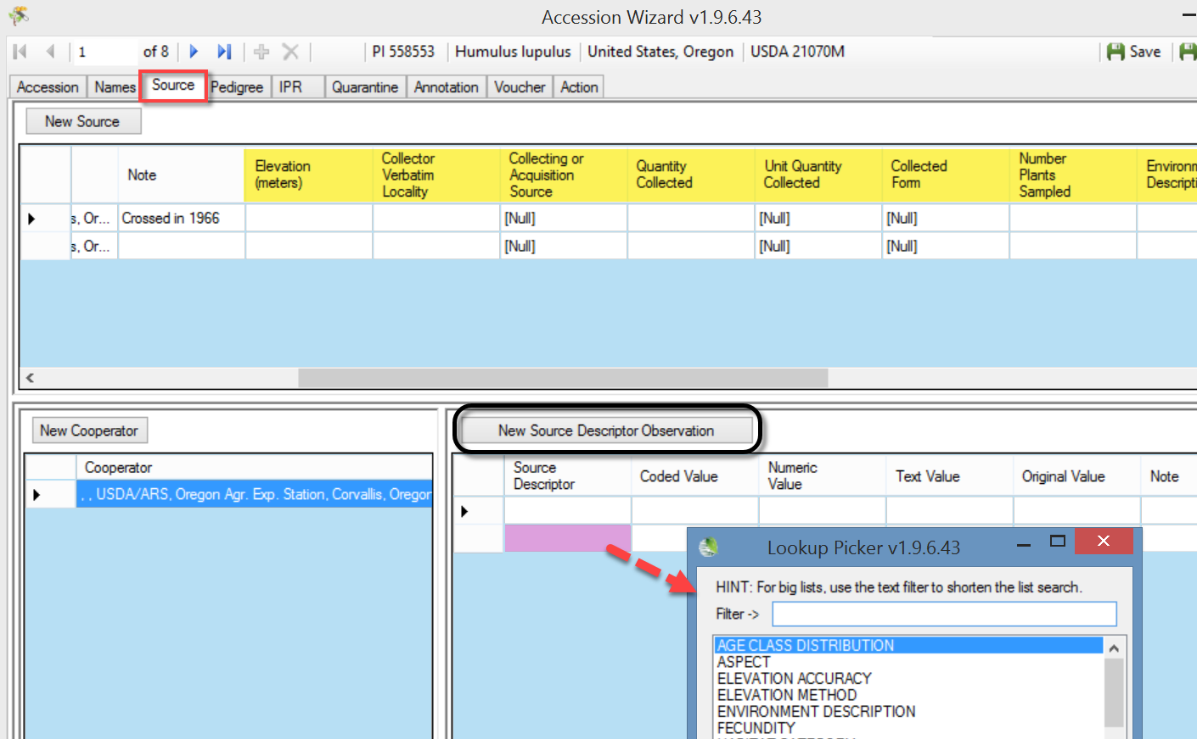,

The following example illustrates the table for SOILTEXTURE as described in the Bioversity’s [Developing Crop Descriptor Lists](http://www.bioversityinternational.org/uploads/tx_news/Developing_crop_descriptor_lists_1226.pdf) (Technical Bulletin #13, 2007):  
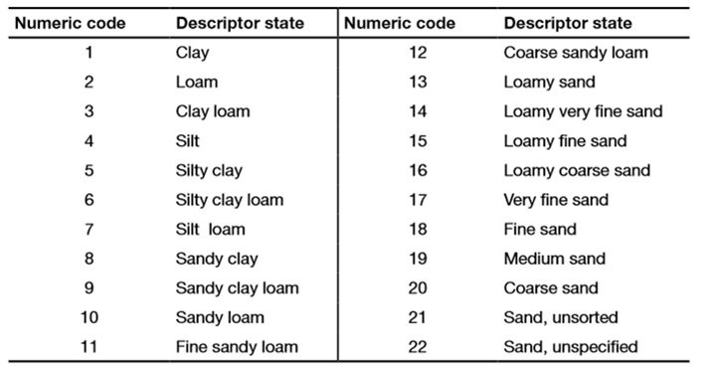

### Codes and Code Groups

##### Background Information

Many of the CT dataviews use dropdowns to assist in selecting valid data – the fields require a value from a pre-populated set of values. Various codes and data values are stored in the **Code Group** tables.

For example, the **Category** field in the **Accession Inventory Name** dataview uses codes:  
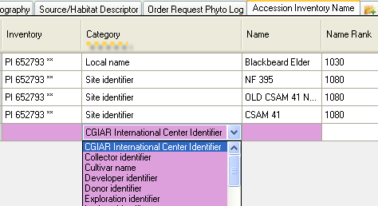

A second example: Five fields in the **Accession** dataview that use codes are shown below. In the example, the user clicked on the **Level Of Improvement** to display and then select a code:  
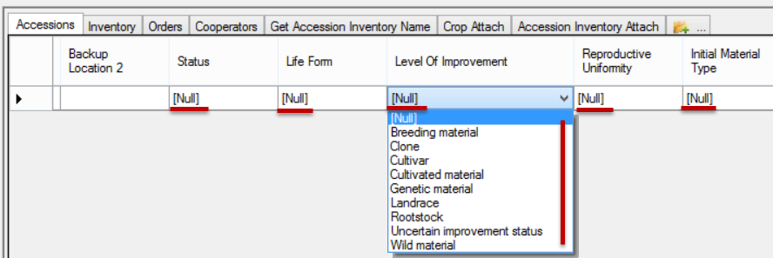

|  |  |
| --- | --- |
| image2449.png | Only the GG administrator can add or edit the codes, ensuring consistency and integrity. As a CT user, if you need a code to adequately describe a record, contact your GG administrator or follow your organization’s procedure for establishing codes. |

##### SQL to Display Codes and Code Groups

SELECT

  cv.code_value_id, cv.group_name as group_name, cv.value, cvl.title

FROM

  code_value cv

LEFT JOIN code_value_lang cvl ON cv.code_value_id = cvl.code_value_id

                                   AND cvl.sys_lang_id = 1

/* use the WHERE clause to search for a specific code – examples: */

/* WHERE cv.group_name LIKE 'inventory%' */

ORDER BY

group_name, cv.value

### Image and Document Handling

A new Inventory Attachment Wizard was included with the CT, beginning with release 1.9.8.14.

GRIN-Global can store and display images and other file types. The **Inventory Attachment Wizard** has been designed specifically to load files and associate them with inventory records. The files may be attached either to a physical inventory record or to an accession’s system inventory record. When attached to a system inventory record, the file is associated with the accession and not with a specific inventory lot.

|  |  |
| --- | --- |
| image2449.png | There are several dataviews with “_attach” as their suffix, implying that they can accept attachments similar to accession_inventory_attach. At the present time they cannot. Some additional code is planned for the Curator Tool to enable this capability. Also, other file types will be handled, including PDFs. |

##### Attachment Documentation

See: <https://www.grin-global.org/docs/gg_inventory_attachment_wizard.docx>

### Reports

#### Curator Tool Reports

|  |  |
| --- | --- |
| image2449.png | When an organization installs GRIN-Global, some basic CT report files are also installed. These reports were created using **Crystal Reports** (from [SAP](http://www.crystalreports.com/)). When the CT is installed, the Crystal Reports Viewer program is also installed. The Viewer makes it possible to display and use these reports, but not create new reports. |

###### Report File Folder Location

In the CT, reports have been designed to work with specific dataviews to display specific data. The report files are loaded in a specific folder, as shown:  
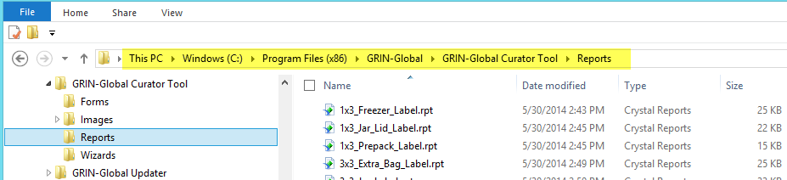

###### ReportsMapping.txt File (Example)

A text file, **ReportsMapping**.txt, gets installed on the CT user’s PC when the CT is installed. The file is needed to indicate the relationship of each.rpt file to the dataviews. For example, as shown below, the **1x3_Freezer_Label.rpt** file works with the **get_inventory** dataview.

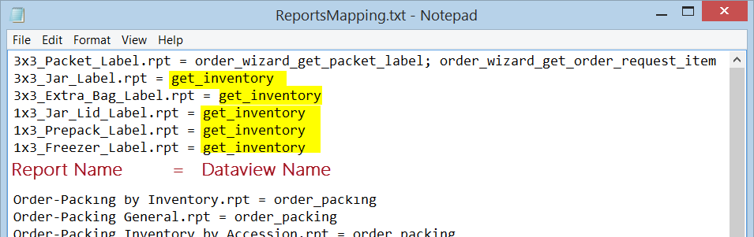

The five inventory reports are displayed under the Reports option when the Inventory dataview is the active dataview (the menu is invoked with a right-click action by the user). Detailed information about editing this **ReportsMapping.txt** file is in the CT User Guide.

###### Resolving Issues When the Reports Do Not Display (AppSettings.txt)

Another .txt file is installed on the CT user’s PC. You may need to edit the AppSettings.txt file when reports are not displaying. Shown below is a Printing dropdown in the Order Wizard; no reports are visible.  
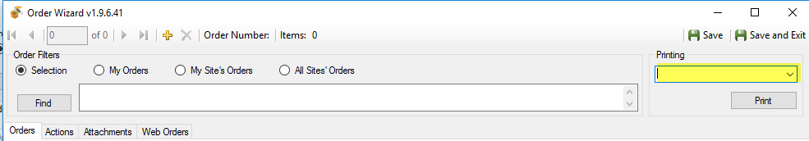

The **AppSettings.txt** file had the line commented with a # symbol:  
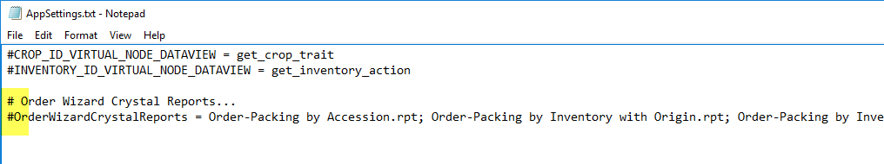Remove the # on the second line. You will need to restart the CT if the CT was open.  
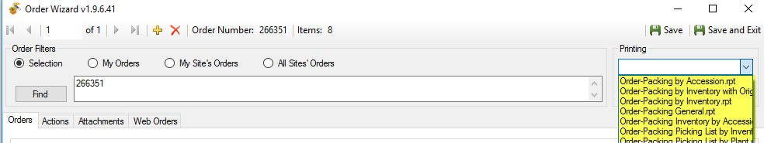

#### One More .txt File

There are three .txt files installed in **C:\Users*username*\AppData\Roaming\GRIN-Global\Curator Tool**). Nothing to do with the reports, but worth mentioning here: the **WebServiceURL.txt** file identifies the connections used in the CT login.   
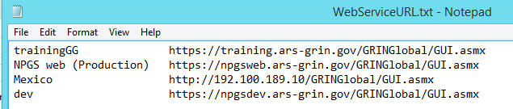

#### SQL Reports

Mentioned previously, a second group of “reports” are the read-only SQL queries. Users added by the GG DBA to the Web Query Users Group will be able to run SQL queries to review data. The online document **GG Library**, has a section containing SQL examples. (see <https://www.ars-grin.gov/npgs/gringlobal/docs/gg_library.pdf> )

#### Public Website Reports

Finally, report dataviews have been designed for the Public Website **Reports** feature. All PW users can see reports that are publicly available. (Only one is currently available to public users.) However, additional PW reports are also available for internal genebank staff. Two conditions must be met: the genebank user must be logged in and the user account must be related to his CT account.

|  |  |
| --- | --- |
| Reports Available to all PW Users | Reports Available to a Logged-in User |
|  |  |

### Security: Ownership and Permissions

#### Overview

An owner typically can update or delete records which she has created. There is only one owner per record. However, the owner can provide permissions (Read, Update, Delete) to multiple users. An owner can also transfer ownership to another user.  
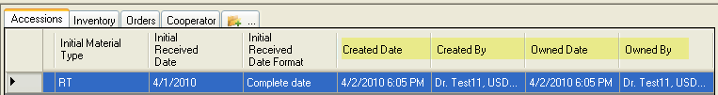

|  |  |
| --- | --- |
| image2449.png | In some cases, the person creating the record is not necessarily the owner of the record. For example, the Inventory record, by default, is assigned the same owner as the owner of the Inventory Maintenance Policy that was used to create the Inventory record. Similarly, Trait Observations inherit the ownership from the Inventory (and hence the Inventory Maintenance Policy records). Someone who creates an observation may need to change the record, and will need the owner to either transfer ownership or give permission to update the record. |

In a Curator Tool dataview, select rows (records) that you intend to transfer ownership; right-click and select **Change Owner…**

##### Change Owner

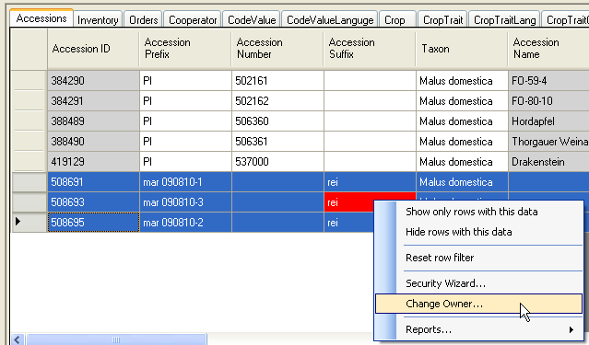

|  |  |
| --- | --- |
|  | Review and then change the ownership information for one or two accessions which you own. Assign ownership to another workshop participant. |

#### Security Wizard

When you own records, use the Security Wizard to change the permissions of the record(s).  
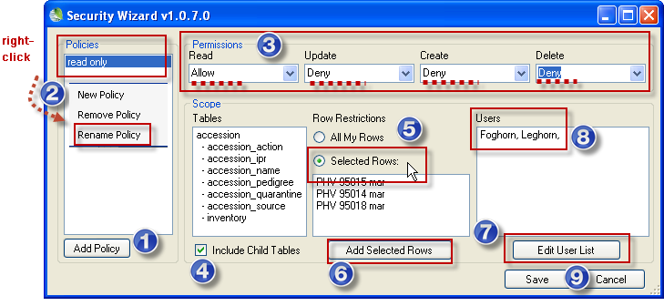

You generally complete the wizard, staring from left to right. “Rows” is used in the wizard as a synonym for records.

Each permission (Read, Update, Create*, Delete) can have one of three values:

|  |  |
| --- | --- |
| **Value** | **Description** |
| Allow | Allows access |
| Deny | Denies access |
| Inherit | Neither allows nor denies access; access is situational; it is inherited from a previous definition (typically the permission value of the parent table) |

* **Create** is also a choice in the wizard, but logically doesn’t make sense (ignore!) – the records have already been created.

|  |  |
| --- | --- |
| **image2449.png** | **Inventory Maintenance Policies** can be shared across the organization, but remember that when a new inventory record is created, and the **Inventory Maintenance Policy** is applied to the new record, the **Curator** field in the **Inventory Maintenance Policy** record determines the owner of the inventory record. |

|  |  |
| --- | --- |
|  | Work with a partner. Each of you will use the Security Wizard to apply the “Deny” updating or Deleting ability to a couple of records. After you have changed the permission, tell your partner the Accession IDs of the records the permission. The partner will attempt to Update or Delete the record(s). |

#### Security: Enabling

Security is enabled by default. With one simple switch in the Admin Tool, the GG DBA can disable security.

|  |  |
| --- | --- |
| **image2449.png** | When setting up a new installation, it is easier to keep security disabled until the users are ready to use the system. (The DBA in the Admin Tool sets the value to “true.”) |

### Taxonomy Overview

#### Taxonomy

When an organization installs GRIN-Global, the administrator has the option to also download the Taxonomy and Geography data copied from the U.S. GRIN system. This is recommended since then the taxonomy and geography information is readily available. An organization can also add its own data as it desires.

A CT user can add taxonomy records, but ideally there iis organizational oversight and only the GG DBA adds taxonomy records. When adding taxonomy, at a minimum every Species record must have a parent Genus which in turn must have a parent Family record.

##### Key Points

* an organization can load the GRIN Taxonomy when it installs the GG database
* this GRIN taxonomy can be complemented with additional taxonomy records supplied by the organization
* someone in the organization should have the responsibility for the taxonomy data
* to load Taxonomy, you need to have the Family, the Genus, and the Species at a minimum
* the AT's Import Wizard can be used by the GG Admin to load Taxonomy data
* you must have the taxonomy in the DB before you can add an accession
* Lookup tables - need to be current

### “Other” Dataviews

#### Literature References | Citations | Methods

##### Literature

This dataview accesses the table of valid books and journals used in literature citations for genera, taxa, accessions, methods, etc. in the database. Abbreviations used should follow recognized standards either from the library field or from taxonomy.

##### Citations

Table of valid books and journals used in literature citations for genera, taxa, accessions, evaluations, etc. in the database. The abbreviations used should follow recognized standards either from the library field or from taxonomy. Documentation is online at <https://www.grin-global.org/docs/gg_citations.docx>.

##### Methods

This dataview accesses the table of methods and procedures. One example of methods are those used in determining the crop specific attributes of the germplasm. Each environment used in an evaluation should have its own record.   
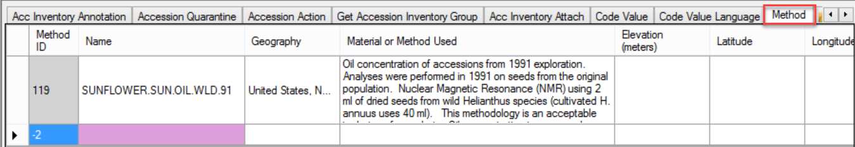

### Brief Overview of GG Administration

A GRIN-Global administrator needs to use the Admin Tool, but understand other tools as well. For example, if in the MS SQL Server environment, the administrator should know how to use SQL Server Management Studio (which is beyond this workshop’s scope).

A full set of documentation is online at <https://www.grin-global.org/admindocs.htm>

#### Admin Tool

The Admin Tool handles diverse functions. Using the GRIN-Global Admin Tool, an administrator can:

* add user accounts and edit GRIN-Global users’ settings such as passwords, permissions, etc.
* review, import, edit, and create dataviews
* use Table Mappings to associate a dataview field with a table field
* add / edit / delete GRIN-Global Code Groups
* configure the GRIN-Global Public Website settings

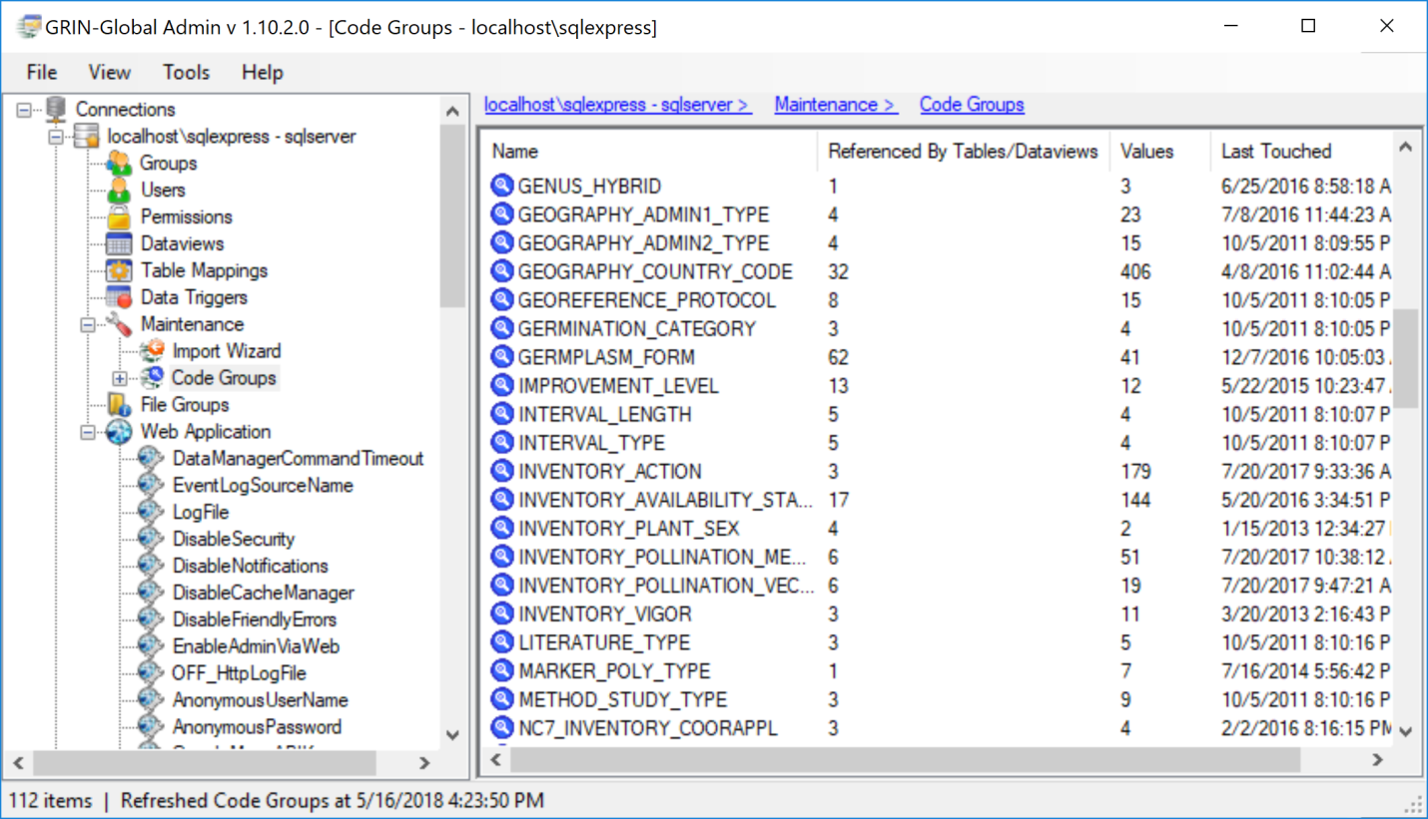

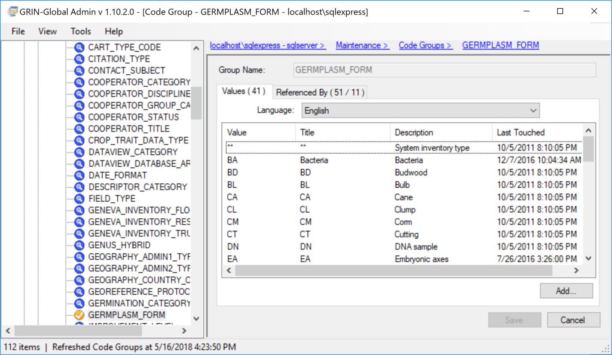

#### Preparing for an Organization’s GG Installation

##### Tools to Use

* Admin Tool (Refer to <https://www.grin-global.org/docs/gg_admin_guide.docx>)
* SQL Server Management Studio (Refer to the website page:   
  <https://www.grin-global.org/sql_examples.htm>)
* Online GG website – see Administrator documents page:  
  <https://www.grin-global.org/admindocs.htm>

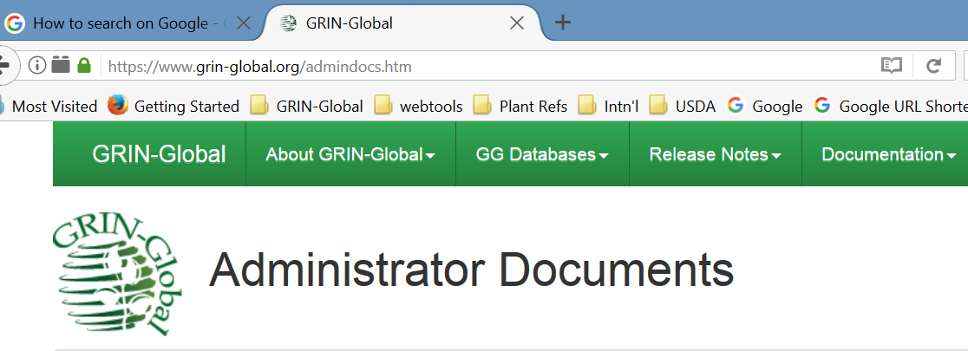

* Online Document: Recommended GG Procedures – Startup & Ongoing:

<https://www.grin-global.org/docs/gg_recommended_procedures.docx>

* Online data dictionary: [Data dictionary](https://docs.google.com/spreadsheets/d/1fG_KLTRX8lZypctXHGJjzPlHYagjDDeVEYQyPuswUzg/edit?hl=en&pref=2&pli=1#gid=2)